Ditto: Experimenting with Moose framework

Contents

1 Mathematical Identities 3

1.1. Continuity equation: 3

1.2. Moose inner product notation: 3

1.3. Integration by parts and divergence theorem 3

2 How to create a the Ditto moose project 4

3 Examples 5

3.1. Diffusion (steady) 5

3.2. ADDiffusion (steady) 7

3.3. ADDiffusion (transient) 8

3.4. Parameterized diffusivity 10

3.5. Introducing Materials: spatio-temporal diffusivity 11

3.6. Initial condition 13

4 Paraview notes 15

# Mathematical Identities

## Continuity equation:



where the first term is the rate of change of *c*, **j** is the flux and *R* the source/sink term for *c*.

## Moose inner product notation:





## Integration by parts and divergence theorem

Let *ψ* be a scalar variable and **u** a vector function. The divergence of their produce is:



By integrating over a domain Ω and rearranging we get:



The divergence theorem transforms a volume integral into a surface integral:



with being an outward normal vector on surface **. By combining eqs and we get:



# How to create a the Ditto moose project

1. Activate moose

conda activate moose

2. Generate the project files w/ stork

cd ~/projects

./moose/scripts/stork.sh Ditto

3. (Optional) Create GitHub repo called Ditto and push the project

cd ~/projects/Ditto

git remote add origin [git@github.com:[insert_name]/Ditto.git](mailto:git@github.com:[insert_name]/Ditto.git)

git push -u origin main

4. Make the executable

make –j4 # e.g., with 4 processors

5. Run the tests

./run_tests

6. Generate a problems folder

mkdir problems

# Examples

## Diffusion (steady)

We will generate a script for steady diffusion in 2D using the Dirichlet boundary conditions *u*left = 1 and *u*right = 0.

Let’s derive the weak form in inner product notation:

Strong form:



Multiply with a test function *ψ* and integrate over the domain



Integrate the first term by parts and apply the divergence theorem (eq. with **u** → ):



Expressing in the inner product notation:



We will set the domain to from -10, +10 along the *x* and *y* directions.

The problems is solved with the script ex01_diffusion.i:

[Mesh]

type = GeneratedMesh

dim = 2

nx = 40

ny = 40

ymin = -10.0

ymax = 10.0

xmin = -10.0

xmax = 10.0

elem_type = QUAD4

[]

[Variables]

[uu]

order = FIRST

family = LAGRANGE

[]

[]

[Kernels]

[diff]

type = Diffusion

variable = uu

[]

[]

[BCs]

[left_uu]

type = DirichletBC

variable = uu

boundary = 'left'

value = 1

[]

[right_uu]

type = DirichletBC

variable = uu

boundary = 'right'

value = 0

[]

[]

[Executioner]

type = Steady

solve_type = 'PJFNK'

[]

[Outputs]

execute_on = 'timestep_end'

exodus = true

[]

We can run the script with the command:

./run.sh ex01_diffusion.i

Paraview output:

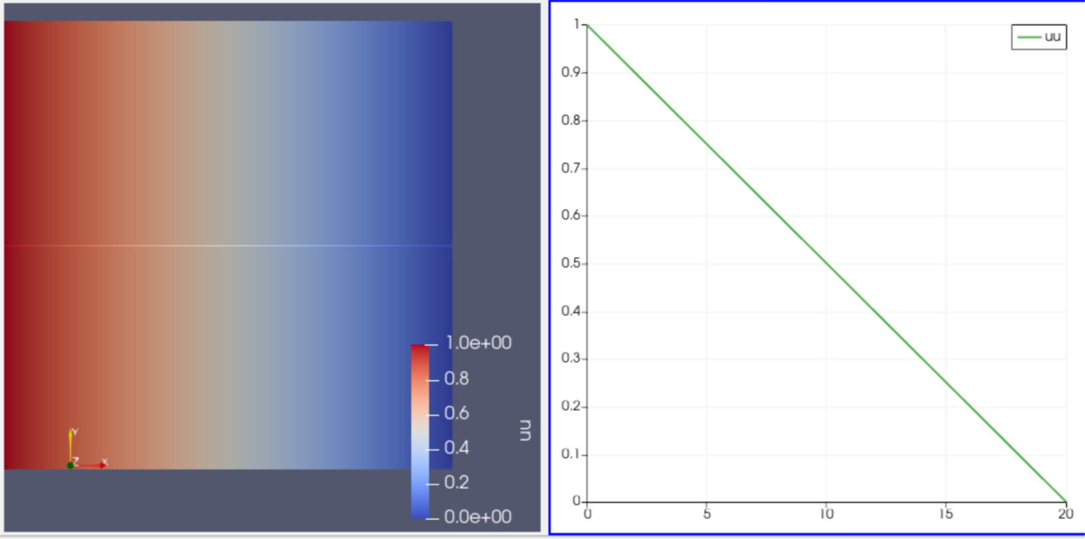

Figure 1. output from exodus file ex01_diffusion_out.e

## ADDiffusion (steady)

Same with example 3.1 but we will use automatic differentiation.

The implementations of the kernels in path are shown below:

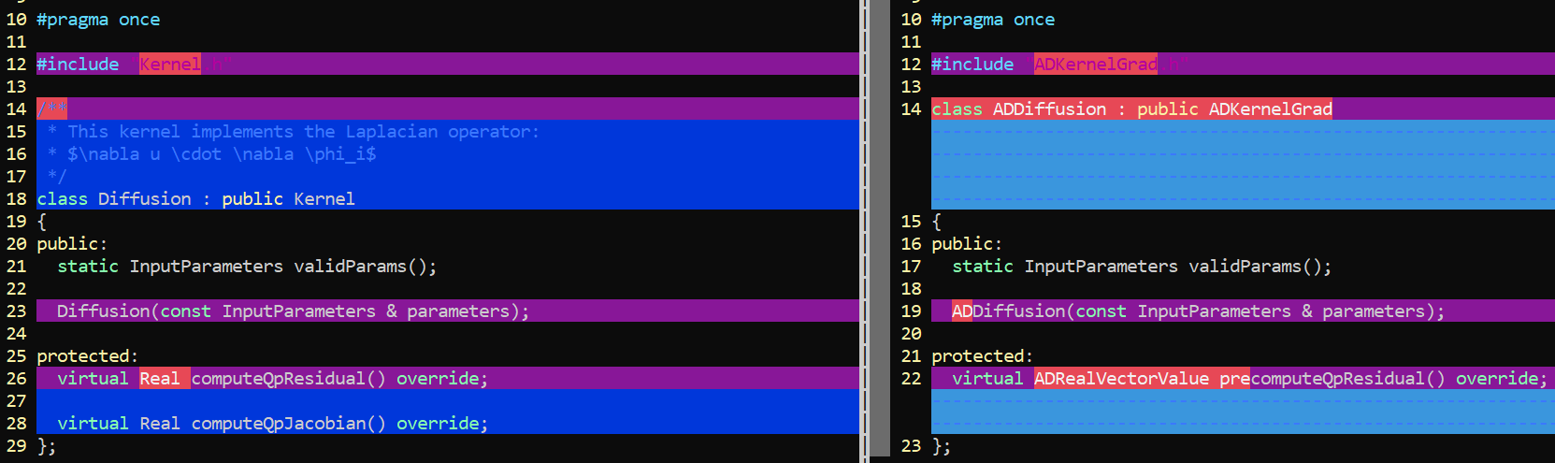



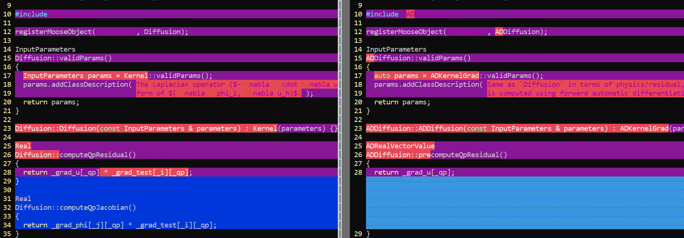



**Notes**

* In ADDiffusion the specification of the Jacobian is not required.
* The test function has been already multiplied in the precomputeQpResidual.

## ADDiffusion (transient)

Let’s derive the weak form in inner product notation:

Strong form:



Multiply with a test function *ψ* and integrate over the domain



Integrate the first term by parts and apply the divergence theorem (eq. with **u** → ):



Expressing in the inner product notation:



We will set the domain to from -10, +10 along the *x* and *y* directions.

The kernel in invoked in example ex03_transient.i.

Difference wrt example 3.2:

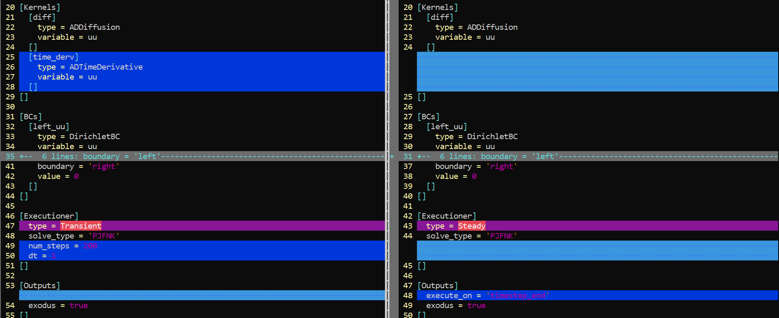



**Notes:**

* Add kernel ADTimeDerivative
* Change executioner to Transient

**Output:**

The evolution of the solution is shown in the left panel of **Figure 2**.

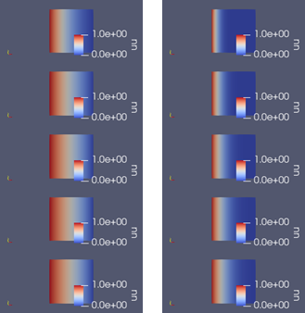

**Figure 2.** Diffused quantity *uu* in steps 0, 40, 80, 120, 160 and 200. Diffusion coefficient = (left) 1 and (right) 0.1.

## Parameterized diffusivity

Same with example 3.3 but we will allow for varying the diffusion coefficient.

* The following files have been added in src/kernel/ADDiffusionParam.C and include/kernel/ADDiffusionParam.h
* The source was recompiled (Make –j6)

The files are similar with the default ADDiffusion kernels in moose framework with the exception that the diffusion coefficient has been made a parameter.

Comparisons are shown below:

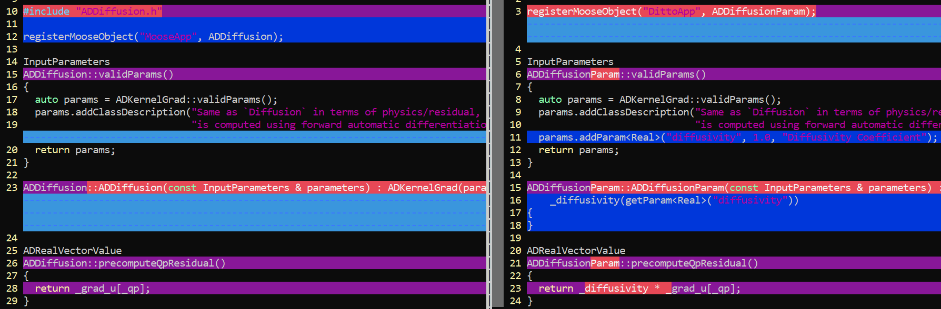



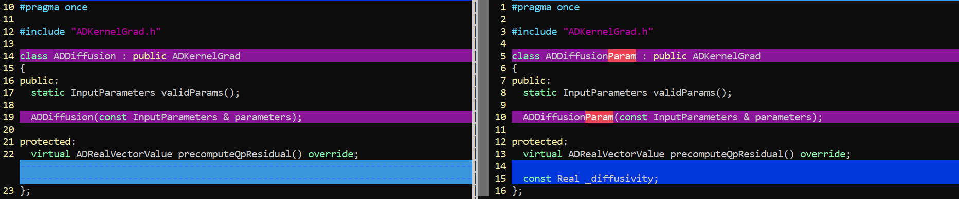



**Output:**

The evolution of the solution is shown in the right panel of **Figure 2**.

## Introducing Materials: spatio-temporal diffusivity

We will introduce a material object whose properties change with time and space, based on a parsed function.

The following files have been introduced to the project:

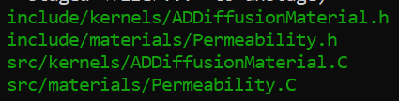

Let’s compare the changes to the diffusion kernel:  
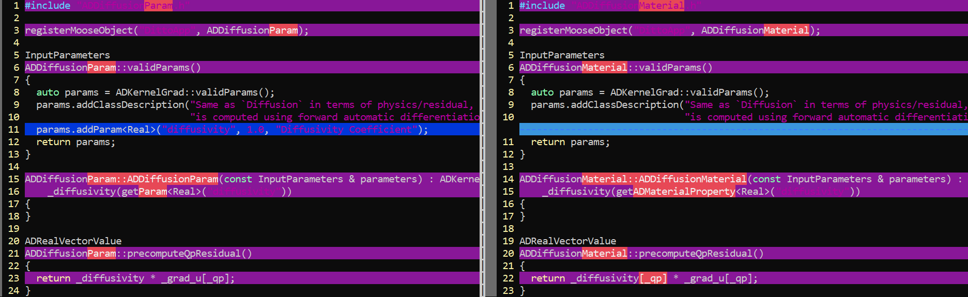



Let’s compare the input of the present example wrt the one from example 3.4.

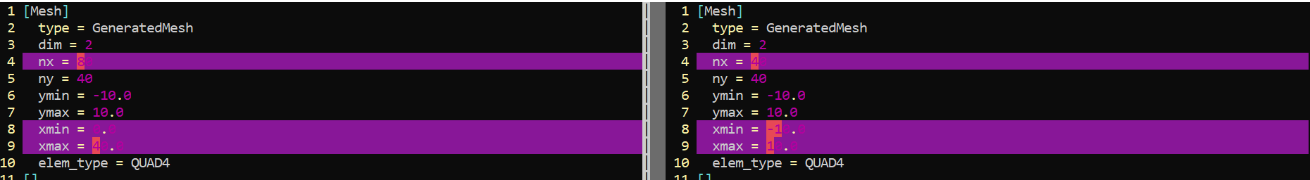

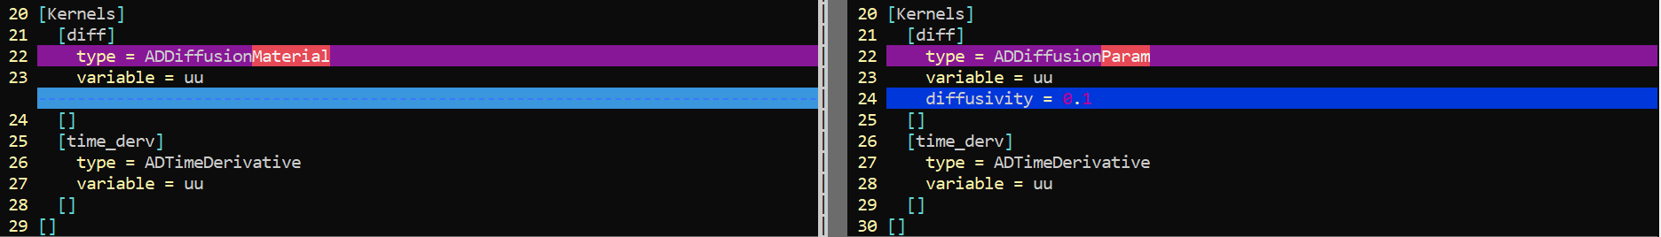

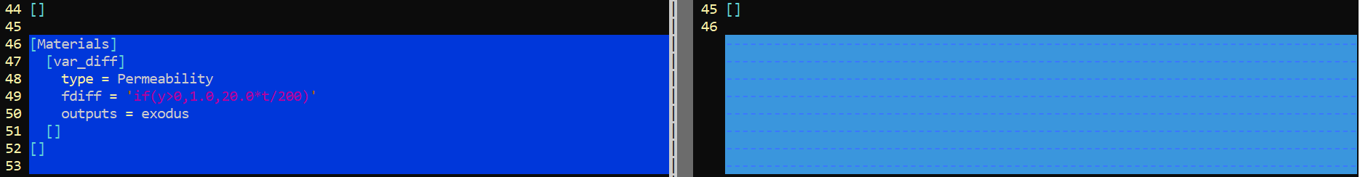



**Notes:**

* The box size have been increased to 80 along x-axis
* The diffusion term is described with the kernel ADDiffusionMaterial
* The properties of the material change with time and space according the parsed function in line 49:



In other words, the diffusion coefficient increases with time for y < 0, and equals to 1 for y > 0.

**Output:**

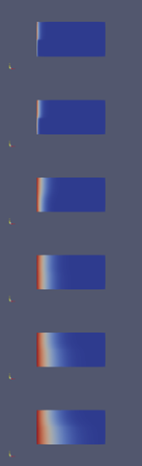

Figure 3. Steps 1, 2, 10, 20, 30, 40. At short times the diffusion at y<0 is 10 times smaller than that at y>0. The situation is reversed at long times since the diffusion at y<0 becomes 20 times larger than that at y>0.

## Initial condition (IC) and boundary conditions (BC)

The example ex06_ic_pulse.i applies an initial condition *u* = 50 across a unit square at the center of a box with dimensions 10×10. Dirichlet BC, *u* = 0 are applied to the edges of the simulation box.

A corresponding snapshot is shown below:

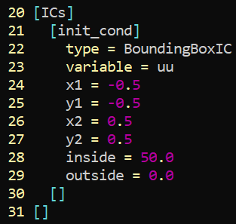

The evolution of the solution is illustrated in **Figure 4**.

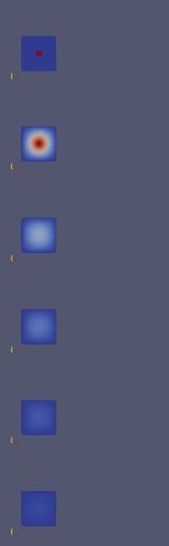

**Figure 4.** Evolution of the solution at steps 0, 2, 4, 6, 8 and 10.

The example ex06_ic_function_neumann.i applies an initial condition based on the following parsed function:

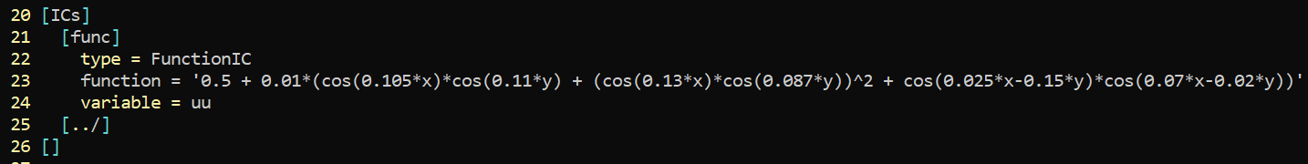

Neumann BC are applied at the edges of the domain with zero flux. The evolution of the solution is illustrated in **Figure 5**.

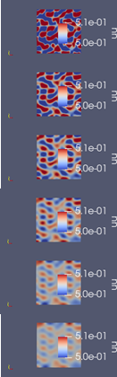

**Figure 5.** Evolution of the solution at steps 0, 40, 80, 120, 160 and 200.

The example ex06_ic_function_per.i implements the periodic boundary conditions; e.g., see snippet below:

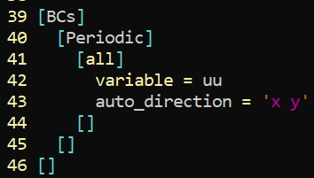

## Diffusion-Advection

The example ex07_diffusion_advection.i solves the diffusion-advection equation with the same initial condition in the example ex06_ic_pulse.i.

A snippet of the kernel section is shown below:

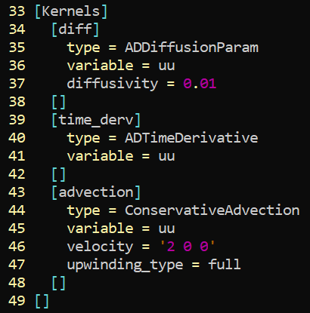

In this case, the diffusivity has been set to 0.01 and the velocity field to **v** = (2, 0, 0).

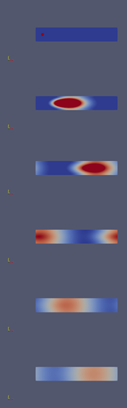

Figure 6. Evolution of the advected initial pulse at steps 0, 10, 20, 30, 40 and 50.

## Adaptive grid

The example ex08_adaptive_grid.i demonstrates the implementation of the adaptive grid. For demonstration purposes we apply the scheme to the pulse from the example ex06_ic_pulse.i in section 3.6.

A snippet of the Executioner section is shown below:

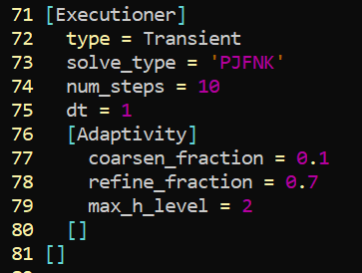

The evolution of the pulse is shown in Figure 7.

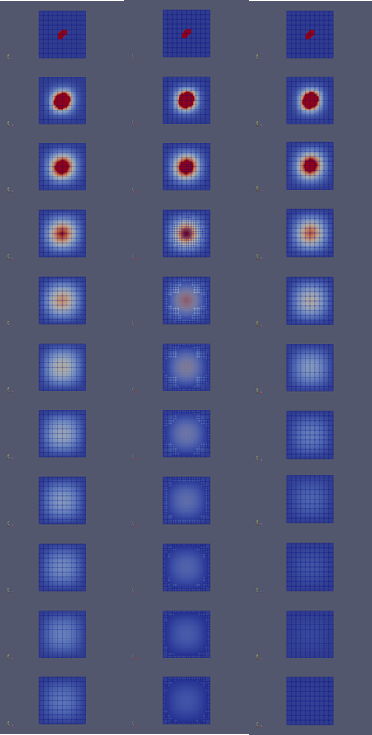

**Figure 7.** Evolution of the pulse during the course of the simulation. (left) original grid; (middle) adaptive grid; (right) original grid with adaptive step.

## Adaptive step

The example ex09_adaptive_step.i demonstrates the implementation of the adaptive step. For demonstration purposes we apply the scheme to the pulse from the example ex06_ic_pulse.i in section 3.6.

A snippet of the Executioner section is shown below:

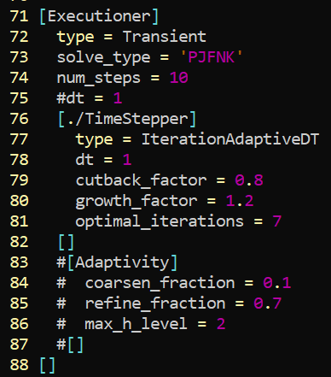

The evolution of the pulse is shown in Figure 7 (right).

We note that the evolution is faster since the time step increases during the course of the simulation.

# Paraview notes

TODO