**Design thinking tools applied to “CollegeXplorer”**

A Report Submitted to



**Visvesvaraya Technological University, Belagavi**

in partial fulfilment of requirements of

II semester Innovation and Design Thinking - 22ME2AEIDT

of

BACHELOR OF ENGINEERING in “RESPECTIVE BRANCH”

Submitted by

|  |
| --- |
| **Akshat Baranwal** |
| **Akshat Kumar Singh** |
| **Akash S.A** |
| **Akshata A**  **Akshay Bhat** |

Under the mentorship of

**Devaraj K**

Assistant Professor

Department of Mechanical Engineering



**Department of Artificial Intelligence and Machine Learning Engineering**

**B. M. S. COLLEGE OF ENGINEERING**

(Autonomous Institution Affiliated to VTU, Belagavi)

Post Box No. 1908, Bull Temple Road, Bengaluru – 560 019

**B. M. S. COLLEGE OF ENGINEERING**

Post Box No. 1908, Bull Temple Road, Bengaluru – 560 019



Department of Artificial Intelligence and Machine Learning Engineering

***Certificate***

Certified that the seminar entitled **CollegeXplorer** is a bonafide work carried out by

|  |
| --- |
| **Akshat Baranwal** |
| **Akshat Kumar Singh** |
| **Akash S.A** |
| **Akshata A**  **Akshay Bhat** |

in partial fulfillment for the award of Bachelor of Engineering in Artificial Intelligence and Machine Learning Engineering of the Visvesvaraya Technological University, Belgaum, during the year 2021– 22. It is certified that all corrections / suggestions indicated for internal assessment have been incorporated in the report deposited in the departmental library. The report has been approved as it satisfies the academic requirements in respect of the course Innovation and Design Thinking (22ME1AEIDT) prescribed for the said degree.

Signature of the Mentor Signature of HOD

(Devaraj K)

Signature of Principal

Semester End Examination

Name of the Examiners Signature with Date

1.

2.**Declaration**

I hereby declare that the report entitled **CollegeXplorer** has been independently carried out by me at Department of **Artificial Intelligence and Machine Learning** Engineering, under the guidance of Devaraj K, Assistant Professor, Department of Mechanical Engineering, B. M. S. College of Engineering, Bengaluru, in partial fulfilment of the requirements of the degree of Bachelor of Engineering in **Artificial Intelligence and Machine Learning** Engineering of Visvesvaraya Technological University, Belagavi.

I further declare that I have not submitted this report either in part or in full to any other university for the award of any degree.

|  |
| --- |
| **Akshat Baranwal** |
| **Akshat Kumar Singh** |
| **Akash S.A** |
| **Akshata A**  **Akshay Bhat** |

Place: Bengaluru

Date: 24/12/2024

**Contents**

|  |  |  |
| --- | --- | --- |
| **Chapters** | **Content** | **Page No.s** |
| **1** | **Summary/Abstract** | **1** |
| **2** | **Introduction** | **2** |
| **3** | **Empathize and Define** | **3-5** |
| **4** | **Ideation** | **6** |
| **5** | **Prototype** | **7** |
| **6** | **Conclusions** | **8** |
| **7** | **References** | **9** |

**Abstract/Summary**

The given IDT project which we are looking to do is called CollegeXplorer which in simple words is a way to shorten and solve a lot of the problems faced by students and parents alike.

The idea arose from the need of a centralized user friendly platform for students regarding college related queries.In India with the growing number of universities and colleges ,there is an increase in the lack of detailed information regarding the college entrance exams, fees, placements etc.

Our goal is to apply the steps of innovative and design thinking to the said topic and give a comprehensive report along with it.

**Chapter 1. Introduction**.

* 1. **Goal with this report?**

To understand the need of a centralized student friendly platform for solving all college related issues**.**

* 1. **Utilising Design Thinking steps for CollegeXplorer.**

Empathise: Our goal is to understand the problems faced by students and parents. We try to understand this better by conducting a survey.

Define: Defining the problem is the next step to design thinking .Students and parents struggle to find a centralized, accurate and user friendly platform to explore colleges ,exams ,cut offs, fees, placements and related data ,making the decision process overwhelming and inefficient.

Ideation: We try to come with ways to tackle the problem by creating the features of the website.

Prototype: Develop a functional prototype .We focus on parts like design, technicality and user friendliness.

Testing: We can test it on a small scale level to gather reviews and then think about future prospects.

**Chapter 2.Empathize**

* 1. **Survey**

To better understand the problems and requirements of the students a survey was conducted which mainly focused on the major things people look for in a platform like CollegeXplorer and the problems they face when searching for college related info.

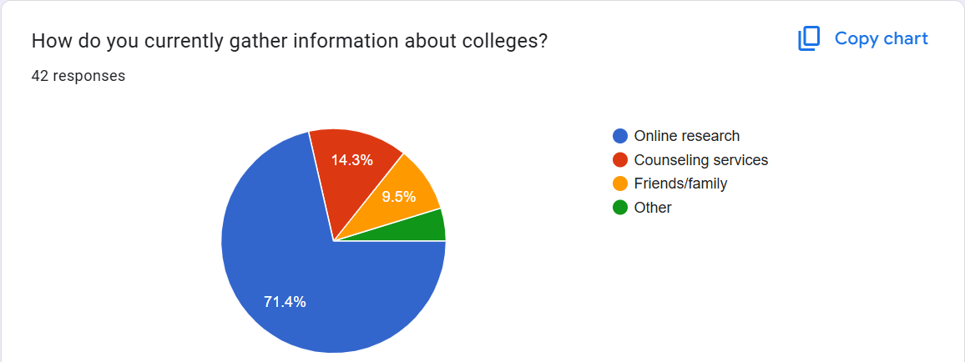

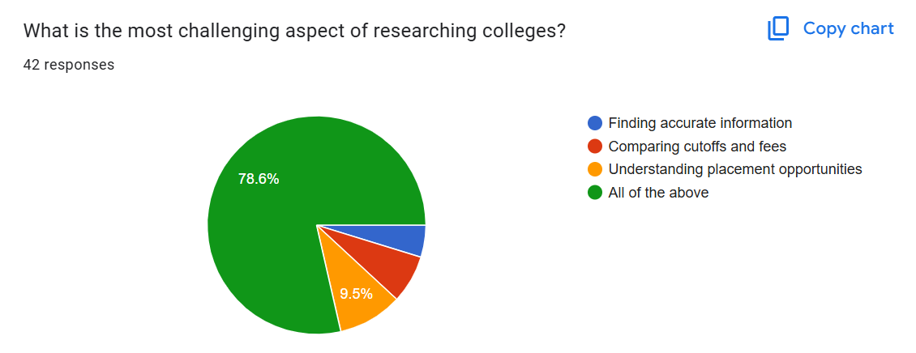

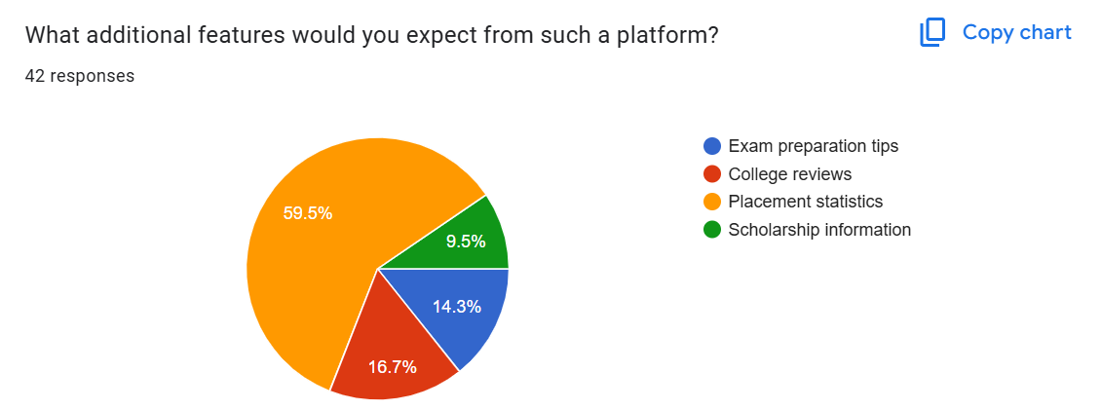

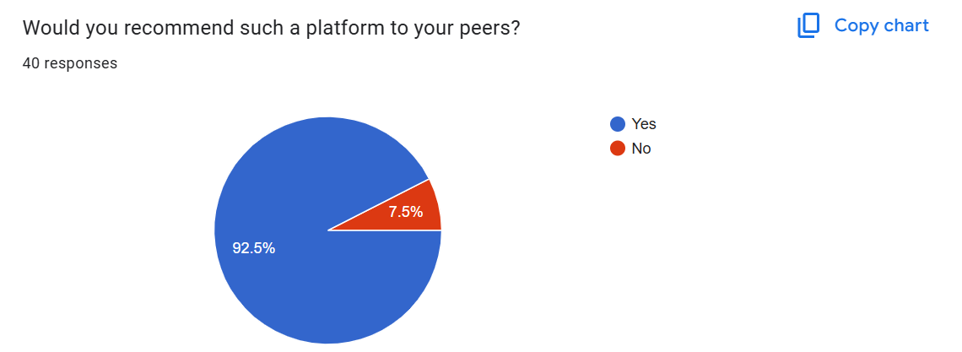

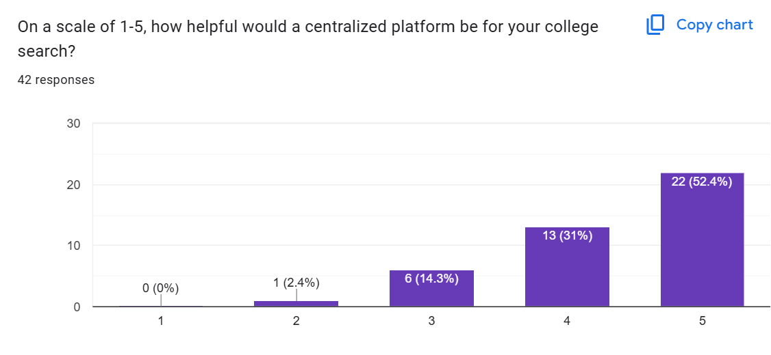

The survey results helped us uncover the following critical insights:

* Most students rely on online research, but they find it difficult to navigate multiple sources for accurate and up-to-date information.
* The biggest challenge is a combination of finding accurate data, comparingcolleges, and understanding placements.
* Over 80% of respondents rated 4 or5 when asked if a centralized platform would be helpful.
* Placement statistics and scholarship information were among the most requested additional features.
* More than 90% of students said they would recommend such a platform to their peers.

These insights reinforced the need for CollegeExplorer and guided us in designing a platform that is user-friendly, informative, and highly relevant to students' needs.

**1.2. Define**

Using the insights from the survey we can frame our problem as

"Students and parents struggle to find a centralized, accurate, and user-friendly platform to explore colleges, exams, cut-offs, fees, placements, and related data, making the college decision process overwhelming and inefficient."

The users need to have access to features that compares colleges based on their requirement with up-to date information on all of them.

**Chapter 3. Ideation**

Our focus is user friendly features and concise data.

**3.1. Features for CollegeXplorer**:

**3.1.1 Search Engine with Filters**:

* + - We allow users to filter colleges by exams, cut-offs, fees, location, and course type.

**3.1.2. Interactive Dashboard**:

* + - Visualize college details (e.g., charts for placement rates or cut-offs).

**3.1.3. Comparison Tool**:

* + - Side-by-side comparison of multiple colleges for easy decision-making.
    1. **AI-Powered Recommendations**:
    - Suggest colleges based on user preferences like exam scores or budget.

**3.1.5. Real-Time Updates**:

* + - Provide updates on cut-offs, application deadlines, and placement statistics.
    1. **Placement Insights**:
    - List companies visiting colleges, average packages, and alumni success stories.

**Chapter 4.Prototype:**

Develop a functional prototype that is implantable on a small scale first. Instead of focusing on major features we start by implementing the basic features

**4.1. Design**:

**4.1.1.** Ensure a clean and responsive user interface with simple navigation.

**4.2. Key Features in the Prototype**:

4.2.1. A search bar with filtering options.

4.2.2. College profile pages displaying details (cut-offs, fees, placement stats).

4.2.3. A placement dashboard showing companies and salary trends.

4.2.4. Comparison functionality.

**4.3. Backend**:

* + 1. We develop a database to store college-related data (exams, fees, placements, etc.).

4.3.2. Using web scraping tools or official APIs to keep the data updated.

**4.4. Testing the Prototype**:

4.4.1. By conducting usability testing with a sample audience of a small number we can understand the faults and improvements to be made (students and parents).

* + 1. We can pitch the idea to colleges and have their insights and support to test our platform.
    2. We gather feedback on navigation, clarity, and the usefulness of the information for our future prospects.

**Chapter 5.Conclusions**

By applying the principles of Design Thinking, **CollegeXplorer** creates a student-first platform that simplifies the complex process of researching colleges .The result is an innovative, accessible, and reliable solution that empowers students and parents to make informed decisions about higher education with more clarity than before .It solves the problem we defined at its core to ensure understanding.

**References:**

For details regarding surveys used in the slide you can refer:

1. **National Association for College Admission Counseling (NACAC):** NACAC conducts comprehensive research on the college admission process, offering data and trends that can enrich your understanding of current challenges.

**Reference:**

* + NACAC Research and Reports: <https://www.nacacnet.org/news--publications/Research/>

1. **Anthology's Student Survey on Admissions and Enrollment:** This 2023 survey reveals that over 60% of students rely on internet searches and institutional websites for information, while 48% doubt their ability to succeed in college during enrollment. It also highlights that 40% of respondents desired an advisor to assist with questions during the enrollment process. citeturn0search1

**Reference:**

* + Anthology News: <https://www.anthology.com/news/student-survey-reveals-opportunities-for-us-higher-ed-to-attract-more-applicants>

1. **NASFAA Report on Student Challenges in Accessing College Cost Information:** According to a report by the National Association of Student Financial Aid Administrators (NASFAA), 63% of students felt lost when researching college costs and financial aid, indicating a need for clearer information and guidance. citeturn0search0

**Reference:**

* + NASFAA News: <https://www.nasfaa.org/news-item/5903/Many_Students_Feel_Lost_Searching_for_College_Cost_Financial_Aid_Information_Report_Says>

1. **Vox Article on the Modern College Application Experience:** This article discusses how the college application process has become both public and isolating, with increased pressure from early-decision offers and social media, contributing to heightened stress among applicants. citeturn0news26

**Reference:**

* + Vox: <https://www.vox.com/life/390714/college-applications-early-decision-date-acceptance-admission>

1. **Parents.com Article on Application Stress Leading Students to Abandon College Plans:** A study highlighted in this article reveals that nearly 13% of students abandon their college plans due to application stress, with many seeking therapy to cope, underscoring the need for a more supportive application process. citeturn0news24

**Reference:**

* + Parents.com: <https://www.parents.com/students-are-skipping-college-due-to-application-stress-8775742>