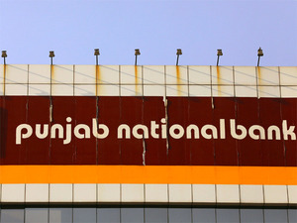

**Title**: Punjab National Bank Scam

**Organization**: Punjab National Bank

**Date**: 15th Feb, 2018

**Location**: Mumbai

**Description**: A Rs.12,600 crores fraud at India’s biggest state run lender Punjab National Bank has disturbed the nation’s financial sector triggering a massive probe and regulatory changes .The CBI registered a case against jeweler Nirav Modi on Thursday in connection with the alleged fraud in credit facilities extended by Punjab National Bank causing a loss of Rs.321crores.

Union Bank of India, Allahabad Bank and Axis Bank are said to have offered credit based on letters of undertaking (LOUs) issued by PNB.  
  
An LOU is in effect a letter of comfort issued by one bank to branches of other banks, based on which foreign branches offer credit to the buyers. Foreign branches of these banks, which had relationships with the outlets of a jeweler company, had taken significant exposures.

The jeweler company, which has shops in foreign locations such as Hong Kong, Dubai, and New York, had been availing buyers’ credit based on such LOUs from as early as 2010, according to banking sources. The arrangements continued to be honored regularly over the years. Sources said the last such obligations were honored on January 5. However, trouble began with the payment cycle that fell due on January 25.  
  
Sources added that PNB officials had sought additional margin of around 10% on the jeweler’s exposure for the facilities to continue. As the jeweler was unable to provide this, the facilities were withdrawn, leading to a collapse.