ASSIGNMENT : 08:
Q1: Create a variable of any 3 datatypes and print their values.
Code:
a=2
print(a)
fruits=["apple","banana","mango"]
print(fruits)
name="arisha"
print(name)
number=33.5
print(number)
isflag=True
print(isflag)

screenshot: 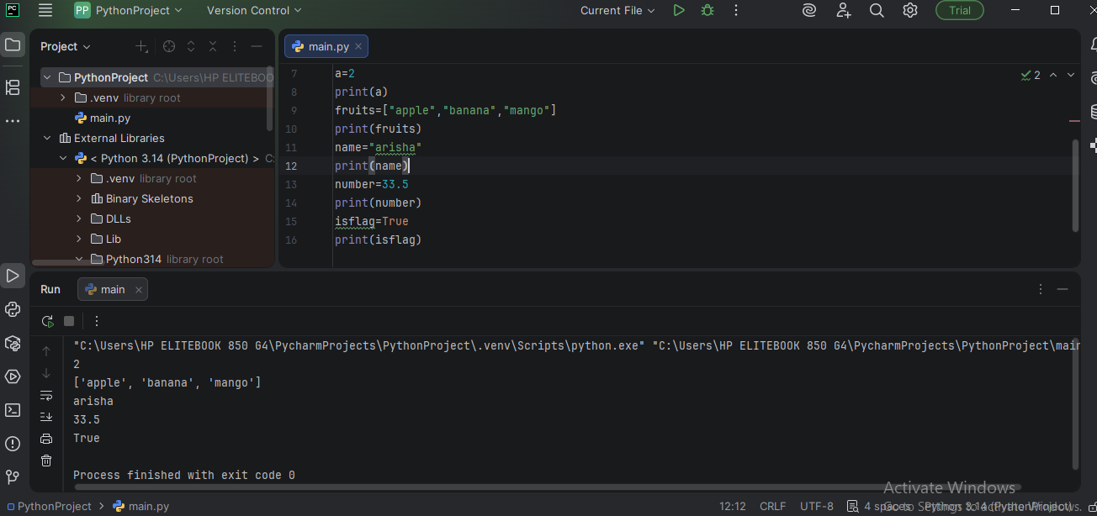

Q2:What are the data types ? Give example of each data type with code example.
Data types are basically just a type of value which tells what type of data we are storing e.g: a=5 so python automatically detects that 5 is a int type of number(datatype) which is stored in variable a.Like in java we use int a=5; so here 5 is an int type of hardcoded data which is stored In a but in python no need to declare it automatically understands.
Q3: Write a program which Print table of 9 upto 10 using for loop.
for i in range(1,11):
num1 = 9
print("9 * ",i ,"=",(num1 * i))

screenshot: 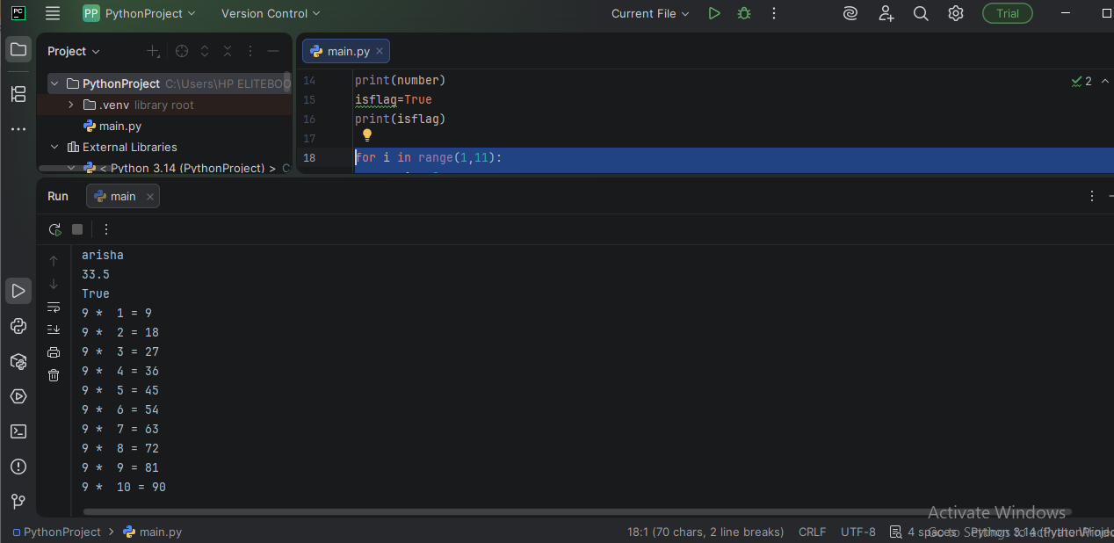
Q4: Write a program if user gives even number it print “qa jobs in lahore” and if user give odd number it prints “AI in software testing course”.
number = int(input("enter your number : "))
print("the number you have entered is ", number)
if number % 2 == 0 :
print("qa jobs in lahore")
else:
print("AI in software testing course")

Screenshot:
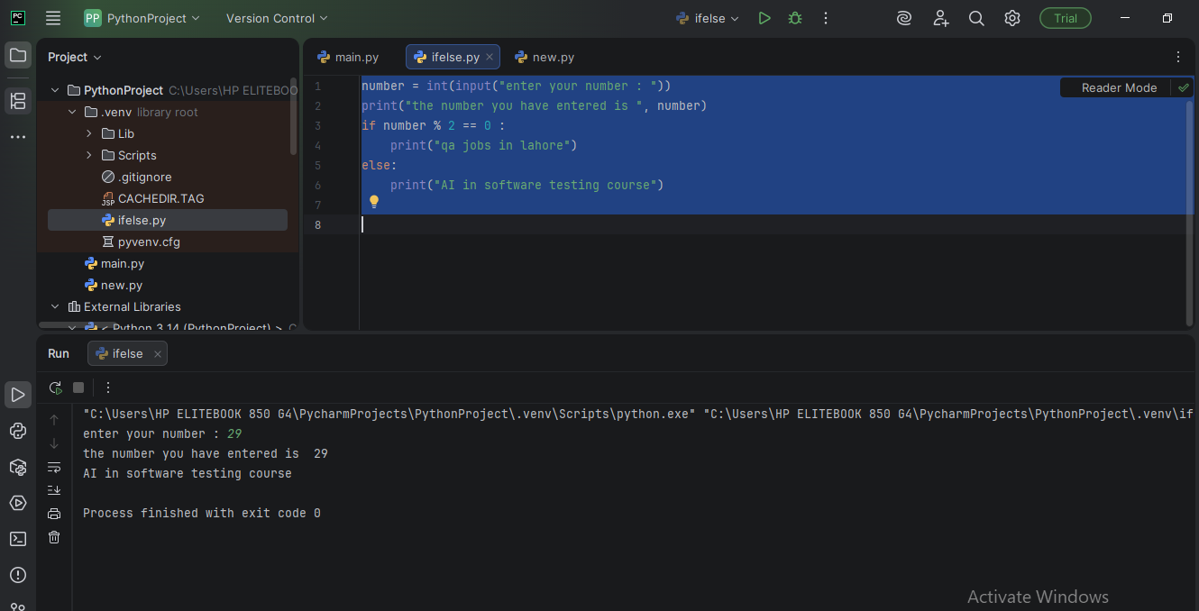
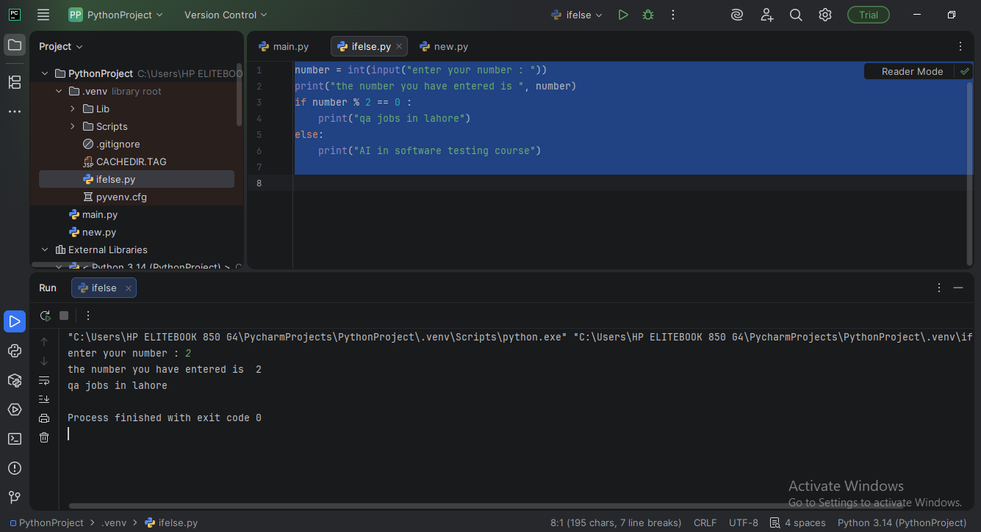
Q5: Create a class and its object and create a method which displays “welcome to AI in software testing course” using class and object.
class HelloFromQA:
manualtester = "True"
automationtester = "False"
def hello(self):
print("Welcome to AI in software testing course")
# Create object outside the class
qa = HelloFromQA()
# Access class variables
var = qa.manualtester
print(var)
var1 = qa.automationtester
print(var1)
# Call method
qa.hello()

screenshot: 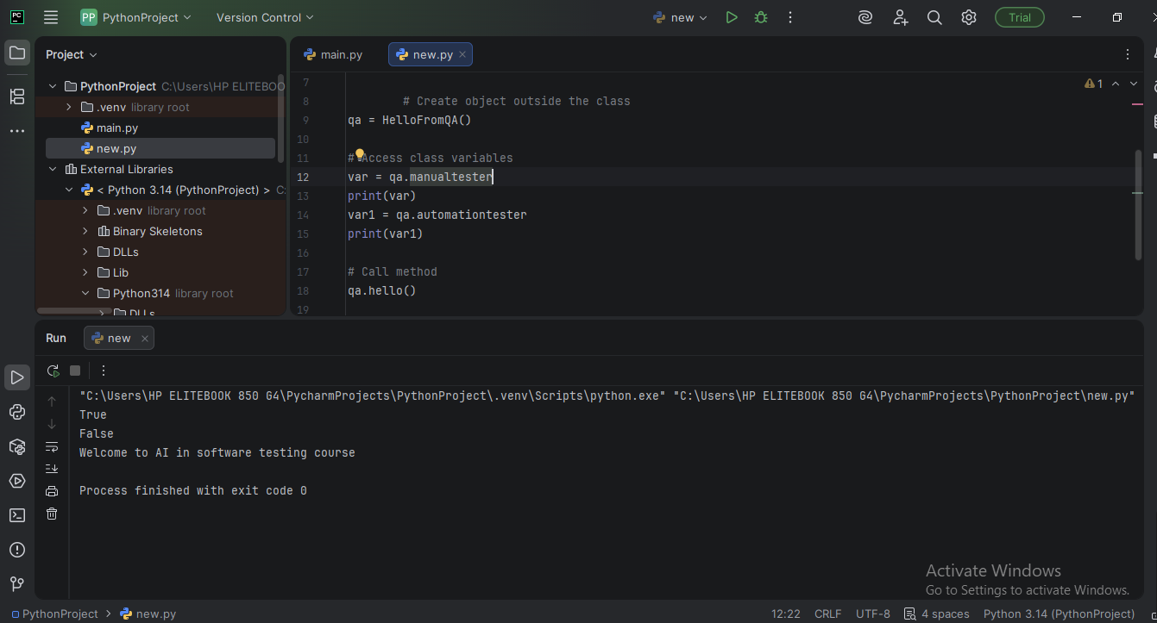

Q6: Write a program that applies inheritance concept and also add the comments that its “inheritance program”
#inheritance program
class Car:
isclassy = True
def check_classy(self):
if self.isclassy:
print("I am a classy car")
else:
print("I am not a classy car")
def accelerate(self):
print("I am a car")
class Ferrari(Car):
isclassy = True
def accelerate(self):
print("I am a ferrari")
class Toyota(Car):
isclassy = True
def accelerate(self):
print("I am a toyota")
class Honda(Car):
isclassy = False
def accelerate(self):
print("I am a honda")
def accelerate(self):
print("I am a honda")
car1 = Car()
car1.accelerate()
car2=Ferrari()
car2.accelerate()
car2.check_classy()
car3=Toyota()
car3.accelerate()
car3.check_classy()
car4=Honda()
car4.accelerate()
car4.check_classy()
Screenshot:
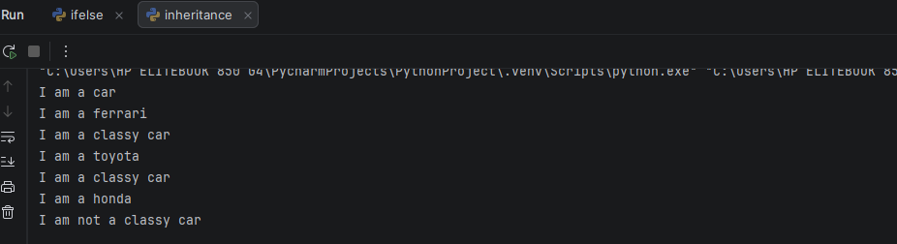

Q7: Write a program that applies polymorphism concept and also add the comments that its “polymorphism program”
#polymorphism program
class Animal:
breed = "normal"
def check_breed(self):
if self.breed == "normal":
print("I am a normal breed")
else:
print("I am a classical breed ")
def sound(self):
print("animal makes sound")
class Dog(Animal):
breed = "classy"
def sound(self):
print("dog is barking")
class Cat(Animal):
breed = "normal"
def sound(self):
print("cat sound: meow meow")
animal=Animal()
animal.sound()
animal.check_breed()
animal1=Dog()
animal1.sound()
animal1.check_breed()
animal2=Cat()
animal2.sound()
animal2.check_breed()

Screenshot:
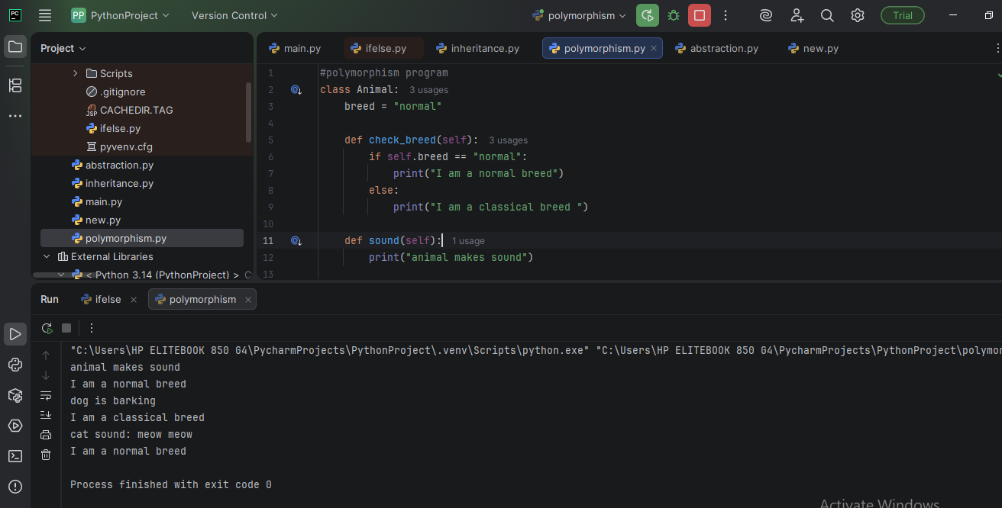

Q8: Write a program that applies abstraction concept and also add the comments that its “abstraction program”
# This is an ABSTRACTION program
def abstractmethod(args):
pass
class Animal():
@abstractmethod
def sound(self):
pass
# Child class
class Dog(Animal):
def sound(self):
print("Dog barks")
# Object creation
d = Dog()
d.sound()

Screenshot:
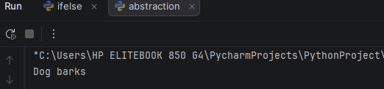

Q9: Write a program that applies Encapsulation concept and also add the comments that its “Encapsulation program”
#ENCAPSULATION program
class Student:
def __init__(self):
self.__marks = 80 # private variable
def getMarks(self):
return self.__marks # get value
def setMarks(self, m):
self.__marks = m # set value
s = Student()
print(s.getMarks())
s.setMarks(90)
print(s.getMarks())
Screenshot:
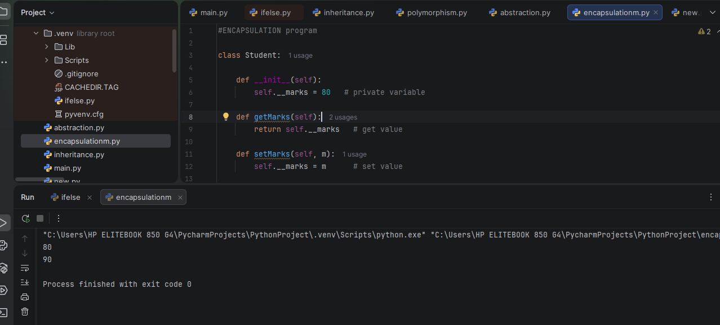
Q10: Setup Selenium, webdriver-manager in PyCharm
