NAME : ARISHA MUMTAZ

ASSIGNMENT 03:

Question:1

1. Test Plan
1.1 Project Overview
Website Name: QA Jobs in Lahore
Purpose: To provide QA courses, job postings and training opportunities in software testing.
URL: https://qajobsinlahore.wixsite.com/qajobs (qajobsinlahore.wixsite.com)
1.2 Test Objectives
- Ensure all pages display correctly on desktop and mobile.
- Check navigation links are working properly.
- Validate content accuracy (courses, job posting, contact form).
- Confirm interactive elements (buttons, forms) work as expected.
- Verify responsiveness and layout. (GeeksforGeeks)
1.3 Scope
In Scope:
All main pages (Home, About Us, Services, Job Posting, Contact)
Navigation menus and links
Forms submission
Responsive design
Images and media
Content consistency with requirements
Out of Scope:
Backend integration (unless defined by requirement)
Third-party services not part of the core website

1.4 Test Items
Website Section | To Be Tested
Home | UI, navigation, images
About Us | Content correctness
Our Services | Course links & details
Demo QA Sessions | Content & download links
Job Posting | UI & navigation
Contact Us | Form validation

1.5 Test Environment
- Browsers: Chrome, Firefox, Edge, Safari
- Devices: Desktop, Tablet, Mobile
- Network: Wi-Fi & Mobile Data
- Operating Systems: Windows, iOS, Android (GeeksforGeeks)
1.6 Test Types
Functional Testing – Check features and navigation
Usability Testing – Content readability and experience
Responsive Testing – Mobile & tablet layout
Compatibility Testing – Different browsers
Form Validation Testing – Contact form behavior
Content & Link Testing – Accuracy and broken links (qatutorial.com)
1.7 Entry and Exit Criteria
Entry:
Website is published and accessible
All pages created
Exit:
All planned tests done
No critical bugs open
Passed basic UI & functionality tests (GeeksforGeeks)
1.8 Roles and Responsibilities
Role | Responsibility
QA Lead | Define test plan & review
Tester | Execute tests & report bugs
Designer | Fix UI bugs
Owner | Final approval

1.9 Risks
Possible content updates after testing
Browser compatibility issues
Mobile layout issues (GeeksforGeeks)

1.10 Deliverables
Test Plan
Test Cases
Bug Reports
Test Summary Report (ijestr.com)
2. Test Strategy (Educational)
2.1 Strategy Overview
A test strategy defines how testing will be executed overall — focusing on methodology, tools and types of testing.
It ensures quality checks are consistent and complete. (Reddit)
2.2 Testing Approach
- Manual Testing First
  - Check UI behavior
  - Test content accuracy
  - Validate navigation
- Cross-Browser Testing
  - Chrome, Firefox, Edge, Safari
- Device Testing
  - Desktop, Tablet, Mobile
- Regression Testing
  - After fixes, re-test environment
2.3 Tools
Category | Tools
Bug reporting | Jira / Excel
Browser testing | Browser DevTools
Mobile responsive | Chrome Mobile View

2.4 Test Priorities
High Priority
- Navigation
- Contact form
- Mobile view
Medium Priority
- Content formatting
Low Priority
- Non-functional UI polish

2.5 Test Environment Needs
- Internet access
- Real devices or emulators
- Test user credentials (if needed)
- Access to Wix backend preview mode

2.6 Risk and Mitigation
Risk | Mitigation
Broken links | Check all links after update
Layout distortion on mobile | Use responsive test tools
Page load speed issues | Optimize images

2.7 Review & Approval
QA Lead approves test plan
Owner signs off after results
Example Test Case Summary (Sample)

ID | Feature | Test Step | Expected Result
TC01 | Home page load | Open URL | Home loads with no errors
TC02 | Navigation to About | Click About Us | Correct page loads
TC03 | Contact form | Submit blank form | Error message shown

Question:2

High Priority + High Severity
Issue:
- Contact Us form accepts invalid inputs for First Name and Last Name
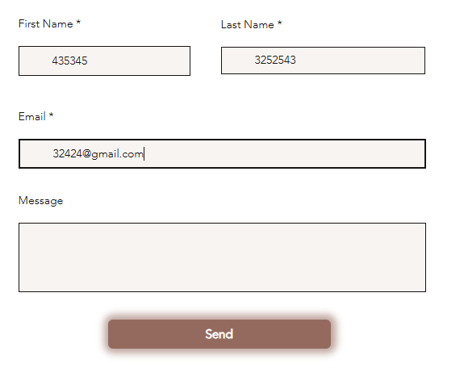
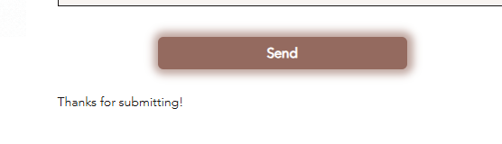
Reason:
- Incorrect data can be submitted
- Core functionality is affected
- Impacts data integrity and user trust

High Priority + Low Severity
Issues:
- Instagram link in footer is not working (Profile not found)
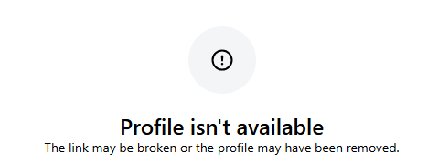

- “Enroll Now” button is missing in Online Courses under Our Services (additional thing for usability) because if a user wants to register after seeing details how can they enroll right away so this should be added for good user experience.
Reason:
- Business and usability are affected
- Website functionality is not broken
- Users may fail to proceed with enrollment or social engagement

Low Priority + High Severity
Issues:
- Testimonials section is not responsive on mobile devices
- Footer section is not responsive on smaller screen sizes

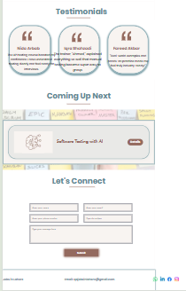
Reason:
- Layout breaks on mobile view
- Content becomes difficult to read or interact with
- Core features still remain usable

Low Priority + Low Severity
Issues:
- Blog usability is poor
- Clicking a blog opens description with all posts listed at the start
- “All Blogs” navigation redirects to the Home page instead of Blogs page
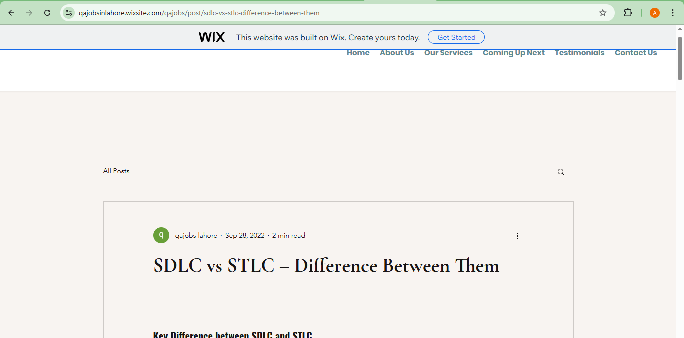

Reason:
- Causes confusion in navigation
- Minor user experience issues
- No functional or data loss impact

Summary Table
Priority | Severity | Issue
High | High | Contact form accepts invalid First & Last Name
High | Low | Instagram footer link not working
High | Low | Missing “Enroll Now” button in Online Courses
Low | High | Testimonials section not responsive
Low | High | Footer not responsive
Low | Low | Blog navigation and usability issues

