NAME: ARISHA MUMTAZ
ASSIGNMENT: 10
Positive Tests:
1) Verify that a user can successfully log in with valid username and password.
2)Test that the 'Login' button is enabled when both fields (username and password) are filled with valid data.
3)Check that the placeholder text for the username and password fields is displayed correctly.
4)Confirm that the password field masks the input (shows asterisks instead of plain text).
5)Ensure that the user remains on the login page after a failed login attempt, allowing for retry.

AUTOMATED TEST CASES: (for login only)
Test_login.py:
# test_login.py
import unittest
from selenium import webdriver
from login_page import LoginPage
class TestLogin(unittest.TestCase):
def setUp(self):
self.driver = webdriver.Chrome()
self.driver.get("https://www.saucedemo.com/")
self.login_page = LoginPage(self.driver)
def tearDown(self):
self.driver.quit()
def test_successful_login(self):
self.login_page.enter_username("standard_user")
self.login_page.enter_password("secret_sauce")
self.login_page.click_login()
self.assertIn("Swag Labs", self.driver.title)
def test_login_button_enabled(self):
self.login_page.enter_username("standard_user")
self.login_page.enter_password("secret_sauce")
self.assertTrue(self.login_page.login_button.is_enabled())
def test_placeholder_text(self):
self.assertEqual(self.login_page.username_input.get_attribute("placeholder"), "Username")
self.assertEqual(self.login_page.password_input.get_attribute("placeholder"), "Password")
def test_password_field_masks_input(self):
self.login_page.enter_password("mypassword")
# Password input should be masked
self.assertEqual(self.login_page.password_input.get_attribute("type"), "password")
def test_failed_login_remains_on_page(self):
self.login_page.enter_username("invalid_user")
self.login_page.enter_password("invalid_password")
self.login_page.click_login()
self.assertIn("Epic sadface: Username and password do not match any user in this service", self.driver.page_source)
self.assertEqual(self.driver.current_url, "https://www.saucedemo.com/")
if __name__ == "__main__":
unittest.main()

Login_page.py:
# login_page.py
from selenium.webdriver.common.by import By
from selenium.webdriver.remote.webdriver import WebDriver
class LoginPage:
def __init__(self, driver: WebDriver):
self.driver = driver
@property
def username_input(self):
return self.driver.find_element(By.ID, "user-name")
@property
def password_input(self):
return self.driver.find_element(By.ID, "password")
@property
def login_button(self):
return self.driver.find_element(By.ID, "login-button")
def enter_username(self, username: str):
self.username_input.send_keys(username)
def enter_password(self, password: str):
self.password_input.send_keys(password)
def click_login(self):
self.login_button.click()

Output: 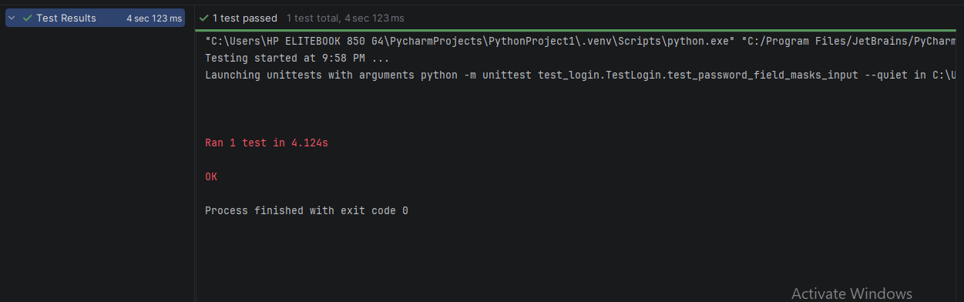
Negative Tests:
Test the login functionality with an empty username and password to verify that an appropriate error message is displayed.
Attempt to log in with an invalid username and a valid password, and check for the correct error message.
Try to log in with a valid username and an incorrect password, ensuring that the error message is appropriate.
Enter special characters in the username and password fields and verify that the system handles them correctly (e.g., shows an error or fails gracefully).
Test the behavior when the 'Login' button is clicked without filling in any fields to ensure no action is taken and an error message is shown.

Creative Test Scenarios:
Simulate a user trying to log in with a username that exceeds the maximum character limit, checking how the system responds.
Test the login process using a username that contains leading or trailing spaces to see if it is trimmed correctly.
Verify the behavior when the user attempts to log in multiple times in quick succession (e.g., rapid clicks on the 'Login' button).
Check how the system handles a login attempt when the username and password fields are filled with extremely long strings.
Test the accessibility of the login form by using keyboard navigation to ensure all fields and buttons are reachable and usable without a mouse.

AUTOMATED TEST CASES FOR NEGATIVE AND CREATIVE SCENARIOS:
Login_page.py:
from selenium.webdriver.common.by import By
class LoginPage:
def __init__(self, driver):
self.driver = driver
@property
def username_input(self):
return self.driver.find_element(By.ID, "user-name")
@property
def password_input(self):
return self.driver.find_element(By.ID, "password")
@property
def login_button(self):
return self.driver.find_element(By.ID, "login-button")
@property
def error_message(self):
return self.driver.find_element(By.CLASS_NAME, "error-message-container")
def enter_username(self, username):
self.username_input.clear()
self.username_input.send_keys(username)
def enter_password(self, password):
self.password_input.clear()
self.password_input.send_keys(password)
def click_login(self):
self.login_button.click()
def get_error_message(self):
return self.error_message.text

test_login.py:
import unittest
from selenium import webdriver
from selenium.webdriver.common.keys import Keys
from login_page import LoginPage
import time
class TestLoginFunctionality(unittest.TestCase):
def setUp(self):
self.driver = webdriver.Chrome()
self.driver.get("https://www.saucedemo.com/")
self.login_page = LoginPage(self.driver)
def tearDown(self):
self.driver.quit()
# Negative / creative scenarios
def test_empty_username_and_password(self):
self.login_page.click_login()
self.assertIn("Username is required", self.login_page.get_error_message())
def test_invalid_username_valid_password(self):
self.login_page.enter_username("invalid_user")
self.login_page.enter_password("secret_sauce")
self.login_page.click_login()
self.assertIn("Username and password do not match any user in this service",
self.login_page.get_error_message())
def test_valid_username_incorrect_password(self):
self.login_page.enter_username("standard_user")
self.login_page.enter_password("wrong_password")
self.login_page.click_login()
self.assertIn("Username and password do not match any user in this service",
self.login_page.get_error_message())
def test_special_characters_in_username_and_password(self):
self.login_page.enter_username("!@#$%^&*()")
self.login_page.enter_password("!@#$%^&*()")
self.login_page.click_login()
self.assertIn("Username and password do not match any user in this service",
self.login_page.get_error_message())
def test_login_button_without_filling_fields(self):
self.login_page.click_login()
self.assertIn("Username is required", self.login_page.get_error_message())
def test_long_strings_in_fields(self):
long_string = "a" * 1000
self.login_page.enter_username(long_string)
self.login_page.enter_password(long_string)
self.login_page.click_login()
self.assertIn("Username and password do not match any user in this service",
self.login_page.get_error_message())
def test_accessibility_with_keyboard_navigation(self):
self.login_page.username_input.send_keys("standard_user")
self.login_page.password_input.send_keys("secret_sauce")
self.login_page.login_button.send_keys(Keys.RETURN)
# Wait a bit for page to load
time.sleep(2)
self.assertIn("Swag Labs", self.driver.title)
def test_successful_login(self):
self.login_page.enter_username("standard_user")
self.login_page.enter_password("secret_sauce")
self.login_page.click_login()
self.assertIn("Swag Labs", self.driver.title)
if __name__ == "__main__":
unittest.main()

output:
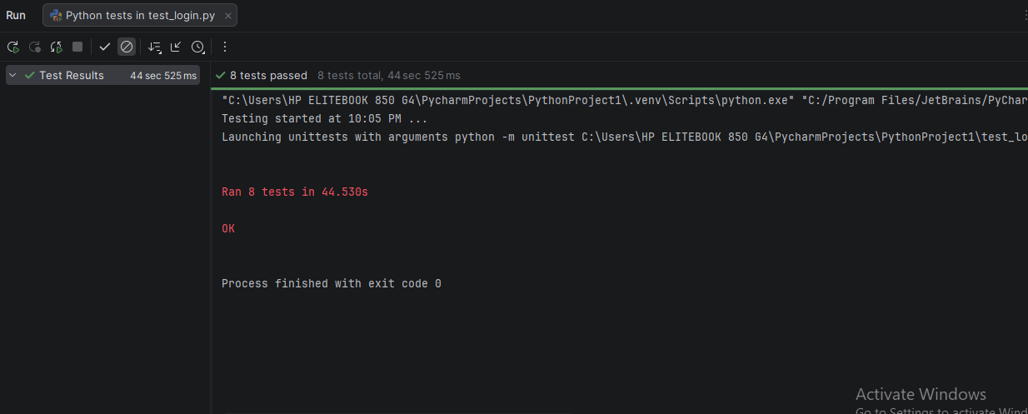
----------------------------------------------------login done -----------------------------------------------------------------------
Product:
Verify that each item in the inventory displays the correct name, description, and price.
Confirm that clicking on the image of an item navigates to the correct detailed view of that item.
Ensure that clicking the "Add to cart" button for each item updates the cart count accurately.
Validate that the price displayed for each item matches the expected price.
Check that the images of the items load correctly without any broken links.
Test that the descriptions of the items are fully visible and correctly formatted.
Confirm that all items can be added to the cart without any errors.
Attempt to add an item to the cart while offline and verify that an appropriate error message is displayed.
Try to click the "Add to cart" button multiple times in quick succession and check for any unexpected behavior or errors.
Verify that the cart count does not increase if the "Add to cart" button is clicked when the item is already in the cart.
Check that an error message appears if an invalid item ID is used to attempt adding an item to the cart.
Attempt to navigate away from the inventory page while an item is being added to the cart and confirm that the operation is either canceled or completed appropriately.
Simulate a scenario where a user with accessibility needs navigates through the inventory using only a keyboard and verify that all functionalities are accessible.
Test the behavior when a user adds the maximum number of items allowed to the cart and ensure that the system handles it gracefully.
Create a scenario where a user applies a discount code after adding items to the cart and verify that the total price updates correctly.
Experiment with adding items to the cart and then refreshing the page to see if the cart retains the correct items and counts.
Validate the experience of a user who interacts with the inventory using a screen reader, ensuring that all elements are announced correctly.
Automated test cases:
Inventory_page.py:
from selenium.webdriver.common.by import By
from selenium.webdriver.remote.webdriver import WebDriver
class InventoryPage:
def __init__(self, driver: WebDriver):
self.driver = driver
@property
def inventory_items(self):
return self.driver.find_elements(By.CLASS_NAME, "inventory_item")
@property
def cart_count(self):
badges = self.driver.find_elements(By.CLASS_NAME, "shopping_cart_badge")
return badges[0] if badges else None
def get_item_name(self, index):
return self.inventory_items[index].find_element(By.CLASS_NAME, "inventory_item_name").text
def get_item_description(self, index):
return self.inventory_items[index].find_element(By.CLASS_NAME, "inventory_item_desc").text
def get_item_price(self, index):
return self.inventory_items[index].find_element(By.CLASS_NAME, "inventory_item_price").text
def get_item_image(self, index):
return self.inventory_items[index].find_element(By.TAG_NAME, "img").get_attribute("src")
def add_item_to_cart(self, index):
button = self.inventory_items[index].find_element(By.TAG_NAME, "button")
button.click()
def click_item_image(self, index):
self.inventory_items[index].find_element(By.CLASS_NAME, "inventory_item_img").click()
def is_image_loaded(self, index):
img = self.inventory_items[index].find_element(By.TAG_NAME, "img")
return self.driver.execute_script(
"return arguments[0].complete && arguments[0].naturalWidth > 0", img
)

test_inventory.py:
import unittest
from selenium import webdriver
from selenium.webdriver.common.by import By
from selenium.webdriver.support.ui import WebDriverWait
from selenium.webdriver.support import expected_conditions as EC
from inventory_page import InventoryPage
import time
class TestInventory(unittest.TestCase):
@classmethod
def setUpClass(cls):
cls.driver = webdriver.Chrome()
cls.driver.get("https://www.saucedemo.com/")
# Login first
cls.driver.find_element(By.ID, "user-name").send_keys("standard_user")
cls.driver.find_element(By.ID, "password").send_keys("secret_sauce")
cls.driver.find_element(By.ID, "login-button").click()
WebDriverWait(cls.driver, 5).until(
EC.url_contains("/inventory.html")
)
cls.page = InventoryPage(cls.driver)
def get_cart_count(self):
return int(self.page.cart_count.text) if self.page.cart_count else 0
def test_add_to_cart_updates(self):
self.page.add_item_to_cart(0)
time.sleep(1)
self.assertEqual(self.get_cart_count(), 1)
def test_add_items_to_cart(self):
for i in range(len(self.page.inventory_items)):
self.page.add_item_to_cart(i)
time.sleep(0.5)
self.assertEqual(self.get_cart_count(), len(self.page.inventory_items))
def test_cart_persistence_on_refresh(self):
for i in range(len(self.page.inventory_items)):
self.page.add_item_to_cart(i)
self.driver.refresh()
time.sleep(2)
self.assertEqual(self.get_cart_count(), len(self.page.inventory_items))
@classmethod
def tearDownClass(cls):
cls.driver.quit()
if __name__ == "__main__":
unittest.main()

output:
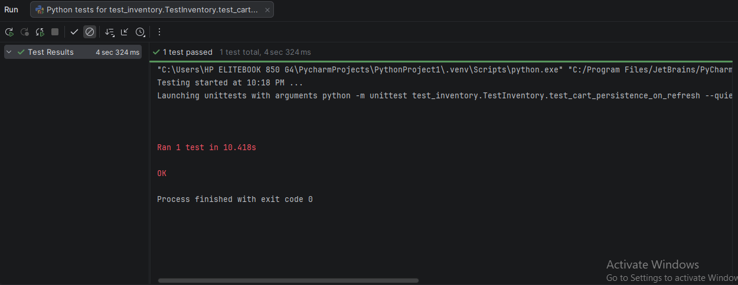
-------------------------------------------------------product done-----------------------------------------------------------------
Positive Tests:
Verify that clicking on the "All Items" link navigates the user to the inventory page displaying all available items.
Confirm that clicking on the "About" link opens the Sauce Labs website in a new tab or window.
Ensure that clicking the "Logout" link successfully logs the user out and redirects them to the login page.
Test that clicking the "Reset App State" link resets the application state to its initial configuration without any errors.

Negative Tests:
Attempt to click on the "All Items" link when the user is not logged in and verify that an appropriate error message is displayed.
Check what happens if the "About" link is clicked when there is no internet connection, ensuring that the user receives a suitable offline error message.
Try to click the "Logout" link multiple times in quick succession and verify that the application handles the action gracefully without crashing.
Test the "Reset App State" link when the application is in a loading state and confirm that it behaves as expected without any interruptions or errors.

Creative Test Scenarios:
Simulate a user experience where a user hovers over the "All Items" link and ensure that a tooltip or visual feedback is displayed indicating the action.
Create a scenario where a user is logged in with limited permissions and attempts to access the "Reset App State" link, verifying that the link is either disabled or an error message is shown.
Test the behavior of the navigation links when the user resizes the browser window to various sizes, ensuring that they remain accessible and functional across different screen resolutions.
Explore the scenario where a user tries to use keyboard navigation (Tab key) to access the links and ensure that all links are reachable and selectable without a mouse.
Automated test cases:
Test_navigation.py:
import unittest
from selenium import webdriver
from selenium.webdriver.common.by import By
from selenium.webdriver.common.keys import Keys
from page_objects import NavigationPage
from selenium.webdriver.support.ui import WebDriverWait
from selenium.webdriver.support import expected_conditions as EC
import time
class NavigationTests(unittest.TestCase):
@classmethod
def setUpClass(cls):
cls.driver = webdriver.Chrome()
cls.driver.get("https://www.saucedemo.com/")
# Login first
cls.driver.find_element(By.ID, "user-name").send_keys("standard_user")
cls.driver.find_element(By.ID, "password").send_keys("secret_sauce")
cls.driver.find_element(By.ID, "login-button").click()
WebDriverWait(cls.driver, 5).until(
EC.url_contains("/inventory.html")
)
cls.navigation_page = NavigationPage(cls.driver)
# Open sidebar menu
menu_button = cls.driver.find_element(By.ID, "react-burger-menu-btn")
menu_button.click()
time.sleep(1) # small delay for menu animation
def test_click_all_items_navigates_to_inventory(self):
self.navigation_page.click_all_items()
self.assertIn("inventory", self.driver.current_url)
def test_click_about_opens_sauce_labs_website(self):
self.navigation_page.click_about()
# switch to new tab
self.driver.switch_to.window(self.driver.window_handles[1])
self.assertIn("saucelabs.com", self.driver.current_url)
self.driver.close()
self.driver.switch_to.window(self.driver.window_handles[0])
def test_click_logout_redirects_to_login(self):
self.navigation_page.click_logout()
self.assertIn("login", self.driver.current_url)
# login again for further tests
self.driver.find_element(By.ID, "user-name").send_keys("standard_user")
self.driver.find_element(By.ID, "password").send_keys("secret_sauce")
self.driver.find_element(By.ID, "login-button").click()
WebDriverWait(cls.driver, 5).until(
EC.url_contains("/inventory.html")
)
menu_button = self.driver.find_element(By.ID, "react-burger-menu-btn")
menu_button.click()
time.sleep(1)
def test_click_reset_app_state_resets_without_errors(self):
self.navigation_page.click_reset_app_state()
container = self.driver.find_element(By.ID, 'inventory_container')
self.assertTrue(container.is_displayed())
def test_multiple_clicks_on_logout_handled_gracefully(self):
for _ in range(2):
self.navigation_page.click_logout()
WebDriverWait(self.driver, 5).until(
EC.url_contains("login")
)
# login again
self.driver.find_element(By.ID, "user-name").send_keys("standard_user")
self.driver.find_element(By.ID, "password").send_keys("secret_sauce")
self.driver.find_element(By.ID, "login-button").click()
WebDriverWait(self.driver, 5).until(
EC.url_contains("/inventory.html")
)
self.driver.find_element(By.ID, "react-burger-menu-btn").click()
time.sleep(1)
self.assertIn("/inventory.html", self.driver.current_url)
def test_navigation_links_accessibility_on_resizing(self):
self.driver.set_window_size(800, 600)
self.assertTrue(self.navigation_page.all_items_link.is_displayed())
self.driver.set_window_size(1200, 800)
self.assertTrue(self.navigation_page.all_items_link.is_displayed())
def test_keyboard_navigation_accessibility(self):
body = self.driver.find_element(By.TAG_NAME, 'body')
body.send_keys(Keys.TAB)
self.assertTrue(self.navigation_page.all_items_link.is_displayed())
@classmethod
def tearDownClass(cls):
cls.driver.quit()
if __name__ == "__main__":
unittest.main()

page_objects.py:
# page_objects.py
from selenium.webdriver.common.by import By
class NavigationPage:
def __init__(self, driver):
self.driver = driver
@property
def all_items_link(self):
return self.driver.find_element(By.ID, 'inventory_sidebar_link')
@property
def about_link(self):
return self.driver.find_element(By.ID, 'about_sidebar_link')
@property
def logout_link(self):
return self.driver.find_element(By.ID, 'logout_sidebar_link')
@property
def reset_app_state_link(self):
return self.driver.find_element(By.ID, 'reset_sidebar_link')
def click_all_items(self):
self.all_items_link.click()
def click_about(self):
self.about_link.click()
def click_logout(self):
self.logout_link.click()
def click_reset_app_state(self):
self.reset_app_state_link.click()

Output:
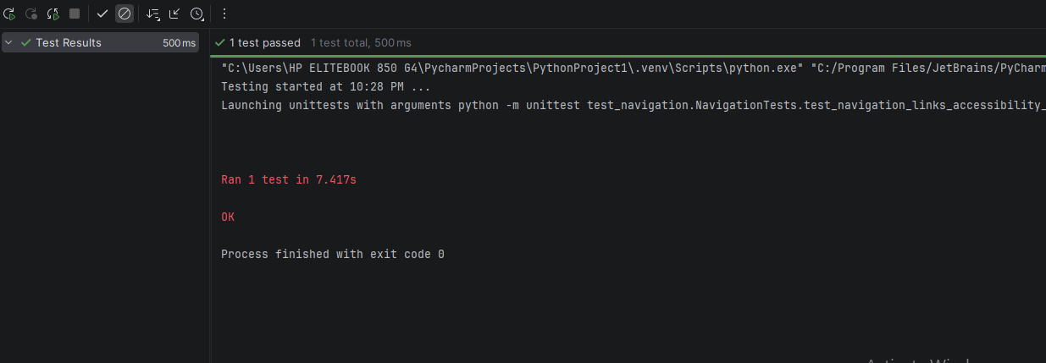
---------------------------------------------------------logout/side panel done-------------------------------------------------

