NAME: ARISHA MUMTAZ

ASSIGNMENT NO: 9

Q1: How can AI help in test result analysis?
AI helps a lot in test result analysis by making the process faster, easier, and more accurate. When we analyze test results manually, it takes more time and human effort, and errors can be missed. With the help of AI, test results can be analyzed automatically.
AI can quickly identify errors, failures, and patterns in test results that humans might overlook. It can compare previous test runs, detect repeated issues, and highlight the root cause of failures. This reduces human effort and saves time.
AI also helps in generating reports, predicting future defects, and suggesting improvements. When most of the analysis work is handled by AI, testers only need to monitor and maintain the system. Overall, AI makes test result analysis more efficient, reliable, and less time-consuming.

Q2) Write test script for login , search ,logout by the help AI.

Website used:
https://www.python.org
from selenium import webdriver
from selenium.webdriver.common.by import By
from selenium.webdriver.support.ui import WebDriverWait
from selenium.webdriver.support import expected_conditions as EC
import time
driver = webdriver.Chrome()
wait = WebDriverWait(driver, 10)
try:
# Login
driver.get("https://www.python.org/accounts/login/")
wait.until(EC.presence_of_element_located((By.ID, "id_login")))
driver.find_element(By.ID, "id_login").send_keys("test@email.com")
driver.find_element(By.ID, "id_password").send_keys("testpassword")
driver.find_element(By.CSS_SELECTOR, "button[type='submit']").click()
print("Login script executed")
# Search
search_box = wait.until(EC.presence_of_element_located((By.ID, "id-search-field")))
search_box.clear() # good practice
search_box.send_keys("Selenium")
driver.find_element(By.ID, "submit").click()
print("Search executed")
# Logout simulation
driver.get("https://www.python.org/")
print("Logout simulated")
except Exception as e:
print("Test Failed:", e)
finally:
time.sleep(3)
driver.quit()
output:
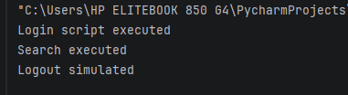
Q2) Take 2 buggy scripts and resolve the error by using Gemini and chatgpt also please add screenshots of prompt as well .
BUGGY CODE:
from selenium import webdriver
from selenium.webdriver.common.by import By
driver = webdriver.Chrome()
driver.get("https://www.python.org/accounts/login/")
driver.find_element(By.NAME, "login_submit").click()
ERROR:
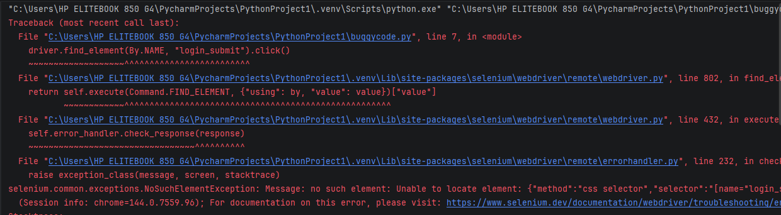
Why this error is coming:
• The element login_submit does not exist on the Python.org login page.
• Selenium cannot find the button because the locator is incorrect.

AI Prompt Example (ChatGPT/Gemini)
I have this Selenium Python code:
driver.find_element(By.NAME, "login_submit").click()
It gives NoSuchElementException. How can I fix it for Python.org login page?
AI Suggested Fix:
driver.find_element(By.CSS_SELECTOR, "button[type='submit']").click()
fixed script:
from selenium import webdriver
from selenium.webdriver.common.by import By
from selenium.webdriver.support.ui import WebDriverWait
from selenium.webdriver.support import expected_conditions as EC

driver = webdriver.Chrome()
wait = WebDriverWait(driver, 10)
driver.get("https://www.python.org/accounts/login/")

# Correct username/password fields
wait.until(EC.presence_of_element_located((By.ID, "id_login"))).send_keys("test@email.com")
driver.find_element(By.ID, "id_password").send_keys("testpassword")

# Fixed login button locator
driver.find_element(By.CSS_SELECTOR, "button[type='submit']").click()
BUGGY CODE #2:
from selenium import webdriver
from selenium.webdriver.support.ui import WebDriverWait
from selenium.webdriver.support import expected_conditions as EC
driver = webdriver.Chrome()
driver.get("https://www.python.org/accounts/login/")
wait = WebDriverWait(driver, 10)
wait.until(EC.title_contains("Dashboard"))
ERROR:
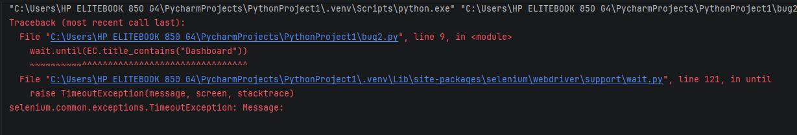
Cause:
The Python.org page does not change the title after login.
Selenium waits for a title that never appears → Timeout.

AI Prompt Example (ChatGPT/Gemini)
In Selenium, my script waits for title "Dashboard" but it never changes.
How can I verify login successfully instead?
AI Suggested Fix:
wait.until(EC.presence_of_element_located((By.ID, "dashboard")))
Wait for a dashboard-specific element instead of title.
FIXED SCRIPT
import time
from selenium import webdriver
from selenium.webdriver.common.by import By
from selenium.webdriver.support.ui import WebDriverWait
from selenium.webdriver.support import expected_conditions as EC
# ---------- Test Data ----------
LOGIN_URL = "https://www.python.org/accounts/login/"
EMAIL = "arishamumtaz340@gmail.com"
PASSWORD = "arisha"
# Initialize Chrome driver
driver = webdriver.Chrome()
driver.maximize_window() # optional, makes it easier to see actions
driver.get(LOGIN_URL)
wait = WebDriverWait(driver, 10)
# Wait for login form to appear
wait.until(EC.presence_of_element_located((By.ID, "id_login")))
time.sleep(2) # small pause to see the form
# Enter credentials
driver.find_element(By.ID, "id_login").send_keys(EMAIL)
driver.find_element(By.ID, "id_password").send_keys(PASSWORD)
time.sleep(1) # pause before clicking submit
driver.find_element(By.ID, "submit").click()
time.sleep(3) # wait for page to start redirecting
# Wait for URL to change after login (indicates success)
wait.until(lambda d: d.current_url != LOGIN_URL)
print("Login successful, redirected to:", driver.current_url)
# Keep browser open for a few seconds to see result
time.sleep(5)
driver.quit()
output:
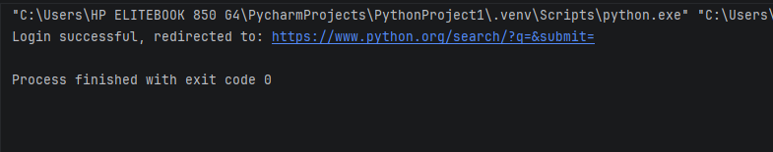

Q3. Choose any public website that contains a login, signup, or dashboard form.
Using Faker, generate realistic test data and automate filling the form.
Your script should:
-Generate fake user data (name, email, password, etc.)
-Fill the selected web form using the generated data
-Submit the form
-Include proper waits and validations
from selenium import webdriver
from selenium.webdriver.common.by import By
from selenium.webdriver.support.ui import WebDriverWait
from selenium.webdriver.support import expected_conditions as EC
from faker import Faker
import time
fake = Faker()
driver = webdriver.Chrome()
driver.maximize_window()
wait = WebDriverWait(driver, 10)
try:
driver.get("https://demoqa.com/automation-practice-form")
# Generate fake data
first_name = fake.first_name()
last_name = fake.last_name()
email = fake.email()
phone = fake.msisdn()[:10]
# Fill form
wait.until(EC.presence_of_element_located((By.ID, "firstName")))
driver.find_element(By.ID, "firstName").send_keys(first_name)
driver.find_element(By.ID, "lastName").send_keys(last_name)
driver.find_element(By.ID, "userEmail").send_keys(email)
# Scroll & click gender
gender_label = driver.find_element(By.XPATH, "//label[text()='Male']")
driver.execute_script("arguments[0].scrollIntoView(true);", gender_label)
gender_label.click()
driver.find_element(By.ID, "userNumber").send_keys(phone)
# Submit
submit_btn = driver.find_element(By.ID, "submit")
driver.execute_script("arguments[0].scrollIntoView(true);", submit_btn)
submit_btn.click()
# Validation
wait.until(EC.presence_of_element_located((By.CLASS_NAME, "modal-content")))
print("Form submitted successfully using Faker data")
except Exception as e:
print("Test Failed:", e)
finally:
time.sleep(3)
driver.quit()

output:
