NAME: ARISHA MUMTAZ
Assignment : 07:

Q1) Role of Ai in Automation:
We use ai to improve efficiency and accuracy and reduce manual effort of human. For Automation we need manual test cases so we can write scripts on them and automate them now role of ai is to make sure that create manual test cases first then write scripts according to those test cases which will reduce human effort and we can now only run and view test cases that how many passed,failed etc.
Q2) I have done installation of both (python and pycharm)
Q3)
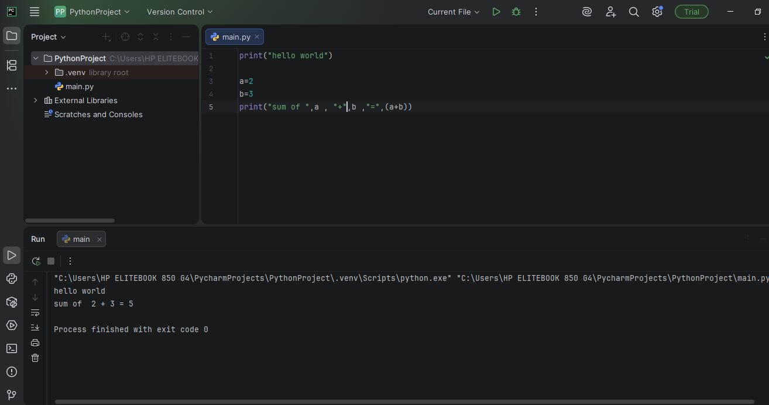
Code:
a=2
b=3
print("sum of ",a , "+",b ,"=",(a+b))

