

Topic: Hospital Appointment Management System

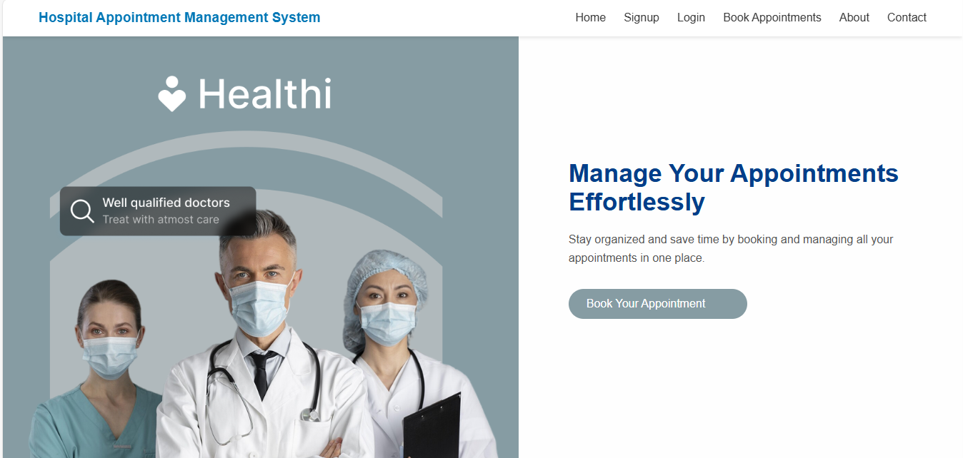

Made by: Arisha Mumtaz (2312358)
Course: Software Construction & Development
Instructors : Sir Abdul Ahad & Sir Khalid Rasheed
Section: 5G

Contents
1
Topic: Hospital Appointment Management System 1
1. Introduction 3
2. Project Overview 3
2.1 Navigation and User Flow 3
3. Features 4
4. Form Validations 4
5. Database Connectivity 8
6. Testing 8
7. Conclusion 10

1. Introduction
The Hospital Appointment Management System is a web-based project designed to simplify the process of booking, managing, and viewing hospital appointments. It allows users to schedule appointments with doctors and also provides the ability to update or correct appointment information when needed. The project focuses on providing a user-friendly interface, smooth database connectivity, and essential CRUD operations.

2. Project Overview
This system enables the booking, viewing, updating, and deleting of appointment records through a simple web interface. It includes separate pages such as Home, About, Contact, Signup, Login, and Appointment Booking. The website maintains data using a MySQL database connected through PHP and hosted locally on XAMPP. Users can book appointments, update and delete appointment records. The application also validates form inputs to ensure data accuracy.

2.1 Navigation and User Flow
The website has a simple navigation system that changes based on the user’s login status.
- Before Login:
The navigation bar on public pages like Home, About, Contact, Login, and Signup shows these links:
Home | About | Contact | Login | Signup
These pages can be opened by anyone to learn about the hospital. To book or manage an appointment, the user must first sign up and log in.
- After Login:
When a user successfully logs in, they are redirected to the Book Appointment page.
The navigation bar after login shows only:
Home | Book Appointment
This makes it simple and clear for the user.
On the Book Appointment page, users can:
- Add a new appointment
- View all appointments (listing) through button ‘view data’.
- Search for a patient’s record (present in list.php)
- Click More Info to view full details (detail.php)
- Update or delete records (update.php & delete.php)
- Contact Form:
The Contact Us page is open to all visitors. It allows users to send messages or inquiries to the hospital. These details are stored in the database.
FLOW:
Landing page(includes about us and contact us page)->signup->login(view list of users)->book an appointment->view and search the appointments booked->update records->delete records ->more info(detail page)

3. Features
• User Signup and Login pages.
• Supports basic CRUD operations:
- Appointment Booking (Create)
- View Appointment Records (Read)
- Edit Appointment Information (Update)
- Remove Appointment Records (Delete)
• Search functionality to quickly find the booking details of any particular person.
• Form validation to ensure correct and complete data entry.
• Separate About and Contact pages for additional information.
• User-friendly interface designed with HTML, CSS, and PHP.
• Navigation bar and footer for easy access and better structure.
• Includes Database connectivity.

4. Form Validations
Form validation plays an important role in ensuring that all required fields are correctly filled before submission. Below are the validations applied in the system:
• Full Name: Only accepts alphabets and cannot be empty.
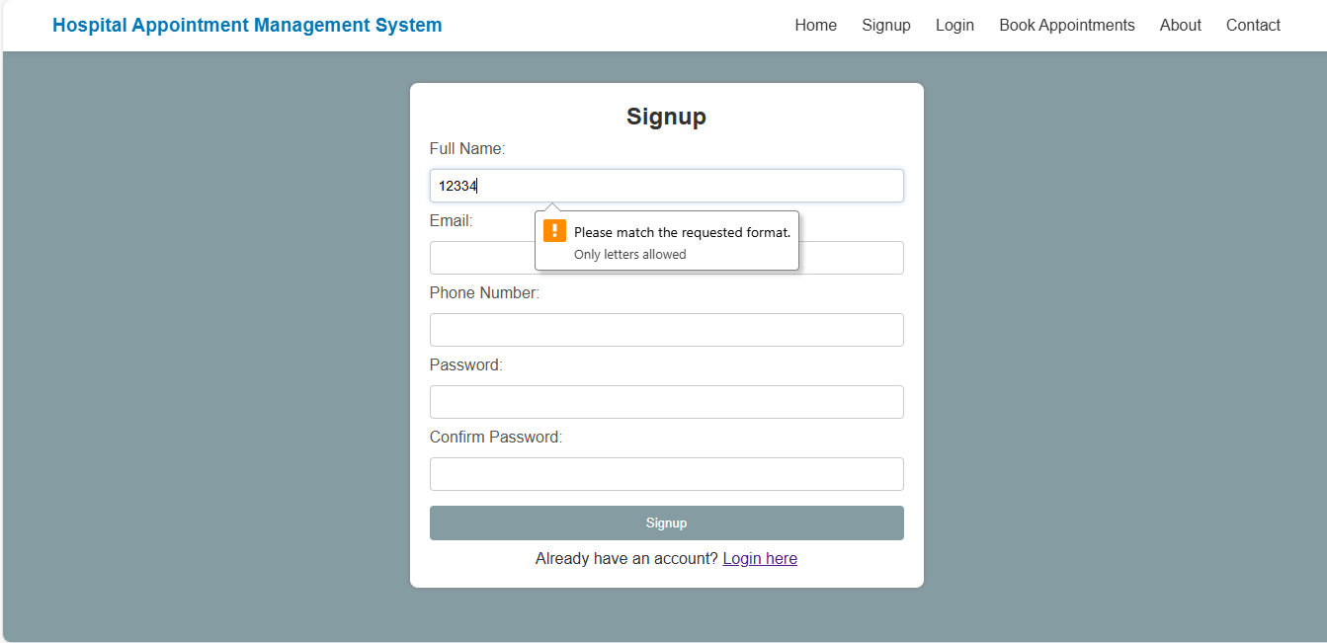
- Cannot be empty:
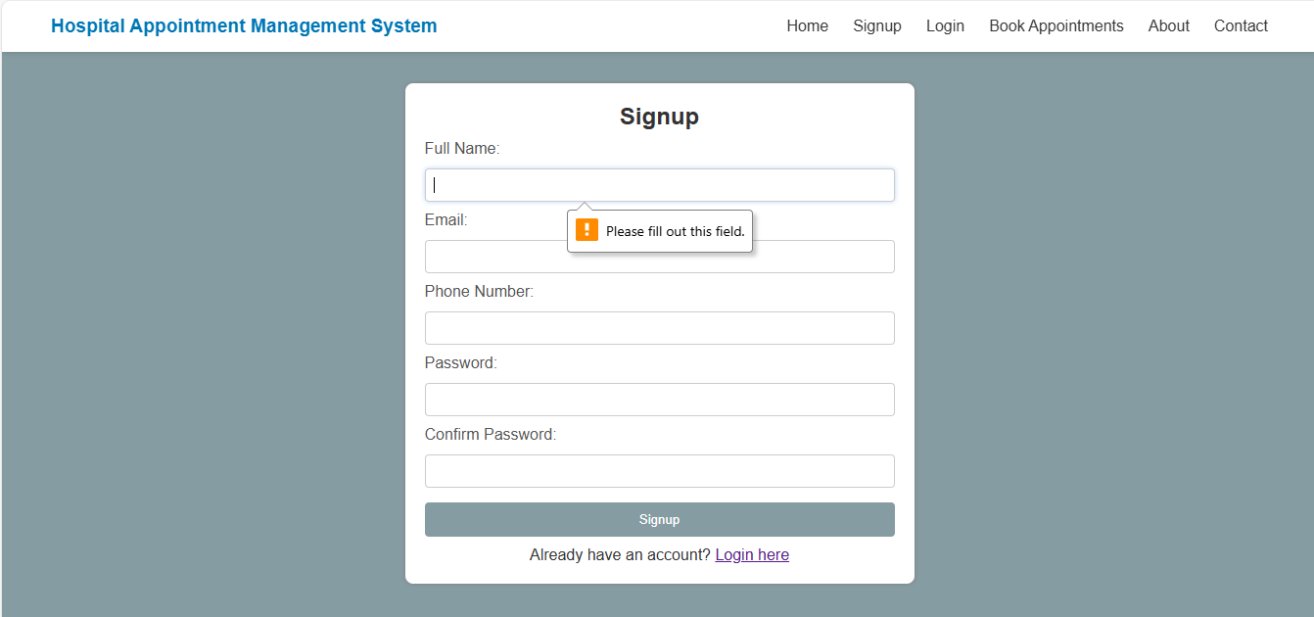
• Email: Must be in valid format (example@gmail.com).
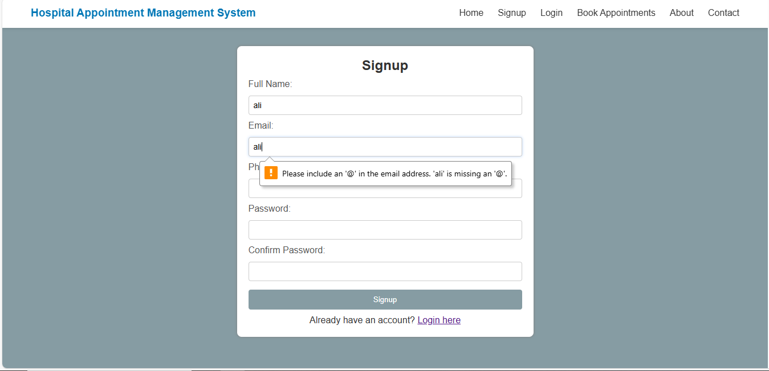
• Phone Number: Must contain 11 digits only.
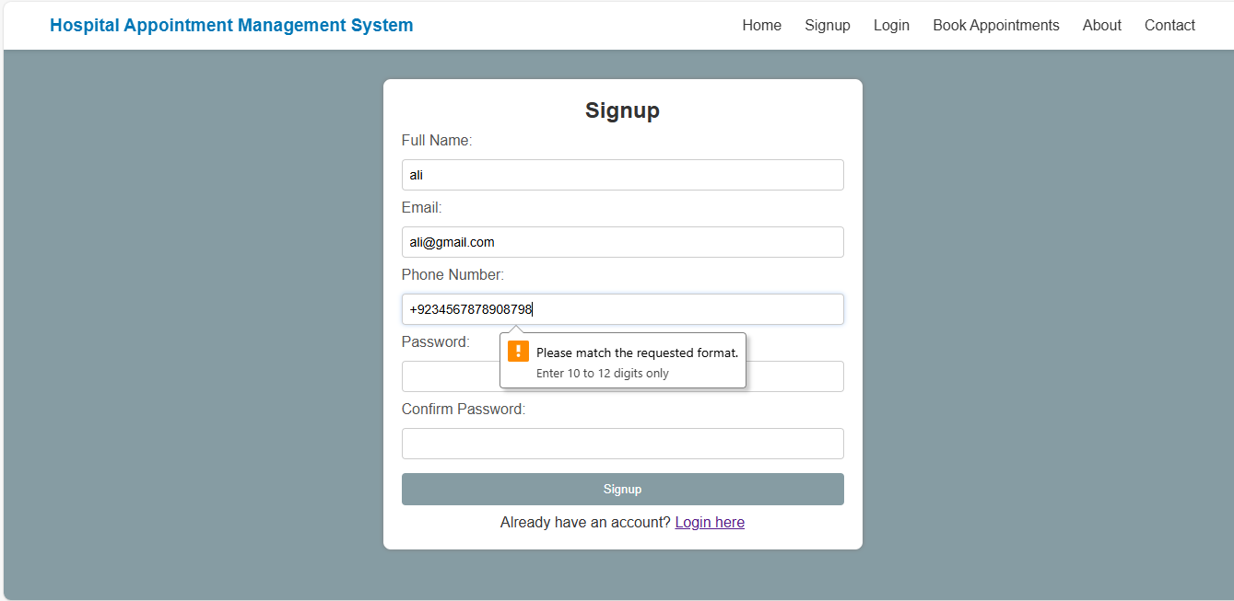
• Gender: Must be selected before submission.

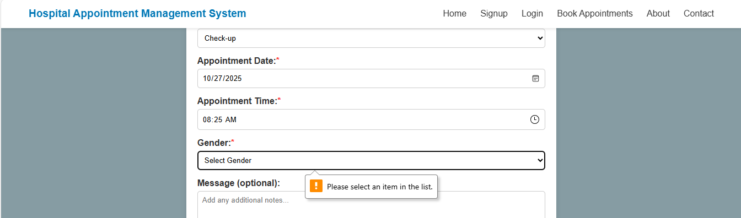
• Service Type: Must be selected before submission.

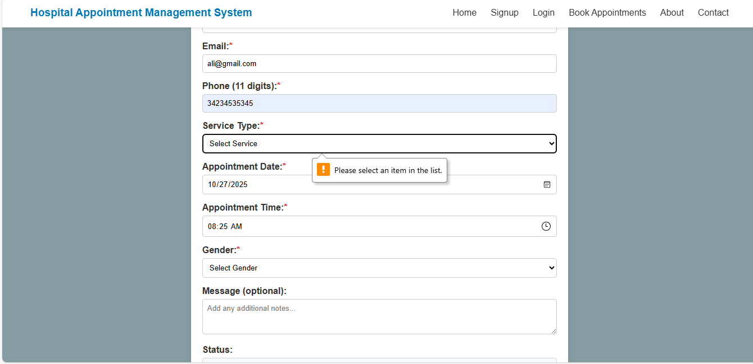
• Appointment Date and Time: Must be provided.

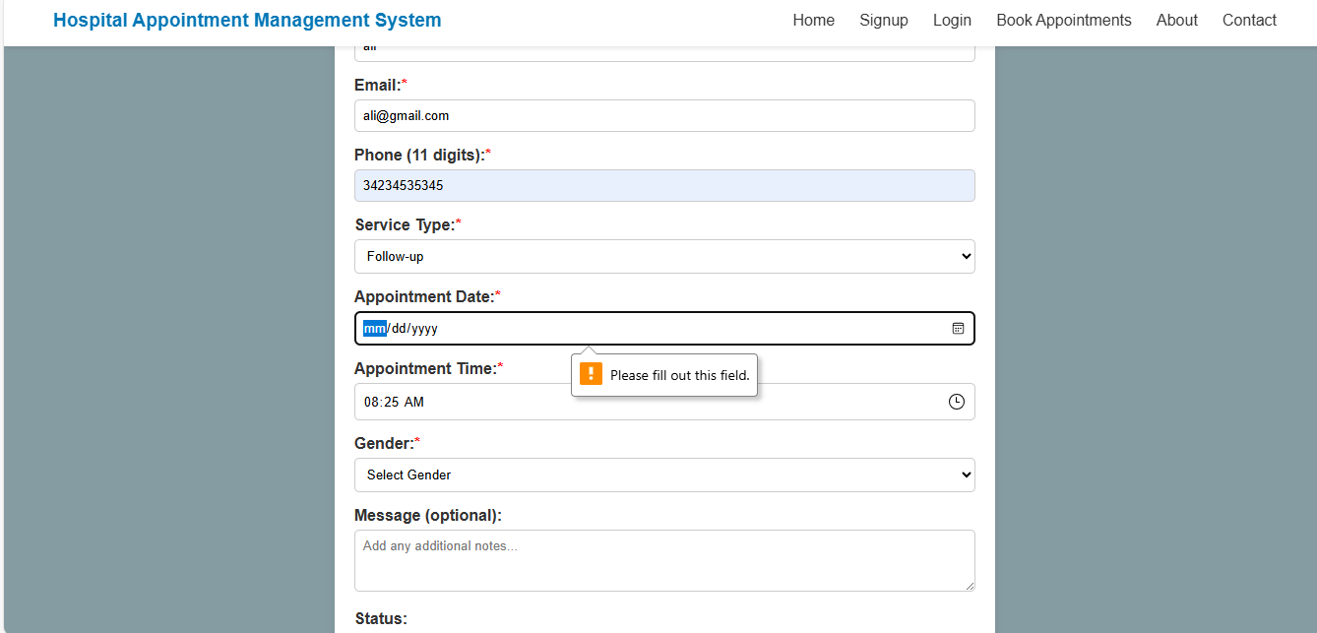
• Message in appointment form: Can be empty(optional) because a patient might just want to book an appointment without adding extra details.
• Message in contact form: Cannot be empty because the hospital should know why the patient is contacting, making the message required is appropriate because the hospital needs to understand why the person is reaching out (for example, inquiries, complaints, or feedback).
All forms such as Signup, Login, Appointment Booking, and Contact include the validation checks. Appropriate messages are displayed accordingly.

5. Database Connectivity
The database is connected using PHP through a separate file named 'db.php'. This file establishes the connection with MySQL using localhost. All operations such as booking, viewing, editing, and deleting appointments are performed through SQL queries.
Example: The 'insertappointmentform.php' file adds new appointments, 'update.php' edits them, 'delete.php' removes records, and 'list.php' retrieves all appointment details and ‘detail.php’ shows the full information about that particular person present in list by clicking on ‘more info’ link present in ‘list.php’.

6. Testing
Testing was done manually by me through filling all forms and checking their validation functionality. Each operation was tested to confirm that it performs as expected.
• Signup Form: Passed – Successfully registered new users.
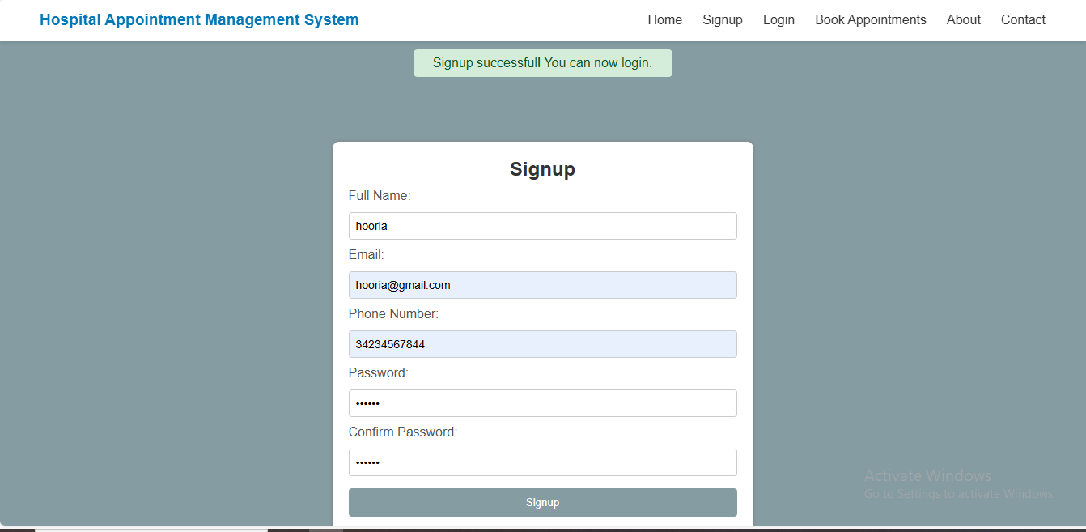
• Login Form: Passed – Redirected to landing page after successful login but before going to landing page it shows a message “welcome $user”
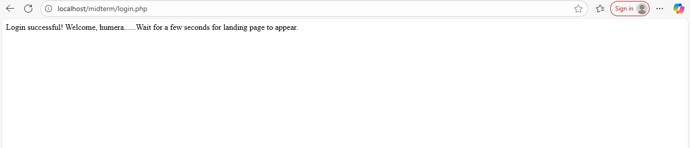
• Appointment Booking Form: Passed – Added data to the database after validation.
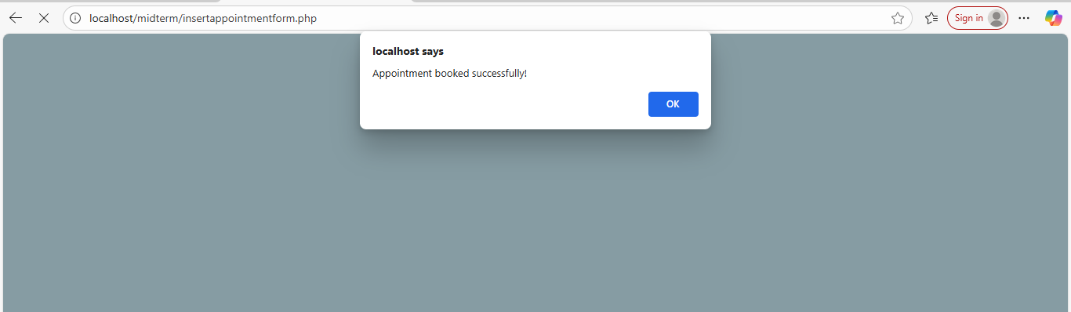
• Update and Delete: Passed – Appointment records were successfully edited and removed when required.

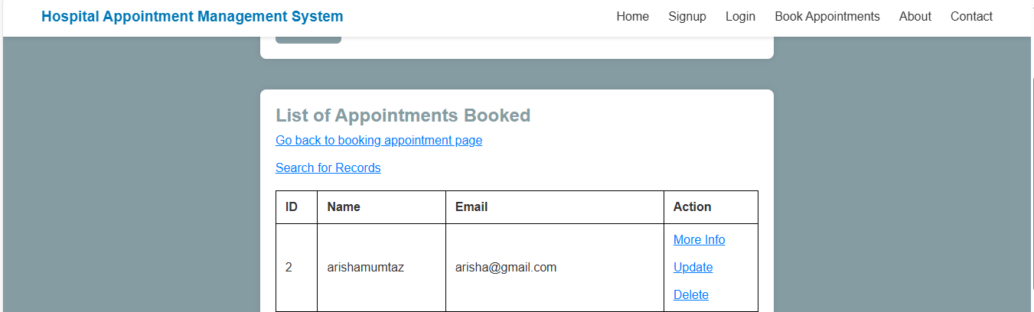

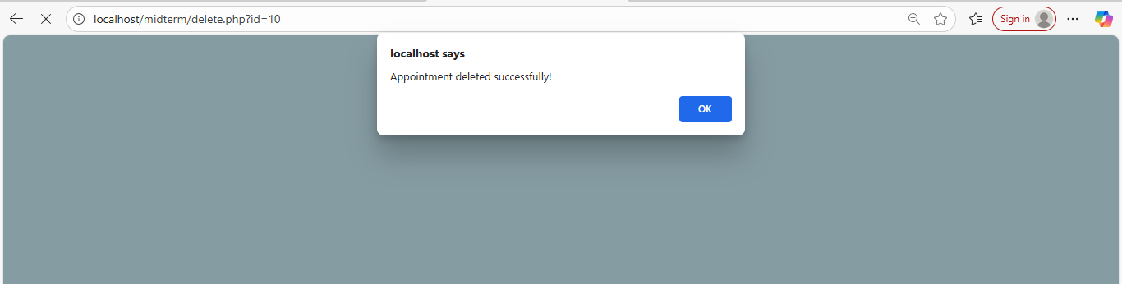
• Contact Form: Passed – Stored form details in the database and displayed success messages.
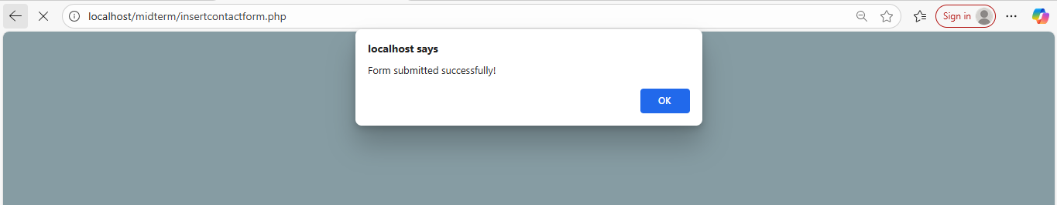

7. Conclusion
The Hospital Appointment Management System efficiently manages hospital appointments, ensuring that patients can book and view appointments easily. With CRUD functionality, form validations, and a clean responsive interface, the project fulfills the requirements of an appointment management system. It demonstrates the integration of front-end and back-end development using HTML, CSS, JavaScript(for alerts), PHP, and MySQL.

