CREATE A ROW-LEVEL TRIGGER ON TABLE brazil_states WHICH WILL STORE THE DELETED ROWS IN ANOTHER TABLE d_tab AND UPDATED TABLES IN ANOTHER TABLE u_tab.

CODE :

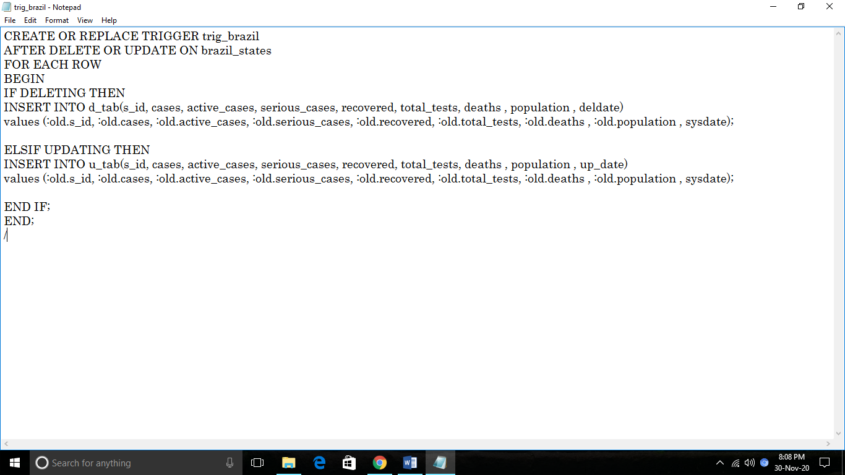

OUTPUT :

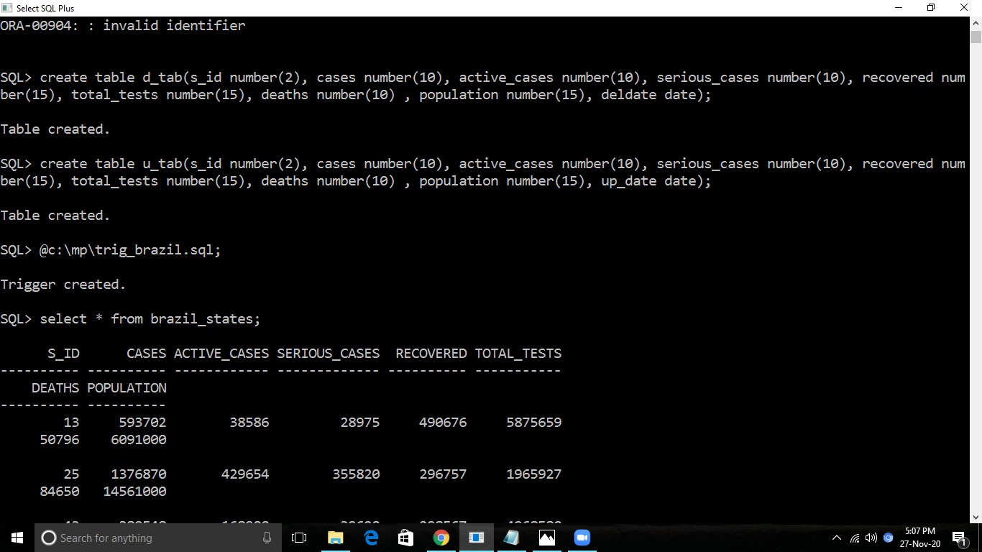

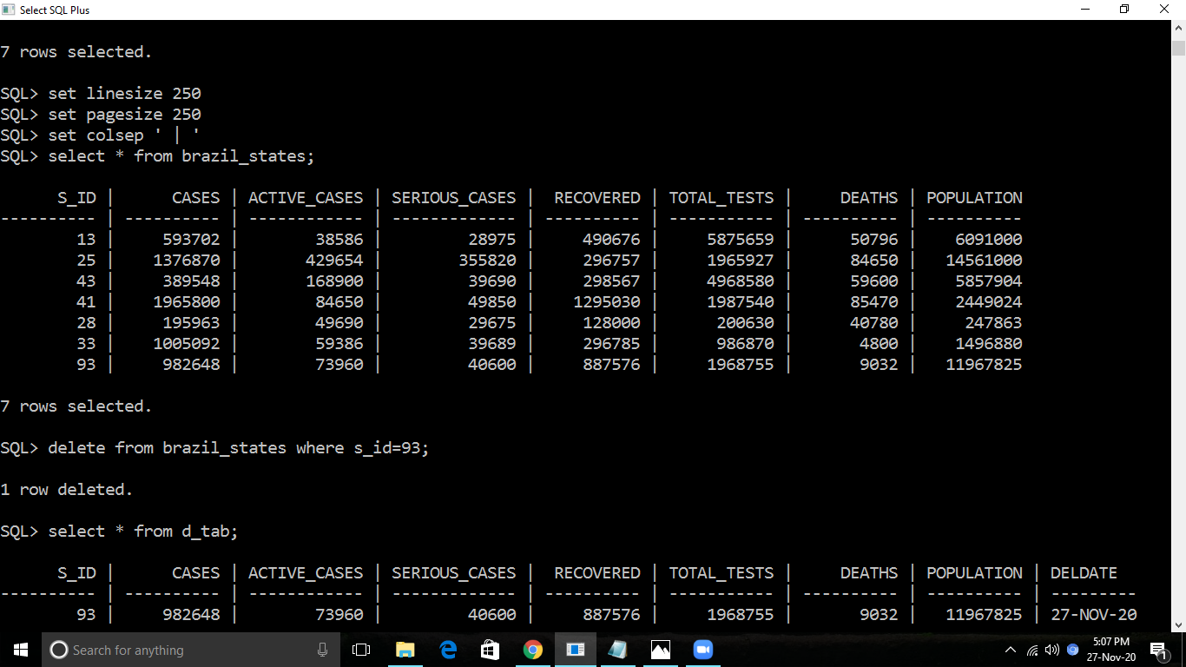

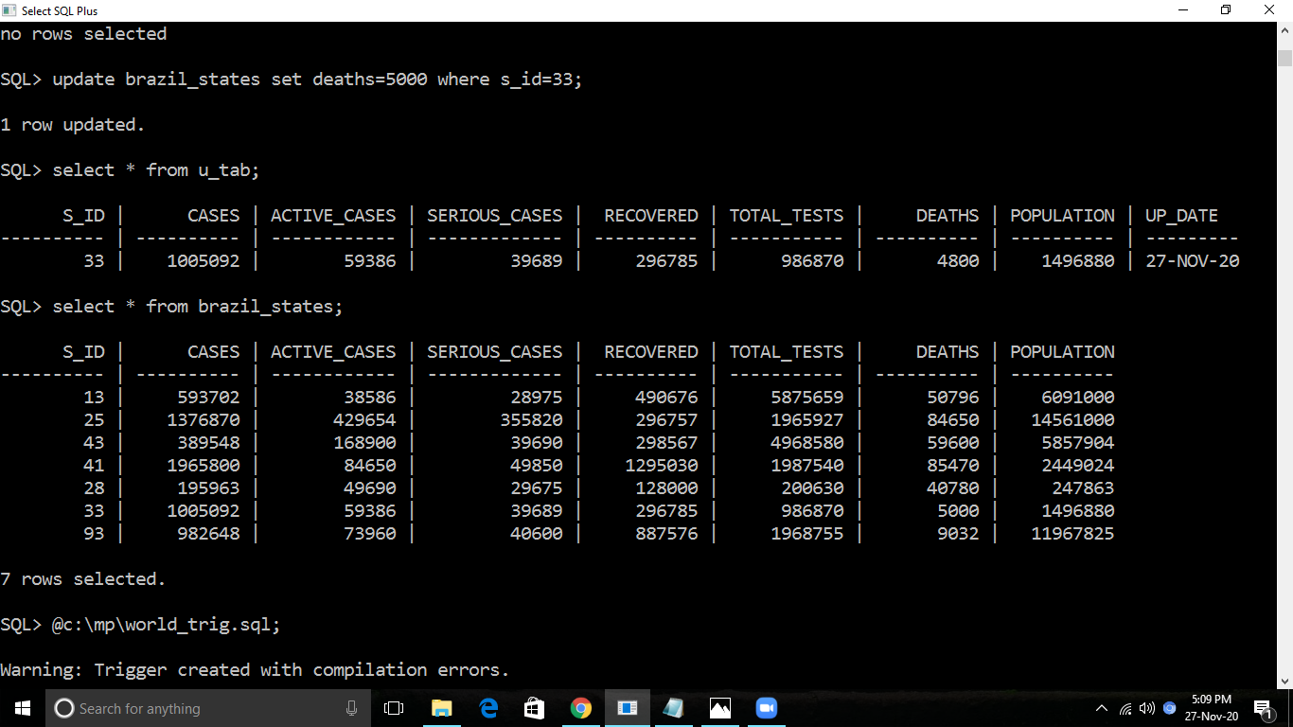

CREATE A TRIGGER ON TABLE world WHICH WILL CALCUATE THE TOTAL CASES FROM ACTIVE CASES, SERIOUS CASES, RECOVERED AND DEATHS.

CODE :

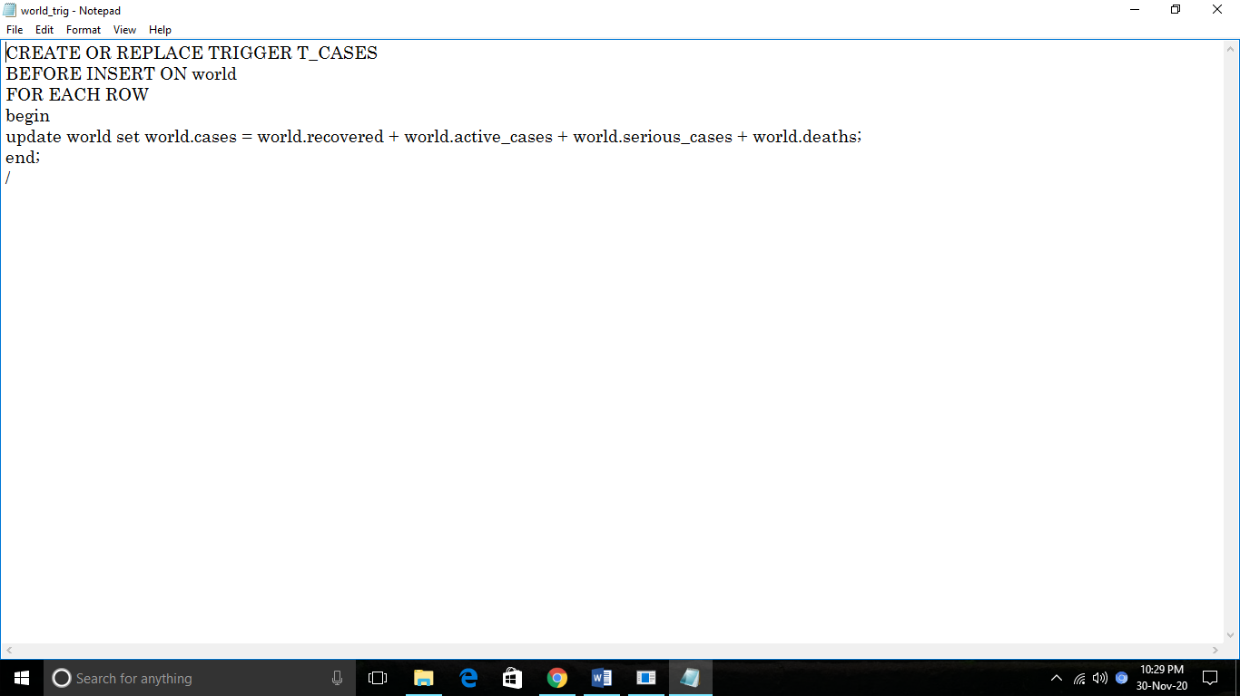

OUTPUT :

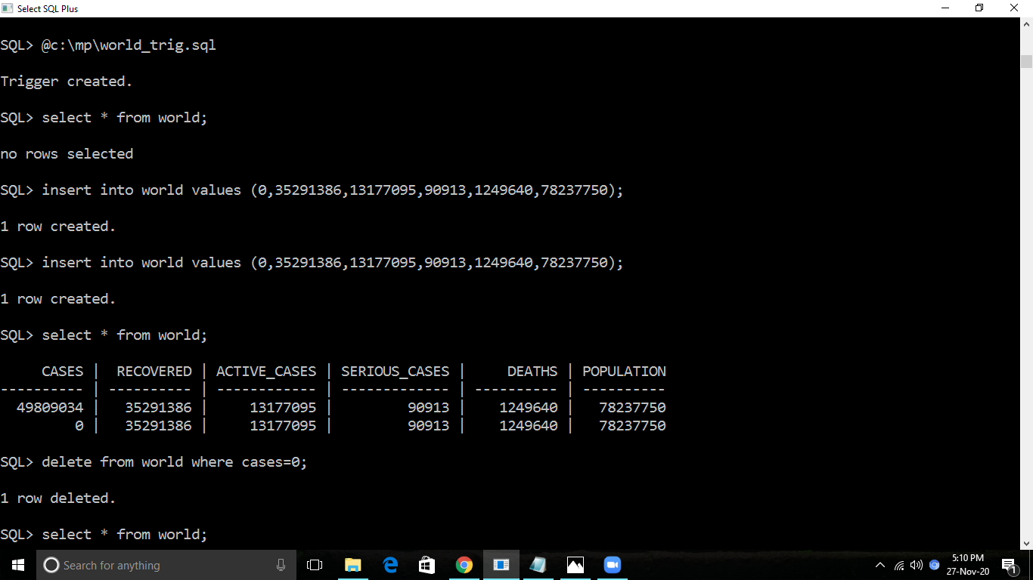

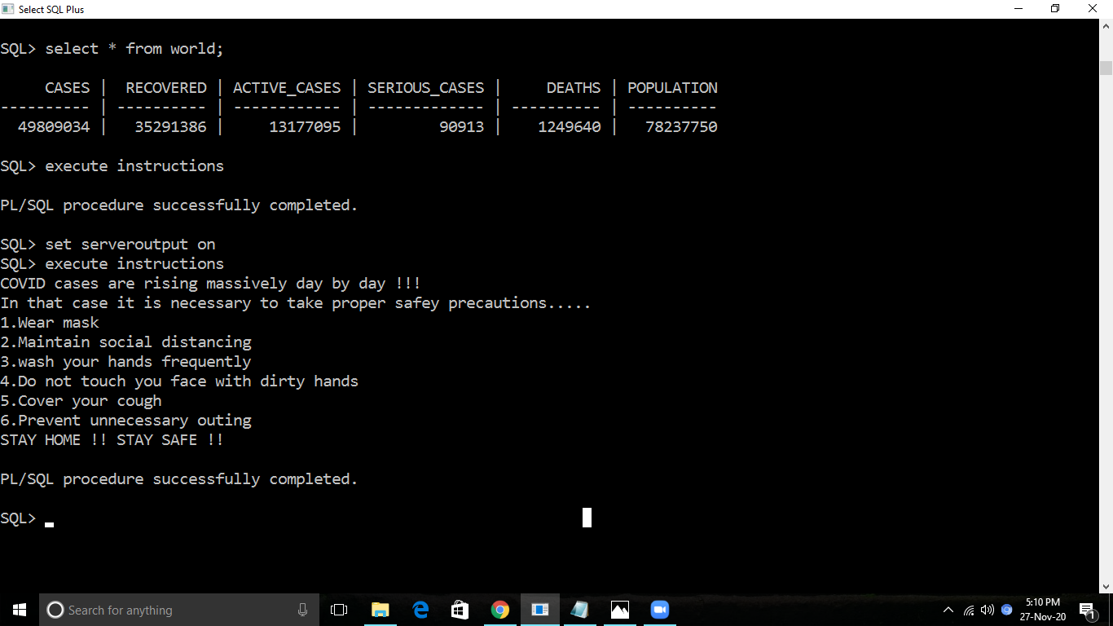

CREATE A STATEMENT-LEVEL TRIGGER ON TABLE ‘world’ WHICH WILL ALLOW THE DML OPERATIONS BETWEEN A SPECIFIC TIME ONLY.

CODE :

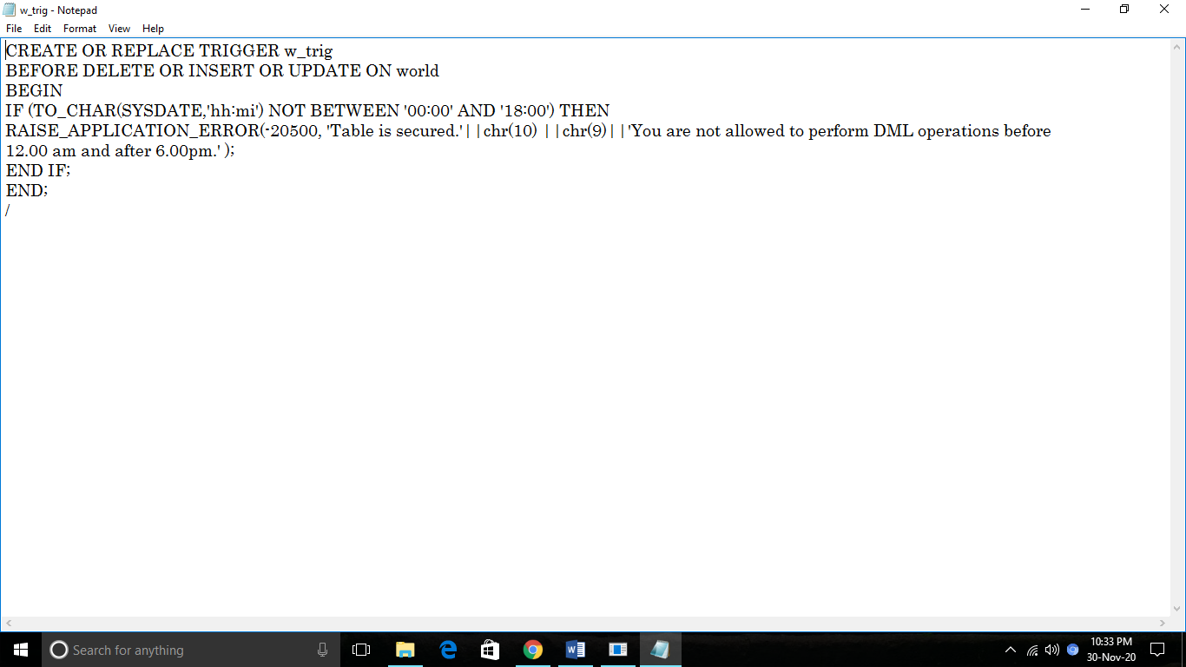

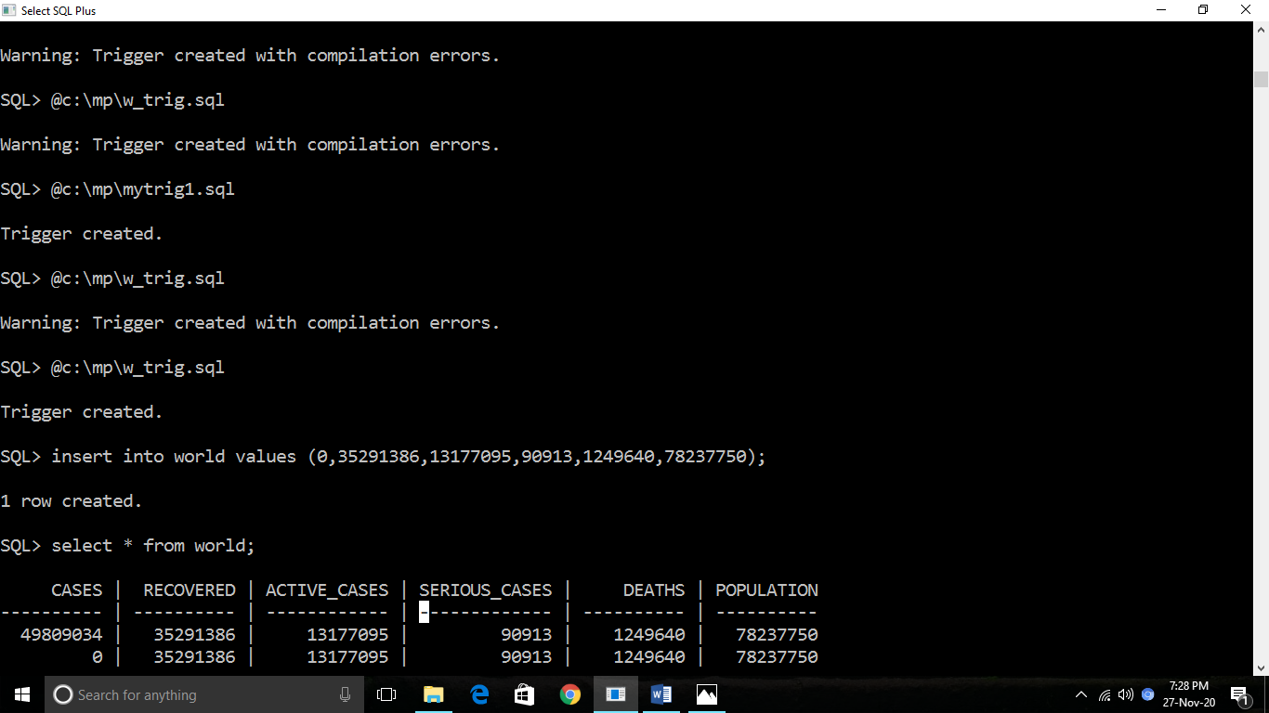OUTPUT :

