Row level triggers

1.] A Row-Level Trigger On Table Brazil_States Which Will Store The Deleted Rows In Another Table D_Tab And Updated Tables In Another Table U_Tab.

First the tables d_tab and u_tab were created in the database.

Creating a trigger

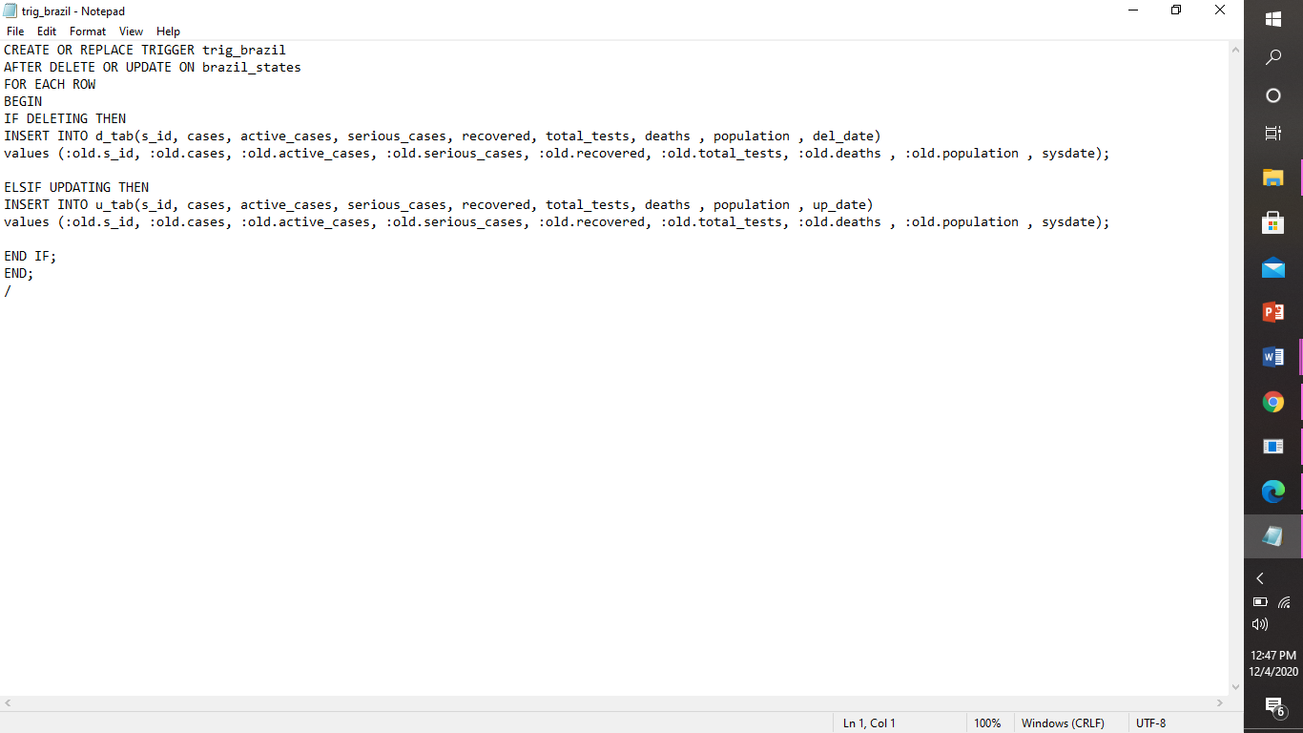

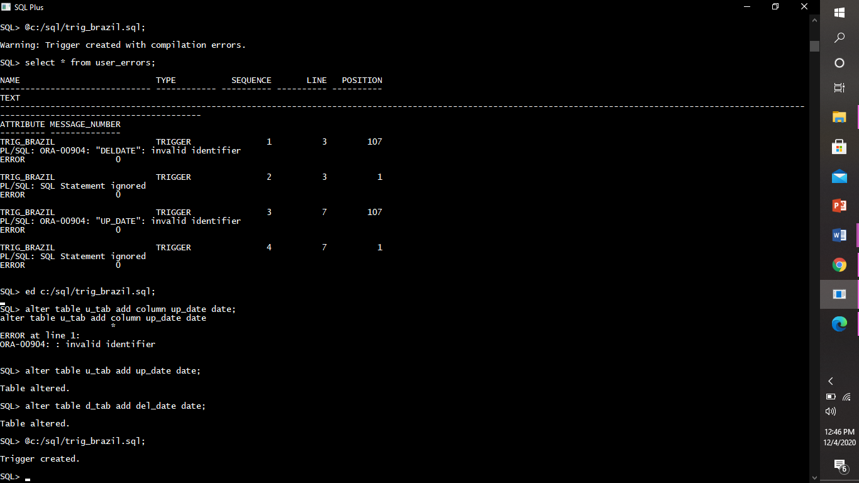

Triggering a trigger

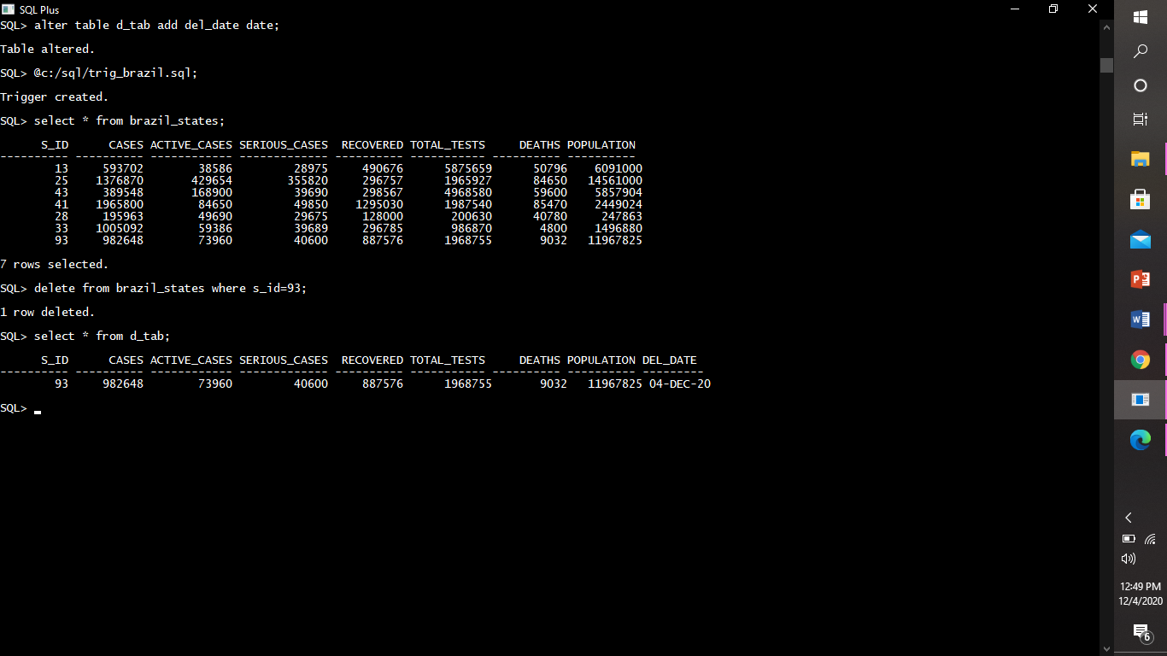

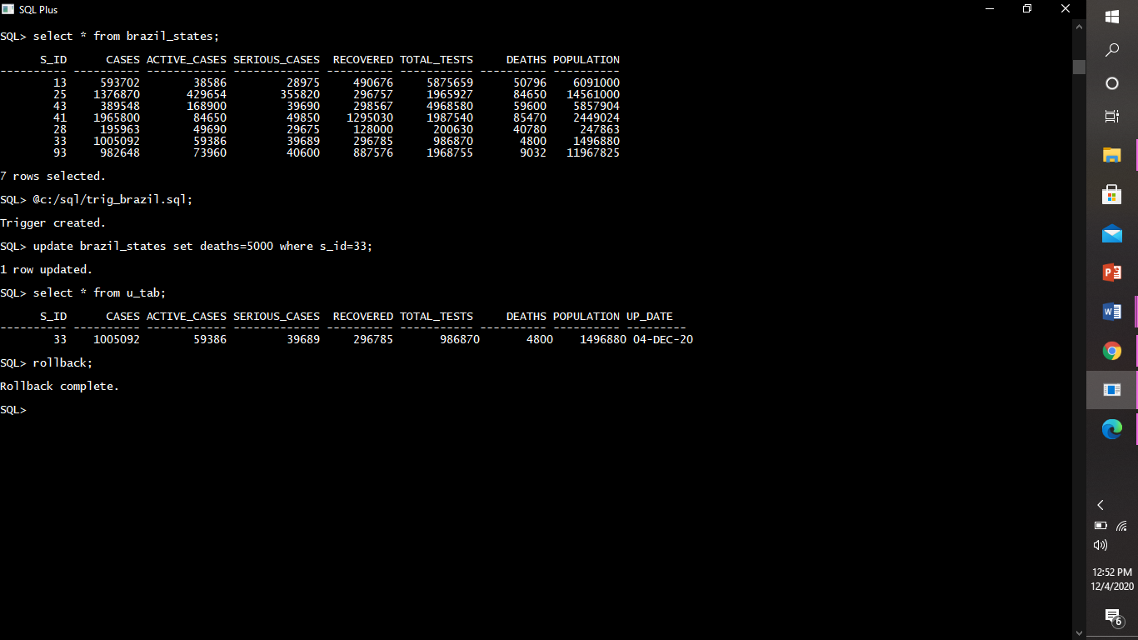

Enabling or disabling trigger

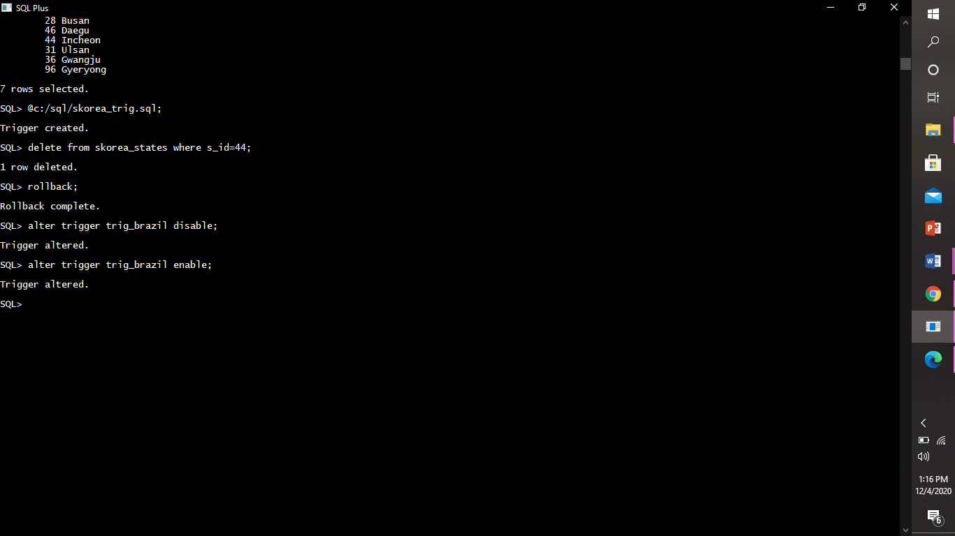

Dropping trigger

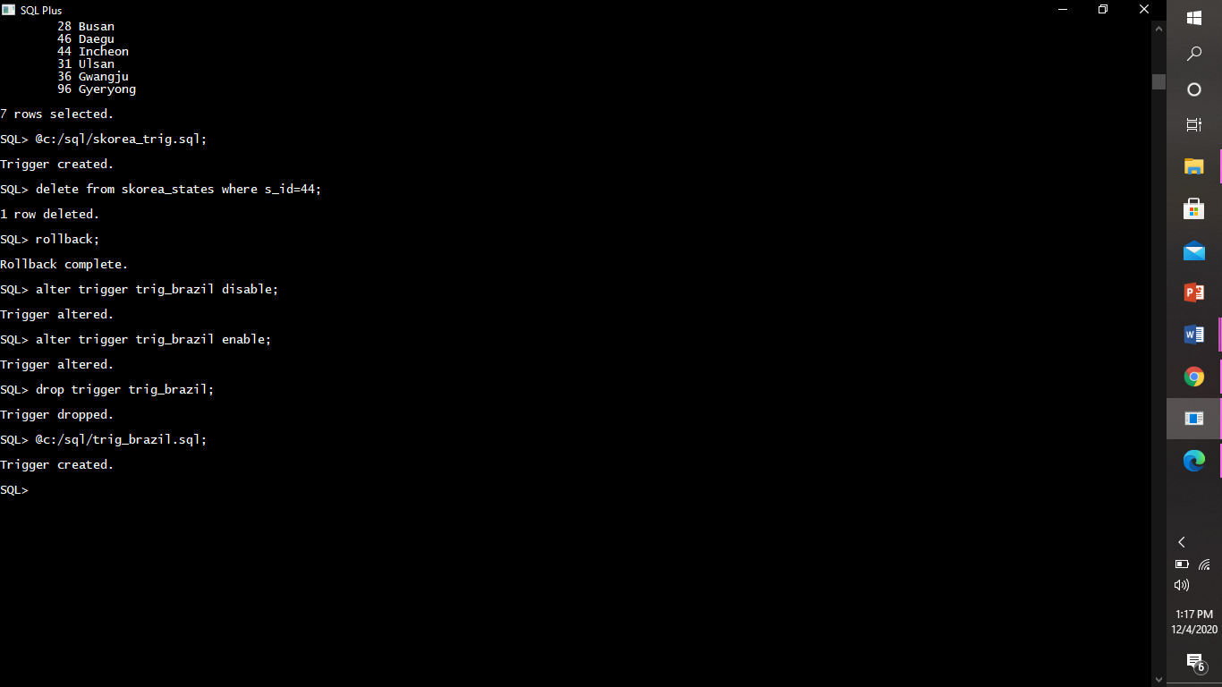

2.] row level trigger for the skorea_states table that would fire for INSERT or UPDATE or DELETE operations performed on the skorea_states table. This trigger will display the difference between the old values and new values of covid cases:

Creating a trigger

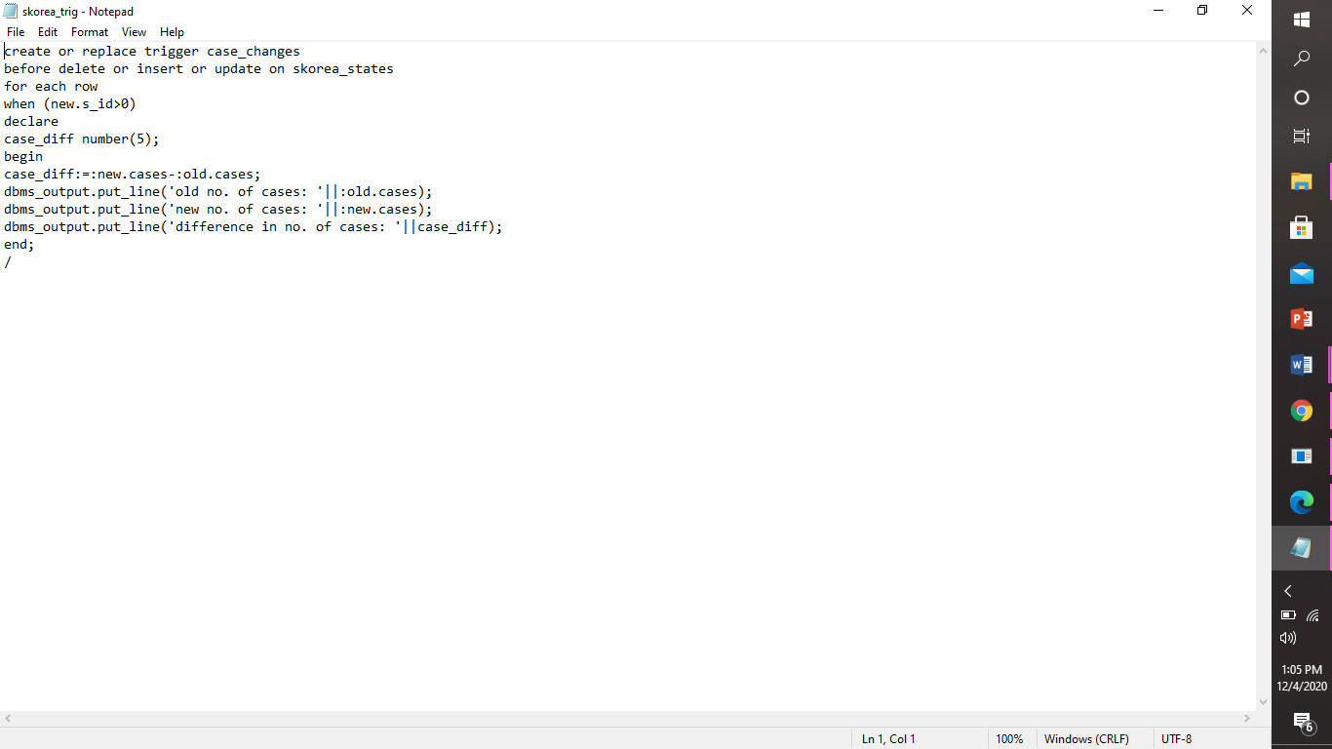

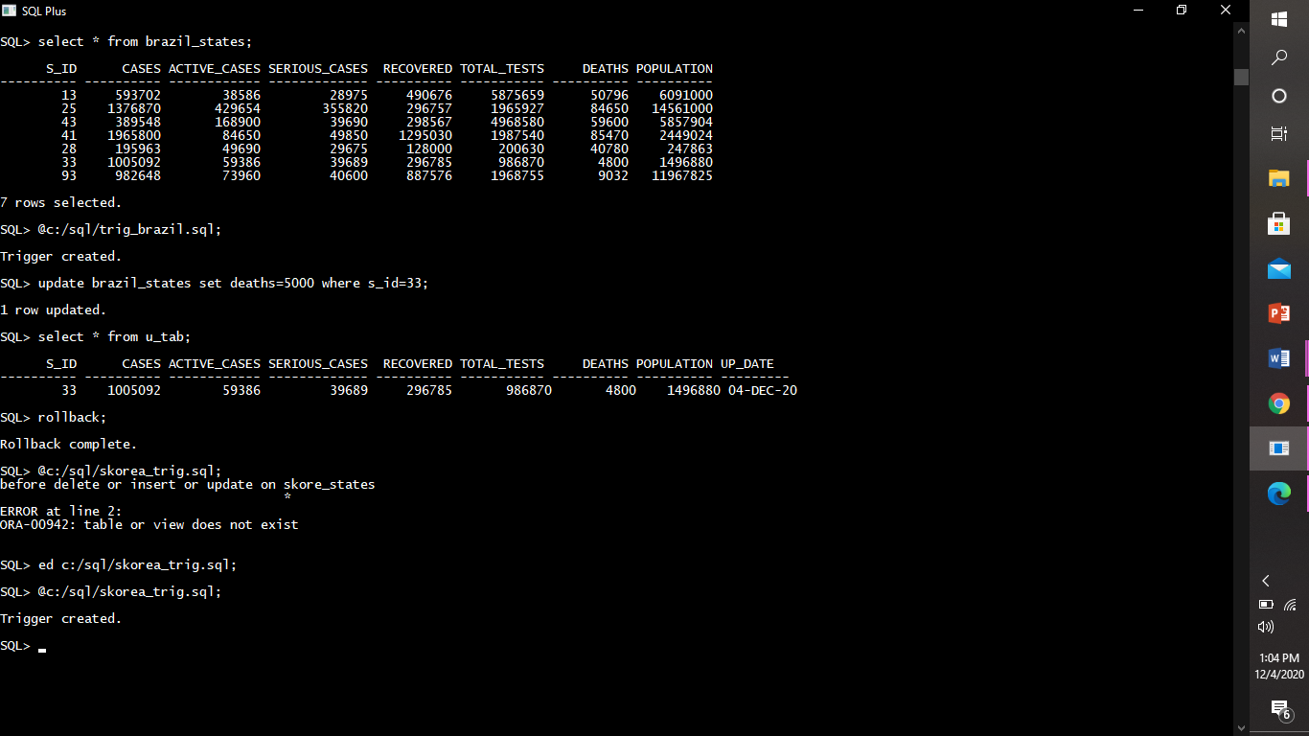

Triggering trigger

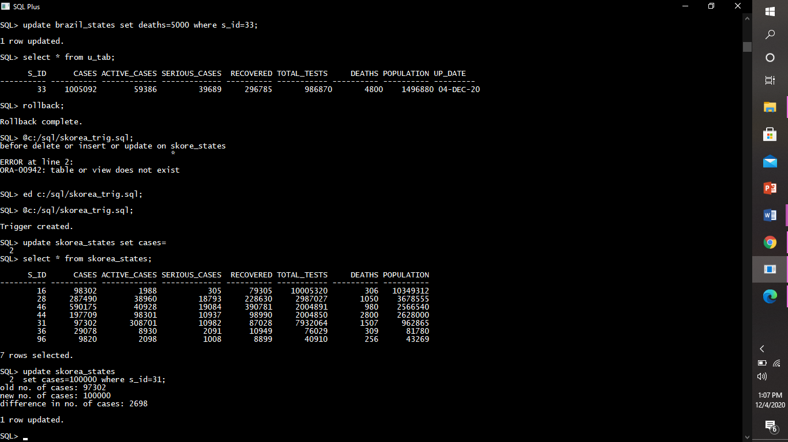

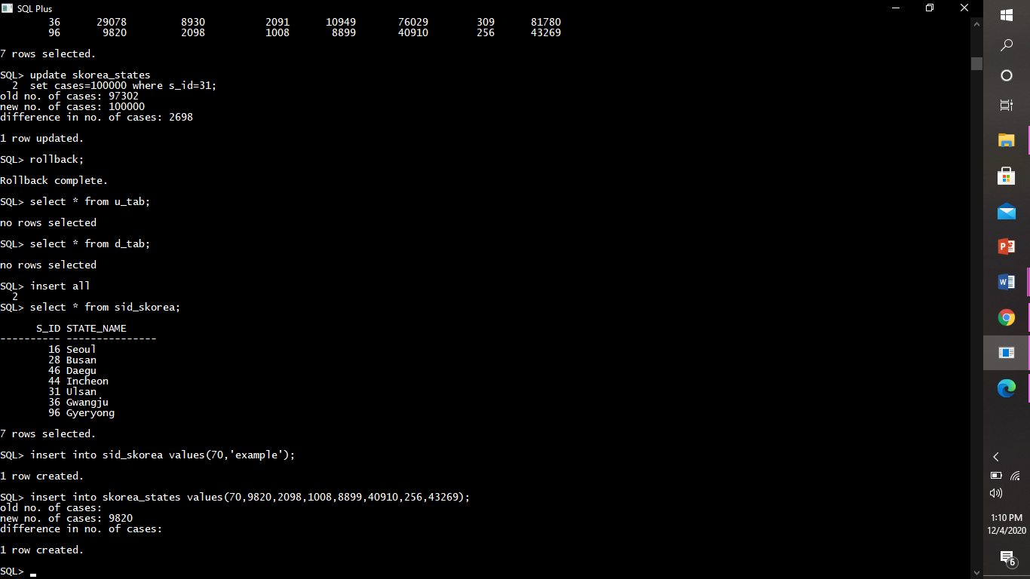

Statement level trigger

1.]a statement-level trigger on table sid_france’ which will allow the DML operations between a specific time only.

Creating trigger

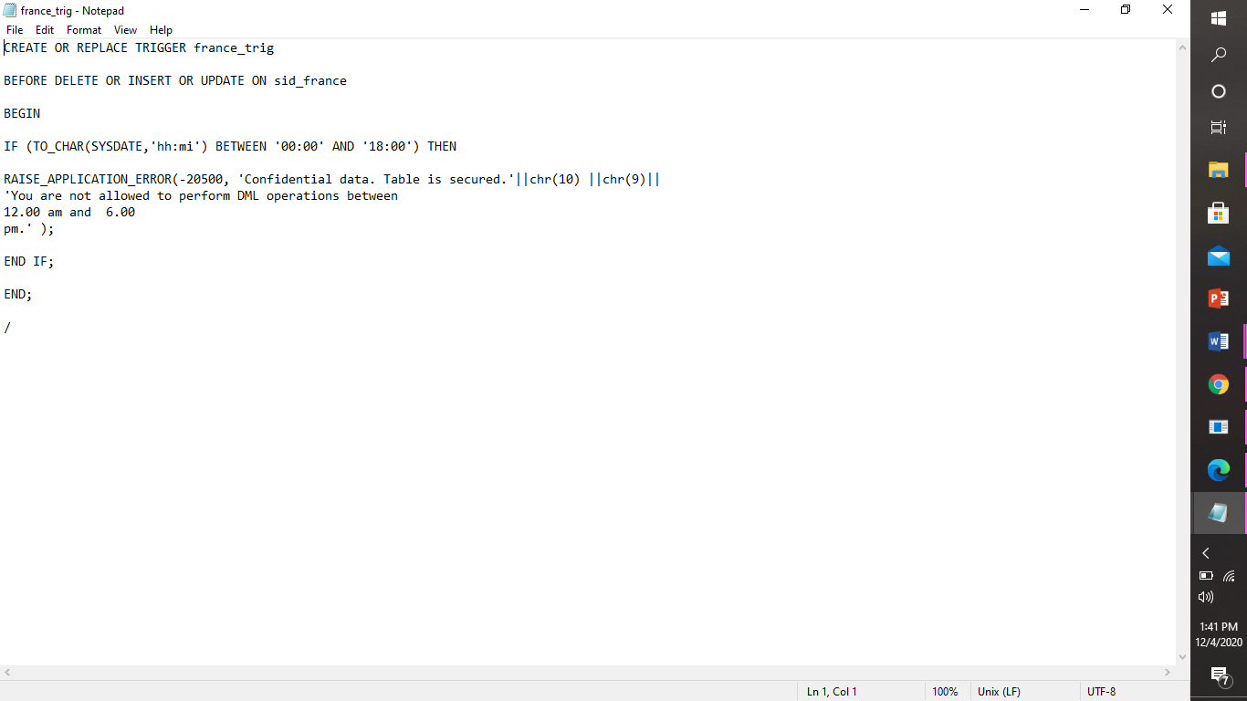

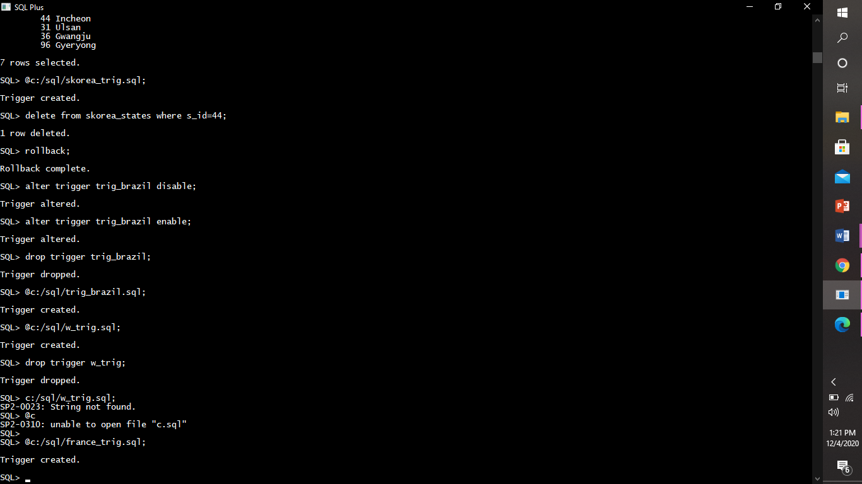

Triggering a trigger

Triggering by deleting

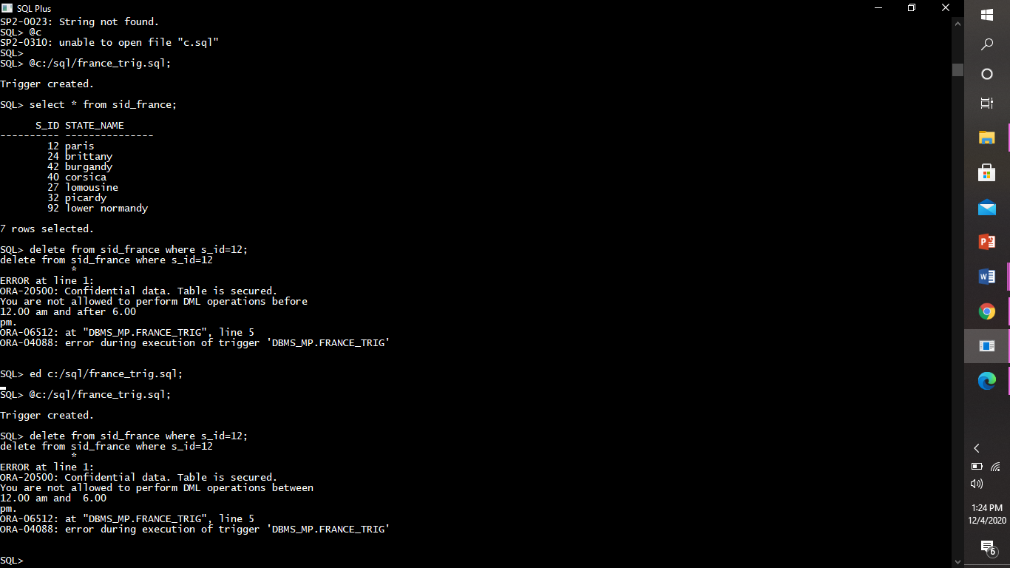

Triggering by inserting

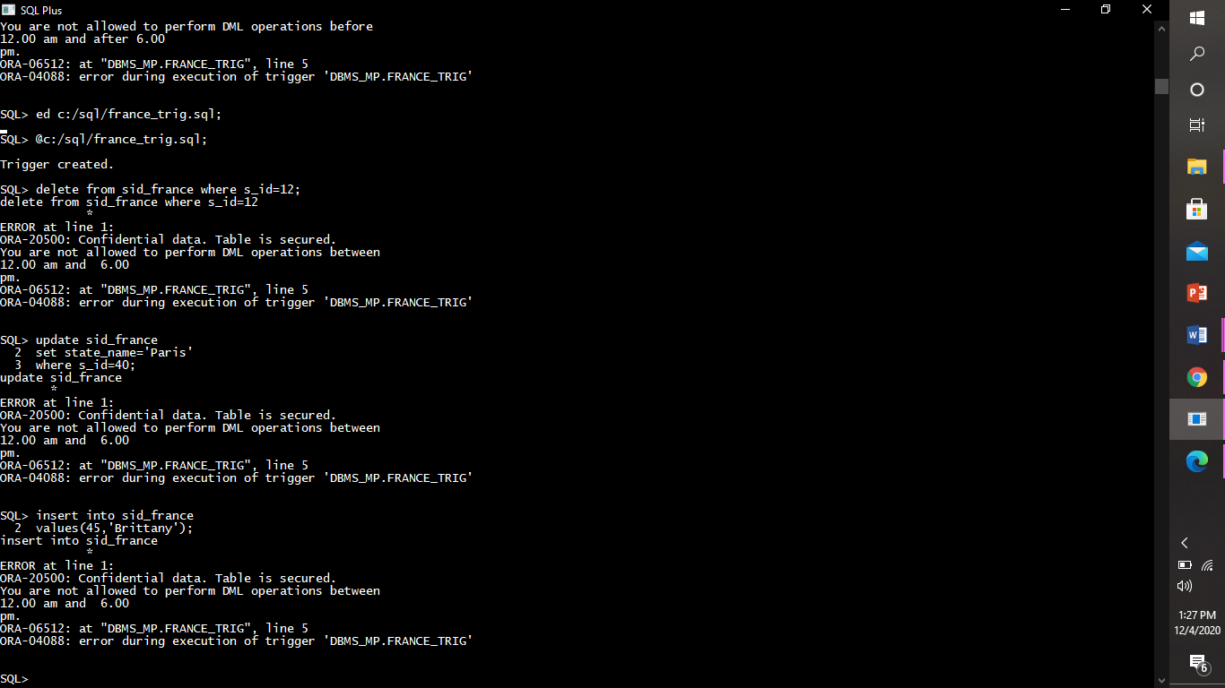

Triggering by updating

