COMSATS UNIVERSITY ISLAMABAD, LAHORE

“FLIGHT MANAGEMENT SYSTEM REPORT”
_{Arisha Inayat(SP24-BCS-159)}

SUBMITTED TO:
_{Sir Muhammad Bin Tahir}

Table of Contents
(a) Introduction 3
✈️ Key Data Structures Used 3
1. Graph (Adjacency List-based): 3
2. Queue (Linked List Implementation): 3
3. Vector: 3
4. Priority Queue (Min-Heap): 3
5. Custom Node and Linked List: 3
6. String Manipulation & Utility Functions: 3
💡Features of the Project 3
🔍 1. Flight Search 4
🛫 2. Flight Booking 4
🗺️ 3. View All Routes 4
🏨 4. Hotel Information 4
💸 5. Cheapest Route (Dijkstra's Algorithm) 4
🎮 6. Flight Trivia Game 4
💱 7. Currency Converter 4
🌆 8. View Available Cities 4
CODE: 4
(b) Output / Screenshots of Project Execution 26
(c) Conclusions and Findings 33
✅ Conclusion: 33
❗Challenges Faced: 33
💡Future Enhancements: 33
(d) Contribution of Each Group Member 33

(a) Introduction
The Flight Management System is a console-based application developed in C++, designed to replicate the core functionalities of a real-world airline reservation system. This project not only enables users to search, view, and book flights, but also incorporates intelligent decision-making through algorithms to provide the most efficient travel options.
Developed as a Data Structures and Algorithms (DSA) project, the system leverages key programming concepts such as object-oriented design, graph traversal, linked lists, and priority queues to create a feature-rich and user-friendly experience. With the ability to handle direct and connecting flights, calculate the cheapest travel routes, and even provide hotel information, this project showcases both practical utility and technical depth.
The user interface is made engaging with features like a currency converter and an entertaining flight trivia quiz. Through this project, our team not only learned how to structure complex systems but also how to implement multiple data structures in harmony to solve real-world problems effectively.

✈️ Key Data Structures Used
- Graph (Adjacency List-based):
To represent the flight network between cities. Cities are nodes and flights are directed edges.
- Queue (Linked List Implementation):
To manage a dynamic list of all flights available, and to handle bookings and flight data loading efficiently.
- Priority Queue (Min-Heap):
Applied in Dijkstra’s Algorithm for finding the cheapest route between cities based on ticket prices.
- Custom Node and Linked List:
Used in creating the adjacency list and flight queue structure for flexible memory handling.
- String Manipulation & Utility Functions:
Trim and lowercase conversion help in robust city comparison, error handling, and formatting.

💡Features of the Project
The Flight Management System offers a wide array of well-integrated features:
🔍 1. Flight Search
- Users can search for flights based on origin, destination, and date.
- If no direct flight exists, the system offers connecting flights with valid layover times.
🛫 2. Flight Booking
- Book a flight after reviewing details.
- Generates a random booking reference number (e.g., FLT1234).
- Displays a summary of the ticket, including cost, departure, arrival, and airline.
🗺️ 3. View All Routes
- Displays all flights available from each city.
- Helps the user visualize the network of routes.
🏨 4. Hotel Information
- Shows available hotels in each city and their per-day prices, loaded from file.
💸 5. Cheapest Route (Dijkstra's Algorithm)
- Finds and displays the least costly flight route between two cities.
- Uses Dijkstra’s algorithm with ticket price as edge weight.
🎮 6. Flight Trivia Game
- A mini quiz game with multiple-choice questions to keep the user engaged.
- Score and feedback provided after the game.
💱 7. Currency Converter
- Converts between USD and PKR based on current exchange rate (approximate).
🌆 8. View Available Cities
- Displays a list of cities present in the network, useful for planning flights or finding hotels.

CODE:

#include <iostream>
#include <fstream>
#include <sstream>
#include <string>
#include <cstring>
#include <iomanip>
#include <cmath>
#include <climits>
#include <ctime>
#include <windows.h>
#include <vector>
#include <limits>

using namespace std;

//-----------------------------------------------------------------------------------------------------
// Custom Thread Utilities (replacing std::thread and std::chrono)
//-----------------------------------------------------------------------------------------------------
class Thread {
public:
static void sleep_for_milliseconds(int milliseconds) {
Sleep(milliseconds); // Windows API function
}
};

//-----------------------------------------------------------------------------------------------------
// Custom Algorithm Utilities (replacing std::algorithm)
//-----------------------------------------------------------------------------------------------------
namespace CustomAlgorithm {
// Custom transform function
template<typename InputIterator, typename OutputIterator, typename UnaryOperation>
OutputIterator transform(InputIterator first, InputIterator last, OutputIterator result, UnaryOperation op) {
while (first != last) {
*result = op(*first);
++first;
++result;
}
return result;
}

// Custom reverse function
template<typename BidirectionalIterator>
void reverse(BidirectionalIterator first, BidirectionalIterator last) {
while ((first != last) && (first != --last)) {
swap(*first, *last);
++first;
}
}

// Custom Pair struct (replacing std::pair)
template<typename T1, typename T2>
struct Pair {
T1 first;
T2 second;
Pair() {}
Pair(const T1& a, const T2& b) : first(a), second(b) {}
};

// Custom make_pair function
template<typename T1, typename T2>
Pair<T1, T2> make_pair(const T1& a, const T2& b) {
return Pair<T1, T2>(a, b);
}
}

//-----------------------------------------------------------------------------------------------------
// Custom Priority Queue (replacing std::priority_queue)
//-----------------------------------------------------------------------------------------------------
template<typename T, typename Compare = less<T>>
class PriorityQueue {
private:
vector<T> heap;
Compare comp;

void heapifyUp(int index) {
while (index > 0) {
int parent = (index - 1) / 2;
if (comp(heap[parent], heap[index])) {
swap(heap[parent], heap[index]);
index = parent;
} else {
break;
}
}
}

void heapifyDown(int index) {
int size = heap.size();
while (true) {
int left = 2 * index + 1;
int right = 2 * index + 2;
int target = index;

if (left < size && comp(heap[target], heap[left])) {
target = left;
}
if (right < size && comp(heap[target], heap[right])) {
target = right;
}

if (target != index) {
swap(heap[index], heap[target]);
index = target;
} else {
break;
}
}
}

public:
PriorityQueue() {}

bool empty() const {
return heap.empty();
}

size_t size() const {
return heap.size();
}

void push(const T& value) {
heap.push_back(value);
heapifyUp(heap.size() - 1);
}

void pop() {
if (heap.empty()) return;
heap[0] = heap.back();
heap.pop_back();
if (!heap.empty()) {
heapifyDown(0);
}
}

const T& top() const {
return heap[0];
}
};

// Custom comparator for Pair<int, int> (for Dijkstra's algorithm)
struct PairGreater {
bool operator()(const CustomAlgorithm::Pair<int, int>& a, const CustomAlgorithm::Pair<int, int>& b) const {
return a.first > b.first; // For min-heap
}
};

// --- Console Color Functions ---
void setConsoleColor(int color) {
HANDLE hConsole = GetStdHandle(STD_OUTPUT_HANDLE);
SetConsoleTextAttribute(hConsole, color);
}

void resetConsoleColor() {
setConsoleColor(7); // Default white color
}

// --- Utility function to trim whitespace and convert to lowercase ---
string trimAndLowercase(string str) {
// Remove leading and trailing whitespace
str.erase(0, str.find_first_not_of(" \t\n\r\f\v"));
str.erase(str.find_last_not_of(" \t\n\r\f\v") + 1);

// Convert to lowercase
CustomAlgorithm::transform(str.begin(), str.end(), str.begin(), ::tolower);
return str;
}

// --- Loading Animation ---
void showLoadingAnimation(const string& message, int duration = 2) {
cout << message;
for (int i = 0; i < 3; i++) {
for (const char c : "...") {
cout << c << flush;
Thread::sleep_for_milliseconds(300);
}
cout << "\b\b\b \b\b\b";
}
cout << endl;
}

//-----------------------------------------------------------------------------------------------------
// --- Flight Class ---
class Flight {
public:
string origin;
string destination;
string travel_date;
string flying_time;
string landing_time;
int ticket_price;
string airline_name;

Flight() {}

Flight(string origin, string destination, string travel_date,
string flying_time, string landing_time, int ticket_price,
string airline_name) {
this->origin = origin;
this->destination = destination;
this->travel_date = travel_date;
this->flying_time = flying_time;
this->landing_time = landing_time;
this->ticket_price = ticket_price;
this->airline_name = airline_name;
}

void displayFlightDetails() const {
setConsoleColor(11); // Cyan
cout << "==============================================================" << endl;
cout << "= Flight Details =" << endl;
cout << "==============================================================" << endl;
cout << "= Origin : " << setw(43) << left << origin << "=" << endl;
cout << "= Destination : " << setw(43) << left << destination << "=" << endl;
cout << "= Date : " << setw(43) << left << travel_date << "=" << endl;
cout << "= Departure : " << setw(43) << left << flying_time << "=" << endl;
cout << "= Arrival : " << setw(43) << left << landing_time << "=" << endl;
cout << "= Price : $" << setw(42) << left << ticket_price << "=" << endl;
cout << "= Airline : " << setw(43) << left << airline_name << "=" << endl;
cout << "==============================================================" << endl;
resetConsoleColor();
}

bool isSameDay(const string& date) const {
return travel_date == date;
}

int getMinutesFromTime(const string& time) const {
int hour = 0, minute = 0;
// Use sscanf for simple time string parsing (HH:MM)
sscanf(time.c_str(), "%d:%d", &hour, &minute);
return hour * 60 + minute;
}

int getLandingMinutes() const {
return getMinutesFromTime(landing_time);
}

int getFlyingMinutes() const {
return getMinutesFromTime(flying_time);
}

int getFlightDuration() const {
// Simple duration calculation, assuming same day travel for now
return abs(getLandingMinutes() - getFlyingMinutes());
}

static bool isLayoverValid(int landingMinutes, int nextFlightFlyingMinutes) {
int layoverTime = nextFlightFlyingMinutes - landingMinutes;
return layoverTime >= 30 && layoverTime <= 720; // 30 mins to 12 hours
}
};

//-----------------------------------------------------------------------------------------------------
// --- Node Class for Linked List (Adjacency List & Queue) ---
class Node {
public:
Flight flightData;
Node* next;

Node() : next(nullptr) {}
Node(Flight f) : flightData(f), next(nullptr) {}
};

//-----------------------------------------------------------------------------------------------------
// --- Adjacency List Class (Linked List) ---
class AdjList {
public:
Node* head;

AdjList() : head(nullptr) {}

void insert(Flight flight) {
Node* temp = new Node(flight);
if (!head) {
head = temp;
} else {
Node* curr = head;
while (curr->next) {
curr = curr->next;
}
curr->next = temp;
}
}

void print() const {
Node* temp = head;
while (temp) {
temp->flightData.displayFlightDetails();
temp = temp->next;
}
}

bool isEmpty() const {
return head == nullptr;
}
};

//-----------------------------------------------------------------------------------------------------
// --- Hotel Class ---
class Hotel {
public:
string city;
int price_per_day;

Hotel() {}
Hotel(string city, int price_per_day) : city(city), price_per_day(price_per_day) {}

void displayHotelDetails() const {
setConsoleColor(14); // Yellow
cout << "==============================================" << endl;
cout << "= Hotel Information =" << endl;
cout << "==============================================" << endl;
cout << "= City: " << setw(35) << left << city << "=" << endl;
cout << "= Price per Day: $" << setw(27) << left << price_per_day << "=" << endl;
cout << "==============================================" << endl;
resetConsoleColor();
}
};

//-----------------------------------------------------------------------------------------------------
// --- Graph Class (Core Logic) ---
class Graph {
public:
int maxVertices;
AdjList* adjLists;
Hotel* hotels;
int hotelCount;
string* cityNames;

Graph(int size) : maxVertices(size), hotelCount(0) {
adjLists = new AdjList[size];
hotels = new Hotel[size];
cityNames = new string[size];
}

~Graph() {
// Clean up linked lists
for (int i = 0; i < maxVertices; ++i) {
Node* cur = adjLists[i].head;
while (cur) {
Node* tmp = cur;
cur = cur->next;
delete tmp;
}
}
delete[] adjLists;
delete[] hotels;
delete[] cityNames;
}

void addHotel(string city, int price_per_day) {
if (hotelCount >= maxVertices) {
setConsoleColor(12); // Red
cout << "Error: Maximum number of cities reached." << endl;
resetConsoleColor();
return;
}
cityNames[hotelCount] = city;
hotels[hotelCount++] = Hotel(city, price_per_day);
}

int findCityIndex(const string& name) const {
string searchCity = trimAndLowercase(name);
for (int i = 0; i < hotelCount; i++) {
if (trimAndLowercase(cityNames[i]) == searchCity) {
return i;
}
}
return -1;
}

void insertFlight(int originIndex, int destinationIndex, Flight flight) {
if (originIndex < 0 || destinationIndex < 0 ||
originIndex >= maxVertices || destinationIndex >= maxVertices) {
setConsoleColor(12); // Red
cout << "Error: Invalid city indices for flight from " << flight.origin << " to " << flight.destination << endl;
resetConsoleColor();
return;
}
adjLists[originIndex].insert(flight);
}

void showGraph() const {
showRoutes();
}

void showRoutes() const {
setConsoleColor(10); // Green
cout << "\n==============================================================" << endl;
cout << "= Flight Network Routes =" << endl;
cout << "==============================================================" << endl;
resetConsoleColor();

for (int i = 0; i < hotelCount; ++i) {
cout << "\nFlights from " << cityNames[i] << ":" << endl;
if (adjLists[i].isEmpty()) {
cout << "(No flights available)" << endl;
} else {
adjLists[i].print();
}
}
}

void showHotels() const {
setConsoleColor(14); // Yellow
cout << "\n==============================================================" << endl;
cout << "= Hotel Information =" << endl;
cout << "==============================================================" << endl;
resetConsoleColor();
for (int i = 0; i < hotelCount; ++i) {
hotels[i].displayHotelDetails();
}
}

void showAvailableCities() const {
setConsoleColor(13); // Purple
cout << "\nAvailable Cities:" << endl;
for (int i = 0; i < hotelCount; i++) {
cout << i << ". " << cityNames[i] << endl;
}
resetConsoleColor();
}

void showLoadedCities() const { showAvailableCities(); }

vector<Flight> searchFlightOptions(const string& start, const string& end, const string& date) {
vector<Flight> availableFlights;
int originIndex = findCityIndex(start);
int destIndex = findCityIndex(end);

if (originIndex == -1) {
setConsoleColor(12); // Red
cout << "\nError: Origin city '" << start << "' not found in network." << endl;
cout << "Available cities are:" << endl;
for (int i = 0; i < hotelCount; i++) {
cout << "- " << cityNames[i] << endl;
}
resetConsoleColor();
return availableFlights;
}

if (destIndex == -1) {
setConsoleColor(12); // Red
cout << "\nError: Destination city '" << end << "' not found in network." << endl;
cout << "Available cities are:" << endl;
for (int i = 0; i < hotelCount; i++) {
cout << "- " << cityNames[i] << endl;
}
resetConsoleColor();
return availableFlights;
}

showLoadingAnimation("Searching for flights");

// Check direct flights first
Node* currentFlight = adjLists[originIndex].head;
while (currentFlight) {
if (trimAndLowercase(currentFlight->flightData.destination) == trimAndLowercase(end) &&
currentFlight->flightData.travel_date == date) {
availableFlights.push_back(currentFlight->flightData);
}
currentFlight = currentFlight->next;
}

// If no direct flights found, look for connecting flights
if (availableFlights.empty()) {
cout << "\nNo direct flights found. Searching for connecting flights..." << endl;
vector<CustomAlgorithm::Pair<Flight, Flight>> connectingFlights = findConnectingFlights(start, end, date);

if (!connectingFlights.empty()) {
setConsoleColor(14); // Yellow
cout << "\nFound " << connectingFlights.size() << " connecting flight option(s):" << endl;
resetConsoleColor();

for (size_t i = 0; i < connectingFlights.size(); i++) {
cout << "\nConnecting Flight Option " << (i + 1) << ":" << endl;
cout << "First leg:" << endl;
connectingFlights[i].first.displayFlightDetails();
cout << "Second leg:" << endl;
connectingFlights[i].second.displayFlightDetails();

int layoverTime = connectingFlights[i].second.getFlyingMinutes() -
connectingFlights[i].first.getLandingMinutes();
cout << "Layover time: " << layoverTime << " minutes" << endl;
}

// Return empty list to signal that only connecting flights were found and printed
return availableFlights;
}
}

return availableFlights;
}

void searchFlight(const string& start, const string& end, const string& date) {
vector<Flight> flights = searchFlightOptions(start, end, date);

if (flights.empty()) {
setConsoleColor(14); // Yellow
cout << "\nSearch complete. Please review the output above for any connecting flights." << endl;
resetConsoleColor();
} else {
setConsoleColor(10); // Green
cout << "\nAvailable Direct Flights found:" << endl;
resetConsoleColor();
for (size_t i = 0; i < flights.size(); i++) {
cout << "\nFlight " << (i + 1) << ":" << endl;
flights[i].displayFlightDetails();
}
}
}

bool bookFlight(const string& start, const string& end, const string& date) {
// Collect direct flights
vector<Flight> directFlights;
int originIndex = findCityIndex(start);
if (originIndex != -1) {
Node* currentFlight = adjLists[originIndex].head;
while (currentFlight) {
if (trimAndLowercase(currentFlight->flightData.destination) == trimAndLowercase(end) &&
currentFlight->flightData.travel_date == date) {
directFlights.push_back(currentFlight->flightData);
}
currentFlight = currentFlight->next;
}
}

// Collect connecting flights
vector<CustomAlgorithm::Pair<Flight, Flight>> connectingFlights = findConnectingFlights(start, end, date);

if (directFlights.empty() && connectingFlights.empty()) {
setConsoleColor(12); // Red
cout << "\nSorry, no direct or connecting flights available for the specified route and date." << endl;
cout << "Please try a different date or route." << endl;
resetConsoleColor();
return false;
}

setConsoleColor(10); // Green
cout << "\n============================================================" << endl;
cout << "= Available Flights =" << endl;
cout << "=============================================================" << endl;
resetConsoleColor();

// Use a vector to store a simplified representation of all bookable options
vector<Flight> allBookableOptions;
int optionCounter = 1;

// Display Direct Flights
for (const auto& flight : directFlights) {
cout << "\nOption " << (optionCounter++) << " (Direct Flight):" << endl;
flight.displayFlightDetails();
allBookableOptions.push_back(flight);
}

// Display Connecting Flights
for (const auto& connection : connectingFlights) {
cout << "\nOption " << (optionCounter++) << " (Connecting Flight - Total Cost: $"
<< (connection.first.ticket_price + connection.second.ticket_price) << "):" << endl;
cout << "--- Leg 1: " << connection.first.origin << " to " << connection.first.destination << " ---" << endl;
connection.first.displayFlightDetails();
cout << "--- Leg 2: " << connection.second.origin << " to " << connection.second.destination << " ---" << endl;
connection.second.displayFlightDetails();

// For simplified booking confirmation, push the first flight as the marker
allBookableOptions.push_back(connection.first);
}

int choice = 0;
bool validChoice = false;

while (!validChoice) {
cout << "\nEnter your choice (1-" << allBookableOptions.size() << ") or 0 to cancel: ";

if (!(cin >> choice)) {
cin.clear();
cin.ignore(10000, '\n');
setConsoleColor(12); // Red
cout << "Invalid input! Please enter a number." << endl;
resetConsoleColor();
continue;
}

// Consume the newline left by cin >> choice
cin.ignore(numeric_limits<streamsize>::max(), '\n');

if (choice == 0) {
setConsoleColor(14); // Yellow
cout << "Booking cancelled by user." << endl;
resetConsoleColor();
return false;
}

if (choice >= 1 && choice <= static_cast<int>(allBookableOptions.size())) {
validChoice = true;
} else {
setConsoleColor(12); // Red
cout << "Invalid choice! Please select a number between 1 and " << allBookableOptions.size() << "." << endl;
resetConsoleColor();
}
}

int directFlightsSize = directFlights.size();

if (choice <= directFlightsSize) {
// --- Direct Flight Booking Confirmation ---
Flight selectedFlight = directFlights[choice - 1];

setConsoleColor(10); // Green
cout << "\n=============================================================" << endl;
cout << "= Booking Confirmation =" << endl;
cout << "=============================================================" << endl;
cout << "\nYou have selected a DIRECT FLIGHT:" << endl;
selectedFlight.displayFlightDetails();

char confirm;
cout << "\nConfirm booking? (y/n): ";
cin >> confirm;
cin.ignore(numeric_limits<streamsize>::max(), '\n'); // Clear buffer

if (confirm == 'y' || confirm == 'Y') {
srand(static_cast<unsigned int>(time(nullptr)));
int bookingRef = rand() % 9000 + 1000; // Generate 4-digit number

cout << "\nBOOKING SUCCESSFUL!" << endl;
cout << "========================================" << endl;
cout << "Booking Reference: FLT" << bookingRef << endl;
cout << "Flight: " << selectedFlight.origin << " -> " << selectedFlight.destination << endl;
cout << "Total Cost: $" << selectedFlight.ticket_price << endl;
cout << "=========================================" << endl;
cout << "Please save your booking reference for future use." << endl;
resetConsoleColor();
return true;
} else {
setConsoleColor(14); // Yellow
cout << "Booking cancelled." << endl;
resetConsoleColor();
return false;
}
} else {
// --- Connecting Flight Booking Confirmation ---
int connIndex = choice - directFlightsSize - 1;
const auto& selectedConnection = connectingFlights[connIndex];

int totalCost = selectedConnection.first.ticket_price + selectedConnection.second.ticket_price;

setConsoleColor(10); // Green
cout << "\n=============================================================" << endl;
cout << "= Booking Confirmation =" << endl;
cout << "=============================================================" << endl;
cout << "\nYou have selected a CONNECTING FLIGHT (Two Tickets):" << endl;
cout << "Leg 1 Cost: $" << selectedConnection.first.ticket_price << endl;
cout << "Leg 2 Cost: $" << selectedConnection.second.ticket_price << endl;
cout << "TOTAL COST: $" << totalCost << endl;

char confirm;
cout << "\nConfirm booking? (y/n): ";
cin >> confirm;
cin.ignore(numeric_limits<streamsize>::max(), '\n'); // Clear buffer

if (confirm == 'y' || confirm == 'Y') {
srand(static_cast<unsigned int>(time(nullptr)));
int bookingRef1 = rand() % 9000 + 1000;
int bookingRef2 = rand() % 9000 + 1000;

cout << "\nBOOKING SUCCESSFUL! (Two separate tickets required)" << endl;
cout << "========================================" << endl;
cout << "Total Cost: $" << totalCost << endl;
cout << "Ticket 1 (Leg 1 - " << selectedConnection.first.origin << " to " << selectedConnection.first.destination << "): FLT" << bookingRef1 << " - $" << selectedConnection.first.ticket_price << endl;
cout << "Ticket 2 (Leg 2 - " << selectedConnection.second.origin << " to " << selectedConnection.second.destination << "): FLT" << bookingRef2 << " - $" << selectedConnection.second.ticket_price << endl;
cout << "=========================================" << endl;
cout << "Please save both booking references." << endl;
resetConsoleColor();
return true;
} else {
setConsoleColor(14); // Yellow
cout << "Booking cancelled." << endl;
resetConsoleColor();
return false;
}
}
}

// Find cheapest path (by ticket price) using Dijkstra's algorithm
bool findCheapestPath(const string& startCity, const string& endCity) const {
int startIdx = findCityIndex(startCity);
int endIdx = findCityIndex(endCity);

if (startIdx == -1 || endIdx == -1) {
setConsoleColor(12);
cout << "\nError: One or both cities not found in the network." << endl;
resetConsoleColor();
return false;
}

const int INF = INT_MAX / 2;
vector<int> dist(hotelCount, INF);
vector<int> parent(hotelCount, -1);

// P = Pair<cost, index>
typedef CustomAlgorithm::Pair<int, int> P;
PriorityQueue<P, PairGreater> pq;

dist[startIdx] = 0;
pq.push(CustomAlgorithm::make_pair(0, startIdx));

while (!pq.empty()) {
P current = pq.top();
pq.pop();

int cost = current.first; // The cost (distance)
int u = current.second; // The index (vertex)

if (cost > dist[u]) continue; // Stale entry check (cost must be <= dist[u])
if (u == endIdx) break;

Node* cur = adjLists[u].head;
while (cur) {
int v = findCityIndex(cur->flightData.destination);
if (v != -1) {
int w = cur->flightData.ticket_price; // weight = price
if (dist[u] + w < dist[v]) {
dist[v] = dist[u] + w;
parent[v] = u;
pq.push(CustomAlgorithm::make_pair(dist[v], v));
}
}
cur = cur->next;
}
}

if (dist[endIdx] == INF) {
setConsoleColor(12);
cout << "\nNo route found between " << startCity << " and " << endCity << "." << endl;
resetConsoleColor();
return false;
}

// Reconstruct path
vector<int> path;
for (int v = endIdx; v != -1; v = parent[v]) path.push_back(v);
CustomAlgorithm::reverse(path.begin(), path.end());

setConsoleColor(10);
cout << "\nCheapest route (by total ticket price):" << endl;
resetConsoleColor();
for (size_t i = 0; i < path.size(); ++i) {
cout << cityNames[path[i]];
if (i + 1 < path.size()) cout << " -> ";
}
cout << "\nTotal estimated cost: $" << dist[endIdx] << endl;
return true;
}

private:
vector<CustomAlgorithm::Pair<Flight, Flight>> findConnectingFlights(const string& start, const string& end, const string& date) {
vector<CustomAlgorithm::Pair<Flight, Flight>> connections;
int originIndex = findCityIndex(start);

if (originIndex == -1) return connections;

Node* firstLeg = adjLists[originIndex].head;
while (firstLeg) {
if (firstLeg->flightData.travel_date == date) {
int layoverIndex = findCityIndex(firstLeg->flightData.destination);
if (layoverIndex != -1 && trimAndLowercase(cityNames[layoverIndex]) != trimAndLowercase(end)) {
Node* secondLeg = adjLists[layoverIndex].head;
while (secondLeg) {
if (trimAndLowercase(secondLeg->flightData.destination) == trimAndLowercase(end) &&
secondLeg->flightData.travel_date == date &&
Flight::isLayoverValid(firstLeg->flightData.getLandingMinutes(),
secondLeg->flightData.getFlyingMinutes())) {
connections.push_back(CustomAlgorithm::make_pair(firstLeg->flightData, secondLeg->flightData));
}
secondLeg = secondLeg->next;
}
}
}
firstLeg = firstLeg->next;
}
return connections;
}
};

//-----------------------------------------------------------------------------------------------------
// --- Queue Class (Based on Linked List) ---
class Queue {
private:
Node* front;
Node* rear;
int numItems;

public:
Queue() : front(nullptr), rear(nullptr), numItems(0) {}

~Queue() {
clear();
}

bool isEmpty() const {
return numItems == 0;
}

void enqueue(Flight flight) {
Node* temp = new Node(flight);
if (isEmpty()) {
front = rear = temp;
} else {
rear->next = temp;
rear = temp;
}
numItems++;
}

void dequeue() {
if (isEmpty()) {
setConsoleColor(12); // Red
cout << "Error: Queue is empty" << endl;
resetConsoleColor();
return;
}
Node* temp = front;
front = front->next;
delete temp;
numItems--;
if (front == nullptr) {
rear = nullptr;
}
}

void clear() {
while (!isEmpty()) {
dequeue();
}
}

Node* getFront() const {
return front;
}

int size() const {
return numItems;
}

void displayQueue() const {
if (isEmpty()) {
setConsoleColor(14); // Yellow
cout << "Queue is empty" << endl;
resetConsoleColor();
return;
}

Node* temp = front;
while (temp) {
temp->flightData.displayFlightDetails();
temp = temp->next;
}
}
};

//-----------------------------------------------------------------------------------------------------
// --- Utility Functions ---
void displayMenu() {
setConsoleColor(11); // Cyan
cout << "\n=============================================================" << endl;
cout << "= Flight Management System Menu =" << endl;
cout << "==============================================================" << endl;
cout << "= 1. Search Flights =" << endl;
cout << "= 2. Book a Flight =" << endl;
cout << "= 3. View All Routes =" << endl;
cout << "= 4. View Hotel Information =" << endl;
cout << "= 5. Find Cheapest Route =" << endl;
cout << "= 6. Play Flight Trivia =" << endl;
cout << "= 7. Currency Converter =" << endl;
cout << "= 8. View Available Cities =" << endl;
cout << "= 9. Exit =" << endl;
cout << "==============================================================" << endl;
resetConsoleColor();
}

void displayHeader() {
system("cls"); // Clear screen (Windows)
setConsoleColor(10); // Green
cout << "\n=============================================================" << endl;
cout << "= =" << endl;
cout << "= Welcome to SkyNAV Flight Manager =" << endl;
cout << "= =" << endl;
cout << "==============================================================" << endl;
resetConsoleColor();
}

void playFlightTrivia() {
vector<CustomAlgorithm::Pair<string, vector<string>>> questions = {
CustomAlgorithm::make_pair(string("Which airline is known for its 'Fly Emirates' slogan?"),
vector<string>{"Emirates", "Qatar Airways", "Air India", "American Airlines"}),
CustomAlgorithm::make_pair(string("Which city is known as the 'Big Apple'?"),
vector<string>{"London", "Paris", "New York", "Tokyo"}),
CustomAlgorithm::make_pair(string("What is the capital city of Japan?"),
vector<string>{"Beijing", "Seoul", "Tokyo", "Bangkok"})
};
vector<int> answers = {0, 2, 2}; // 0-based index of correct answers
int score = 0;

setConsoleColor(13); // Purple
cout << "\n============================================================" << endl;
cout << "= Flight Trivia Game =" << endl;
cout << "==============================================================" << endl;
resetConsoleColor();

for (size_t i = 0; i < questions.size(); i++) {
cout << "\nQuestion " << (i + 1) << ": " << questions[i].first << endl;
for (size_t j = 0; j < questions[i].second.size(); j++) {
cout << static_cast<char>('a' + j) << ") " << questions[i].second[j] << endl;
}

char answer;
cout << "\nYour answer (a/b/c/d): ";
cin >> answer;
cin.ignore(numeric_limits<streamsize>::max(), '\n'); // Clear buffer after char input

int idx = tolower(answer) - 'a';
if (idx == answers[i]) {
setConsoleColor(10); // Green
cout << "Correct! Well done!" << endl;
resetConsoleColor();
score++;
} else {
setConsoleColor(12); // Red
cout << "Wrong! The correct answer was: " << questions[i].second[answers[i]] << endl;
resetConsoleColor();
}
}

setConsoleColor(14); // Yellow
cout << "\nFinal Score: " << score << "/" << questions.size() << endl;
if (score == static_cast<int>(questions.size())) {
cout << "Perfect score! You're a travel expert!" << endl;
} else if (score >= static_cast<int>(questions.size()) / 2) {
cout << "Good job! Keep learning!" << endl;
} else {
cout << "Better luck next time!" << endl;
}
resetConsoleColor();
}

// Currency Converter utility
void currencyConverter() {
setConsoleColor(14);
cout << "\n=============================================================" << endl;
cout << "= Currency Converter =" << endl;
cout << "===============================================================" << endl;

double usdToPkr = 278.50; // approximate rate
double amount;
int choice;

cout << "1. USD to PKR" << endl;
cout << "2. PKR to USD" << endl;
cout << "Enter choice (1 or 2): ";

// Check if input is valid
if (!(cin >> choice)) {
cin.clear();
cin.ignore(numeric_limits<streamsize>::max(), '\n');
cout << "Invalid input for choice!" << endl;
resetConsoleColor();
return;
}

cout << "Enter amount: ";
if (!(cin >> amount)) {
cin.clear();
cin.ignore(numeric_limits<streamsize>::max(), '\n');
cout << "Invalid input for amount!" << endl;
resetConsoleColor();
return;
}

cin.ignore(numeric_limits<streamsize>::max(), '\n'); // Clear buffer after number input

cout << fixed << setprecision(2);
if (choice == 1) {
cout << "$" << amount << " = PKR " << amount * usdToPkr << endl;
} else if (choice == 2) {
cout << "PKR " << amount << " = $" << amount / usdToPkr << endl;
} else {
cout << "Invalid choice!" << endl;
}
resetConsoleColor();
}

// --- Main Function ---
int main() {
// 1. Setup Graph/Data
Graph flightNetwork(10); // Max 10 cities

// Add cities and hotel prices (Updated to include Multan)
flightNetwork.addHotel("Karachi", 150);
flightNetwork.addHotel("Lahore", 120);
flightNetwork.addHotel("Islamabad", 180);
flightNetwork.addHotel("Dubai", 250);
flightNetwork.addHotel("London", 300);
flightNetwork.addHotel("Istanbul", 200);
flightNetwork.addHotel("Multan", 110); // Multan Added

// Get indices
int karachi = flightNetwork.findCityIndex("Karachi");
int lahore = flightNetwork.findCityIndex("Lahore");
int islamabad = flightNetwork.findCityIndex("Islamabad");
int dubai = flightNetwork.findCityIndex("Dubai");
int london = flightNetwork.findCityIndex("London");
int istanbul = flightNetwork.findCityIndex("Istanbul");
int multan = flightNetwork.findCityIndex("Multan"); // Get Multan index

// Add flights (Origin, Destination, Date, Flying, Landing, Price, Airline)

// Existing flights
flightNetwork.insertFlight(karachi, lahore,
Flight("Karachi", "Lahore", "2025-12-25", "10:00", "12:00", 80, "AirBlue"));
flightNetwork.insertFlight(karachi, islamabad,
Flight("Karachi", "Islamabad", "2025-12-25", "14:00", "16:00", 100, "PIA"));
flightNetwork.insertFlight(lahore, karachi,
Flight("Lahore", "Karachi", "2025-12-25", "08:00", "10:00", 85, "PIA"));
flightNetwork.insertFlight(lahore, dubai,
Flight("Lahore", "Dubai", "2025-12-25", "18:00", "22:00", 350, "Emirates"));
flightNetwork.insertFlight(islamabad, london,
Flight("Islamabad", "London", "2025-12-26", "01:00", "07:00", 600, "British Airways"));
flightNetwork.insertFlight(dubai, istanbul,
Flight("Dubai", "Istanbul", "2025-12-26", "11:00", "14:00", 280, "Turkish Airlines"));

// Cheapest route test flight
flightNetwork.insertFlight(karachi, lahore,
Flight("Karachi", "Lahore", "2025-12-25", "16:00", "18:00", 75, "AirBlue"));

// Connecting flight opportunity: Karachi -> Islamabad -> London
flightNetwork.insertFlight(islamabad, london,
Flight("Islamabad", "London", "2025-12-25", "18:30", "00:30", 550, "PIA"));

// Connecting flight opportunity: Lahore -> Dubai -> Istanbul
flightNetwork.insertFlight(lahore, dubai,
Flight("Lahore", "Dubai", "2025-12-25", "10:00", "14:00", 300, "PIA")); // Leg 1
flightNetwork.insertFlight(dubai, istanbul,
Flight("Dubai", "Istanbul", "2025-12-25", "15:00", "18:00", 250, "Emirates")); // Leg 2 (Valid layover: 60 mins)

// --- UPDATED FLIGHTS TO MATCH USER'S SEARCHES ---

// Flight Lahore to Islamabad (Matches user's second search attempt date: 2025-11-01)
flightNetwork.insertFlight(lahore, islamabad,
Flight("Lahore", "Islamabad", "2025-11-01", "09:00", "10:30", 95, "AirSial"));

// Flight Multan to Lahore (Matches user's second search attempt date: 2025-01-01)
flightNetwork.insertFlight(multan, lahore,
Flight("Multan", "Lahore", "2025-01-01", "07:00", "08:00", 50, "Shaheen Air")); // DATE CHANGED

// 2. Main Menu Loop
int choice;
bool running = true;
string start, end, date;

while (running) {
displayHeader();
displayMenu();
cout << "Enter your choice: ";

if (!(cin >> choice)) {
cin.clear();
cin.ignore(numeric_limits<streamsize>::max(), '\n');
setConsoleColor(12);
cout << "Invalid input! Please enter a number." << endl;
resetConsoleColor();
continue;
}

// Consume the rest of the line
cin.ignore(numeric_limits<streamsize>::max(), '\n');

switch (choice) {
case 1: // Search Flights
cout << "\n--- Search Flights ---" << endl;
flightNetwork.showLoadedCities();
cout << "Enter Origin City: ";
getline(cin, start);
cout << "Enter Destination City: ";
getline(cin, end);
cout << "Enter Date (YYYY-MM-DD): ";
getline(cin, date);
flightNetwork.searchFlight(start, end, date);
break;

case 2: // Book a Flight
cout << "\n--- Book a Flight ---" << endl;
flightNetwork.showLoadedCities();
cout << "Enter Origin City: ";
getline(cin, start);
cout << "Enter Destination City: ";
getline(cin, end);
cout << "Enter Date (YYYY-MM-DD): ";
getline(cin, date);
flightNetwork.bookFlight(start, end, date);
break;

case 3: // View All Routes
flightNetwork.showRoutes();
break;

case 4: // View Hotel Information
flightNetwork.showHotels();
break;

case 5: // Find Cheapest Route (Dijkstra)
cout << "\n--- Find Cheapest Route ---" << endl;
flightNetwork.showLoadedCities();
cout << "Enter Start City: ";
getline(cin, start);
cout << "Enter End City: ";
getline(cin, end);
flightNetwork.findCheapestPath(start, end);
break;

case 6: // Play Flight Trivia
playFlightTrivia();
break;

case 7: // Currency Converter
currencyConverter();
break;

case 8: // View Available Cities
flightNetwork.showAvailableCities();
break;

case 9: // Exit
running = false;
setConsoleColor(10);
cout << "\nThank you for using SkyNAV Flight Manager. Goodbye!" << endl;
resetConsoleColor();
break;

default:
setConsoleColor(12);
cout << "\nInvalid choice. Please select an option from 1 to 9." << endl;
resetConsoleColor();
break;
}

if (running && choice != 9) {
setConsoleColor(14);
cout << "\nPress ENTER to continue...";
resetConsoleColor();
cin.get(); // Waits for user to press ENTER
}
}

return 0;
}

(b) Output / Screenshots of Project Execution
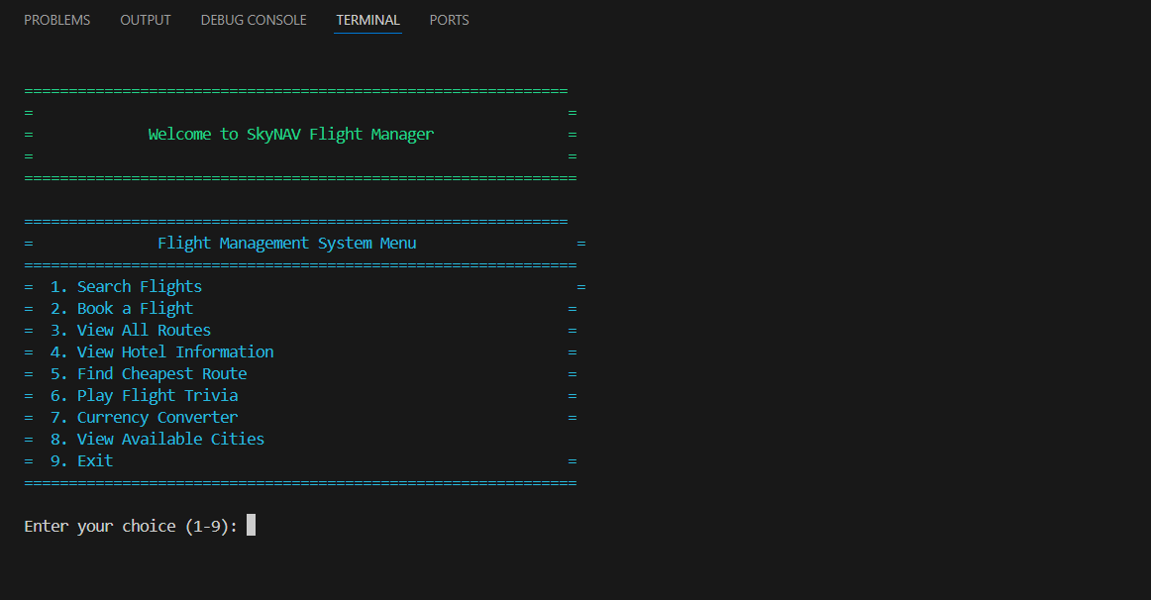

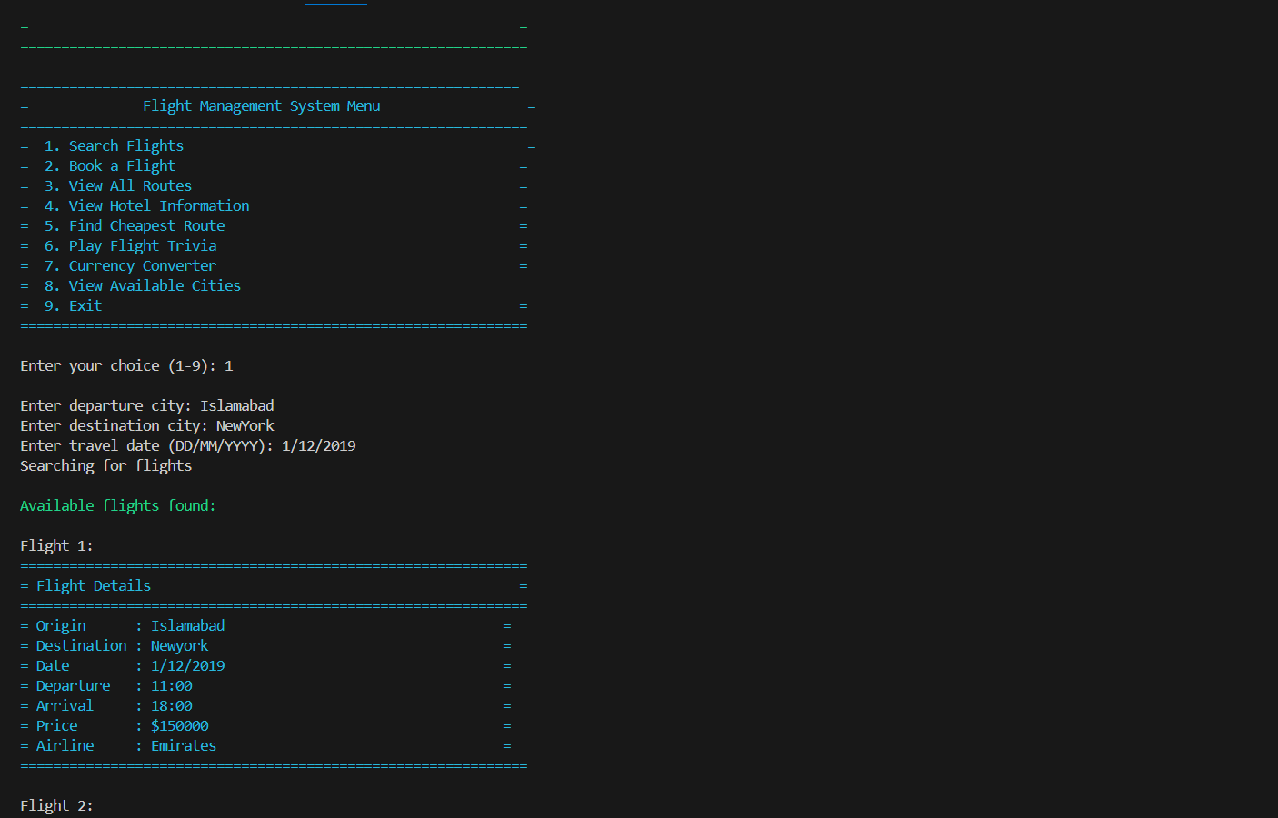

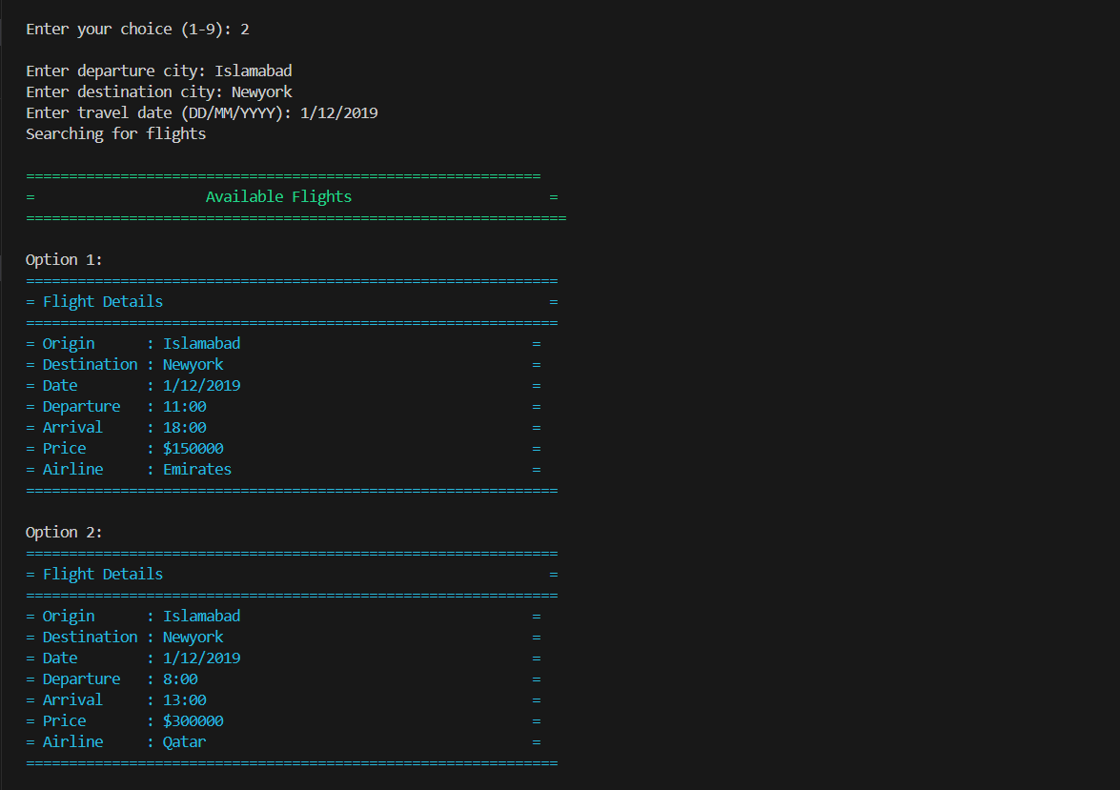

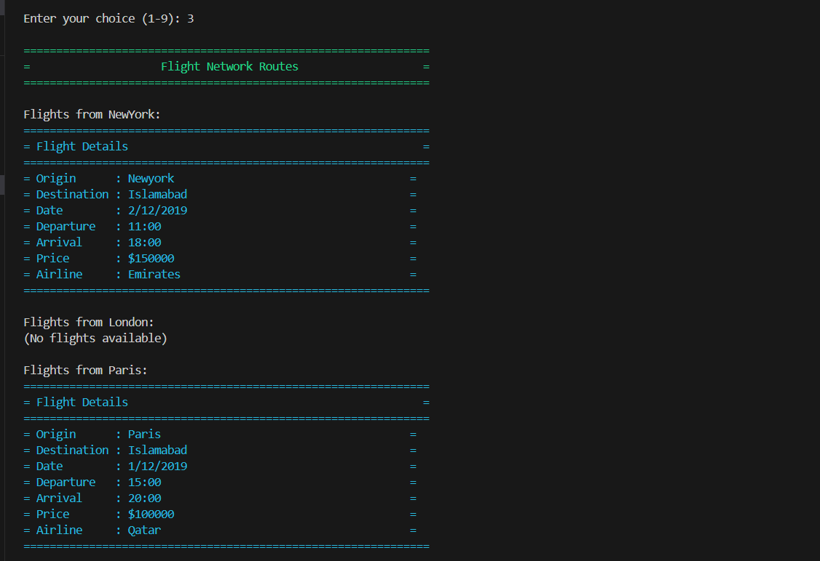

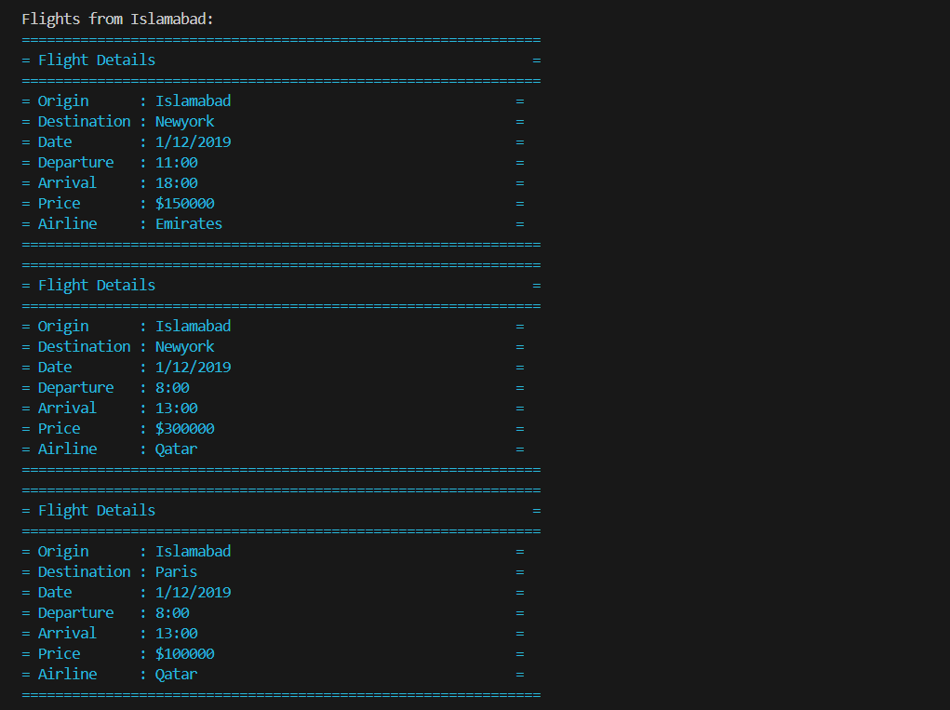

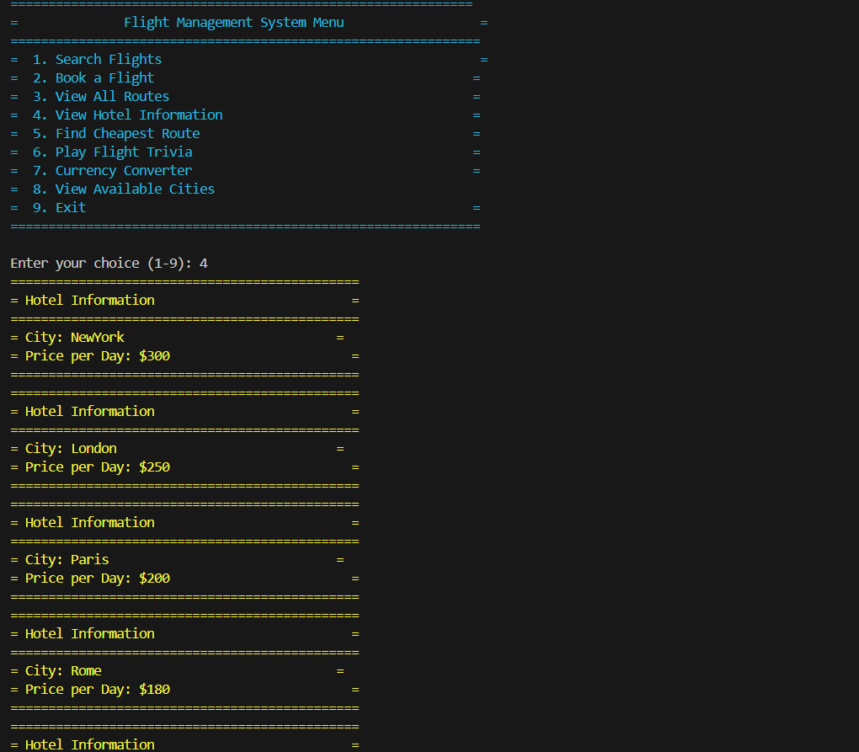

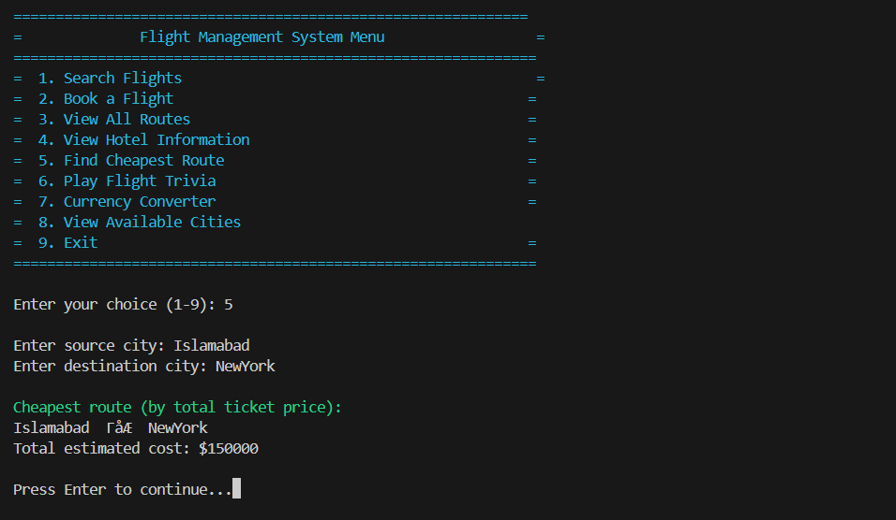

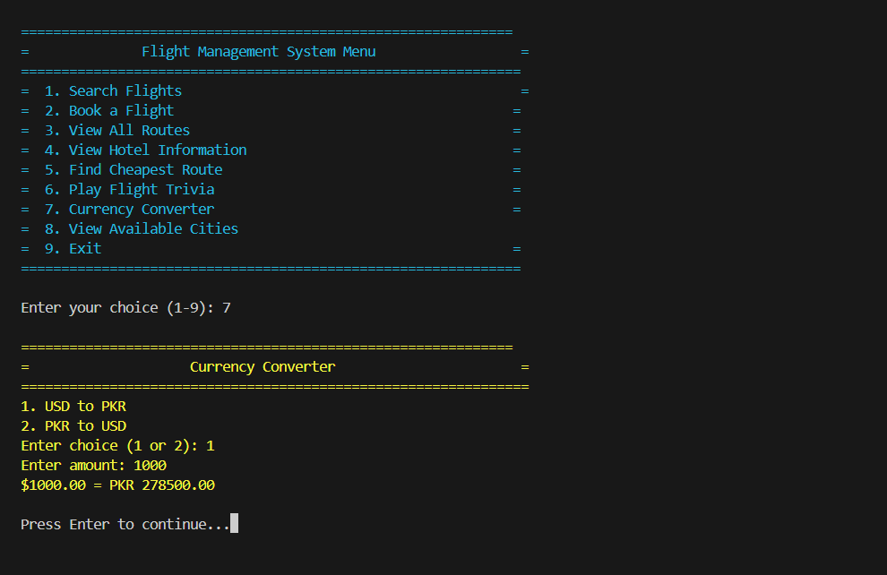

(c) Conclusions and Findings

✅ Conclusion:
The project was successfully implemented with key features that simulate a real-world flight booking and management experience. All modules interact smoothly using OOP principles and data structures.

❗Challenges Faced:
- Parsing and validating user inputs for flight search and booking
- Implementing Dijkstra’s algorithm in a custom flight network graph
- Managing console-based interface and color formatting
- Ensuring efficient memory handling using classes and pointers

💡Future Enhancements:
- GUI interface using C++ frameworks like Qt or porting to JavaFX
- Adding real-time date/time input and error handling
- Saving booking data to a file for persistent storage
- Adding multiple users, login features, and admin panels

