Lab Sheet 4
Advanced Data Analytics
Ian Nabney

Tableau calculations
(Partly based on a tutorial presented at the Alan Turing Institute).
So far you have only visualized aggregations of values that are stored in a dataset (e.g., average Internet Usage for a given Region), but often you want to visualize data that needs to be calculated from the content of your dataset. Tableau provides several ways of doing that, and mastering calculations is essential if you are to unlock the full power of Tableau. However, be warned – it is often non-trivial to determine how a calculation should be formulated to produce the data and visualizations that you want. There’s no substitute for systematic thinking, plenty of practice and experience!
Calculations can be useful in many different circumstances, including:
- To segment a field
- To convert the data type of a field, such as converting a string to a date.
- To aggregate data
- To filter results
- To calculate ratios

Quick table calculations
Open the “World Indicators” dataset. We are going to revisit the line graph example we did on sheet 2 (Section 2.3.2) of Introduction to Data Analytics. For completeness, the instructions are repeated here.
Create a line chart of Year (columns shelf) vs. Region and average CO2 Emissions (row shelf) – remember to change the Measure from Sum to Average. Tableau creates a stack of six line charts (one for each Region) and, by default, all of the axes have the same range. That helps you to make absolute comparisons between the regions, but Africa’s emissions are so low you cannot see whether or not they are changing.
Double-click within the area of any of the CO2 Emissions axes to open the Edit Axis dialog window, and choose Independent axis ranges for each row or column and then Apply.
Instead of visualizing the quantity of CO2 Emissions you might want to visualize the change in those emissions. You can show the percentage change by choosing Quick Table Calculation -> Percent Difference from the CO2 Emissions pill (see Figure 1(a)). If you filter the years to remove the artefact that caused by null data in 2011 and 2012 you can see details of the year-on-year change (see Figure 1(b)). You can also edit the calculation, for example, to calculate emissions as a percentage of the first year.
- (b)
Figure 1: CO2 emissions: (a) Calculating the annual percentage difference, and (b) the result.

Basic expressions: calculating a new field
If you have all the data values you need on the visualisation, a table calculation is the right choice. If not, you should create a new field using a basic expression. There is a third type of expression called a level-of-detail (LOD) expression that enables you to control the level of granularity of the calculation in even more detail. However, that will take us beyond the scope of this worksheet. More detail can be found here https://help.tableau.com/current/pro/desktop/en-us/calculations_calculatedfields_understand_which.htm We will revisit this on a later worksheet as it turns out to be useful to calculate correlation matrices.
Calculated fields may contain elements for fields, functions (SUM, COUNT, COUNTD, etc.), operators (+, -, etc.), parameters and comments (any text that follows ‘//’ characters). A simple example is this. Create a new worksheet. The dataset contains Tourism Inbound and Tourism Outbound fields. To create a field for the surplus, select Tourism Inbound -> Create -> Calculated Field from the left-hand panel and enter the formula [Tourism Inbound] – [Tourism Outbound]. Note that if you type the start of a field name, there is a pop-up menu that offers you various completions – this saves typing and makes it less error-prone. Name the field Net Tourism (by editing the small text box at the top of the window) and create a set of graphs similar to those in Figure 1. Note how the icon for the new calculated field is =# to show that it is numeric but also calculated.
A data aggregation example is as follows (again, create a new worksheet). The number of countries may be calculated by counting the distinct (COUNTD) Country names: create a basic expression to compute this value with the name Number of Countries. This effectively defines a database query that Tableau executes when the Number of Countries field is added to a worksheet, so the result depends on other fields: place this field on the rows shelf and Region on the columns shelf and then you can see the number of countries in each region (see Figure 2).

More on calculations
The syntax for calculation in Tableau is explained here https://help.tableau.com/current/pro/desktop/en-us/functions_operators.htm There are four basic components:
- Functions: statements used to transform values (Tableau includes such statements as IF, ELSEIF etc. as functions).
- Fields: dimensions or measures (columns) from the data. These are usually surrounded by square brackets [ ].
- Operators: numerical or logical, such as comparators >, <=, AND etc.
- Literal expressions: constant values such as strings (written in double quotes), numbers, dates (with a leading hash symbol #), Booleans (true, false).

Figure 2: Calculating the number of countries. Left: a bar chart showing the number for the whole world. Right: a bar chart showing the number for each region.
As you can imagine, there are a very large number of built-in functions in Tableau which are listed here https://help.tableau.com/current/pro/desktop/en-us/functions_all_alphabetical.htm I am not going to cover all (or even many) of them here, but here are a few that are useful or which have already turned up:
- WINDOW_MAX (and corresponding window functions for MIN, AVE, MEDIAN, etc.). This function takes optional parameters start and end: WINDOW_MAX(expression, [start, end]). It computes the maximum of the expression within the window. The window is defined by means of offsets from the current row. Use FIRST()+n and LAST()-n for offsets from the first or last row in the partition. If the start and end are omitted, the entire partition is used. This is useful for computing functions of elements within a visualisation.
- CORR(expression1, expression2) computes the Pearson correlation coefficient of two expressions. It is available only for certain data sources (primarily databases). So you should either apply it to a Tableau data extract (always possible) or use the WINDOW_CORR form instead.
- ZN(expression) returns the expression if it is not null, otherwise returns zero. Use this function to replace null values by zero.
- DISTANCE(geometry1, geometry2, “units”) returns distance measurement between two points in a specified unit. Supported unit names: meters ("meters," "metres" "m), kilometers ("kilometers," "kilometres" or "km"), miles ("miles"), feet ("feet" or "ft").

Parallel coordinates plot
On this sheet, I will take you through all the steps for creating a parallel coordinates plot using calculations.
- Load the autoDataXL file into Tableau. Choose about four characteristics of cars of interest to you: I selected curb-weight, horsepower, price, and city-mpg.
- Drag the first variable onto the rows shelf. This will produce a vertical bar showing the sum of all the curb weights in the dataset. Now drag the second variable towards the y-axis. While it is over that axis you should see two vertical green bars. Let the variable go at that point, and you should see the plot in Figure 3. (Alternatively, you can drag the variable onto the Measures box).
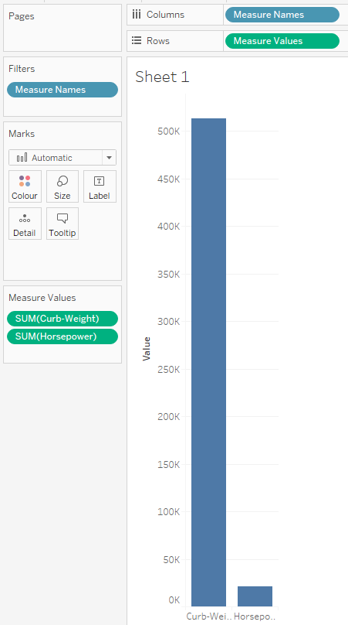
Figure 3: Step 2 of the parallel coordinates plot exercise.
- Add the remaining variables to the Measures shelf to generate more vertical bars. You can reorder the bars by simply dragging the pills in the Measures shelf to the right order. Change the aggregation on each measure from Sum to Average. Note that the default aggregation measure of SUM is used, which means that makes with more entries (for different car models), have a higher value simply by scaling.
- Now change the Mark type from Automatic to Line: this gives a single line graph. To split this up, drag the Make onto the Details shelf, to obtain one line graph for each make. Mousing over lines should show the make and the corresponding value. On the menu bar, select the view (showing ‘Standard’) and set it to ‘Entire View’ which stretches out the x-axis to the width of your Tableau screen. This should look like Figure 4. The basics are now in place, but the scaling of each vertical axis is different.

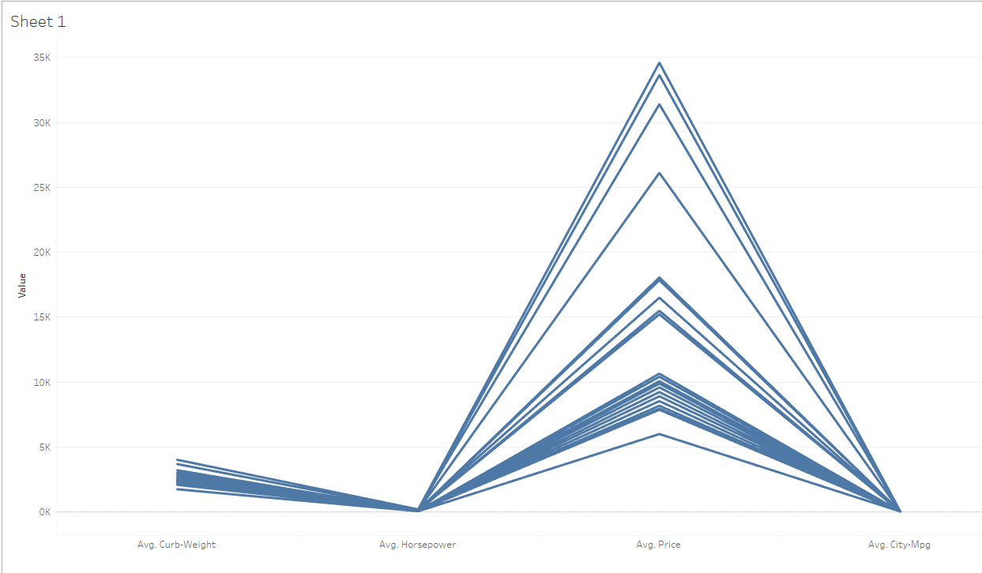
Figure 4: Step 4 of the parallel coordinates exercise.
- The next step is to set up one calculated field for each measure of interest. This can be found in a small drop-down menu near the top of the Data palette (at the left side of the display)
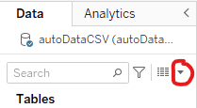
- I have called the first calculated variable I created ScaledPrice. If you type the following rather complicated formula, then there is auto-completion that will (for example) provide a list of valid functions and even put the square brackets around the field name.
This variable is now added to the list of fields in the left pane.
- This now needs to be repeated for the other variables of interest. This is quite tedious and error-prone (getting the brackets right takes a bit of concentration), so a faster way to do it is to click on the ScaledPrice pill in the left pane and select ‘Duplicate’. You can then rename the calculated field and replace Price by the appropriate field name in each location (again, name completion will help with this).
- We are nearly there now. Move ScaledPrice to the Measures shelf and remove Price. Note the triangle on the pill for ScaledPrice, denoting a calculated field. You will see a message on the graph stating that there are 88 nulls. This is because we have to change the calculation to work by Make: click on the field in the Measures shelf, select Compute Using -> Make. The values of the new variable on the graph when you hover over the line will all be 0 or 1 and the graph will look very compressed for this variable. Don’t panic!! This is because we have scaled the variable to the range 0 to 1, but the other variables have not been scaled yet so dominate the y-axis.
- Do the same process as in step 8 for the other three variables. You should get a result like Figure 5. Note how the labels on the x-axis have changed to show how the calculation is computed.
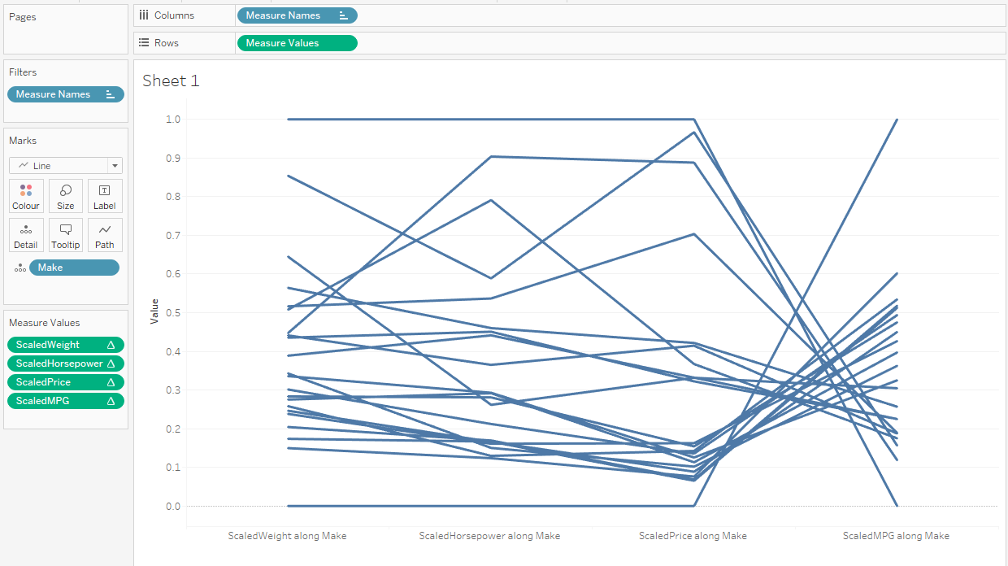
Figure 5: Step 9 of parallel coordinate plot exercise.
- There is more that could be done to this plot to improve it, but I shall leave you to experiment with the details.
- The variable names on the x-axis are rather unwieldy. Returning them to the original names (Price etc.) would be beneficial. Just click on the name and choose Edit Alias.
- Click on the Make pill in the details shelf and select Show Highlighter. This will provide a drop-down menu on the right of the graph to select an individual case.
- To get the vertical lines denoting axes, duplicate the green pill (of measures) in the Rows (which will create a duplicate graph below your first graph) and for the second set of Measure Values, put your Make variable on the path shelf. This should give a vertical line for each variable in the lower of the two plots. Then select Dual Axis on the second Measure Variables pill and synchronise the plot (by right-clicking on one of the axes and selecting Synchronise). You can change the colour of the vertical lines (to distinguish them from the data lines) by clicking on Color in the second Measure Values and choosing a different colour.
If you prefer following a video to reading text, try one of these
https://www.vizwiz.com/2019/07/parallel-coordinates.html has a lot more detail around more sophisticated interactions in the second half of the video.
https://www.youtube.com/watch?v=w-IRwQJ5YRA is simpler and shorter for the basics.
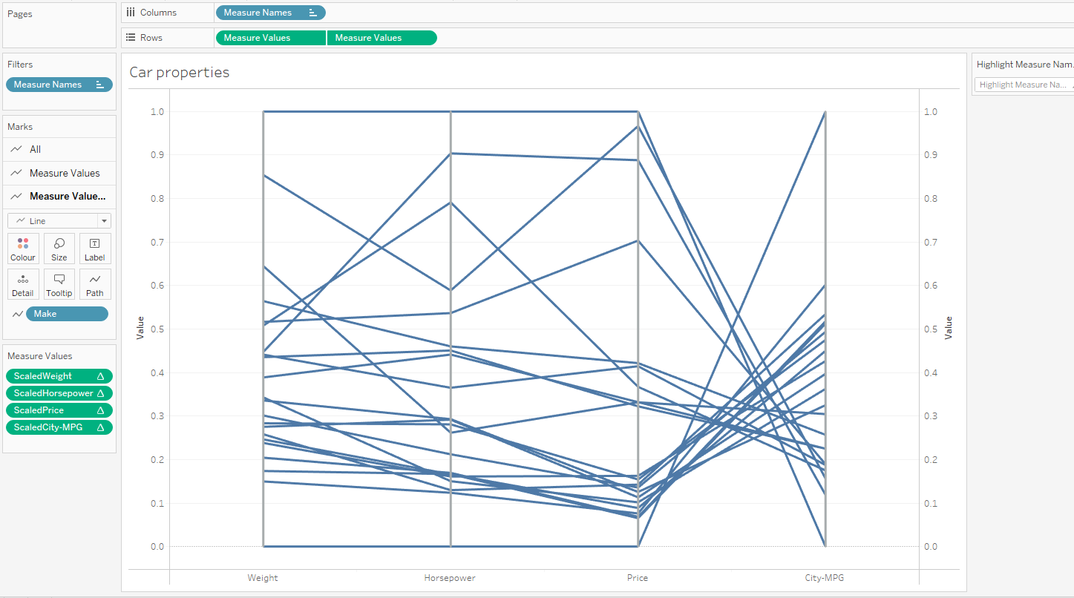Figure 6: Step 10 of the parallel coordinates exercise (optional).

Challenge Exercise: Scatterplot Matrices
We are going to show how simple it is to generate a scatterplot matrix.

- Create a new worksheet in Tableau.
- Double-click on the numeric variables that are of interest to you (at least 3). You should see the plot change from a bar chart, to a single scatterplot, and then a matrix of scatterplots (once you have clicked on the third measure). At this point there should be three measures on the Rows shelf and three on the Columns shelf. Keep going with this until you have as many measure variables as you want.
- Now change the aggregation on all of the variables (in both shelves) to AVG (from SUM). This should now show a matrix of scatterplots with one point plotted in each.
- Now move the Make field to the Details shelf: you should see normal scatterplots in each cell.
- Make the symbols smaller by selecting the Size channel on the Marks pane and adjusting it. You should see something like Figure 6.

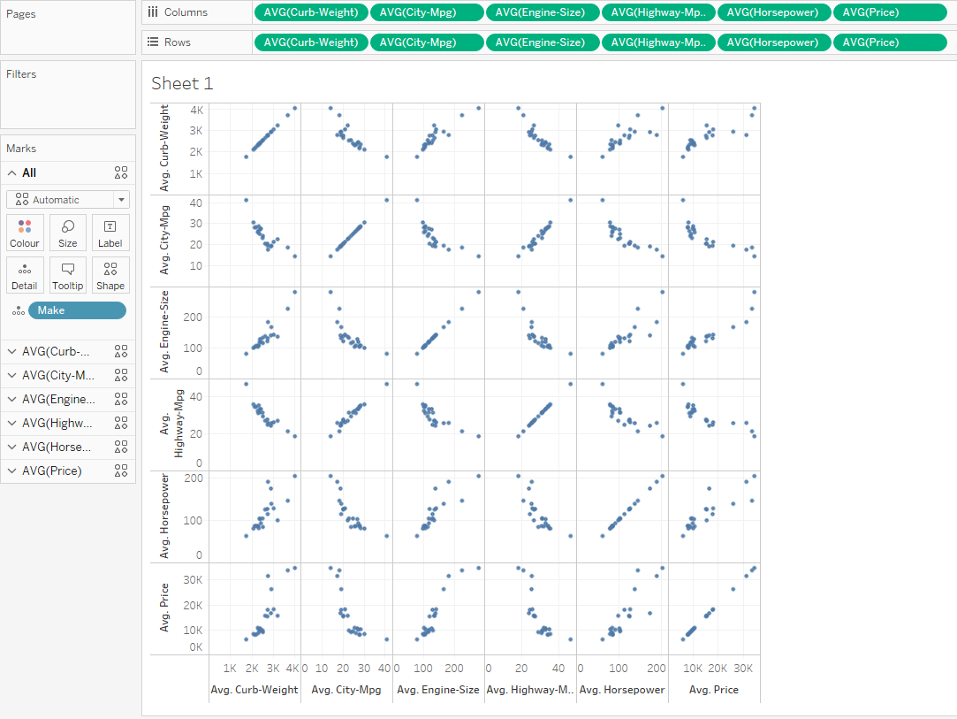
Figure 7: Scatterplot matrix.
Inspect the graph – what does it tell you about the relationships between pairs of variables?

Tableau joins
In lab 3, we looked at the Tableau data model (which has two layers: logical and physical) and showed how relationships could be used in a simple way to link multiple tables together. Relationships (otherwise known as data blending) are part of the logical model for data, but there are occasions when we need to link information at the physical layer and this requires the use of joins (the concept will be familiar to you if you have studied relational database systems).
You combine data between tables at the physical layer using joins and unions. Each logical table contains at least one physical table in this layer. Think of the physical layer as the Join/Union canvas in the Data Source page. Double-click a logical table to view its physical layer or add joins and unions. In place of the noodles that showed relationships, Tableau uses Venn diagrams to denote joins (see Figure 9 for an example).
Tables added to the physical layer (joined or unioned) create a single, flattened table (denormalized) for analysis. Tables at the logical layer are not merged in the data source, they remain distinct (normalized), and maintain their native level of detail. Logical tables act like containers for merged physical tables. A logical table can contain a single, physical, table or it can contain multiple physical tables merged together through joins or unions.
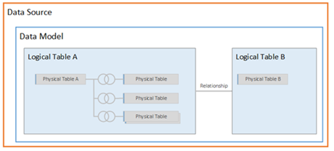
Figure 8: Logical and physical tables in Tableau.
Joins are a more static way to combine data. Joins must be defined between physical tables up front, before analysis, and can’t be changed without impacting all sheets using that data source. Joined tables are always merged into a single table. As a result, sometimes joined data is missing unmatched values, or duplicates aggregated values. Joins have the following properties.
- Are displayed with Venn diagram icons between physical tables
- Require you to select join types and join clauses
- Joined physical tables are merged into a single logical table with a fixed combination of data
- May drop unmatched measure values
- May duplicate aggregate values when fields are at different levels of detail
- Support scenarios that require a single table of data, such as extract filters and row level security
- Load the Bookshop Excel file (this is the same one as we used in week 3 of Introduction to Data Analytics). Drag the Book table to the canvas. If you dragged a second table to the canvas, a relationship would be formed.
- Instead of working in the logical layer, we will now move to the physical layer. Select Open from the context menu (right-click on the Book table in the canvas) or double-click the Book table. This will open the Join canvas.
- Now drag the Author table to the canvas. Instead of a noodle you should see a small Venn diagram joining the two tables, as in Figure 9. If you hover the mouse over the Venn diagram what text does the tooltip contain? From this you can see that an inner join is the default type of join.
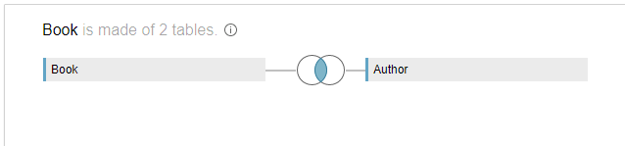
Figure 9: Two tables joined in the physical layer.
- Now click on the icon. This gives you the choice of different types of join and you can also select how the join is made. In this case, Tableau has automatically detected two fields with the same name and has joined Auth ID to be equal to Auth ID (Author). You can configure this with different types of join, or more joining fields if you wish.
- The data has been joined in a single table, which you can inspect in the Data Grid (lower pane of the Tableau interface). You will notice that there the fourth column is labelled Auth ID (Author) and the third is labelled Auth ID.
There are four different types of join in Tableau: inner, left, right, and full outer (there is also a union, but we won’t discuss it). They differ primarily in how they treat fields where there is not a complete match.
Join type | Result
Inner | A table that contains values that have matches in both tables.  When a value doesn't match across both tables, it is dropped entirely.
Left | A table that contains all values from the left table and corresponding matches from the right table.  When a value in the left table doesn't have a corresponding match in the right table, you see a null value in the data grid.  Data blending has some of the properties of a left join.
Right | A table that contains all values from the right table and corresponding matches from the left table.  When a value in the right table doesn't have a corresponding match in the left table, you see a null value in the data grid.
Full outer | A table that contains all values from both tables.  When a value from either table doesn't have a match with the other table, you see a null value in the data grid.
Table 1: Join types.
Not all databases support all join types. If an option is unavailable in the join dialog, it is likely to be due to a constraint from your data source.
A join is performed by setting up one or more join clauses. The join clause tells Tableau which fields are shared between the tables and how to match the corresponding rows. For example, rows with the same ID are aligned in the results table.
Join clauses most often use the equality operator (=) which matches rows with the same values. It is also possible to perform non-equi joins, such as less than (<) and not equal (<>).
A join can also have multiple join clauses. For example, if First name and Last name are stored in separate columns, it may be beneficial to join only if both “First name = First name” and “Last name = Last name”. Both conditions will have to be true for rows to be joined. Alternatively, if the goal was to return results when the last name is shared but the first name is not, the join clauses could be “First name <> First name” and “Last name = Last name”.
You can also create calculations to join two tables. For example, if table X contains two fields ‘First name’ and ‘Last Name’ while table Y contains a single field ‘Name’ which contains both first and last name, they can still be joined by creating a join calculation (the last option in the join dialog). The result is a calculated field on the left side of the join condition that is accessible only from the join dialog. This calculation converts the field in the Patron table into a format that now matches the format of the field in the Contact table on the right side of the join condition.as shown in Figure 10.
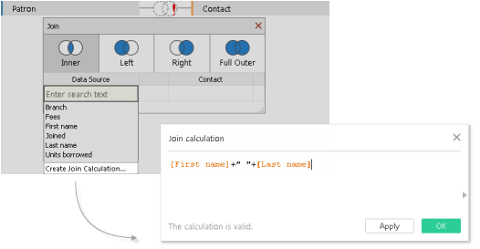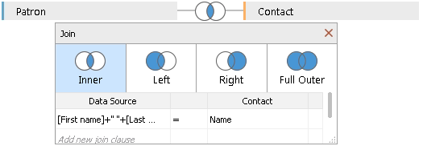
Figure 10: Join calculation.
It is also possible to create joins across more than one database: see the Tableau documentation if you need to do that.

Level-of-detail calculations
Earlier in this lab, we learned about calculated fields and showed how they could be used in creating a parallel coordinates plot where every variable was scaled appropriately. One type of more complex calculation that we didn’t cover was what is known as a ‘level-of-detail’ calculation (also known as a LOD expression): but we need this on some occasions to get more control over the way that a calculation works. So, this section will introduce the concept and show how it can be useful.
Create a new workbook and load the Superstore sample dataset in the Data Source tab. This will enable you to try out the exercises below. The data I have in my locale relates to the UK – it may vary for you depending on how your Tableau is set up. Nevertheless, it is worth doing the exercises below even if the graphs look a little different.
In Tableau, expressions referencing unaggregated data source columns are computed for each row in the underlying table. In this case, the dimensionality of the expression is row level. An example of a row-level expression is:
[Sales] / [Profit]
This calculation is evaluated in each row of the database. If you create a calculation with this definition, save it with the name [ProfitRatio], and then drag it from the Data pane to a shelf, Tableau aggregates the calculated field for the view: SUM([ProfitRatio]). As you know, it is possible to change the function that is applied in the aggregation.
By contrast, expressions referencing aggregated data source columns are computed at the dimensionality defined by the dimensions in the view. In this case, the dimensionality of the expression is view level. An example of a view-level expression is:
SUM([Sales]) / SUM([Profit])
If you drag this calculation to a shelf (or type it directly on a shelf as an ad-hoc calculation), Tableau encloses it in an AGG function:
AGG(SUM(Sales) / SUM(Profit))
This is what is known as an aggregate calculation.
Let’s go over a simple example of a LOD expression in action before going into more detail.
- From the Data pane, under Dimensions, drag Region (which is in the Location group) to the Columns shelf; under Measures, drag Sales to the Rows shelf. This will show a bar chart with the sum of sales for each region (remember that SUM is the default aggregation that Tableau applies).
- You can use an LOD expression to calculate the average sales per customer for each region. Create a new calculated field named ‘SpC’ (for Sales per Customer) and enter this expression:
{ INCLUDE [Customer Name] : SUM([Sales]) }
Take care to use the right type of bracket in each place. (We will discuss how the syntax works a bit later). This expression is added to the Data pane as a measure. (There is a measure with this value already – but it is more useful for you to learn how to do it yourself).
- Take this measure from the Data pane and drag it to the Rows shelf, to the left of SUM(Sales). Right click on the SpC measure and select Measure(Sum) -> Average. You can now see both the sum of all sales and the average sales per customer for each region. For example, you can see that in the Central region, the sales totalled approximately £500,000 with an average sale for each customer being approximately £800. This is shown in Figure 11.

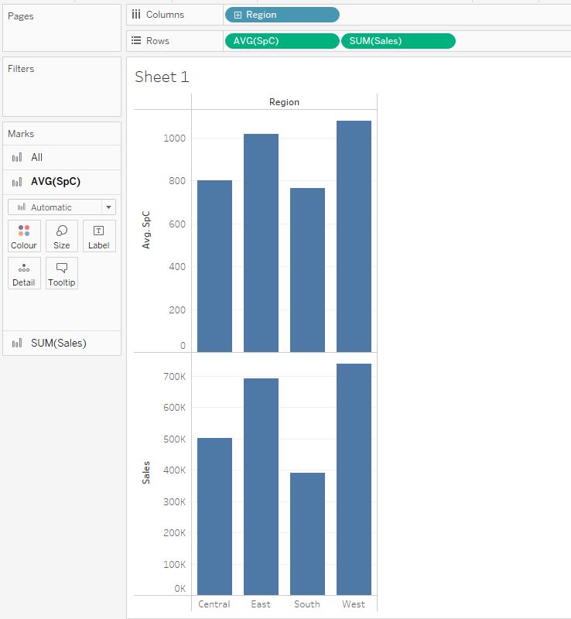
Figure 11: Result of LOD expression for Sales Per Customer.
Now let us scrutinise the Level of Detail expression syntax:
{ [FIXED | INCLUDE | EXCLUDE] <dimension declaration> : <aggregate expression> }
The opening and closing curly braces delimit the expression. One of the scoping keywords FIXED, INCLUDE and EXCLUDE follows. They refer to one or more dimensions to which the aggregate expression is joined. It is strongly recommended that you drag fields into the calculation editor when creating dimension declarations, instead of typing them. The colon character separates the declaration and the aggregate expression, which is the calculation carried out.
- FIXED level of detail expressions compute a value using the specified dimensions, without reference to the dimensions in the view.
- INCLUDE level of detail expressions compute values using the specified dimensions in addition to whatever dimensions are in the view. INCLUDE level of detail expressions can be useful when you want to calculate at a fine level of detail in the database and then re-aggregate and show at a coarser level of detail in your view. Fields based on INCLUDE level of detail expressions will change as you add or remove dimensions from the view. In the first example, the total sales were calculated for each customer, and then this was aggregated (initially with a SUM and then an AVERAGE) at the level in the view, which is Region.
- EXCLUDE level of detail expressions declare dimensions to omit from the view level of detail. EXCLUDE level of detail expressions are useful for ‘percent of total’ or ‘difference from overall average’ scenarios. They are comparable to such features as Totals and Reference Lines. EXCLUDE level of detail expression cannot be used in row-level expressions (where there are no dimensions to omit) but can be used to modify either a view level calculation or anything in between (that is, you can use an EXCLUDE calculation to remove dimension from some other level of detail expression).
We will now work through an example of each of these scopes.
- FIXED. Remove all the pills from the Rows and Columns shelves. Create a new LOD expression named ‘Sales by Region’ to compute the sum of sales per region:
{ FIXED [Region] : SUM([Sales]) }
Put the Region and State/Province dimensions on the rows and add the ‘Sales by Region’ measure to the Text mark. You should see a table like that in Figure 12.
- The view level of detail is [Region] plus [State/Province], but because FIXED level of detail expressions do not consider the view level of detail, the calculation only uses the dimension referenced in the calculation, which in this case is Region. Because of this, you can see that the values for the individual states in each region are identical. In other words, a FIXED scope does not respond to changes in the view.
- If the INCLUDE keyword had been used in the level of detail expression instead of FIXED, the values would be different for each state, because Tableau would add the dimension in the expression ([Region]) with any additional dimensions in the view ([State]) when determining values for the expression. Try it out!
- INCLUDE. We have already seen one example of the INCLUDE statement and here is a second one. Remove all the attributes from the Rows and Columns shelves and the ‘Sales per Region’ measure from the Text mark. Now create an LOD expression with INCLUDE scope to calculate the sum of sales on a per-state basis.
- Put this measure on the Rows shelf, aggregating it with Average, and put Category (under Product) on the Columns shelf. The resulting visualization averages the sum of sales by state across categories.
- When Segment is added to the Columns shelf and the calculated field is moved to Label, the LOD expression results update. Now you can see how the average sum of sales per state varies across categories and segments (as in Figure 13). This responsiveness to changes in the view means that INCLUDE scope is used much more often the FIXED scope. (I have added Segment also to the Color mark to support comparison across the three segments).
- EXCLUDE. Remove all the attributes from the Rows and Columns shelves. Now create an LOD expression called ‘AvgCategorySales’ to compute the average sales no lower than Category level:
{EXCLUDE [Sub-Category] : AVG([Sales]) }
and a calculation (called DiffFromAvgCategorySales) using it:
AVG([Sales]) - ATTR([AvgCategorySales])
The ATTR function is used to denote that we expect a single value to return from the variable. It aggregates multiple values to a single value.
- Now add Category and Sub-Category to the Rows shelf. Drag in turn Sales (convert its aggregation to Average), and the two calculations you have just created onto the table. Put ‘Measure Names’ into the Columns shelf (it may be placed there automatically) and you should see a table as in Figure 14. Note that FIXED would have given the same result, but you can now add more dimensions (such as Segment) to the columns (put it to the left of ‘Measure Names’), and you will see the table change accordingly.

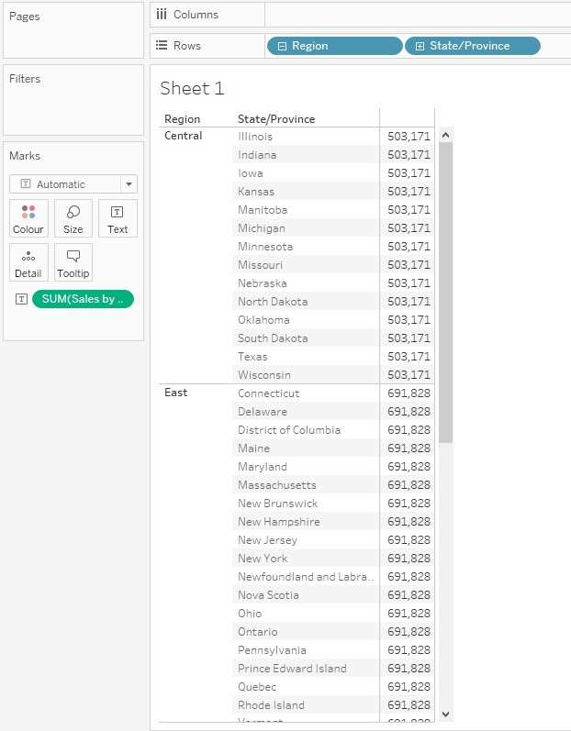
Figure 12: FIXED LOD expression.

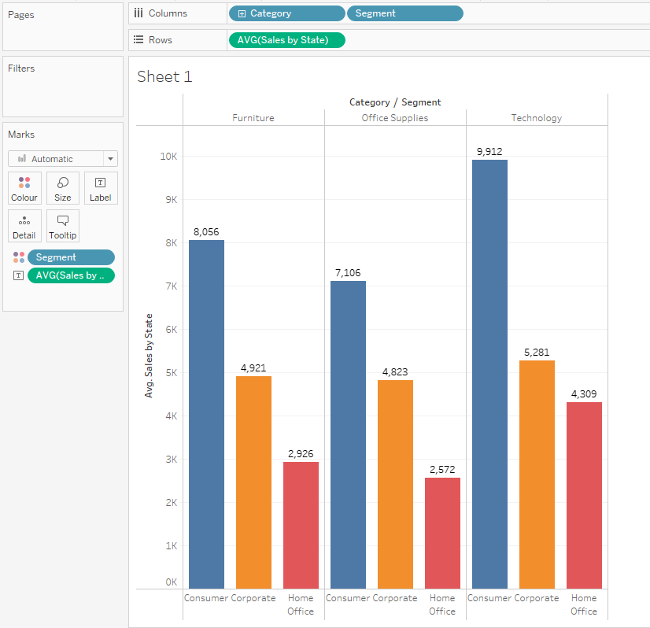
Figure 13: INCLUDE expression: average sum of sales per state as it varies across categories and segments.

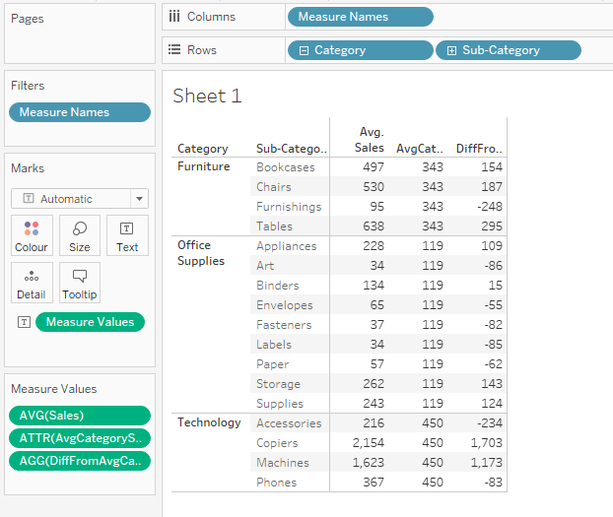
Figure 14: EXCLUDE scoping example.

You can do this by holding control (on Windows) or cmd (on Mac) while dragging it to the right.

