**Introduction**

We will use the random walk algorithm to estimate the polarization for community in subreddit.

The random walk polarization measure uses the notion of random walks:

$$RW=P_{XX}P_{YY}-P_{XY}P_{YX}$$

Where $P_{AB},A,B∈\{X,Y\}$ is the probability of a random walk that starts from partition A and ends in partition B. The more polarized (well-separated) the two partitions $X$ and $Y$ are, the lower the probability of not crossing the two polarized partitions, and therefore, the higher the polarization. So, the higher the $RW$ the more polarized a graph is.

**Graph Va****riations**

We will use 3 different graph variations to run the random walk algorithm. First, from the comment trees that we created we will make a user multi directed graph, in which each node represents a user, and an edge represents the reply that a user made to another. After this, we take the largest weakly connected component of the graph and convert it to an undirected graph. In this variation, every next step of the random walk is chosen with uniform probability.

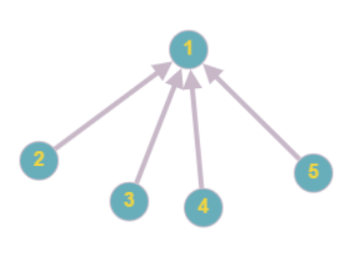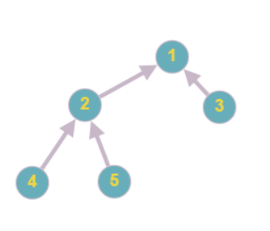The second variation is that we modify the comment tree structure. Each root node stays normally the root but now all his children, grandchildren and generally all his offspring becomes their children. For example, this tree:

And the third variation is to use weights in the graph as probabilities. If we take the neighbors of a node there are some that the node communicates more often than the others, so we exploit that information by counting in the multidigraph the edges for all the neighbors of each node. Each next step of the random walk now is not uniform but weighted.

**Random Walk Parameters**

*Intra or Inter:* For each type of polarization we partition the graph differently. For the intra polarization we partition the graph with the library metis. Metis is a library that (to be completed). For the inter polarization each partition is the set of users, of each graph before their merge, the users that were a part of both graphs join a partition with ½ probability. So, it should be declared before the execution of the random walk if it is inter or intra polarization.

*Type:* There are 3 different types to run the random walk algorithm. The ‘rr’, ’rp’ and ’pp’. The ‘r’ stands for random and ‘p’ for popular. The ‘rr’ indicates that we randomly select a 10% subpartition of each partition and we start the random walk from a subpartition until we end up to either the subpartition that we started or the other. The ‘rp’ type is the same as ‘rr’ but with different termination criteria. We start, in the same way from random nodes until we end up to a popular one. We take the 10 most popular nodes from each partition. A popular node is defined as the node with the most neighbors. And the ’pp’ means that the random walk starts from popular nodes and ends with the first popular node it finds.

*Weighted:* This should be turned to True when we want to calculate the next step of the random walk based on the weights(probabilities) of the edges of the graph.

*Number of experiments:* The number of experiments that the random walk we want to perform. At the end we calculate the average. In our case we ran 100 experiments for each variation

**The experiments**

**Variation 1**

For the first graph variation, we ran the experiments for each subreddit and for the case of intra polarization we have the following results:

|  |  |  |  |  |  |  |  |  |  |
| --- | --- | --- | --- | --- | --- | --- | --- | --- | --- |
| Subreddit | RW(rr) | | | RW(rp) | | | RW(pp) | | |
| Top | Contr. | Both | Top | Contr. | Both | Top | Contr. | Both |
| Coronavirus | 0,3038 | 0,5233 | 0,3026 | 0,1378 | 0,5574 | 0,1611 | 0,0041 | 0,0895 | -0,0221 |
| conspiracy | 0,2574 | 0,6181 | 0,2617 | 0,144 | **0,739** | 0,1423 | -0,0492 | 0,2731 | -0,0261 |
| science | 0,5972 | **0,8966** | 0,6034 | 0,4789 | **0,879** | 0,527 | 0,1346 | **0,8482** | 0,0883 |
| MensRights | 0,5601 | **0,7118** | 0,5838 | 0,415 | **0,9151** | 0,4121 | 0,172 | 0,6795 | 0,2283 |
| WitchesVsPatriarchy | 0,3564 | **0,7838** | 0,381 | 0,2411 | **0,9152** | 0,2785 | -0,0142 | 0,5815 | 0,0306 |
| lgbt | 0,369 | 0,5348 | 0,5231 | 0,5047 | **0,711** | 0,5616 | 0,0353 | 0,1685 | 0,0331 |
| Conservative | 0,3565 | **0,8714** | 0,3436 | 0,38 | **0,9901** | 0,3574 | 0,0011 | **0,8284** | 0,0308 |
| conspiracy | 0,56 | 0,2378 | 0,587 | 0,5187 | **0,7578** | 0,5439 | 0,2222 | 0,136 | 0,2498 |
| space | **0,7072** | **0,857** | **0,9408** | 0,586 | **0,9256** | **0,8189** | 0,15 | **0,7772** | 0,6669 |

Table 1: Intra polarization Simple Variation

We can notice that the highest scores of polarization are noted in the controversial posts. This is an expected outcome, as in these posts people tend to disagree. The experiments ran by ‘rp’ parameter usually score more in the controversial posts than the others, while the ‘rr’ type scores higher polarization in the ‘top’ and ‘both’ posts. The ‘pp’ has the lowest and even negative scores of polarization which is explained by the high connectivity between the popular nodes. The highest score of polarization(0,99) is noted at the ‘Conservative’ subreddit in the controversial posts and it was calculated with the ‘rp’ random walk type, while the lowest score was found in conspiracy subreddit in the set of ‘top’ posts ran by ‘pp’ parameter.

As for the inter polarization we have the following table:

|  |  |  |  |  |  |  |  |  |  |
| --- | --- | --- | --- | --- | --- | --- | --- | --- | --- |
| 2-Subreddits | RW(rr) | | | RW(rp) | | | RW(pp) | | |
| Top | Contr. | Both | Top | Contr. | Both | Top | Contr. | Both |
| Coron.&consp. | 0,7812 | **0,8972** | 0,7809 | 0,5224 | **0,8234** | 0,46 | 0,4701 | **0,8121** | 0,415 |
| science&consp. | 0,7594 | **0,9541** | 0,7633 | 0,568 | **0,9563** | 0,52 | 0,334 | **0,9067** | 0,48 |
| WvP & MR | **0,9811** | **0,9305** | **0,9743** | **0,9465** | 0,7734 | **0,9385** | **0,9442** | 0,7556 | 0,7633 |
| lgbt & Cons. | **0,9956** | no inter | **0,9935** | **0,996** | no inter | **0,987** | **0,993** | no inter | **0,9881** |
| space & consp. | **0,9408** | no inter | **0,9393** | 0,8189 | no inter | **0,854** | 0,6669 | no inter | **0,8068** |

Table 2: Inter polarization Simple Variation

Generally, we can notice that we have higher levels of polarization and this is expected because, we chose opposing subreddits to merge, so it is more unlikely for a user to be part or participate on both subreddits. Namely, users tend to interact with users of similar opinions. For example, the merge of ‘WitchesVsPatriarchy’ and ‘MensRights’ seems to have the highest polarization no matter the parameters of the algorithm, because users have completely opposite opinions about patriarchy, and this is reasonable, while ‘Coronavirus’ and ‘conspiracy’ hit the lowest scores, because they do not necessarily seem to be opposing subreddits. no inter means that there was no intersection in the process of merging the two subreddits. This could also be mathematically translated to polarization score of 1 because, there is no chance of the random walk to end up at a different partition that it started at. The merge of controversial posts tend to have higher scores, while ‘top’ and ‘both’ similar scores.

**Variation 2**

As for the variation that we modify the trees as explained above, in a similar way we perform the experiments and have the following results:

|  |  |  |  |  |  |  |  |  |  |
| --- | --- | --- | --- | --- | --- | --- | --- | --- | --- |
| Subreddit | RW(rr) | | | RW(rp) | | | RW(pp) | | |
| Top | Contr. | Both | Top | Contr. | Both | Top | Contr. | Both |
| Coronavirus | 0,2842 | 0,504 | 0,2903 | 0,3025 | 0,7214 | 0,3339 | -0,009 | 0,0427 | 0,0172 |
| conspiracy | 0,254 | 0,6109 | 0,2703 | 0,2595 | **0,873** | 0,3223 | -0,027 | 0,2091 | -0,0521 |
| science | 0,5597 | **0,9062** | 0,5173 | 0,7181 | **0,998** | 0,6644 | 0,0483 | **0,8014** | -0,061 |
| MensRights | 0,5565 | **0,7731** | 0,5631 | 0,5783 | **0,9823** | 0,5796 | 0,2735 | 0,6643 | 0,3286 |
| WitchesVsPatriarchy | 0,3517 | **0,8287** | 0,3485 | 0,3734 | **0,983** | 0,3664 | 0,0449 | **0,7051** | 0,0223 |
| lgbt | 0,3741 | 0,5899 | 0,5311 | 0,6318 | 0,8777 | 0,6728 | 0,0311 | 0,2832 | 0,1047 |
| Conservative | 0,3274 | **0,8671** | 0,3227 | **0,6684** | **0,993** | **0,6403** | 0,002 | 0,592 | -0,0775 |
| conspiracy0 | 0,4914 | 0,0195 | 0,5813 | 0,6156 | 0,5003 | 0,6368 | 0,1021 | **0,5118** | 0,2608 |
| space | 0,6958 | **0,8195** | 0,709 | 0,8492 | **0,9831** | **0,7988** | 0,0412 | 0,577 | **0,1104** |

Table 3: Intra polarization Modified Variation

The results are similar and analogous to the previous variation. The green numbers indicate a noticeable increase while the red a noticeable decrease and the others an indifferent change. Controversial posts remain with the highest score, while ‘top’ and ‘both’ posts have similar values. The experiments ran with ‘rp’ parameter have generally improved. Now, they also score higher in ‘top’ and ‘both’ posts. As we can see in the Table 3 there are many higher scores than before. There have not been observed any significant changes in the ‘rr’ parameter except of two decreases. Similarly, in the ‘pp’ type nothing remarkable has been noticed except few changes. A very huge decrease in the experiment of space subreddit of ‘both’ posts, as well as a huge increase in the conspiracy subreddit in controversial posts. The highest polarity score again appears at the Conservative subreddit in the set of controversial posts ran by ‘rp’ parameter, whereas the lowest score was found again at the Conservative subreddit in the ‘both’ category ran by ‘pp’ algorithm. That was unexpected and contradictory, because from the one hand Conservative Both is a different graph from Conservative Controversial, but from the other hand, Conservative Both was the union of ‘Top’ and ‘Controversial’, so they must have a similar structure. It is about the same topic with similar graphs, so we can observe the significance of the parameter type of the algorithm.

Now, we will study the inter polarization of this variation with the help of this table:

|  |  |  |  |  |  |  |  |  |  |
| --- | --- | --- | --- | --- | --- | --- | --- | --- | --- |
| 2-Subreddits | RW(rr) | | | RW(rp) | | | RW(pp) | | |
| Top | Contr. | Both | Top | Contr. | Both | Top | Contr. | Both |
| Coron. & consp. | 0,7979 | 0,7855 | 0,8028 | 0,7222 | 0,8359 | **0,7** | 0,6454 | 0,813 | **0,6525** |
| science & consp. | 0,7768 | 0,9539 | 0,7748 | 0,6955 | 0,99 | **0,717** | 0,488 | 0,8169 | 0,4908 |
| WvP & MR | 0,9865 | 0,8888 | 0,9803 | 0,9701 | **0,9709** | 0,975 | 0,972 | 0,7339 | **0,9425** |
| lgbt & Cons. | 0,9954 | no inter | 0,994 | 0,997 | no inter | 0,993 | 0,992 | no inter | 0,987 |
| space & consp | 0,9455 | no inter | 0,9494 | 0,9293 | no inter | 0,924 | 0,8135 | no inter | 0,8543 |

Table 4: Inter polarization Modified Variation

The results have slightly increased, they are analogous to the previous variation and in some cases the are up to 60% higher. In the same way, the green numbers indicate the experiments that have made a noticeable increase, as well as the red numbers indicate the decrease correspondingly. The rest numbers are the experiments that do not have any remarkable difference to the previous variation. In the ‘rp’ section only improvements have been made. Also, in the ‘pp’ section, we again have noticed some increases with a small exception. As for the ‘rr’ most of the experiments remained intact, and that was expected, because the modification that we did to the graph is closely related to the huge increase of popularity of some nodes.

**Variation 3**

And the last variation with the weighted edges:

|  |  |  |  |  |  |  |  |  |  |
| --- | --- | --- | --- | --- | --- | --- | --- | --- | --- |
| Subreddit | RW(rr) | | | RW(rp) | | | RW(pp) | | |
| Top | Contr. | Both | Top | Contr. | Both | Top | Contr. | Both |
| Coronavirus | 0,3033 | 0,5189 | 0,3064 | 0,1762 | 0,5471 | 0,1836 | -0,0318 | 0,1293 | -0,007 |
| conspiracy | 0,2639 | 0,6104 | 0,2686 | 0,1431 | 0,7592 | 0,1156 | 0,003 | 0,1988 | -0,0372 |
| science | 0,6003 | 0,8841 | 0,5992 | 0,4574 | 0,8679 | 0,4901 | 0,0762 | 0,8493 | 0,0861 |
| MensRights | 0,5545 | 0,7014 | 0,5824 | 0,3876 | 0,8545 | 0,442 | 0,1445 | 0,759 | 0,2252 |
| WitchesVsPatriarchy | 0,3849 | 0,8081 | 0,3859 | 0,2938 | 0,95 | 0,2316 | 0,031 | 0,796 | 0,0299 |
| lgbt | 0,3716 | 0,5596 | 0,5072 | 0,5231 | 0,6965 | 0,5425 | 0,0823 | 0,1968 | 0,081 |
| Conservative | 0,34 | **0,3889** | **0,0433** | **0,88** | 0,994 | **0,8271** | **0,3463** | **0,392** | 0,006 |
| conspiracy | 0,56 | 0,2366 | 0,5685 | 0,5147 | 0,6992 | 0,5284 | 0,2455 | 0,2956 | 0,2159 |
| space | 0,7028 | 0,8576 | 0,7075 | 0,5868 | 0,9389 | 0,5865 | 0,172 | 0,7971 | 0,2339 |

*Table 5: Intra polarization Weighted Variation*

In this variation there have not been noticed many changes. There are some increases and some decreases. The most interesting observation is that the community of ‘Conservative’ has the most and largest changes up to 130% increase and 56% decrease, respectively. For every type of parameter there are two changes. The ‘rr’ has two decreases, the ‘rp’ has two increases and the ‘pp’ one each. This means that the subreddit ‘Conservative’ has people that tend to maintain a longer conversation between each other, because in this variation the weight of an edge means how many times two users have interacted each other. Also, the ‘space’ subreddit has been subject to three noticeable decreases of score, but generally, most of the other scores have not changed significantly. The highest score remains the same as before with not such a big difference. It is the ‘Conservative’ subreddit in the set of controversial posts ran by the ‘rp’ parameter while the lowest score is in the ‘Coronavirus’ subreddit in the ‘Both’ section ran by the ‘pp’ parameter, as it does not vary than the previous variation.

As for the inter weighted polarization:

|  |  |  |  |  |  |  |  |  |  |
| --- | --- | --- | --- | --- | --- | --- | --- | --- | --- |
| 2-Subreddits | RW(rr) | | | RW(rp) | | | RW(pp) | | |
| Top | Contr. | Both | Top | Contr. | Both | Top | Contr. | Both |
| Coron. & consp. | 0,7847 | 0,8689 | 0,7821 | 0,484 | 0,8474 | 0,4407 | 0,4281 | 0,8279 | 0,4364 |
| science & consp. | 0,7587 | 0,952 | 0,7625 | 0,5094 | 0,976 | 0,5554 | 0,4301 | 0,8248 | 0,4228 |
| WvP & MR | 0,9812 | 0,9418 | 0,9756 | 0,9533 | 0,9681 | 0,935 | 0,9461 | 0,83 | 0,94 |
| lgbt & Cons. | 0,9967 | no inter | 0,9938 | 0,994 | no inter | 0,99 | 0,996 | no inter | 0,978 |
| space & consp | 0,9383 | no inter | 0,9421 | 0,779 | no inter | 0,8736 | 0,8068 | no inter | 0,8261 |

*Table 6: Intra polarization Weighted Variation*

According to the Table 6, considering the weights of the edges in our merged graphs for the computation of the inter polarization, we notice that there have not been any major changes except of three decreases, as the table indicates. So, the weights have not made a huge impact on this type of experiment, and whatever is said for the inter polarization in the first variation can also apply here.

**Visualization**

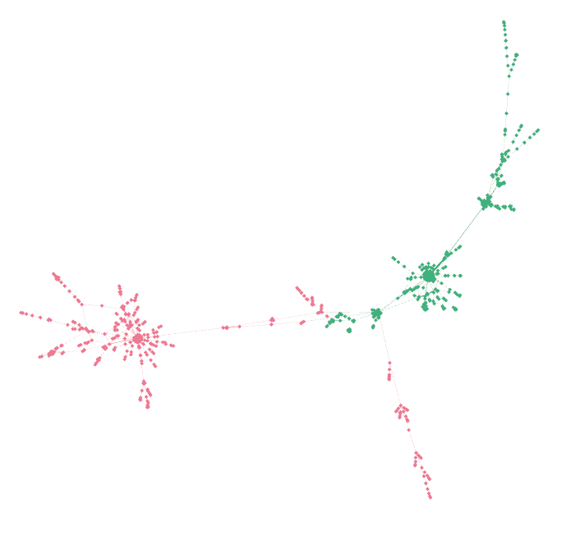It would be very interesting to visualize the structure of the graphs, so we can intuitively comprehend the above scores. For this purpose, we can take advantage of the software named ‘Gephi’ to display some of our graphs.

(b) Controversial ‘science’ community

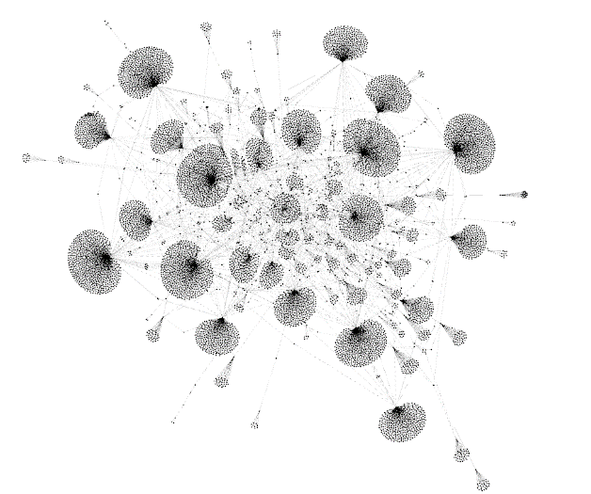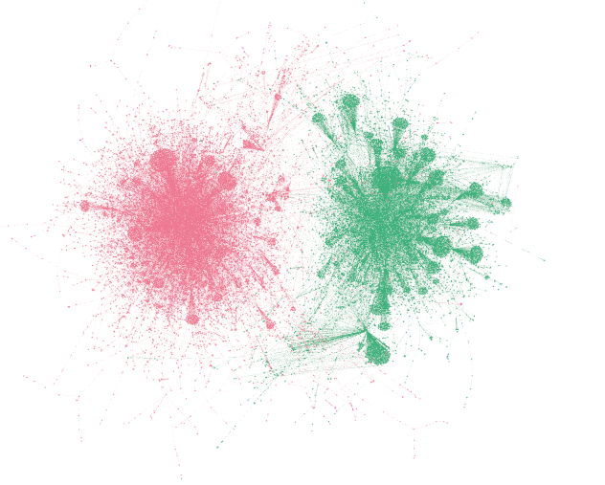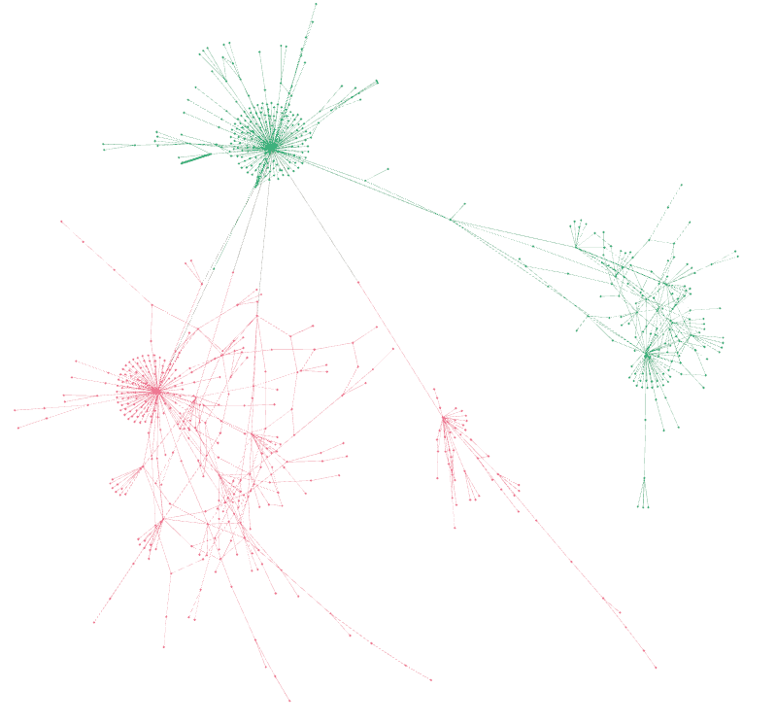

(d) ‘space’ community with the modified variation

(c) lgbt & Conservative

(a) Controversial ‘Conservative’ community

The first two images depict the intra polarization of two subreddits, of the ‘Conservative’ and ‘science’. To cluster the graphs into two categories, red and green, we used the METIS library as explained above, which does not work deterministically. So, the way, the nodes have been clustered is not definite. Those two images have deliberately selected because of their high polarization, and we can verify that they are somehow polarized. As for the third image, we distinguish inter polarization between the communities ‘lgbt’ and ‘Conservative’. We can also verify here the polarization of the graph which is very obvious, as it had one of the highest scores of polarization. On the fourth image, we selected a graph, in which the second variation has been applied and one can observe the change of the structure of the trees, while building the graph, in the phase of preprocessing

**Comparing the variations**

After all these experiments and variations, we will gather all the data together. We will average out for every category(‘top’, ’controversial’, ‘both’) and will make a bar plot. So, for the intra polarization we have the following plot:

*Figure 1: Average of scores of Intra polarization Figure 2: Average of scores of Intra polarization*

As the Figure 1 shows, the controversial posts always conspicuously demonstrate a higher rate of polarization. Then, we observe that the modified variation has higher rates compared to other variations especially the simple one, as well as it keeps the highest scores of every set of posts. Also, only in the weighted variation the ‘both’ posts have lower polarization than the ‘top’ posts.

It is obvious that the inter polarization has much higher rates of polarization no matter the parameters and the variation, compared to intra polarization, as the Plot 2 indicates. The highest average of all is the controversial posts of the weighted variation to 0,89 while the other controversial scores of the other variations still remain high to 0,87.

We can also compare, the parameter types by averaging the score of each type, of every variation for both inter and intra polarization, so we have:

Figure 3: Comparison of the parameter types of random walk

The demonstration of Figure 3 indicates that for the intra polarization the ‘rp’ parameter showed ,on average, the highest levels of polarization(0,58) followed by the ‘rr parameter(0,52). The ‘pp’ parameter has by far the lowest average of scores(0,22). As for the averages of inter polarization all remain high(>0,77) with ‘rr’ keeping the highest score(0,91) followed by ‘rp’(0,84) and ‘pp’(0,78).