Student ID: 10945821
Name: David Ayim Obuobi

Software Requirement Specification (SRS)

Project Title: Election Management System

CONTENTS:
1. Requirements:
- Functional Requirements
- Non-Functional Requirements

2. Tables:
- List of required tables
- E/R Model

3. Business Rules

4. UML diagram tools
Design:
- Use Case Diagrams
- Class Diagrams

Election Management System (EMS)
The Election Management System is a dedicated platform aimed at simplifying the election process for student representatives, including student council and class elections. By utilizing technology, EMS overcomes the challenges associated with traditional voting methods, improving efficiency, transparency, accessibility, and security.

Technology Stack:
- Frontend: HTML5, CSS3, JavaScript (ECMAScript 6)
- Backend: PHP 8.2
- Database: MySQL
- Hosting Providers: Google Cloud
- Security: SSL encryption, Google 2FA QR
- Email Notification: Php Mailer
- SMS Notification: Arkesel SMS Gateway, Push Notification

1. Functional Requirements
1.1 User Roles
Admin Role (Faculty):
- Manage student accounts (create, update, deactivate)
- Set up and configure election parameters (e.g. positions, timelines)
- Monitor system usage and performance
- Generate reports related to voter turnout and results
- Configure security settings and access controls

Student Role (Voter):
- Register as a voter using student ID
- Update personal information and verify registration status
- View candidate information and their manifestos
- Cast votes securely during designated voting periods
- View election results after official declaration

Candidate Role (Student):
- Register as a candidate with required details
- Submit nomination papers and personal information
- Upload manifesto and campaign information
- View and analyze election results

Election Officer Role (Student Volunteers):
- Verify voter and candidate registrations
- Monitor the voting process at designated polling stations
- Submit polling station status reports
- Participate in the vote-counting process

Observer Role (Student Volunteers):
- Monitor election processes for transparency
- Report on election conduct
- Access non-sensitive election data
- Generate observation reports

1.2 Voter Registration Management
- Allow students to register as voters using their student ID
- Enable update and verification of voter information
- Implement duplicate checking to prevent multiple registrations
- Generate voter IDs with unique identifiers
- Maintain voter registration history and changes

1.3 Candidate Management
- Facilitate candidate registration with required details
- Enable submission and verification of nomination papers
- Allow candidates to upload their profiles and manifestos
- Implement an approval workflow for candidate eligibility
- Manage candidate withdrawals and substitutions

1.4 Election Configuration
- Set up election parameters (date, time, positions)
- Configure voting methods (e.g. online voting)
- Establish security protocols for the voting process
- Set up result declaration protocols

1.5 Voting Process Management
- Enable secure authentication of voters using student IDs
- Facilitate online ballot voting
- Implement controls to prevent double voting
- Record voting status and turnout statistics

1.6 Result Management
- Tabulate results according to predefined rules
- Visualize results through charts and graphs
- Support result auditing and verification

1.7 Communication and Notifications
- Implement messaging features for communication between stakeholders
- Enable automated notifications for registration status, voting reminders, and result updates
- Facilitate secure information exchange between election officials

2. Non-Functional Requirements
2.1 Performance
- The system should support 1000 users during peak voting hours
- Response time should be under 3 seconds for each user action
- Ballot processing should be completed within 5 seconds

2.2 Usability
- User interfaces must be intuitive and easy to navigate
- Provide help sections and user guides for all stakeholder types

2.3 Security
- Implement role-based access control to protect sensitive data
- Utilize encryption for vote transmission and storage
- Implement multi-factor authentication for administrative access

2.4 Reliability
- The system should maintain an up-time of 99.9% during election periods
- Implement redundant systems and failover mechanisms
- Provide detailed error logging and recovery procedures

2.5 Compatibility
- The system should be accessible on various devices, including desktops, tablets, and smartphones
- Ensure compatibility with major web browsers (Chrome, Firefox, Safari, Edge)
- Support for different operating systems (Windows, macOS, Linux, Android, iOS)

3. SQL Table Creation Statements
Table: Students (Voters)
SQL Statement
CREATE TABLE Students (
studentID INT PRIMARY KEY AUTO_INCREMENT,
name VARCHAR(100) NOT NULL,
dateOfBirth DATE NOT NULL,
department VARCHAR(100) NOT NULL,
contactNumber VARCHAR(15),
email VARCHAR(100),
registrationDate DATE NOT NULL,
status VARCHAR(20) DEFAULT 'Active'
created_at DATETIME DEFAULT CURRENT_TIMESTAMP

);

SQL Statements in Tabular Form:
Column Name | Data Type | Constraints
studentID | INT | PRIMARY KEY, AUTO_INCREMENT
name | VARCHAR(100) | NOT NULL
dateOfBirth | DATE | NOT NULL
department | VARCHAR(100) | NOT NULL
contactNumber | VARCHAR(15) | Optional
email | VARCHAR(100) | Optional
registrationDate | DATE | NOT NULL
status | VARCHAR(20) | DEFAULT 'Active'
createdAt | DATE | NOT NULL

Table: Candidates
SQL Statement:
CREATE TABLE Candidates (
candidateID INT PRIMARY KEY AUTO_INCREMENT,
studentID INT,
position VARCHAR(100) NOT NULL,
manifesto TEXT,
photo VARCHAR(255),
status VARCHAR(20) DEFAULT 'Pending',
registrationDate DATE NOT NULL,
FOREIGN KEY (studentID) REFERENCES Students(studentID));

SQL Statements in Tabular Form:
Candiates | Data Type | Constraints | Description
candidateID | INT | PRIMARY KEY, AUTO_INCREMENT | Unique identifier for Candidates
studentID | INT | FOREIGN KEY (References Students) | Foreign key referencing Students table
position | VARCHAR(100) | NOT NULL | Position contesting for
manifesto | TEXT | Optional | Candidate's manifesto
photo | VARCHAR(255) | Optional | Path to candidate's photo
status | VARCHAR(20) | DEFAULT 'Pending' | Status (Pending, Approved, Rejected)
registrationDate | DATE | NOT NULL | Date of candidate registration

Table: Elections
SQL Statements:
CREATE TABLE Elections (
electionID INT PRIMARY KEY AUTO_INCREMENT,
name VARCHAR(255) NOT NULL,
description TEXT,
startDate DATETIME NOT NULL,
endDate DATETIME NOT NULL,
status VARCHAR(20) DEFAULT 'Scheduled',
type VARCHAR(50) NOT NULL,
createdBy INT NOT NULL,
createdDate DATETIME DEFAULT CURRENT_TIMESTAMP
);

SQL Statements in Tabular From:
Election | Data Type | Constraints
electionID | INT | PRIMARY KEY, AUTO_INCREMENT
name | VARCHAR(255) | NOT NULL
description | TEXT | Optional
startDate | DATETIME | NOT NULL
endDate | DATETIME | NOT NULL
status | VARCHAR(20) | DEFAULT 'Scheduled'
type | VARCHAR(50) | NOT NULL
createdBy | INT | NOT NULL
createdDate | DATETIME | DEFAULT CURRENT_TIMESTAMP

Table: Votes
SQL Statements:
CREATE TABLE Votes (
voteID INT PRIMARY KEY AUTO_INCREMENT,
electionID INT,
candidateID INT,
studentID INT,
timestamp DATETIME DEFAULT CURRENT_TIMESTAMP,
status VARCHAR(20) DEFAULT 'Recorded',
FOREIGN KEY (electionID) REFERENCES Elections(electionID) ON DELETE CASCADE,
FOREIGN KEY (candidateID) REFERENCES Candidates(candidateID) ON DELETE CASCADE,
FOREIGN KEY (studentID) REFERENCES Students(studentID) ON DELETE CASCADE);

SQL Statements in Tabular Form:
Votes | Data Type | Constraints
voteID | INT | PRIMARY KEY, AUTO_INCREMENT
electionID | INT | FOREIGN KEY (References Elections), ON DELETE CASCADE
candidateID | INT | FOREIGN KEY (References Candidates), ON DELETE CASCADE
studentID | INT | FOREIGN KEY (References Students), ON DELETE CASCADE
timestamp | DATETIME | DEFAULT CURRENT_TIMESTAMP
status | VARCHAR(20) | DEFAULT 'Recorded'

Table: Results
SQL Statement
CREATE TABLE Results (
resultID INT PRIMARY KEY AUTO_INCREMENT,
electionID INT,
candidateID INT,
voteCount INT DEFAULT 0,
percentage DECIMAL(5,2) NOT NULL DEFAULT 0.00,
status VARCHAR(20) DEFAULT 'Preliminary',
lastUpdated DATETIME DEFAULT CURRENT_TIMESTAMP,
FOREIGN KEY (electionID) REFERENCES Elections(electionID) ON DELETE CASCADE,
FOREIGN KEY (candidateID) REFERENCES Candidates(candidateID) ON DELETE CASCADE
);

SQL Statement in Tabular form
Results | Data Type | Constraints
resultID | INT | PRIMARY KEY, AUTO_INCREMENT
electionID | INT | FOREIGN KEY (References Elections), ON DELETE CASCADE
candidateID | INT | FOREIGN KEY (References Candidates), ON DELETE CASCADE
voteCount | INT | DEFAULT 0
percentage | DECIMAL(5,2) | DEFAULT 0.00
status | VARCHAR(20) | DEFAULT 'Preliminary'
lastUpdated | DATETIME | DEFAULT CURRENT_TIMESTAMP

Table: Category
SQL STATEMENT:
CREATE TABLE categories (
categoryID INT PRIMARY KEY AUTO_INCREMENT,
electionID INT NOT NULL,
name VARCHAR(255) NOT NULL,
addedBy INT DEFAULT NULL,
updatedBy INT DEFAULT NULL,
createdAt TIMESTAMP NOT NULL DEFAULT CURRENT_TIMESTAMP,
updatedAt TIMESTAMP NULL DEFAULT NULL ON UPDATE CURRENT_TIMESTAMP,
FOREIGN KEY (electionID) REFERENCES elections(electionID),
FOREIGN KEY (addedBy) REFERENCES students(studentID),
FOREIGN KEY (updatedBy) REFERENCES students(studentID)
);

SQL Statement in Tabular Form:
Category | Data Type | Constraints | Description
categoryID | INT | PRIMARY KEY, AUTO_INCREMENT | Unique identifier for each category
electionID | INT | NOT NULL, FOREIGN KEY (Elections) | Links to an election in the Elections table
name | VARCHAR(255) | NOT NULL | Name of the category (e.g., "President")
addedBy | INT | DEFAULT NULL, FOREIGN KEY (Students) | Student who added the category
updatedBy | INT | DEFAULT NULL, FOREIGN KEY (Students) | Student who last updated the category
createdAt | TIMESTAMP | NOT NULL, DEFAULT CURRENT_TIMESTAMP | Timestamp of category creation
updatedAt | TIMESTAMP | NULL, DEFAULT NULL ON UPDATE CURRENT_TIMESTAMP | Timestamp of last update

Key Aspects of the Schema:
- Data Types: Each of the fields is given a suitable data type based on the expected content

- Primary Keys: Each table includes a primary key, which uniquely identifies each record.

- Foreign Keys: Relationships between tables are established using foreign keys to maintain referential integrity, allowing cascading deletions where appropriate.

- Validation: Some fields include validation constraints, such as checks on score values and unique constraints for email and username fields.

4. Business Rules for Student Election Management System
1. Voter Registration Rules:
- Each student must have a unique student ID number.
- A student can only vote once per election.
- Students must be registered in the institution to participate.

2. Candidate Registration Rules:
- Each candidate must be a registered student.
- A candidate can only contest for one position per election.
- Candidates must submit required details by the nomination deadline.

3. Election Setup Rules:
- Each election must have a defined start and end date.
- Election parameters cannot be modified once voting has begun.
- The election schedule must be published at least 7 days before election day.

4. Voting Process Rules:
- A student can only cast one vote per election.
- Votes must be cast within the designated election period.
- Provisional ballots can be issued to students whose eligibility is in question.

5. Result Publication Rules:
- Preliminary results can be published once 75% of votes are counted.
- Final results require 100% of votes counted and certification by the election committee.
- Results must include vote counts and percentages for all candidates.

5. E-R Diagram for Student Election Management System
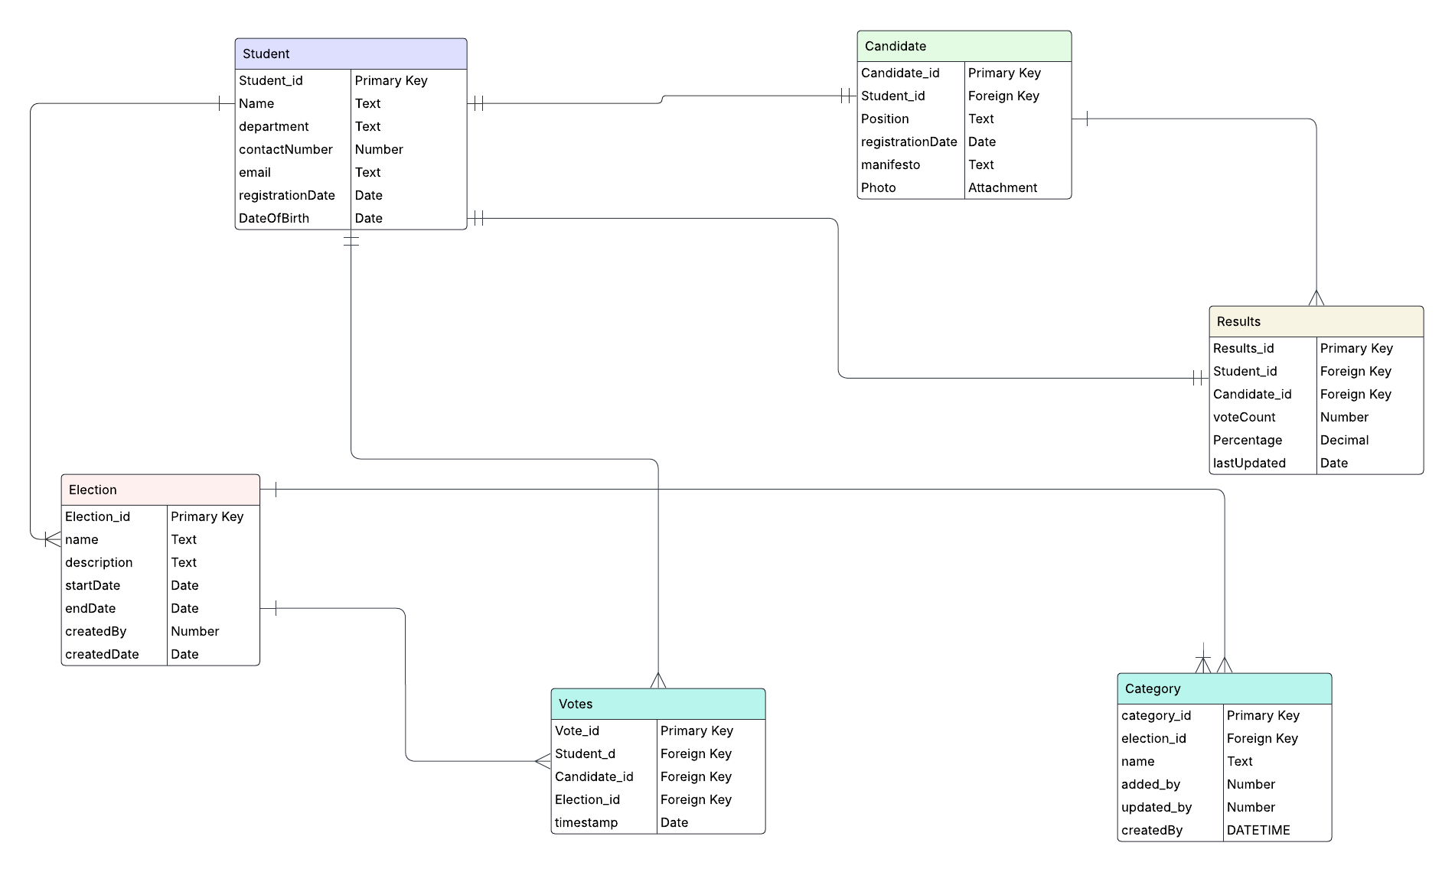
link to LucidChart
Key Classes Explained:
1. Actors
a. Student (Voter)
- Role: The primary user who interacts with the system to register, vote, and view election results.
- Key Interactions:
  - Register as a voter.
  - Log in to the system.
  - Cast a vote.
  - View election results.

b. Candidate
- Role: A student who is contesting in the election.

- Key Interactions:
  - Register as a candidate.
  - Submit nomination details.
  - Upload manifesto.
  - View election results.
c. Admin (Faculty/Staff)
- Role: Manages the system, sets up elections, and oversees the election process.
- Key Interactions:
  - Configure system settings.
  - Set up elections.
  - Manage user accounts.
  - Generate reports.
d. Election Officer (Student Volunteer)
- Role: Assists in managing the election process at polling stations.
- Key Interactions:
  - Verify voter identities.
  - Monitor the voting process.
  - Report incidents.
  - Participate in vote counting.
e. Observer (Student Volunteer)
- Role: Monitors the election process for transparency and fairness.
- Key Interactions:
  - Monitor election processes.
  - Generate observation reports.

2. Use Cases
a. Student Use Cases
- Register: Students can register as voters in the system.
- Log In: Students can log in to their accounts.
- Update Profile: Students can update their personal information.
- View Ballot: Students can view the list of candidates and their manifestos.
- Cast Vote: Students can cast their vote in the election.
- View Results: Students can view election results after the results are declared.

b. Candidate Use Cases
- Register: Students can register as candidates in the election.
- Submit Nomination: Candidates can submit their nomination details.
- Upload Manifesto: Candidates can upload their campaign manifesto.
- View Results: Candidates can view election results.

c. Admin Use Cases
- Configure System: Admin can configure system settings and parameters.
- Set Up Elections: Admin can create and manage elections.
- Manage Users: Admin can manage user accounts (e.g., activate/deactivate accounts).
- Generate Reports: Admin can generate reports related to voter turnout and election results.

d. Election Officer Use Cases
- Verify Voter: Election officers can verify the identity of voters.
- Monitor Voting: Election officers can monitor the voting process at polling stations.
- Report Incident: Election officers can report any irregularities during the election.
- Count Votes: Election officers can participate in the vote-counting process.

e. Observer Use Cases
- Monitor Process: Observers can monitor the election process for transparency.
- Generate Reports: Observers can generate observation reports.

6. Class based Diagram for election management system
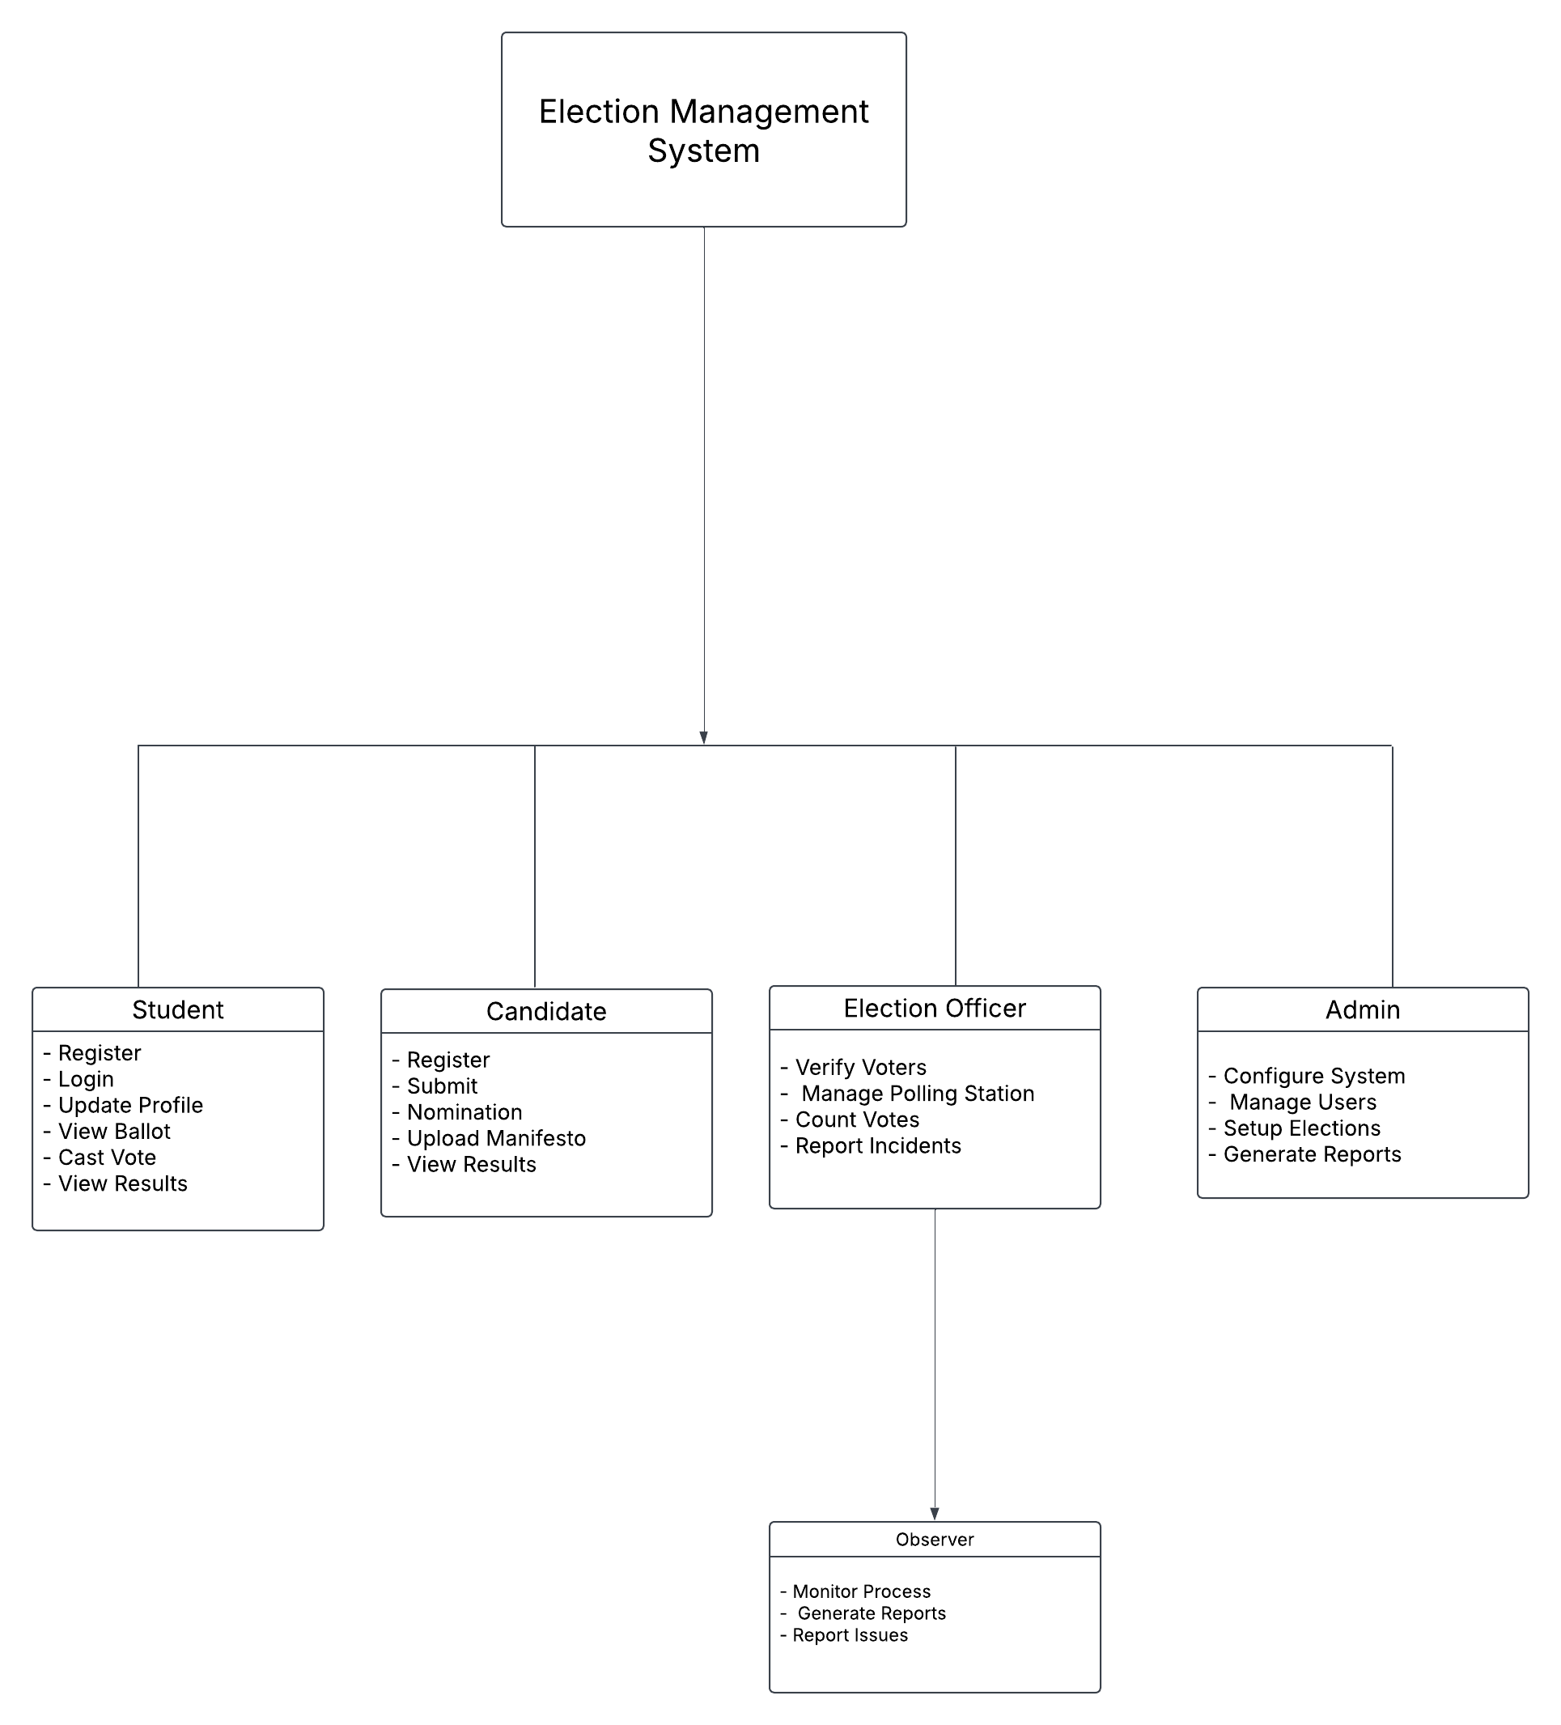

link to LucidChart

3. Class Diagram Components
a. Student (Voter)
- Attributes:
  - studentID: Unique identifier for each student.
  - name: Full name of the student.
  - studentNumber: Unique student ID number.
  - department: Department or program the student belongs to.
  - status: Current status of the student (e.g., Active, Inactive).
- Methods:
  - register(): Allows the student to register as a voter.
  - updateProfile(): Enables the student to update their personal information.
  - checkStatus(): Allows the student to check their registration status.
  - castVote(): Enables the student to cast their vote in an election.
b. Candidate
- Attributes:
  - candidateID: Unique identifier for each candidate.
  - studentID: Foreign key referencing the Student table.
  - position: The position the candidate is contesting for (e.g., President, Secretary).
  - manifesto: The candidate's campaign platform or manifesto.
  - status: Current status of the candidate (e.g., Pending, Approved, Rejected).
- Methods:
  - register(): Allows the student to register as a candidate.
  - submitManifesto(): Enables the candidate to upload their manifesto.
  - viewResults(): Allows the candidate to view election results.
c. Election
- Attributes:
  - electionID: Unique identifier for each election.
  - name: Name of the election (e.g., "Student Council Election 2023").
  - startDate and endDate: The start and end dates of the election.
  - status: Current status of the election (e.g., Scheduled, Ongoing, Completed).
- Methods:
  - createElection(): Allows the system to create a new election.
  - updateElection(): Enables the system to update election details.
  - closeElection(): Marks the election as completed.

d. Vote
- Attributes:
  - voteID: Unique identifier for each vote.
  - electionID: Foreign key referencing the Election table.
  - candidateID: Foreign key referencing the Candidate table.
  - studentID: Foreign key referencing the Student table.
  - timestamp: The time the vote was cast.
  - status: Status of the vote (e.g., Recorded, Counted, Disputed).
- Methods:
  - castVote(): Allows a student to cast their vote.
  - verifyVote(): Ensures the vote is valid and recorded correctly.

e. Result
- Attributes:
  - resultID: Unique identifier for each result record.
  - electionID: Foreign key referencing the Election table.
  - candidateID: Foreign key referencing the Candidate table.
  - voteCount: Number of votes received by the candidate.
  - percentage: Percentage of total votes received by the candidate.
- Methods:
  - calculateResults(): Calculates the vote counts and percentages.
  - publishResults(): Publishes the results to all stakeholders.

