# backgroundData 61 and CSIRO logoAristotle Cloud Services Australia

## Aristotle Cloud Services Australia is helping agencies define their data.

We’re making it easier for agencies to bring all their information together in one place by using a cloud based portal that helps them tell the world about what they’re doing.

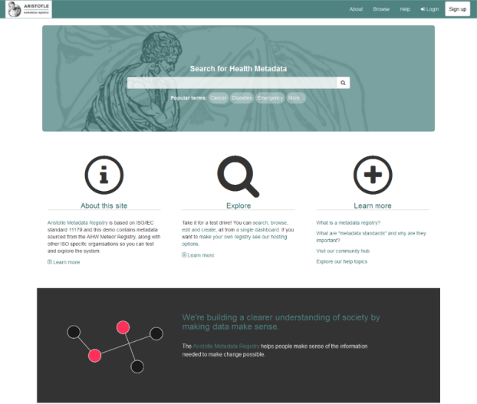

**Find & import information easily**

* We help agencies import existing CSV’s, Excel files,

PDF’s, and Word documents into their registries

* There are helpful wizards and step by step

creation processes

that encourage the reuse of existing metadata

* Users can accurately find information quickly using an

integrated search engine to improve metadata discovery

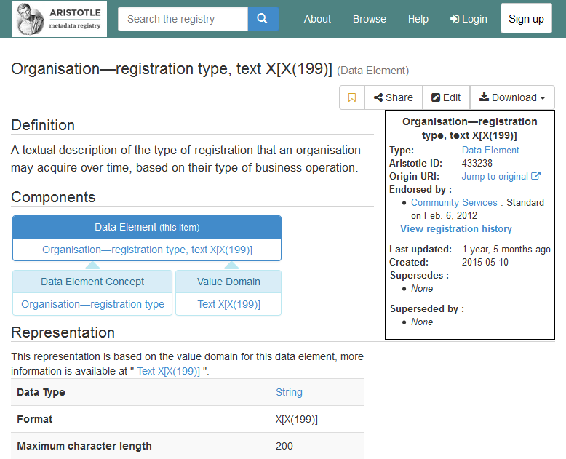

**User friendly screens for data definitions**

* Provides the missing link for data agencies to showcase definitions of data to improve organisational understanding
* By encouraging the descriptions of data, custodians can ensure that information is understood and used correctly, and that definitions can be reused through the entire data lifecycle
* Our interfaces are designed to be part of day to day work, to capture business definitions in a user focused environment

For further information

Samuel Spencer   
Senior Software Engineer

t +61 0402481914

e sam.spencer@data61.csiro.au

w www.aristotlemetadata.com

CONTACT US

t 1300 363 400

+61 3 9545 2176

e csiroenquiries@csiro.au

w www.data61.csiro.au

At CSIRO we shape the future

We do this by using science and technology to solve real issues.   
Our research makes a difference to industry, people and the planet.



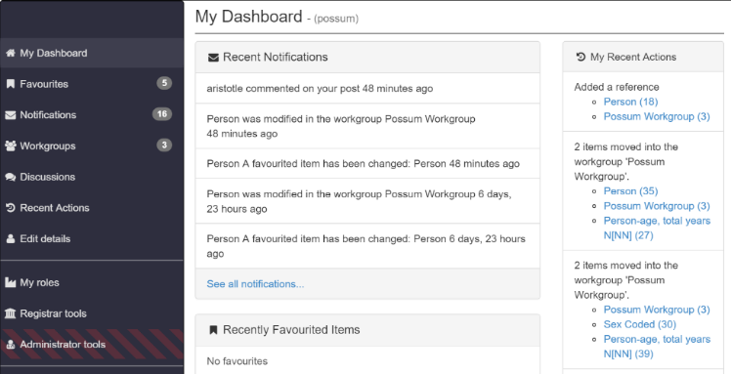**Intuitive dashboard** **that encourage metadata reuse**

* Helps users keep track of their changes and

manage their workload through an intuitive dashboard

* Users also have access to many quick tasks through

the menu bar on every page that allows them to

quickly search for or create content, access

their tracked metadata items, or quickly jump

to common tasks

**Some other key features**

* Workflows and approvals
  + Our flexible role based permissions allow for a proactive approach to managing and endorsing business knowledge that passes responsibility smoothly between users to securely publish content
* Reports on items
  + In-built reporting tools give administrative users the power to track how metadata is used across an organisation to examine usage and analyse the impact of changes throughout a metadata framework
* Ontology design
  + Flexible system design allows information architects to describe custom relationships between data

**Aristotle Cloud Services Australia is open for business!**

Our client base already includes many government and private sector organisations, with multi-year service contracts already underway. With the ongoing support of Data61 we plan for this growth to continue over the next several years.

We’re building a platform that people want to use and be a part of.

For more information, visit us at [www.aristotlemetadata.com](http://www.aristotlemetadata.com) or contact [enquires@aristotlemetadata.com](mailto:enquires@aristotlemetadata.com)

