Screenshots from the Working project:

Input Strategic Data Model/Dictionary:

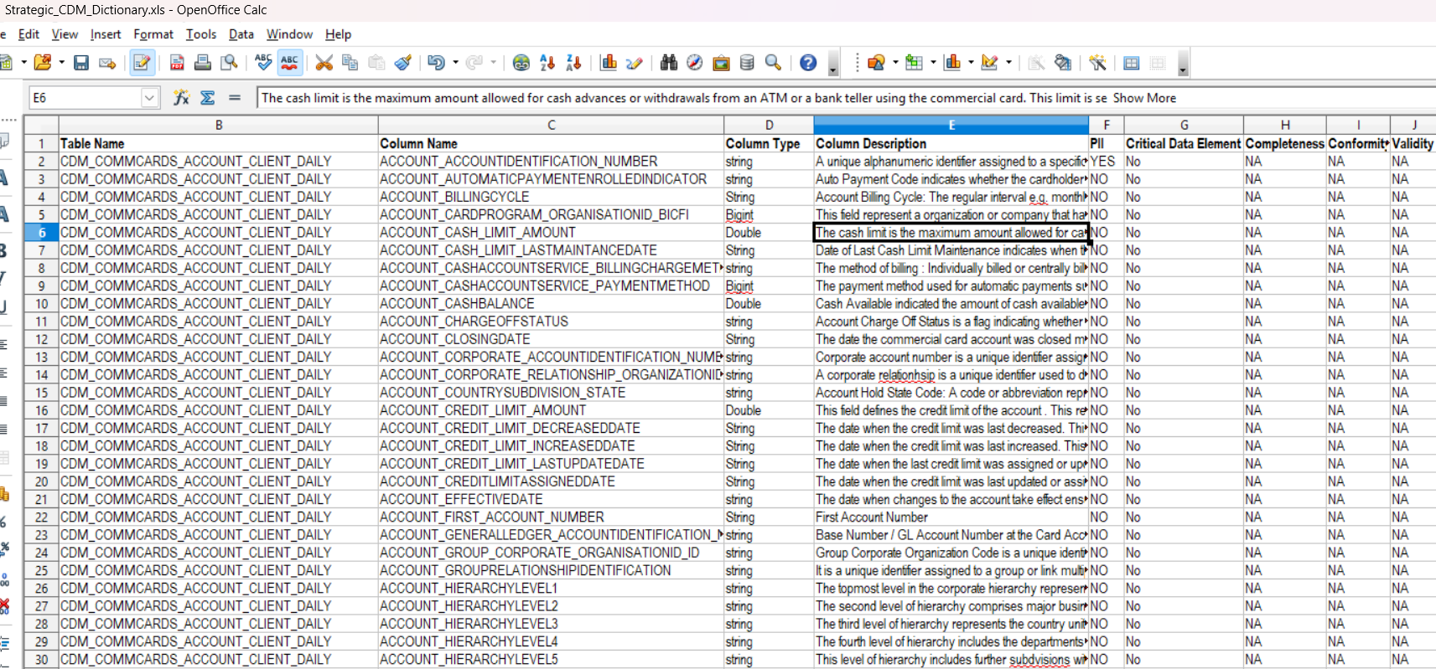

Input Legacy Data Model/Dictionary for running the search and remapping :

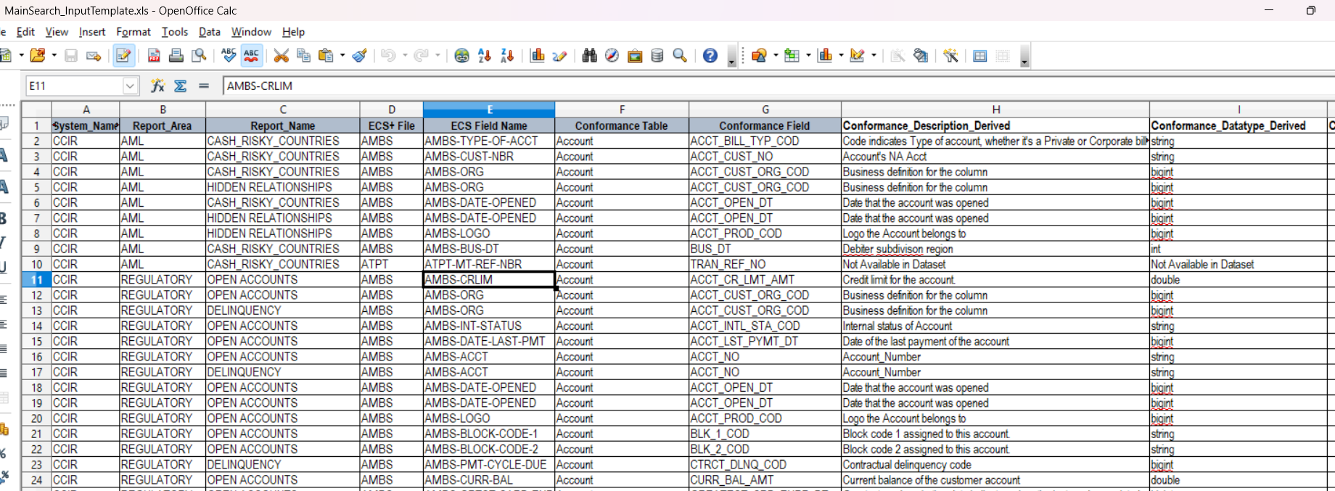

VS-Code Project Structure :
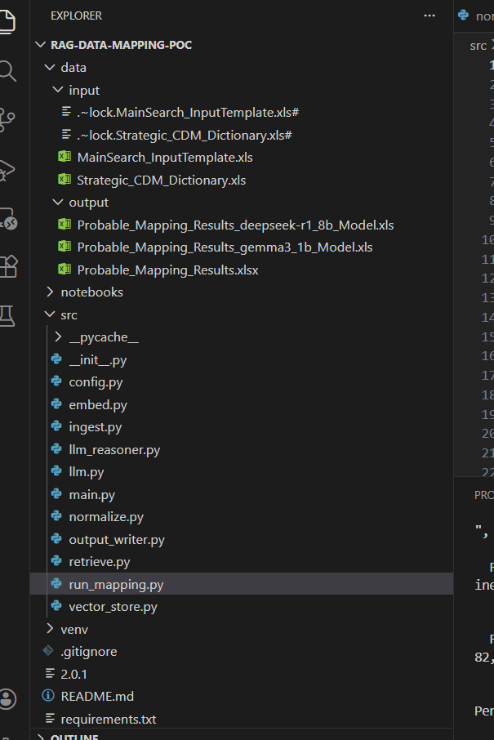

Actual Run Initiation of the main module/Python code :

Starting parameters like model, Match_threshold etc. is also shown here:
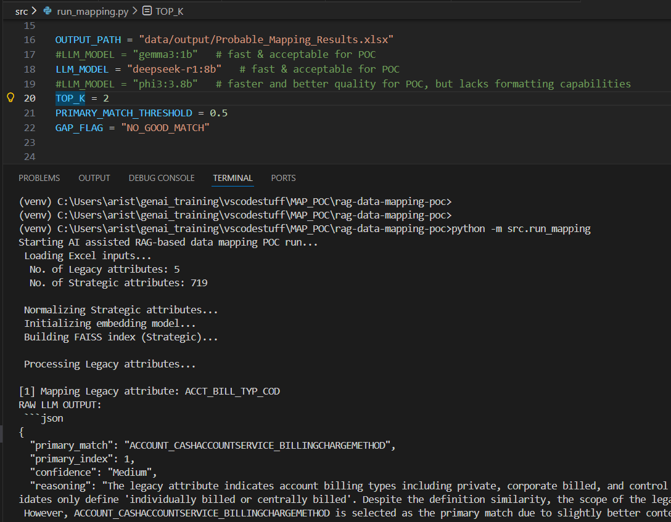

Actual Run Completion of the main module/Python code :
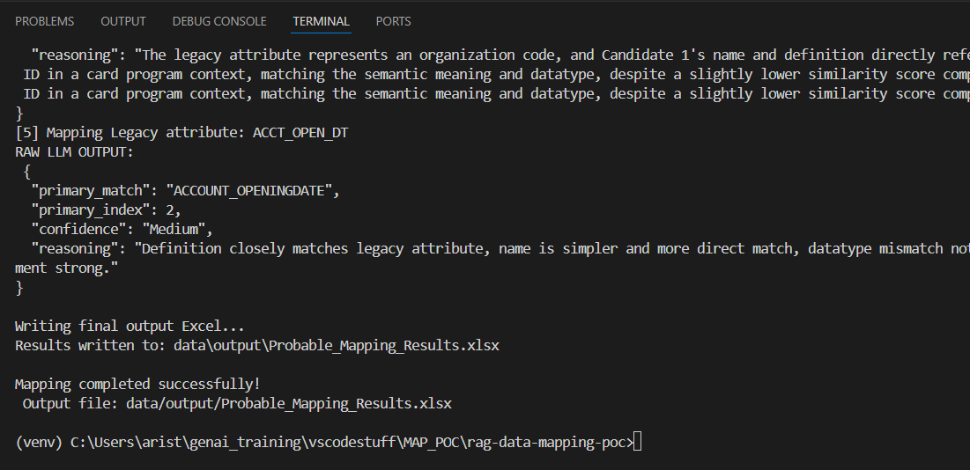
Output File created with intended Strategic Model Mapping along with confidence score :

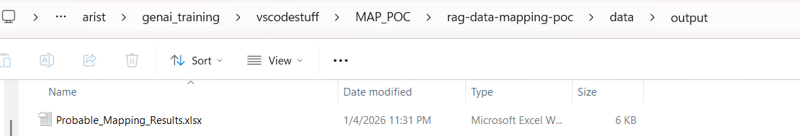

Final Excel content shown below, minor formatting(alignment/wrap etc.) was done manually to fit this page:
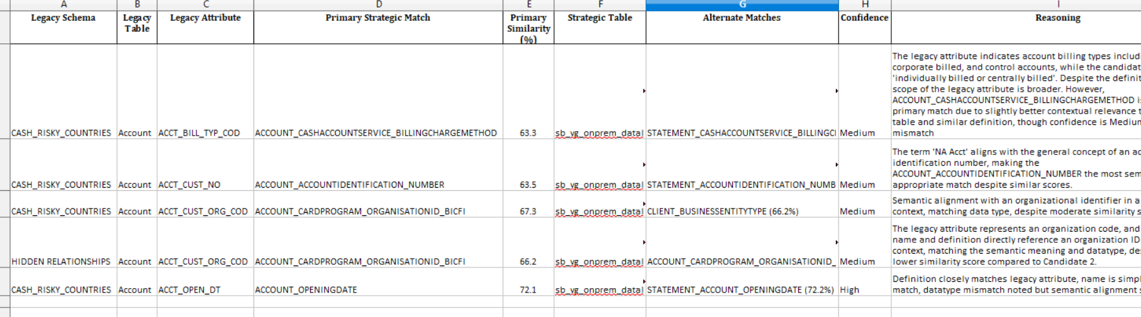

Final Notes:

In this solution, AI / LLM is used for semantic judgment, not search. Similarity scores are deterministic (using RAG Embedding Models). Gaps are flagged, not hidden (when low confidence score (<50%) is achieved.”

It was observed that locally Deepseek is the best model in reasoning and formatting the JSON output as per given prompt.

