Our Formula Student vehicle’s motor controller uses isolated CAN for its control. However, our ECU does not support isolated CAN. For that reason, in order to protect our Low Voltage system from High Voltage (in case of a malfunction in the motor controller) and to further improve the signal integrity of the CAN bus (eliminating noise due to the switching pulses of the inverter) we decided to design and implement a CAN repeater.

## **Step 1: TIDA-01487 reference design**

The basis for the design of this CAN repeater is the reference design “TIDA-01487”, courtesy of Texas Instruments. You can find more info on this reference design here: <https://www.ti.com/tool/TIDA-01487>. The main differences between the TIDA-01487 and our design can be discerned by the block diagrams below.

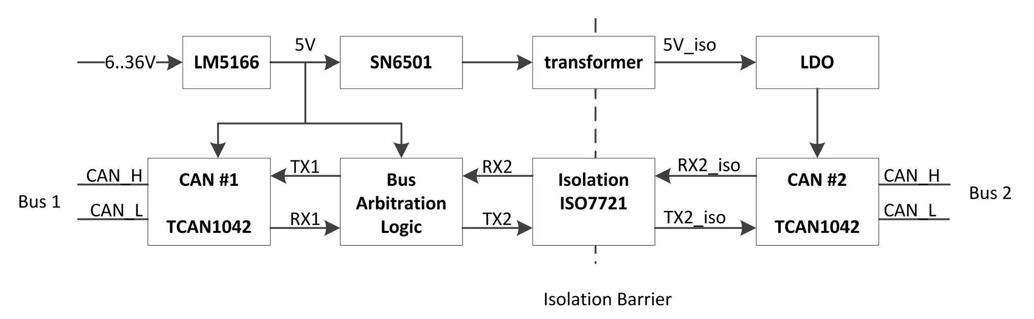TIDA-01487  
  
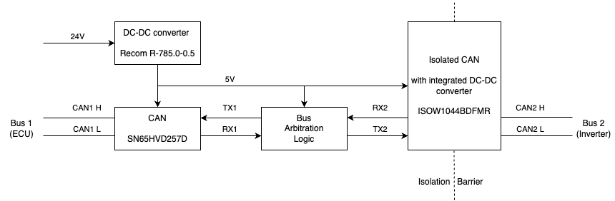Aristurtle CAN repeater

As you can see, the design has been significantly simplified, due to the use of the ISOW1044BDFMR chip which essentially combines a CAN transceiver, a digital isolator and an isolated DC-DC converter all in one chip.

## **Step 2: Schematic**

## 

## **Step 3: Hardware**

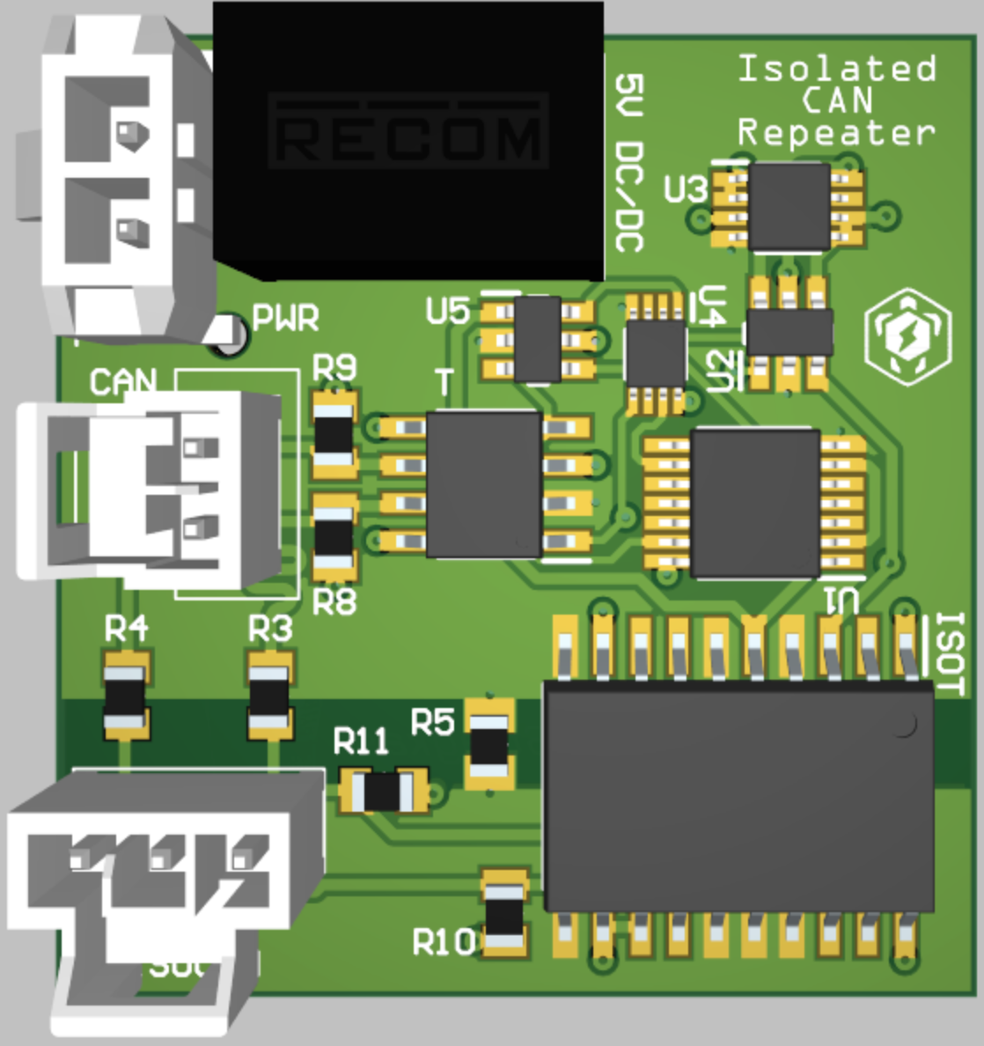

The CAN repeater consists of :

1 x SN74LVC2G132DCTR Dual 2-Input NAND gate

1 x SN74LVC2G08DCUR Dual 2-Input AND gate

1 x SN74LVC2G07DBVR Buffer

1 x SN74LVC2G04DBVR Dual inverter

1 x SN74LV32APWR Quadruple 2-Input OR Gates

1 x SN65HVD257D CAN transceiver

1 x ISOW1044BDFMR Isolated CAN FD Transceiver with Integrated DC-DC Converter

1 x R-785.0-0.5 24V to 5V DC-DC converter

0805 Resistors, 0805 Capacitors and connectors according to the schematic

Last but not least, 1 x Custom CAN repeater PCB

## **Step 4: How to Order PCBs From JLCPCB**

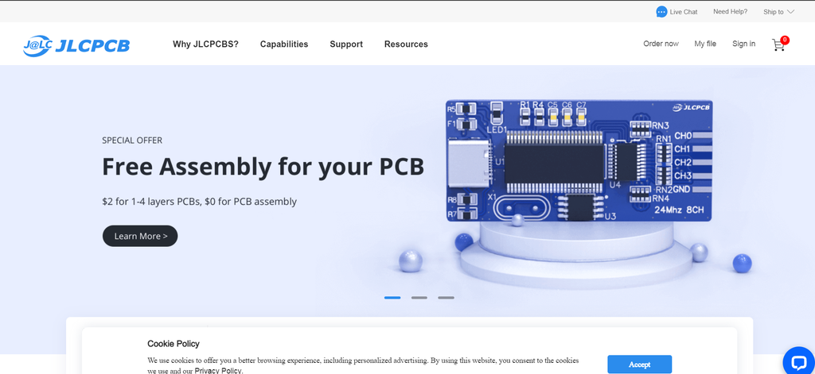

Here, we would like to take this opportunity to express our gratitude towards JLCPCB for providing the PCBs and making this project a reality. You can order your own PCBs from JLCPCB by clicking [here](https://cart.jlcpcb.com/quote?_ga=2.17987517.563975083.1639401898-1263694621.1639401898&_gac=1.124415352.1639401898.CjwKCAiA-9uNBhBTEiwAN3IlNIEV7ibkJ1lvgoEonYr5TrKDM_epSN5g5Y9j1ZUBvCrAybO94xG4JBoCLLMQAvD_BwE). First of all, you have to add a gerber file. Gerber files can be exported from the software with which you design the PCB. In our case that software is Altium Designer. The next step is to select all the characteristics you require for your PCB. After that, you will have to add any additional files, such as the BOM files and the pick and place files. Upload these files and you are ready to complete the order.

## **Step 5: Proof of Concept (?)**