A Comparative Study of 24-Hour Ahead Electricity Demand Forecasting in Brazil
-Aritra Chakraborty, MSc Statistics & Computing Banaras Hindu University

Abstract
This study presents a comparative analysis of statistical and deep learning models for 24-hour ahead electricity demand forecasting using hourly electricity demand and meteorological data from Brazil. The dataset contains over 200,000 hourly observations collected between 2000 and 2023 and includes electricity demand, air temperature, relative humidity, wind speed, and apparent temperature.
Data preprocessing involved anomaly treatment, feature engineering, structural break analysis, correlation analysis, seasonal decomposition, and stationarity assessment using the Kwiatkowski–Phillips–Schmidt–Shin (KPSS) test. Four forecasting models were developed: Seasonal Autoregressive Integrated Moving Average (SARIMA), Seasonal Autoregressive Integrated Moving Average with Exogenous Variables (SARIMAX), Recurrent Neural Network (RNN), and Long Short-Term Memory (LSTM). Two SARIMAX configurations were evaluated to examine the contribution of weather variables. Model performance was assessed using Mean Absolute Error (MAE), Root Mean Squared Error (RMSE), and Mean Absolute Percentage Error (MAPE). The Wilcoxon Signed-Rank Test was applied to determine whether differences in forecasting accuracy were statistically significant.
The LSTM model achieved the highest forecasting accuracy (MAE = 772.92 MW, RMSE = 997.62 MW, MAPE = 1.14%), followed closely by the RNN (MAPE = 1.33%). Both deep learning models substantially outperformed SARIMA and SARIMAX. Incorporating apparent temperature slightly improved SARIMAX over SARIMA, whereas adding additional weather variables did not provide further improvement. Although LSTM achieved the best overall performance, its advantage over RNN was not statistically significant. Therefore, the RNN model may be the more practical choice for real-world applications, offering comparable forecasting accuracy with lower computational cost.
Keywords: Electricity demand forecasting, SARIMA, SARIMAX, RNN, LSTM, deep learning, time series forecasting, weather variables.

Introduction
1.1 Background
Electricity plays a vital role in modern society by supporting industrial, commercial and residential activities. As electricity systems become increasingly complex, accurate demand forecasting has become essential for efficient generation scheduling, grid stability and energy resource management. Electricity demand is influenced by multiple factors, including weather conditions, seasonal patterns and human behavior, making forecasting a challenging task. Traditional statistical approaches such as SARIMA have been widely used for load forecasting, while recent advances in deep learning have introduced models capable of capturing complex nonlinear temporal relationships.
1.2 Problem Statement
Accurate short-term electricity demand forecasting is critical for day-ahead operational planning. Forecasting errors can lead to inefficient resource allocation, increased operating costs and reduced grid reliability. Although statistical models have traditionally been employed for this task, their ability to capture complex demand patterns may be limited. Therefore, it is important to investigate whether modern deep learning approaches can provide improved forecasting performance compared to conventional time-series models.
1.3 Objectives of the Study
The primary objective of this study is to compare statistical and deep learning models for day-ahead electricity demand forecasting using Brazilian electricity demand and weather data. The specific objectives are:
• To preprocess and analyze historical electricity demand and weather data.
• To develop SARIMA, SARIMAX, RNN and LSTM forecasting models.
• To evaluate forecasting performance using MAE, RMSE and MAPE.
• To compare the models in terms of forecasting accuracy and computational efficiency in order to identify a practical and cost-effective forecasting solution.

Dataset Description
2.1 Electricity Demand Dataset
Variable | Description
index | Hourly timestamp
hourly_demand | Electricity demand (MW)
The electricity demand dataset was obtained from the Kaggle repository "23 Years of Hourly Electric Energy Demand in Brazil" (Arusouza, 2023).
https://www.kaggle.com/datasets/arusouza/23-years-of-hourly-eletric-energy-demand-brazil
The dataset contains 201,318 hourly observations of hourly electricity demand observations for Brazil from January 2000 to January 2023. Each record contains a timestamp and the corresponding electricity demand measured in megawatts (MW). This dataset serves as the target series for forecasting.
Table 2.1 summarises the key characteristics of the electricity demand dataset.
Characteristic | Value
Number of Observations | 201,318
Number of Variables | 2
Frequency | Hourly
Start Date | January 2000
End Date | January 2023
Target Variable | hourly_demand
Missing Values | None
Table 2.2: Descriptive Statistics of the Electricity Demand Dataset
Statistic | Value (MW)
Count | 201,318
Mean | 54,391.82
Standard Deviation | 12,211.55
Minimum | 0.00
25th Percentile | 45,169.57
Median | 53,929.60
75th Percentile | 63,809.80
Maximum | 90,120.00

2.2 Weather Dataset
Variable | Description
time | Timestamp
temperature_2m | Air temperature (°C)
relative_humidity_2m | Relative humidity (%)
wind_speed_10m | Wind speed
apparent_temperature | Feels-like temperature

To investigate the influence of meteorological conditions on electricity consumption, a weather dataset containing hourly atmospheric observations was incorporated. The dataset includes temperature, humidity, wind speed and apparent temperature measurements corresponding to the same time period as the electricity demand dataset.
2.3 Dataset Integration
The electricity demand dataset and weather dataset were merged using their timestamp variables. A left join was performed to align each electricity demand observation with the corresponding weather measurements. The resulting dataset contains both demand and meteorological features, enabling the development of forecasting models that utilise external explanatory variables.
Variable Category | Variables
Target Variable | hourly_demand
Weather Features | temperature_2m, relative_humidity_2m, wind_speed_10m, apparent_temperature
Time Feature | timestamp

Data Preprocessing & EDA

3.1 Date Time Conversion
The timestamp column was converted to a datetime format to facilitate time-series analysis and enable temporal feature extraction.

3.2 Feature Engineering
Feature engineering was performed to improve forecasting performance by incorporating temporal and meteorological information. Since electricity demand exhibits strong cyclical behaviour, the hour of the day, day of the week, and month of the year were extracted from the timestamp and transformed using sine and cosine functions to create the features hour_sin, hour_cos, dow_sin, dow_cos, month_sin, and month_cos.
In addition, the weather variables temperature_2m, relative_humidity_2m, wind_speed_10m, and apparent_temperature were included because of their influence on electricity consumption. The final feature set used for the deep learning models consisted of the target variable hourly_demand, six cyclical time features, and four meteorological variables, resulting in a total of eleven input features.
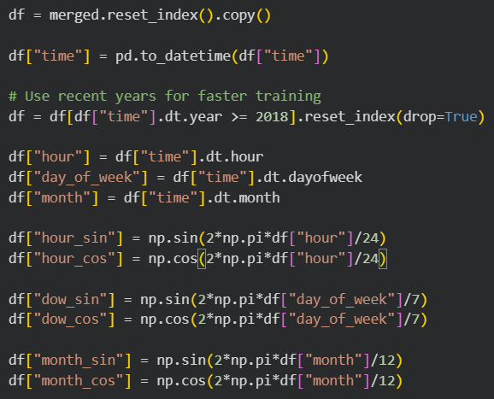
Table 3.1 : Engineered temporal and meteorological features used in the deep learning models.
Feature | Description
hour_sin, hour_cos | Daily seasonality
dow_sin, dow_cos | Weekly seasonality
month_sin, month_cos | Annual seasonality
temperature_2m | Air temperature
relative_humidity_2m | Relative humidity
wind_speed_10m | Wind speed
apparent_temperature | Apparent temperature

Figure 3.1: Brazil Hourly Electricity Demand (2000–2023)

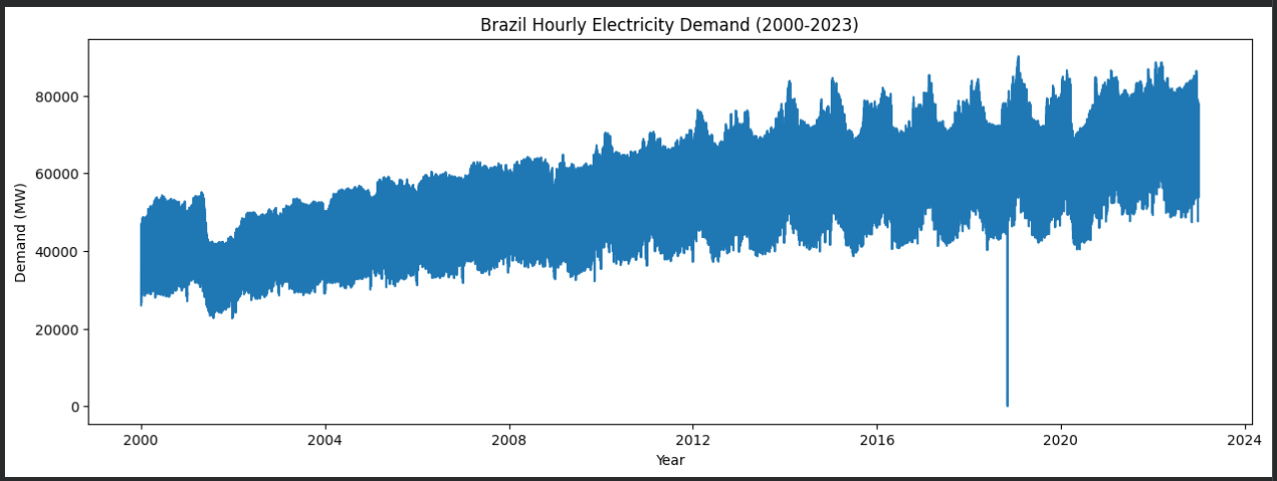
•
Figure 3.2: Year-wise Distribution of Brazil Electricity Demand
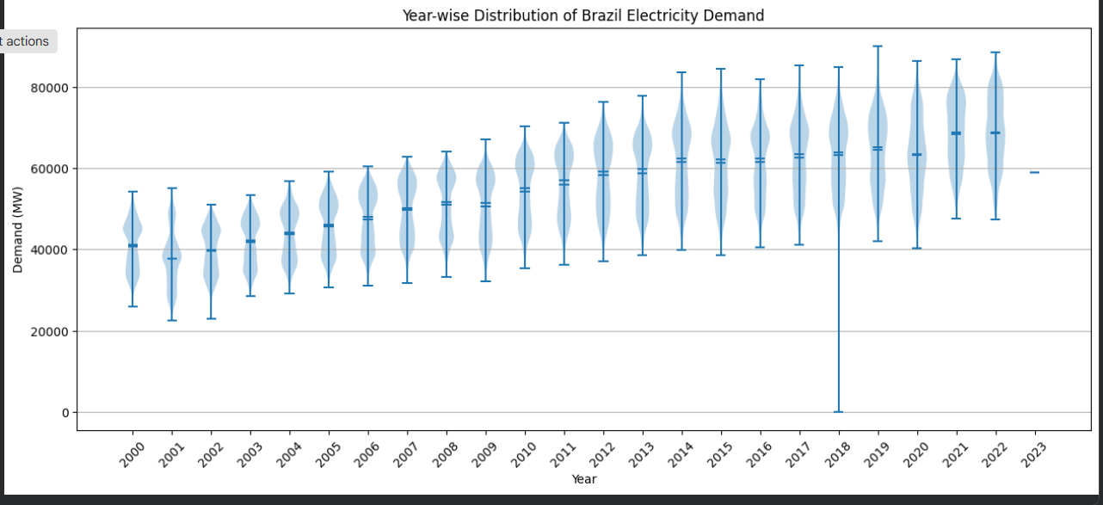
Visual inspection of the time series and descriptive statistics revealed a single observation with a demand value of 0 MW on 4 November 2018. Since national electricity demand cannot realistically be zero, the observation was treated as an anomaly.

3.3 Linear Interpolation
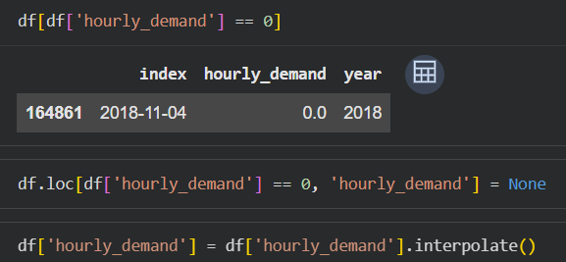
The value was replaced with a missing value and subsequently estimated using linear interpolation to preserve the continuity of the time series.
3.4 Average Hourly Electricity Demand
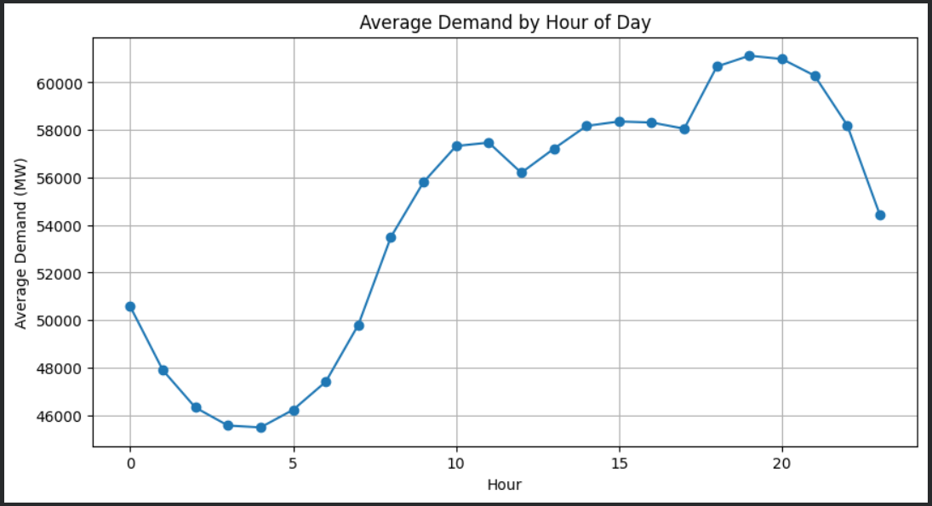
Figure 3.3 illustrates the average electricity demand for each hour of the day, computed over the entire study period. A clear daily cycle is observed, indicating strong intraday seasonality. Demand decreases during the early morning hours, reaching its minimum around 03:00–04:00, before increasing steadily throughout the day. The highest demand occurs during the evening hours, with a peak around 19:00–20:00, after which demand gradually declines.

3.5 Identification of Structural Break
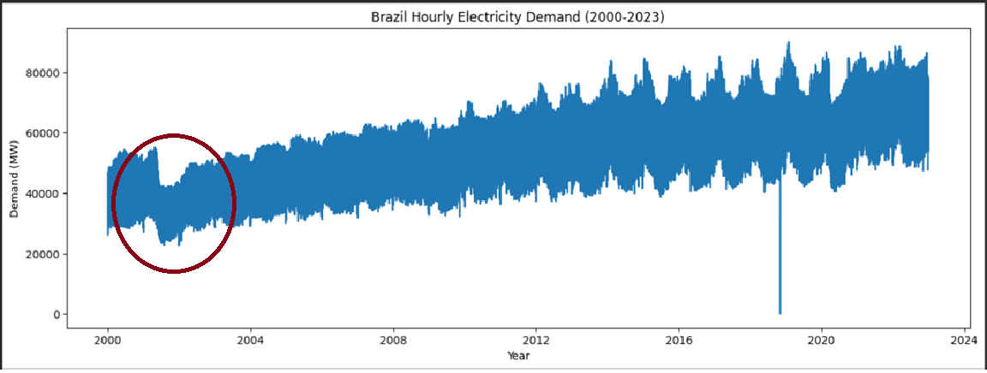
Structural break analysis was conducted to identify any abrupt changes in the behaviour of the electricity demand series over time. Structural breaks are important in time-series modelling because they can alter the underlying statistical properties of the data, potentially affecting model estimation and forecasting performance.
Visual inspection of the hourly electricity demand series revealed an unusual decline in demand beginning around May 2001 and persisting until early 2002. During this period, the series exhibited a noticeable downward shift in its overall level compared to the preceding and subsequent observations. The change was substantially larger than the normal seasonal fluctuations observed throughout the dataset, suggesting the presence of a structural break rather than ordinary variation.
The presence of the identified structural break suggests that the electricity demand series contains an anomalous period that may influence model estimation and forecasting performance. Accordingly, this issue is addressed in a later section of the report.

3.6 Correlation Analysis
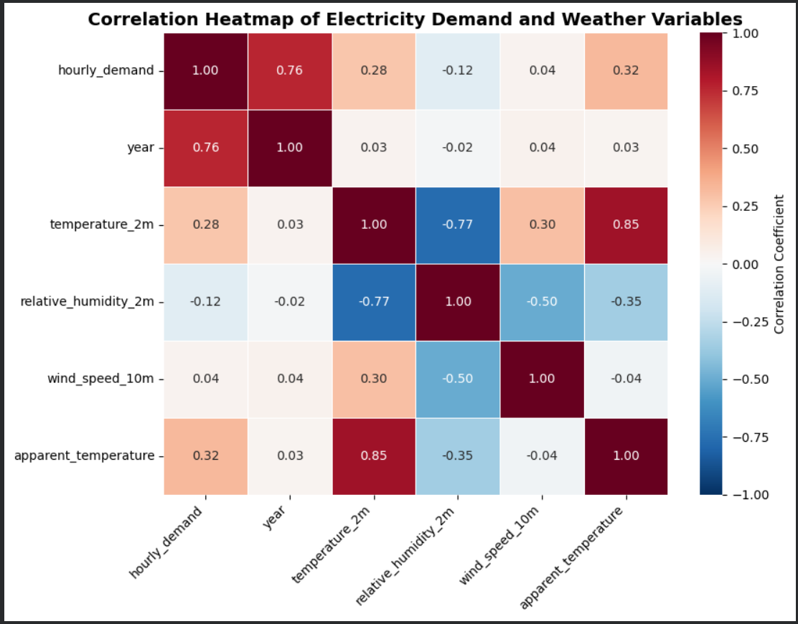
A Pearson correlation analysis was conducted to examine the relationships between electricity demand and the selected weather variables. The correlation matrix indicates that apparent temperature exhibits the strongest positive relationship with hourly electricity demand (r = 0.322), followed by air temperature (r = 0.280). This suggests that electricity consumption tends to increase during warmer conditions, possibly due to higher cooling requirements.
Relative humidity shows a weak negative correlation with electricity demand (r = -0.115), indicating that humidity has a limited inverse relationship with electricity usage. Wind speed demonstrates an almost negligible correlation with demand (r = 0.036), suggesting that it contributes little direct explanatory power.
Among the weather variables themselves, air temperature and apparent temperature are highly positively correlated (r = 0.850), while air temperature and relative humidity exhibit a strong negative correlation (r = -0.773). These relationships are consistent with meteorological expectations and confirm the interdependence of weather-related variables.
Overall, temperature-related variables appear to be the most influential weather factors associated with electricity demand and were therefore retained as explanatory variables for subsequent forecasting models.
3.7 Time Series Decomposition of Electricity Demand
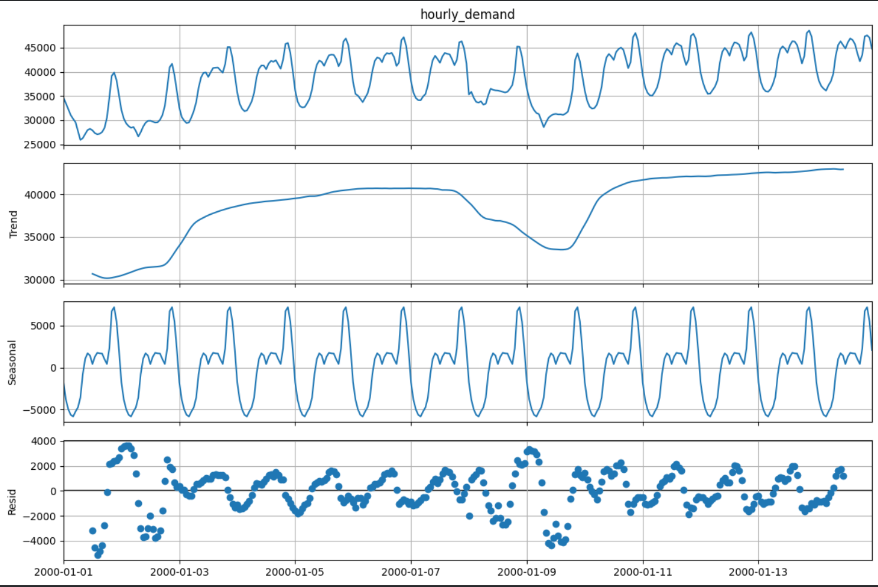
Observed Series
The first panel represents the original hourly electricity demand series. The series exhibits recurring fluctuations over time, suggesting the presence of a strong seasonal pattern. In addition, gradual changes in the overall level of demand indicate the existence of an underlying trend component.
Trend Component
The trend component captures the long-term movement in electricity demand after removing short-term seasonal fluctuations. The trend initially increases, experiences a temporary decline around the middle of the observed period, and subsequently recovers. This suggests that electricity demand is influenced by broader changes occurring over multiple days in addition to regular daily cycles.
Seasonal Component
The seasonal component displays a highly regular repeating pattern with a period of 24 hours. The consistency of this pattern confirms the presence of strong daily seasonality in the electricity demand series. Demand tends to rise and fall at similar times each day, reflecting recurring consumption behavior associated with residential, commercial, and industrial activities.
Residual Component
The residual component contains the variation remaining after removing the trend and seasonal effects. Most residual values are centred around zero, indicating that a substantial proportion of the variation in electricity demand is explained by the trend and seasonal components. However, a few larger positive and negative residuals remain, suggesting the presence of short-term irregular fluctuations that are not fully captured by the decomposition.
Overall Interpretation
The decomposition demonstrates that the electricity demand series is characterized by:
- A clear trend component,
- Strong daily seasonality,
- Relatively smaller irregular fluctuations.

Stationarity Analysis
Stationarity is a fundamental assumption in many time-series forecasting methods, particularly those based on autoregressive models. A stationary time series has statistical properties, such as the mean, variance, and autocorrelation structure, that remain constant over time. Non-stationary series may exhibit trends, seasonality, or structural changes that adversely affect model estimation and forecasting performance. Therefore, the stationarity of the electricity demand series was assessed prior to model development.
Stationarity was examined using the Kwiatkowski–Phillips–Schmidt–Shin (KPSS) test (Kwiatkowski et al., 1992). The KPSS test was selected because its null hypothesis assumes stationarity, allowing a direct assessment of whether the series satisfies the stationarity assumption required for time-series modelling. In contrast, the Augmented Dickey–Fuller (ADF) test assumes the presence of a unit root under the null hypothesis. Since the two tests employ complementary hypotheses, they are often used together to assess stationarity. In this study, the KPSS test was adopted as the primary stationarity test.
The KPSS model represents the observed series as

$$y_{t}=r_{t}+βt+ε_{t}$$

where $rt$ denotes a random walk component, $βt$ is the deterministic trend, and ε
is a stationary error process. The random walk evolves according to
$$r_{t}=r_{\left\{t-1\right\}}+v_{t}$$
where $v_{t}$ is an independent and identically distributed random error. The presence of the random walk component implies that the series is non-stationary.
The hypotheses of the KPSS test are
$$H_{0}: y_{t }is level stationary$$
$$H_{1}:; y_{t} is non stationary\left(contains a unit root\right)$$
The KPSS test was applied to the hourly electricity demand series, and the resulting test statistic and p-value are reported below.
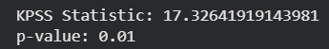
Since the obtained p-value (0.01) is less than the 5% significance level, the null hypothesis was rejected, indicating that the electricity demand series is non-stationary. This finding is consistent with the trend and pronounced seasonal behaviour observed during the exploratory analysis. Consequently, differencing and seasonal forecasting models were employed during the subsequent modelling stage to account for the non-stationary nature of the series.
.

Kwiatkowski, D., Phillips, P. C. B., Schmidt, P., & Shin, Y. (1992). Testing the null hypothesis of stationarity against the alternative of a unit root: How sure are we that economic time series have a unit root? Journal of Econometrics, 54(1–3), 159–178. https://doi.org/10.1016/0304-4076(92)90104-Y

Methodology
4.1 Forecasting Framework
Following data preprocessing and exploratory analysis, the integrated dataset was divided into training, validation, and testing subsets using a chronological split to preserve the temporal structure of the series. Observations from January 2000 to December 2019 were used for model training, data from January 2020 to December 2020 were used for validation, and observations from January 2021 to December 2022 were reserved for final model evaluation.
Prior to developing advanced forecasting models, a naïve forecasting approach was implemented as a benchmark. The naïve model assumes that electricity demand at a given hour is equal to the demand observed during the corresponding hour of the previous day. The benchmark provides a reference against which the performance of more sophisticated forecasting methods can be evaluated.
Subsequently, four forecasting approaches were developed and compared: Seasonal Autoregressive Integrated Moving Average (SARIMA), Seasonal Autoregressive Integrated Moving Average with Exogenous Variables (SARIMAX), Recurrent Neural Network (RNN), and Long Short-Term Memory (LSTM). The SARIMA and SARIMAX models represent traditional statistical forecasting techniques, while RNN and LSTM represent deep learning approaches capable of modelling complex temporal dependencies.
The forecasting accuracy of all models was evaluated using Mean Absolute Error (MAE), Root Mean Squared Error (RMSE), and Mean Absolute Percentage Error (MAPE). These metrics were used to compare model performance and identify the most effective method for short-term electricity demand forecasting.
4.2 Data Partitioning
The integrated dataset was partitioned chronologically into training, validation, and testing subsets to preserve the temporal structure of the time series. The training set was used for model estimation, the validation set was used for model selection and tuning, and the testing set was reserved for final performance evaluation. The dataset partitioning is presented in Table 4.1.
Table 4.1
Dataset | Period | Observations
Training | 2000–2019 | 175,013
Validation | 2020 | 8,784
Testing | 2021–2022 | 17,520

4.3 Model Development Strategy
A progressive modelling strategy was adopted in this study to evaluate increasingly sophisticated forecasting approaches. The analysis began with the SARIMA model, a widely used statistical technique capable of modelling trend and seasonal patterns using only historical electricity demand observations. SARIMA served as a baseline statistical forecasting model for capturing the temporal structure of the series.
Although SARIMA effectively models historical demand patterns, it does not incorporate external factors that may influence electricity consumption. The correlation analysis conducted in the exploratory phase indicated that temperature-related variables exhibit meaningful relationships with electricity demand. Therefore, the SARIMAX model was subsequently developed to extend SARIMA by incorporating weather variables as exogenous predictors.
While SARIMA and SARIMAX rely on linear statistical relationships, electricity demand patterns may also contain complex nonlinear dependencies that are difficult to capture using traditional time-series models. To address this limitation, deep learning approaches were considered. A Recurrent Neural Network (RNN) was first implemented because of its ability to model sequential data and learn temporal dependencies directly from historical observations.
However, conventional RNNs often struggle to retain information over longer sequences due to the vanishing gradient problem. Consequently, a Long Short-Term Memory (LSTM) network was also developed. The LSTM architecture introduces memory cells and gating mechanisms that enable the model to capture longer-term temporal dependencies more effectively. The performance of all models was subsequently compared using standard forecasting accuracy measures.

4.4 Seasonal Autoregressive Integrated Moving Average (SARIMA)
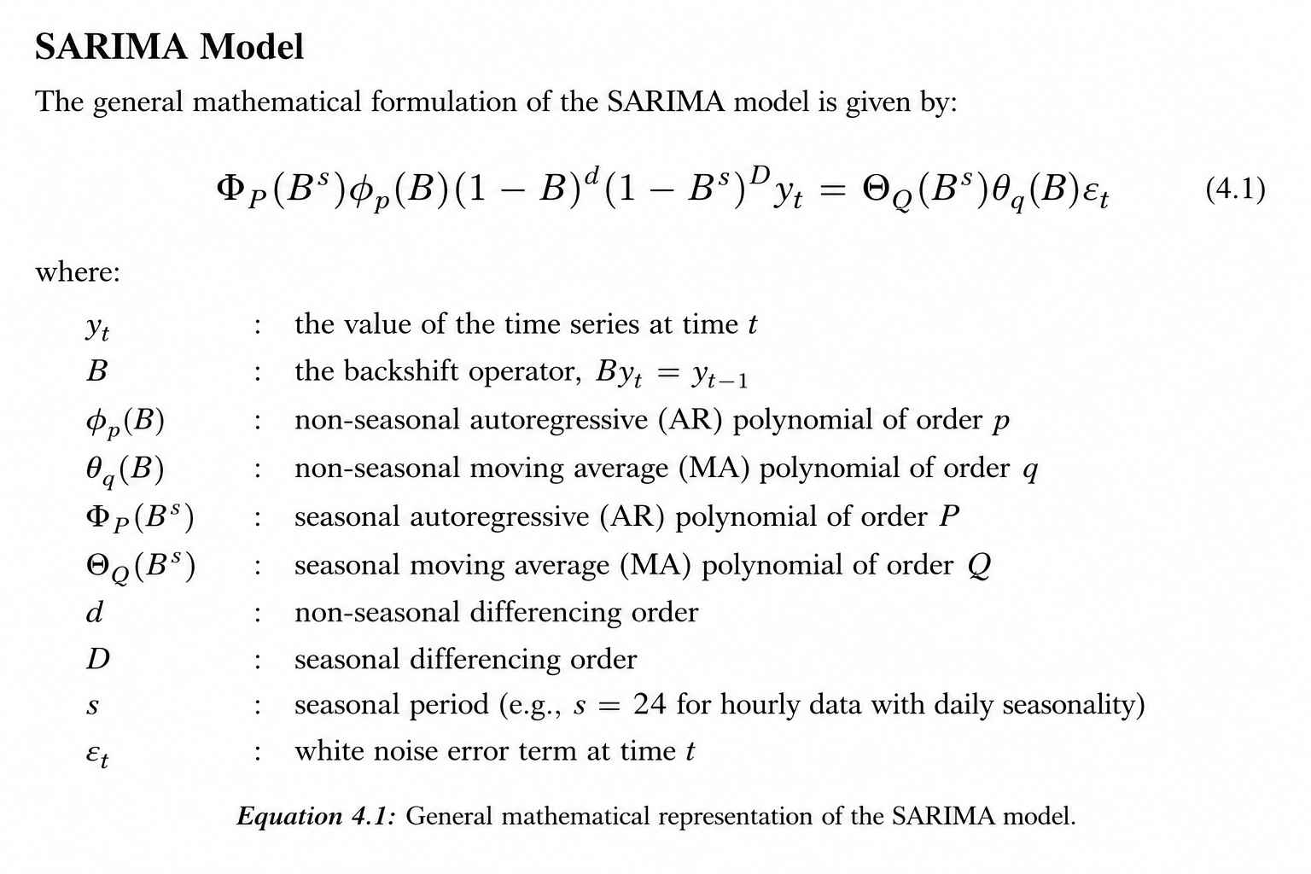
The Seasonal Autoregressive Integrated Moving Average (SARIMA) model was selected as the primary statistical forecasting model due to its widespread use in electricity demand forecasting and its ability to model both trend and seasonal patterns within time-series data. Electricity demand exhibits strong temporal dependence and recurring daily cycles, making SARIMA an appropriate baseline model.
A SARIMA model is denoted as SARIMA(p,d,q)(P,D,Q)s, where p, d and q represent the non-seasonal autoregressive, differencing and moving average orders, respectively, while P, D and Q represent the corresponding seasonal components. The parameter s denotes the seasonal period.
The stationarity analysis conducted in Chapter 3 indicated the presence of trend and seasonal effects in the electricity demand series. Furthermore, exploratory analysis revealed a pronounced daily seasonal cycle. Consequently, a seasonal period of 24 hours was adopted.
The final specification selected for this study was SARIMA(1,1,1)(1,1,1,24). The model orders were chosen based on the observed characteristics of the series, evidence from previous electricity demand forecasting studies, and empirical experimentation using the validation dataset. The selected configuration provided a balance between model complexity and forecasting performance while adequately capturing the temporal structure of the data.
The SARIMA model utilised only historical electricity demand observations and therefore served as the benchmark statistical forecasting approach for subsequent comparisons.
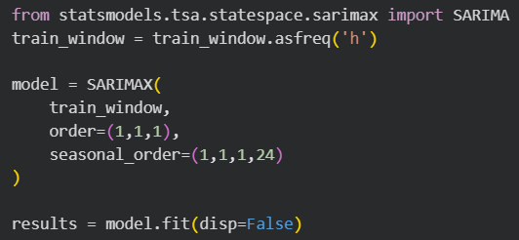

4.5 Seasonal Autoregressive Integrated Moving Average with Exogenous Variables (SARIMAX)
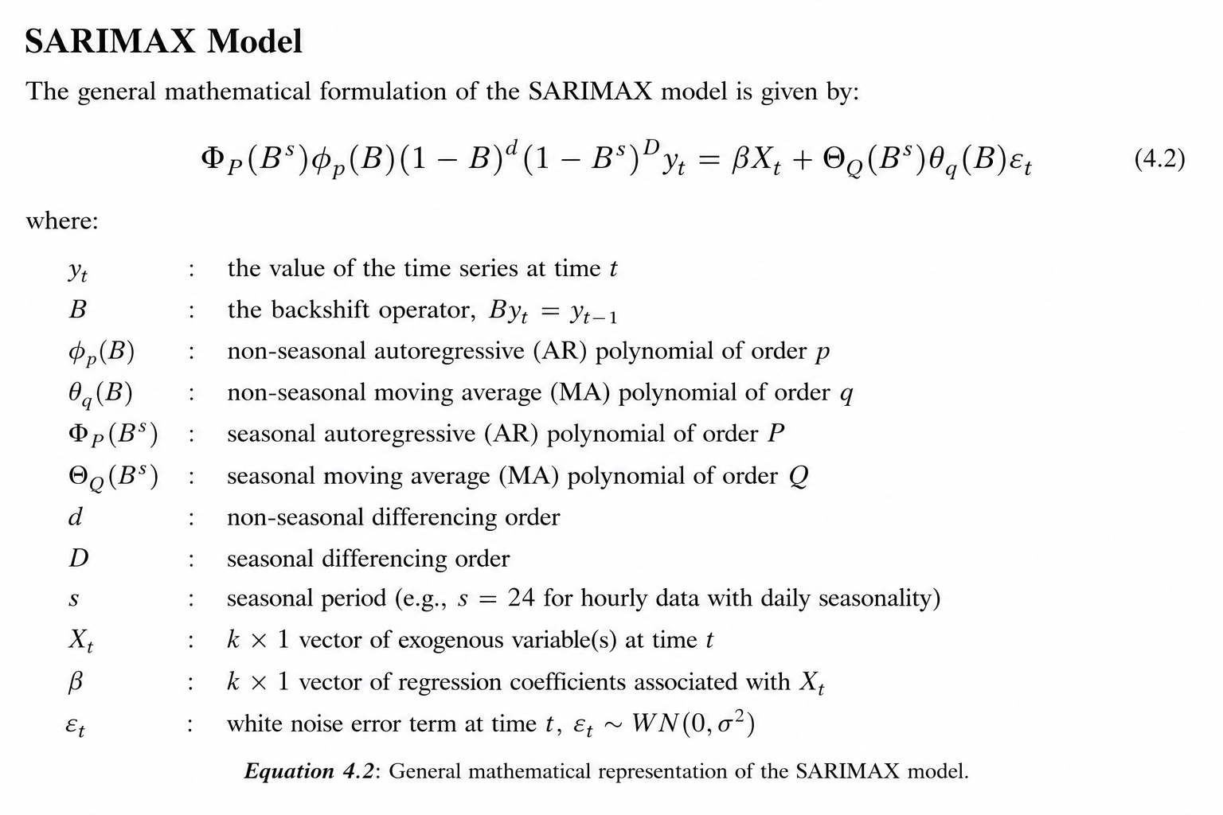
Although SARIMA effectively captures temporal patterns present in historical demand observations, electricity consumption is also influenced by external factors, particularly weather conditions. To incorporate these effects, the Seasonal Autoregressive Integrated Moving Average with Exogenous Variables (SARIMAX) model was employed.
SARIMAX extends the SARIMA framework by incorporating explanatory variables alongside the target series. The inclusion of exogenous variables enables the model to account for external influences that may not be captured through historical demand observations alone.
Based on the correlation analysis presented in Chapter 3, four meteorological variables were selected:
• Air Temperature (temperature_2m)
• Relative Humidity (relative_humidity_2m)
• Wind Speed (wind_speed_10m)
• Apparent Temperature (apparent_temperature)
These variables were chosen because they represent important environmental factors associated with electricity consumption behaviour. Temperature-related variables demonstrated the strongest relationships with electricity demand and were therefore expected to contribute additional predictive information.
To evaluate the contribution of meteorological information, SARIMAX modelling was conducted in two stages. Initially, apparent temperature was introduced as the sole exogenous variable. Apparent temperature was selected because it combines the effects of temperature, humidity and wind conditions and therefore provides a more realistic representation of perceived atmospheric conditions.
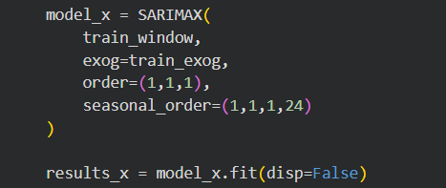
Subsequently, the model was extended by incorporating four meteorological variables, namely air temperature, relative humidity, wind speed and apparent temperature. This allowed an assessment of whether a richer weather feature set could provide additional predictive information beyond a single weather indicator.
For both stages, the same SARIMA structure, SARIMAX(1,1,1)(1,1,1,24), was retained to ensure that any change in forecasting performance could be attributed primarily to the inclusion of additional exogenous variables rather than changes in model specification.
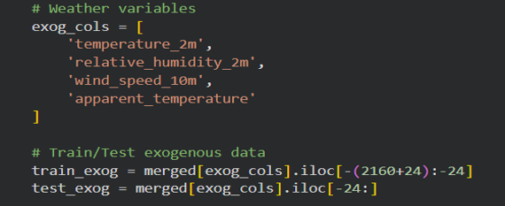

4.6 Recurrent Neural Network (RNN)
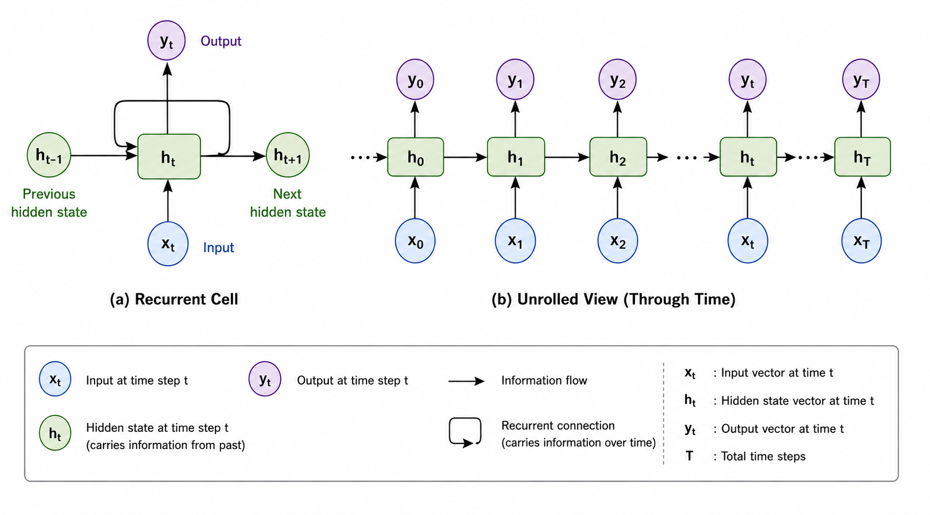
Traditional statistical forecasting models rely primarily on linear relationships and predefined model structures. However, electricity demand may exhibit complex nonlinear patterns that are difficult to capture using conventional time-series approaches. To address this limitation, a Recurrent Neural Network (RNN) was implemented.
RNNs are specifically designed for sequential data and are capable of learning temporal dependencies directly from historical observations. Unlike feed-forward neural networks, RNNs maintain hidden states that allow information from previous time steps to influence future predictions.
Prior to model development, all input features were standardised using z-score normalisation to improve training stability and convergence. A sliding-window approach was then employed to generate sequential training samples.
The sequence length was fixed at 72 hours (three days). This choice was motivated by the strong daily seasonality observed during exploratory analysis and by common practices reported in short-term load forecasting literature, where multiple daily cycles are frequently used as model inputs.

The final RNN architecture consisted of:
• Input sequence length: 72 hours
• Hidden layer size: 64 units
• Number of recurrent layers: 2
• Dropout rate: 0.2
• Output layer: Fully connected linear layer
The hidden size and network depth were selected through empirical experimentation and validation performance while maintaining a relatively simple architecture to reduce overfitting. The dropout layer was incorporated to improve generalisation.
Training was performed using the Adam optimisation algorithm with a learning rate of 0.001. Mean Squared Error (MSE) was used as the loss function, and the model was trained for 10 epochs.
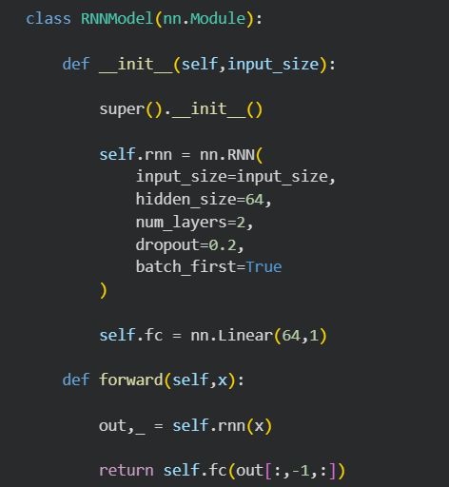

Training and Validation Loss
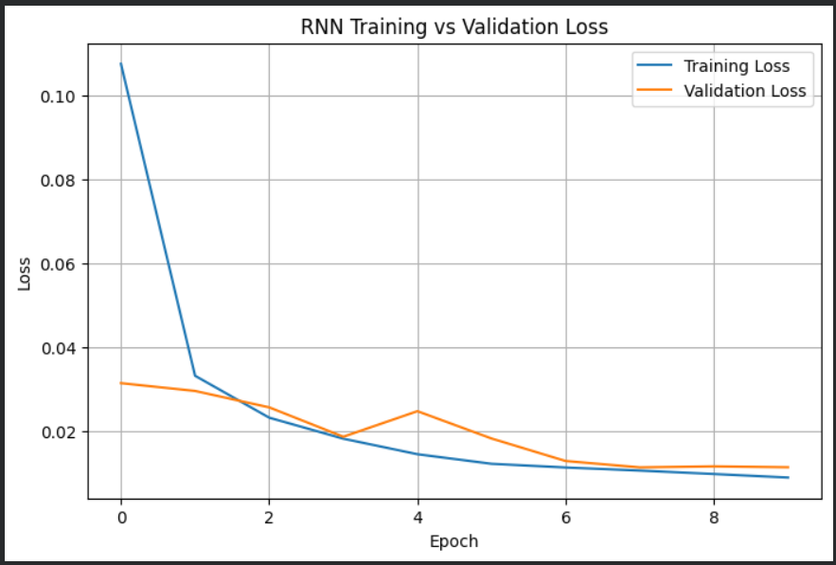
The training and validation loss curves demonstrate steady convergence throughout the training process. Both losses decrease rapidly during the initial epochs and gradually stabilize after approximately the sixth epoch. The relatively small gap between the training and validation losses suggests that the model generalizes well to unseen data and does not exhibit severe overfitting.

4.7 Long Short-Term Memory (LSTM)
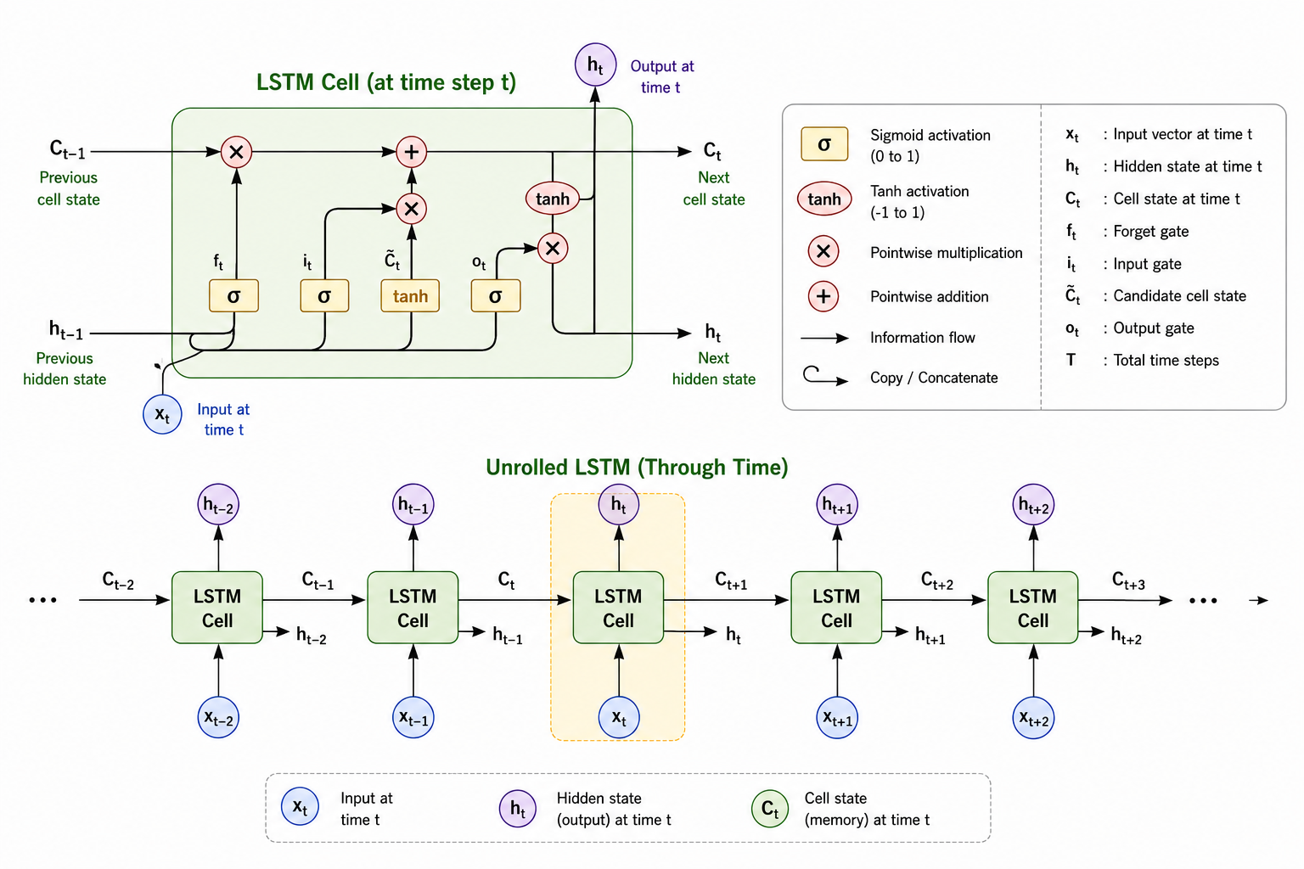
Although RNNs are capable of modelling sequential data, they often encounter difficulties when learning long-term temporal dependencies due to the vanishing gradient problem. As information propagates through many time steps, the network may gradually lose important historical information.
To overcome this limitation, a Long Short-Term Memory (LSTM) network was implemented. LSTM is an advanced recurrent architecture that incorporates memory cells and gating mechanisms to regulate information flow through the network.
The forget gate, input gate and output gate collectively enable the network to retain relevant information while discarding unnecessary information. This capability makes LSTM particularly effective for electricity demand forecasting, where both short-term and long-term temporal dependencies may influence future demand.
To ensure a fair comparison with the RNN model, the same input structure and training strategy were adopted. The final architecture consisted of:
• Input sequence length: 72 hours
• Hidden layer size: 64 units
• Number of recurrent layers: 2
• Dropout rate: 0.2
• Learning rate: 0.001
• Number of epochs: 10
• Loss function: Mean Squared Error (MSE)
The hyperparameters were selected based on recommendations from previous deep learning forecasting studies and empirical validation performance. The LSTM model was expected to outperform the standard RNN by more effectively capturing long-range temporal dependencies within the electricity demand series.
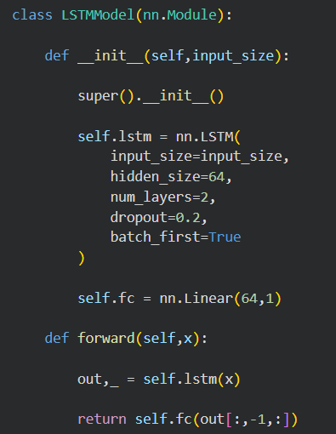

Training and Validation Loss
Figure 5.4: LSTM Training and Validation Loss
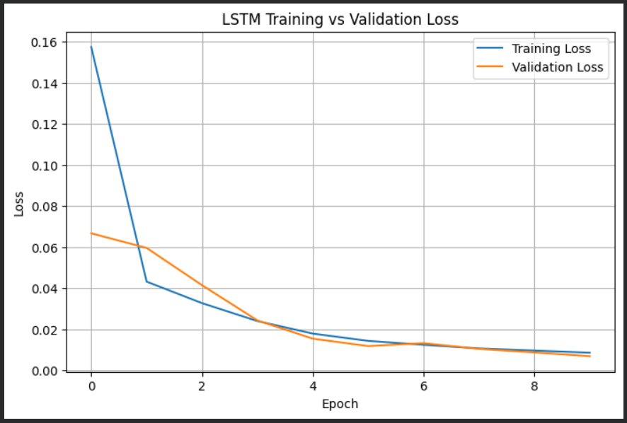
The training and validation losses decrease steadily across epochs, indicating that the model is learning effectively. The close alignment between the two curves suggests good generalization and minimal overfitting. By the final epochs, both losses converge to low values, indicating that the LSTM model has achieved stable and efficient training performance.

4.8 Experimental Setup and Performance Evaluation
A 24-hour-ahead forecasting framework was adopted throughout the study. Following data preprocessing and feature engineering, the integrated dataset was divided chronologically into training, validation and testing subsets to preserve the temporal ordering of observations and prevent information leakage.
The statistical forecasting models (SARIMA and SARIMAX) were implemented using the Statsmodels library. Daily seasonality was represented through a seasonal period of 24 hours, consistent with the patterns identified during exploratory analysis.
The deep learning models (RNN and LSTM) were implemented using the PyTorch framework. Input sequences of 72 hours were generated using a sliding-window approach. All predictor variables were standardised prior to training, and optimisation was performed using the Adam algorithm with a learning rate of 0.001.
Model performance was assessed using Mean Absolute Error (MAE), Root Mean Squared Error (RMSE) and Mean Absolute Percentage Error (MAPE). These metrics are widely used in forecasting studies and provide complementary information regarding prediction accuracy. Lower values of MAE, RMSE and MAPE indicate superior forecasting performance.
$$MAE = (1/n) Σ |yi - ŷi|$$
$$RMSE = √[(1/n) Σ (yi - ŷi)²]$$
$MAPE = (100/n) Σ |(yi - ŷi)/yi$|
where yi represents the actual electricity demand, ŷi represents the predicted electricity demand, and n denotes the total number of observations.
MAE measures the average absolute forecasting error.
RMSE places greater emphasis on large prediction errors due to the squaring operation.
MAPE expresses forecasting error as a percentage of the actual value, making the results easier to interpret and compare.
Although the evaluation metrics indicate differences in forecasting accuracy, statistical validation is required to determine whether these differences are significant. Therefore, the Wilcoxon Signed-Rank Test was employed to assess whether the differences in forecasting errors between pairs of competing models were statistically significant.

Wilcoxon Signed-Rank
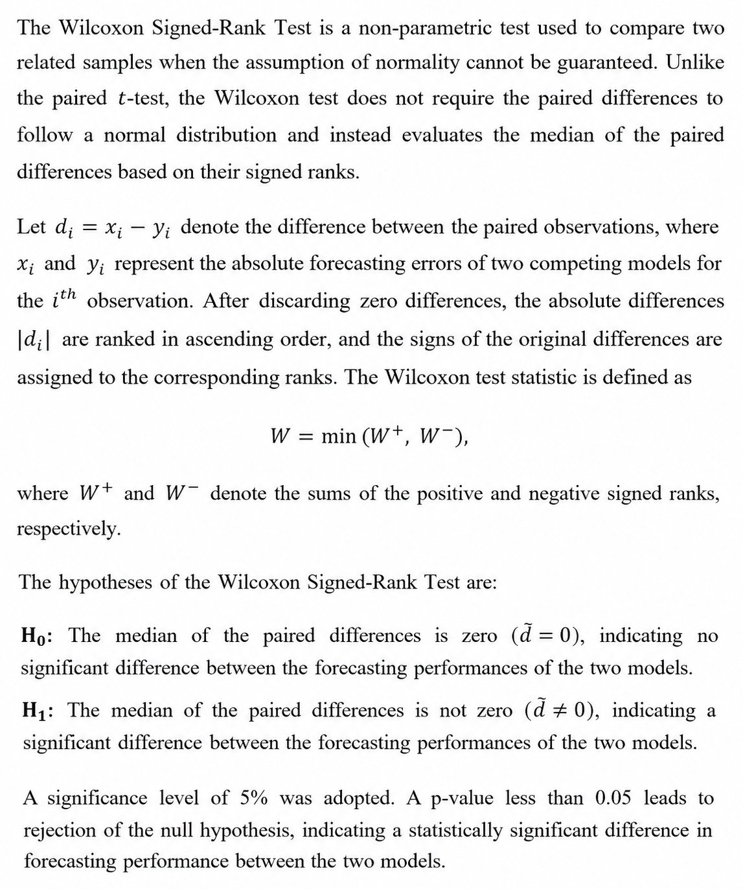

Results and Comparison

5.1 Error Table
Table 5.1: Forecast Accuracy Comparison of the Forecasting Models
Model | MAE | RMSE | MAPE (%)
SARIMA | 5285.93 | 6231.51 | 9.11
SARIMAX (Apparent Temperature) | 5266.44 | 6212.18 | 9.08
SARIMAX (All Weather Variables) | 5419.08 | 6379.81 | 9.35
RNN | 924.30 | 1267.77 | 1.33
LSTM | 772.92 | 997.62 | 1.14

Table 5.1 compares the forecasting accuracy of the five models using MAE, RMSE, and MAPE. Among the statistical models, SARIMAX with apparent temperature achieved the lowest forecasting error, marginally outperforming the baseline SARIMA model. However, incorporating all weather variables did not improve performance, resulting in higher errors than both SARIMA and SARIMAX with apparent temperature. The deep learning models substantially outperformed the statistical models, with LSTM achieving the lowest MAE (772.92), RMSE (997.62), and MAPE (1.14%), followed closely by RNN. Although LSTM produced the best overall performance, its improvement over RNN was relatively small.

5.2 Last 24-Hour Forecast Comparison
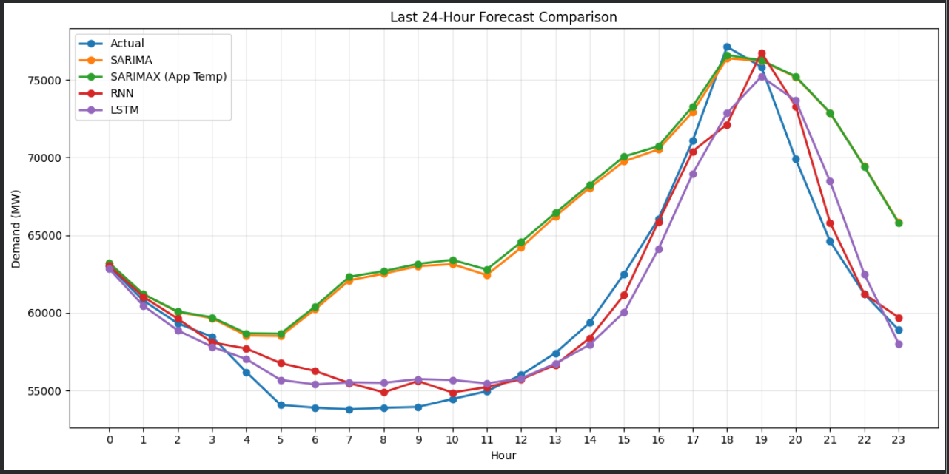Figure 5.1: Comparison of Actual and Predicted Electricity Demand for the Final 24-Hour Forecast Horizon
This plot compares the actual electricity demand with forecasts generated by SARIMA, SARIMAX, RNN and LSTM over the final 24-hour forecasting horizon. Both statistical models capture the overall demand trend but show larger deviations from the observed values, particularly during periods of rapid change. In contrast, the RNN and LSTM models more closely follow the actual demand pattern, including both troughs and peak periods. Although LSTM provides the closest visual fit, its improvement over RNN is marginal, while both deep learning models substantially outperform the statistical models.

5.3 Wilcoxon Result
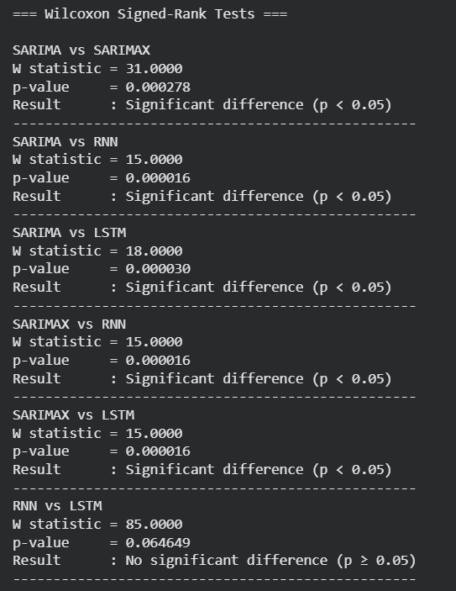
Table 5.2: Wilcoxon Signed-Rank Test Results
The Wilcoxon Signed-Rank Test revealed statistically significant differences between SARIMA and SARIMAX (p = 0.000278), indicating that the inclusion of apparent temperature as an exogenous variable significantly improved the forecasting performance of the statistical model. Furthermore, both SARIMA and SARIMAX differed significantly from RNN and LSTM (p < 0.05), demonstrating that the deep learning models achieved superior forecasting accuracy. However, the comparison between RNN and LSTM yielded a p-value of 0.064649, indicating that the difference in forecasting performance between the two deep learning models was not statistically significant at the 5% significance level. Therefore, while the deep learning models significantly outperformed the statistical models, neither RNN nor LSTM showed a statistically significant advantage over the other.

Structural Break Adjustment Analysis


As discussed in the Exploratory Data Analysis (EDA), visual inspection of the electricity demand series revealed a pronounced structural break between May 2001 and February 2002, characterized by an abrupt decline in demand levels relative to the surrounding observations.
The identified structural break indicates that the demand series does not evolve uniformly throughout the entire observation period. Consequently, careful consideration of this anomalous segment was required before proceeding with model development and forecasting.
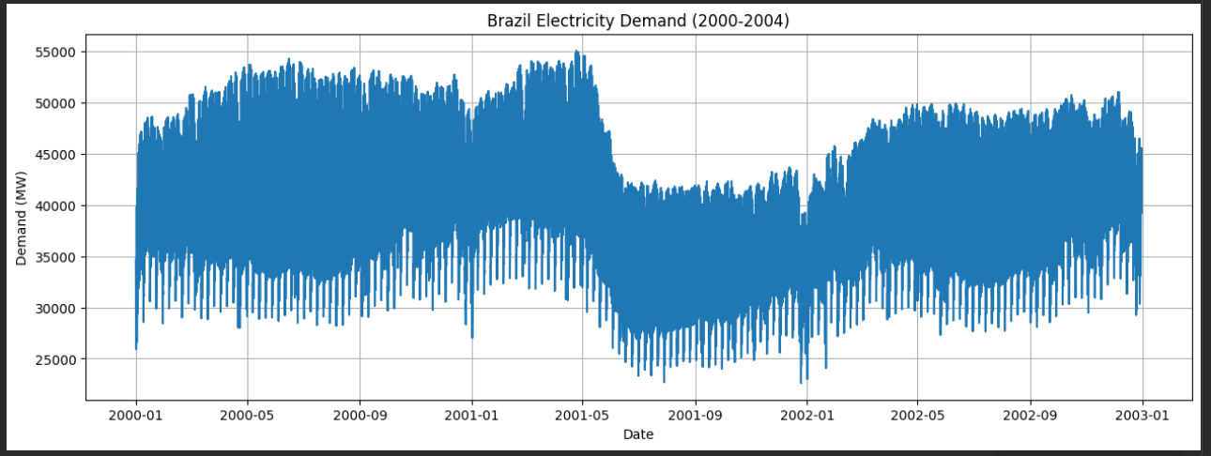
Further investigation revealed that the abnormal decline in electricity demand observed between 2001 and 2002 coincided with a well-documented electricity crisis in Brazil. During this period, electricity rationing measures were implemented nationwide due to shortages in hydroelectric power generation, leading to a substantial reduction in electricity consumption. This event explains the structural break identified in the demand series.
Source: World Bank (2005), Brazil: Background Study for a National Rural Electrification Strategy: Aiming for Universal Access (ESMAP). Available at: https://documents.worldbank.org/en/publication/documents-reports/documentdetail/318661468018272065/brazil-background-study-for-a-national-rural-electrification-strategy-aiming-for-universal-access

Since this abnormal period was caused by an external nationwide electricity crisis rather than normal demand dynamics, observations from 15 May 2001 to 15 February 2002 were excluded prior to model development. Removing this period allowed the forecasting models to be trained on data that better represent the underlying long-term electricity demand behaviour.
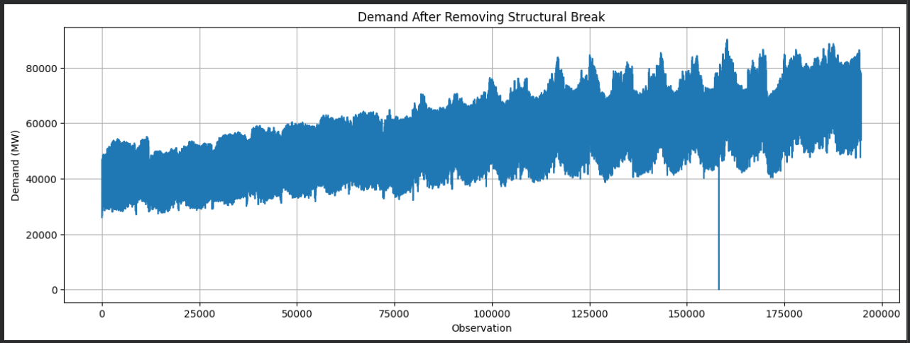
This figure shows the electricity demand series after removing the structural break associated with the 2001–2002 electricity crisis. The remaining series exhibits a more consistent long-term trend and seasonal pattern, making it more suitable for subsequent forecasting analysis.

Forecast Performance after Structural Break Adjustment
Table 6.1 Forecast Accuracy of the Forecasting Models after Structural Break Adjustment
Model | MAE | RMSE | MAPE (%)
SARIMA | 5514.96 | 6261.86 | 9.55
SARIMAX (Apparent Temperature) | 6412.95 | 7130.95 | 11.11
RNN | 1160.52 | 1588.61 | 1.65
LSTM | 1286.07 | 1724.76 | 1.84

This table presents the forecasting performance of the SARIMA, SARIMAX, RNN, and LSTM models after excluding the 2001–2002 Brazilian electricity crisis period. Following the removal of this interval, all models exhibited higher forecasting errors compared with the analysis performed on the original dataset. The reduction in forecasting performance is likely attributable to the discontinuity introduced by deleting a continuous segment of the time series, which disrupted the natural temporal and seasonal structure of the data. Consequently, observations belonging to different seasonal periods (e.g., summer and winter) became adjacent, reducing the continuity of the seasonal cycle and limiting the models' ability to accurately learn and capture recurring seasonal patterns.
Among the statistical models, SARIMA outperformed SARIMAX (Apparent Temperature), achieving lower MAE, RMSE, and MAPE values. This indicates that the inclusion of apparent temperature did not improve forecasting accuracy for the modified dataset. Among the deep learning models, RNN achieved the lowest forecasting errors (MAE = 1160.52 MW, RMSE = 1588.61 MW, MAPE = 1.65%), followed closely by LSTM (MAPE = 1.84%). Despite the overall increase in forecasting errors after removing the crisis period, both deep learning models continued to substantially outperform the statistical models, demonstrating their superior ability to model the complex nonlinear relationships present in electricity demand data.

Conclusion
This study compared the performance of SARIMA, SARIMAX, RNN, and LSTM models for 24-hour ahead electricity demand forecasting using hourly electricity demand and weather data from Brazil. Exploratory analysis revealed strong daily seasonality, a long-term trend, and a structural break during the 2001–2002 electricity crisis, while apparent temperature showed the strongest association with electricity demand among the weather variables.
The results demonstrated that the deep learning models consistently outperformed the statistical models. LSTM achieved the highest forecasting accuracy, closely followed by RNN, whereas SARIMA and SARIMAX produced comparatively larger forecasting errors. The Wilcoxon Signed-Rank Test further confirmed that the improvements of the deep learning models over the statistical models were statistically significant, while the difference between RNN and LSTM was not statistically significant.
Overall, the findings indicate that deep learning models are highly effective for short-term electricity demand forecasting. Although LSTM achieved the best predictive performance, RNN offers a practical alternative by providing comparable accuracy with lower computational complexity, making it well suited for real-world forecasting applications.

Future Scope
The forecasting performance achieved in this study can be further improved through systematic hyperparameter tuning of the deep learning models, including the optimization of network architecture, sequence length, learning rate, batch size and the number of hidden units.
Future research may also explore advanced deep learning architectures such as GRU, Transformer-based models and hybrid forecasting frameworks that combine statistical and neural network approaches. Additionally, the inclusion of external variables such as holidays, economic indicators and electricity price information may further enhance forecasting accuracy.
Finally, the proposed models may be evaluated on different forecasting horizons and electricity markets to assess their generalizability and robustness across diverse operating conditions.

Code Availability
The complete implementation, including the source code, Jupyter notebook, and supporting files used in this study, is publicly available at: https://github.com/Aritra200003/Electricity-Demand-Forecasting

References

Arusouza. (2023). 23 Years of Hourly Electric Energy Demand in Brazil [Dataset]. Kaggle. https://www.kaggle.com/datasets/arusouza/23-years-of-hourly-eletric-energy-demand-brazil
Elman, J. L. (1990). Finding structure in time. Cognitive Science, 14(2), 179–211. https://doi.org/10.1207/s15516709cog1402_1
Hochreiter, S., & Schmidhuber, J. (1997). Long short-term memory. Neural Computation, 9(8), 1735–1780. https://doi.org/10.1162/neco.1997.9.8.1735
Kwiatkowski, D., Phillips, P. C. B., Schmidt, P., & Shin, Y. (1992). Testing the null hypothesis of stationarity against the alternative of a unit root: How sure are we that economic time series have a unit root? Journal of Econometrics, 54(1–3), 159–178. https://doi.org/10.1016/0304-4076(92)90104-Y
Wilcoxon, F. (1945). Individual comparisons by ranking methods. Biometrics Bulletin, 1(6), 80–83. https://doi.org/10.2307/3001968
World Bank. (2005). Brazil: Background Study for a National Rural Electrification Strategy: Aiming for Universal Access. Energy Sector Management Assistance Program (ESMAP). https://documents.worldbank.org/en/publication/documents-reports/documentdetail/318661468018272065/brazil-background-study-for-a-national-rural-electrification-strategy-aiming-for-universal-access

