**ASSIGNMENT 9**

ARITRA KUMAR LAHIRI

ASU ID: 1207275819

CSE 530 EMBEDDED OPERATING SYSTEM INTERNALS: PROJECT 2d:

**Synchronizing the driver:**

The major differences between semaphores and spinlocks are as follows:

1) Spinlocks can only be used for mutual exclusion, that is it can allow only one process into the critical region at any given time.   
In semaphores we can use it for either mutual exclusion or it can be used as counting semaphore to allow more than on process into the critical region.   
  
2) In spinlocks a process waiting for lock will keep the processor busy by continuously polling for the lock.   
In semaphores a process waiting for a semaphore will go into sleep to be woken up at a future time and then try for the lock again.   
  
3) In spinlocks a process waiting for lock will instantly get access to critical region as the process will poll continuously from the lock.   
In semaphores the process waiting for a lock might not get into critical region as soon as the lock is free because the process would have gone to sleep and will enter the critical region only when it is waken up.   
  
4) Spinlocks can have only two values LOCKED and UNLOCKED.   
Semaphores if used as mutex will have value 1 or 0, but used as counting semaphore it can have different values.   
  
5)Spinlocks are not very useful in single processor systems as they will keep the processor busy while polling for the lock, thus disabling any other process from running.   
Semaphores don't keep the processor busy while waiting for the lock thus, they can be conveniently used in a single processor system   
  
6) It is recommended to disable interrupts while holding a spinlock.   
Semaphores can he locked with interrupts enabled.

The following is the use of the drivers in synchronization mode. Among the two comparing the performance I have used semaphore to perform the synchronization. The given screenshots testifies the performance of the driver and the use of driver in synchronization.

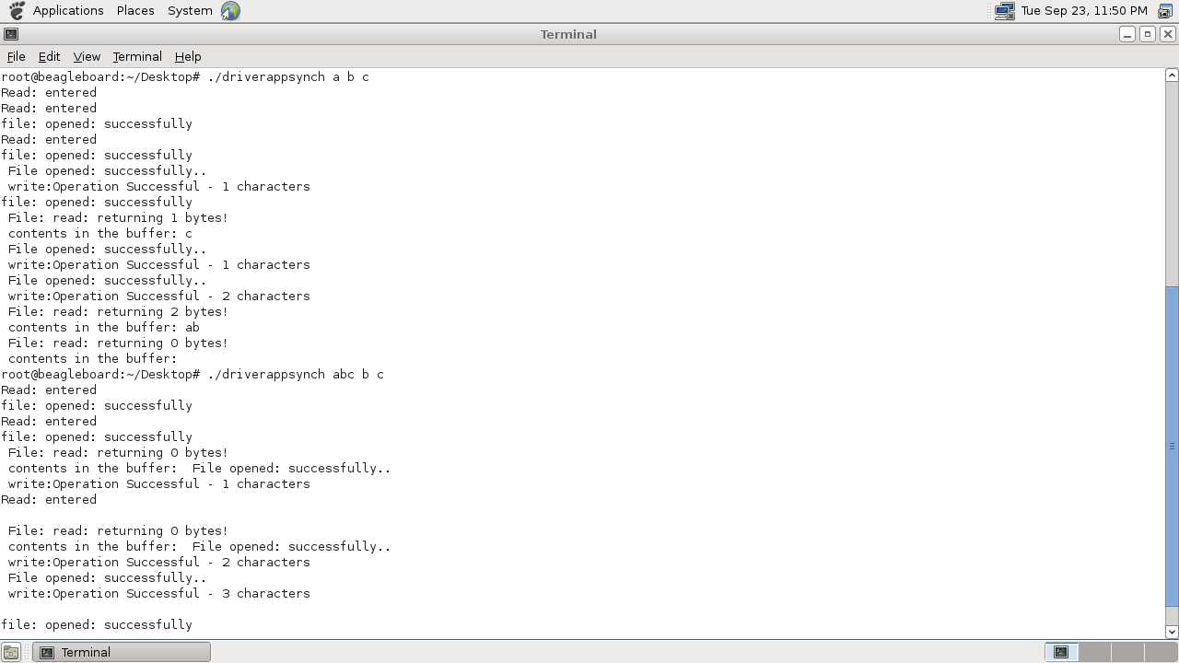

The given screenshot shows the synchronized write and read functions.