**ASSIGNMENT 11**

ARITRA KUMAR LAHIRI

ASU ID: 1207275819

CSE 530 EMBEDDED OPERATING SYSTEM INTERNALS: PROJECT 3b:

**Implementing my kernel driver to provide some services:**

As a part of the final project I have designed the kernel driver in such a way that it does certain string manipulations. Accordingly I have used the functionalities of the projects in 2a, 2b, 2c and 2d and thereby build upon it to do my final project. I have reworked and coded the reader and the writer buffer in such a way that it can read a string input as provided with or without whitespaces, find its length and then reverses the entire string character by character including the whitespaces. I have also used writer application driver to test the functionality of my driver module and shown the output by running the module in the beagle-board. The following screenshot demonstrates the use of the character driver module as it shows the reversal of string function in the screenshot.

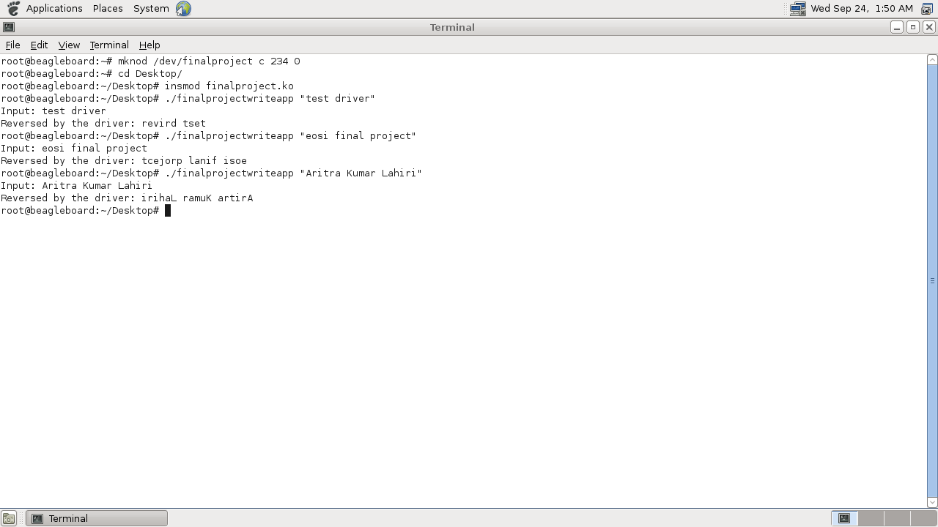

The above screenshot clearly depicts the functionality of my final project report. Attached with this report is my driver application source code as well as the .ko file.