**Circuit Diagram:**

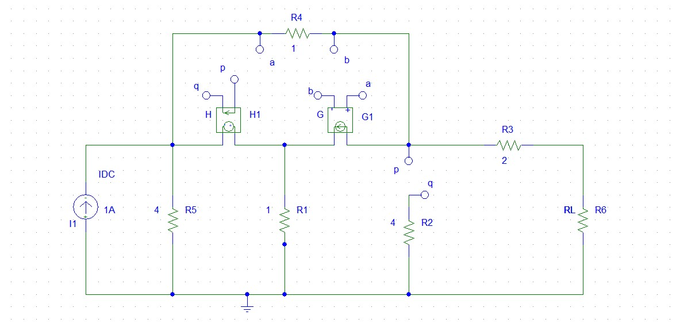

Fig 1: Main Circuit

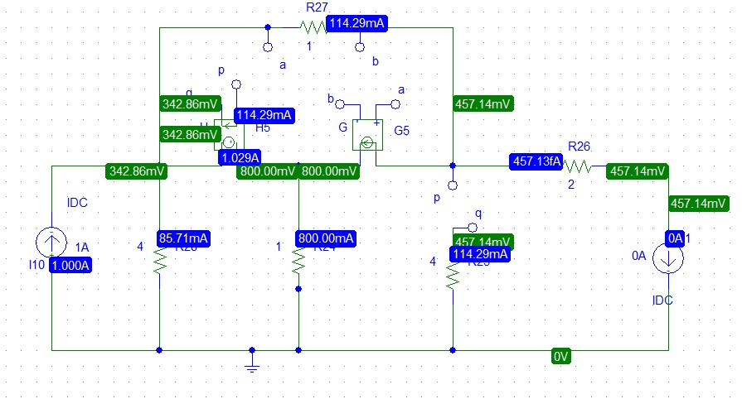

Figure 2: Open Circuit Voltage

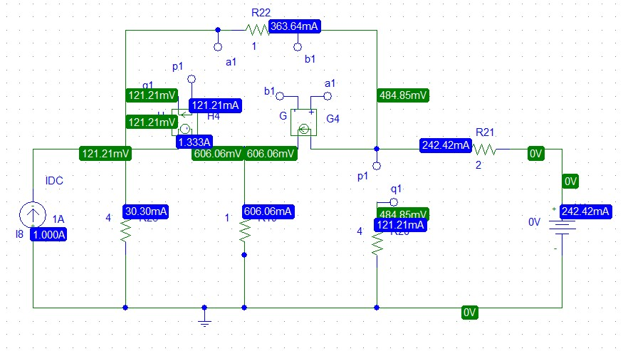

Figure 3: Short Circuit Current

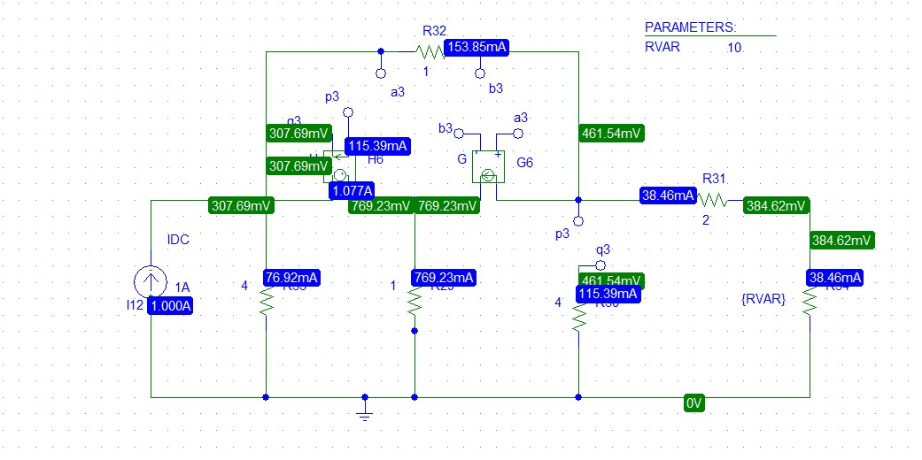

Figure 4: RVAR

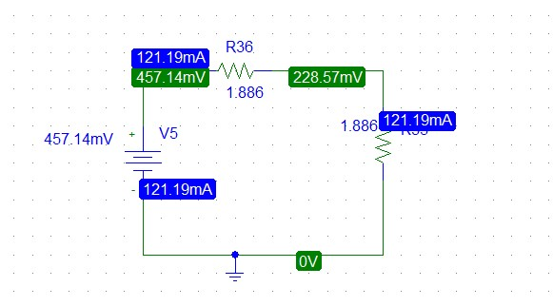

Figure 5: Thevenin Circuit

**Explanation:**

**Step1:**

**Practically:**



Figure 6: Open Circuit Voltage

1. At first, we replaced the load resistance RL with 0 Ampere current source because we want to measure open circuit voltage.

Therefore, we have got VOC **=** VTh = 457.14mV or, 0.457 V.



Figure 7: Short Circuit Current

1. Secondly, we replaced the load resistance RL with 0 Volt voltage source because we want to measure short circuit current.

Therefore, we have got ISC **=** 242.42 mA or, 0.242A.

1. Finally, The formula of RTh is,

RTh =

RTh =

RTh = 1.886 $Ω$

If there is a voltage source and a resistor in series that should be a Thevenin circuit. So, we get Thevenin Circuit,

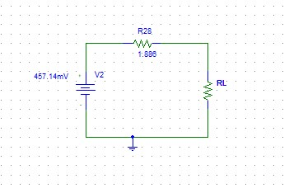

Figure 8: Thevenin Circuit

**Step2:**

**Theoretically:**

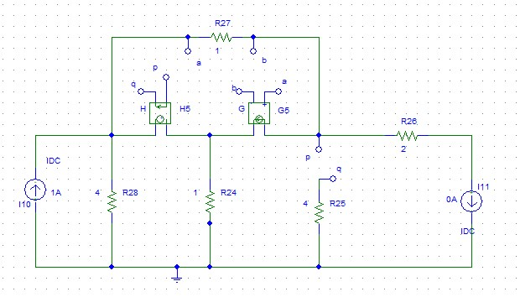

Figure 9: Open Circuit Voltage

Calculating the value of VOC ,

Current dependent voltage source is in between two non refrence node. So,

V2 – V1 = 4Io

V2 – V1 = 4 × ()

V1 - V2 + V3 = 0……………..(1)

Applying KCL at supernode,

1 + 2Vo = + +

1 + 2(V1 – V32) = V1 – V3 + + V2

- V1 + V2 + V3 = 1………….(2)

Applying KCL at node 3,

= 2Vo +

V1 – V3 = 2(V1 – V3) +

V1 - V3 = 0……………..(3)

Solving three equation we get,

V3 = VOC = 0.457V

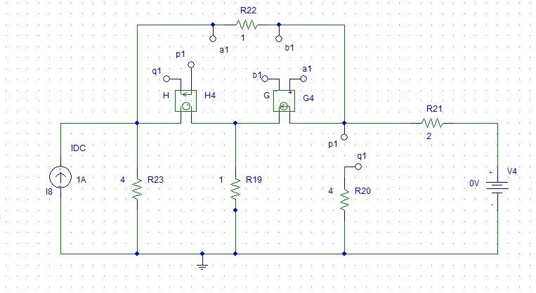

Figure 10: Short Circuit Current

Now, calculating the value of ISC,

Current dependent voltage source is in between two non refrence node. So,

V2 – V1 = 4Io

V2 – V1 = 4 × ()

V1 - V2 + V3 = 0……………..(1)

Applying KCL at supernode,

1 + 2Vo = + +

1 + 2(V1 – V32) = V1 – V3 + + V2

- V1 + V2 + V3 = 1………….(2)

Applying KCL at node 3,

= 2Vo + +

V1 – V3 = 2(V1 – V3) + +

V1 - V3 = 0………..(3)

Calculating three equation we get,

V3 = 0.4848V

So, ISC = = 0.2424A

RTh = = 1.886 $Ω$

Now, if we compare theoretically and PSpice then we get,

From Thevenin circuit in PSpice simulation we get,

RTh = 1.886 $Ω$

VTh = 457.14mV = 0.457V

Moreover, theoretical value and PSpice simulation value are same.

We know, the maximum power Theorem value that is RL = RTh.

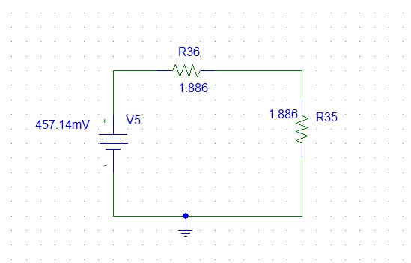

Figure 11: Thevenin Circuit

Now, calculating the value of maximum power,

Pmax =

Pmax =

Pmax = 0.0277W



Figure 12: Thevenin Circuit

From Thevenin Circuit, calculating the maximum value from simulation,

RTh = 1.886 $Ω$

VTh = 457.14mV = 0.457V

Now, calculating the value of maximum power,

Pmax =

Pmax =

Pmax = 0.0277W

**Step3:**

There are some steps to get a graph.

1. In PSpice simulation, we have to set {RVAR} in set attribute value name. Then, we set parameter and set the name as RVAR and the value is any random. Finally, we go to the setup box and select DC sweep. We set global parameter and starting value is 1 and end value is 20 and increment is 0.1.

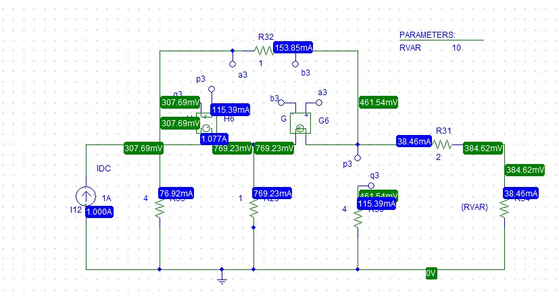

Figure 13: RVAR

Therefore, after simulation we get a graph and RL in X axis and in Y axis, we have to select voltage across RL square and it was divided by RVAR.

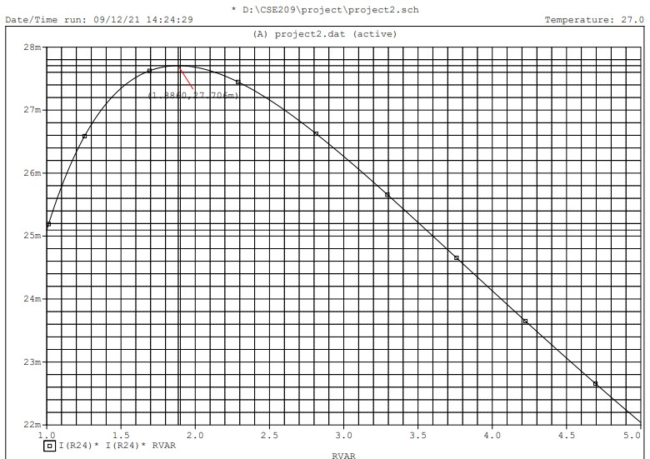

Figure 14: Maximum Power

From that graph, we can measure the value of maximum power and it is also known for what value of RL the maximum power was found. From the graph, we see RL is 1.8860 Ohm and corresponding maximum power is 27.706mW.

**Step4:**

Comparing the value of RL and the maximum power obtained in step 2 and 3

Table 1

|  |  |
| --- | --- |
| **Theoretical values from step-2** | **Simulated values from step-3** |
| RL = 1.886 $Ω$ | RL = 1.8860 $Ω$ |
| Pmax = 0.0277W | Pmax = 27.706mW |

**Conclusion:** There is no discrepancy between the theoretical value and experimental value. Theoretically, we get the maximum power is 0.0277W and in PSpice simulation we get the maximum power is 27.706mW.