**A PROJECT REPORT**

**ON**

**‘IMPACT OF PUBLIC SENTIMENT ON RETURN AND VOLATILITY OF STOCK’**

** **

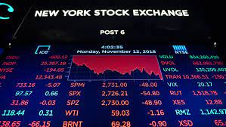

**Submitted to: Submitted by:**

Professor Abhishek Samantray Aritra Maity

(Dept. of Humanities (Dept. of Electrical and

and Social Sciences) Electronics Engineering)

IIT Roorkee NIT Tiruchirappalli

|  |  |
| --- | --- |
| **Topic** | **Page Number** |
| Introduction/Objective | 3 |
| Theory | 3-4 |
| Data | 5 |
| Methods Used | 5-6 |
| Result | 6-11 |
| Discussion | 11 |
| Conclusion and Link | 12 |

**INDEX**

**Introduction/Objective:**

In the digital age, the advent of social media and online news platforms has revolutionized the way information is disseminated and received. This unprecedented accessibility to real-time news and opinions has given rise to a new dimension in financial markets—the influence of public sentiment on stock index returns and volatility. As individuals express their beliefs, emotions, and perceptions about various assets and economic events through social media, news articles, and other channels, the collective sentiment generated can significantly impact market dynamics. The emergence of sentiment analysis tools and techniques has enabled researchers to harness vast amounts of data from social media posts, news articles, and online discussions to quantify and analyse public sentiment in near real-time. This study aims to objectively examine the intricate relationship between public sentiment, derived from diverse online sources, and its subsequent effects on stock index performance. By rigorously investigating this emerging phenomenon, we seek to uncover valuable insights into the role of public sentiment as a potential driver of market fluctuations, offering investors and policymakers a deeper understanding of the multifaceted factors that shape the ever-evolving landscape of the financial world.

**Theory:**

**Understanding Public Sentiment:**

Public sentiment reflects the prevailing mood, perceptions, and attitudes of individual investors, traders, and the broader public concerning financial markets and economic conditions. This sentiment can be positive, characterized by optimism and confidence, or negative, driven by fear and uncertainty. It is often shaped by various factors, including economic indicators, corporate earnings reports, geopolitical events, and societal trends. The emergence of sentiment analysis tools and techniques has enabled researchers to harness vast amounts of data from social media posts, news articles, and online discussions to quantify and analyse public sentiment in near real-time.

**Impact on Stock Index Returns:**

Public sentiment plays a crucial role in influencing investor behaviour. Positive sentiment tends to fuel bullish market sentiments, encouraging greater participation in the stock market, and resulting in higher demand for stocks. Consequently, this heightened demand can lead to an increase in stock prices and drive stock index returns upward. Conversely, negative sentiment can trigger risk-averse behaviour, causing investors to sell off stocks, leading to a decline in stock prices and subsequently lowering stock index returns. As a result, the overall sentiment prevailing in the public domain can create pronounced movements in stock index returns over short to medium-term periods.

**Volatility and Sentiment:**

The relationship between public sentiment and stock index volatility is equally noteworthy. Extreme shifts in sentiment, such as sudden waves of optimism or panic, can amplify market volatility. During periods of high positive sentiment, investors may become excessively optimistic, leading to overvalued assets and creating the potential for sharp market corrections. Conversely, periods of intense negative sentiment can cause heightened market uncertainty, leading to increased price swings and volatility spikes. The unpredictability introduced by such sentiment-driven fluctuations can have significant implications for risk management strategies, portfolio diversification, and overall market stability.

**Sentiment-Driven Feedback Loops:**

The impact of public sentiment on stock index returns and volatility is not unidirectional. Stock market performance, in turn, influences public sentiment, creating a feedback loop. Positive returns tend to reinforce positive sentiment, while negative returns can further amplify negative sentiment. These feedback loops can sometimes lead to market bubbles or crashes, as sentiment-driven behavior perpetuates self-reinforcing cycles.

**Data:**

* **News Headlines:** <https://drive.google.com/file/d/1vs0M12KI2flEJoKtqHM2VNkp_w5tCxnY/view?usp=sharing> (Description:- This is a collection of the top 10 viewed articles on a particular day, ranked accordingly. The label column is indicated with either 0 or 1. 0 indicates that the closing index fell down and 1 indicates that that the closing index had risen up)
* **Stock Index:**

The stock index was downloaded directly into the notebook using the yfinance (Yahoo Finance) Python module. The Dow Jones Industrial Average Index was downloaded for a certain range of date.

**Methods Used:**

The project was divided in two parts: -

* **Using Sentiment Intensity Analyser and Linear Discriminant Analysis Model**

In this method we used the News headlines and Labels provided in the csv. The news csv was merged with the stock index csv and the Subjectivity and the Polarity scores were calculated for each day using the TextBlob module (an API for common NLP task) . The Polarity scores lie between -1 to 1 where 1 is a positive overall news and -1 is a negative overall news. The Subjectivity score lie in between 0 to 1 where 1 implies an overall Subjective news (Based on personal opinions, emotion, judgement) and 0 implies an overall Objective news (Based on factual information). Then the news was divided into positive, negative and neutral percentages using the Sentiment Intensity Analyser from the vaderSentiment module. The data is then divided into training and testing dataset. Linear Discriminant Analysis (closely related to ANOVA and regression analysis) was then used to fit the training dataset and run the model on the testing datasets. The model summary shows how well the model could predict the rising and falling of stock index by defining various parameters.

* **Using the ARIMA model to predict the subsequent stock index values**

We are using the ARIMA model for this part. First the Dickey Fuller test was performed to check for the stationarity of the time series of stock index. The auto_arima was used from the pmdarima module which provided the values of p,d,q for the ARIMA model. These values were fit in to get the ARIMA model. The closing value of the stock index was divided into train and test datasets which were then pu in the ARIMA model to get the predicted values. Various parameters like the R2 score and mean square value are calculated. Also the future values could be predicted by providing the future dates.

Both the Sentiment Analysis and the ARIMA model when used together would provide us with the accurate measurements and prediction. We can check using the Sentiment Analysis scores the degree at which the news headlines might affect the stock index along with the ARIMA model giving us the numerical value of rise and drop of the values.

**Result:**

The following results were obtained after performing the analysis of Dow Jones Index:

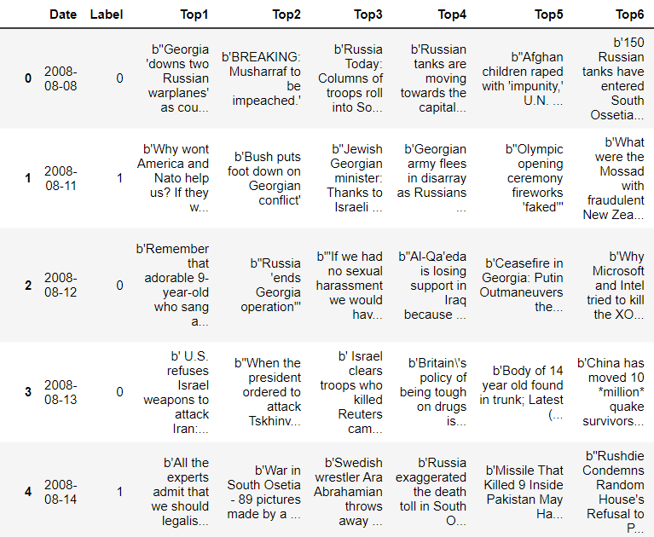

Given news headlines with with the labels (0 or 1)

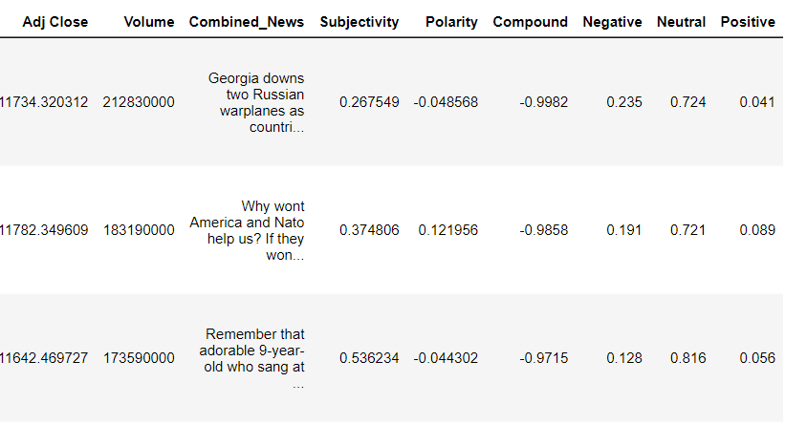

Calculated Polarity, Subjectivity scores along with degree of sentiment (positive, negative and neutral score)

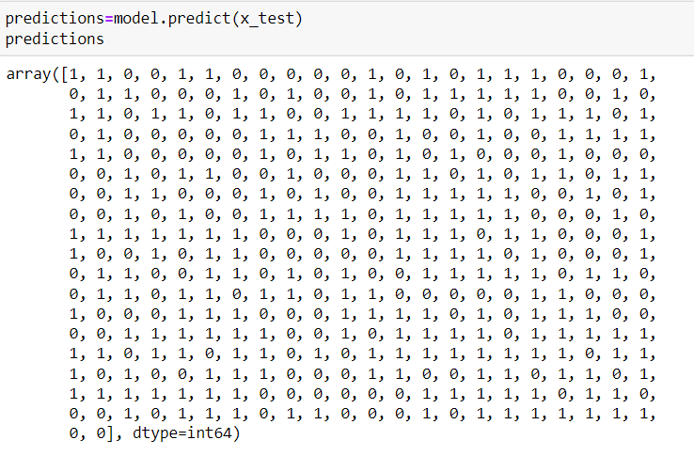

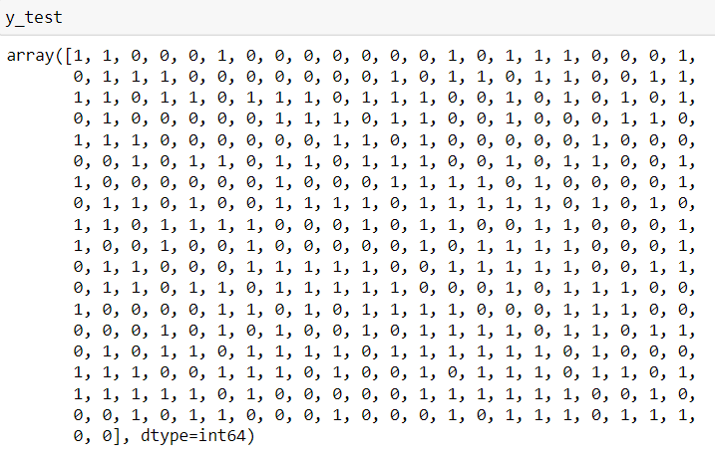

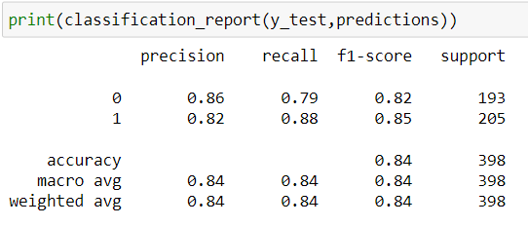

Above we can see different values of the labels. Comparison of the test dataset x_test and y_test shows some of the values not matching with each other(as model is not 100% accurate). The recall, precision and f1- scores are given for the y_test and the prediction set (derived from x_test). The model gives an accuracy of 84% which is decent and can be improved. The value 0 indicates stock index going down whereas 1 indicates that the stock index is rising.

Dow Jones Industrial Average Stock Index (2008-2017)

Dickey Fuller Test along with ARIMA model selection using autoarima function.

ARIMA model summary with number of observations.

Predicted values of the ARIMA Model for the stock index

Future values of the stock index provided by the model

**Discussion: -**

**How can the above analysis be helpful for a particular individual or a company?**

The stock index gives an overall view of how the market is performing. Whether the company/individual should start investing on certain stocks depends on the trend of the graph. Any news which hampers the market trend can be detrimental for the company/individual. Therefore, if the rise or fall of the index can be predicted using only the news headlines it would be beneficial for the company to gain larger profits or incur less losses by buying growing stocks or selling it at the right time. In the above workings, the Sentiment Analysis was performed which gave us the information whether the market would go up or down. Similarly fresh news headlines can be put in the model to give a fair idea of the situation. To get a more factual analysis the use of ARIMA model is established. It gives near accurate values of the actual stock index and also helps in predicting the future values of the index. Hence it is required to use both the Sentiment Analyser as well as the ARIMA model so that companies can plan whether to invest more or invest less according to the current situation.

**Conclusion: -**

In conclusion, the advent of the digital age and the proliferation of online platforms have given rise to a new paradigm in financial markets, where public sentiment plays a pivotal role in shaping stock index returns and volatility. Understanding the dynamics of sentiment and its potential impact on market outcomes is of paramount importance for investors, traders, and policymakers alike. By recognizing the power of public sentiment in influencing market behaviour, stakeholders can make more informed decisions and develop strategies that adapt to the ever-changing sentiment landscape, promoting greater market resilience and stability in the face of evolving investor sentiments.

**Link to GitHub Repository: -**

<https://github.com/Aritra5323/Sentiment_Analysis_Stock_Index>