Technical Memorandum
Temporal, Weather, and User-Type Drivers of Bike-Sharing Demand in Washington, D.C.
Item | Detail
Dataset | UCI Bike Sharing Dataset — hourly records, Capital Bikeshare, Washington, D.C.
Period covered | 1 January 2011 – 31 December 2012 (17,379 hourly observations)
Prepared for | Technical Assessment — Data Analytics, Statistics & Predictive Modeling
Date | 17 September 2026

1. Executive Summary
This memorandum analyzes two years of hourly Capital Bikeshare rental records to characterize demand patterns and to build models that explain and forecast hourly rental volume (count). Three tasks are addressed: (1) descriptive/exploratory analysis of temporal, weather, and user-type patterns; (2) inferential regression analysis of the drivers of demand and the statistical issues that arise; and (3) an out-of-sample forecasting exercise using a leakage-safe temporal train/test split (days 1–20 train, days 21–end test, within every month).
Key findings:
- Demand is heavily right-skewed (mean 189 vs. median 142 rentals/hour) and is a count variable, not a continuous Gaussian one — ordinary least squares (OLS) is systematically misspecified, and Negative Binomial regression is preferred over Poisson due to severe overdispersion (deviance/df ≈ 117).
- Registered users dominate volume (81.2% of rentals) and drive the commute-hour bimodal pattern (peaks at 08:00 and 17:00–18:00); casual users are more weekend- and leisure-oriented, peaking in the early-to-mid afternoon.
- Temperature is the strongest single driver of demand (Pearson r with cnt is the largest among weather variables); humidity is negatively associated with demand; hour-of-day, season, and weather situation are all highly significant categorical drivers (ANOVA p < 0.001).
- For forecasting, gradient-boosted trees (XGBoost) sharply outperform the statistical Negative Binomial baseline (test RMSE ≈ 59–60 vs. 110.8; R² ≈ 0.89 vs. 0.63). A 168-hour (weekly) rolling-mean feature, computed strictly from information available before the forecast window, gives the best result (RMSE 59.52, R² 0.892), though the gain over the model with no lag features at all is modest — calendar and weather covariates already explain most of the variance.

2. Task 1 — Descriptive Statistics & Exploratory Analysis

2.1 Data Quality & Structure
The hourly dataset contains 17,379 records spanning 2011-01-01 to 2012-12-31 with 17 fields and no missing values or duplicate rows. All numeric weather covariates (temp, atemp, hum, windspeed) are pre-normalized to [0,1]. As a consistency check, casual + registered was verified to equal cnt for every one of the 17,379 rows, confirming the two components are exhaustive and additive.

2.2 Distribution of Rental Demand
Hourly rental count (cnt) has mean 189.46, median 142, variance ≈ 32,901, and skewness 1.28 — a pronounced right skew consistent with a small number of very high-demand hours (rush hours, good-weather afternoons) alongside a large mass of low-demand overnight hours. A log(1+cnt) transform substantially symmetrizes the distribution, motivating the count-regression treatment used in Task 2.
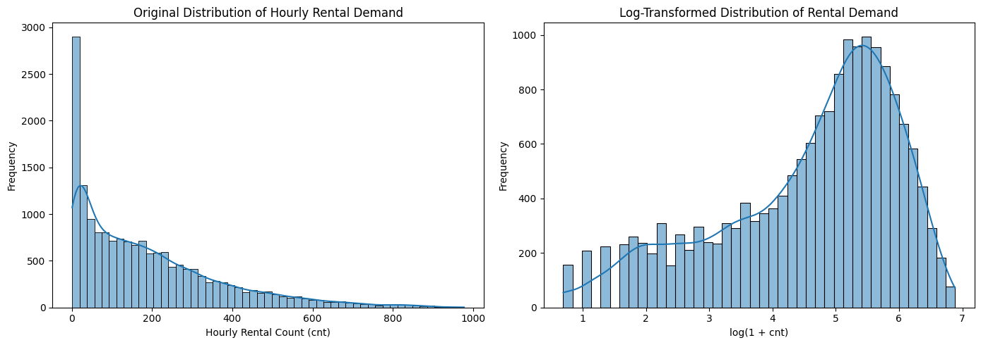
Figure 1. Hourly rental demand — raw (left, right-skewed) vs. log-transformed (right).

2.3 Casual vs. Registered Users
Across the full period, registered users account for 2,672,662 rentals (81.2%) versus 620,017 (18.8%) for casual users. The two groups follow markedly different temporal signatures: registered rentals show a sharp bimodal commuting pattern peaking near 08:00 and 17:00–18:00, while casual rentals rise gradually through the day and peak in the early afternoon (roughly 12:00–16:00), consistent with leisure/tourist usage.
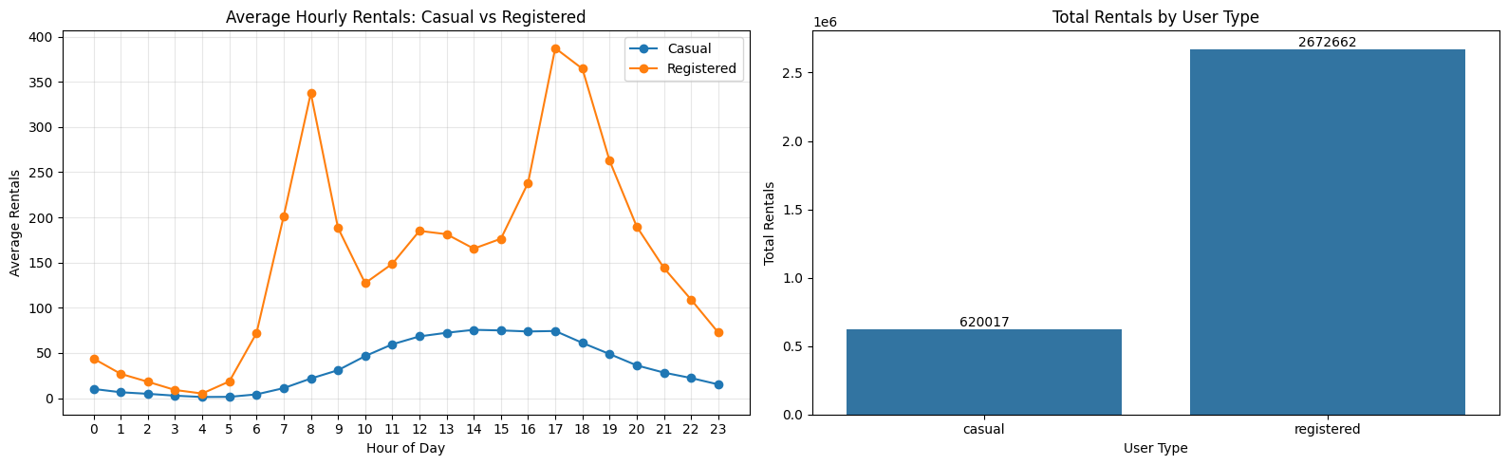
Figure 2. Average hourly rentals by user type (left) and total rentals by user type (right).
This asymmetry is confirmed by working-day averages: average casual rentals fall from 57.4/hour on non-working days to 25.6/hour on working days, while registered rentals rise from 124.0/hour to 167.6/hour — a clear substitution between commute-driven and leisure-driven demand.

2.4 Temporal Patterns
Hour-of-day is the single strongest categorical driver of demand in a one-way ANOVA (F = 759.1, p < 0.001), followed by season (F = 409.2, p < 0.001), month (F = 128.1, p < 0.001), weather situation (F = 127.2, p < 0.001) and weekday (F = 3.5, p = 0.0019 — a much weaker but still significant effect). Working vs. non-working days show visibly different hourly shapes (a single midday hump on weekends/holidays vs. the commute double-peak on working days), and demand is highest in fall/summer and lowest in winter/spring, tracking temperature.
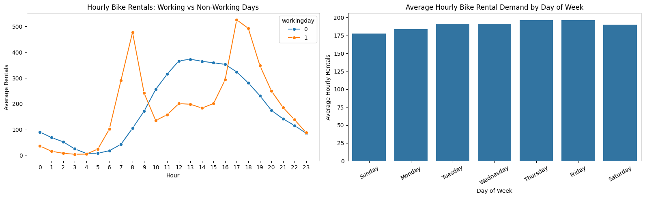
Figure 3. Hourly demand by working-day status (left) and average demand by day of week (right).

2.5 Weather Effects
Rental demand declines monotonically as weather worsens (clear → mist/cloudy → light precipitation → heavy precipitation), with the heavy-rain/snow category both rare and associated with the lowest median counts. Demand rises broadly with temperature up to a point before leveling off at the highest normalized values (consistent with the mild non-linearity discussed in Task 2), and is dispersed but negatively associated with humidity and, more weakly, with wind speed.
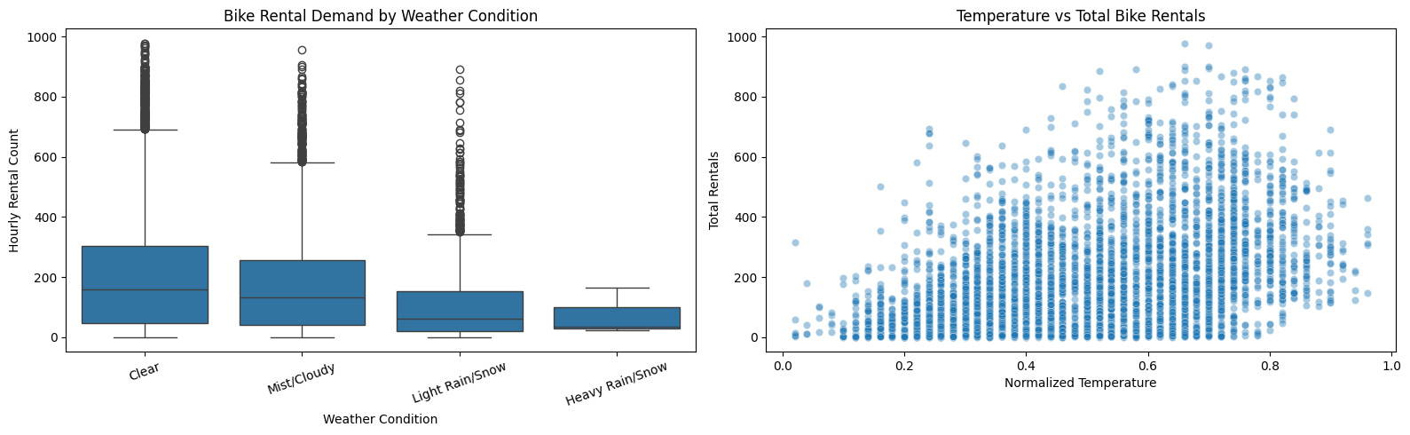
Figure 4. Rental demand by weather condition (left) and vs. normalized temperature (right).

3. Task 2 — Statistical & Regression Analysis

3.1 Variable Screening: Correlation and Multicollinearity
Pearson and Spearman correlations among the continuous predictors (temp, atemp, hum, windspeed) and cnt were used as a screening step, alongside variance inflation factors (VIF) to check multicollinearity before model specification. As expected, temp and atemp are extremely highly correlated (near-collinear, since 'feels-like' temperature is derived from temperature); only one of the two is retained in the regression models to avoid redundancy. Humidity and wind speed carry acceptable VIFs and were retained alongside temperature.
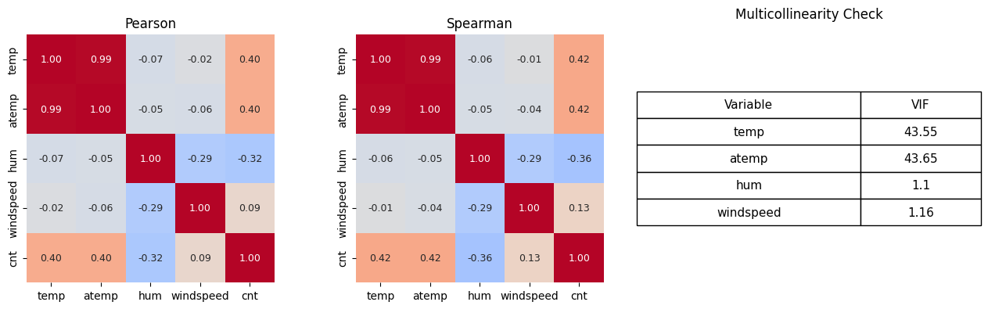
Figure 5. Pearson (left) and Spearman (center) correlation heatmaps, and VIF diagnostics (right).

3.2 Categorical Drivers (ANOVA)
Variable | ANOVA F | p-value
Hour of Day | 759.09 | < 0.001
Weekday | 3.49 | 0.0019
Month | 128.10 | < 0.001
Season | 409.18 | < 0.001
Weather Situation | 127.17 | < 0.001

3.3 Non-Linearity Check
Binning each continuous predictor into decile groups and comparing linear vs. quadratic OLS fits shows mild but real non-linearity, most notably for temperature and humidity: adding a quadratic term improves AIC for all three variables, with the largest relative gain for wind speed and the largest absolute R² improvement remaining modest overall — the dominant relationship is monotone rather than strongly curved.
Variable | Linear R² | Quadratic R² | Linear AIC | Quadratic AIC
temp | 0.1638 | 0.1640 | 226,976.45 | 226,974.74
hum | 0.1043 | 0.1054 | 228,172.44 | 228,152.01
windspeed | 0.0087 | 0.0122 | 229,934.45 | 229,875.31

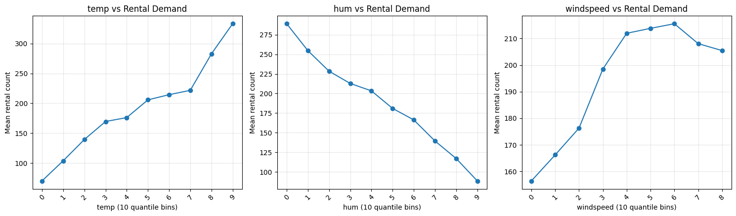
Figure 6. Mean rental count across decile bins of temperature, humidity, and wind speed.

3.4 Binary Predictors (Welch's t-test)
Variable | Group 1 | Group 2 | Welch t | p-value
Workingday | Working day | Non-working day | 4.095 | 4.25e-05
Holiday | Non-holiday | Holiday | 4.694 | 3.40e-06
Year | 2011 | 2012 | -34.181 | 1.38e-246

All three binary factors are statistically significant, though the year effect dwarfs the others (t = -34.2): overall ridership grew substantially from 2011 to 2012, reflecting system growth/adoption rather than a seasonal or weather effect — this motivates including yr as a control in the forecasting models in Task 3.

3.5 Regression Models and Diagnostics
An OLS model (cnt ~ temp + hum + windspeed + season + weathersit + workingday + holiday) was fit as a baseline. It explains only a modest share of variance (R² = 0.283) and its residual diagnostics show clear heteroscedasticity (residual spread widening with fitted values) and non-normal, heavy-tailed residuals — expected for strictly non-negative, over-dispersed count data. A Poisson GLM was then fit and rejected on distributional grounds: its deviance-to-degrees-of-freedom ratio is 117.17, far above the value of ≈1 expected under the Poisson assumption, indicating severe overdispersion. A Negative Binomial (NB) GLM, which adds a dispersion parameter to absorb this excess variance, is therefore the preferred inferential model.
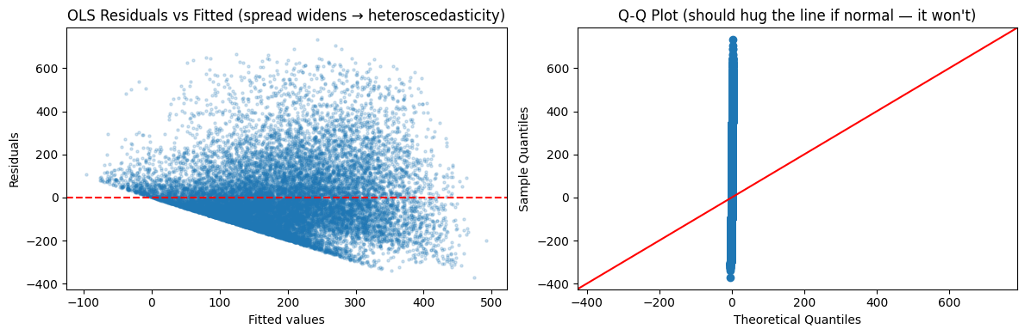
Figure 7. OLS residuals vs. fitted values (heteroscedasticity) and Q-Q plot (non-normal residuals).
OLS coefficients (selected)
Term | Coef. | p-value | Interpretation
temp | 454.79 | < 0.001 | Strongest positive driver of raw count
hum | -286.65 | < 0.001 | Strong negative driver
windspeed | 31.65 | 0.002 | Small positive effect
season = fall | -43.40 | < 0.001 | Lower than spring baseline
season = winter | 57.09 | < 0.001 | Higher than spring baseline
weather = mist/cloudy | 17.02 | < 0.001 | Modest increase vs. clear
weather = heavy rain/snow | 104.82 | 0.238 | Not significant (very rare category)

Negative Binomial GLM (log link) — incidence rate ratios (IRR)
Term | Coef. (log) | IRR = eᶜᵒᵉᶠ | p-value
Intercept | 4.539 | 93.6 | < 0.001
temp | 2.680 | 14.58× | < 0.001
hum | -1.525 | 0.22× | < 0.001
windspeed | 0.191 | 1.21× | 0.004
season = fall | -0.217 | 0.81× | < 0.001
season = winter | 0.386 | 1.47× | < 0.001
weather = mist/cloudy | 0.155 | 1.17× | < 0.001
weather = light rain/snow | -0.111 | 0.89× | < 0.001

The IRR reading is multiplicative: moving temperature from its minimum to maximum normalized value multiplies expected demand by roughly e^2.68 ≈ 14.6× holding other covariates fixed (an extreme, mostly out-of-sample comparison; realistic within-range moves are smaller), while a one-unit increase in normalized humidity is associated with a ~78% reduction in expected demand. Together, the OLS and NB results agree on sign and relative importance of drivers (temperature dominant and positive, humidity strongly negative, wind speed weak positive, fall/winter seasonal shifts, deteriorating weather reduces demand); the NB model is preferred for inference and prediction because it correctly models cnt as a non-negative, over-dispersed count outcome rather than as continuous and homoscedastic.

4. Task 3 — Demand Forecasting & Predictive Modeling

4.1 Train/Test Partitioning and Leakage Control
Per the assessment specification, the first 20 days of every month were assigned to the training set and days 21 through month-end to the test set, applied uniformly across both years (11,460 training observations spanning 2011-01-01 to 2012-12-20; 5,919 test observations spanning 2011-01-21 to 2012-12-31). Because the split interleaves many short train/test blocks across the two-year horizon rather than a single chronological cut, any lag or rolling-window feature must be computed using only information that would genuinely have been available before the forecast point — using future values (even from the same month) would leak information across the train/test boundary.
To enforce this, temporal features (24-hour and 168-hour/weekly lags and rolling means) were built from a series in which test-period target values are masked to NaN before computing shifts/rolls, so no test-period cnt value can contaminate a feature. At inference time, a recursive multi-step forecasting procedure walks forward hour-by-hour through the test window: each new prediction is written back into the 'known' series so that subsequent lag/rolling features for later test hours are built from the model's own prior predictions (or from genuine train-period history when close enough to day 20), never from actual held-out targets.

4.2 Evaluation Metric(s)
Three complementary metrics were used: Mean Absolute Error (MAE, interpretable in rentals/hour and robust to outliers), Root Mean Squared Error (RMSE, penalizing large misses more heavily — relevant for capacity/rebalancing decisions), and R² (share of variance explained, for cross-model comparability). RMSE was used as the primary ranking criterion since large under-forecasts during demand spikes are operationally costlier than many small errors.

4.3 Feature Engineering
The base feature set uses only information already required by the model at prediction time: hour, weekday, month, season, weather situation, temperature, humidity, wind speed, holiday, working-day, and year flags. On top of this base set, seven experiments add leak-safe temporal features individually and in combination: 24-hour lag, 168-hour (weekly) lag, 24-hour rolling mean, 168-hour rolling mean, and combinations of the two lag and two rolling-mean features.

4.4 Model Architecture & Training Setup
Two model families were compared. (1) A Negative Binomial GLM (the Task 2 inferential model, refit on the training partition only) serves as a statistical baseline, using only the base feature set. (2) Gradient-boosted trees (XGBRegressor: 500 trees, max depth 6, learning rate 0.05, 80% row/column subsampling, squared-error objective) were trained once per feature-set experiment on the training partition, then evaluated on the test partition — using direct one-shot prediction for the no-lag base model, and the leak-safe recursive multi-step procedure described above for every model that includes lag or rolling-window features.

4.5 Empirical Results
Model / Feature Set | MAE | RMSE | R²
Rolling-168 only | 37.54 | 59.52 | 0.892
Rolling-24 only | 36.84 | 59.80 | 0.891
XGBoost base (no lags) | 36.98 | 59.88 | 0.891
All rolling (24+168) | 37.93 | 60.18 | 0.890
Lag-168 only | 39.85 | 69.05 | 0.855
Lag-24 only | 44.23 | 78.53 | 0.812
All lags (24+168) | 46.57 | 81.88 | 0.796
Negative Binomial GLM (baseline) | 68.17 | 110.80 | 0.626

Two patterns stand out. First, every XGBoost variant substantially outperforms the statistical NB baseline (RMSE roughly halved), confirming that non-linear interactions among hour, weather, and calendar features — which the additive NB-GLM cannot capture — carry real predictive value. Second, within the XGBoost family, smoothed rolling-mean features beat single-point lag features (e.g., Rolling-168 RMSE 59.52 vs. Lag-168 RMSE 69.05): a single lagged observation is noisy, whereas a weekly or daily rolling average better represents the recent demand regime. Notably, the base model with no temporal features at all (RMSE 59.88) is nearly indistinguishable from the best rolling-feature model (RMSE 59.52) — most of the predictable signal is already captured by hour-of-day, calendar, and weather covariates, and the recursively-generated lag/rolling features add only a modest further gain given the leakage constraints imposed by the multi-block train/test design.
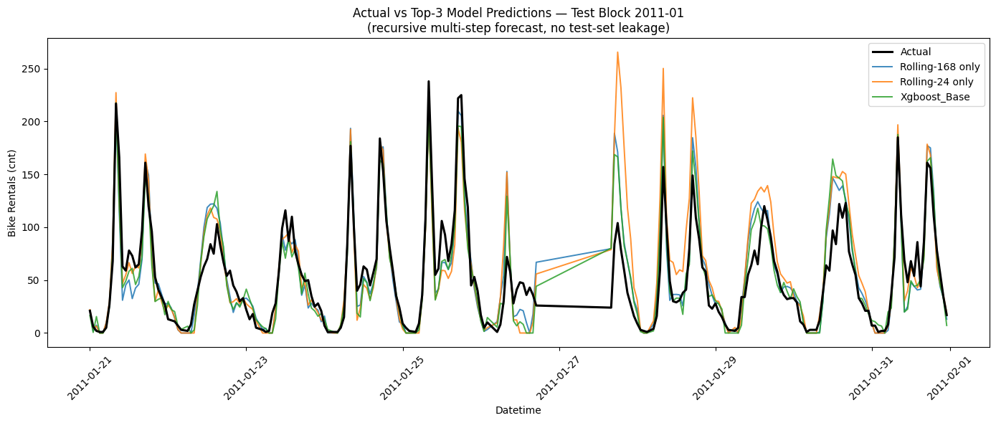
Figure 8. Actual vs. predicted hourly counts for the top-3 models, first test block (recursive multi-step forecast).

5. Conclusions & Recommendations
- Treat rental count explicitly as an over-dispersed count outcome: Negative Binomial regression is appropriate for interpretable inference on driver effects; OLS understates uncertainty and misrepresents the error structure.
- Temperature, humidity, hour-of-day, season, weather situation, and year are all robust, statistically significant drivers of demand and should anchor any operational forecasting or rebalancing model.
- Casual and registered users have distinct temporal signatures (leisure midday vs. commute double-peak) and are worth modeling or capacity-planning separately where the business use case allows (e.g., station rebalancing before the morning/evening commute vs. weekend leisure corridors).
- For operational forecasting under the specified train/test protocol, gradient-boosted trees with a 168-hour rolling-mean feature, computed with strict leak controls, gave the best out-of-sample accuracy (RMSE 59.5, R² 0.89) and are recommended over both the NB-GLM baseline and simple point-lag features.
- Because the gain from temporal (lag/rolling) features over the no-lag base model is modest under this partitioning scheme, further improvement is more likely to come from richer weather/calendar interactions or external data (e.g., local events, precipitation intensity) than from more elaborate lag engineering alone.

