Software architecture of the NarrowAisleBot platform under ROS 2
Working notes, October 2026. The diagrams were derived from the code and launch files in the repository. All robot measurements are the most recent recorded values, up to 1 Oct 2026.
The robot uses three computing units. A Raspberry Pi 5 runs ROS 2 Jazzy and makes all high-level decisions. An ESP32 executes the wheel-speed control loop at 100 Hz. An Arduino Mega controls the arm and the UV tubes. The ESP32 and the Mega each connect to the Pi over a serial link, at 921600 baud and 115200 baud respectively.

1. Operating system and ROS 2 installation
The Pi runs Ubuntu 24.04.4 LTS (Noble Numbat), 64-bit ARM. This is the Ubuntu release targeted by ROS 2 Jazzy. The release can be checked with lsb_release -a, and uname -m should report aarch64.
lsb_release -a
uname -m
ROS 2 was installed from the binary apt packages rather than built from source, which avoids a lengthy compilation on the Pi. The ros-base variant was chosen over the desktop variant because the robot normally operates headless and Foxglove Studio provides the visual debugging. The installation sequence was as follows.
sudo apt update && sudo apt upgrade -y
sudo apt install -y locales software-properties-common curl
sudo locale-gen en_US en_US.UTF-8
sudo update-locale LC_ALL=en_US.UTF-8 LANG=en_US.UTF-8
export LANG=en_US.UTF-8
sudo add-apt-repository universe
sudo curl -sSL https://raw.githubusercontent.com/ros/rosdistro/master/ros.key \
-o /usr/share/keyrings/ros-archive-keyring.gpg
echo "deb [arch=$(dpkg --print-architecture) signed-by=/usr/share/keyrings/ros-archive-keyring.gpg] \
http://packages.ros.org/ros2/ubuntu $(. /etc/os-release && echo $UBUNTU_CODENAME) main" | \
sudo tee /etc/apt/sources.list.d/ros2.list > /dev/null
sudo apt update
sudo apt install -y ros-jazzy-ros-base ros-jazzy-joy python3-colcon-common-extensions
echo "source /opt/ros/jazzy/setup.bash" >> ~/.bashrc
This sequence installs the core packages, the joystick driver and colcon. The remainder of the stack requires a second apt command (Nav2, slam_toolbox, twist_mux, Foxglove Bridge and Cyclone DDS, which replaces the default middleware), pyserial for the two serial bridges, and membership of the dialout group so that the user can open /dev/esp32 and /dev/mega. The group change takes effect only after the user logs out and back in.
sudo apt install -y ros-jazzy-navigation2 ros-jazzy-nav2-bringup ros-jazzy-slam-toolbox \
ros-jazzy-twist-mux ros-jazzy-foxglove-bridge ros-jazzy-rmw-cyclonedds-cpp
pip3 install pyserial --break-system-packages
sudo usermod -a -G dialout $USER
The YDLIDAR driver is not available through apt. The script install.sh builds the YDLIDAR SDK from source and clones ydlidar_ros2_driver alongside it. The workspace is then built with colcon. Because the build uses --symlink-install, edits to Python files do not require a rebuild; only changes to setup.py or package.xml do.
cd ~/ros2_ws && colcon build --symlink-install

2. System overview
Solid boxes denote components started at boot. Dashed boxes denote components started on demand: mapping from the MAP button on the phone, and Nav2 manually. Grey boxes denote hardware.
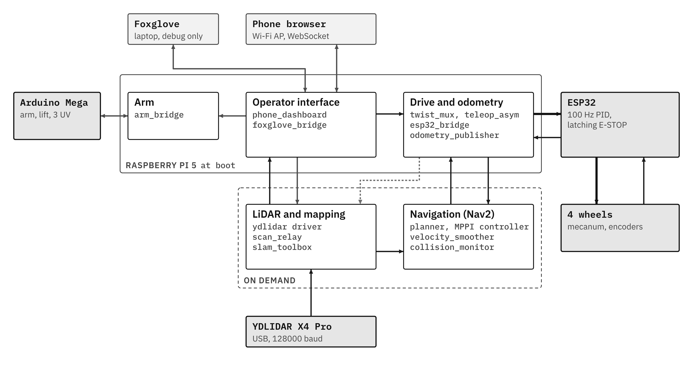

3. Boot sequence and launch structure
At boot, systemd runs start_aislebot.sh. The script sets ROS domain 42 with Cyclone DDS on loopback, waits for the ESP32 (aborting after 30 s) and the Mega (warning after 15 s), and then launches 11 processes. Mapping must be started before Nav2; otherwise the global costmap rejects the map until one arrives.
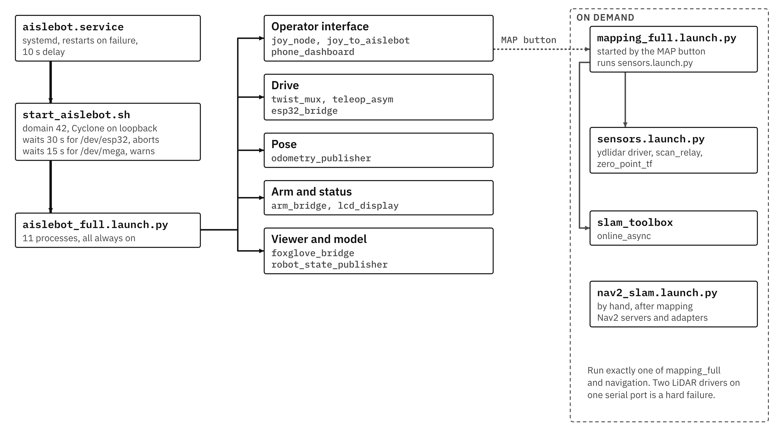

4. Node inventory and rationale
Nodes marked (ours) were written for this robot. All other nodes are standard ROS 2 or Nav2 packages.

Running at boot
Node | What it does | Rationale
phone_dashboard (ours) | Web page served to the phone over the robot's own Wi-Fi: joystick, E-STOP, arm and UV buttons, live map and scan, tap-to-goal, start and stop mapping, CSV logs. | The phone serves as the operator console, so no laptop or gamepad is needed on the floor.
joy_node, joy_to_aislebot | Read a USB gamepad and turn sticks and buttons into drive and arm commands. | Backup control path. No gamepad is currently fitted.
twist_mux | Picks between manual and Nav2 commands. Manual priority 100, Nav2 10; each source dropped after 0.5 s of silence. | Manual control always takes precedence over the planner, which prevents conflicting commands to the wheels.
teleop_asym (ours) | Inverse kinematics for the asymmetric base: body velocity (vx, vy, wz) to four wheel speeds. | The wheelbase is not rectangular, so the standard mecanum equations would give incorrect wheel speeds.
esp32_bridge (ours) | Serial link to the ESP32 at 921600 baud: wheel-speed setpoints out, 20 Hz telemetry in, E-STOP forwarded. Sends zero speeds after 0.5 s without input. | Keeps the real-time loop on the microcontroller and all other processing in ROS.
odometry_publisher (ours) | Integrates measured wheel speeds into position and heading. Publishes /wheel_odom and the odom to base_link transform. | The only pose source. The robot has no IMU, and SLAM scan matching is disabled.
arm_bridge (ours) | Serial link to the Mega at 115200 baud: arm and lift velocity, homing, UV tube sequence. Own 300 ms watchdog. | Keeps stepper timing and relay switching off the Pi.
lcd_display (ours) | Shows the Pi's IP address and network mode on the 16x2 LCD every 2 s. | The robot operates headless, so the display is used to find its address on the network.
robot_state_publisher | Publishes the fixed transforms in the URDF, including where the LiDAR sits. | SLAM and Nav2 require the position of the sensor relative to the robot centre.
foxglove_bridge | Streams every topic to Foxglove Studio on a laptop. | Debugging only. It is the one place where the costmaps, the plan and the collision monitor can be inspected live.

Started with mapping
Node | What it does | Rationale
ydlidar driver | Talks to the YDLIDAR X4 Pro over USB and publishes /scan, measured at about 11.4 Hz. | Vendor driver, used as supplied.
scan_relay (ours) | Undoes the sensor's mirrored bearing, blanks the 90 degree arc hidden by the rear mast (107 beams, set to NaN), republishes as RELIABLE. | Without it, the map is mirrored, the mast appears as an obstacle, and SLAM and the costmaps (which subscribe RELIABLE) receive no scans.
slam_toolbox | Builds the occupancy-grid map; publishes /map and the map to odom correction. | The robot operates in unknown space and must build the map on which it plans.
zero_point_tf | Static marker at the map origin. | Provides a repeatable start position for tests.

Started with Nav2
Node | What it does | Rationale
bt_navigator | Runs Nav2's stock behaviour tree: plan, follow, and on failure clear costmaps, spin, back up, retry. | Standard Nav2, unmodified.
planner_server | NavFn with A* on the global costmap; may plan through unknown cells. | The map continues to grow while the robot drives.
controller_server | MPPI on a 3 x 3 m rolling local costmap. Turns the path into velocity commands. | Its Omni motion model samples lateral velocity directly, which a mecanum base requires.
behavior_server | Recovery moves: Spin, BackUp, Wait. | On this robot, BackUp is a 0.30 m strafe to the left, because Nav2 assumes +X is forward whereas +X is right here.
velocity_smoother | Caps speed at 0.12 m/s and 0.30 rad/s, limits acceleration (0.3 m/s² up, 0.5 down), stops after 1 s without input. | Provides smooth, bounded commands regardless of the controller output.
collision_monitor | Projects the footprint 1.2 s ahead along the command; slows or stops if laser points fall inside. | A final check before the wheels, based on the live scan rather than the map.
cmd_vel_axis_adapter (ours) | Rotates the command from map axes (+X right, +Y forward) to wheel axes (+X forward, +Y left). | Upstream nodes use one axis convention and the wheel kinematics use another, so a translation step is required.
goal_pose_adapter (ours) | Turns a tap on the dashboard map into a Nav2 goal. | Lets the phone set goals.
smoother_server, waypoint_follower, lifecycle_manager | Path smoothing, multi-goal runs, and bringing the Nav2 servers up in order. | These belong to the standard Nav2 set and have not been used extensively.

5. Drive command path from two sources to the wheels
Manual commands take precedence while they are being published and lose it 0.5 s after the last message. Commands from Nav2 reach the wheels only after passing through velocity_smoother and collision_monitor. The E-STOP button on the dashboard zeroes the drive, sends <S> to the ESP32 (where it latches in firmware), stops the arm, cancels any Nav2 goal and stops mapping.
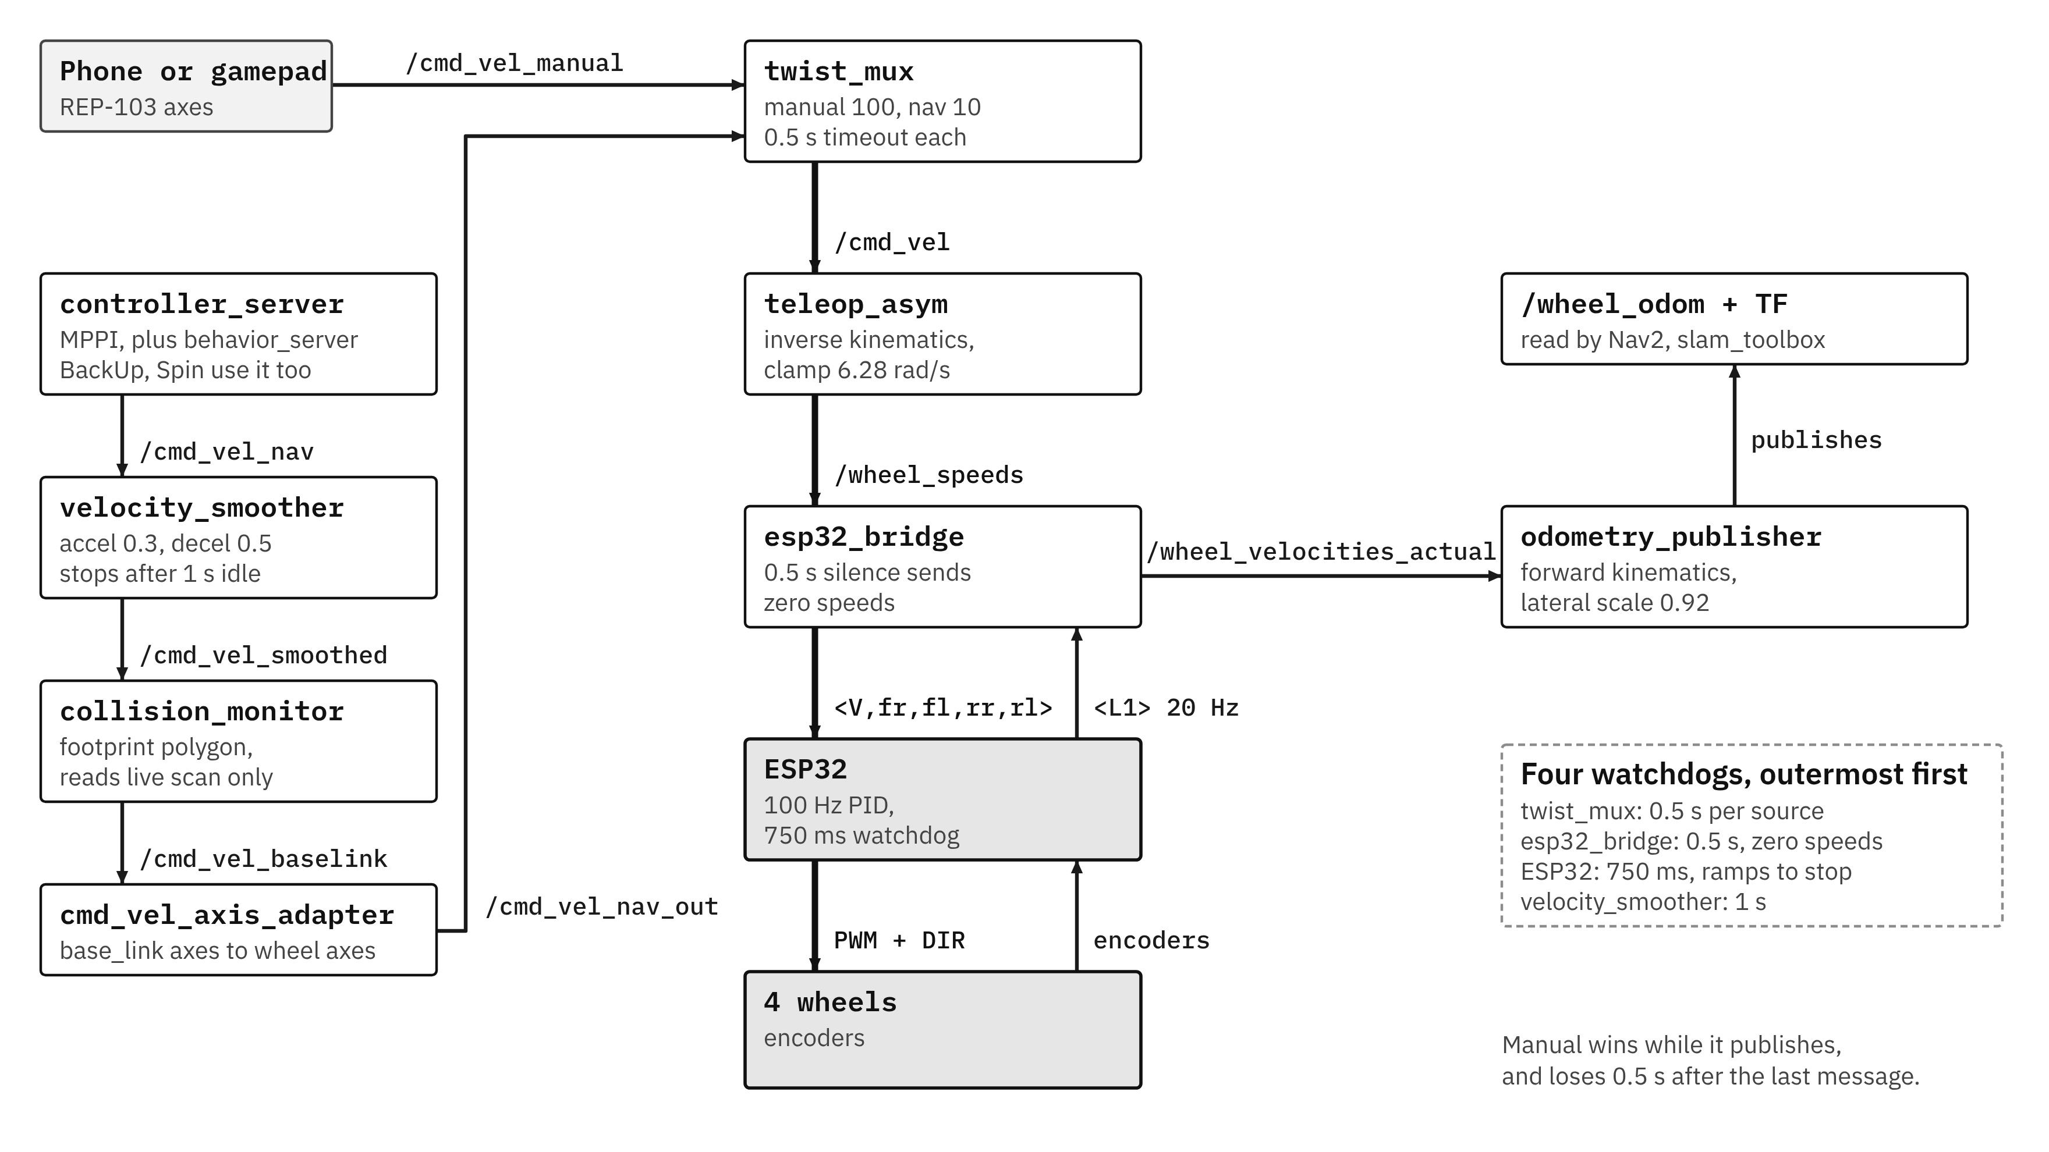

6. ESP32 firmware structure
The firmware consists of two FreeRTOS tasks, one per core. Core 0 handles communication: it parses commands and sends telemetry. Core 1 runs the PID loop every 10 ms, and each cycle proceeds in a fixed order: encoder reading, filtering, slew limiting, feedforward plus PID, PWM output and safety checks. Any failed safety check latches an E-STOP, which only <E1> clears.
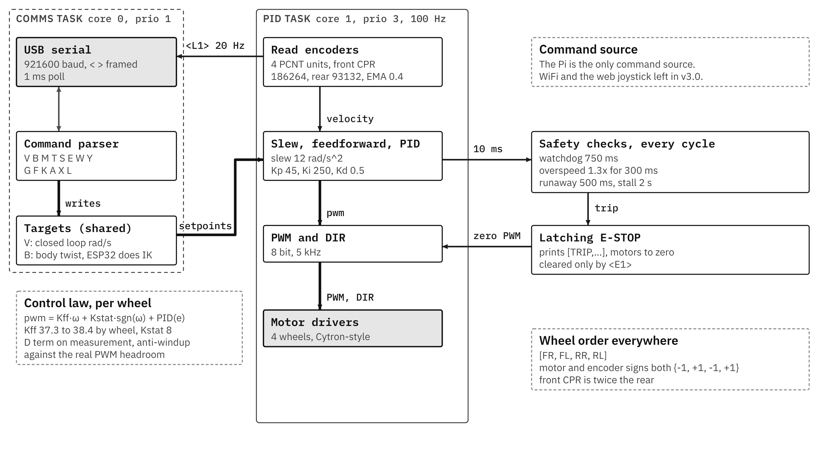

Pin map (firmware v3.0)
Motor | PWM | DIR | Encoder A | Encoder B | PCNT unit | Dir sign
FR | GPIO 4 | GPIO 16 | GPIO 36 (SP)* | GPIO 39 (SN)* | 0 | -1
FL | GPIO 17 | GPIO 18 | GPIO 34* | GPIO 35* | 1 | +1
RR | GPIO 19 | GPIO 21 | GPIO 32 | GPIO 33 | 2 | -1
RL | GPIO 22 | GPIO 23 | GPIO 25 | GPIO 26 | 3 | +1
* Input-only pins, which have no internal pull-ups. PWM and DIR connect directly to the two MDD20A drivers at 3.3 V. The encoders operate at 5 V, so their signals pass through an 8-channel BSS138 level shifter. Wire colours differ between front and rear: the front encoders (GTK08) use Green for A and White for B, and the rear encoders (RMCS-2086) use Yellow for A and Green for B.
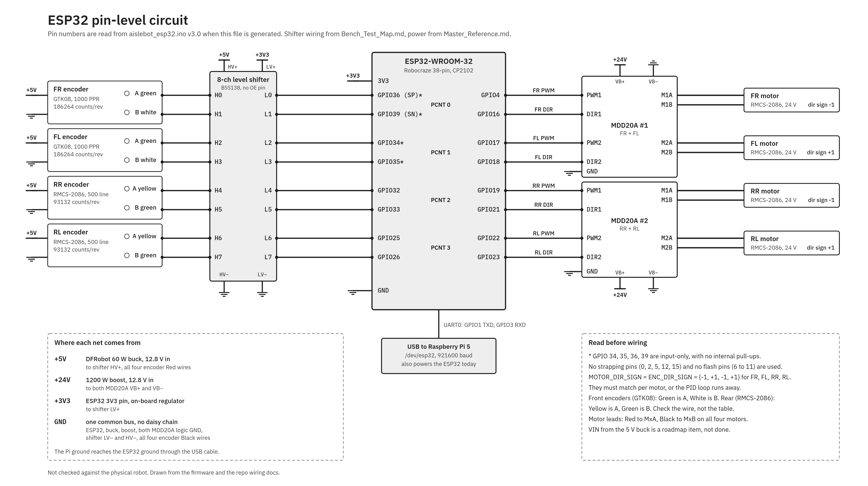

7. Wheel odometry as the sole source of pose
The inverse kinematics, used by teleop_asym and by the ESP32, are as follows (axes: x forward, y left).
ω_{FR} = (vx + vy + K_{out}·ωz) / r
ω_{FL} = (vx − vy − K_{in}·ωz) / r
ω_{RR} = (vx − vy + K_{in}·ωz) / r
ω_{RL} = (vx + vy − K_{out}·ωz) / r
The forward kinematics, used by odometry_publisher, are:
vx = (r/4)(ω_{FR} + ω_{FL} + ω_{RR} + ω_{RL})
vy = (r/4)(ω_{FR} − ω_{FL} − ω_{RR} + ω_{RL}) × 0.92
ωz = (r/4)(ω_{FR}/K_{out} − ω_{FL}/K_{in} + ω_{RR}/K_{in} − ω_{RL}/K_{out})
K_{out} = l₁ + d = 0.561 m, K_{in} = l₂ + d = 0.491 m, r = 0.0762 m. The factor 0.92 is a lateral scale correction, applied because the rollers scrub during strafing; a value of 0.80 was measured on a different floor.
- Wheel odometry alone accumulated a final position error of 0.229 m over a 21.85 m drive (3 Sep).
- The robot has no IMU and no filter, so heading drift and strafe error are currently uncorrected.
- The time step dt is taken from the arrival time of each 20 Hz telemetry message at the Pi, and the integrated speeds are the filtered wheel speeds reported by the ESP32.

8. From LiDAR scan to map
The LiDAR driver publishes with BEST_EFFORT reliability, whereas slam_toolbox and the costmaps subscribe with RELIABLE, so no scan reaches them without scan_relay. In the TF tree, each transform has a single owner: slam_toolbox publishes map to odom, odometry_publisher publishes odom to base_link, and the URDF defines base_link to laser_frame.
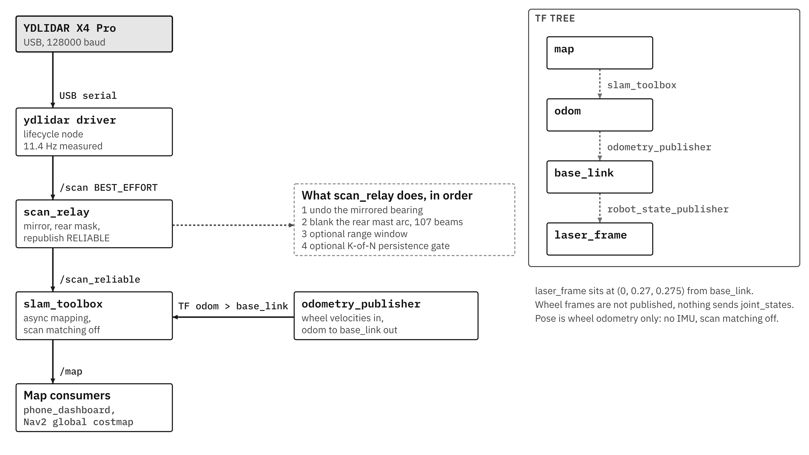

SLAM settings as running
Setting | Value
Package | slam_toolbox 2.8.5, online asynchronous mapping
Solver | Ceres, sparse normal Cholesky, Levenberg-Marquardt
Scan matching | Off
Loop closing | On, 2.0 m search distance
New graph node | Every 0.2 m or 0.2 rad of travel
Laser range used | Up to 5.0 m
Map resolution | 0.05 m per cell
Scan input | /scan_reliable from scan_relay

Rationale for disabling scan matching
Over the same 21.85 m drive, wheel odometry alone ended 0.229 m off, whereas odometry combined with the scan matcher ended 0.706 m off, roughly three times worse. The scan matcher was therefore disabled. The likely cause lies in the input data: with the robot stationary, 75 to 78 % of rays alternate between valid and invalid from one scan to the next. This explanation is a hypothesis and has not been verified.
A consequence is that map to odom changes only when slam_toolbox accepts a new scan, approximately every 0.18 m. The map returns to the start mark within 6 to 30 mm, but 77 to 85 % of cells remain unknown against a target of 50 % (15 Sep).

9. Nav2 with the MPPI controller
A tap on the phone map becomes a goal. bt_navigator requests a path from the planner and velocity commands from the MPPI controller, and these commands pass through the velocity smoother, the collision monitor and the axis adapter before reaching twist_mux.
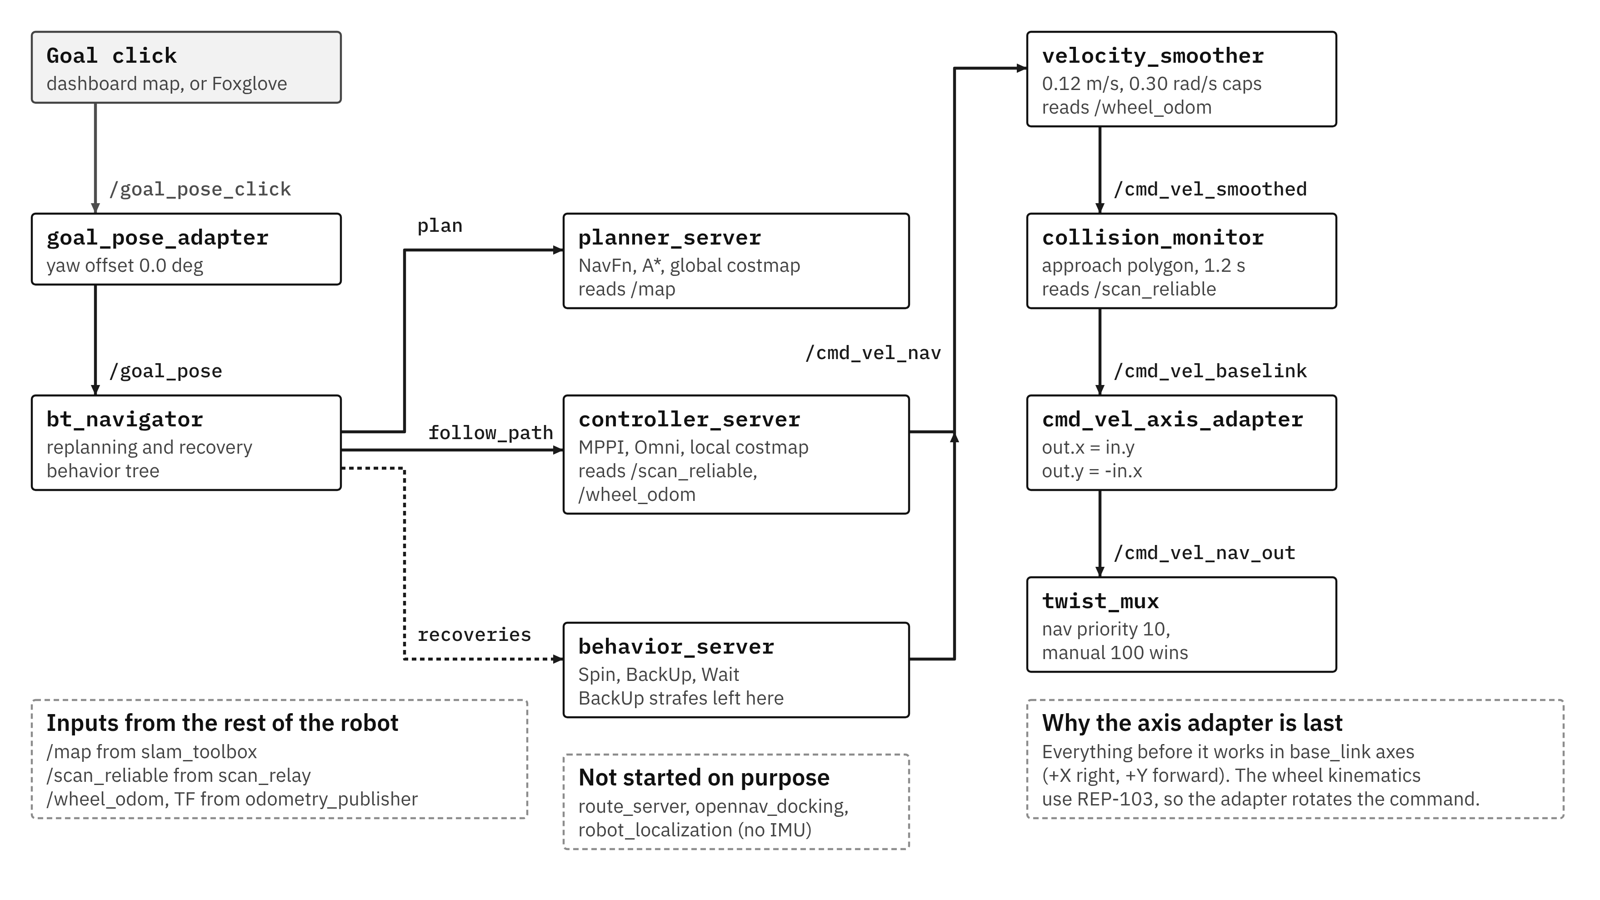

How MPPI selects a command in each cycle
- The controller starts from the best control sequence of the previous cycle: 40 steps of 0.05 s, giving a 2 s horizon.
- Random noise is added to produce 300 candidates (σ = 0.06 m/s in x and y, 0.15 rad/s in yaw).
- Each candidate is rolled forward with the Omni motion model, clipped to 0.12 m/s and 0.30 rad/s.
- Each candidate is scored by seven critics (weights in the table below). A candidate that collides with the costmap receives a score of 1,000,000.
- The candidates are averaged with weights exp(−(S − S_{min})/λ), λ = 0.3. The first command is sent, the sequence is shifted and the cycle repeats. The requested rate is 20 Hz; the measured rate on the Pi is 5 to 14 Hz.

Critic | Weight | What it pushes for
PathAlign | 14 | Stay aligned with the planned path
Goal | 5 | Get close to the goal position
PathFollow | 5 | Make progress along the path
Twirling | 5 | Avoid needless spinning
Constraint | 4 | Stay inside the velocity limits
Cost | 3.81 | Keep away from obstacles in the costmap
GoalAngle | 3 | Arrive facing the right way

Loss of commanded speed (1 Oct test)
The goal was 0.6 m straight ahead. Nav2 aborted the attempt after 194 s and 16 recoveries; the robot crept at about 1.5 mm/s without contact. A recorded bag of every stage of the command chain shows MPPI itself requesting about 4 mm/s against a limit of 120 mm/s, with every later stage passing the command on unchanged.
Stage | 0 to 10 s | 10 to 20 s | 20 to 30 s | 30 to 40 s
/cmd_vel_nav (MPPI) | 4.4 | 5.1 | 3.8 | 4.4
/cmd_vel_smoothed | 4.4 | 5.1 | 3.8 | 4.3
/cmd_vel_baselink | 4.4 | 5.0 | 3.8 | 4.3
/cmd_vel (to the wheels) | 4.4 | 5.0 | 3.8 | 4.3
Mean speed in mm/s per 10 s window.
- This rules out velocity_smoother, collision_monitor, the axis adapter, twist_mux and the ESP32 as the cause, since each passes the command through unchanged.
- The data implicate the averaging step within MPPI itself. Noise alone gives 0.06 / √300 = 3.5 mm/s, close to the measured 4.4 mm/s, which suggests that the optimiser barely favours any direction.
- The 0.3 m/s² acceleration limit is a possible but unproven cause; it allows only 0.015 m/s per 0.05 s step.
- The next test repeats the same goal with the Nav2 stock limits (3.0 m/s²), which are already set on the live node but not yet in the repository file.

10. Current status

Verified functionality
- Wheel-speed loop on the ESP32 at 100 Hz, with latching safety trips.
- Manual drive from the phone, with priority over Nav2 and four stacked watchdogs.
- Wheel odometry with an error of 0.229 m over a 21.85 m drive.
- Mapping that returns to the start mark within 6 to 30 mm.
- The global planner finds paths from the start mark (1 Oct).

Open issues
- No autonomous goal has been reached, because MPPI requests only about 4 mm/s.
- Map coverage is low: 77 to 85 % of cells are unknown, against a target of 50 %.
- The robot has no IMU, so heading drift is uncorrected.
- A 90 degree blind arc exists behind the mast.
- The robot has no hardware E-stop, and the ESP32 is still powered from the USB port of the Pi.

Planned work
- The 0.6 m goal will be repeated with the stock MPPI acceleration limits.
- If the robot drives, its real acceleration will be measured on a straight run and the limits set from that measurement.
- If the robot still creeps, the temperature, sampling spread, critic weights and real loop rate will be examined.
- A ladder of goals will follow: 1 m forward, 1 m sideways, a 90 degree turn and a reverse.
- Rear sensing for the blind arc will be added, either a rear LiDAR or a ring of ToF sensors.

Appendix: all nodes and topics on one sheet
This sheet is deliberately dense and is best viewed zoomed in.
