STUDY GUIDE FOR THE ANNUAL PROGRESS SEMINAR
Development and Validation of Narrow-Aisle Robotic and IoT-Based Systems for Warehouse Management

Everything in the report, explained in plain language, with the numbers, the reasoning, and the answers to the questions the panel will ask.
Aritra Das
Roll No. 25D0074
Supervisor: Prof. Ambarish Kunwar
Department of Biosciences and Bioengineering, IIT Bombay
IITB-FedEx ALFA fellowship
Seminar: 23 September 2026, 14:30 to 15:30
Built against the submitted APS report. Every number in this document traces to that report or to this project's own repository.

Contents
Right-click and choose "Update field" in Word to fill in the page numbers.

How to use this document
This is the study companion to the APS report. The report is written for a reader who already knows robotics vocabulary. This document is written for you, the night before, and it assumes nothing. Every idea is explained twice: once in plain words with a picture you can hold in your head, and once with the real numbers from this robot.
Three rules run through the whole thing, and they are the rules the panel will actually test you on.
- Never state a number without its evidence grade. "We measured 0.91 per cent closure over 10.61 m" is a strong answer. "It is about one per cent" is a weak one. "We have not tested that" is a strong answer too, and it beats a guess every single time.
- Never drop the qualifier. The report says closure stays below 1 per cent out to about 10 m. Say the whole sentence. The moment you shorten it to "below 1 per cent" you have claimed something you cannot defend, and a good examiner will find the 18 m route where it is 1.42 per cent.
- A failure explained well scores higher than a success stated flatly. Three of the strongest results in this project are things that did not work: scan matching made the pose worse, the proportional-gain argument turned out to rest on a wrong number, and the commissioning map cannot pass its own coverage test. Each of those is a result. Present them as results.

WHAT IS IN HERE
Part 1 sets up the problem. Part 2 walks every piece of hardware and says why it is on the robot. Part 3 is the kinematics. Part 4 is the control chapter, the long one: feedforward, P, I, D, every value and where it came from. Part 5 is odometry, Part 6 the lidar, Part 7 is SLAM and every constraint you hit, Part 8 is navigation and the same. Part 9 explains all 21 figures one by one. Parts 10 and 11 cover the other two strands. Part 12 is the question bank. Part 13 is the one-page cheat sheet to read in the corridor.

The twenty numbers to know cold
If you are woken at three in the morning you should be able to say these. Not being able to state your own robot's mass or footprint is the single worst impression available in a viva.

Quantity | Value | Why it matters
Chassis footprint | 1.00 m x 0.36 m | Tape-measured on the built machine. The 0.36 m is what the collision footprint uses.
Mass | 45.54 kg | This is the number that makes it a full-scale machine rather than a prototype.
Outer wheel distance, l1 | 0.403 m | Front-right and rear-left, the far diagonal pair.
Inner wheel distance, l2 | 0.333 m | Front-left and rear-right, the near diagonal pair.
Asymmetry offset | 70 mm | l1 minus l2. The entire geometric novelty of the platform.
Half track width, d | 0.15769 m | Same for all four wheels. Only the longitudinal distance differs.
Wheel radius, r | 0.0762 m | 6 inch mecanum wheel, rollers at 45 degrees.
Outer lever arm, Ko | 0.5607 m | l1 + d. Used by FR and RL in the yaw term.
Inner lever arm, Ki | 0.4907 m | l2 + d. Used by FL and RR. 14 per cent shorter than Ko.
Control loop rate | 100 Hz | On the ESP32, four independent loops, one per wheel.
Kff (feedforward slope) | 37.3 / 38.4 / 38.3 / 38.0 | Drive counts per rad/s, FR / FL / RR / RL. A 3 per cent spread.
Kstat (breakaway term) | 8.0 counts, all four | Static friction. Faded in over 0.05 to 0.20 rad/s.
Kp, Ki, Kd | 45, 250, 0.5 | The deployed gains. Ki was 30 before; that is the headline change.
Tracking error, unloaded | 0.040 to 0.047 rad/s RMS | Wheels in the air, 26,468 samples over three runs.
Tracking error, loaded | 0.066 to 0.074 rad/s RMS | Full chassis weight on the floor, 35,248 samples.
Endpoint closure | 0.23, 0.29, 0.91 % of path | Over 8.00 m, 9.61 m and 10.61 m, against a floor mark.
Kinematics round-trip error | 2.22 x 10^-16 | Worst case over 20,000 generated cases. Machine epsilon.
Lidar beams per revolution | 430, at 11.35 Hz | Measured on the installed unit, not taken from the data sheet.
Self-occlusion wedge | 90 degrees, 107 of 430 beams | The mast blocks a quarter of every scan, permanently.
Scan matching, the key row | 16.2 mm vs 206.7 mm | Same wheels, same scans, matcher off vs on. It made things worse.

THE FIVE SENTENCES THAT WILL SAVE YOU
1. "The asymmetry changes only the yaw column of the transformation. The translation terms are identical."
2. "The feedforward supplies most of the drive; the PID only corrects what the feedforward gets wrong. That is why the integral gain can be as large as 250."
3. "Coverage accumulates through translation, not rotation. The robot classifies what it drives past, and the room is only a few metres across."
4. "Scan matching was measured against wheel odometry rather than assumed better, and it increased the error on all three routes tested."
5. "The inertial sensor is absent by decision, not by omission. Without an unfused baseline there is no way to say what fusion bought."

Part 1 The problem, and why the robot looks like this

1.1 Why the aisle, and not the rest of the warehouse
Warehouse automation already works. Goods move on conveyors, on pallet shuttles, on autonomous forklifts that drive down wide, well-marked main routes. What almost nothing works in is the aisle itself: the narrow slot between two racks where the stock actually sits.
The reason is geometry, not intelligence. An aisle is sized for two things: the boxes on the racks, and a human being who has to walk in and pick from them. It is not sized for a vehicle. So a robot working there has a few centimetres of clearance on each side, not a few metres.

Think of a corridor in a crowded hostel, with a suitcase against each wall. You can walk down it. You cannot turn a bicycle around in it. That is exactly the difference between a human picker and a conventional mobile robot, and it is the whole problem this project starts from.

Now add the second problem. A normal robot (differential drive, like a wheelchair, or car-like steering) cannot move sideways. If it ends up 5 cm too close to the left rack, it cannot simply shuffle 5 cm to the right. It has to perform a manoeuvre: turn slightly, drive forward, turn back. That manoeuvre eats forward distance, and the corridor does not have spare forward distance to give. Worse, once such a platform is misaligned inside an aisle, getting straight again means either reversing all the way out or doing a long sequence of short forward and backward moves. Both cost time and both risk scraping the racking.

1.2 Why mecanum wheels
A mecanum wheel is an ordinary wheel with a ring of small barrel-shaped rollers bolted around its rim, each roller set at 45 degrees to the wheel axle. The rollers spin freely; nothing drives them.
Because the roller is at 45 degrees, when the wheel is driven forward the patch of rubber touching the floor cannot simply push straight backwards. It pushes at 45 degrees. So every wheel produces a force with two parts: one along the direction the wheel is rolling, and one sideways along the roller axis.

Imagine four people standing at the corners of a stretcher, each of them allowed to push only along a diagonal, like a bishop on a chessboard. One person alone can only go diagonally. But if all four push their diagonals at the right speeds, the unwanted sideways parts cancel and the wanted parts add, and the stretcher can be made to move in any direction, or to spin on the spot, without anybody turning their feet.
That is a mecanum base. Nothing steers. The direction of travel is chosen purely by picking four wheel speeds.

The practical consequence for the aisle problem: a mecanum platform corrects a 5 cm lateral error by translating sideways 5 cm. In the ideal case that manoeuvre uses zero forward distance. That is the property the whole platform is built around.

The cost of mecanum, which you should volunteer before being asked
- Slip is built in. The rollers are supposed to slide sideways. That is the mechanism. But it means the contact patch is small, and the relationship between how far a wheel turns and how far the robot actually moves is not exact. This is the root of the odometry error later in this document.
- Efficiency is lower. Some of the motor torque always goes into sideways scrubbing rather than into useful motion.
- Floor sensitivity. Performance depends on the surface. This project measured it directly: the same commanded drive on different patches of the same laboratory floor gave ground-load increases of 24 per cent, 14 per cent and 3 per cent.
- Four independent motors. There is no mechanical coupling to average out an error. If one wheel is wrong, the robot goes somewhere the model did not predict.

1.3 Why asymmetric, and what "asymmetric" actually means
A conventional four-wheel mecanum robot puts its wheels at the four corners of a rectangle. That is the standard layout in every textbook.
The trouble is that the rectangle sets the width of the machine. The chassis has to be wide enough to carry the wheel rectangle, whether or not the payload needs that width. So the vehicle is wide because of its wheels, not because of its job. In a narrow aisle that is exactly the wrong thing to be.
The alternative used here moves one diagonal pair of wheels inward along the length of the robot. The layout becomes point-symmetric (it looks the same if you rotate it 180 degrees about its centre) instead of mirror-symmetric. Front-right and rear-left sit 0.403 m from the centre; front-left and rear-right sit 0.333 m. The difference, 70 mm, is the asymmetry.

Think of four people carrying a long plank. In the standard arrangement they stand at the four corners, so the plank has to be as wide as their shoulders. In the asymmetric arrangement two of them step inward along the plank. The plank can now be narrower, and it is still carried at four points, and it can still be moved in any direction. What changes is that the two people standing further out have more leverage when the group wants to spin the plank, and the two standing inward have less.

That leverage difference is the entire technical consequence, and it is worth being exact about it, because this is where marks are won.

The lever arm, precisely
When a robot rotates about its own centre, each wheel has to travel around a circle. The radius of that circle is the wheel's "lever arm": how far it is from the centre of rotation, measured perpendicular to the direction it pushes. For a mecanum wheel that lever arm works out as the longitudinal distance plus the half track width.
Ko = l1 + d = 0.403 + 0.15769 = 0.5607 m (outer pair: FR, RL)
Ki = l2 + d = 0.333 + 0.15769 = 0.4907 m (inner pair: FL, RR)
Those two differ by 14 per cent. On a symmetric platform there is one number and it serves all four wheels. Here there are two, and each wheel must use its own.

THE RISK, IN ONE SENTENCE
If a wheel is driven with the wrong lever arm, the robot yaws at a rate that is wrong by 14 per cent, and nothing else in the transformation gives any sign of it. Forward motion looks perfect. Sideways motion looks perfect. The tracking plots look clean. Only the heading is quietly wrong. This is why the report says the 14 per cent is both the whole of the difference and the whole of the risk.

And notice what does not change: the translation terms. Forward and lateral motion use exactly the same coefficients on both layouts. Push the robot forward and it behaves like any other mecanum robot. Only the yaw column of the transformation is different. If you remember one sentence about the geometry, make it that one.

1.4 What was inherited and what was built
Be precise about this in the viva, because it is a fairness question and examiners ask it directly.

Inherited | Built during this year
The geometric idea. Earlier work in this laboratory derived the kinematics for the asymmetric non-collinear layout and demonstrated it on a small prototype. | The transition to full scale: a 45.54 kg machine, and the measurement campaign that says whether the geometry survives that transition.
An assembled mechanical platform: chassis, four mecanum wheels on the asymmetric layout, four geared motors, two motor drivers, the power system. | All firmware. Closed-loop velocity control at every wheel, the two-term feedforward, the safety trips.
Motor control by an Arduino Mega 2560, with no velocity regulation at all. | The move to an ESP32, the level-translation hardware for the encoder return path, and the 100 Hz control loop.
Nothing above that. | The whole ROS 2 stack: serial bridges, the asymmetric inverse kinematics node, odometry, the scan relay, the operator dashboard, the analysis tools, and every measurement quoted in the report.

THE SENTENCE FROM THE REPORT
"Everything reported beyond that point, the firmware, the ROS 2 software, the instrumentation and every measurement quoted in this report, was carried out by the author."

1.5 The three strands, and the honest reason they are together
The project runs three things in parallel. A panel will ask why, and the weak answer is "they are all about warehouses". The strong answer is the one the report gives.
- Strand 1, the robot. The machine that moves through the aisle. Built, instrumented, measured. This is the principal strand and most of the report.
- Strand 2, environmental monitoring. The condition of the air in the space the robot moves through. Deployed and running across four zones.
- Strand 3, contactless fatigue assessment. The condition of the people who share that space. A hypothesis and a completed literature survey. Nothing built, no data.
What links them is not the subject. It is the instrumentation. Multi-sensor integration, calibration against a physical reference, real-time acquisition, and control that fails safe are common to all three. And the traffic between them is real, not decorative:
- The monitoring system established the practice of verifying a configuration against the running system rather than against a file. That practice was then applied to the robot, and it is why the scan-matching experiment could be trusted.
- The robot work established that a control law must be observed responding to a change rather than inferred from a steady-state snapshot. That was then applied back to the monitoring system, and it is exactly what Chapter 2 admits it still owes.

THE LINE TO USE
"An error made in one strand has repeatedly become a method in the next, and that return accrues whether or not the three ever converge into a single system."

1.6 The five objectives, and where each one honestly stands

Objective | Status, stated honestly
O1. Build and experimentally characterise a full-scale asymmetric mecanum platform. | Closed. Controller, kinematics and odometry are characterised against measured references.
O2. Localisation and autonomous navigation at corridor-width clearances. | Closes as characterised, not as optimal. Navigation demonstrated inside a live mapping session, not against a saved map.
O3. Quantify the cost and benefit of the asymmetric layout. | Open. No matched symmetric baseline has been built, so the effect of the asymmetry itself is unquantified. A consistent absence of penalty is not a measured cost of zero.
O4. A closed-loop environmental monitoring system. | Deployed across four zones. Two physical calibrations outstanding before any reading can be quoted as a quantity.
O5. A contactless framework for worker fatigue. | Proposed. Survey complete, hypothesis stated, nothing built.

Saying this table out loud early in the talk is a strong move. It tells the panel you know exactly what you have and have not proved, which means everything you claim afterwards is more credible.

Part 2 Every piece of hardware, and why it is there
An examiner can point at any component and ask "why that one?". The answer should never be "it was available". Every item below has a reason, and where the reason is a trade-off rather than a fact, the trade-off is stated so you can defend the side you took.

2.1 The chassis and the wheel layout
Steel chassis, 1.00 m long, 0.36 m across the wheels, carrying four mecanum wheels on the asymmetric non-collinear layout inherited from the prior work in this laboratory.
Why steel and not aluminium. Mass is not a problem here, it is almost a feature: the machine has to hold its line in a corridor and a heavier base is less easily deflected by a roller slipping. The real requirement is stiffness. A mecanum base puts four independent forces into the frame at four different points, and if the frame flexes, the four wheels are no longer where the kinematic model says they are. A flexible frame quietly changes l1, l2 and d under load, and every equation downstream inherits the error.

THE TWO WIDTH NUMBERS, AND WHICH ONE TO QUOTE
Two width figures appear in the report and they measure the same span by different means. 0.360 m is the tape measurement of the built machine, wheel outer edge to wheel outer edge. 0.3754 m is derived from the assembly drawing (twice the 157.69 mm half track, plus two 30 mm wheel half-widths). They differ by 15.4 mm.
Every experimental result in the report is referenced to the tape figure, and so is the collision footprint. If asked, say that plainly: in a corridor with centimetres of clearance, a 15 mm disagreement is not a rounding detail, so the report states which one it used rather than quietly averaging them.

2.2 The mecanum wheels
Four 6-inch mecanum wheels, radius 0.0762 m, rollers at 45 degrees. Chosen for the reason in Part 1: they are the only common wheel type that gives true sideways translation with no steering mechanism and no fore-aft travel.
Why 45 degrees specifically. At 45 degrees the forward and sideways components of the contact force are equal in magnitude. That makes the inverse kinematics come out with coefficients of exactly 1 on the forward and lateral terms, which is why the equations in Part 3 look as clean as they do. Other roller angles work but produce an asymmetric authority between the forward and lateral axes.
Why 6 inch. Bigger wheels roll over floor joints and debris better and give a larger contact patch, which matters because a mecanum contact patch is already small. Smaller wheels would lower the deck and reduce the mast lever arm, but would make the machine more sensitive to exactly the floor irregularity that a warehouse has.

2.3 The drive motors
Four Rhino RMCS-2086 geared DC motors: 24 V, 1:47 planetary reduction, 60 rpm rated at the output shaft, roughly 1.57 N m rated torque and 3.73 N m stall.
- Why geared, and why 1:47. A bare DC motor spins fast and weakly. A 45.54 kg machine needs torque at low speed, which is exactly what a reduction gearbox trades speed for. 60 rpm at the output is 6.28 rad/s, which at a 0.0762 m radius is about 0.48 m/s of rim speed, comfortably above the 0.12 m/s the robot actually operates at. The margin is deliberate: the controller must never be asking the motor for something near its limit, or there is no authority left for correction.
- Why DC and not stepper. A stepper holds position open-loop but stalls silently under load and has no useful torque at speed. A geared DC motor with an encoder gives closed-loop velocity, which is what a velocity controller needs.
- Why four independent motors and no mechanical differential. The mecanum principle requires four independently commandable wheel speeds. Any coupling between them would remove degrees of freedom and defeat the point.

THE NUMBER TO HAVE READY
Stall current is up to 30 A per motor. That is why the drivers are rated 20 A continuous, why the battery is a 30 Ah LiFePO4 rather than a small pack, and why the runaway trip in the firmware exists at all: a motor pinned at stall is a gearbox failure waiting to happen.

2.4 The encoders, and the trap hidden in them
This is one of the best stories in the project and it is worth telling well.
The two front motors carry GTK08 encoders. The two rear motors carry the original optical units. After full quadrature decoding and the gear reduction they produce different counts per revolution of the wheel:

Motor | Encoder | Counts per wheel revolution | One count is
FR, FL (front) | GTK08, 1000 PPR | 1000 x 4 x 46.566 = 186,264 | 3.37 x 10^-5 rad of wheel rotation
RR, RL (rear) | Optical, 500 line | 500 x 4 x 46.566 = 93,132 | 6.75 x 10^-5 rad

What "quadrature" means, in plain words
A quadrature encoder has two output channels, usually called A and B, and they are deliberately offset so that their pulses do not line up. As the shaft turns, A and B each produce a square wave, but one leads the other by a quarter of a cycle.

Two people clapping at the same tempo, but one of them deliberately claps slightly late. If you listen to the pattern of claps you can tell not just how fast they are going but which one is leading, and therefore which direction the shaft is turning. That is the whole trick: one channel gives speed, two channels give speed and direction.
And because each channel has a rising and a falling edge, there are four distinguishable edges per cycle, which is why a 1000 pulse-per-revolution encoder gives 4000 counted edges per revolution. That is what "full quadrature decoding" means, and it is where the x4 in the table comes from.

The bug that this arrangement caused, and why it was invisible
An earlier firmware version hard-coded a single constant, ENCODER_CPR = 93132, for all four motors. On this hardware, the front wheels produce 186,264 counts per revolution. Divide 186,264 by 93,132 and you get 2.0. So a front wheel turning once reported that it had turned twice.
Now follow what the controller does with that lie. The controller sees a wheel apparently going twice as fast as commanded. It believes the sensor. It cuts the drive until the reported speed matches the target. The wheel is then physically turning at half the commanded velocity. The rear wheels, correctly scaled, track properly.

WHY THIS IS THE SCARIEST CLASS OF FAULT
The result is a permanent front-to-rear speed split that scales with commanded velocity. The robot yaws when told to go straight, and curves when told to rotate. And every diagnostic looks clean: no error is raised, no warning is printed, and the tracking plots are beautiful, because the loop genuinely is tracking. It is just tracking a lie.
The only test that can catch it is one that cross-checks front against rear independently of the software. That is exactly the bench campaign that was run: at matched drive and matched duration, the front-to-rear raw count ratio came out at 2.0 to 2.1 on physically identical gearmotors, which confirms the constants rather than assuming them.

The fix, and why it needs no scaling factors anywhere else
ENCODER_CPR became a per-motor array. The velocity calculation in the control loop is three lines:
int32_t delta = readEncoderDelta(i); // counts this tick
float rev = (float)delta / ENCODER_CPR[i]; // counts -> revolutions
float raw_vel = rev * (2.0f * PI) / PID_DT; // revolutions -> rad/s

Each motor's raw count is divided by its own constant. That converts a sensor-specific quantity (edges) into a physical one (revolutions), and the factor of two cancels exactly, because the encoder that produces twice as many counts is divided by a twice-larger number. Two wheels turning at the same speed report the same rad/s. Everything downstream, the PID, the feedforward, the inverse kinematics, the odometry, sees only rad/s and never learns which encoder produced it. There is no per-motor special-casing anywhere else in the firmware.
What genuinely differs is resolution, and only resolution. At a 100 Hz loop the smallest velocity change a front encoder can see is 0.0034 rad/s; for a rear encoder it is 0.0067 rad/s. Both sit far below the mechanical and electrical noise floor, so neither limits the velocity loop. That is why the velocity filter can stay light without the derivative term picking up quantisation hash. The extra front resolution matters for odometry, where counts accumulate over minutes, not for control.

2.5 The level shifter, and why it is on one side only
An ATmega2560 runs at 5 V logic and accepts a 5 V encoder output directly. An ESP32 does not: its input pins are 3.3 V parts with an absolute maximum near 3.6 V, and they are not 5 V tolerant. The encoders on this platform produce an output close to 4.7 V. Feeding that straight into a 3.3 V pin exceeds its specified limit and risks permanent damage.
So all eight encoder channels (two quadrature channels on each of four motors) pass through an eight-channel bidirectional level translator, a discrete-transistor board with separate low-voltage and high-voltage supply rails.
One asymmetry here is deliberate, and it is a good question to be asked. Only the feedback direction is translated. The motor drivers have a logic threshold of 1.5 V, so they accept the ESP32's 3.3 V drive and direction signals directly with no translation at all. The translator sits only on the encoder returns.

THE JUSTIFICATION, WORD FOR WORD
"Fewer components in the command path is worth having, because a fault in the command path moves the machine while a fault in the feedback path only misreports it."
This is a safety-ordering argument, and it is the kind of reasoning a panel rewards. Every component you add to the path that commands motion is another thing that can fail in a way that drives a wheel. A component in the sensing path can only ever tell you the wrong thing, which the safety trips are there to catch.

2.6 The motor drivers
Two dual-channel drivers, 20 A continuous each, 1.5 V logic threshold. Four motors, two channels per driver.
- Why 20 A continuous. Each motor can draw up to 30 A at stall. A driver sized to the running current would survive normal operation and fail on the first jam. Sizing to the stall case is the only defensible choice on a machine that operates next to racking.
- Why the 1.5 V threshold matters. It is what makes the no-translation command path legal. A driver with a 2.5 V or 3.5 V threshold would have forced level shifting on the command side too, and the safety argument above would have had to be given up.
- Why dual channel. Fewer boards, fewer connectors, fewer wiring runs on a 360 mm-wide chassis. Every connector is a place where a channel can end up on the wrong pin, which has already happened once during commissioning.

2.7 The ESP32, and the calculation that forced it
This is the cleanest quantitative justification in the whole project and you should be able to do it on a whiteboard.
The four motors together, at rated speed, produce:
2 x 186,264 + 2 x 93,132 = 558,792 counted edges per second
At rated speed the output shaft turns once per second, so that is exactly one wheel revolution's worth of counts, per second, per motor.
An ATmega2560 runs at 16 MHz, which is 16 million instruction cycles per second. Divide:
16,000,000 / 558,792 = 28.6 cycles per edge
Twenty-nine cycles. That is the entire budget for interrupt entry, saving registers, decoding the quadrature state, updating the counter, and returning, before a single cycle has been spent on the velocity loop, the serial protocol or the safety logic. A minimal interrupt service routine on that architecture does not fit in that budget. Encoder counting alone saturates the processor.

A receptionist who has to personally answer every single phone call in the building. If the calls come in fast enough, she never gets to do anything else, and eventually she cannot even answer the phones. The ATmega is that receptionist.
The ESP32 has a pulse counter peripheral: dedicated silicon that decodes quadrature in hardware and keeps the count without the processor being involved at all, across four independent units, one per motor. That is an answering machine. The processor is then free for the 100 Hz control loop and the serial link to the host.

Two further properties of the part were useful and are worth mentioning if asked whether the choice was over-determined: substantially more processing capability and memory than the part it replaced, and an integrated 2.4 GHz Wi-Fi radio, which allowed the first phone-based control surface to be hosted on the controller itself before the host computer existed.

THE HONEST FOOTNOTE
That early Wi-Fi joystick path applied one shared yaw coefficient rather than the two the geometry requires, so it never actually carried the asymmetry the platform is built around. It was also the only point at which two writers could contend for the same wheel setpoints. It was removed when the host computer became the single command source. Volunteer this if the conversation reaches it; it is a bug that was found and closed, not one that is still open.

2.8 The Raspberry Pi 5 host, and the division of labour
The Pi 5 runs Ubuntu 24.04 and ROS 2, and does the planning and perception. The ESP32 keeps the real-time control. The split follows directly from the timing argument above.

Runs on the ESP32 | Runs on the Pi 5
Work that must happen on a fixed schedule: the 100 Hz velocity loop, quadrature decoding, the safety trips. | Work that benefits from an operating system: SLAM, path planning, the costmaps, the dashboard web server, logging.
Failure mode if late: a wheel is controlled badly, which is dangerous. | Failure mode if late: a plan arrives a few milliseconds late, which the velocity layer absorbs.

Why a Pi 5 and not something smaller. SLAM and a costmap stack on a live scan are genuinely demanding. The report records the consequence of the limit honestly: three components, the global planner, the local controller and the safety chain, all work correctly but run below their requested update rates because of the processing available. The global planner runs at 1.25 Hz against 5 Hz requested; the local controller at 7.5 to 13.7 Hz against 20 Hz. That is a property of the computer, not of the software, and a faster host raises all three.
Why not a GPU machine. It was considered and ruled out by measurement rather than assumption. The MPPI controller comes from a paper whose own experiments ran on a GPU, and the fear was that a CPU-only Pi could not sustain it. Measured on hardware, 500 sampled trajectories at 20 Hz with full-footprint collision checking held the loop rate. So the GPU origin of the algorithm did not turn out to be the binding constraint on this platform.

2.9 The lidar
A YDLIDAR X4 Pro: a single-plane triangulation scanner, 360 degrees, rated 0.12 to 10 m.

How a triangulation lidar works

Shine a laser pointer at a wall and photograph the dot with a camera mounted a few centimetres to the side. If the wall is close, the dot appears near one edge of the photo. If the wall is far, it appears nearer the middle. The distance from the camera to the wall can be worked out from where the dot lands, because the laser, the camera and the dot form a triangle with one known side (the gap between laser and camera) and one measured angle.
Spin that whole assembly and you get a 360-degree slice of the room, 430 times per revolution on this unit.

Why triangulation and not time-of-flight. Triangulation units are an order of magnitude cheaper. The cost is accuracy that degrades with range, because the triangle gets thinner and thinner as the target moves away, so a fixed pixel error on the sensor turns into a growing distance error. That degradation is exactly what this project measured, and it is why Part 6 spends time on it.

What was measured rather than assumed
- 430 points per revolution at 11.35 Hz. Not the data sheet figure and not what the configuration file asks for. The driver has a frequency parameter set to 6.0 Hz, and it does nothing on this unit: the motor is not commanded by the driver, so the head free-runs at its own native speed. Measured 11.35 Hz with about 8 ms of deviation on an 88 ms period, so it is stable, just not requested.
- Range accuracy. The manufacturer states 2 cm below 1 m and 3.5 per cent of range from 1 to 6 m, with nothing specified beyond 6 m despite a 10 m rated range. The report treats that as a factory acceptance condition rather than a runtime error distribution, and measures the installed unit directly instead.
- A range cap set to 10 m, not 5 m, on purpose. The driver reports what the sensor can genuinely do. The SLAM configuration separately chooses to use only 5 m. Two different questions: range_max is a hardware fact, max_laser_range is a policy. Capping at the driver would destroy the data before anything could measure what the cut cost.

A GOOD LINE ABOUT THIS SENSOR
"The case against the present lidar is now quantitative rather than impressionistic. Repeating the same routes with a higher-grade scanner, using the same analysis tools, would convert that inference into a controlled result. That question is currently answered in the literature by convention rather than by measurement."

2.10 Power
A LiFePO4 pack, 12.8 V nominal, 30 Ah, with a boost converter to the 24 V drive rail and a buck converter to the 5 V logic rail.
- Why LiFePO4 and not lithium-ion. Thermal safety. A LiFePO4 cell does not go into thermal runaway the way a standard lithium-ion cell can, which matters on a machine that will eventually be left charging unattended in a warehouse. It also tolerates far more charge cycles, and its discharge voltage is flat, so the drive rail stays stable as the pack depletes.
- Why 30 Ah. Four motors capable of 30 A each at stall. The pack has to hold the rail up during a current transient without sagging, and a small pack would brown out the logic every time the machine started from rest against a load.
- Why boost to 24 V rather than a 24 V pack. A single lower-voltage pack is simpler to charge and safer to handle, and the boost converter isolates the drive rail's transients from the logic rail.
- Why a separate buck to 5 V. The logic must not see what the motors do to the supply. This is the same principle that the monitoring system learned the hard way in Chapter 2, where a cellular modem drawing 2 A in bursts on a shared rail caused brownout resets until the supplies were split.

2.11 The mast, the cargo arm and the lighting
A vertical mast carries three ultraviolet tubes and the stepper axis of the cargo arm. Two lateral and one vertical stepper axis in total. These are retained on the original Arduino Mega, which was reassigned to the payload rather than discarded.
- Why keep the Mega at all. It is perfectly capable of sequencing an arm and a lamp, neither of which has a hard real-time requirement. Reassigning it costs nothing and keeps the payload logic off the controller doing the 100 Hz work.
- Why the lighting is sequenced on that controller rather than from the host. So the staging survives loss of the serial link, with a latched emergency stop. If the Pi crashes, the lamp does not stay on in an uncontrolled state.

THE COST OF THE MAST, AND YOU SHOULD SAY IT FIRST
The mast and its payload sit inside the lidar scan plane. That is the direct cause of the 90-degree self-occlusion wedge, 107 of 430 beams, a quarter of every scan, permanently missing in a fixed direction relative to the body.
This is not a mistake so much as an unavoidable consequence of carrying a payload above a single-plane scanner, and the report says the trade-off between sensor placement, sector masking and accepted coverage loss does not appear to be characterised quantitatively in the literature. If asked how you would fix it: raise the lidar above the payload, or move to a multi-plane sensor, or accept the wedge and mask it, which is what is done today.

2.12 What is deliberately NOT on the robot
Absences are as defensible as presences, and examiners probe them. Each of these has a reason.

No inertial measurement unit
This gets its own full treatment in Part 5, because it is the single most likely question. The short version: Objective 2 asks which sensing a pose estimate requires. Fitting an IMU at the start would have removed the ability to answer that question, because there would be no unfused baseline to compare against. The absence is what made the wheel-only behaviour measurable.
What is not claimed: that the platform is better off without one. It is the right next purchase, and the part is already chosen (a BNO085, on the ESP32's I2C pins that have been reserved for it, run in 6-axis mode with the magnetometer held out because a 24 V 30 A motor bus sits a few centimetres away).

No optical flow ground sensor
An IMU fixes heading. It does nothing for translational slip, which is the other half of the odometry error: a commanded 1.00 m sideways move reads 1.245 m in the raw odometry, measured twice, 3 mm apart. An optical flow sensor measures true ground velocity and does not care what the wheels are doing. It is on the roadmap, not on the robot. The candidate parts are chosen but ground clearance has never been measured on this chassis, which is the honest blocker.

No proximity ring
A 360-degree, roughly 1 m short-range ring is specified as a hard override that stops the robot when something enters a cushioning zone, working alongside SLAM rather than inside it. The part choice is worked out (time-of-flight rather than ultrasonic, because ultrasonic pings bounce away off cloth, foam or any oblique surface, which is precisely what warehouse cargo is made of) but nothing is fitted.

HOW TO TALK ABOUT A ROADMAP ITEM
The rule this project uses is a good one to quote: a value in a document is not a value on the robot, and by the same rule, a part in a roadmap is not a part in the parts bin. Say clearly that none of these is installed. Then say what each would buy and what measurement would prove it. That is a much stronger position than implying they are nearly done.

Part 3 Kinematics, in plain language
Kinematics is the dictionary between two languages. One language is what you want the robot to do, spoken as three numbers. The other is what the four wheels must do, spoken as four numbers. Nothing here involves forces, masses or motors: kinematics is pure geometry.

3.1 The three numbers that describe any motion on a flat floor
A rigid body moving on a plane has exactly three degrees of freedom, and there is no fourth.
- u, forward velocity, in metres per second.
- v, lateral (sideways) velocity, in metres per second.
- omega, yaw rate, how fast the body is spinning about its own centre, in radians per second.
Together these three are called the body twist. A differential-drive robot can only produce two of them (forward and yaw) and is therefore called non-holonomic: it cannot move in a direction it is not pointing. A mecanum robot can produce all three independently and is holonomic. That is the whole reason it is here.

3.2 Inverse kinematics: from what you want to what the wheels must do
Inverse kinematics takes the three body numbers and gives you the four wheel speeds. For this platform:

omega_FR = (1/r) ( u + v + omega * Ko )
omega_FL = (1/r) ( u - v - omega * Ki )
omega_RR = (1/r) ( u - v + omega * Ki )
omega_RL = (1/r) ( u + v - omega * Ko )

Read those four lines column by column rather than row by row, because that is where the structure is.
- The u column. Every wheel has a +u. Tell the robot to go forward and all four wheels turn the same way. Obvious, and identical on a symmetric platform.
- The v column. The signs alternate: + - - +. Tell the robot to strafe right and one diagonal pair turns forward while the other turns backward. The forward components cancel, the sideways roller components add, and the robot slides. Also identical on a symmetric platform.
- The omega column. Here is the asymmetry. +Ko, -Ki, +Ki, -Ko. Two wheels use the long lever arm and two use the short one.

THE SENTENCE THAT EARNS THE MARK
"The translation terms are identical between the symmetric and the non-collinear layouts, which is why forward and lateral motion feel the same on either machine. Only the yaw column changes. That is the whole of the difference, and it is also the whole of the risk, because a wheel driven with the wrong lever arm produces a yaw rate wrong by 14 per cent and nothing else in the transformation gives any sign of it."

The practical warning that follows: substituting a single shared coefficient anywhere in the software reduces the machine, in that code path alone, to an ordinary symmetric mecanum platform. That is not a hypothetical. It happened in the early Wi-Fi joystick firmware, which is one of the reasons that path was removed.

3.3 Forward kinematics and odometry: from what the wheels did to where you are
Run the dictionary the other way. Measure the four wheel speeds with the encoders, invert the system above, and you recover the three body numbers. Integrate those over time and you get a position and a heading. That is wheel odometry.

Walking across a dark room counting your steps. You know your stride length, so after 40 steps forward and 10 steps to the left you can say roughly where you are. You are not looking at anything; you are adding up what your legs did.
It works beautifully at first and gets worse the further you walk, because every step carries a small error and the errors add up and never cancel. That is dead reckoning, and it is exactly what wheel odometry is.

Two things make it worse on a mecanum base than on a normal robot. First, the rollers are designed to slip sideways, so the relationship between wheel rotation and ground travel is not exact by construction. Second, there are four wheels contributing rather than two, so there are four places for the error to enter.
This project measured the mecanum penalty directly. Driving 1.00 m forward read 1.009 m in the odometry, a 0.9 per cent error, which is accurate. Driving 1.00 m sideways read 1.245 m, twice, 3 mm apart. The wheels genuinely turned that far; the chassis simply did not travel that far, because the rollers scrubbed. A correction factor of 0.92 is applied to the lateral term for that reason, and the report is careful to call it an empirical constant for one floor rather than a model.

3.4 The free observable, and why it is worth less than it first looks
This is a genuinely novel piece of the work and it is easy to overstate, so learn the careful version.
Look again at the four inverse-kinematic rows. The first and fourth (FR and RL) share the same translational combination u + v. The second and third (FL and RR) share its complement u - v. That means you can take the difference within each diagonal pair and the translation cancels, leaving only yaw:

omega_outer_estimate = r ( omega_FR - omega_RL ) / ( 2 Ko )
omega_inner_estimate = r ( omega_RR - omega_FL ) / ( 2 Ki )

So the robot has two independent estimates of its own yaw rate, from two disjoint pairs of wheels, with no extra sensor at all. The mean of the two is what gets published as the yaw rate. The difference is a residual: if the drivetrain were perfect, it would be exactly zero, so whatever is left is a measure of something being wrong.

Two people independently counting the crowd at a gate. If both say 400, you believe it. If one says 400 and the other says 460, you do not know which is right, but you do know something is off. The published number is the average; the disagreement is the alarm.

Now the honest qualifications, which are the part that scores
- It is not a calibrated measurement of slip. Unequal effective wheel radii, encoder scale error, backlash and mechanical compliance all contribute to the same residual. Separating them needs an external reference.
- The two estimates are not statistically independent. A disturbance that hits both pairs enters both estimates.
- The asymmetry does not create the observable. What makes them separate estimates is that they come from disjoint pairs of wheels, and a symmetric platform has disjoint pairs too. A symmetric mecanum platform carries a residual of exactly the same algebraic form, and it does not vanish there either once slip and measurement error are present.
So what does the asymmetry actually change? The weighting. Write each measured pair difference as its ideal value plus an error term, and the residual comes out as:
e_omega = (r/2) ( delta_outer / Ko - delta_inner / Ki )
On a symmetric platform Ko and Ki are equal, the two error terms enter with identical weight, and any component common to both pairs cancels exactly. Here they enter with different weights, so a common-mode component survives, scaled by:
(r/2) ( 1/Ko - 1/Ki ) = 0.0097

THE CAREFUL CLAIM
"The asymmetry does not create the observable. It makes the residual sensitive to a class of error that a symmetric layout cancels, at roughly one per cent of the magnitude of that error. Whether that sensitivity is useful for drivetrain diagnostics is a question for measurement rather than for algebra."
Say it that way. If you claim the asymmetry gives you a slip sensor, a good examiner will derive the symmetric case on the board and you will be in trouble.

What the residual actually did
Evaluated across four analysed drives, one of them a deliberately irregular trajectory rather than a clean circuit:

Statistic | Value | Reading
Median while moving | 0.035 rad/s | The normal disagreement between the two pairs.
95th percentile | 0.111 to 0.124 rad/s | Across the four drives.
Worst instantaneous value | 0.354 rad/s | A single sample, on the irregular drive.
Episode threshold | 0.5 rad/s | Never crossed by any sample in any of the four drives.

Two caveats to volunteer. The 0.5 rad/s threshold is the default of the analysis tool, not a value derived from this drivetrain, and it was fixed before the drives were analysed rather than chosen afterwards. It sits about four times the observed 95th percentile, so it detects gross events and would not resolve a slow systematic drift. And the whole measure is blind to a slip mode in which all four wheels slip together, because then both pairs are equally wrong and the difference stays small. That blindness is exactly the gap the photogrammetry result in Part 5 walks into.

3.5 The 20,000-case test, and what it does and does not prove
The implemented forward-kinematic transformation was checked against independently generated reference twists across twenty thousand simulated cases. The round trip reproduces them to a worst case of 2.22 x 10^-16, which is machine epsilon for double-precision arithmetic.
Similarly, position was recomputed offline from the raw encoder record for a complete drive and compared against the estimate the robot published live. They diverge by at most 0.0054 m at any point and by 0.0000 m at the end.

What these two checks establish | What they do NOT establish
The transformation is coded correctly and contributes no numerical error of its own. | Anything about the physical wheel-ground model. The equations could be perfectly implemented and still describe a robot that does not exist.
The online and offline implementations are numerically consistent, which rules out a discrepancy between them as the source of the observed drift. | An error shared by both. They integrate the same measurements through the same model, so a wrong wheel radius or a wrong encoder constant would pass this test untouched.

THE QUESTION YOU WILL BE ASKED
"Your kinematics are exact to 10^-16 but your robot drifts by centimetres. Explain."
Answer: those measure two completely different things. 10^-16 says the arithmetic is right. The drift is in the physics: the wheel radius is not exactly 0.0762 m under load, the rollers slip, the floor is not uniform. A correct model of a slightly different robot. Separating the two is exactly why the report checks them separately, and why the floor measurements exist at all.

Part 4 Wheel control: feedforward and PID, from first principles
This is the longest part of this document, because it is the layer everything else is built on, and because it is the layer a panel can interrogate most deeply. The whole chapter answers one question: when the software says "turn at 2.0 rad/s", how does the wheel actually end up turning at 2.0 rad/s?

4.1 The problem: a command is not an obedience
The ESP32 does not speak to the motor in rad/s. It speaks in a drive count, a number from 0 to 255 that sets how hard the driver pushes current through the motor. (It is a PWM duty cycle: 255 means the supply is connected to the motor all the time, 128 means about half the time, and the motor's own inductance smooths that into an average.)
So the controller's entire job is a translation problem: given a wanted speed in rad/s, choose a number between -255 and +255.
And that translation is not fixed. It changes with:
- Load. The same drive count produces a different speed with the wheels in the air than with 45.54 kg pressing them onto the floor. This project measured the difference: about 24 per cent more drive needed on the ground, on average.
- Speed itself. Getting a stationary wheel to start moving needs more push per unit of speed than keeping a moving wheel going. That is static friction.
- Which motor. Four nominally identical motors are not identical. Measured spread here: 3 per cent.
- Battery voltage, temperature, the patch of floor, and the direction of travel.

Driving a car up a hill you have never driven before. You want to hold 40 km/h. The accelerator pedal is your drive count; the speedometer is your encoder. You have two ways to do this.
Open loop: press the pedal to where 40 km/h usually is, and never look at the speedometer. Fast to react, but wrong the moment the hill gets steeper.
Closed loop: watch the speedometer and adjust. Always correct eventually, but always a little late, because you only move the pedal after you have already seen the error.
A good driver does both: pedal roughly where experience says, then trim against the speedometer. That is exactly what this controller does, and the two halves have names: feedforward and PID.

4.2 The structure: feedforward first, then three corrections
The loop runs at 100 Hz on the ESP32, one completely independent loop for each of the four wheels. Every 10 ms, for each wheel, the firmware does this:

pwm = FEEDFORWARD (from the commanded speed alone)
+ P x error
+ I x (accumulated error)
+ D x (rate of change of measurement)

The crucial sentence, and it is the one to memorise for the viva:

WHY THE STRUCTURE MATTERS
"The feedforward supplies most of the drive from the commanded velocity alone, and the three feedback terms correct only what the feedforward gets wrong. That separation is what permits the integral gain to be as large as it is without the loop becoming oscillatory."
On a bare PID with no feedforward, the integral term has to build up the entire drive from zero every time. That takes time and a large integral gain would make it violently unstable. Here, the integral is trimming a small residual, so a gain that would be reckless on a bare loop is appropriate.

Why four independent loops rather than one controller for the whole robot: because each wheel has its own friction, its own encoder, its own load and its own driver channel. A single controller would have to average them, and averaging is exactly what you must not do on a mecanum base, where an error on one wheel becomes an unwanted body motion rather than a slower body motion.

4.3 Feedforward: the experienced driver
Feedforward means: from the speed you want, predict the drive count you will need, before measuring anything. It is the pedal position from experience.

Why a single straight line does not work
The obvious model is pwm = Kff x omega: double the wanted speed, double the drive. Fit one number and you are done.
The raw data says that is wrong, and it says so before any fit is attempted. The ratio of drive command to resulting wheel speed rises as speed falls. At 1.50 rad/s the ratio is higher than at 2.77 rad/s. A straight line through the origin cannot reproduce that, because a straight line through the origin has a constant ratio by definition.

Pushing a heavy crate across a floor. Getting it to start moving takes a big shove. Once it is sliding, keeping it going takes much less. The extra effort at the start is static friction, sometimes called breakaway or Coulomb friction, and it does not scale with speed: it is a fixed lump you have to pay to get moving at all.
A model that only says "effort is proportional to speed" charges nothing for starting, so it always under-drives at low speed.

The two-term model actually used
pwm_ff = Kff * omega + Kstat * sign(omega)
- Kff is the viscous, speed-proportional term. It covers everything that gets harder the faster you go: back-EMF in the motor, viscous drag in the gearbox.
- Kstat is the static, breakaway term. It is a fixed lump, and it carries the sign of the command so it pushes in whichever direction you asked for.
The fitted values, per motor:

Motor | Kff (counts per rad/s) | Kstat (counts) | Relative speed at matched drive
FR (front right) | 37.3 | 8.0 | 1.018
FL (front left) | 38.4 | 8.0 | 0.990
RR (rear right) | 38.3 | 8.0 | 0.992
RL (rear left) | 38.0 | 8.0 | 1.000

A 3 per cent spread across the four. Read that as a good sign: four nominally identical gearmotors behaving nearly identically means the drivetrain is healthy and the measurement is trustworthy. An earlier firmware shipped a 19 per cent spread, and that turned out to be an artefact of the faulty feedback path before the front-rear encoder cross-connection was found, not a real property of the motors.
Kstat is one number for all four because nothing in the available data distinguishes them. The test that would give per-motor breakaway values is a staircase test (step the drive up from rest in increments of 2 until each wheel breaks away) and it has not been run. Say that if asked; it is the honest state.

How the fit was made: three campaigns, not one
This is a methodology point worth making, because fitting to a single dataset is exactly how you fool yourself.

Source | What it was | Confidence
Campaign A | A manual drive logged at steady state. All four motors converge to a 1.83 to 1.94 rad/s band at drive count 80. Mean 1.885 rad/s. | Highest. Reported while running, so it is true steady state.
Campaign B | An automated test sweeping demand in 1.5 s windows at drive count 110. Overall mean 2.621 rad/s. | Good for the relative comparison between motors (identical window for all four). Only approximate in absolute terms, because the window starts from rest and therefore includes spin-up, so it under-reads true steady state.
Campaign C | A back-calculation from an earlier closed-loop run at 0.6 to 2.2 rad/s. | Lowest (this was the campaign with the encoder faults). But it carries one piece of information nothing else does: the drive-per-speed ratio is higher at low speed, which is the evidence for the static term.

Fitting Kff around 38 and Kstat around 8 against all three:

Wanted speed (rad/s) | Model predicts | Actually measured | Error
1.50 | 65.0 | 70.4 | -8 %
1.885 | 79.6 | 80 | -0.5 %
2.621 | 107.6 | 110 | -2 %
2.77 | 113.3 | 120 | -6 %

Every measured point inside 8 per cent, and the two high-confidence points inside 2.2 per cent. The residual error is exactly what a correctly tuned integral term is for, and at the deployed integral gain that 8 per cent gap closes in about 0.3 s.

THE HONEST LIMITATION, AND VOLUNTEER IT
The split between Kff and Kstat is not well determined by this data. Every measurement sits between 1.8 and 2.8 rad/s, and over that narrow span many pairs fit almost equally well. A fit with Kff = 34.5 and Kstat = 15 is barely distinguishable from Kff = 38 and Kstat = 8.
What is well determined is the value of the whole expression across the measured range, and that is what the controller actually consumes. Separating the two properly needs the staircase test, which has not been run.
Also: above about 3 rad/s the model extrapolates, and it will over-predict near the top of the range because the motor approaches its rated 60 rpm and stops behaving linearly. Over-prediction is the safe direction: the output saturates and the integral unwinds it, rather than the wheel coming up short.

The fade-in, a small detail with a real reason
If the static term were applied as a step at any non-zero command, then asking for 0.001 rad/s would produce an instant 8-count jump at the output. Instead, Kstat is faded in linearly across 0.05 to 0.20 rad/s:
static inline float feedforward(int idx, float w) {
float aw = fabsf(w);
float ff = Kff[idx] * w;
if (aw > KSTAT_FADE_LO) {
float fade = (aw - KSTAT_FADE_LO) / (KSTAT_FADE_HI - KSTAT_FADE_LO);
if (fade > 1.0f) fade = 1.0f;
ff += Kstat[idx] * fade * (w > 0 ? 1.0f : -1.0f);
}
return ff;
}

So a very small commanded velocity does not produce a discontinuity in the drive. In a narrow aisle, where the robot is often making tiny corrective moves, that discontinuity would show up as a jerk.

4.4 P, the proportional term: the spring
P looks at the error right now (wanted speed minus measured speed) and pushes in proportion to it.
p_term = Kp * error with Kp = 45

A spring. Pull it 1 cm and it pulls back a little. Pull it 10 cm and it pulls back ten times as hard. The further you are from where you should be, the harder the correction.
Everyone understands the appeal, and everyone runs into its two limitations.

What Kp = 45 means in real units
Suppose the wheel is running 0.1 rad/s slower than commanded. Then:
p_term = 45 x 0.1 = 4.5 drive counts of extra push
That is the instant, proportional response. It is applied within the same 10 ms tick that the error appeared.

The two problems with P alone
- P alone leaves a permanent error. This is the one people find surprising, so understand it properly. The P term produces output only when there is an error. If the error were ever zero, the P term would be zero, so there would be no push at all, so friction would slow the wheel and the error would come back. The loop settles at whatever small error produces exactly enough push to balance the losses. That permanent leftover is called steady-state error or droop. On this robot the feedforward mostly hides it, which is another reason the feedforward earns its place.
- P alone overshoots and can oscillate. Raise Kp to kill the droop and the correction becomes so aggressive that the wheel shoots past the target, then gets pushed back hard, then shoots past the other way. A spring with no damping rings.

4.5 I, the integral term: the stubborn assistant
I adds up the error over time and pushes based on the total. Even a tiny error, if it persists, eventually accumulates into a large correction.
integral += error * dt (dt = 0.01 s)
i_term = Ki * integral with Ki = 250

A stubborn assistant with a notebook. Every 10 ms she writes down how far short you are. She does not care that today's shortfall is small; she cares that you have been short for a while. The longer the error lasts, the more insistently she pushes.
Her job is the one P cannot do: eliminate the permanent error, because the only state in which her notebook stops growing is the state where the error is genuinely zero.

Why Ki = 250, and why the previous value of 30 was the real bug
This is the single biggest change in the deployed firmware and the best worked example in the project. Do the arithmetic out loud in the viva; it is simple and it is convincing.
At the old Ki = 30. A tracking error of 0.1 rad/s moves the integral term by:
30 x 0.1 = 3 drive counts per second
Now ask how long it takes to close a realistic feedforward gap of 10 drive counts. Three counts per second means over three seconds. And that is exactly what the logs showed: an air run in May settled in up to 3.79 s. Three and a half seconds is an eternity inside a manoeuvre. What was actually settling the loop was mostly the proportional term, with the integral quietly and far too slowly absorbing the under-calibration.
At the new Ki = 250. The same 0.1 rad/s error moves the output by:
250 x 0.1 = 25 drive counts per second
The same 10-count gap closes in 0.4 s. Roughly a factor of eight faster, and it turns the integral from a term that was theoretically present into one that actually does work inside the time a manoeuvre takes.

THE ANSWER TO "WASN'T THAT RECKLESS?"
"Raising a gain by a factor of eight at once is a large change, and it was only safe because of the feedforward. When the feedforward carries the bulk of the command, the integral is correcting a small residual rather than supplying drive from zero, so a gain that would be reckless on a bare loop is appropriate here."

Integral windup, and the anti-windup that actually binds
Windup is the classic failure of an integral term, and this project has a good version of the story.

The assistant keeps writing in her notebook even when you are physically unable to go faster. Imagine the wheel is jammed against a wall. The error never goes away, so the notebook fills with an enormous total. Then the wall is removed. The assistant now demands a correction proportional to that huge accumulated total, and the wheel leaps forward violently before the notebook can be unwound.

The old anti-windup did not work, and understanding why is instructive. The previous firmware clamped the raw integral state at plus or minus 200, with Ki = 30. Multiply them out:
200 x 30 = 6000 drive counts of integral term, against an output range of 255
The clamp existed but could never bind. It permitted an integral term twenty-three times the entire output range. It was a safety feature that was, in practice, absent.
The new anti-windup clamps against the authority genuinely left over. By the time the integral is computed, the feedforward, the P term and the D term are all known, so the exact remaining headroom is known too. The integral is never allowed to accumulate past it:
float base = m.ff_output + p_term + d_term;

if (Ki > 1e-6f) {
m.integral += m.error * PID_DT;

float i_hi = ( (float)PWM_MAX - base) / Ki;
float i_lo = (-(float)PWM_MAX - base) / Ki;
if (i_lo > i_hi) { float t = i_lo; i_lo = i_hi; i_hi = t; }

m.integral = constrain(m.integral, i_lo, i_hi);
m.integral = constrain(m.integral, -INTEGRAL_ABS_MAX, INTEGRAL_ABS_MAX);
i_term = Ki * m.integral;
}

THE TWO PROPERTIES THIS BUYS
Windup is structurally impossible, not merely bounded. The integral cannot reach a value that would demand more output than exists.
Recovery from saturation is immediate, rather than waiting for the accumulated error to bleed back off. The moment the wheel can move again, the clamp releases and the term is already in range.

4.6 D, the derivative term: the shock absorber
D looks at how fast the measured speed is changing and pushes against it. It is a brake on rapid movement, regardless of which side of the target you are on.
d_term = Kd * ( -d(measurement)/dt ) with Kd = 0.5

A shock absorber on a car. The spring (P) decides where the car should sit. The shock absorber does not care about position at all; it resists motion. Without it a car with good springs bounces for ten seconds after every bump. With it, the bounce dies out in one.
Here, the derivative term resists the wheel accelerating or decelerating fast, which is what damps the overshoot that P alone would produce.

Why Kd is small, and deliberately so
Against a genuinely first-order plant, a matched proportional-integral pair needs no derivative action at all. Everything this term is doing is damping lag that the first-order model does not contain: driver delay, compliance in the gearbox, and the velocity filter itself.
Work out what it is actually worth. At a typical step acceleration of about 30 rad/s squared:
0.5 x 30 = about 15 drive counts of damping
The previous firmware used Kd = 3.0, which would have applied 90 counts at the same acceleration, actively fighting the acceleration the controller had just asked for. Reducing it by a factor of six is a real fix, not a cosmetic one.

The two details that matter more than the value
Detail one: the derivative acts on the measurement, not on the error. This is important and is a common exam question.
The host computer sends stepped setpoints at 20 Hz. If you differentiate the error, then every setpoint step produces a derivative spike proportional to the size of the step, because the error jumps instantaneously even though nothing physical has happened yet. That spike is called derivative kick, and on this robot it would appear as a jolt at the start of every commanded move.
Differentiating the measurement instead gives identical damping with no kick, because the measurement cannot jump: it is a physical wheel. The minus sign in the code preserves the correct sense:
float raw_d = -(m.actual_velocity - m.prev_velocity) / PID_DT;

Detail two: it is filtered, and more heavily than the velocity signal. Differentiating amplifies noise: a small wobble in the measurement becomes a large wobble in its rate of change. So the derivative is passed through its own low-pass filter, heavier than the one on the velocity signal itself.

Estimating how fast a queue is moving by watching only the last two people. If one person shuffles, your estimate swings wildly. Averaging over a few seconds gives a number you can act on. That averaging is the filter, and the derivative needs more of it than the raw speed does.

4.7 Putting the three together, at one tick
Here is the whole tick, as the deployed firmware runs it, with the reasoning in place.

Step | What happens | Why
0. At rest | If the slewed target is below 0.01 rad/s, everything is held at zero: error, integral, derivative, output. | Coasting to a stop is kinder to the drivers and safer than active braking. The slew limiter has already walked the setpoint down before this point.
1. Feedforward | ff = Kff * target + Kstat * sign(target) (faded). | Supplies the bulk of the drive immediately, in the same tick the command arrives.
2. Error | error = slewed_target - actual_velocity. | Note it is the slewed target, not the raw command. The loop chases a reachable target, not an instantaneous jump.
3. P term | 45 * error. | Proportional correction now.
4. D term | 0.5 * filtered(-d(measurement)/dt). | Damping, no kick, filtered.
5. I term | Accumulate, then clamp against the headroom left after FF + P + D, then multiply by 250. | Kills steady-state error. Cannot wind up.
6. Output | pwm = round(ff + p + d + i), clipped to plus or minus 255. | One number, sent to the driver.

4.8 The three arrangements that do more than the gains do
If you only have time to say one thing about tuning, say this: on this robot, three structural choices mattered more than the gain values.

One: the slew limiter, 12 rad/s squared
Before the loop ever sees a command, the commanded velocity is walked toward the new target at no more than 12 rad/s per second:
float step = max_wheel_accel * PID_DT; // 12 * 0.01 = 0.12 rad/s per tick
float diff = target - m.slewed_target;
if (diff > step) m.slewed_target += step;
else if (diff < -step) m.slewed_target -= step;
else m.slewed_target = target;

Why. A step command from the host would otherwise ask for an acceleration the hardware physically will not produce. Asking for the impossible is precisely the condition that drives an integrator into saturation in the first place. Limiting the setpoint is a cheaper and more reliable fix than trying to handle the saturation afterwards.
There is a second, subtler reason recorded in the firmware comment: the whole four-wheel set is snapshotted atomically against the serial parser running on the other CPU core. Without that, a command arriving mid-loop could be applied to two wheels this tick and two the next, which on a mecanum base is a momentary commanded twist that nobody asked for.

Two: the minimum drive output, lowered from 15 to 5
Below a certain drive count the motor does not move, it just hums. The old firmware suppressed that by refusing to output anything below 15 counts.

WHY THAT WAS A MISTAKE
It cut a dead zone straight through the middle of the range in which the controller does its fine regulation. When the feedforward has got the wheel nearly right, the correction the PID needs is small, often under 15 counts. The controller would ask for 8 counts, get 0, wait, ask for 20, get 20, overshoot, ask for 8, get 0, and so on. That is a limit cycle: the wheel hunts back and forth at low speed and never settles.
With breakaway friction now handled properly by the static feedforward term, the threshold can sit at the level where the motor is genuinely silent, which is 5.

Three: the dynamic integral clamp
Covered in 4.5. Repeated here because it belongs in this list: clamping against the leftover authority rather than a fixed bound is what made the anti-windup real.

4.9 The velocity filter
The measured velocity is smoothed with a simple exponential filter, VEL_FILTER_ALPHA = 0.4. That means each new reading contributes 40 per cent and the running estimate keeps 60 per cent.
Why it can stay this light. The encoder quantisation is far below the noise floor: 0.0034 rad/s on the front wheels and 0.0067 rad/s on the rear, at 100 Hz. Neither limits the loop. If the encoders were coarse, the filter would have to be heavier, which would add lag, which the derivative term would then have to fight. Good sensing buys you a light filter, and a light filter buys you a responsive loop.

4.10 The safety trips, and the one that only exists for a specific fault
Three trips watch every wheel. If any fires, a latched emergency stop halts all four motors.

Trip | What it watches for | Why it exists
Overspeed | Measured speed above 1.30 times the speed ceiling, held for a set time. | A runaway drive or a command that slipped past the clamp.
Stall | Drive commanded but the wheel is not turning. | A jam, a seized gearbox, a wheel lifted off the floor and then caught.
Runaway | A saturated command pushing one way while the wheel turns the other and is not slowing down. | The sign-inversion fault, below.

The sign-inversion fault, and why nothing else would catch it
Each motor has two sign conventions that must agree: the direction the drive signal pushes, and the direction the encoder counts. If they disagree on one motor, the loop sees positive feedback: the motor spins the wrong way, the controller reads that as a larger error, pushes harder, and the wheel ends up pinned at full drive in the wrong direction.
The reason a dedicated trip is needed: a motor rated at 60 rpm cannot physically overspeed its way past the overspeed threshold, so the overspeed trip will never fire on this fault. The wheel just sits at full drive going the wrong way until a gearbox tooth or a driver transistor gives out.

THE DETECTION SUBTLETY, WHICH IS A GOOD THING TO KNOW
"Drive one way, wheel the other" is also exactly what an ordinary hard deceleration looks like. You brake by driving against the current motion. So a naive detector would trip on every fast reversal.
The distinguishing feature is that under braking the wheel is slowing down, and under runaway it is not. Hence the deceleration check: the trip compares the current speed against a checkpoint taken one window earlier, and only fires if the wheel is not losing speed. Without that check the robot would be un-drivable.

Part 5 Where the gain values came from
"Why 45, 250 and 0.5?" is the single most likely technical question in the viva, because it is the one place where a candidate either has a derivation or has been turning knobs. This project has a derivation, and it also has an honest story about the one gain where the derivation failed. Both are worth telling.

5.1 The method: direct synthesis, not trial and error
The feedforward fit does something useful beyond supplying drive: it hands over the plant's DC gain directly. The plant is the motor plus gearbox plus wheel, treated as a black box.
K = 1 / Kff = 1 / 38 = 0.0263 rad/s per drive count
Read that as: one extra drive count buys 0.0263 rad/s of steady-state speed.
For a first-order plant, direct-synthesis tuning (also called lambda tuning) gives both gains in closed form:

Ki = 1 / ( K * lambda )
Kp = tau * Ki

where lambda is the closed-loop time constant you choose (how fast you want the loop to respond) and tau is the plant's own mechanical time constant (how fast the motor physically can respond).

THE USEFUL PROPERTY, AND THE REASON THIS WORKED
Ki does not contain tau. It follows from K and lambda alone, and both of those were known: K from the feedforward fit, lambda by choice. So the integral gain could be computed correctly long before anybody had measured the motor's time constant.
Kp is the one that needs tau, and tau was the number nobody had. That is the whole shape of the story in 5.3.

5.2 Computing Ki
The choice of lambda is the engineering judgement. It was set to 0.15 s, which is fifteen control periods at 100 Hz. That is deliberately conservative: you want the closed loop comfortably slower than the sampling rate, or the controller is trying to react to things it cannot see properly.
Ki = 1 / ( 0.0263 x 0.15 ) = 253
The deployed value is 250, rounded. Nothing more than that: 253 is not more accurate than 250 given an 8 per cent fit band.

IF ASKED "WHY 0.15 AND NOT SOMETHING ELSE?"
Smaller lambda means a faster closed loop, and a larger Ki. Faster sounds better until the loop starts chasing noise and fighting the unmodelled lag. Fifteen control periods is a standard conservative choice and it leaves margin for the plant being different under load, which it is: on the ground K drops, which by the same formula means Ki should rise. That re-derivation on the floor is listed as outstanding work.

5.3 Kp, and the part of the argument that did not survive
Tell this story properly. It is the strongest methodological moment in the control chapter, and trying to hide it would be both dishonest and worse for your marks.

Step one: the assumption
Kp = tau x Ki needs tau, the plant's mechanical time constant. It had never been measured on this machine, because every bench run to that point had logged steady-state points and no transients. You cannot get a time constant from steady-state data; a time constant is entirely a property of the transient.
So a value was assumed: tau = 0.18 s, on the grounds that it is plausible for a 100 W motor behind a 47:1 planetary gearbox. That gives:
Kp = 0.18 x 250 = 45
And the report says plainly that this is the one quantity in the loop that is an estimate rather than a fit.

Step two: the measurement
Later, plant identification was run properly: six open-loop drive steps per motor at plus and minus 70, 110 and 160 counts, wheels in the air, 1251 samples logged at 50 Hz.

Motor | K measured (rad/s per count) | tau, all six steps | tau, excluding the smallest step
FR | 0.02442 | 0.089 s | 0.089 s
FL | 0.02306 | 0.089 s | 0.089 s
RR | 0.02428 | 0.103 s | 0.092 s
RL | 0.02386 | 0.103 s | 0.092 s

tau is about 0.09 s, half what had been assumed. By the same formula, that calls for:
Kp = 0.09 x 250 = about 22

ONE MEASUREMENT WAS EXCLUDED, AND THE REASON IS STATED
RR and RL both show tau = 0.154 s at their smallest step (drive count 70), an outlier that neither front motor reproduces at the same step. Drive count 70 sits closest to the breakaway threshold, where a first-order-lag fit is least trustworthy.
Dropping that one step per motor collapses the front-to-rear split from 0.103 s to 0.092 s and leaves all four motors at 0.089 to 0.092 s, which is the physically simpler result: one drivetrain, one tau, not a real front-to-rear mechanical difference.
The excluded point was kept in the data file rather than discarded, so the next person to run the test can decide for themselves whether they agree. Say that if challenged on the exclusion; it is the right answer.

Step three: the prediction, registered in advance
Before flashing anything, a prediction was written down: both candidate values, 22 and 26, should settle faster than the shipped 45, with overshoot flat or reduced and no new saturation, since a Kp moved toward the true tau is supposed to help rather than trade against something.

Step four: the prediction was wrong, and cleanly so
Three gain sets were swept against each other, four setpoints (1.00, 2.00, 3.00, 4.50 rad/s) times four motors times three gain sets, 48 rows.

Gain set | Mean overshoot (rad/s) | Against the baseline
Kp = 45 (shipped) | 0.107 | baseline
Kp = 22 | 0.164 | +54 per cent worse
Kp = 26 | 0.153 | +43 per cent worse

Kp = 45 posted the lowest overshoot in 16 of 16 rows. Not a majority: all of them. Steady-state error moved the other way (45: 0.009, 22: 0.005, 26: 0.006 rad/s mean), but every one of those numbers sits below the 0.003 to 0.007 rad/s encoder velocity quantum, so that difference is noise floor, not signal.

Step five: why the theory failed here
This is the explanation to have ready, and it is reasoned from the data rather than separately measured, which you should say.
The formula Kp = tau x Ki comes from pole-zero cancellation on the bare plant: the controller's zero is placed exactly on top of the plant's pole so they cancel.

BUT THIS CONTROLLER DOES NOT COMMAND A BARE PLANT
The two-term feedforward supplies most of the drive the instant a setpoint changes. So the closed-loop Kp term's real job here is damping the transient around that feedforward jump, not cancelling a pole the feedforward has already largely pre-compensated.
Lowering Kp weakens exactly that damping. The sweep shows the result directly: more overshoot, not less.
Honest caveat to volunteer: this explanation has not been tested against a Kp sweep with the feedforward disabled, so it is reasoned from the data in front of it, not itself a measured result.

Step six: the decision
Kp stays at 45. Nothing was flashed. The objective closes as confirmed, not as changed. Both are legitimate outcomes of the same measurement, and this project's standing rule is to report whichever one the data actually gives.

THE SENTENCE FROM THE REPORT, WORTH QUOTING VERBATIM
"This is the least satisfying part of the tuning and it is recorded as such: the deployed gain is right, but the argument that originally justified it turned out to rest on a number that was wrong by a factor of two."
Delivering that line yourself, before anyone asks, is worth more than any polished answer you could give afterwards.

5.4 A bug found in the measuring tool, in the same session
Worth knowing because it shows the difference between a result and an artefact.
Every row in the sweep printed settle(s): none, for all three gain sets, at every setpoint. That looks like a finding. It was not.
Root cause: the settling-time function's pass condition was "never leaves the band again", checked against the entire remaining run rather than the window belonging to that step. So a later setpoint, or the run's own final return to zero, always eventually pulled the signal back out of band. The check was structurally guaranteed to fail regardless of the gains.
Fixed by windowing the series to each step's own end time before the check. Overshoot and steady-state error were computed correctly throughout and are unaffected; only the settle-time column was silent. The overshoot result above is unambiguous on its own, which is why the sweep did not need re-running.

THE GENERAL LESSON, AND IT APPLIES TO SLAM TOO
A measurement that always returns the same answer regardless of the input is not a measurement. It is a broken instrument. This project hit the same class of problem three separate times: this settling-time check, the dashboard syntax error that took a whole page offline while every server-side signal said "fine", and a scan-matching front end whose corrections fired on a fixed schedule rather than in response to the scans.

5.5 Air values versus ground values, and the headroom problem
Every gain above is an air value: measured with the wheels off the ground. The report is explicit that ground calibration is outstanding, and there is one consequence that is genuinely a safety-of-operation issue rather than a refinement.

The velocity ceiling arithmetic
The wheel speed ceiling is 5.20 rad/s. Work out what the worst motor needs at that speed:
38.4 x 5.20 + 8 = 208 drive counts
Out of 255 available. That leaves 47 counts, about 18 per cent of the range, as authority for the feedback terms. That is the margin the P, I and D terms have to work within.

NOW APPLY THE MEASURED GROUND LOAD
Ground load raises the feedforward demand by a measured mean of 24 per cent. Apply that to 208 counts and the feedforward alone wants about 258, which is more than the output range. The controller would have nothing left to regulate with: it would sit saturated at full drive, the integral would be clamped at its limit, and the loop would effectively be open.
The documented fix is to lower the ceiling to roughly 4.2 rad/s before serious floor work, and to re-measure the feedforward under load. Note that this is not the operating limit the robot actually drives at (0.12 m/s linear, 0.30 rad/s yaw, which is far below the ceiling), so the machine has not been run in this condition. But the ceiling is the number that would let it happen, and it is listed as outstanding.

The largest demand actually observed
For balance, quote the measured figure alongside the worst case: the largest drive demand observed at the operating velocity limit was 131 of 255, leaving about 49 per cent of the commanded range unused under the tested condition.
And immediately qualify it, the way the report does: that is headroom in the command, not a measurement of torque or traction reserve. It bounds what the controller was asked for, not what the drivetrain could deliver.

5.6 The result the controller actually achieves

Condition | Per-wheel RMS error | Samples | Saturation
Wheels free of the ground | 0.040 to 0.047 rad/s | 26,468 over three bench runs | 0.0 per cent
Under full chassis weight | 0.066 to 0.074 rad/s | 35,248 over three floor runs | 0.0 per cent

The two conditions are reported separately because the figures differ by about half. The loaded figure is the one that matters operationally. The unloaded figure is reported because it separates the controller from the wheel-ground interaction, which is the only way to say whether a given error belongs to the loop or to the floor.
One step response, for the concrete picture: on the largest commanded step in a bench run, the wheel reaches within 5 per cent of the commanded -2.207 rad/s in 0.20 s, overshoots by 3.5 per cent, and then holds the level to a mean offset of 0.003 rad/s.

HOW TO SUMMARISE THE WHOLE CONTROL LAYER IN ONE BREATH
"Four independent loops at 100 Hz. A two-term feedforward, fitted against three campaigns rather than tuned, supplies most of the drive. The integral gain follows from direct synthesis and closes the residual in about 0.4 s. The proportional gain is confirmed rather than derived, because the derivation rested on a time constant that turned out to be wrong by a factor of two, and a closed-loop sweep kept the shipped value on evidence. The result tracks to 0.066 to 0.074 rad/s under chassis weight with no channel ever saturating."

Part 6 Odometry, and the error nobody could see

6.1 What was measured, and against what
Endpoint closure means: drive a route, come back to the mark you started from, and ask how far the robot thinks it is from that mark. If the estimate were perfect it would read zero.

Route | Closure | As a fraction of path
8.00 m, 162 s | 19 mm | 0.23 per cent
9.61 m, 179 s | 28 mm | 0.29 per cent
10.61 m, 233 s | 96 mm | 0.91 per cent
18 m route | 0.229 m | 1.27 per cent
18.14 m route | 0.257 m | 1.42 per cent
4.582 m (short, straight) | 3.1 mm | 0.07 per cent, see the caveat below
38 s square, 1.42 m | 2.58 cm | Above the reference floor, so a meaningful figure

The caveat you must give with the best number
The reference is a mark on the floor, read by tape and eye. That is good to a few millimetres at best. So the 4.582 m route closing to 3.1 mm should be read as "closure at or below the resolution of the reference", not as "a 3.1 mm measurement". The 2.58 cm square is comfortably above that floor and is a meaningful figure.

THE DEFENSIBLE STATEMENT, WHICH IS THE ONE TO MEMORISE
"Closure stays below 1 per cent of path on every route up to about 10 m, reaches roughly 0.1 per cent on short straight runs, and sits between 1.1 and 1.5 per cent on the longest routes driven. It should not be generalised past the route lengths it was measured on."

Why the longest route is the worst
Look at the three logged drives again: 0.23, 0.29, then 0.91 per cent. The jump to 0.91 is on the route with the most rotation, not simply the longest route.
That is consistent with the physics. During a rotational manoeuvre the rollers do more lateral scrubbing than during a straight drive, and lateral scrubbing is exactly the motion the wheel encoder cannot see. So error grows with the amount of rotation a route contains, as well as with its length.
Separating those two effects needs routes that vary length and rotation independently, which is a direct use for a larger test space and is listed as outstanding.

6.2 The photogrammetry result: the robot came back, the estimators did not
This is the most important measurement in Chapter 1 and it deserves to be told slowly.

The method
Heading at the end of a drive was measured from video against world-static floor features, using the orientation of the tile grout as the reference. (The alignment criterion used throughout the project is the chassis edge parallel to the tile line, so the grout was already the operational reference.) Frames were extracted with ffmpeg, position taken from a threshold centroid on floor brackets, and heading from a gradient-orientation histogram on the grout lines.

The instrument was validated before its output was believed
This is the part that makes the result usable.

Commanded rotation | Instrument reported | Agreement
-28.0 degrees | -27.07 degrees | within 1 degree
-19.4 degrees | -18.50 degrees | within 1 degree

That agreement is the only uncertainty estimate available for the method, so its resolution is taken as of order one degree. That matters, because it is what makes the result below interpretable: the errors found are several times the instrument's demonstrated agreement, not comparable to it.

TWO FAILURE MODES WERE FOUND DURING VALIDATION
The first one is almost funny and is worth telling: the original attempt measured the robot against a camera mounted on the robot's own mast, which by construction reports no rotation at all. A camera that turns with the thing it is measuring can never see that thing turn.
This is the same class of mistake as the settling-time bug in Part 5: an instrument that structurally cannot produce the answer you are looking for. Catching both is a methodology story, and it is a good one.

The result
On two structurally different routes:

Source | Heading change reported at the end of the drive
Wheel odometry | 3.85 degrees and 4.49 degrees
The published pose estimate | the same
The SLAM pose | the same
The floor, read photogrammetrically | within 0.03 degrees of the starting heading

The robot came back to its heading. The estimators did not.

THE LOGICAL MOVE, AND IT IS THE GOOD BIT
"Three estimates agreeing with one another while all three disagree with the floor is the signature of an error they share, not one that separates them."
This is why agreement between your own estimators means nothing on its own. They all derive from the same wheel measurements, so they will all inherit the same wheel-level error and all report it confidently.

What this narrows the error to, stated carefully
Two candidates survive:
- An encoder or wheel-radius scale error. This is estimator error. The wheels turned a certain amount, the model converted it to a heading with a slightly wrong constant. Recoverable by calibration.
- A rigid all-wheel slip mode, in which all four wheels slip together and the platform's motion stays rigid. This is physical. The wheels genuinely turned that much; the robot genuinely did not rotate that much. Not recoverable by calibration.
What rules the other candidates out: the yaw-consistency residual rules out significant differential slip between wheels, and the offline re-integration rules out an integration fault.

THE ELIMINATION IS NOT EXHAUSTIVE, AND THE REPORT SAYS SO
A geometric parameter error, a systematic mounting offset, or a timing error between the encoder and pose streams would all produce a similar signature, and none has been separately excluded.
Say this. A panel that hears "we narrowed it to two possibilities" will immediately think of a third, and it is much better if you got there first.

6.3 Why there is no IMU, and how to defend it
Expect this question. Expect it to be the first one. Here is the full argument in the order to deliver it.

The argument
- Objective 2 asks for a pose estimate characterised against an independently measured physical reference, with an explicit account of which sensors are required to reach it. That third clause is the research content. It is a question about sensing, not a requirement to own a particular sensor.
- Fitting inertial measurement at the start would have removed the ability to answer it. Fusion improves an estimate; that is not in doubt. But without a characterised unfused baseline at the operating scale, there is no way to say by how much, or which error it removed.
- The unfused platform is that baseline, and it is now characterised: 0.23 to 0.91 per cent closure to 10 m, 1.27 to 1.42 per cent on 18 m routes, and 3.85 and 4.49 degrees of heading error invisible to every fitted instrument.
- A rate gyroscope measures angular rate independently of the wheels. Integrating it gives a heading estimate that drifts with bias but that does not share the wheel-derived error. That is precisely what would make this class of error observable, and precisely what would separate an encoder scale error from a rigid all-wheel slip mode.
- So the next measurement is not a general improvement. It is a falsifiable test with a number already written down: fit the sensor, re-run the same two routes, and see whether the 3.85 and 4.49 degrees go away.

THE DISCLAIMER THAT MAKES THE ARGUMENT CREDIBLE
"What is not claimed is that the platform is better off without one. Fusion would reduce heading error, an inertial sensor is the right next purchase, and nothing here argues otherwise. The claim is about order of work."
Without that sentence the argument sounds like a rationalisation. With it, it is a research-design decision.

The honest limit of the argument
The report goes further and admits something most would leave out. Which instrument binds the error at the 5 m operating scale is not something this year's data settles.
- Endpoint closure was never measured at 5 m. The routes driven were either short and straight (about 0.1 per cent) or long and rotation-heavy (1.1 to 1.5 per cent). Applying either rate to an intermediate distance is extrapolation, not measurement.
- The scanner is characterised on its own terms instead: stationary ray scatter of 22.3 mm in the 1.5 to 2.0 m band in one capture and 31.9 mm in a second, the latter failing the 25 mm half-cell criterion the mapping resolution implies. Beyond 2.5 m the two captures do not agree with each other.
- What that establishes is that the scanner is unreliable at the ranges a corridor-width map depends on, not that it is the larger of two quantified error terms.
So: both estimators have limitations at the intended scale, and separating their contributions needs the third measurement an inertial sensor would provide. Objective 2 therefore closes as characterised rather than as optimal.

6.4 The lateral scale correction, and why it is called a constant rather than a model
A detail from the repository that is worth having, because it is the concrete face of mecanum slip.
Controlled tests, robot re-zeroed at the mark each time: driving 1.00 m forward read 1.009 m in the odometry (0.9 per cent, accurate). Driving 1.00 m sideways read 1.245 to 1.248 m, twice, 3 mm apart. Too tight to be floor noise, too large to be rounding.
Before blaming software, the wheel-level check was done: the live wheel velocities during a pure right strafe read exactly what the asymmetric inverse kinematics predict, with the computed forward and yaw components landing on precisely zero. The teleoperation node, the odometry's reverse kinematics, the serial bridge's channel ordering and the firmware's per-motor sign table were all read and are internally consistent. Nothing is miswired. The error is physical: mecanum rollers scrub sideways across the floor during a strafe, so the wheels turn further than the chassis actually travels, and the ideal kinematic model has no way to know that.
The fix is a single lateral_scale parameter applied where the lateral velocity is produced, so the integrated position, the published twist and everything downstream inherit one correction. The longitudinal axis was left untouched, because it measured accurate and "fixing" an axis that is not broken is how you introduce a new error.

WHY IT IS A CONSTANT AND NOT A MODEL
The value needed on one floor was 0.80. On a second floor it was 0.92. Two independent routes to the same number on that second surface. Surface dependence is the finding here, not a footnote.
That is why the parameter is live-readable rather than cached at startup, and why the report calls it an empirical single-floor constant rather than a model of slip. A model would predict the value on a new floor. This does not.
One more thing measured and deliberately not modelled: during a 1.00 m pure strafe the chassis visibly drifted 2 to 3 cm off the tape line while the odometry reported zero forward-axis change. That is a small unmodelled cross-coupling, about 0.6 cm over a 0.25 m nudge. Recorded, not corrected.

Part 7 The lidar, and what it can and cannot see

7.1 What was measured rather than assumed
Three properties of the installed sensor were measured directly, because each affects what the mapping layer can achieve, and because a data sheet describes a class of part rather than the unit on your robot.

One: the scan rate and point count
The scanner returns approximately 430 points per revolution at 11.35 Hz and does not respond to a commanded scan rate.
That second clause is a genuine finding. The driver has a frequency parameter, and lowering it should trade scan rate for angular density (points per revolution is roughly the sample rate divided by the frequency, so 5000 divided by 6 would give about 833 points instead of 500). The parameter was set to 6.0. Measured result: it has no effect on this unit, because the driver never commands the motor, so the head free-runs at its own native speed. Measured 11.35 Hz with about 8 ms of deviation on an 88 ms period: stable, just not requested.

WHY THIS IS A GOOD THING TO TELL
A whole planned improvement ("reduce the frequency for 67 per cent more points, for free") turned out not to exist on this hardware. It was found by measuring the live topic rather than by trusting the configuration file. That is the same discipline as verifying a parameter against the running node rather than reading the YAML, and it is one of this project's two standing conventions.
The measured 430 points also confirms the model: 5000 divided by 11.35 is about 441, against 430 measured, a 2.5 per cent error. So the model is right; the lever simply is not connected.

Two: range accuracy, measured as scatter
The manufacturer states 2 cm absolute below 1 m and 3.5 per cent of range between 1 and 6 m, with nothing specified beyond 6 m despite a 10 m rated range.
The report treats that as a factory acceptance condition rather than a runtime error distribution, and measures the installed unit instead: the robot parked with nothing moving in the room, every ray logged for 60 s, and the scatter reported per range bin as the spread of a given bearing's returned range across consecutive sweeps.

Range band | Capture 1 | Capture 2 (different parking spot) | Reading
Below 1.5 m | 12 to 14 mm | 12 to 14 mm | Solid in both. Well inside what the map needs.
1.5 to 2.0 m | 22.3 mm | 31.9 mm | The second capture fails the 25 mm half-cell criterion the 0.05 m occupancy resolution implies.
Beyond 2.5 m | 55 to 200 mm | 55 to 200 mm | Both large, and they do not agree with each other.

Neither a linear nor a quadratic degradation model reproduces that pattern, since both predict a single smooth curve. The behaviour is scene-dependent and is not explained by range alone in these captures.

WHICH IS ITSELF THE RESULT
"A range cap derived in one position is a fact about that position until it reproduces elsewhere."
That sentence is the honest conclusion and it is better than a fitted curve would have been. It also explains why the SLAM range cap is treated as policy to be tested rather than as a derived constant.

Three: self-occlusion
The robot blocks part of its own sweep, because the mast and payload sit within the scan plane.

Property | Value
Blind sector | Approximately 90 degrees, centred on directly behind the robot
Beams affected | 107 of the 430 returned per revolution, about a quarter of every scan
Measured at | Five independent headings, one full rotation
Handling | Masked in software before the scan reaches the mapping layer

The discriminator, which is the clever part
How do you tell a self-occlusion return from a real wall, when both look like "something close, every scan"?

Stand in a room and spin slowly with your arm held out in front of your face. The room sweeps past your eyes. Your arm does not. Anything that stays in the same place in your own field of view as you turn is attached to you.
That invariance is the entire test, and it needs no props, no reference objects and no measuring equipment.

Run in practice: the bearing analysis was done at five headings roughly 90 degrees apart. Exactly one contiguous bearing block returned a nonzero close reading in every one of the five independent headings, at consistent percentages each time (one bin read 42, 43, 39, 41 and 40 per cent across the five runs, a four-point spread despite the robot facing a completely different way each time). Every other sector that any individual run flagged appeared in exactly one run and nowhere else: those are real walls the robot happened to be facing, correctly not persisting.
The single nearest point across all five scans clustered at the same bearing and at 0.12 to 0.13 m range every time, right at the lidar's own minimum range. Five-way agreement at that scale is not plausible for a real object.

7.2 Why the masking must be "invalid", not "free" and not "occupied"
This is a subtle point and a good one to be asked.

If those beams were treated as... | What happens
Occupied (the original bug) | The costmap marks cells occupied at a fixed bearing relative to the body. They translate and rotate with the robot: a permanent obstacle welded to the chassis that can never be escaped or cleared. The inflation layer expands it, and the planner concludes that entire direction is blocked. Everywhere. Forever.
Free | Worse in a different way. A beam that returns nothing is used to clear cells along its path, so the robot would confidently erase real obstacles behind its own mast.
Invalid (correct) | The beams neither mark nor clear. Cells behind the mast simply stay unknown. With the planner configured to allow unknown space, that is tolerable: the robot has no information there, which is the truth.

THE PRINCIPLE
"A beam carrying no information must be dropped, not reinterpreted." Turning an absence of data into either positive evidence or negative evidence is how a mapping layer poisons itself.

7.3 The scan relay, and why an extra node sits in the path
The raw scan from the driver is republished by a small relay node before it reaches anything else. Two jobs:
- A quality-of-service bridge. The driver publishes best-effort; several consumers want reliable. A mismatch there means a subscriber silently receives nothing, which is one of the more frustrating ways for a ROS 2 stack to fail.
- The self-occlusion mask. It is the natural place, because it is one node, already in the path, already touching every scan.
Why it is stated as a design decision rather than an implementation detail: because it is the single point where a scan can be edited before it reaches both SLAM and the costmap. Doing the masking in two places would eventually let them disagree.

Part 8 SLAM: the theory, then every constraint you hit

8.1 The chicken-and-egg problem
SLAM stands for Simultaneous Localisation And Mapping. The robot has to recover two unknowns from one stream of lidar measurements, and each one depends on the other:
- To build a good map, you need to know where you were when each scan was taken, so you can project the scans into a common frame.
- To know where you are, you need a good map to compare the current scan against.

You wake up in an unfamiliar building with no phone and no map. You want to draw a floor plan and mark where you currently are on it. Every step you take, you note what you can see and roughly how far you moved. The plan and your position on it grow together, and an error in either corrupts the other.
That is SLAM, and the reason it is hard is that there is no external truth to check against, only internal consistency.

8.2 The two halves: front end and back end
Every practical SLAM system splits the problem in two, and the distinction is the whole of Chapter 1's most important negative result, so learn it properly.

 | Front end (scan matching) | Back end (pose-graph optimisation)
Job | Given two nearby scans, or a scan and the map, estimate the rigid transformation between them. | Given many local estimates plus occasional loop closures, find the globally consistent set of poses that best explains all of them at once.
Scope | Local. It only ever compares nearby poses. | Global. It optimises the entire trajectory jointly.
Error behaviour | Errors accumulate. Drift is permanent, because each estimate only corrects relative to the previous pose. | Drift is correctable. Recognising a place you have been before injects one new constraint that the optimiser spreads over the whole trajectory.
Analogy | Measuring each room against the one next door. Each measurement is good; by the twentieth room the floor plan is bent. | Discovering two rooms you thought were far apart share a wall, and redrawing everything so all the measurements fit.

8.3 How the occupancy map is stored, and why in log-odds
The map is a grid of square cells, 0.05 m on a side here. Each cell holds a probability that it is occupied.
But the probability is not stored directly. It is stored as log-odds:
l = log ( p / (1 - p) )
Two reasons, and both are practical:
- Updates become additive. In probability form, combining a new observation with an old belief requires a multiplication and a renormalisation. In log-odds form you simply add a fixed amount when a beam terminates in a cell (evidence of occupied) and subtract a fixed amount when a beam passes through it (evidence of free). Addition is cheap and it never needs renormalising.
- Numerical stability. A cell observed as free a thousand times would have a probability like 0.0000001, which floating-point arithmetic handles badly. In log-odds it is just a large negative number, comfortably represented.

Keeping score in a debate by adding and subtracting points rather than by recomputing a percentage after every argument. Much easier to run, and extreme confidence in either direction does not break the scoreboard.

This is visible directly in the saved map file. The convention in the saved image is 0 for occupied, 254 for free and 205 for unknown. Those are the log-odds value saturated toward its extremes where observations accumulated, and left at the midpoint where too few observations exist to be confident either way.

THE SENTENCE THAT CONNECTS THEORY TO THE RESULT
"81 per cent unknown" in a map is not a separate metric from that equation. It literally means: these cells never accumulated enough log-odds evidence to move off the midpoint.
Say that and the coverage failure in 8.5 stops sounding like a vague shortcoming and starts sounding like a measured quantity.

8.4 Why slam_toolbox and not the alternatives
Have this comparison ready. "Why did you pick that package?" answered with "it is the ROS 2 default" is a weak answer; the reasoning below is a strong one.

Alternative | What it does | Why not here
GMapping / particle filter SLAM | Carries a population of pose hypotheses, each with its own copy of the map. | Memory and compute scale with particle count times map size. That is a real cost on a Pi 5 with no GPU. Dedicated hardware accelerators exist in the literature precisely because this approach is too slow on embedded hardware. Comparisons on low-cost rotating scanners of this exact class also report it noisier than scan-matching approaches.
Hector SLAM | Scan matching at a high scan rate, deliberately without using odometry as a prior. | A legitimate alternative, and its no-odometry philosophy was the right call while this project's odometry was unreliable. But it has no pose-graph back end and no loop closure: drift is minimised going forward and never corrected once accumulated.
Cartographer | Submaps plus branch-and-bound global scan matching. | More sophisticated and a reasonable future upgrade if map scale grows well beyond a single aisle. For the scale here it is more machinery than the problem needs.
slam_toolbox (chosen) | Correlative scan-matching front end plus a Ceres-based pose-graph back end. | Carries one map, not N. Gets Hector's scan-matching-only option and an optimisation back end. Purpose-built for this deployment class; the package's own motivating examples are retail and warehouse floors.

8.5 Constraint 1: the room, and why it is the binding one
This is the most important constraint in the whole project. Get the argument right and the panel will accept it; get it vague and it sounds like an excuse.

The four acceptance criteria, fixed before the mapping work began

Criterion | Threshold | Result on the three commissioning maps | Verdict
Map is not folded | binary | None of the three is folded | Pass
Return to starting mark | within 0.15 m | Passes comfortably on each; best measured at 6.4 mm | Pass
Doubled walls | under 1 % of occupied cells | 0.7, 0.8 and 2.9 per cent | Two of three
Unclassified cells | under 50 % of mapped area | 73.0, 78.3 and 84.6 per cent | Fail, on all three

These are engineering acceptance thresholds set by this project, not values from the literature. Only the 0.15 m return figure has a physical basis: it is the order of clearance the target aisle geometry allows. The other three were chosen as the condition a map would have to reach before attempting localisation against it was worthwhile. State that; it shows the bar was fixed in advance and is not being moved to suit the result.

The mechanism behind the coverage failure
Coverage accumulates through translation past surfaces, at a rate set by how far the robot can drive while observing new geometry. The laboratory available permits a traversable circuit of only a few metres, much of it bounded by furniture rather than by continuous wall.

THE ONE-SENTENCE ARGUMENT
"The robot classifies what it drives past. A drive confined to a few metres cannot accumulate the observation the coverage criterion requires, however well the platform performs, because the criterion is a statement about how much of the mapped area has been seen."
This is why the report calls it a statement about the space, not about the mapping layer. Everything else about the maps passes.

The qualification the report volunteers, and you should too
The unclassified percentage is computed over every cell in the published occupancy grid, which is the bounding extent the mapper happened to allocate, not the traversable floor area. Cells the robot could never reach or see are counted in the denominator.
- So the figure is sensitive to how large a window the mapper allocates, and it overstates the fraction of reachable space left unobserved.
- It is used anyway because it is the criterion that was written down before the mapping work began, and because the same definition applies to every run compared, which makes the run-to-run comparison valid even where the absolute number is soft.
- A coverage criterion computed over a fixed region of interest corresponding to the traversable area would be the better measure, and the report says it is owed.

A LIKELY QUESTION
"So your headline failure metric is partly an artefact of your own denominator?"
Answer: yes, partly, and the report says so before you ask. But the run-to-run comparison is still valid because the definition is identical across runs, and the direction of the bias is known: it makes the number look worse, not better. The right measure is over a fixed region of interest and it is listed as owed.

What the constraint propagates into
This is the part that turns one limitation into four, and it is why the report treats it as the binding constraint rather than one item on a list.

small test area
|
v
coverage criterion fails
|
v
no accepted commissioning map
|
+--> localisation against a saved map is never exercised
|
+--> the named-location library has no coordinates to store
|
+--> autonomous navigation stays inside a live mapping session

Four entries in the status figure, and one cause. No further work on the platform moves any of them. A test space offering a continuous traversable loop lifts all four together.
The proposed target is fifteen to twenty metres of path, and the report is careful to say this is proposed on the grounds that it is several times the few metres currently available, not derived from a measured coverage-accumulation rate. Establishing that rate, and with it the path length a 50 per cent criterion actually demands, is itself one of the first measurements the new space would support. Do not over-claim this number.

8.6 Constraint 2: rotating in place contributes almost no coverage
This is the most operationally consequential perception result in the report, and it changed a procedure.

Drive pattern | Duration | Occupied cells gained | Equivalent length
Pure rotation in place, 714 degrees | 642 s | 43 | 2.1 m
Arc, rotation combined with translation | 111 s | 1545 | 77.2 m
Full perimeter drive | 621 s | (reference) | 88.1 m

The arc produced 88 per cent of what a full perimeter drive accumulates, in 18 per cent of its duration. Rotation in place produced essentially nothing: ten and a half minutes of driving for 43 cells.

Why this mattered so much
The commissioning procedure in use had specified rotating in place at each corner to survey the space. That procedure discards its own corner observations. The robot was being asked to spend most of its time doing the one thing that adds nothing.

The mechanism, and the honest scope
The thresholds governing when a scan is integrated and when a pose-graph node is inserted are both motion-dependent. Specifically, the configuration requires a minimum travel distance and a minimum travel heading before a new node is added. Pure rotation trips the heading threshold but the resulting node sees almost the same geometry from almost the same place, so it commits very little new occupancy.

SCOPE IT CORRECTLY
"The effect is a property of that configuration rather than of lidar in general, since the thresholds governing when a scan is integrated and when a pose-graph node is inserted are both motion-dependent, and neither was varied here."
Then immediately give the reason it still matters: "It is nonetheless the configuration the robot maps in, so the procedural consequence stands."
That pairing, a narrow technical claim plus a real operational consequence, is exactly the register the whole report is written in.

The fix
Turns are taken as rounded arcs while rolling, not as stationary pivots. Correcting the procedure required no hardware modification, no code change and no re-tuning. The report calls it the highest-value procedural change identified during the work, and it is: 88 per cent of the coverage for 18 per cent of the time, for free.

8.7 Constraint 3: scan matching made the pose estimate worse
This is the headline negative result of Chapter 1. Tell it as a proper experiment.

The measurement

Route | Range cap | Wheel odometry alone | With the scan-matching front end
38 s square, 1.42 m of path | 10 m | 2.58 cm | 6.2 cm
1047 s drive, 21.85 m of wheel path | 10 m | 0.229 m, 10.53 deg | 0.477 m, 16.18 deg
82.5 s circle, 3.193 m of path | 5 m | 16.2 mm, 0.51 % | 206.7 mm, 6.47 %

The same wheel data and the same scans on each row, differing only in whether the front end was applied. On every route the front end increased the endpoint error.

Ruling out the obvious objections, one at a time
- "Your back end never ran." Nineteen loop closures fired during the 21.85 m drive. It ran.
- "Your range cap was too generous, so the matcher was fed noise." The third row was run last, specifically for this. The cap was reduced from 10 m to 5 m and verified against the live node before the drive. The cap did not rescue the matcher.
- "The wheel odometry was unusually good on that run." The third row carries its own control. Both estimates come from the same 3.193 m of driving, the same wheels and the same scans, with the robot physically returned to its mark. The matching-on drive's own wheel odometry closed at 16.2 mm, which is healthy, and the matched estimate on that same data closed at 206.7 mm.
- "You decided afterwards that it failed." Four revert criteria had been written down before the drive and three fired. Of five keep criteria, the only one met was the one predicted to be neutral.

The mechanism, which is the substantive finding
It is not enough to say it got worse. The report says why, and that is what makes it a result rather than a complaint.

THE DIAGNOSIS
All seventeen corrections in the circle run fired at a mean odometry spacing of 0.183 m, with about a centimetre of spread across the whole drive. And the smallest correction in the run was 106.7 mm against a deployed search half-width of 150 mm.
"A front end that corrects at a fixed odometric interval is responding to a schedule rather than to disagreement between scans."
The corrections track the creation of pose-graph nodes, which happen every 0.2 m of travel by configuration. They do not track whether the scans actually disagree. That also explains the zero loop closures on a route that returns to its own start: a closure would arrive off-cadence, and none did.

A quality inspector who stamps "corrected" on every twentieth item regardless of whether anything was wrong with it. The stamps are regular, confident and entirely uninformative. Worse, each stamp moves the item, so the production line ends up further from correct than if nobody had inspected at all.

And the bounds on the finding, which you must give
- It is bounded to this scanner, this front-end configuration, and three routes.
- Two of the three routes are tight circuits, and the project's own notes flag circle geometry as degenerate for a matcher, because a circle shows the same walls from continuously rotating vantage points. So the third row cannot separate a matcher that fails on this robot from one that fails on circles.
- A one-variable comparison on the 12.04 m perimeter route, against an existing matching-off baseline on identical geometry, is still owed.
- Stating the result as a property of scan matching in general would go past the evidence.

THE DECISION THAT FOLLOWED
Scan matching is switched off. It is the one entry in the status figure that is off by choice rather than by constraint, and the choice rests on a measurement rather than on a preference.

8.8 Constraint 4: a quarter of every scan is missing
The 90-degree self-occlusion wedge from Part 7 is a mapping constraint as well as a perception one, and it interacts badly with everything in this chapter.
- 107 of 430 beams are masked as invalid, permanently, in a fixed body-relative direction. A quarter of every scan is absent.
- A genuine revisit to a known place therefore legitimately scores lower than it would on a full 360-degree scan, because a quarter of the evidence is simply not there.
- That is why the loop-closure match-quality gates had to be relaxed from their stock values (coarse 0.35 to 0.25, fine 0.45 to 0.35). Stock thresholds assume a feature-rich environment and a full scan, and would reject real loop closures as if they were bad matches.

AND THE COST OF RELAXING THEM, STATED HONESTLY
Relaxing the gates trades a higher risk of a wrong closure for any closure at all. That is the right trade when the measured state is zero closures and half a metre of drift, and it is the wrong trade the moment the map starts folding. The configuration carries a written instruction that these two gates are the first thing to raise back if a map ever visibly folds or tears.

8.9 Constraint 5: the environment is ambiguous
The test space is a junction with several radiating aisles that look alike. A scan matcher comparing a new scan against the map does not just face noisy constraints there; it faces genuinely ambiguous ones, because several different poses explain the scan almost equally well.

Finding your seat in a cinema by looking at the row you are in. Every row looks the same. Your view from row 12 is nearly identical to your view from row 13, so no amount of looking harder will tell you which one you are in. That is aliasing, and it is a property of the room, not of your eyesight.

This is also why the earlier "flower petal" map shape appeared: driving down the centreline of each radiating aisle gave thin, poorly-defined edges rather than solid walls, and manual driving was changed to hug the walls instead.

8.10 Constraint 6: the doubled-wall versus folded-map trade-off
A nice illustration that the criteria are not independent.
The run with the best coverage had the worst doubled-wall figure (2.9 per cent), because it was driven with the loosest lidar quality gate: more returns admitted means more area covered and more chance of a wall being drawn twice slightly offset.
Tightening that gate did reduce doubled walls, to 1.1 and 0.9 per cent. But it tore the free space into disconnected regions and the map graded folded.

THE JUDGEMENT, AND THE REASONING
The looser gate was retained, "on the grounds that a connected map with thicker walls is more useful than a clean one that has come apart."
A planner can route through a slightly thick wall boundary. It cannot route across a gap between two disconnected free-space regions. Connectivity is the property navigation actually needs; wall thickness is cosmetic by comparison.

8.11 Constraint 7: compute
slam_toolbox was killed outright by the Pi running out of CPU on at least one occasion. Two configuration consequences follow, and both are worth knowing because they are examples of paying for headroom deliberately:
- Interactive mode is turned off. It lets you drag pose-graph nodes by hand in the visualiser, which this project never does, and it keeps extra state alive for the whole session. An unused feature that costs memory on a machine that has run out of it is a cost with no benefit.
- Map resolution stays at 0.05 m. A 0.03 m grid would suit a narrow-aisle chassis better, and it is listed as the next single-variable test, but it costs CPU roughly as the square of the resolution change and the CPU is already the ranked blocker.

8.12 The configuration decisions, and the reason for each
If asked "how did you tune SLAM?", the answer is not "by trial and error". Every value that was moved off stock was moved against a specific measured number. Have two or three of these ready.

Parameter | Stock | Here | The measured reason
use_scan_matching | true | false | The three-route comparison in 8.7. Switched off on evidence.
max_laser_range | 12.0 | 5.0 | The scatter measurement in Part 7: beyond 2.5 m the two captures do not even agree with each other, so those returns are noise carrying a number.
loop_match_minimum_chain_size | 10 | 8, earlier 5 | At a 0.2 m travel threshold, 10 nodes means about 2 m of driving before loop closure is even eligible to fire. In a workspace a few metres across, most real revisits were structurally ineligible.
loop_search_maximum_distance | 3.0 m | 2.0 to 5.0 m | A search radius must comfortably exceed the drift it is meant to correct, and 0.5 m of drift was measured. The 5.0 value was set for that reason; the Stage G file runs 2.0 with matching off.
loop_match_minimum_response coarse / fine | 0.35 / 0.45 | 0.25 / 0.35 | A quarter of every scan is permanently masked, so a genuine revisit legitimately scores lower. Section 8.8.
correlation_search_space_dimension | 0.5 m | 0.3 m (Stage G), 0.7 earlier | The odometry prior is imperfect (lateral slip corrected but not eliminated), so the matcher needs room to find the true pose beyond where the prior says it should be. Frozen at 0.3 while matching is off, so the comparison stays clean when it is turned back on.
distance / angle_variance_penalty | 0.5 / 1.0 | 0.7 / 1.2 | Raised means trusting the odometry prior less. Set when odometry was known to over-report strafe by 25 per cent. A later test of this lever made the correction worse, so it was frozen rather than tuned further.
enable_interactive_mode | true | false | CPU and memory. Section 8.11.

THE DISCIPLINE BEHIND THIS TABLE
One change at a time, wherever possible, because an earlier session changed six parameters at once and paid for it across three subsequent sessions. Where two were changed together, the file states why they are separable in the analysis: one changes what is drawn into the grid, the other changes where it is drawn.
And a second rule, learned twice the hard way: a configuration committed to the repository is not a configuration running on the robot. Both failures in this project came from a file landing under a name nothing loads. The deploy is now hash-checked against the live file.

8.13 The five-line summary of the SLAM position
- Maps are produced repeatedly and reliably, and within the regions that accumulate enough observation, the recovered wall geometry is consistent across all three runs and with the layout of the room.
- Three of the four acceptance criteria pass or nearly pass. The fourth, coverage, fails on all three runs and is a statement about the size of the room rather than about the mapping layer.
- Rotating in place adds almost nothing. Coverage accumulates through translation, and the commissioning procedure was corrected accordingly.
- Scan matching was measured rather than assumed and made the pose estimate worse on all three routes it was tested on, with a diagnosed mechanism. It is switched off.
- A quarter of every scan is permanently missing behind the mast, which makes genuine loop closures score lower and forced the match gates to be relaxed, with a known and stated risk.

Part 9 Navigation: planning, control, and every constraint

9.1 The one idea that makes obstacle avoidance work
A path planner searching a grid naturally treats the robot as a point: it finds a sequence of free cells from A to B. But a real robot is a rigid body with extent. A path that threads a point through a gap narrower than the robot is not a path, it is a collision.
There are two ways to reconcile that, and knowing which is in play matters for every parameter below.

Approach | How it works | Cost
Footprint (exact) | Declare the robot's outline as a polygon. For every candidate pose, test whether that polygon, rotated and translated, overlaps any occupied cell. | Exact, but expensive: a full polygon-versus-grid test per candidate pose.
Inflation (approximate) | Instead of growing the robot, grow the obstacles. Expand every occupied cell outward, then plan with a point robot on the inflated grid. | Cheap. The expansion is computed once per costmap update, and planning is then a plain grid search.

The stack uses both, at different stages: inflation for fast global planning, exact footprint collision checking for local trajectory validation.

9.2 Inflation, precisely, and the trap it sets for a narrow-aisle robot
Two radii characterise any footprint polygon:
- Inscribed radius: the largest circle that fits inside the footprint. For a rectangle of width w, that is w/2.
- Circumscribed radius: the smallest circle that contains the footprint. For a rectangle l by w, that is half the square root of (l squared plus w squared).
The costmap then assigns every cell a cost from 0 to 254 according to its distance from the nearest obstacle:

Distance from obstacle | Cost | What it means
Zero (the obstacle cell itself) | 254, LETHAL | Occupied.
Up to the inscribed radius | 253, INSCRIBED | Any robot pose whose centre is this close is in collision regardless of heading, because the inscribed circle is inside the footprint at every rotation. Planning must treat these as blocked.
Between inscribed and circumscribed | decaying exponentially | Collision depends on heading. A point-robot planner cannot resolve this, which is exactly why the local controller re-checks the true polygon.
Beyond the inflation radius | 0, FREE | No statement about collision at all.

THE SEMANTIC POINT WORTH INTERNALISING
Beyond the circumscribed radius, the decaying cost is not a collision statement. It is a preference. It biases paths toward the middle of free space without forbidding proximity.
Confusing preference with safety is the single most common costmap mistake, and it causes the trap below.

THE NARROW-AISLE TRAP, AND IT IS REAL
Setting the inflation radius too large makes an aisle that the robot physically fits through appear impassable, because the inflation from both walls meets in the middle and the planner sees no free corridor at all.
So the inflation radius must be tuned against the narrowest aisle the robot must traverse, not set generously "for safety".
Safety comes from the footprint check. Inflation is about path preference. That distinction matters disproportionately on this platform and it is worth saying in exactly those words.

9.3 Layered costmaps
The costmap is composed from ordered layers, each of which may write to the master grid.

Layer | What it contributes
Static | The SLAM or map-server occupancy grid. Long-lived structure.
Obstacle | Live lidar returns, and it does two distinct things per scan. Marking: a beam that terminates at some range marks that cell occupied. Clearing: raytracing along the beam from the sensor out to that range, clearing every cell passed through. Clearing is what lets a moved obstacle disappear rather than smearing across the map forever.
Inflation | Applies the cost function above to whatever the layers beneath wrote.

Why layers rather than one fused grid. Each layer owns its own semantics and update rule, and layers can be added without touching the others. That extensibility is directly relevant here: a future "no-go zone near the loading area" is a new layer, not a rewrite.
It is also the mechanism that made the self-occlusion bug so damaging. The obstacle layer marks what it is given. If the mast's own returns reach it, they are marked, they move with the robot, and inflation expands them. Fixing it at the layer would be the wrong place; it is fixed upstream in the scan relay, because a beam with no information should never reach a layer that will interpret it.

9.4 Global planning
The global planner searches the costmap for a route from the current pose to the goal, using A* (or Dijkstra with a zero heuristic).
A* minimises cost-so-far plus an admissible estimate of cost-to-go. With a zero heuristic it degenerates to Dijkstra: still optimal, but expanding far more nodes. The heuristic costs nothing and prunes heavily, so A* is the right default.

The parameter that decides whether exploration is possible at all
allow_unknown. With it set false, the planner refuses to route through cells the map marks unknown. On a fully pre-mapped floor that is the safe choice.

BUT ON THIS ROBOT
While SLAM is building the map live, most of the world is still unknown: the commissioning maps were 73 to 85 per cent unknown. With allow_unknown: false the planner can essentially never find a path to anywhere interesting.
So it must be true, with the local costmap and the footprint check providing the actual safety. This is a good example of a parameter whose correct value is set by a measured property of your environment, not by a general preference for caution.

9.5 Local control: why DWB failed and MPPI replaced it
The global path is geometric: a line through free space, computed on a possibly stale map, ignoring the robot's dynamics. The local controller converts it into velocity commands at about 20 Hz, reacting to things the global map does not know about.

The first choice: the dynamic window approach
DWB searches directly in velocity space rather than position space. Three ideas:
- Search over velocities, not positions. Each candidate velocity, held for a short horizon, implies a trajectory.
- Restrict to the dynamic window: only velocities reachable from the current velocity within one control period, given the acceleration limits. This is what makes it dynamically feasible rather than a kinematic fantasy.
- Admissibility: discard any velocity from which the robot could not stop before hitting the nearest obstacle on that trajectory.
Surviving candidates are scored by a weighted sum of critics: plugins scoring goal progress, path alignment, obstacle proximity via the true footprint, and oscillation. Highest score wins.
It was adopted first on the reasoning that it is computationally lighter, which on a Pi 5 with no GPU was a defensible starting point.

Why it failed, diagnosed from source rather than from symptoms

THE FAILURE MODE
The deployed configuration stalled on rotation-only goals. The robot would arrive near a goal, still need to rotate to the final heading, and the controller would report "no valid trajectories".
Root cause: DWB's rotate-to-goal critic invalidates every candidate carrying translational motion once the robot is near the goal but not yet aligned. And because that configuration sampled velocities on a full cross-product grid, only a small fraction of candidates were pure rotation, so almost everything was thrown out.

Scope it honestly, because the report does. This is a property of the configuration rather than of the dynamic window approach as such. The critic's behaviour depends on the goal tolerance, the velocity sample set and the simulation horizon, and none of those was varied before the controller was replaced. If asked "did you try tuning it first?", the answer is no, and the reason to give is the structural one below.

The structural difference that decided it

THE ARGUMENT WORTH MEMORISING
DWB's critics can individually reject a trajectory, reducing the candidate set to zero. MPPI's critics only ever add cost to a trajectory.
A weighted sum over many sampled trajectories cannot reach zero candidates the way a sequence of hard admissibility filters can. So that particular failure mode is structurally impossible in the replacement, rather than merely tuned away.

MPPI, and what it is
Model Predictive Path Integral control is a sampling-based stochastic optimal control method. In plain words:
- Sample many noisy control sequences (500 of them here).
- Roll each one forward through a model of the robot over a short horizon, producing a predicted trajectory.
- Score each trajectory with a cost function.
- Form the next command as an importance-weighted average of all the samples, weighted by the exponential of the negative cost, rather than by picking a single best.

Asking 500 people to guess the route, then taking a weighted average of their answers with the good guesses weighted far more heavily, rather than picking the single best guess and discarding the rest.
The averaging is why it degrades gracefully. If the best option disappears, the answer shifts smoothly toward the next-best group. A winner-take-all scheme, in the same situation, can find itself with no winner at all.

Why it suits a mecanum base specifically: it samples the full continuous forward, lateral and yaw space. DWB discretises the lateral axis coarsely, which for a genuinely omnidirectional platform throws away most of what the platform can do.
And the concern that turned out not to bind: the method comes from a paper whose own experiments ran on a GPU, and this robot is a Pi 5 with none. That was treated as a question to answer with a CPU measurement rather than assumed either way. Measured: 500 sampled trajectories at 20 Hz with full-footprint collision checking held the control loop rate with no missed-rate warnings. So the GPU origin did not turn out to be the binding constraint.

9.6 Two stock critics deliberately disabled, and the bug class behind it
This is a small thing that demonstrates real care, and it is worth raising yourself.
Two stock MPPI critics are not enabled: the path-angle critic and the prefer-forward critic. Both assume the robot's +X axis is its forward direction, which is the ROS convention.

THIS ROBOT'S BASE FRAME IS DELIBERATELY NOT THAT
On this platform +X is the right side and +Y is forward. So the path-angle critic, which computes the angle of travel assuming +X is the nose, would reward travelling sideways and rotate the chassis toward it. The prefer-forward critic penalises negative forward velocity, which is meaningless once that axis means strafe, and it encodes a differential-drive reluctance to reverse that a mecanum base simply does not have.
Both were checked against source and dropped rather than reparametrised, because no parameter renames which axis is forward.

The bug class. Axis-convention mismatches have recurred five separate times on this project. The worst instance: the first autonomous goal ever sent produced motion at 88.4 degrees to the commanded direction, measured from the action's own feedback poses. Two individually correct, individually validated axis conventions met at one topic and nothing had ever reconciled them. The planner, wanting forward motion, published on the lateral channel, and the teleoperation node executed a sideways strafe. Because the error was a constant 90-degree rotation sitting inside a closed loop, the planner's own cross-track corrections came out rotated too, so the drive did not fail as a single wrong turn, it failed by never converging.
The fix was an explicit axis adapter node sitting between the navigation output and the wheel layer, plus a written axis-convention document so the derivation does not have to happen a sixth time.

9.7 The command pipeline, and why a multiplexer sits at the end
Commands from three sources converge before reaching the wheels:

planner --> controller --> velocity smoother --> collision monitor
|
axis adapter
|
v
phone joystick / dashboard ------------------------> twist_mux
|
v
asymmetric inverse kinematics
|
v
ESP32, four PID loops

- The multiplexer gives manual override priority. Manual outranks the planner at the single point where the two meet. One place, one rule.
- The collision monitor is the hard safety layer. It forward-simulates the commanded velocity against the true footprint polygon in real time and can veto or slow a command the planner already approved, independently of whether the costmap is stale. The project's own note calls it "the one thing on this robot that must not be subtly wrong."
- The asymmetric inverse kinematics are evaluated exactly once, in the teleoperation node on the host. Whichever source holds control, the same transformation runs. That is what stops the early Wi-Fi joystick bug (one shared yaw coefficient instead of two) from ever recurring.

9.8 What autonomous navigation actually achieved

Trial | Result
First complete autonomous round trip, August | Drove out, reversed its heading, returned. Held direction to within 5.5 and 3.7 degrees on the two legs, stopped 4.6 cm short of the commanded stop point.
Dashboard tap-to-goal trials | Goals selected by tapping the map. Reached in 21 s and 26 s.
Trial count | Three goals across three trials, all three reached.
Interface verification | The tapped-pixel to world-coordinate transform agrees with its analytic value to within one part in a million at three display pixel densities, which over the test map is well under a millimetre.

THE QUALIFIERS THAT MUST TRAVEL WITH THOSE NUMBERS
Inside a live mapping session, not against a saved map. That is because there is no accepted commissioning map to run against, which is the room constraint from Part 8 again.
Three trials is a small number. Establishing a success rate, a stopping-error distribution and behaviour against obstacles needs a larger trial count in a space that permits varied routes.
The interface check is a check that the transformation is coded correctly, not a statement about pointing accuracy. Pointing accuracy is set by the size of a fingertip against the map scale and was not measured.

9.9 Localisation against a saved map: configured, never run
Monte Carlo localisation (AMCL) is the intended mode once an accepted map exists. It is worth understanding because the panel may ask what the robot would do in a real warehouse, where the map is made once and reused.

How a particle filter localises

Drop a thousand pins on a floor plan, each one a guess at "maybe I am here, facing this way". Then, every cycle:
Move them. Shift every pin by however much the robot thinks it moved, plus a bit of random noise, because the motion estimate is not exact.
Score them. For each pin, ask: if I really were here, what would the lidar see? Compare that against what the lidar actually sees. Pins whose predicted view matches reality score high.
Resample. Redraw the thousand pins in proportion to their scores. Bad guesses die out, good guesses multiply, and the cloud concentrates on the poses the scan actually supports.

The parameters that matter here: the four motion-noise terms scale how much the filter distrusts the odometry it is given (rotation from rotation, rotation from translation, and the two reverses). The robot model is set to omnidirectional, which is correct for mecanum, where lateral motion carries its own noise character distinct from forward motion. And the initial pose already accounts for the non-standard base frame: a robot facing forward along map +X has a base-frame yaw of -90 degrees here, not 0. Get that wrong and the very first scan match starts from a hypothesis rotated 90 degrees from reality.

THE HONEST STATE
It is configured but never hardware-tested, because no accepted map has ever been saved for it to load. It has never been exercised against real particle convergence, real drift under motion, or real recovery behaviour.
Also worth knowing, because it is a good question: AMCL and SLAM must never run at the same time. Both publish the same coordinate transform, so running both means two nodes fighting over one transform and the resulting pose estimate is meaningless. Pick one per run.

9.10 Frontier exploration: not used, and that is a decision
The standard way to make mapping autonomous is frontier exploration: find the boundaries between known-free and unknown space, drive to one, repeat. A panel may ask why the mapping is driven manually.
The answer is not "we did not get to it". It is that manual driving lets a human apply two pieces of domain knowledge that frontier selection cannot:
- Hug the walls rather than the aisle centreline. Centreline driving produced thin, poorly-defined map edges instead of solid walls.
- Translate rather than rotate wherever possible. Pure rotation gives the mapper almost nothing, as Part 8 measured.
Automating frontier selection would have to re-encode both of those hard-won findings as an algorithm before it could safely replace a person driving. It is worth revisiting once a good map exists and repeated remapping of known territory becomes the actual cost driver. Not before.

9.11 The navigation constraints, collected

Constraint | Status and justification
No saved map to navigate against | The room constraint. Navigation therefore runs inside a live mapping session. Not a navigation defect; the same single cause as four other open entries.
Small trial count | Three goals, three trials. A success rate and a stopping-error distribution need varied routes, which need space.
Three components run below their requested rate | Global planner at 1.25 Hz against 5 Hz requested; local controller at 7.5 to 13.7 Hz against 20 Hz; the safety chain likewise. A property of the host computer, not of the software. A faster host raises all three.
DWB abandoned without exhausting its tuning | Stated honestly. The replacement was chosen on a structural argument (critics that add cost cannot produce zero candidates) rather than on a tuning comparison.
Inflation radius must be small | Forced by the aisle width. Safety therefore rests on the footprint check and the collision monitor rather than on a generous inflation band.
Non-standard axis convention | Deliberate, documented, and the cause of five separate recurrences of one bug class. Handled by an explicit adapter node and by disabling two stock critics that cannot be reparametrised.
Unmodelled slowness on one long drive | A nominal 1 m strafe took 87.4 s, with repeated progress-checker events and control-loop rate warnings coinciding with costmap clear-and-replan cycles. Plausibly CPU contention, plausibly a moving target from the global planner republishing a shifted path as the live map grew. Not distinguished. Left open and stated as open.

Part 10 Every figure, explained
Twenty-one figures. For each one: what is actually plotted, what it demonstrates, the sentence to deliver while it is on screen, and the question it invites. If you can do this for all twenty-one you can survive any figure the panel points at.

Figure 1. The prior work: chassis variants and the kinematic model
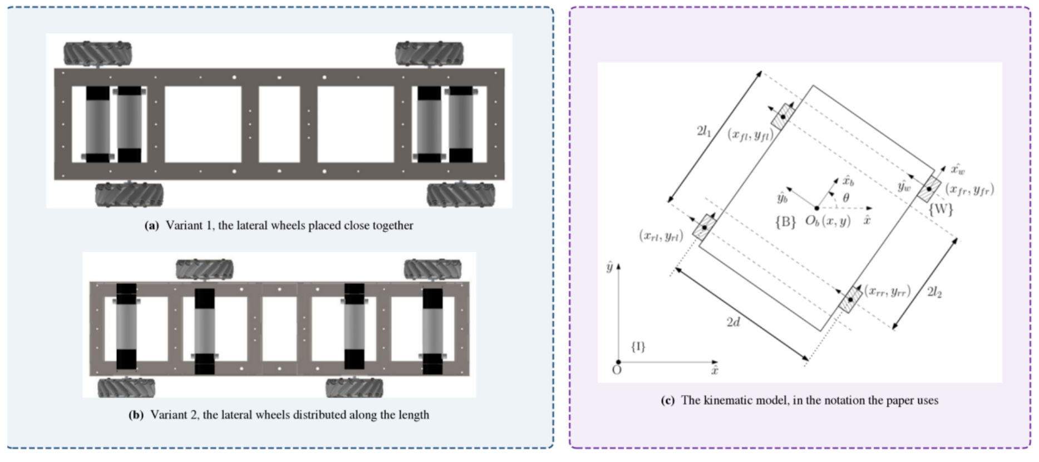
Reproduced from the prior laboratory study. This is the geometry the platform inherits.

What is plotted
Three panels from the earlier paper. Panels (a) and (b) are the two chassis variants that paper proposes: in (a) the lateral wheels sit close together, in (b) they are distributed along the length. Panel (c) is that paper's kinematic schematic, with the wheel origins at longitudinal distances l1 and l2 from the body centre and a half track of d.

What it shows
That the asymmetric non-collinear geometry is inherited, not invented here. Variant (a) is the arrangement built. The symbols l1, l2 and d in panel (c) are the same symbols used throughout the report.

SAY THIS
"This slide is somebody else's result. The prior work derived the kinematics and demonstrated the principle on a small prototype. What it did not establish is whether the geometry survives the transition to a full-scale machine, and that is where my year begins."

EXPECT TO BE ASKED
"What exactly is your contribution then?" Answer: the transition to 45.54 kg, closed-loop control at every wheel, and the measurement campaign. A prototype shows the transformation is correct. It says nothing about whether four geared motors will hold a commanded velocity on a machine this size, whether the resulting pose estimate is good enough to navigate on, or whether a perception stack can be built on top.

Figure 2. Symmetric and non-collinear wheel layouts
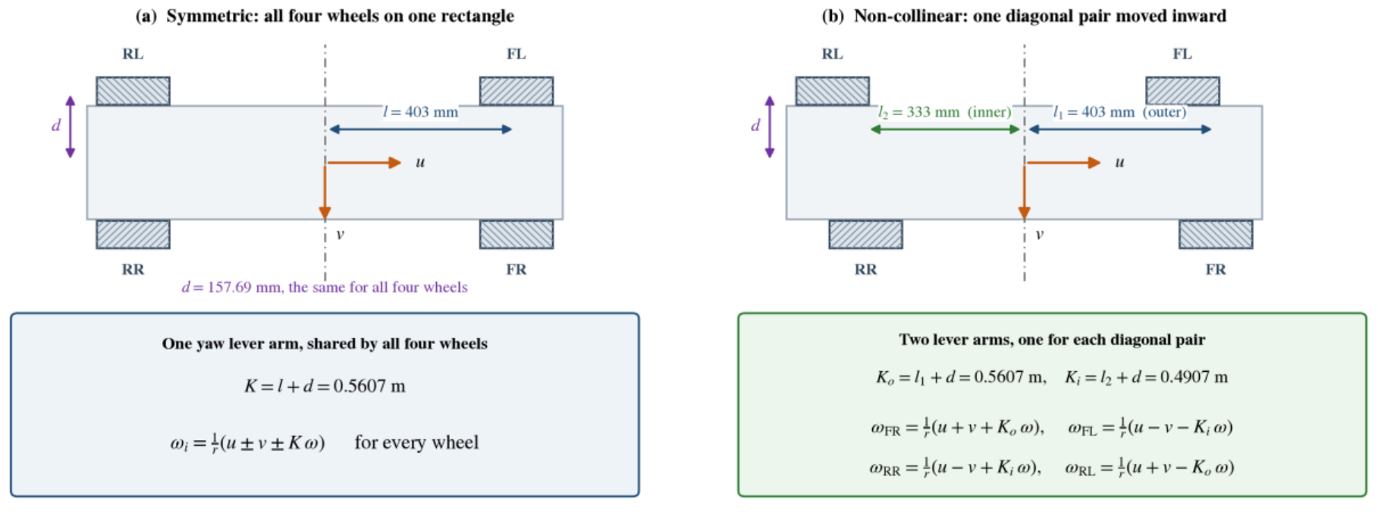
Drawn at the dimensions of the machine built here.

What is plotted
Two side-by-side plan views. On the left, the symmetric layout with all four wheels on one rectangle and one shared yaw lever arm. On the right, the non-collinear layout with one diagonal pair moved inward and two lever arms. Underneath each, the inverse kinematics that follow.

What it shows
In the symmetric case one coefficient, K = l + d = 0.5607 m, serves every wheel. In the non-collinear case there are two: Ko = 0.5607 m and Ki = 0.4907 m, a 14 per cent difference.
And, critically, the translation terms are byte-for-byte identical between the two. Only the yaw column changes.

SAY THIS
"Only the yaw column changes. That is the whole of the difference, and it is also the whole of the risk, because a wheel driven with the wrong lever arm produces a yaw rate wrong by 14 per cent and nothing else in the transformation gives any sign of it."

EXPECT TO BE ASKED
"So is the asymmetry an advantage or just a complication?" Answer honestly: the geometric advantage is real (vehicle width decouples from the wheel rectangle) and it is not yet quantified, because no matched symmetric baseline has been built. Objective 3 is open for exactly that reason. What can be said is that no asymmetry-specific penalty has been detected in any experiment performed.

Figure 3. The machine as built
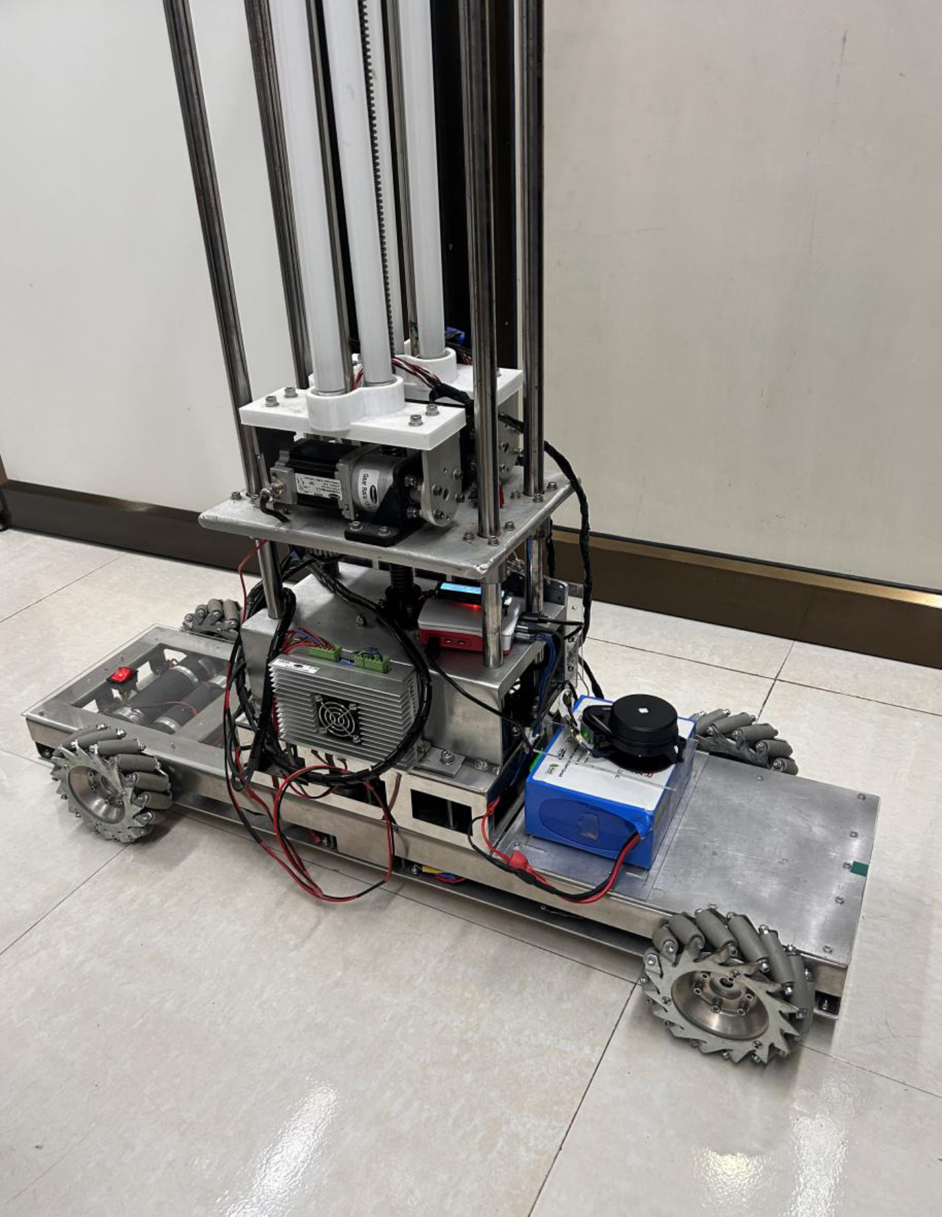
1.00 m long, 0.36 m wide across the wheels.

What is plotted
A photograph of the platform on the laboratory floor.

What it shows
The four mecanum wheels sitting non-collinearly rather than at the corners of a rectangle: the pair nearer the camera is visibly offset along the length from the pair behind. The vertical mast carrying the three ultraviolet tubes and the stepper axis of the cargo arm. The lidar, the black unit above the battery.

SAY THIS
Point at the wheels first, because the offset is genuinely visible and that makes the geometry concrete before any equation. Then point at the mast: "the mast and its payload sit within the plane of the lidar, and they are the cause of the 90-degree self-occlusion sector measured later."

EXPECT TO BE ASKED
"Why is the lidar so low, under the mast?" Answer: it is mounted above the battery for cable routing and for a clear forward view, and the consequence is measured rather than guessed. Raising it above the payload is the obvious fix and would cost mast height and stability. The masking approach was chosen because it costs nothing and the wedge is measurable.

Figure 4. The physical platform and the commissioning measurements
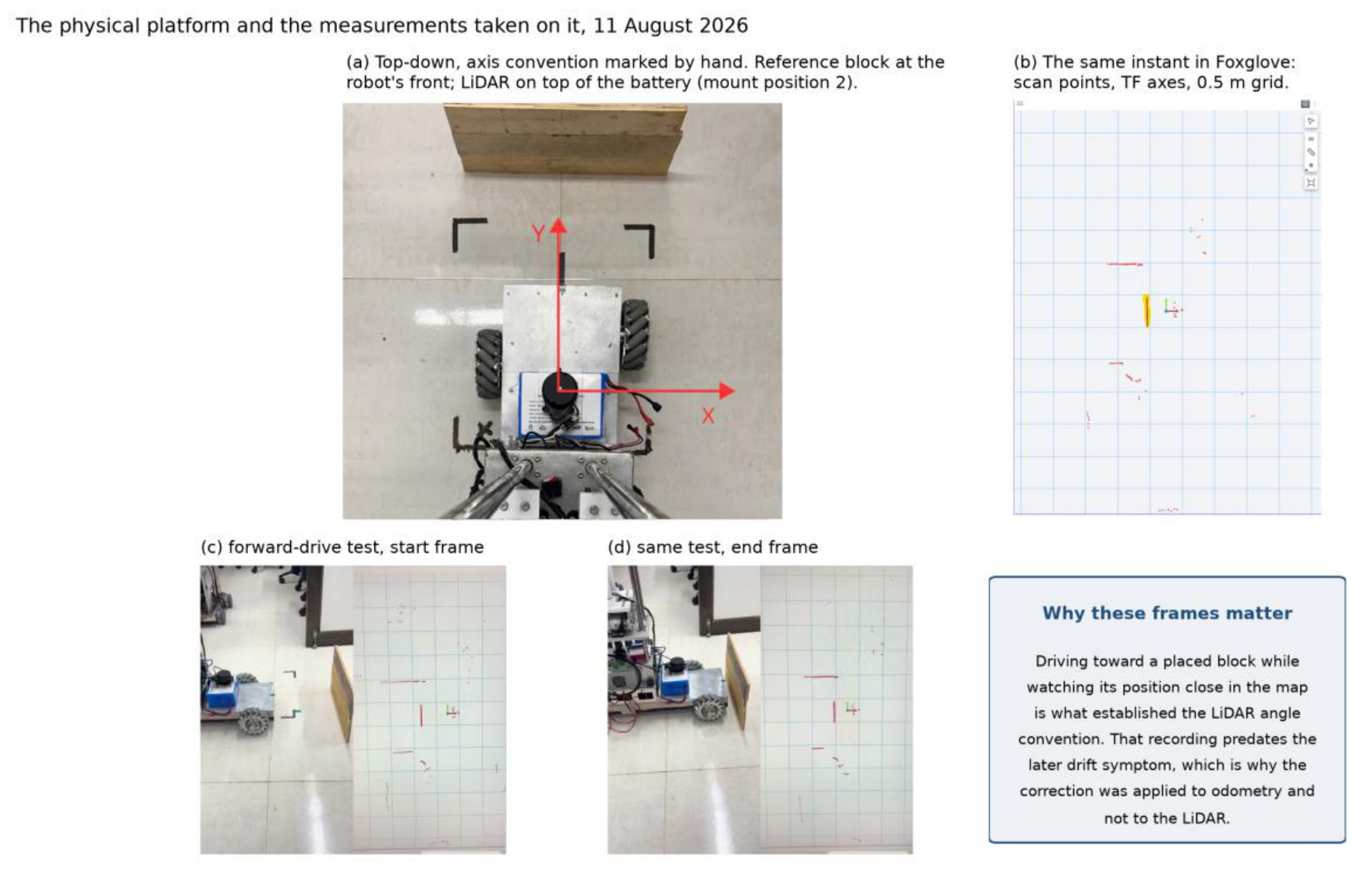
Photographed during hardware trials, 11 August 2026.

What is plotted
Four panels. (a) A top-down view with the body axis convention marked by hand and the lidar at its mounting position. (b) The corresponding view in the visualiser. (c) and (d) The start and end frames of the forward-drive test used to establish the lidar angular convention.

What it shows
That the axis convention was established empirically, by driving against a placed block and recording the result, rather than assumed from the data sheet.

SAY THIS
"Establishing which way the scanner counts its angles took a drive against a placed block, recorded start to end, because nothing on the sensor says which way it is looking. A fault of that kind is trivial to correct once identified and costly for as long as it is not."

EXPECT TO BE ASKED
"Is that not in the manual?" Answer: the manual describes a class of part. This is about the installed unit in its installed orientation, and the mirror-convention bug it uncovered had already been silently corrupting the map. The general rule this project works to is to verify against the running system rather than against a document.

Figure 5. Deployed electronics, end to end
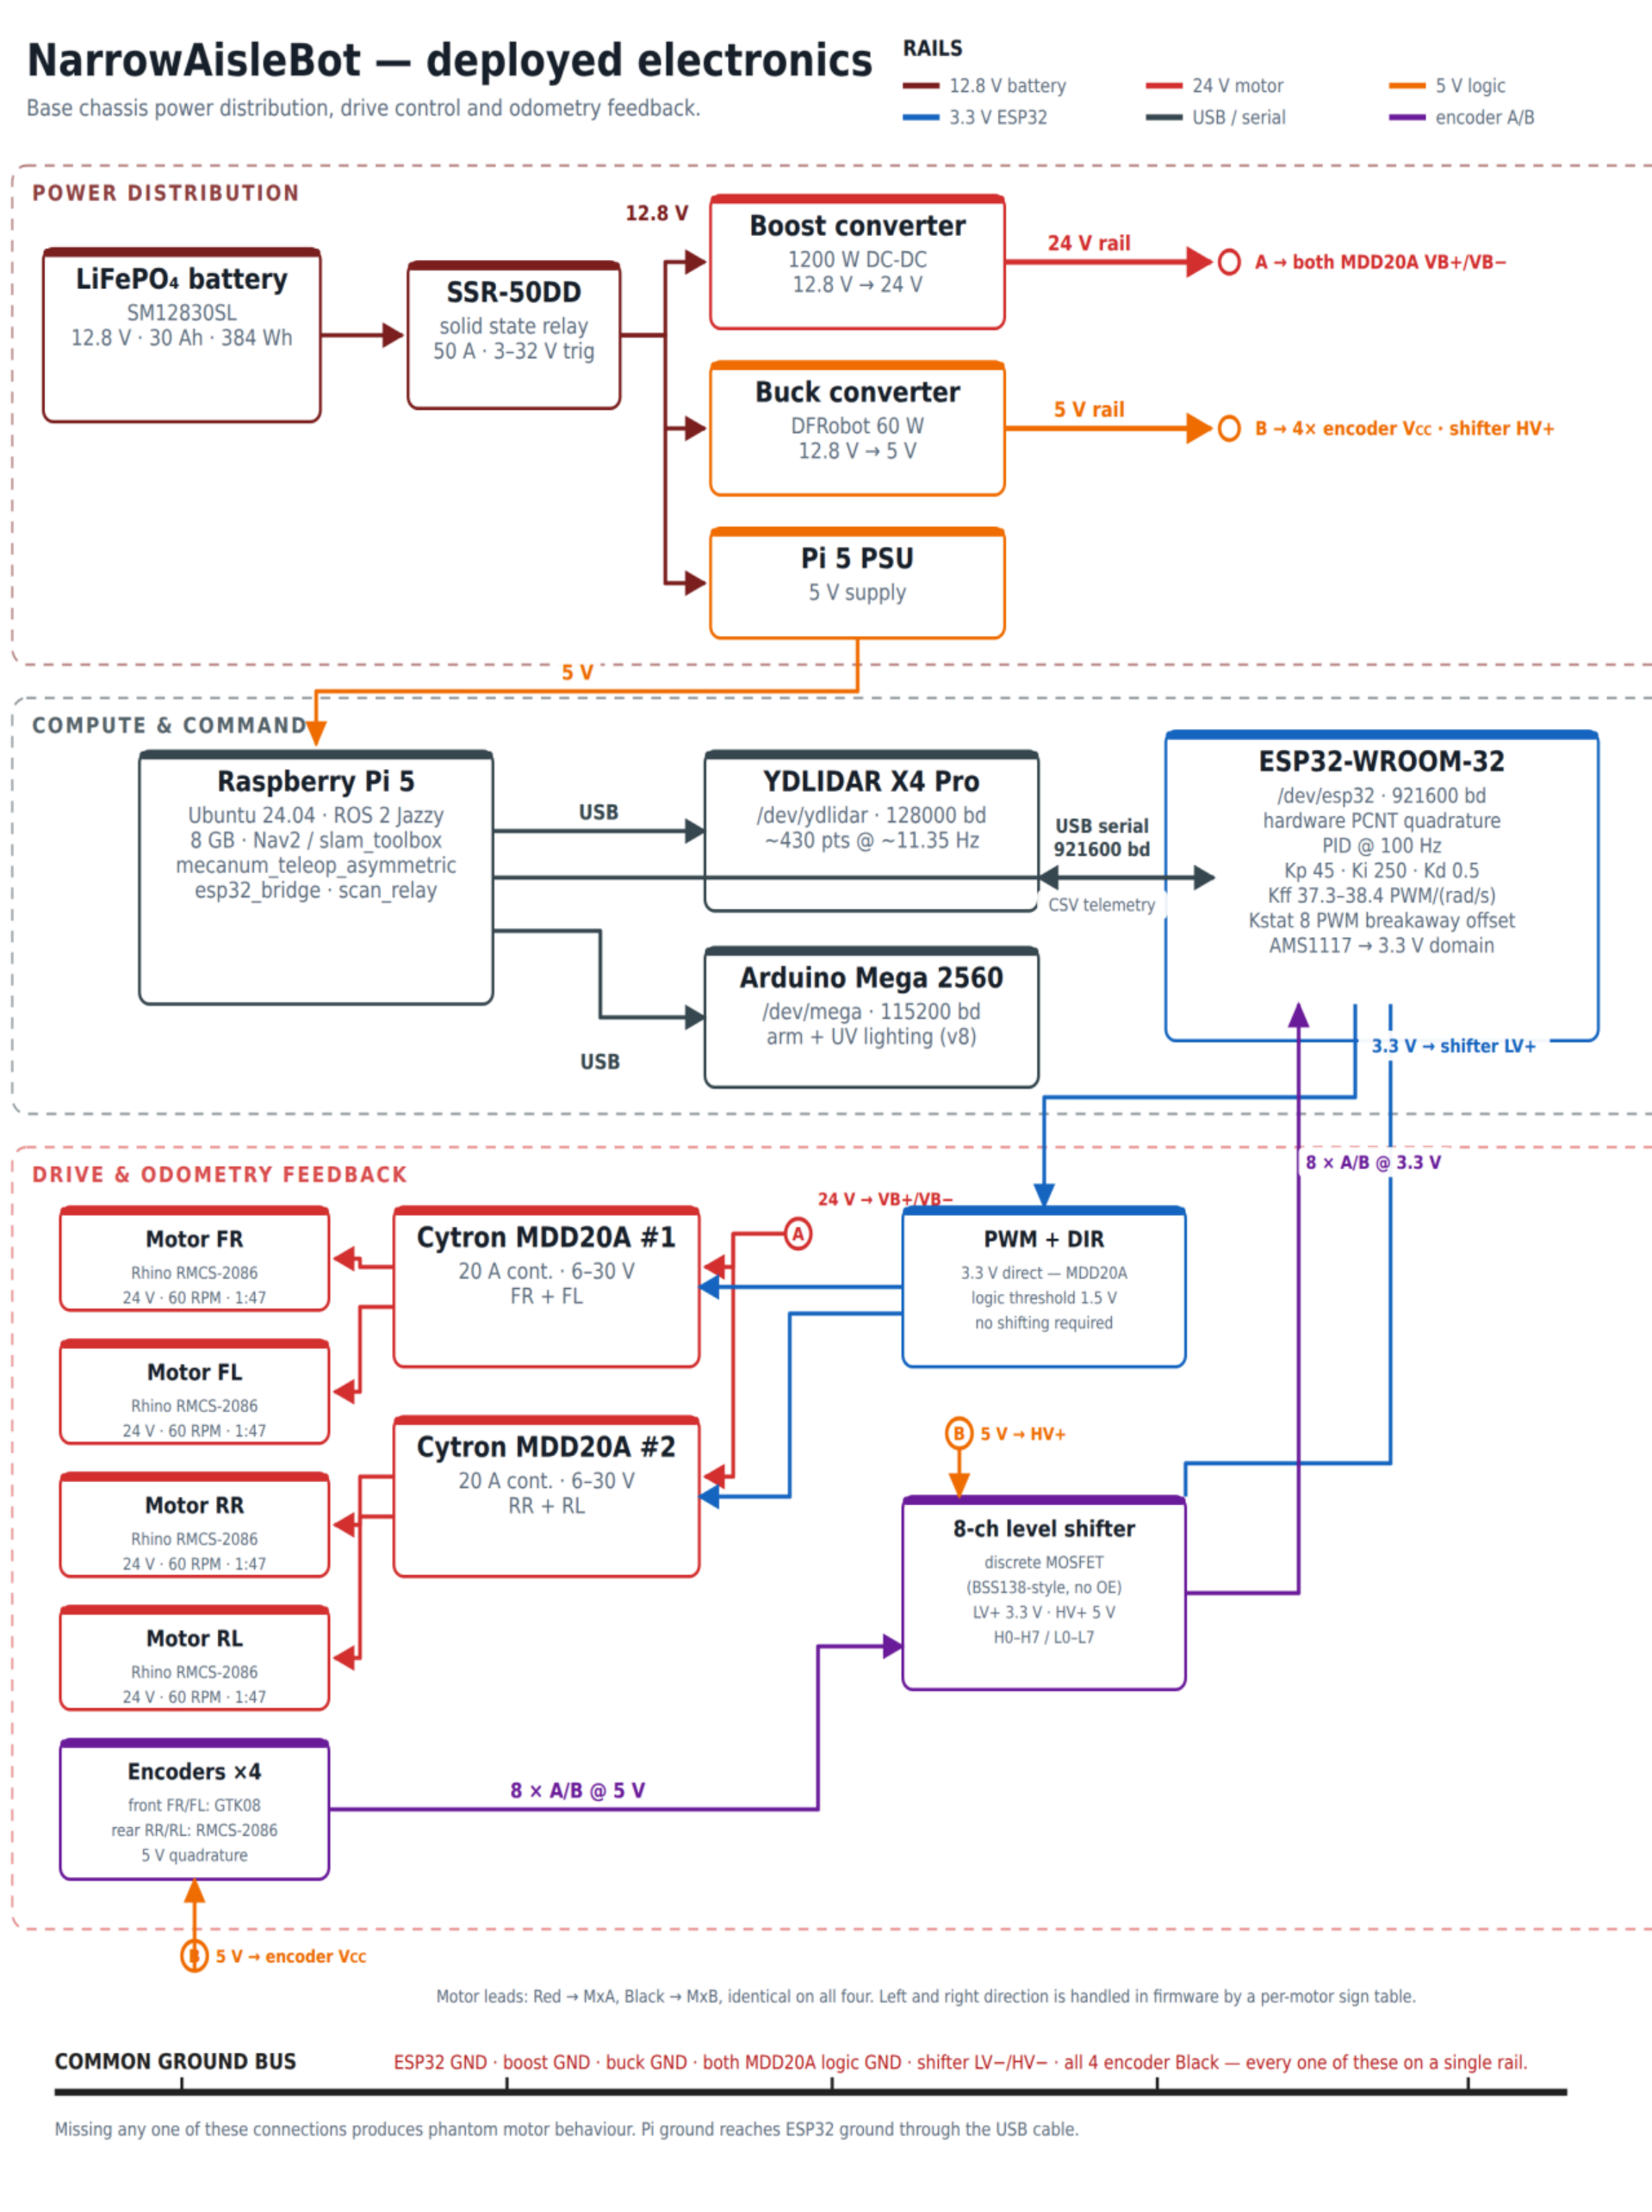
Three layers, each on its own rail colour: power distribution, compute and command, drive with odometry feedback.

What is plotted
A full system schematic. Power from the battery up to the 24 V drive rail and down to the 5 V logic rail; compute and command; drive with its odometry return through the level translator.

What it shows
The complete signal and power topology, and in particular that the level translator sits only on the encoder returns, not on the command path.

SAY THIS
Do not walk this figure block by block. Trace one path and stop: battery to the drive rail, the ESP32 command out to a driver, the encoder return back through the level shifter. Then say the one thing the figure is really for: "the encoder rows carry their wire colours, because the front and rear motors do not share a convention, and that difference has already put a channel on the wrong pin once during commissioning."

EXPECT TO BE ASKED
"Why is the translator only on one side?" This is the good question and you should welcome it. Answer: the drivers threshold at 1.5 V and accept 3.3 V directly, so no translation is needed there. Fewer components in the command path is worth having, because a fault in the command path moves the machine while a fault in the feedback path only misreports it.

Figure 6. Asymmetric wheelbase geometry
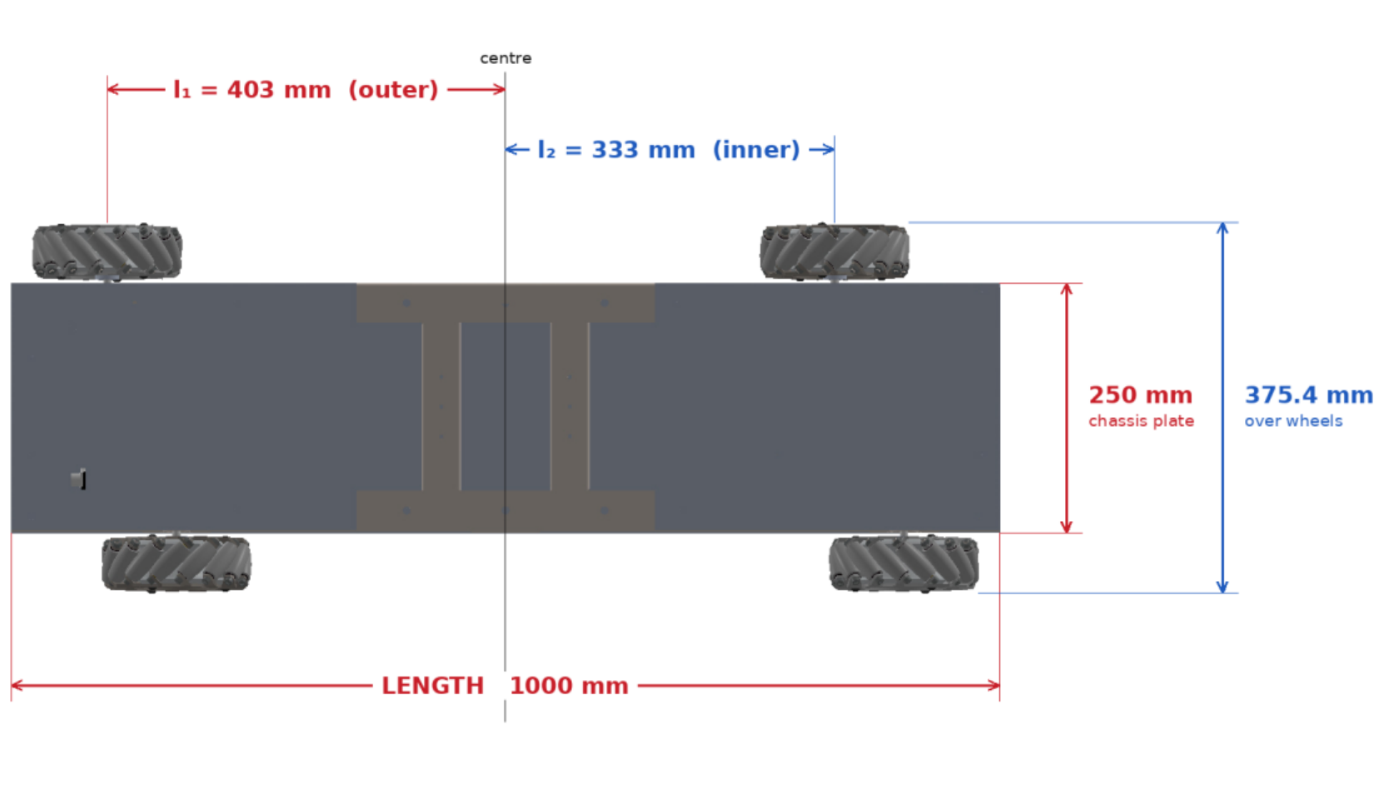
Dimensioned plan view, taken from the mechanical assembly.

What is plotted
The chassis in plan, with the outer diagonal pair at 403 mm from the body centre along the longitudinal axis, the inner pair at 333 mm, and the half track width marked.

What it shows
The 70 mm offset that is the entire geometric novelty, and both width figures: 360 mm by tape and 375.4 mm derived from the assembly.

SAY THIS
"Two width figures appear in this report and they measure the same span by different means. The 360 mm is the tape measurement of the built machine and is what every experimental result and the collision footprint are referenced to. The 375.4 mm is derived from the assembly. They differ by 15.4 mm, and in a corridor with centimetres of clearance that is not a rounding detail, which is why the report says which one it used."

EXPECT TO BE ASKED
"Which one is right?" Neither is wrong; they measure differently. The tape figure is the one the robot is operated against, because a collision footprint has to match the physical object, not the drawing.

Figure 7. The per-wheel velocity loop
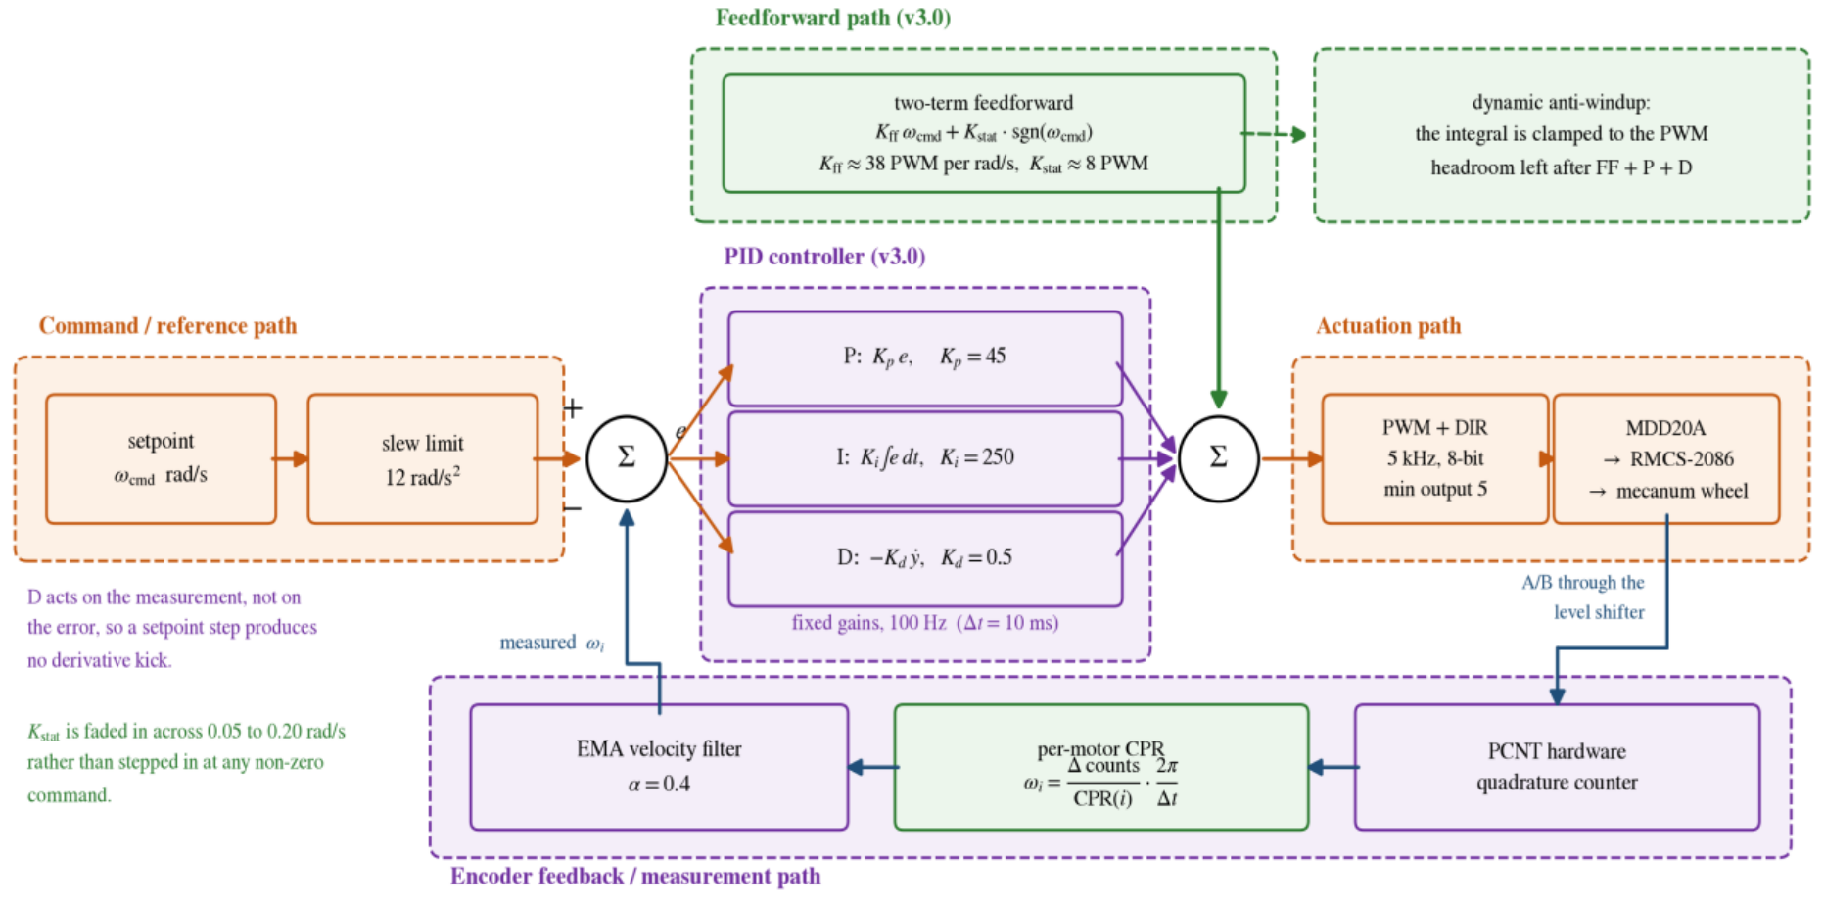
As the deployed firmware runs it, one loop for each of the four wheels at 100 Hz.

What is plotted
A block diagram of one control loop. Green marks the three blocks this firmware version added, orange the command path out to the wheel, purple the controller and the measurement path back from the encoder. Two notes at the left carry details a block diagram cannot show.

What it shows
That this is not a plain PID. The two-term feedforward sits in the forward path and supplies most of the drive; the three feedback terms sit in a correction path.

SAY THIS
"The feedforward supplies most of the drive from the commanded velocity alone, and the three feedback terms correct only what the feedforward gets wrong. That separation is what permits the integral gain to be as large as it is without the loop becoming oscillatory."

EXPECT TO BE ASKED
"What are the two notes at the left?" They are the things a block diagram cannot express: that the derivative acts on the measurement rather than the error, so a stepped setpoint produces no derivative kick, and that the integral clamp is recomputed every tick against the authority actually left over.

Figure 8. The feedforward model
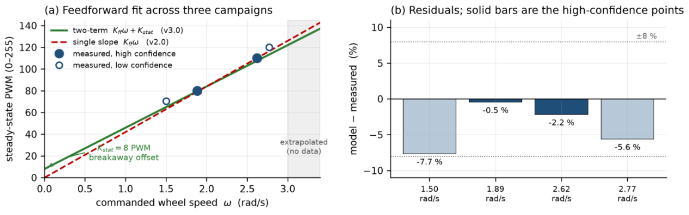
The two-term model fitted against measured open-loop data.

What is plotted
Left panel: steady-state drive count against commanded wheel speed, with the measured points from three campaigns, the fitted two-term model, and a single-slope model for comparison. Right panel: the residuals, with the two high-confidence points marked.

What it shows
That a single slope through the origin systematically under-drives the wheels at low speed, and that adding a static term fixes it. Every measured point lands inside 8 per cent, and the two high-confidence points inside 2.2 per cent.

SAY THIS
"The inadequacy of a single-slope model is evident in the raw data, before any fit is attempted: the ratio of drive command to resulting wheel speed rises as speed falls, which is the signature of a breakaway friction term that a straight line through the origin cannot reproduce."

EXPECT TO BE ASKED
"How well separated are your two coefficients?" Volunteer the limitation before it is asked. Every measurement sits between 1.8 and 2.8 rad/s, and over that narrow span many pairs fit almost equally well: Kff 34.5 with Kstat 15 is barely distinguishable from Kff 38 with Kstat 8. What is well determined is the value of the whole expression across the measured range, which is what the controller consumes. Separating them properly needs a staircase test that has not been run.

Figure 9. Closed-loop tracking
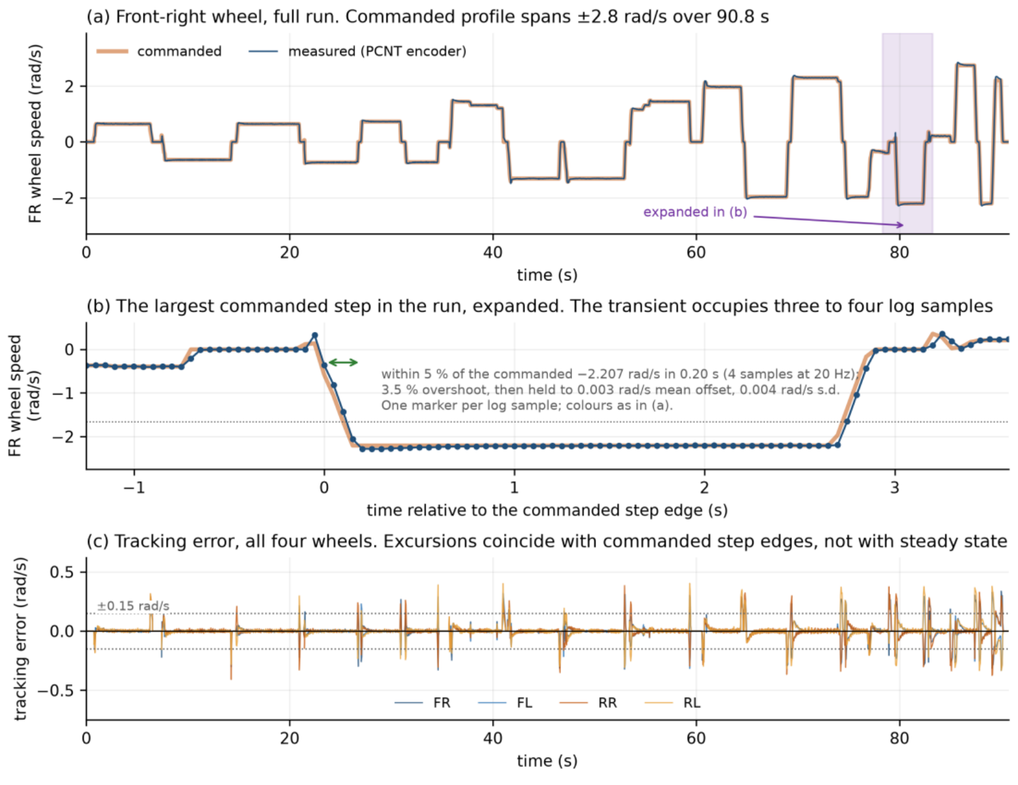
Wheel velocity against command, with the wheels free of the ground.

What is plotted
Panel (a): the front-right wheel over the full 90.8 s run, commanded and measured, with a shaded band marking the region expanded below. Panel (b): the largest commanded step in the run, expanded, plotted against time relative to the step edge, one marker per 20 Hz log sample. Panel (c): tracking error for all four wheels across the whole run.

What it shows
(b) is the quantitative core: the wheel reaches within 5 per cent of the commanded -2.207 rad/s in 0.20 s, overshoots by 3.5 per cent, and then holds the level to a mean offset of 0.003 rad/s.
(c) is the qualitative core: the error excursions coincide with commanded step edges, not with steady state. A loop that was badly tuned would show error during the steady sections too.

SAY THIS
"The step transient occupies three to four log samples, which is why it appears in panel (a) as a vertical edge. Panel (b) is the same event expanded so you can see it is a clean first-order response with a small overshoot, not a ringing one."

EXPECT TO BE ASKED
"Your logging is at 20 Hz but your loop runs at 100 Hz. Are you seeing the real transient?" Honest answer: the transient occupies three to four log samples, so it is sampled but coarsely. The overshoot and steady-state figures are reliable; a settling-time figure to the millisecond would need faster logging.

Figure 10. Ground load
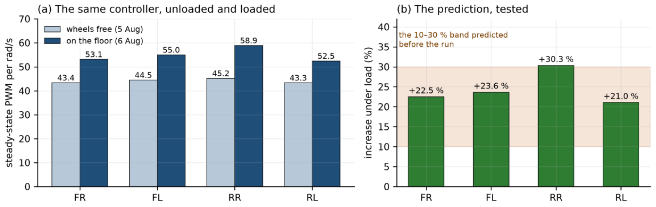
Steady-state drive demand per unit wheel speed, unloaded against loaded.

What is plotted
Left panel: the same controller, unloaded and loaded, per motor. Right panel: the measured percentage increase per motor against the band predicted before the run.

What it shows
Measured increases of 22.5, 23.6, 30.3 and 21.0 per cent, a mean of 24, against a band of 10 to 30 per cent written down in advance. Three motors fall inside. The rear-right reaches 30.3, which is 0.3 points above its upper bound, and is reported as an exceedance rather than rounded into agreement.

SAY THIS
"The ground-load result is stated as a prediction and a test rather than as an observation, because the predicted band was written down before the run. That is one of this project's two standing conventions; the other is that configuration is verified by querying the running system rather than by reading a file."

EXPECT TO BE ASKED
"Is 24 per cent a reliable number?" No, and say so. Two later runs the same afternoon, at the same commanded levels but over different patches of floor, gave means of 14 and 3 per cent. The increase is real; its size is not established to better than the width of the band it was predicted against. The likeliest reason is the surface rather than the load, and a staircase test holding position and sweeping demand is what would settle it. It has not been run on the floor.

Figure 11. Endpoint closure
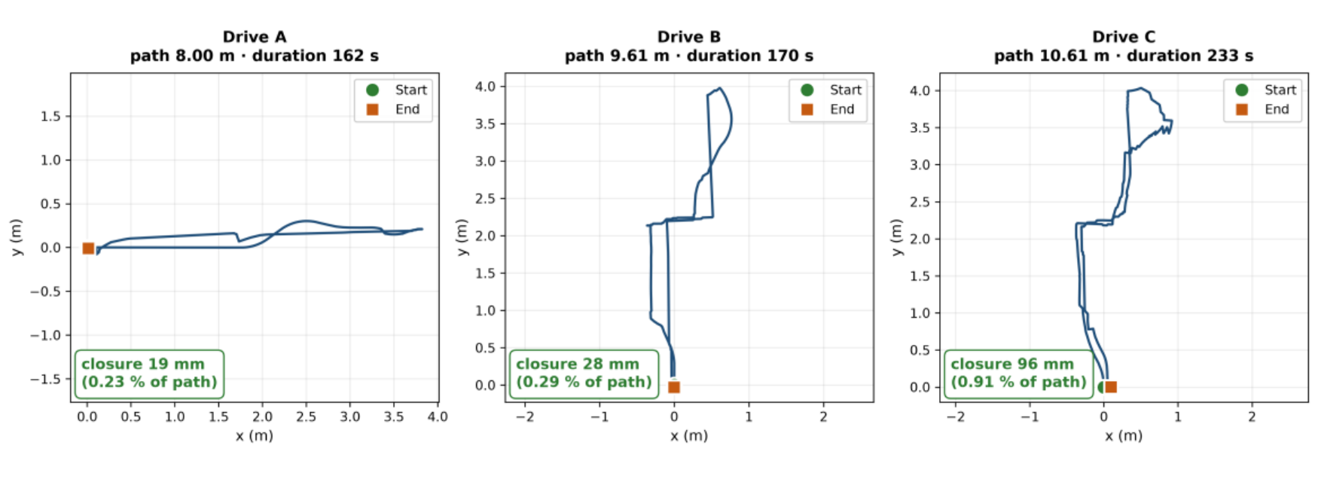
Wheel-odometry trajectories for three logged drives, each driven manually and returned to its starting mark.

What is plotted
Three plan-view trajectories, plotted from the recorded pose, with the start and end marks shown on each.

What it shows
Closure of 19 mm over 8.00 m, 28 mm over 9.61 m and 96 mm over 10.61 m: 0.23, 0.29 and 0.91 per cent of path travelled.

SAY THIS
"The longest of the three, which includes the most rotation, closes at 0.91 per cent. Error grows with the amount of rotation a route contains as well as with its length, which is consistent with the increased lateral roller motion expected during rotational manoeuvres."

EXPECT TO BE ASKED
"Can you generalise that to a warehouse aisle?" No, and the report says so explicitly. On an 18 m route the same estimator closed 0.229 m, 1.27 per cent, and on a second long route 0.257 m over 18.14 m, 1.42 per cent. The defensible statement is bounded: below 1 per cent out to about 10 m, 1.1 to 1.5 per cent on the longest routes driven. Separating length from rotation needs routes that vary the two independently, which needs a larger space.

Figure 12. Self-occlusion
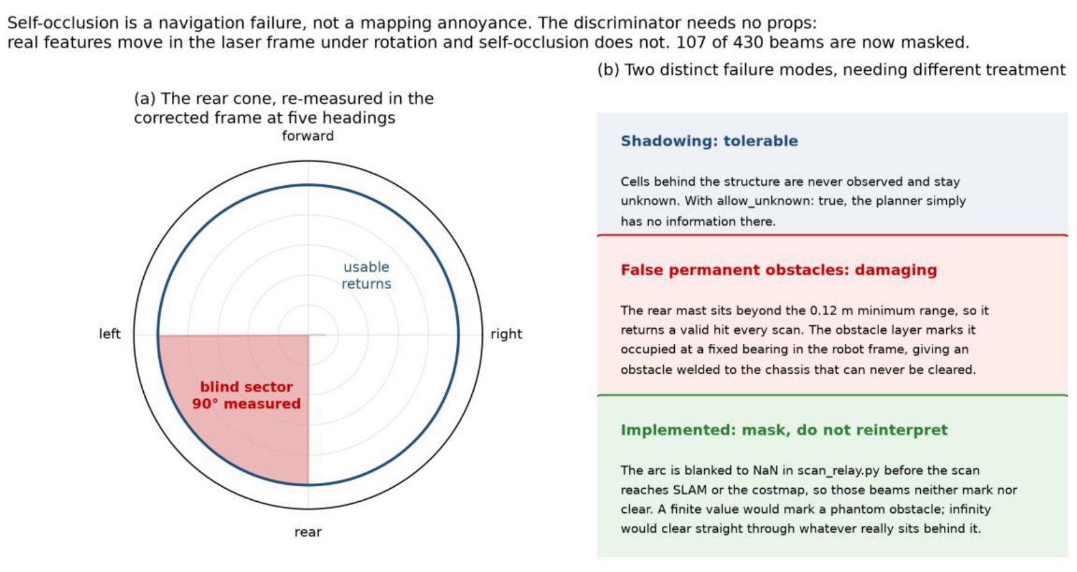
The occluded sector, re-measured at five independent headings.

What is plotted
A polar diagram in the corrected body frame, showing the wedge that returns a close reading at every heading, and a panel distinguishing the two failure modes that unmasked returns would cause.

What it shows
A wedge of approximately 90 degrees centred on directly behind the robot, covering 107 of the 430 beams returned per revolution.

SAY THIS
"Real features move in the laser frame as the robot rotates. Self-occlusion does not. That invariance is the discriminator, and it needs no props, no reference objects and no physical construction. One contiguous bearing block returned a close reading in all five independent headings at consistent percentages; every other sector that any single run flagged appeared in that run and nowhere else."

EXPECT TO BE ASKED
"Why mask rather than mark occupied?" Because a fixed-bearing occupied cell translates and rotates with the robot: a permanent obstacle welded to the chassis that can never be cleared, which inflation then expands until the planner concludes that entire direction is blocked. And you cannot mark it free either, because a clearing beam would erase real obstacles behind the mast. A beam carrying no information must be dropped, not reinterpreted.

Figure 13. Rotation and mapping coverage
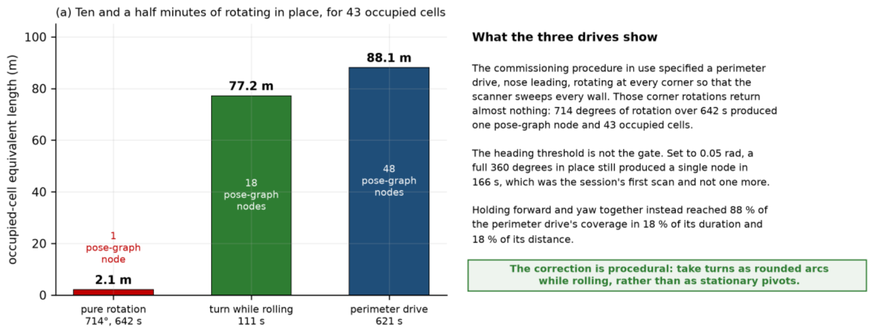
Map coverage accumulated under three drive patterns.

What is plotted
A bar chart of occupied-cell equivalent length for three drives: pure rotation in place, an arc combining rotation with translation, and a full perimeter drive.

What it shows
A deliberate 714-degree rotation over 642 s produced 43 occupied cells, 2.1 m on this measure. A 111 s arc produced 1545 cells, 77.2 m, which is 88 per cent of a full perimeter drive's coverage in 18 per cent of its duration.

SAY THIS
"This is the most operationally consequential perception result obtained. The commissioning procedure in use had specified rotating in place at each corner to survey the space. That procedure discards its own corner observations. Coverage accumulates through translation, so turns must be taken as rounded arcs while rolling rather than as stationary pivots. Correcting it required no hardware modification."

EXPECT TO BE ASKED
"Why does the total exceed the perimeter of the room?" Because the quantity is an occupied-cell equivalent length: occupied-cell count times the 0.05 m cell size. It is a proxy for how much occupancy the map has committed to, not a physical wall length, and a single wall rendered several cells thick contributes several times its own length. Have that answer ready; the number does look odd.

Figure 14. Commissioning maps
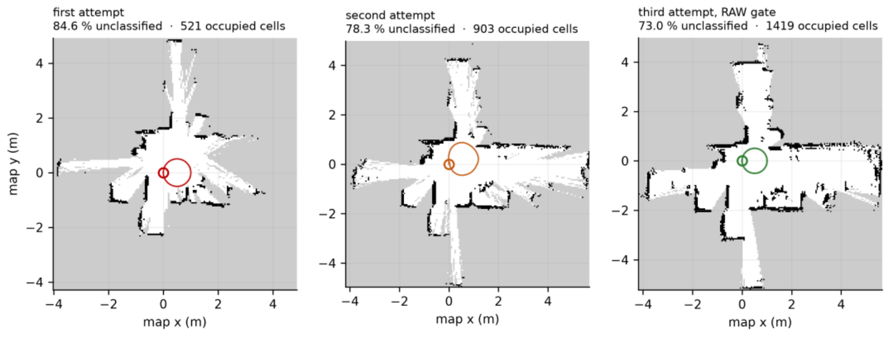
The three maps of 15 September, rendered from the saved occupancy grids.

What is plotted
Three occupancy grids side by side, with the driven path overlaid on each. Grey regions are cells that never accumulated enough observation to be classified.

What it shows
Within the classified regions, the recovered wall geometry is consistent across all three runs and with the layout of the room, and the robot returns to its starting mark in each case. The grey regions are the criterion that fails.
The driven path is visible as a small loop near the origin in each panel, which is the coverage problem seen directly.

SAY THIS
"The driven path is that small loop. The robot cannot classify what it cannot drive past, and the available circuit is a few metres. Unclassified cells occupy 73.0, 78.3 and 84.6 per cent against a threshold of 50. That is a statement about the space rather than about the mapping layer, because everything else about these maps passes."

EXPECT TO BE ASKED
"Is your coverage metric fair?" Volunteer the answer: the percentage is computed over every cell in the published occupancy grid, which is the bounding extent the mapper allocated rather than the traversable floor area, so it overstates the fraction of reachable space left unobserved. It is used because it is the criterion written down before the mapping work began and because the same definition applies to every run compared. A criterion over a fixed region of interest would be better and is owed.

Figure 15. System validation status
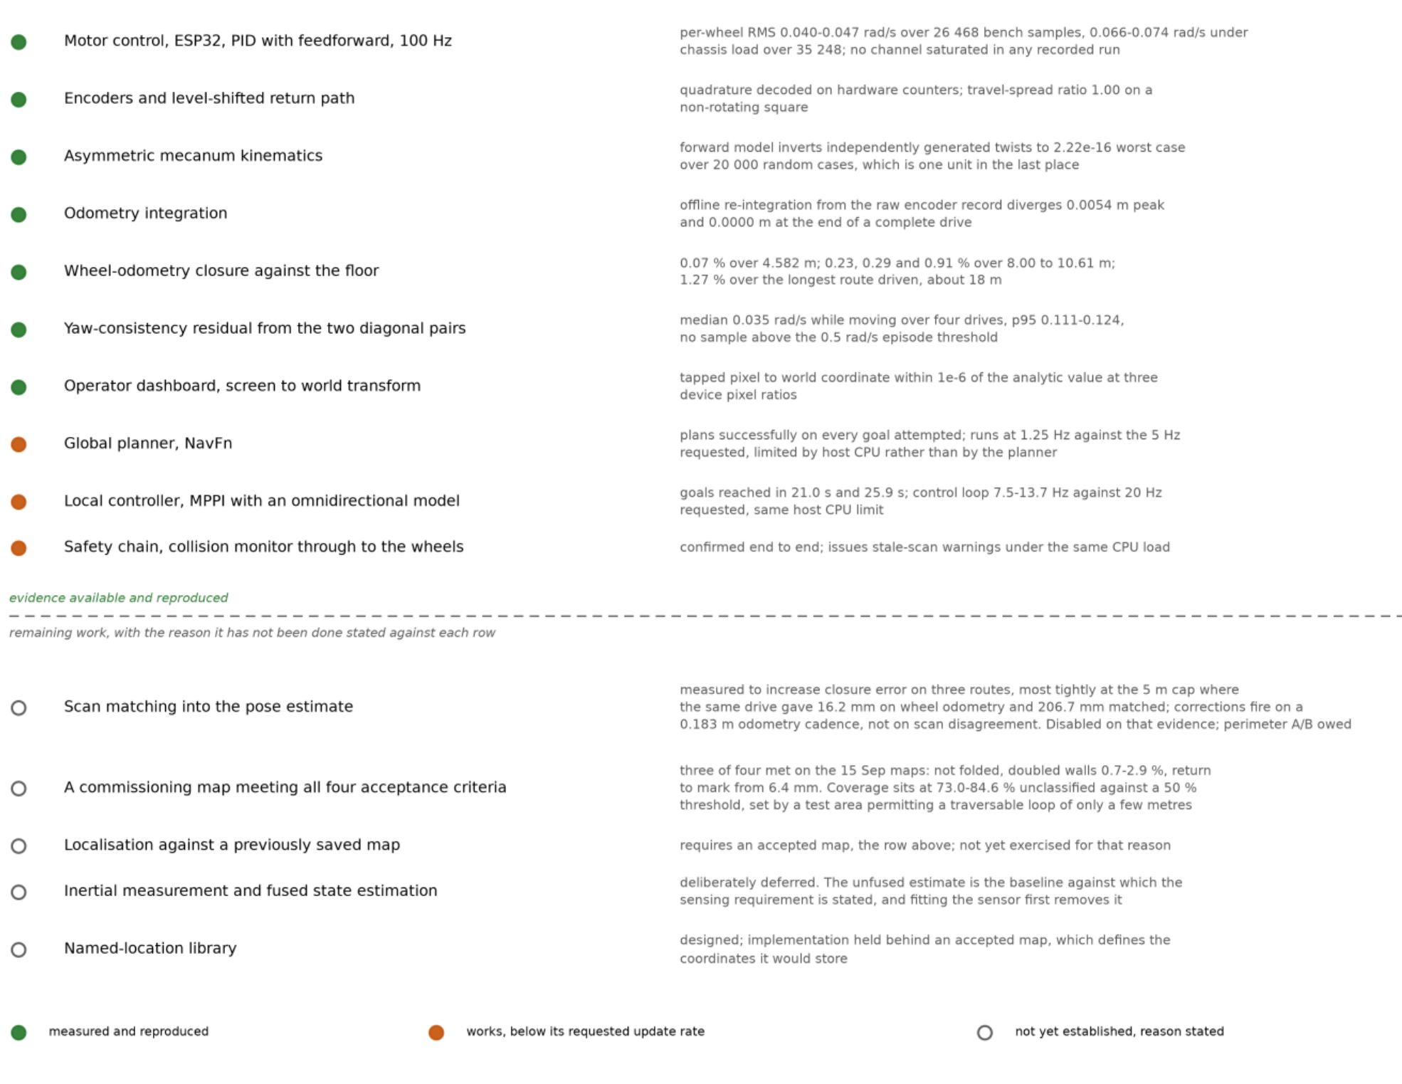
Each layer with the measurement that supports it, or the reason it has none.

What is plotted
A two-part status board. The upper half lists layers that are established, with the measurement against each. The lower half lists layers that are not, with the specific reason against each.

What it shows
That the evidence is not all of one kind. Closure against the floor is an external reference. The kinematics and odometry rows are checks against an independent implementation. The planner, controller and safety rows are operational demonstrations rather than measurements against a reference.
And that three components work correctly but run below their requested update rates because of the processing available on the host.

SAY THIS
"For the five layers that are not yet established, the entry states the specific reason rather than recording a failure. And in three of those five the reason is the size of the available test area rather than anything on the platform. Four entries, one cause."

EXPECT TO BE ASKED
"Which of these would you fix first?" The test space, because it lifts four entries at once and no work on the robot moves any of them. Then the inertial sensor, because it has a measured target to be tested against.

Figure 16. The appliance and the sensing node
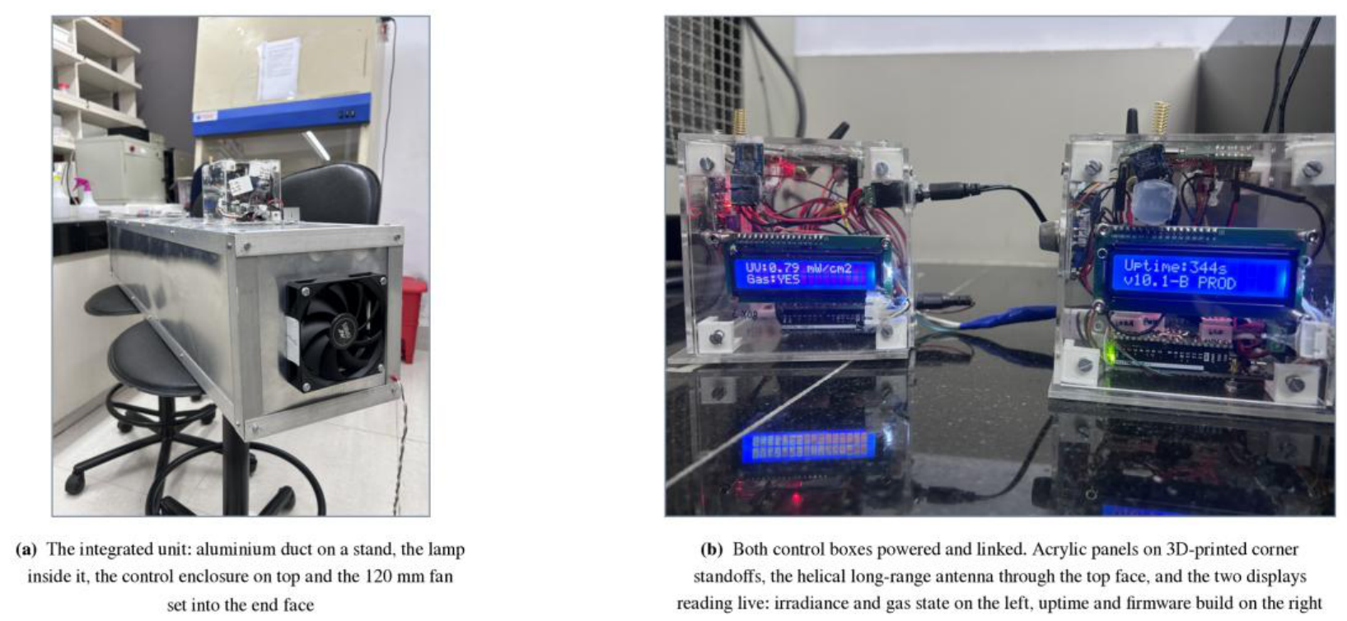
Both units as built.

What is plotted
Panel (a): the integrated air-treatment unit, an aluminium duct on a stand with the germicidal lamp inside, the control enclosure mounted on top near one end, and the 120 mm fan set into the end face. Panel (b): both control boxes powered and linked, with the two helical antennas and the transparent panels visible.

What it shows
The physical arrangement, and that the electronics sit outside the treated air path: the only things inside the duct are the lamp and the airflow.
The displays are reading live, which is how a node is checked in the laboratory without attaching a computer to it: irradiance and gas state on the left, uptime and firmware build on the right.

SAY THIS
"The enclosure was designed rather than bought. Acrylic, each face a separate panel held by printed corner standoffs, so any one face can come off without disturbing the others. And one correction worth recording, because earlier project documents have it wrong: the enclosure is not a cube. The photographs show a box visibly wider than it is deep."

Figure 17. Monitoring and control architecture
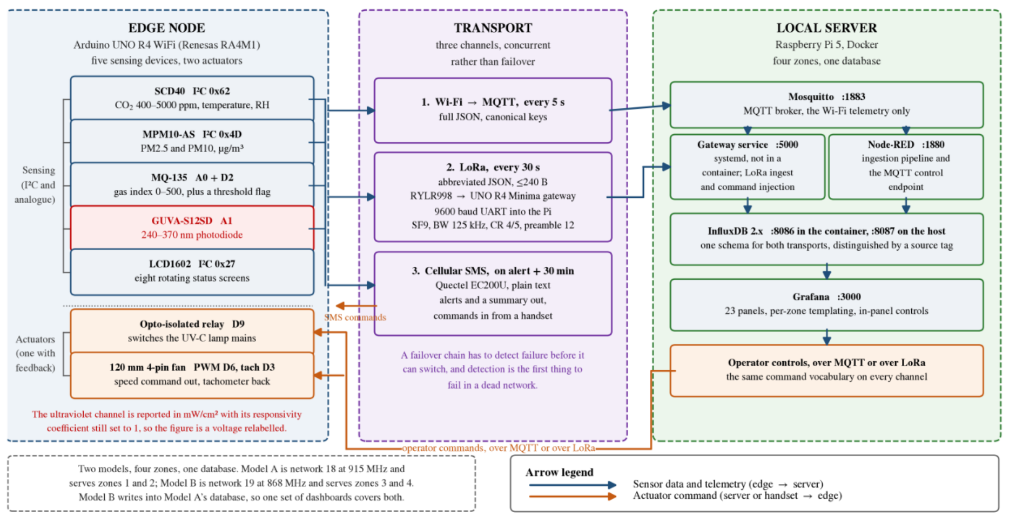
End to end, from the devices on the edge node through three communication channels to the containerised stack.

What is plotted
A full architecture diagram. Blue is telemetry travelling outward from the node; orange is a command travelling back to it; red marks the one measurement channel that is fitted, reads, and does nothing.

What it shows
That the three channels are not variants of one path. Only the Wi-Fi telemetry passes through the message broker. The radio path never touches it, because the gateway speaks a framed serial protocol and its service writes to the database directly. And the cellular path is not ingested at all: it delivers a message to a person, and nothing on the server records it.

SAY THIS
"The figure is drawn so each channel can be followed separately, because the three arrive at three different places and only two of them reach the database. A reader who assumes all three converge on the broker would draw the wrong conclusion about what a server outage costs."

EXPECT TO BE ASKED
"Why concurrent rather than failover?" Because a failover design must detect failure before it can switch, and detection is the first thing to fail in a dead network. Running independent channels concurrently avoids that dependency at a bandwidth cost a low-rate telemetry system can absorb.

Figure 18. The operator dashboard in service
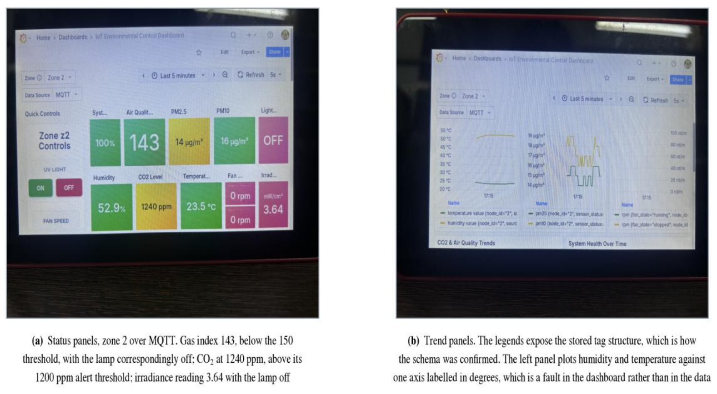
Photographed off the screen rather than captured from it.

What is plotted
Panel (a): the status view for one zone. Panel (b): the trend view, whose legends expose the stored tag structure.

What it shows
The deployed system in a single consistent operating state: the gas index below its actuation threshold with the lamp correspondingly off, and the carbon dioxide reading at the same instant above its alert threshold with an alert raised on all three channels.

SAY THIS
"That establishes the deployed logic produces the configured actuator and alert states for the inputs present at an instant. What it does not do is show the control path responding to a change. A time-resolved recording, with the measurement, the threshold crossing, the actuator command and the response on one time axis, is the next capture the control path needs, and it is straightforward to take on the running system."

EXPECT TO BE ASKED
"Why photograph the screen rather than screenshot it?" It is the primary record as captured, including the operator's own annotation, and the report keeps it alongside the regenerated counterpart rather than replacing it. The figure also happens to catch the system 40 ppm above the carbon dioxide threshold, which is well inside the range where the alert path flaps, which is a known defect stated in the text.

Figure 19. The operating condition, and where each method stops
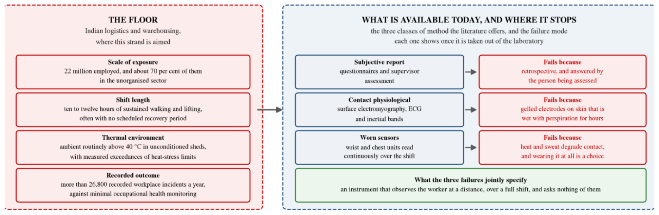
The conditions any instrument would have to work in, against the class of method now in use and why each fails.

What is plotted
Two columns. The left states the operating conditions of an Indian warehouse floor. The right pairs each established class of fatigue measurement with the specific reason it does not survive those conditions.

What it shows
That the three reasons are not equivalent, which is the whole argument for the strand. Subjective report is unreliable at its source, and no instrument corrects that. Contact methods are reliable in themselves and cannot be maintained in contact across a ten-hour shift above 40 degrees.

SAY THIS
"The contact methods fail for a limitation of the instrument rather than of the measurement principle, and that is therefore a tractable failure. It is that second class of failure, and only that class, which this strand addresses."

EXPECT TO BE ASKED
"Why not just improve the wearables?" Fair question, and the honest answer is that the objections are practical rather than evidential: discomfort over an eight-hour shift, electrode contact degrading with perspiration, compliance depending on the worker choosing to wear it, and a daily charging burden across hundreds of people. None is fatal alone. Together they are why the strand asks whether the measurement can be made without contact at all.

Figure 20. The proposed pipeline, capture to score
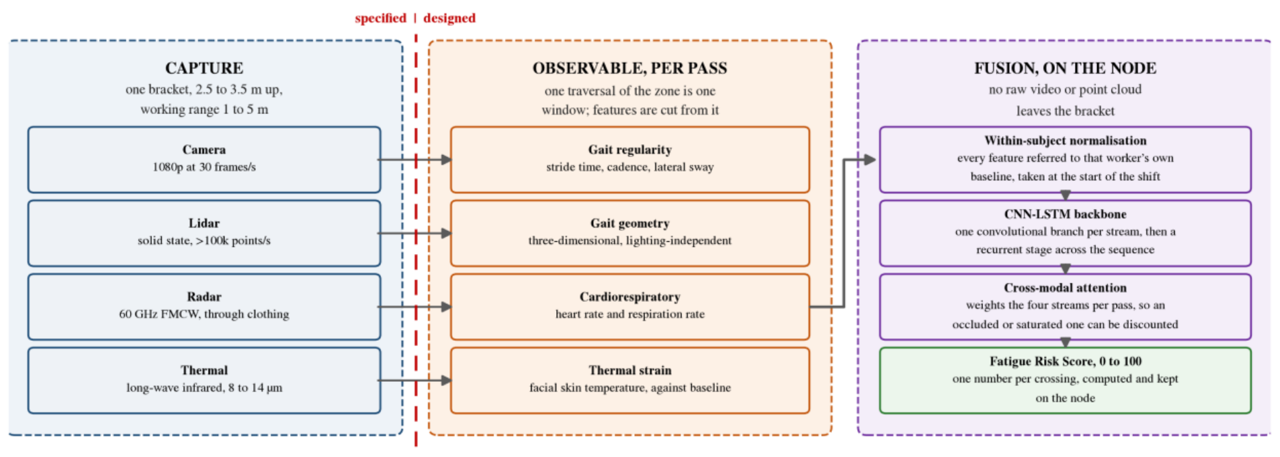
One crossing of the monitored zone, from capture to a single score.

What is plotted
Four contactless streams reduced on the node itself, each supplying a distinct fatigue indicator, feeding a fused estimate. A dashed rule marks the limit of what the proposal fixes.

What it shows
The sensor set, the mounting, and the two design decisions that carry most of the risk. Everything to the right of the dashed rule is design rather than specification.

SAY THIS
"The fused estimate is computed without any raw video or point cloud leaving the sensor bracket, which is what makes the privacy position a property of the architecture rather than an undertaking. India's data protection legislation of 2023 makes a device that extracts a derived score a different legal object from one that streams a camera feed to a server."

EXPECT TO BE ASKED
"Could this become surveillance?" Meet it head on. Gait carries enough information to identify a person; the point-cloud benchmark cited in the review exists to demonstrate exactly that. A system installed to estimate fatigue must not become one that recognises individuals, so the pipeline has to discard identity by construction rather than by policy. That constrains which features may be retained and what may be stored, and it is easier to design for at the start than to retrofit.

Figure 21. The three objectives, and the reference each is measured against
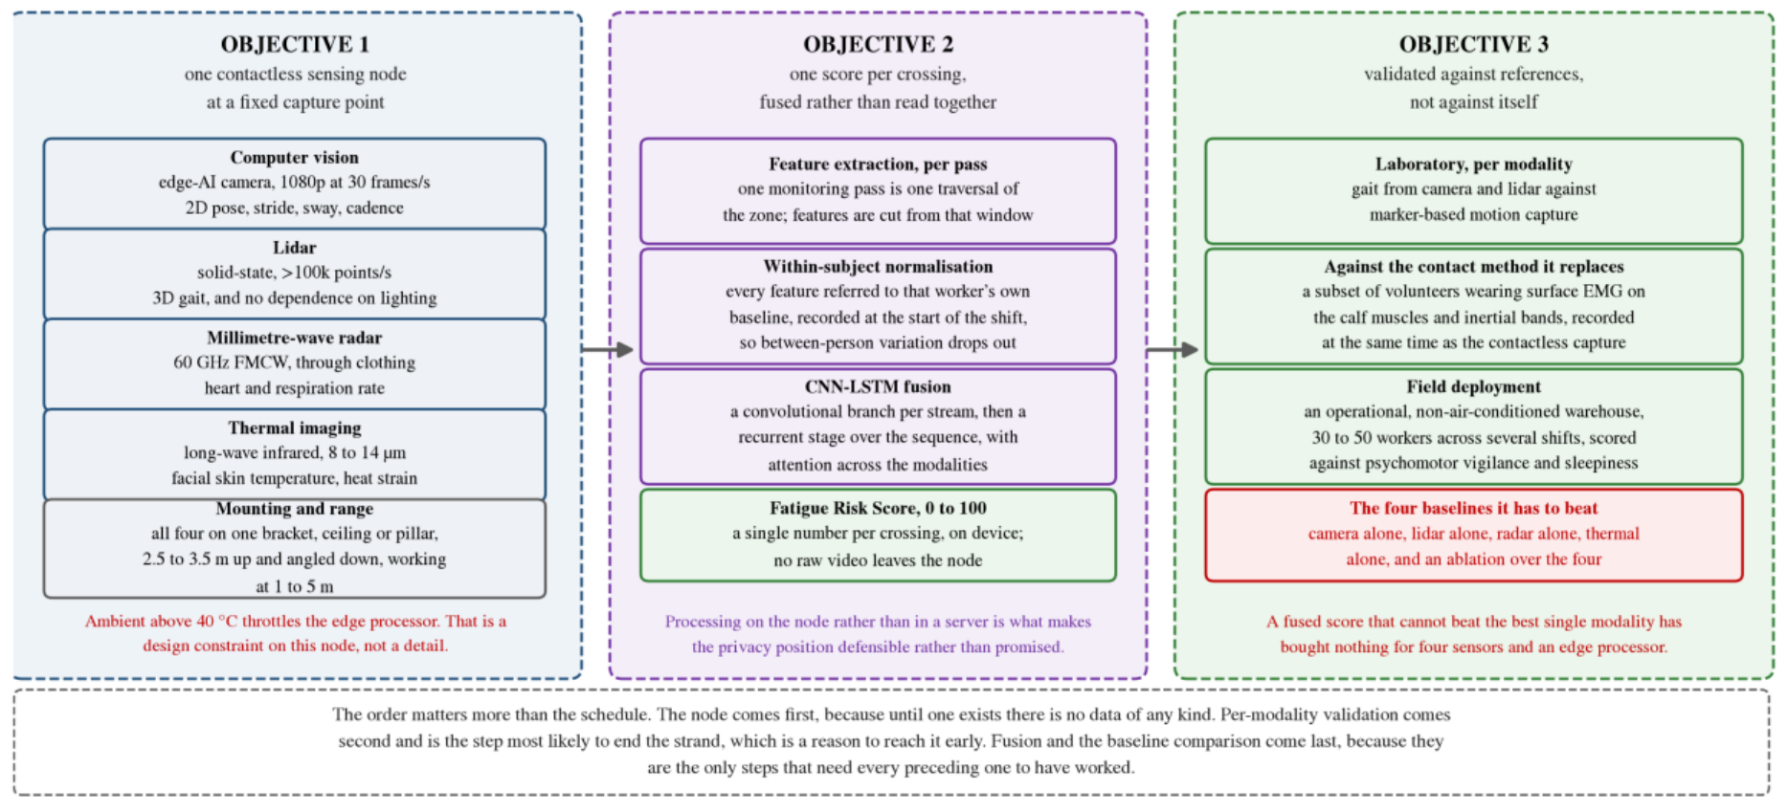
Where Figure 20 gives the signal path, this gives the order of work.

What is plotted
Three objectives in sequence, each with the external reference it would be validated against in the right-hand column.

What it shows
That the strand is set up to be falsified. Gait from the camera and the lidar is checked against marker-based motion capture, which is an external physical reference rather than another estimate. A subset of volunteers wears surface electromyography at the same time as the contactless capture, so the proposed method is compared directly against the established method it proposes to replace, on the same subjects during the same task.

SAY THIS
"Reading down the right-hand column establishes the order: a modality that has not been checked against motion capture cannot sensibly be fused, and a fused score has nothing to be compared against until the contact reference has been recorded on the same subjects during the same task. The comparison that decides it is the last row: the fused score must beat all four single-modality baselines plus an ablation. A fused score that cannot beat the best single modality has bought nothing for four sensors and an edge processor."

EXPECT TO BE ASKED
"Why set that bar now, before any data?" Because it is exactly the comparison that becomes easy to avoid once a pipeline exists and produces plausible-looking numbers. Registering it in advance is the same discipline as writing the ground-load prediction down before the run.

Part 11 Strand two: environmental monitoring

11.1 The argument for building it
Two considerations motivated the strand, and both are about the difference between measuring and acting.
- Environmental variables relevant to storage conditions and worker exposure are measurable, but are not necessarily incorporated into the control of air-treatment systems. The sensing exists; the loop does not.
- Timer-based operation of treatment equipment provides no feedback from the condition of the air being treated. Open-loop operation cannot adapt treatment to changing conditions and cannot indicate whether treatment is required at all.
The narrower form of the argument is the one to use in a viva, because it is concrete:

A room heater on a mechanical timer. It runs from six to eight every evening whether the room is cold or not, and it has no idea whether its own element has burnt out. You would only find out by noticing the room is cold.
A treatment duct on a timer is the same object. It cannot raise airflow when the air is contaminated, and it cannot report the failure of its own lamp.

And why local rather than cloud: cloud-hosted monitoring makes continuity of monitoring depend on external connectivity. For a facility where the monitored condition matters most during a disruption, that dependency is misplaced. A locally hosted data platform removes it.

11.2 The node, and why each part is there

Part | What it does | Why this one
Arduino UNO R4 WiFi | The sensing node. | Enough for five sensors on one bus and two actuators, with an integrated radio. No real-time requirement here, so the ESP32-class argument from the robot does not apply.
Sensirion SCD40 | CO2, temperature and humidity. | Three quantities, one device, one calibration. A photoacoustic CO2 sensor rather than a cheap metal-oxide proxy, so the reading is a concentration rather than an index. 400 to 5000 ppm.
MPM10-AS optical counter | PM2.5 and PM10 particulate mass. | Optical counting gives a mass concentration at two size fractions, which is what both product quality and worker exposure standards are written against.
MQ-135 metal-oxide module | A general reducing-gas index, 0 to 500. | Cheap and sensitive, but non-selective: it responds to a mixture of reducing gases rather than to any one species. That is exactly why the report calls its output an index and not a concentration.
GUVA-S12SD photodiode | Ultraviolet irradiance, 240 to 370 nm. | The only way to confirm the lamp is actually emitting. This is the sensor that turns the unit from a timer into a closed loop, and it is the one with an outstanding calibration.
LCD1602, eight rotating screens | Local status display. | So a node can be checked in the laboratory without attaching a computer to it. A surprisingly practical thing to have.
Opto-isolated relay | Switches the lamp mains. | Opto-isolation means no electrical path between the mains side and the logic. Non-negotiable when a microcontroller shares an enclosure with switched mains.
120 mm four-wire fan | Airflow, driven by a duty-cycle command with the tachometer read back. | The tachometer is the point. It makes this the one actuator in the system whose response can be confirmed rather than assumed.
Two isolated 12 V supplies, one common ground | Power. | Not elegance: see 11.4. It exists to prevent a measured failure.

11.3 Three channels at once, not a failover chain

Channel | What it carries | Where it ends up
Wi-Fi | A full message every 5 s. | A broker on the server, then a flow engine, then the time-series database.
Long-range radio | At most 240 bytes every 30 s. | A second microcontroller acting as a gateway; a dedicated service reads that gateway over serial and writes to the same database with the same schema, distinguished only by a source tag.
Cellular | A short message on any threshold breach, on the corresponding clear, and a summary every 30 minutes. | A person. Nothing on the server records it.

THE DESIGN ARGUMENT, AND IT IS A GOOD ONE
"A failover design must detect failure before it can switch, and detection is the first thing to fail in a dead network. Running independent channels concurrently avoids that dependency at a bandwidth cost that a low-rate telemetry system can absorb."
Most facility monitoring systems arrange their radios as a chain: try Wi-Fi, fall back to radio, fall back to cellular. This one does not, on that reasoning.

And the honest reading of the architecture: only two of the three reach the database. A reader who assumes all three converge on the broker would draw the wrong conclusion about what a server outage costs.
The cellular channel is also the only one bidirectional at the human end. The node accepts the same command vocabulary on every channel, including text messages from a handset, so an operator with no network access can still ask a node for a snapshot or switch its lamp. Dashboard commands travel one of two ways, selected at runtime by a variable read from the browser address rather than by a firmware change, which is what lets a zone move in and out of coverage without anything being reflashed.

11.4 Three design decisions that were responses to observed failures
Say this phrase exactly: these were responses to observed failures, not anticipatory choices. That is a stronger claim than good design, because each one is a fault that was diagnosed and engineered out.
- Driving the long-range radio directly from the host computer's pins was attempted and abandoned. The command protocol requires deterministic timing that a non-real-time operating system does not provide, and scheduler jitter produced dropped packets that were indistinguishable from radio link failures. Interposing a dedicated microcontroller moved the timing-critical work to where timing is deterministic. Note the parallel with the ESP32 argument on the robot: the same principle, arrived at independently, in a different strand.
- The cellular modem draws approximately 2 A in transmit bursts. Sharing a supply rail with the microcontroller produced brownout resets. Two supplies with a single common ground point eliminated them.
- The three channels run concurrently rather than as a chain, for the detection reason above.

TWO THINGS STATED RATHER THAN IMPLIED
Separation between the two co-located deployments is by network identifier, which the transceiver filters at the protocol layer, so the two operate without physical frequency separation. That is a documented vendor feature rather than a contribution of this work, and it is an addressing filter, not a security mechanism: the control path carries no message authentication, so any transmitter within range configured to the right identifier can actuate a lamp. Acceptable on an isolated laboratory network. Not acceptable anywhere else.
The two deployments were configured on different frequencies, and neither matches the delicensed band available in India. The link works and the deployment is a bench one, so this has obstructed nothing, but it would have to be settled before the system went near a real facility.

11.5 The control law
Actuation is driven from the gas index, with hysteresis and a dead band.

Element | Rule | Why
Lamp | On above an index of 200, off below 150. | The two thresholds are separated by a band in which nothing changes, so the relay cannot chatter around a single setpoint.
Fan | Not switched but ramped, from half command at the lamp-on threshold to full command at an index of 500. | Proportional response rather than on-off. Worse air means more airflow, continuously.
Fan floor | Never below half duty while the lamp is energised. | Irradiating stationary air accomplishes little. The lamp and the airflow are two halves of one treatment.
Alerts | Fire simultaneously on all three channels; the state is latched. | A sustained breach does not generate a message on every cycle.
Particulate handling | Evaluated only when the reading is valid; a sensor that fails to respond is transmitted as a negative marker rather than as zero. | A failed sensor never raises a false alarm, and a broken particulate sensor stays distinguishable from genuinely clean air. Zero would look like perfect air.

THE DEFECT IN THE ALERT PATH, AND IT IS A REAL ONE
The alert path does not have the dead band the control path does. It compares a noisy signal against a bare threshold, so a reading sitting near a limit flaps, and each transition sends a message.
Figure 18 happens to catch the system 40 ppm above the carbon dioxide threshold, which is well inside that flapping range. Point at it yourself rather than hoping nobody notices.

11.6 What the source-level audit found, and what it fixed
A firmware audit was carried out during the reporting period and its findings have since been implemented. Four items, and the first is the important one.
- Lamp-failure detection now runs from the irradiance measurement the unit was already taking. Once the relay has been closed for longer than the lamp strike time, irradiance above a threshold is required, and its absence raises an alert. That is the capability that separates the unit from a timer. Before the fix, the sensor was fitted, it read, its value reached the display and both telemetry payloads, and it appeared in no control path and no alert path, which meant the loop described in project documents as taking two inputs in fact took one.
- The operator off-command persists rather than being reverted by the automatic law on its next pass. The on-commands always did clear automatic mode; the off-command did not. The off command is the one an operator issues to halt automatic actuation, which makes this a safety defect rather than an inconvenience.
- The cellular inbox poll no longer blocks the main loop, which removed the publish jitter and the command latency together.
- The gas channel is driven from the stored calibration rather than from a rescaled analogue count. A calibration routine had been running at first boot, computing a value, storing it, and the control law had never read it.

11.7 What is deployed, and what it does not establish

Established | Not established
Four zones across two radio-isolated installations sharing one database. All three channels, both control paths and the dashboards in service. Automatic recovery after a power interruption without intervention. | That the system has been shown responding to a change. The capture shows one consistent operating state at one instant.
The deployed logic produces the configured actuator and alert states for the inputs present at an instant. | A time-resolved recording, with the measurement, the threshold crossing, the actuator command and the response on one time axis. Straightforward to take on the running system and owed.
An engineering result: a complete system taken from nothing to a deployment running unattended. | A measured result. The report is careful about the difference and so should you be.
Transferability is designed for: zones are templated, the database takes one schema regardless of transport, and adding an installation means adding a node and a zone identifier. | Transferability is demonstrated. The system has so far been deployed in one application, and transferability is a design expectation rather than a demonstrated result.

WHAT REMAINS IS INSTRUMENTATION, NOT SOFTWARE
Two channels need a physical reference before their readings can be quoted as quantities: the gas channel against a reference gas, and the ultraviolet channel against a reference radiometer at a fixed geometry.
The responsivity coefficient that converts photodiode voltage to irradiance is a property of the installed part and cannot be recovered from firmware. That is why this is an instrument problem rather than a development-time problem, and it is a good distinction to be able to draw.

Part 12 Strand three: contactless fatigue assessment

12.1 Open by saying what it is not
The single best move on this chapter is to state its status before anyone asks. It is a hypothesis, a completed literature survey and a research proposal built on both. No hardware has been built, no data has been collected, and nothing has been measured.
Then give the reason it is in the report anyway: because the argument is already specific enough to state, to criticise and to test, and because the first year of a doctorate is the right time to establish whether a direction is worth pursuing at all.

12.2 The setting

Fact | Figure
People employed in India's logistics and warehousing sector | over 22 million
Recorded workplace incidents per year | more than 26,800
Share of that workforce in the unorganised sector, where occupational health protocols are minimal or absent | nearly 70 per cent
Typical shift | ten to twelve hours, sustained walking and lifting
Ambient temperature | routinely exceeds 40 degrees C

Occupational heat stress in Indian workplaces has been measured directly, with documented exceedances of established thresholds and associated health and productivity consequences, across steel, construction and multi-sector settings.

12.3 Why every existing method fails, and why the reasons are not equivalent
This distinction is the whole argument for the strand. Get it right.

Method class | What it is | Why it fails here | Tractable?
Subjective instruments | Sleepiness and perceived-exertion scales, vigilance tests. The accepted references. | They interrupt the work they are measuring, which rules them out as a continuous signal. And they are unreliable at source. | No. No instrument corrects an unreliable source.
Contact-based physiological monitoring | Surface electromyography with inertial measurement. Reports 87.9 per cent accuracy on induced fatigue under leave-one-subject-out validation across 35 participants. | Requires skin-contact electrodes and per-subject placement. Cannot be maintained across a ten-hour shift above 40 degrees. | Yes. This is a limitation of the instrument, not of the measurement principle.
Driver drowsiness systems | The most mature deployed fatigue systems. Thermal facial imaging alone reaches 82 per cent against observer-rated drowsiness in a simulator. | They assume a seated, stationary, forward-facing, cooperative subject at a fixed distance. A worker walking an aisle under load satisfies none of those. | Partly, and that is what this strand attempts.

THE SENTENCE
"It is that second class of failure, and only that class, which this strand addresses."

12.4 The hypothesis, stated so it can be wrong
The hypothesis: physical fatigue shows itself as a correlated signature across several physiological domains at once: gait regularity deteriorating, heart and respiration rates rising, and facial skin temperature climbing.
What follows if it holds: a system watching all of those at the same time should beat any system watching one of them, and it should beat it hardest under exactly the conditions where single modalities struggle, which are occlusion, heat and an uncontrolled floor.
The gap: the fusion of contactless modalities for whole-body physical fatigue assessment in an uncontrolled industrial environment. No study meeting the criteria used in this review was identified.

BOUND THE GAP CLAIM, BECAUSE IT IS THE EASIEST THING TO ATTACK
The review covered the publication record indexed through Crossref and the scite database, searched between June and September 2026, on combinations of fatigue, gait, thermal imaging, millimetre-wave radar and lidar with industrial, occupational and warehouse qualifiers, and admitted peer-reviewed work only.
It is a bounded search rather than an exhaustive one, and the claim should be read as a gap in a search rather than a gap in the field. Say that yourself. A panel member who has read one paper you missed will otherwise use it to discredit the whole chapter.

12.5 The four modalities, and what each is for

Modality | What it recovers | Why it is in the set | Reported accuracy in the literature
Camera with on-device pose estimation | Two-dimensional gait: stride, cadence, trunk sway, left-right asymmetry. | Cheapest and richest. Gait is the primary hypothesised signal. | Mean absolute error of 0.02 s on temporal parameters and 4.0, 5.6 and 7.4 degrees on sagittal hip, knee and ankle angles, against marker-based motion capture.
Solid-state lidar | The same geometry in three dimensions, adding step width and centre-of-mass motion. | Insensitive to illumination, which a warehouse aisle is not. | A point-cloud gait benchmark establishes the signal carries enough information to identify individuals, which this strand must constrain rather than exploit.
60 GHz millimetre-wave radar | Heart rate, respiration and their variability, through clothing. | Neither of the other two can see a heartbeat. | Correlating with a reference sensor at 94 per cent on respiration and 80 per cent on heart rate, established for near-stationary subjects and degrading with body motion, which the surveyed literature treats as an open problem.
Long-wave infrared camera | Facial skin temperature and the forehead-to-cheek gradient. | Responds to thermal strain, which in a 40-degree facility is likely to carry more information than it would in a temperate one. | Used to detect exercise-induced fatigue directly, subject to the absolute accuracy limits of low-cost sensors.

12.6 The two design decisions that carry the risk
- Capture is fixed and single-subject. Rather than tracking several people continuously across a floor, the node sits at one point everybody passes, an aisle end or a doorway, mounted two and a half to three and a half metres up and angled down, working at one to five metres. Each crossing yields one clean measurement of one person.
That trades coverage for tractability, and it is the trade the strand makes deliberately. Continuous multi-person tracking is a harder problem than the one being asked about, and solving it is not a prerequisite for answering whether fatigue is legible at all.
- Every feature is referred to the worker's own baseline, recorded at the start of their shift, before it reaches the model.

Judging whether someone is ill by comparing their temperature today against their own temperature yesterday, rather than against a population average. People differ enormously; the same person over one shift differs much less. The within-subject change is the quantity the question is actually about.

The fusion itself is a convolutional branch per stream followed by a recurrent stage over the sequence, with attention across the modalities so the model can lean on whichever streams are usable when one is occluded. It produces a single number per crossing, computed on the node, and no raw video leaves it.

12.7 The constraint the design respects rather than exploits

THE PRIVACY PROBLEM, MET HEAD ON
Gait carries enough information to identify a person, and the point-cloud benchmark cited in the review exists to demonstrate exactly that.
"A system installed to estimate fatigue must not become a system that recognises individuals, so the pipeline has to discard identity by construction rather than by policy. That is easier to design for at the start than to retrofit, and it constrains which features may be retained and what may be stored."
There is a second, regulatory half: India's data protection legislation of 2023 has created real uncertainty about workplace monitoring, and an architecture that extracts a derived score on the device and never transmits raw video is a different legal object from one that streams a camera feed to a server.

12.8 How it would be validated, and the bar set in advance
- Gait from the camera and the lidar checked against marker-based motion capture. An external physical reference, not another estimate.
- A subset of volunteers wears surface electromyography on the calf muscles and inertial bands at the same time as the contactless capture, so the proposed method is compared directly against the established contact method it proposes to replace, on the same subjects during the same task.
- Field deployment in an operational, non-air-conditioned warehouse across thirty to fifty workers and several shifts, scored against the vigilance and sleepiness instruments.
- The comparison that decides it: the fused score must beat four single-modality baselines, camera alone, lidar alone, radar alone and thermal alone, together with an ablation over the four.

WHY THE BAR IS SET NOW
"Setting that bar before any data is collected is deliberate, because it is exactly the comparison that becomes easy to avoid once a pipeline exists and produces plausible-looking numbers. A fused score that cannot beat the best single modality has bought nothing for four sensors and an edge processor."

12.9 The sequence, and the one practical constraint
The order matters more than the schedule:
- First, the capture node. Until one exists there is no data of any kind.
- Second, per-modality laboratory validation. This is the step most likely to end the strand, which is a reason to reach it early rather than late. If two of the four modalities carry no usable fatigue signal on walking subjects, the design changes before anything is built around them.
- Last, fusion, field deployment and the baseline comparison, because they are the only steps that need every preceding one to have worked.

THE CONSTRAINT THAT SITS ACROSS ALL OF IT
Simultaneously processing four high-bandwidth streams on a single edge platform generates heat, and a non-air-conditioned Indian warehouse above 40 degrees is precisely where that platform will throttle.
That is a design constraint on the node rather than a footnote, and it is one of the reasons the hardware objective has to be completed and tested in situ before the algorithmic one means anything.

THE CLOSING LINE FOR THIS CHAPTER
"A negative result is a useful contribution while there is still time to act on it, and stops being one once there is not."
That is the whole justification for carrying an unbuilt strand in a first-year report, and it is a good one.

Part 13 The question bank
Three tiers. Tier 1 will almost certainly be asked. Tier 2 will be asked if the examiner engages with the detail. Tier 3 is for the examiner who knows this field well. Then the four hostile questions, which are the ones that decide how the session feels.

13.1 Tier one: expect these
Q. What is the novelty of your work?
Be precise, because overclaiming here is fatal. The geometry is not the novelty; it is inherited from prior work in this laboratory. The novelty is taking it from a demonstrated principle on a small prototype to a characterised, full-scale, 45.54 kg autonomous platform, and measuring what the transition costs.
And then the four measured results: velocity control to 0.066 to 0.074 rad/s RMS under chassis weight with no channel saturating; kinematics and odometry numerically consistent to machine precision across twenty thousand cases; endpoint closure below 1 per cent of path to about 10 m; and scan matching measured to increase pose error rather than reduce it.
Q. Why mecanum wheels?
Because the aisle problem is a lateral-correction problem. A differential-drive platform cannot correct a lateral offset without a manoeuvre, and the manoeuvre consumes longitudinal space the corridor does not have. A mecanum platform corrects a lateral offset by translating sideways, which in the ideal case requires no fore-aft travel at all.
Then volunteer the cost, which makes the answer credible: slip is built in by design, efficiency is lower, and performance is floor-dependent. This project measured that last one: the same commanded drive gave ground-load increases of 24, 14 and 3 per cent on different patches of the same floor.
Q. Why asymmetric? What does it actually change?
On a conventional mecanum platform the wheel rectangle sets the vehicle width, so the machine is wide because of its wheels rather than because of its payload. Moving one diagonal pair inward decouples the two.
What changes mathematically is only the yaw column of the transformation. The translation terms are identical. The two diagonal pairs get lever arms of 0.5607 m and 0.4907 m, 14 per cent apart, so each wheel carries its own yaw coefficient instead of one shared one.
And the risk: substituting a single shared coefficient anywhere in the software reduces the machine, in that code path alone, to an ordinary symmetric platform, and nothing in the telemetry would show it.
Q. Explain your control loop.
Four independent loops, one per wheel, at 100 Hz on an ESP32. Each has a two-term feedforward that supplies most of the drive from the commanded velocity alone, plus a PID that corrects only the residual.
The feedforward is Kff * omega + Kstat * sign(omega): a viscous slope around 38 drive counts per rad/s and a breakaway term of 8 counts, fitted against three independent open-loop campaigns. Every measured point lands inside 8 per cent.
The gains are 45, 250 and 0.5. The integral gain follows from direct synthesis: the plant DC gain is 1 over 38, a closed-loop time constant of 0.15 s was chosen, and Ki = 1/(K times lambda) gives 253, deployed as 250.
The separation is the point: because the feedforward carries the bulk of the command, the integral is correcting a small residual rather than supplying drive from zero, which is why a gain of 250 is appropriate here and would be reckless on a bare loop.
Q. What do P, I and D each do?
P responds to the error right now, in proportion to it. Like a spring: further from target means harder correction. On its own it leaves a permanent steady-state error, because the term only produces output when there is an error to produce it from.
I accumulates the error over time, so even a small persistent error eventually produces a large correction. It is what eliminates the steady-state error P leaves. Its danger is windup.
D responds to how fast the measurement is changing and opposes it. Like a shock absorber: it does not care where you are, only how fast you are moving. It damps the overshoot P produces.
Concretely on this robot: a 0.1 rad/s error gives 4.5 counts from P immediately, and moves the output by 25 counts per second through I.
Q. Why is Ki so large? 250 sounds enormous.
Two answers. First, it is not a free parameter: it follows from Ki = 1/(K * lambda) with a measured plant gain and a deliberately conservative 0.15 s closed-loop time constant.
Second, and more important: the previous value of 30 was the actual bug. At Ki = 30 a 0.1 rad/s error moved the output 3 counts per second, so closing a realistic 10-count feedforward gap took over three seconds. The logs show an air run settling in up to 3.79 s. At 250 the same gap closes in 0.4 s.
It is only safe because of the feedforward. On a bare loop it would be reckless.
Q. How do you prevent integral windup?
By clamping the integral against the drive authority genuinely left over, recomputed every tick, rather than against a fixed bound. By the time the integral is computed, the feedforward and the P and D terms are all known, so the exact remaining headroom is known too.
The old scheme clamped the raw integral state at plus or minus 200 with Ki = 30, which permits an integral term of 6000 counts against an output range of 255. The clamp existed but could never bind.
The new scheme makes windup structurally impossible rather than merely bounded, and recovery from saturation is immediate rather than waiting for accumulated error to bleed off.
Q. What is SLAM and which algorithm do you use?
Simultaneously recovering the robot's trajectory and a map of the environment from a stream of lidar measurements, where each depends on the other.
Every practical system has a front end that estimates the transformation between nearby scans (local, so its errors accumulate) and a back end that jointly optimises the whole trajectory against all constraints including loop closures (global, so it can actually remove drift).
The choice is slam_toolbox: graph-based, one map rather than one per particle, which matters on a Pi 5 with no GPU. Particle-filter SLAM scales with particle count times map size. Hector SLAM has no pose-graph back end so drift is never corrected. Cartographer is more machinery than this scale needs.
Q. Why did you turn scan matching off? Is that not the whole point of lidar SLAM?
It was measured rather than assumed, and it increased pose error on all three routes tested. The tightest row: the same 3.193 m of driving, the same wheels and the same scans, robot physically returned to its mark. Wheel odometry alone closed at 16.2 mm. The matched estimate closed at 206.7 mm.
And the mechanism is diagnosed, which is what makes it a result: all seventeen corrections fired at a mean odometry spacing of 0.183 m with about a centimetre of spread, and the smallest was 106.7 mm against a 150 mm search half-width. A front end that corrects at a fixed odometric interval is responding to a schedule rather than to disagreement between scans.
Then bound it, unprompted: this scanner, this configuration, three routes of which two are tight circuits, which are degenerate geometry for a matcher. A one-variable comparison on the perimeter route is still owed. Stating it as a property of scan matching in general would go past the evidence.
Q. Why does your map fail its own coverage criterion?
Because coverage accumulates through translation past surfaces, and the available circuit is a few metres, much of it bounded by furniture rather than continuous wall. The robot classifies what it drives past.
Everything else about those maps passes: none of the three is folded, return to mark passes comfortably with a best of 6.4 mm, and the recovered wall geometry is consistent across all three runs. Only coverage fails, at 73.0, 78.3 and 84.6 per cent unclassified against a 50 per cent threshold.
Then volunteer the qualification: the percentage is over the whole allocated grid rather than the traversable area, so it overstates the fraction of reachable space unobserved. It is used because it was fixed before the work began and because the same definition applies to every run compared.
Q. Why is there no IMU?
Objective 2 asks which sensing a pose estimate requires. Fitting an IMU at the start would have removed the ability to answer that, because there would be no unfused baseline to compare against.
The unfused platform is that baseline, and it is now characterised. The photogrammetry measured 3.85 and 4.49 degrees of heading error that every instrument on the robot missed, because all of them derive from the same wheel measurements.
A rate gyroscope measures angular rate independently of the wheels, so it would make that class of error observable and would separate an encoder scale error from a rigid all-wheel slip mode. That is a falsifiable test with the number already written down.
And the disclaimer, which makes the argument credible rather than defensive: it is not claimed that the platform is better off without one. Fusion would reduce heading error, it is the right next purchase, and the claim is only about order of work.

13.2 Tier two: if the examiner engages
Q. Your kinematics are exact to 10^-16 but your robot drifts by centimetres. Reconcile that.
They measure different things. The 10^-16 says the arithmetic is right: the code contributes no numerical error of its own. The drift is in the physics: the wheel radius is not exactly 0.0762 m under load, the rollers slip, and the floor is not uniform. A correct model of a slightly different robot.
That is precisely why the report checks them separately, and why the floor measurements exist at all. And the offline re-integration check has the same shape: it rules out a discrepancy between the online and offline implementations, and explicitly does not rule out an error they share.
Q. Does the asymmetry give you a slip sensor?
Be careful here, because the overclaim is easy and the correction is embarrassing. No. The two yaw estimates come from disjoint pairs of wheels, and a symmetric platform has disjoint pairs too, so it carries a residual of exactly the same algebraic form.
What the differing lever arms change is the weighting. On a symmetric platform the common-mode component of the error cancels exactly; here it survives, scaled by (r/2)(1/Ko - 1/Ki) = 0.0097.
So: the asymmetry does not create the observable. It makes the residual sensitive to a class of error a symmetric layout cancels, at roughly one per cent of that error's magnitude. Whether that is useful for diagnostics is a question for measurement.
Q. Your Kp derivation gives 22 but you shipped 45. Explain.
This is the honest one and you should welcome it. The derivation needed the plant time constant, which had never been measured because every bench run to that point logged steady-state points and no transients. 0.18 s was assumed on plausibility grounds, giving Kp = 45.
Plant identification later measured it at about 0.09 s, half that, which by the same formula calls for about 22. Two recomputed candidates were swept against the shipped value across sixteen combinations of setpoint and motor. Both produced more overshoot, and 45 won 16 of 16 rows.
The reasoned explanation: Kp = tau * Ki comes from pole-zero cancellation on the bare plant. This controller does not command a bare plant, because the feedforward supplies most of the drive the instant the setpoint changes. So Kp's real job here is damping the transient around that feedforward jump, not cancelling a pole the feedforward has already pre-compensated. Lowering it weakens exactly that damping.
Caveat, volunteered: that explanation has not been tested against a Kp sweep with feedforward disabled, so it is reasoned from the data rather than itself measured. The objective closes as confirmed, not as changed.
Q. Why 90 degrees of self-occlusion? Could you not just move the lidar?
The mast and payload sit in the scan plane, and the wedge was measured at five independent headings rather than assumed from the geometry: 107 of 430 beams, consistently, centred on directly behind the robot.
Moving the lidar above the payload is the obvious fix and costs mast height and stability. A multi-plane sensor is the other. Masking costs nothing and the wedge is measurable, which is why it was chosen.
And the general point the report makes: this is a consequence of carrying a payload above a single-plane scanner, and the trade-off between sensor placement, sector masking and accepted coverage loss does not appear to be characterised quantitatively in the literature.
Q. Why did you replace DWB with MPPI? Did you tune DWB first?
No, and say so. The reason is structural rather than a tuning comparison. DWB's rotate-to-goal critic invalidates every candidate carrying translational motion once the robot is near the goal but not aligned, and because that configuration sampled velocities on a full cross-product grid, almost everything was rejected, giving "no valid trajectories" on rotation-only goals.
DWB's critics can individually reject a trajectory, reducing the candidate set to zero. MPPI's critics only ever add cost. A weighted sum over many sampled trajectories cannot reach zero candidates the way a sequence of hard admissibility filters can. So the failure mode is structurally impossible in the replacement rather than tuned away.
Honest scope: this is a property of that configuration rather than of the dynamic window approach as such. The goal tolerance, velocity sample set and simulation horizon were none of them varied before the controller was replaced.
Q. MPPI comes from a GPU paper. How does it run on a Pi?
That was treated as a question to answer with a CPU measurement rather than assumed either way. Measured: 500 sampled trajectories at 20 Hz with full-footprint collision checking held the control loop rate with no missed-rate warnings. The GPU origin did not turn out to be the binding constraint on this platform.
What is binding: three components run below their requested update rates, the global planner at 1.25 Hz against 5 Hz requested and the local controller at 7.5 to 13.7 Hz against 20 Hz. That is a property of the computer, not of the software.
Q. Why is your inflation radius small? Is that not unsafe?
Because inflation is a path preference, not a collision statement. Setting it large in a narrow aisle makes a corridor the robot physically fits through appear impassable, because inflation from both walls meets in the middle and the planner sees no free corridor.
Safety comes from the exact footprint check and from the collision monitor, which forward-simulates the commanded velocity against the true footprint polygon in real time and can veto a command the planner already approved.
Q. What is log-odds and why use it?
A cell's occupancy is stored as the logarithm of the odds rather than as a probability. Two reasons, both practical. Updates become additive: add a fixed amount when a beam terminates in a cell, subtract when a beam passes through, with no multiplication and no renormalisation. And it is numerically stable at the extremes, where a probability like 0.0000001 would be handled badly.
It also explains the map file directly: 0 for occupied, 254 for free, 205 for unknown are the log-odds value saturated toward its extremes or left at the midpoint. "84.6 per cent unclassified" literally means those cells never accumulated enough evidence to move off the midpoint.
Q. Your two front encoders differ from the rear. Does that not need correction factors everywhere?
No, and this is a nice answer. ENCODER_CPR is a per-motor array and each motor's raw count is divided by its own constant, which converts edges into revolutions. The factor of two cancels exactly. Everything downstream sees only rad/s and never learns which encoder produced it. There is no scaling term anywhere else in the firmware.
What genuinely differs is resolution only: one count is 3.37 x 10^-5 rad of wheel rotation on the front and 6.75 x 10^-5 on the rear, which at 100 Hz is a velocity quantum of 0.0034 and 0.0067 rad/s. Both sit far below the noise floor, so neither limits the loop. The extra front resolution matters for odometry, where counts accumulate over minutes.
And the reason it was worth getting right: a single shared constant made the fronts report double their true speed, the controller believed them, and the fronts settled at half the commanded velocity. A permanent, silent, speed-dependent yaw bias with clean tracking plots.

13.3 Tier three: the deep ones
Q. Why does your endpoint error grow faster with rotation than with distance?
Because rotational manoeuvres involve more lateral roller motion, and lateral roller motion is exactly what the wheel encoder cannot see. The encoder measures how far the wheel turned about its own axle; the roller sliding sideways underneath it contributes nothing to that count while contributing everything to the position error.
The evidence: three logged drives at 0.23, 0.29 and 0.91 per cent, and the 0.91 is the route with the most rotation rather than simply the longest. Separating length from rotation needs routes that vary the two independently, which is a direct use for a larger test space and is listed as owed.
Q. Three of your estimators agree with each other. Is that not evidence they are right?
It is evidence of nothing, and that is the point of the photogrammetry result. Wheel odometry, the published estimate and the SLAM pose all reported 3.85 and 4.49 degrees of heading change; the floor, read against the tile grout, put the robot within 0.03 degrees of where it started.
Three estimates agreeing with one another while all three disagree with the floor is the signature of an error they share, not one that separates them. They all derive from the same wheel measurements, so they all inherit the same wheel-level error and all report it confidently.
Q. Your scatter measurement does not fit a linear or a quadratic model. Is that not a failed measurement?
No, it is the result. Below 1.5 m both captures are solid at 12 to 14 mm. In the 1.5 to 2.0 m band one capture gives 22.3 mm and a second, from a differently obstructed parking spot, gives 31.9 mm, which fails the 25 mm half-cell criterion the occupancy resolution implies. Beyond 2.5 m both return 55 to 200 mm and do not agree with each other.
Neither model reproduces that, since both predict a single smooth curve. The behaviour is scene-dependent and is not explained by range alone in these captures, which is itself the result: a range cap derived in one position is a fact about that position until it reproduces elsewhere.
Q. Why relax the loop-closure thresholds? Is that not just making the test easier?
It is making the test appropriate to the sensor. A quarter of every scan is permanently masked behind the mast, so a genuine revisit legitimately scores lower than stock thresholds expect, because a quarter of the evidence is simply absent. Stock values assume a feature-rich environment and a full 360-degree scan; this robot has neither.
And the cost is stated rather than hidden: relaxing them trades a higher risk of a wrong closure for any closure at all. The right trade when the measured state is zero closures and half a metre of drift, and the wrong one the moment a map folds. The configuration carries a written instruction that these two are the first thing to raise back if that happens.
Q. How would you quantify the benefit of the asymmetry?
A matched symmetric baseline: same mass, same wheels, same motors, same controller parameters, same routes, same analysis tools. In simulation first, and on hardware if the wheelbase can be reconfigured without a new chassis.
That is what closes Objective 3, and until it exists the honest statement is the one in the report: no asymmetry-specific penalty has been detected in any experiment performed, and an absence of penalty across a year of measurement is not the same thing as a measured cost of zero.

13.4 The four questions that can go badly
Q. So it does not actually work yet?
Do not get defensive, and do not overclaim. Separate the layers.
"Below the map, it works and it is measured: the motors track to a known error loaded and unloaded, the encoder path is clean, the feedforward is fitted rather than guessed, the kinematic and odometry implementations are verified against an independent reference, the planner plans, the local controller reaches goals, and the operator interface is geometrically correct."
"At and above the map, three layers are not established, and in each case the reason is specific. Mapping produces consistent and repeatable geometry but cannot meet a coverage criterion in a room this size. Localisation against a saved map has never been run, because there is no accepted map to run it against. And a scan-matching front end, measured rather than assumed, made the pose estimate worse, so it is switched off."
"Two of those three resolve to the size of the available test area, which is an environmental limit rather than anything on the platform."
Q. Is the asymmetry not just a manufacturing defect you rationalised afterwards?
Answer factually rather than indignantly. It is a designed layout from a prior laboratory study with published kinematics, built to a drawing, and the offset is a deliberate 70 mm rather than a tolerance.
The geometric motive is concrete: on a conventional layout the wheel rectangle sets the vehicle width, so the machine is wide because of its wheels rather than its payload. This decouples the two.
And then concede the open part, which is what makes the answer credible: "the benefit is geometric and real; the cost is unquantified, because no matched symmetric baseline has been built. That is Objective 3, and it is open."
Q. Why not just buy a commercial autonomous mobile robot?
Because no commercial platform is dimensioned for this. Commercial AMRs are built for wide, well-structured routes, and the aisle is exactly the part of the building they work around rather than in.
And because the research question is not "can a robot move boxes". It is: does an asymmetric non-collinear mecanum geometry survive the transition to full scale, what does it cost, and what sensing does a pose estimate at corridor-width clearances actually require? None of those can be answered with a sealed commercial product, because the questions are about the parts a commercial product does not expose.
Q. Three strands in one year sounds unfocused. Why not do one properly?
The honest answer is the one the report gives, and it is about shared engineering rather than shared subject matter.
"They share instrumentation. Multi-sensor integration, calibration against a physical reference, real-time acquisition, and control that fails safe recur in all three, and an error made in one has repeatedly become a method in the next."
Give the two concrete examples: the monitoring system established the practice of verifying a configuration against the running system rather than against a file, which was then applied to the platform; and the platform work established that a control law must be observed responding to a change rather than inferred from a steady-state snapshot, which was then applied back to the monitoring system and is exactly what Chapter 2 still admits it owes.
Then add the structural point: "each strand is developed until it stands on its own, because a strand whose behaviour has not been characterised in isolation contributes nothing measurable to anything built above it."

Part 14 The corridor sheet
Read this in the ten minutes before you go in. Nothing here is new; it is the whole document compressed.

Geometry

Footprint | 1.00 x 0.36 m | Mass | 45.54 kg
l1, outer (FR, RL) | 0.403 m | l2, inner (FL, RR) | 0.333 m
Asymmetry offset | 70 mm | Half track d | 0.15769 m
Wheel radius r | 0.0762 m | Roller angle | 45 degrees
Ko = l1 + d | 0.5607 m | Ki = l2 + d | 0.4907 m
Ko vs Ki | 14 per cent apart | Common-mode weight | 0.0097
Operating limit | 0.12 m/s, 0.30 rad/s | Wheel speed ceiling | 5.20 rad/s (air)

Control

Loop rate | 100 Hz, four independent | Controller | Two-term FF plus PID
Kff (FR/FL/RR/RL) | 37.3 / 38.4 / 38.3 / 38.0 | Kstat | 8.0, all four
Kstat fade | 0.05 to 0.20 rad/s | Fit band | all points inside 8 %
Kp | 45 (confirmed, not derived) | Ki | 250 (was 30)
Kd | 0.5, on measurement | Plant gain K | 0.0263 rad/s per count
lambda chosen | 0.15 s = 15 periods | tau measured | 0.09 s (assumed 0.18)
Slew limit | 12 rad/s^2 | Min drive output | 5 counts (was 15)
Velocity filter | alpha = 0.4 | Encoder quantum | 0.0034 / 0.0067 rad/s
Encoder CPR front | 186,264 | Encoder CPR rear | 93,132
Edge rate, 4 motors | 558,792 per second | ATmega budget | 29 cycles per edge

Results, with their qualifiers

Result | Number | The qualifier that must travel with it
Tracking, unloaded | 0.040 to 0.047 rad/s RMS | 26,468 samples, three bench runs, wheels in the air.
Tracking, loaded | 0.066 to 0.074 rad/s RMS | 35,248 samples, three floor runs. The band that matters operationally.
Saturation | 0.0 per cent | Every channel, every recorded run. So these are controller performance, not an artefact of hitting a limit.
Ground load increase | mean 24 per cent | Predicted 10 to 30 before the run. Three of four inside; rear-right at 30.3 is an exceedance. Two later runs gave 14 and 3 per cent, so the size is not settled.
Kinematics round trip | 2.22 x 10^-16 | 20,000 cases. Says the arithmetic is right, nothing about the physics.
Offline re-integration | 0.0054 m peak, 0.0000 m final | Rules out a discrepancy between implementations, not an error they share.
Endpoint closure | 0.23, 0.29, 0.91 per cent | Over 8.00, 9.61, 10.61 m. Below 1 per cent out to about 10 m. 1.27 and 1.42 per cent on 18 m routes.
Yaw residual | median 0.035 rad/s | p95 0.111 to 0.124, worst 0.354. Threshold 0.5 never crossed, and it is the tool default, not derived.
Self-occlusion | 90 degrees, 107 of 430 beams | Measured at five independent headings.
Rotation coverage | 43 cells in 642 s | Against 1545 cells in a 111 s arc. 88 per cent of a perimeter drive in 18 per cent of the time.
Map criteria | 3 of 4 pass or near | Unclassified 73.0 / 78.3 / 84.6 per cent against 50. Denominator is the whole allocated grid, which overstates it.
Scan matching | 16.2 mm vs 206.7 mm | Same wheels, same scans, matcher off vs on. Bounded to this scanner, this config, three routes, two of them circles.
Photogrammetry | 3.85 and 4.49 deg vs 0.03 deg | Instrument validated to about 1 degree. Narrowed to scale error or rigid all-wheel slip; elimination not exhaustive.
Autonomous navigation | 3 goals, 3 trials, all reached | Inside a live mapping session, not against a saved map. 5.5 and 3.7 deg heading hold, 4.6 cm stopping error.

Strand two, in six numbers

Deployment | 4 zones, 2 radio-isolated installations, 1 database
Channels | Wi-Fi every 5 s, radio every 30 s at 240 bytes, cellular on breach and every 30 min
Control law | Lamp on above gas index 200, off below 150; fan ramped half to full across 200 to 500
Alert thresholds | 38 C, 1200 ppm CO2, gas index 200, 55 ug/m3 PM2.5
Recovery | Automatic after power interruption, without intervention
Outstanding | Two physical calibrations: reference gas, reference radiometer at fixed geometry

Strand three, in six numbers

Sector size | Over 22 million people; more than 26,800 incidents a year; nearly 70 per cent unorganised
Conditions | 10 to 12 hour shifts, routinely above 40 degrees C
Contact benchmark | 87.9 per cent accuracy, leave-one-subject-out, 35 participants
Driver benchmark | 82 per cent, thermal facial imaging, simulator
Capture | One fixed node, 2.5 to 3.5 m up, working at 1 to 5 m, one person per crossing
Field target | 30 to 50 workers, several shifts, non-air-conditioned warehouse

The eight sentences

SAY THESE, VERBATIM IF YOU CAN
1. "Only the yaw column of the transformation changes. That is the whole of the difference and the whole of the risk."
2. "The feedforward supplies most of the drive; the PID corrects only what the feedforward gets wrong. That is why the integral gain can be 250."
3. "The deployed proportional gain is right. The argument that originally justified it rested on a number that was wrong by a factor of two, and the report records it as such."
4. "Coverage accumulates through translation, not rotation. The robot classifies what it drives past, and the room is a few metres across."
5. "Scan matching was measured against wheel odometry rather than assumed better. A front end that corrects at a fixed odometric interval is responding to a schedule, not to disagreement between scans."
6. "Three estimates agreeing with one another while all three disagree with the floor is the signature of an error they share."
7. "The inertial sensor is absent by decision, not by omission. It is the right next purchase, and the claim is only about order of work."
8. "An absence of penalty across a year of measurement is not the same thing as a measured cost of zero. Objective 3 stays open until a matched symmetric baseline exists."

The three habits

WHAT THE PANEL IS ACTUALLY MARKING
Evidence grading. Every number arrives with how it was obtained. Measured on this robot, checked against an independent implementation, reasoned but not tested, or not yet done. Four different grades, and saying which one you are using is worth more than the number.
Qualifiers survive. "Below 1 per cent out to about 10 m" never shortens to "below 1 per cent". "Demonstrated inside a live mapping session" never shortens to "demonstrated".
Failures are results. Scan matching making things worse, the proportional-gain argument collapsing, the coverage criterion failing: each one is a measurement with a diagnosed mechanism. Lead with them rather than being led to them.

Last thing. If you do not know, say you do not know, and then say what measurement would find out. That answer is never wrong, and on this project it is almost always available, because the open items all have a named next step.

