Table of Contents

Annual Progress Report — Year 1

An Asymmetric Mecanum Platform for Autonomous Operation in Narrow Aisles
Aritra Das Roll No. 25D0074 Department of Biosciences and Bioengineering Indian Institute of Technology Bombay
Research Supervisor: Prof. Ambarish Kunwar
Reporting period: first year of registration Draft revision: 3 September 2026

Status of this document. A working draft, assembled from the project’s own version-controlled record rather than written from memory: Research_Journal.md (3594 lines, 56 dated entries in Part XVII alone), the theory and audit documents under docs/, twenty-two analysis tools and scripts under tools/, four telemetry logs under data/bench_logs/, and three field runs with pose and map data under data/field_runs/. Every quantitative claim is traceable to one of those or to a paper in §13. Numbers in the results sections were recomputed from the raw logs for this report and agree with the journal.
Items marked [CONFIRM] need a decision or a piece of information the repository does not hold.
[CONFIRM] Before submission: the APS deadline and cycle with the Academic Office; the departmental report format and expected length; the supervisor’s view on how much of §11 to include; and the IRCC position on disclosing the UV-C subsystem if a patent filing is contemplated.

Contents
- Summary
- Motivation and problem statement
- Literature reviewed and where this work sits
- Objectives
- The platform as built
- Closed-loop velocity control
- Perception, mapping and the frame-convention faults
- The SLAM front-end investigation
- Autonomous navigation
- Critical evaluation
- Parallel project — instrumentation and control for a UVGI air-disinfection unit
- Research gaps and the plan for years 2 to 4
- References
- Appendices

1. Summary
This year produced a working 45.5 kg omnidirectional robot, a validated control stack beneath it, autonomous point-to-point navigation on top of it, and a five-week measurement campaign that root-caused why the one remaining component does not work. The last of those is the most substantial research content, and it is the reason this report is organised the way it is.
The platform is built around a non-collinear mecanum wheelbase: the two diagonal wheel pairs sit at different longitudinal distances from the body centre, 403 mm and 333 mm, and that 70 mm offset is the geometric premise the machine exists to test.
What works, measured and reproduced. Closed-loop velocity control tracks commanded wheel speeds to 1.2–1.4 % of peak with no saturation and roughly half the actuator range unused. The controller has now been exercised on the floor as well as in the air, and the ground-load increase in feedforward demand came out at a mean of 24 %, inside the 10–30 % band predicted in advance. Wheel odometry closed a 4.582 m route to 3.1 mm, which is 0.07 %, and 21.85 m to 0.229 m, which is 1.27 % and exactly its own specification. The robot completed its first autonomous forward-and-return round trip on 14 August, and by late August was reaching operator-tapped goals inside a live mapping session in 21–26 seconds.
What does not work, and why. Every occupancy map this project has produced grades as folded and unusable for localisation. Five sessions of scan-matcher tuning did not fix it, and the reason they could not is the single sharpest result of the year: the cumulative pose correction measured 2.80, 2.85 and 2.86 m across three different parameter sets, invariant to within 2 %. A quantity that does not move when every available lever is pulled is not being set by those levers. Measuring the sensor input instead, for the first time in the project, found 74.8–78 % of LiDAR rays flipping between valid and invalid between consecutive scans with the robot stationary. The scan matcher is handed a different point cloud every sweep. The YDLIDAR X4 Pro is a triangulation scanner rated at under 2 % of range and it is performing to that specification; the specification is not sufficient for the task.
The response was to select the better of two measured estimators rather than keep tuning the worse one. Disabling the sequential scan matcher, so the pose comes from the wheels and the scan is stamped down there, removed the fault completely: zero corrections across 698 seconds and 18.5 m of driving on two structurally different routes, against 48 correction events on the drive it replaced.
One finding that changes a load-bearing assumption. Photogrammetry on the run video, measured against the floor tile grout and validated each time against a frame of known rotation, found that heading error the project had recorded as physical wheel slip is substantially estimator error. Two runs, on different routes: odometry reported 3.85° and 4.49° of heading drift where the floor says 0.03° and 0.00°. Physical slip cannot be corrected by better estimation. Estimator error can. This converts the case for an inertial sensor from a general recommendation into one with a measurement behind it.
What has not been done. No accepted commissioning map exists, and the localisation mode that depends on one has never executed. The inertial sensor has not been procured. Eighty-two distinct defects were root-caused and fixed across the year, and §10.2 treats the pattern in them as a finding rather than as housekeeping.
Alongside this, a second and independent project was carried out: an instrumentation and control system for a UV-C air-disinfection unit under a departmental TIH-IoT activity, reported in §11 with its own objectives and its own self-audit.

2. Motivation and problem statement

2.1 The environments that motivate the geometry
A robot working in a warehouse aisle, an aircraft cabin corridor or a restaurant service passage faces a constraint most mobile-robot research does not treat as primary: the corridor is barely wider than the machine. Differential-drive and steered platforms handle this badly, because correcting lateral position requires a manoeuvre that consumes longitudinal space the corridor does not have. Mecanum wheels remove that constraint by decoupling the three planar degrees of freedom.
Mecanum kinematics alone do not solve the problem, because a conventional four-wheel platform places its wheels at the corners of a rectangle and the chassis must then be at least as wide as the track plus clearance. This platform breaks that symmetry, placing wheels non-collinearly in a point-symmetric rather than mirror-symmetric layout, following the geometry established in the foundational paper on asymmetric narrow-aisle platforms [1].
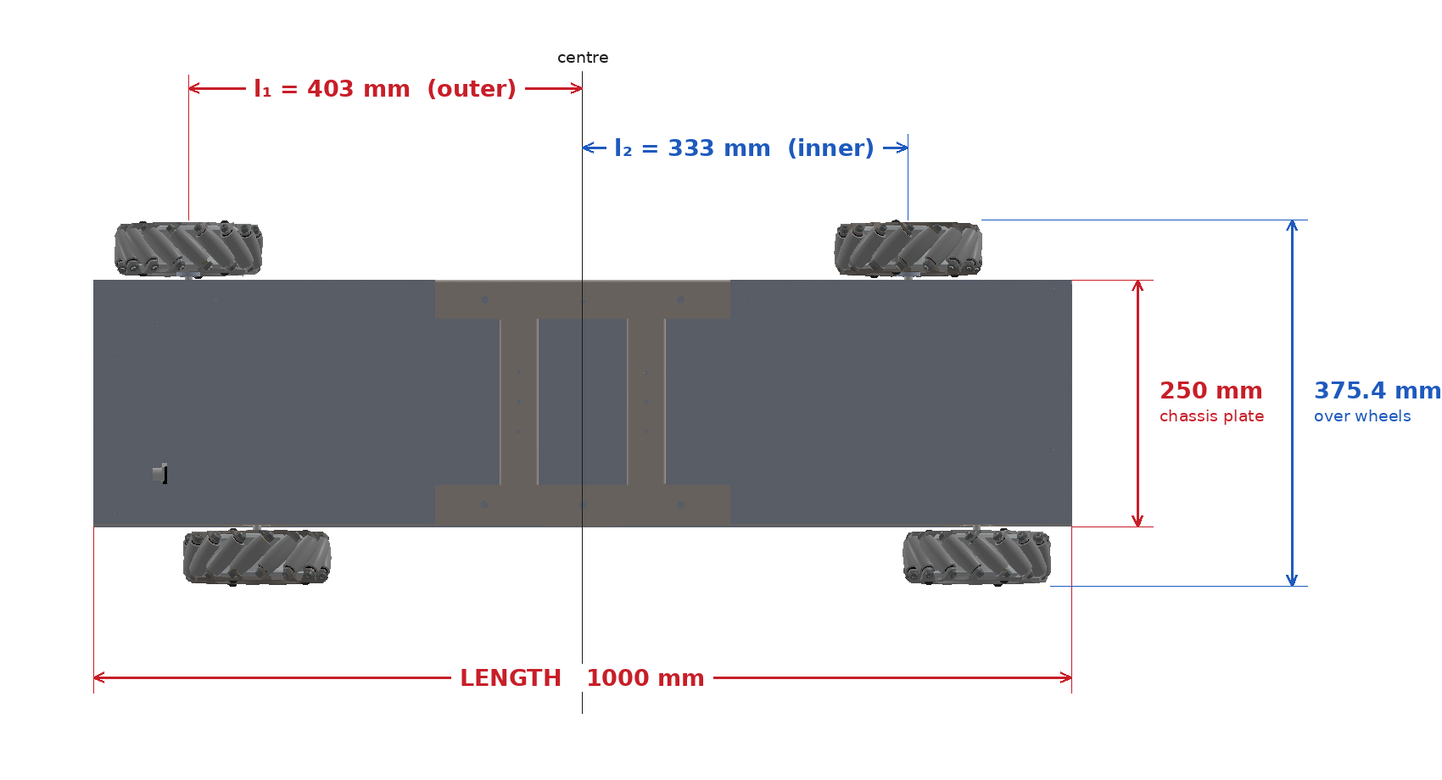
Asymmetric wheelbase geometry
Figure 1. Dimensioned plan view, a real render from the SolidWorks assembly (cad/renders/chassis_top_dimensioned.png), not a reconstruction. $l_{1}=403$ mm and $l_{2}=333$ mm are the same values used throughout this report, and are now independently confirmed twice over: once from the foundational geometry [1], and again directly from the base-plate DXF, whose wheel-mount hole pattern places the two pair-midpoints at exactly 403 mm and 333 mm (cad/extracted_geometry.md). The 1000 mm length matches the DXF outline exactly. The render’s own over-wheels dimension, 375.4 mm, differs slightly from the 360 mm tape measurement used elsewhere in this report (§5.1); the CAD figure is nominal design geometry, the tape measurement is the built machine, and the report treats the latter as authoritative where they disagree, consistent with how §2.2 in cad/README.md already resolved a similar plate-versus-track question. Each wheel carries its own yaw coefficient in the kinematics that follow; substituting a single symmetric value for K anywhere in the software converts the machine, in that code path only, into an ordinary mecanum platform. This happened once; see Appendix D.
The inverse kinematics that follow are
$$ω_{FR}=1/{r_{w}}\left(u+v+rK_{o}\right), ω_{FL}=1/{r_{w}}\left(u−v−rK_{i}\right),$$
$$ω_{RR}=1/{r_{w}}\left(u−v+rK_{i}\right), ω_{RL}=1/{r_{w}}\left(u+v−rK_{o}\right),$$
with $r_{w}=0.0762$ m, $K_{o}=l_{1}+d=0.5607$ m and $K_{i}=l_{2}+d=0.4907$ m.
An unexpected consequence of the asymmetry, found by auditing the kinematics in August, is worth recording because it is the best piece of theory the platform has produced. Rows 1 and 4 of the inverse-kinematics matrix share the translational term $\left(u+v\right)$ and rows 2 and 3 share $\left(u−v\right)$, so each diagonal pair measures yaw independently, on its own lever arm:
$${\hat{ω}}_{\text{outer}}=\frac{r\left(ω_{FR}−ω_{RL}\right)}{2K_{o}}, {\hat{ω}}_{\text{inner}}=\frac{r\left(ω_{RR}−ω_{FL}\right)}{2K_{i}}$$
Their mean is the published yaw rate. Their difference, scaled by $2K_{o}/r$, is exactly the slip residual
$$s=ω_{FR}+1.142656 ω_{FL}−1.142656 ω_{RR}−ω_{RL}$$
which the wheel-forensics tool uses to detect slip from encoders alone. The yaw signal and its own error bar come out of the same measurement, and the pair is non-degenerate only because $l_{1}≠l_{2}$. The asymmetry that motivates the chassis also, incidentally, makes the drivetrain self-diagnosing.

2.2 The application thread, and the connection to this department
Two application targets appear in the record and both are relevant to a Department of Biosciences and Bioengineering. The platform carries a three-tube staged UV-C germicidal lighting subsystem on its cargo arm, giving a mobile aisle-scale disinfection capability; the parallel project in §11 instruments a fixed UV-C air-disinfection chamber. The unifying question across both is dose delivery: germicidal effect depends on the product of irradiance and exposure time, and neither system yet measures the irradiance it delivers in a way that could close a loop around that product.
The record also describes an autonomous food-delivery cart as a long-term target, which imposes a different constraint set (smooth motion so liquids are not spilled, predictable behaviour around people, acoustic noise as a first-order parameter).
[CONFIRM] Which of these is the thesis application, or whether the thesis is framed at the platform level with both as demonstrators. This shapes §4 and §12 and should be settled with the supervisor before the seminar. The draft below is written at the platform level, with UV-C dose delivery as the primary application thread, because that is the framing with the clearest connection to the department.

2.3 The research question
Does non-collinear mecanum wheel placement deliver a usable reduction in chassis width without a corresponding loss of trajectory-tracking accuracy or disturbance rejection, and can a platform built on that geometry localise and navigate reliably in corridors whose clearance is comparable to its own inscribed radius?
Three sub-questions follow, and the third emerged from this year’s measurements rather than from the literature:
- What is the quantitative cost of the asymmetry? The foundational paper validates the kinematics in simulation. No controlled comparison of an asymmetric platform against a symmetric one of matched capability appears to have been published.
- How does the eccentricity between geometric centre and centre of mass affect tracking under a varying cargo load?
- What sensing is actually required for corridor-width localisation? This year’s work establishes that a low-cost triangulation LiDAR, performing to its own specification, is not sufficient, and that a substantial part of the remaining error is estimator drift rather than physical slip. Both findings narrow the question from “add sensors” to a specific, measured deficit.

3. Literature reviewed and where this work sits
Every paper cited was retrieved from the publication record and checked for retractions before use; the full list with DOIs is maintained in research_articles/README.md and reproduced in §13.

3.1 Asymmetric and omnidirectional platforms
The geometric basis comes from the foundational work on asymmetric narrow-aisle platforms [1], which derives the wheel-velocity to body-velocity transformation for non-collinear placement and validates it in simulation. The contribution here is a physical implementation with a closed control loop and a perception stack, not a new kinematic derivation.
Galati and co-workers provide the empirical result that shaped the whole autonomy roadmap [2]: open-loop heading on a mecanum platform drifts 4.56° over 10 m on industrial concrete. For a machine 0.36 m wide in a corridor with a few centimetres of clearance per side, that is roughly 0.8 m of lateral error over 10 m, which is a collision rather than a tolerance problem. This number is why fused localisation was scheduled as a separate phase. It is also, as §8.4 reports, a number this project can now partly attribute to the estimator rather than to the floor.
Adaptive and fuzzy tuning approaches [3, 4] were read and deliberately not adopted. A fixed-gain controller whose plant has not been identified is not a fair baseline against which to judge an adaptive scheme, so the comparison is deferred to §12.

3.2 SLAM
The algorithm choice was reviewed before any parameter was touched, and written up in docs/SLAM_Theory.md. The conclusion was to retain slam_toolbox [5] on stated grounds.
Rao-Blackwellised particle filtering [6] carries one map copy per particle, so memory and computation scale with particle count times map size. That cost is quantified by the two accelerator papers of Sugiura and Matsutani [7, 8], which exist because the method is too slow on embedded hardware without dedicated silicon; this platform runs on a Raspberry Pi 5 with no GPU. An empirical comparison on an RPLidar-A1, the same class of low-cost rotating sensor as the YDLIDAR used here, found GMapping noisier and less accurate than scan-matching methods on that sensor tier [9].
Hector SLAM [10] is a legitimate alternative whose no-odometry design suited this project while its own odometry was unreliable. It has no pose-graph back-end, so drift is minimised going forward and never corrected. Cartographer [11] is more capable, using submaps with branch-and-bound global matching, and remains a sensible upgrade if the mapped area grows beyond a single aisle environment. slam_toolbox was retained because it offers scan-matching-only operation and a Ceres-based pose-graph optimiser descended from Sparse Pose Adjustment [12].
The mathematics the pipeline runs was derived rather than cited in passing: the point-to-line ICP metric [13] that correlative front ends approximate, the nonlinear least-squares pose-graph formulation [14], and the Bayesian log-odds occupancy update [15]. That last connection turned out to be practically useful. The three-value PGM convention the map files use, 0 occupied, 205 unknown, 254 free, is the saturated log-odds value, so the recurring “85 % unknown” figure of §7.4 is not a separate diagnostic but a direct statement that those cells never accumulated enough evidence to move off a prior of one half.
One structural property of the chosen implementation had to be established by reading its source rather than its documentation, and it materially shaped the investigation in §8. This installed build of slam_toolbox registers no listener for the automatic loop-closure candidate events and publishes no topic carrying them, confirmed against the running node’s own topic list. There is no observable signal, console or topic, for whether an automatic closure was accepted or rejected. A whole class of instrumentation is therefore unavailable on this stack, and knowing that saved subsequent sessions from searching for it.

3.3 Navigation
The navigation stack, its layered costmap architecture and its local controllers were reviewed in docs/Navigation_Theory.md [16–20]. The stack itself [16] contributes behaviour-tree task orchestration over lifecycle-managed nodes, with collision checking in SE(2) that admits holonomic platforms rather than assuming a differential-drive motion model; its motivating deployments are warehouse and retail floors.
Two results from that reading changed the configuration materially.
The layered-costmap semantics [17] make explicit that the inflation band is a path preference, not a collision statement, and that safety comes from the exact footprint polygon check. That distinction matters disproportionately here, because an inflation radius set generously “for safety” makes an aisle the machine physically fits appear impassable.
The choice between the Dynamic Window Approach [18] and Model Predictive Path Integral control [20] was settled on source rather than preference, and then revisited on evidence. DWB was adopted first on the reasoning that it is lighter and the original MPPI experiments run on a GPU this robot does not have. That choice was then reversed in August for a reason the earlier reading had not anticipated: DWB’s rotate-to-goal critic enforces a bit-exact zero-translation test, and because the sampler builds a full cross-product grid, only one candidate in fifty survives it. Rotation-only goals failed structurally, not intermittently. MPPI’s critics are uniformly additive with no throw-and-eliminate path anywhere in the optimiser, so that failure class cannot occur by construction, and its omnidirectional motion model samples the lateral axis genuinely rather than as a coarse discretisation. Li and co-workers’ diagnosis of DWA’s local-minimum behaviour in dead ends [19] is why the global planner and the recovery behaviours remain load-bearing.

3.4 The gap this work addresses
The asymmetric narrow-aisle geometry has been derived and simulated [1] but not, as far as the reviewed literature shows, built and characterised on hardware with a closed control loop. Mecanum drift has been measured empirically on symmetric platforms [2], and the standard slip formulation assumes symmetry; whether per-wheel slip differs between the inner and outer pairs of a non-collinear layout has not been reported. Navigation stacks and their costmap machinery are mature [16, 17], but the parameter regime they are documented for assumes clearance comfortably exceeding the robot’s inscribed radius, which is exactly what a narrow-aisle deployment violates. To those three this year adds a fourth, which is empirical rather than theoretical: the sensor tier that the low-cost 2D SLAM literature is built on has a specified accuracy that, quantified against a corridor-width error budget, does not close.

4. Objectives

4.1 Thesis objectives
Objective 1: Build and characterise a physical asymmetric mecanum platform with closed-loop velocity control. Deliverable: a machine whose wheels track commanded velocities to a stated accuracy, loaded and unloaded, with the calibration methodology and its uncertainties documented reproducibly.
Objective 2: Establish localisation adequate for corridor-width clearances. Deliverable: a pose estimate characterised against ground truth, with a stated drift figure over a stated distance, and an explicit account of which sensors are required to reach it.
Objective 3: Demonstrate autonomous point-to-point navigation in a corridor whose clearance is comparable to the platform’s inscribed radius. Deliverable: repeated goal-directed runs with success rate, clearance statistics and failure modes reported.
Objective 4: Quantify the cost and benefit of the asymmetry. Deliverable: a controlled comparison against a symmetric baseline of matched capability.
Objective 5: Close a dose-based control loop for the UV-C payload. Deliverable: measured germicidal irradiance driving exposure time or traverse speed, so a stated log-reduction is delivered rather than assumed.
Objective 6: Carry a cargo-handling manipulator on this chassis, and establish what the chassis has to supply for it to work. This is the next goal, and it is stated here as design work rather than as a result, because no hardware for it exists. A companion study (HeXBuddy, documented in docs/HeXBuddy_Arm_Integration.md) has produced a fully specified arm sized to this chassis and this aisle geometry — a self-locking lift, a turntable, a telescopic boom, a wrist and a gripper, holding position against gravity at approximately zero motor power. Nothing has been built, bench-tested or simulated on this platform; the design rests on a first-order model that its own documentation flags as needing re-validation before any part is bought. Deliverable, in order: re-run the design optimisation against this platform’s measured 45.54 kg mass rather than the 25 kg the model assumed, since a heavier base changes the tipping margin that the design found binding; validate the result in simulation with mass properties taken from CAD; and only then bench a single joint. The reach-and-payload envelope, and how much of it the base’s own travel is expected to supply, are open design questions rather than settled ones, and §12.1 states them as such.

4.2 Objectives set for year 1, and their outcome
# | Objective | Outcome
1.1 | Closed-loop velocity control on real-time hardware | Achieved, validated in air and on the floor
1.2 | Per-motor feedforward calibration from measured data | Achieved; the ground-load increase was predicted at 10–30 % and measured at 24 %
1.3 | Plant identification for the velocity loop | Not achieved. The proportional gain remains an estimate
1.4 | Live LiDAR perception and a savable occupancy map | Achieved and repeatable
1.5 | Automated post-run analysis of every recorded run | Achieved; grew into twelve analysis tools
1.6 | Inertial measurement and fused state estimation | Not started. Sensor not procured. §8.4 now gives a measured case for it
1.7 | Autonomous navigation | Achieved on a live map, 14 August. Not achieved on a saved map
1.8 | An accepted commissioning map | Not achieved. One of four acceptance sub-criteria met, once
Objective 1.7 was reached before 1.6, which the roadmap had listed as its prerequisite. That is recorded as an out-of-order result rather than tidied away: navigation inside a live mapping session does not need fused localisation, and it was worth having a working demonstration in hand while the harder problem was worked. Navigation on a saved map still needs 1.8, which needs the sensing question of 1.6 resolved.

5. The platform as built
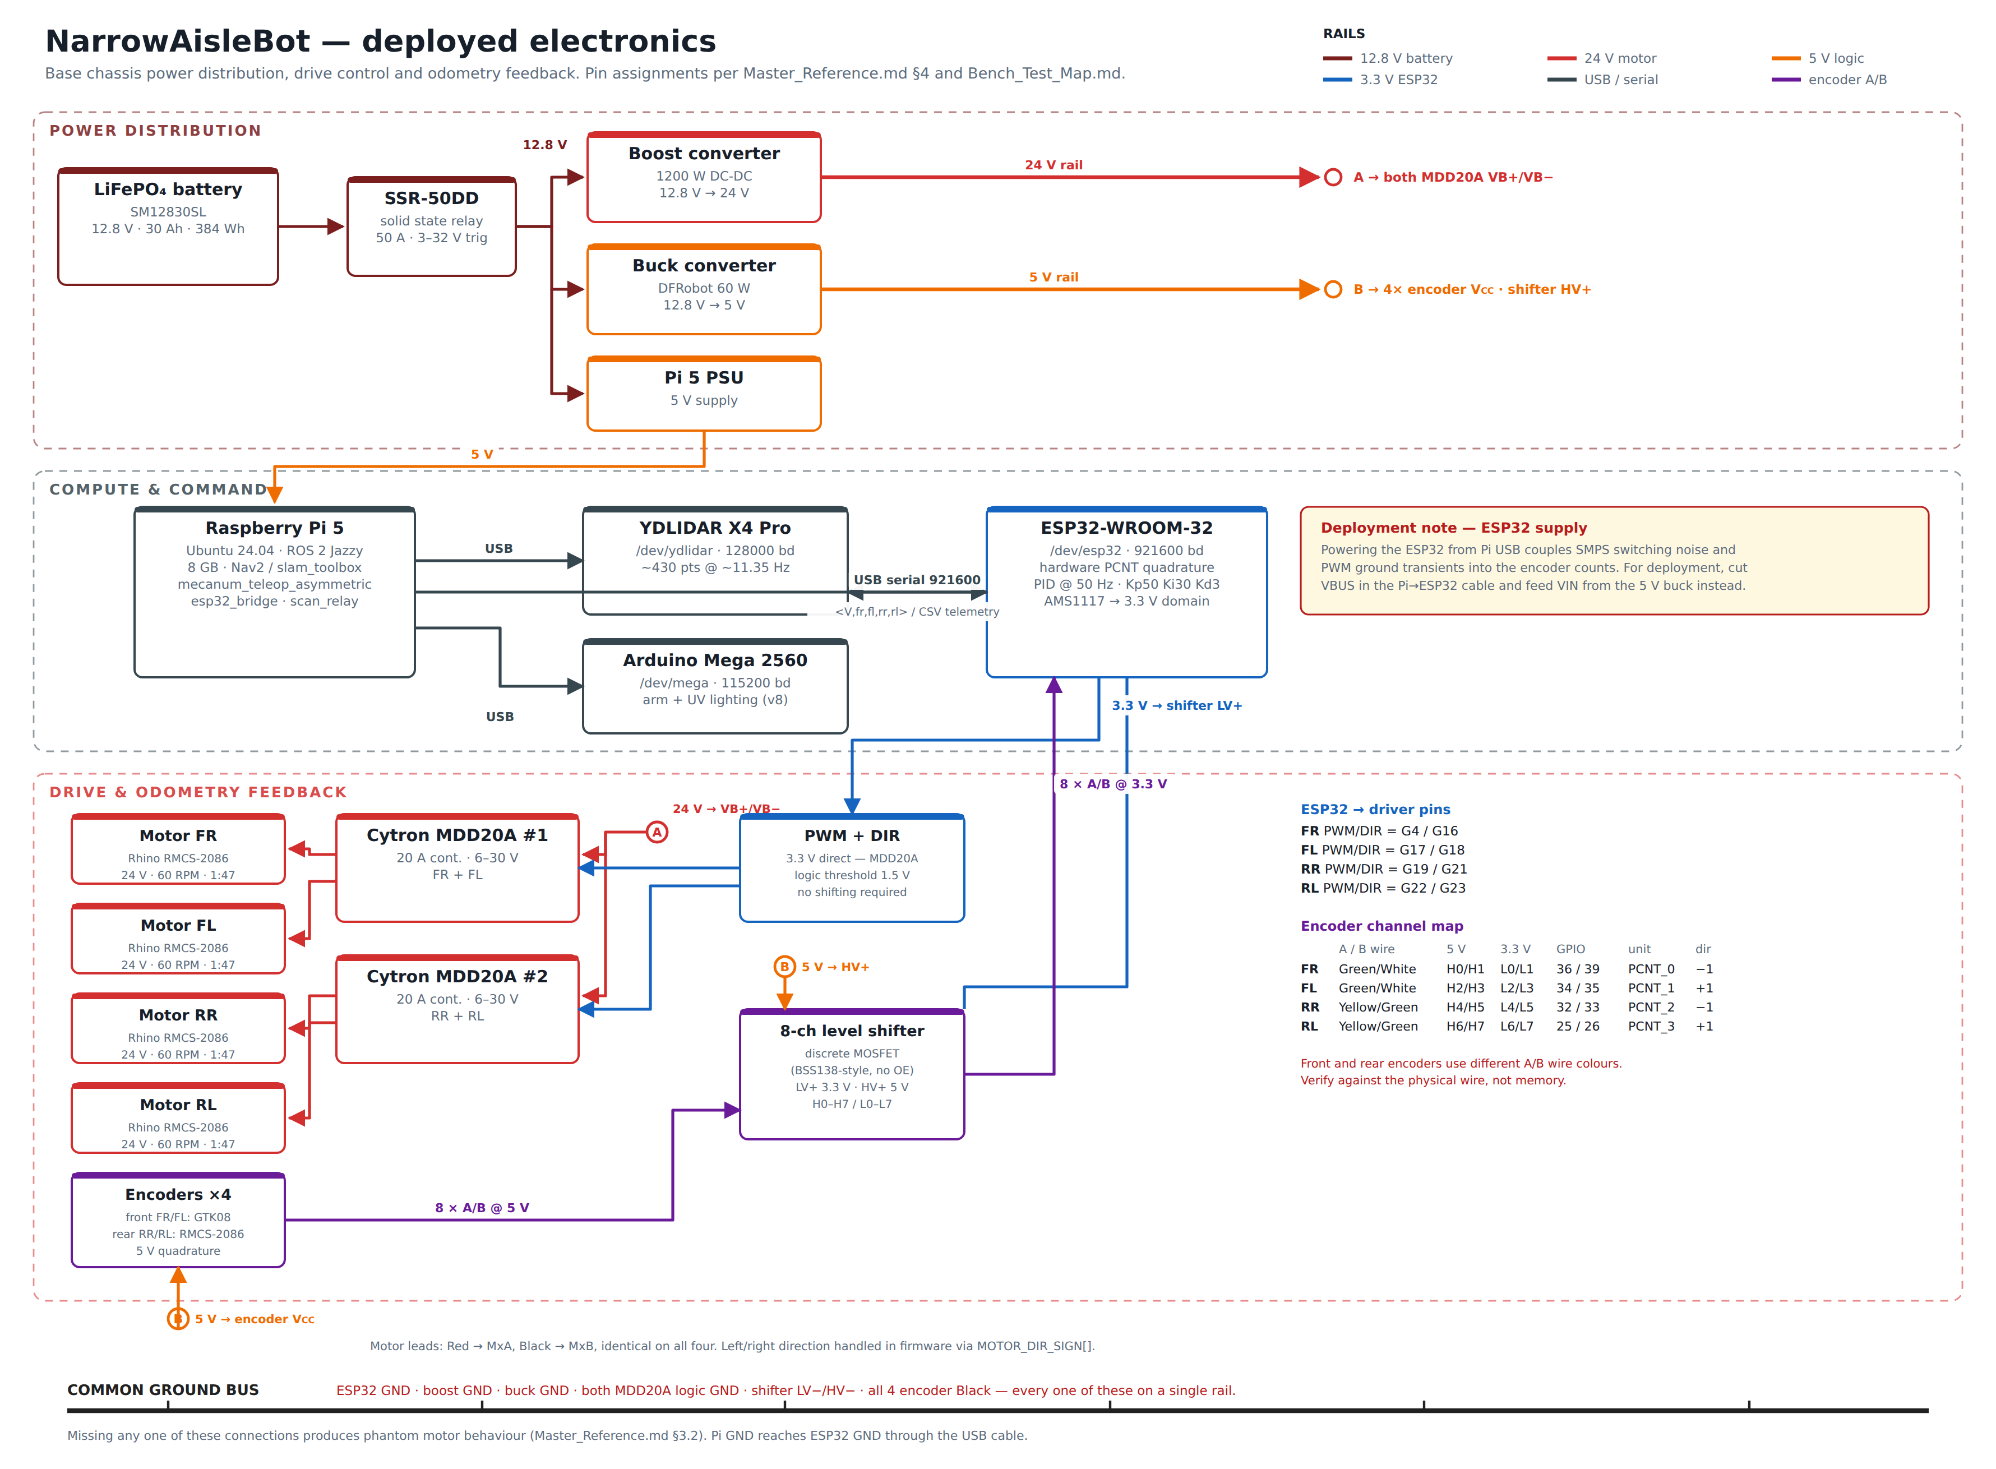
Deployed electronics
Figure 2. The real deployed-electronics diagram (docs/hardware/nab_circuit_diagram.png), generated from the repository’s own hardware documentation rather than drawn from memory, so every pin, rail and baud rate on it is checked against Master_Reference.md, Bench_Test_Map.md and RMCS-2086_Encoder_Replacement.md rather than assumed from a generic mecanum reference. Three layers: power distribution, compute and command, drive and odometry feedback, each on its own rail colour. It shows two facts a generic diagram would get wrong: the front two motors run GTK08 encoders rather than the rear pair’s integrated RMCS-2086 units, with different A/B wire colours between them — Bench_Test_Map.md records this exact mix-up already corrupting a channel once — and the level-shifter board actually deployed is an 8-channel discrete-MOSFET design, not the TXS0108E Master_Reference.md §4.4 describes. The diagram’s own deployment note, that powering the ESP32 from Pi USB couples switching noise into the encoder counts and VIN should instead come from the 5 V buck rail, is not yet applied on the robot; it is carried into Appendix F as an open item.
At the software layer, which this diagram does not show, the command loop was closed on 14 August: the planner’s velocity now runs through an axis adapter and a priority multiplexer into the same asymmetric inverse kinematics the operator drives through, so manual override outranks the planner at the one point they meet.
The Mega/ESP32 responsibility split visible in the diagram follows from a hardware constraint rather than a software preference. With the encoders originally fitted, each motor at rated speed produces about 93,000 counts per second, and the two replacement units fitted since produce twice that. Interrupt-driven quadrature counting at those rates consumes the entire instruction budget of an ATmega2560. The ESP32’s pulse-counter peripheral decodes quadrature in silicon at no processor cost, which is why motor control moved onto it.

5.1 Principal specifications
Item | Value
Footprint, measured | 1.00 × 0.36 m (wheel outer to wheel outer)
Mass | 45.54 kg
Outer / inner wheel distance | $l_{1}=0.403$ m, $l_{2}=0.333$ m
Half track width | $d=0.15769$ m
Wheel radius | $r_{w}=0.0762$ m
Drive motors | 4 × Rhino RMCS-2086, 24 V, 1:47, 60 RPM
Encoders | FR/FL GTK08 at 186 264 CPR; RR/RL optical at 93 132 CPR
Real-time controller | ESP32-WROOM-32, FreeRTOS, 100 Hz loop
Host | Raspberry Pi 5, Ubuntu 24.04, ROS 2 Jazzy
LiDAR | YDLIDAR X4 Pro, triangulation, rated under 2 % of range
Local controller | MPPI, omnidirectional motion model
Power | LiFePO₄ 12.8 V / 30 Ah; boost 24 V drive, buck 5 V logic
Cargo arm | 2 × NEMA 23 lateral, 1 × NEMA 34 vertical, 3-tube staged UV-C
Operating velocity clamp | 0.12 m/s linear, 0.30 rad/s yaw

5.2 A deliberate departure from the standard frame convention
This robot’s base frame puts $+X$ to the right and $+Y$ forward, which is not the ROS convention. The choice was made in August after two independently validated subsystems were found to disagree about which way the robot faces, and it was resolved by changing the side with weaker evidence rather than the side that was more convenient. That reasoning is recorded in §7.3.
The decision has cost more than it saved, and the report says so. Five separate stale compensations for it have been found and removed since, in the dashboard canvas, in a print-site relabel, in a goal-pose adapter, in a zero-point yaw constant, and in the localisation node’s initial pose. Four of them together hid a real frame fault for two weeks. The convention is now unified across all three frames, stated once in docs/Axis_Convention.md, and enforced by a verification script that fails if it is edited back out. A project starting over would adopt the standard convention and place the compensation at the sensor.

6. Closed-loop velocity control

6.1 Why open loop was insufficient, established by measurement
The first complete platform was open loop. Forward and backward motion was adequate; lateral translation stuttered audibly. Characterising all four motors at a fixed PWM explained it.
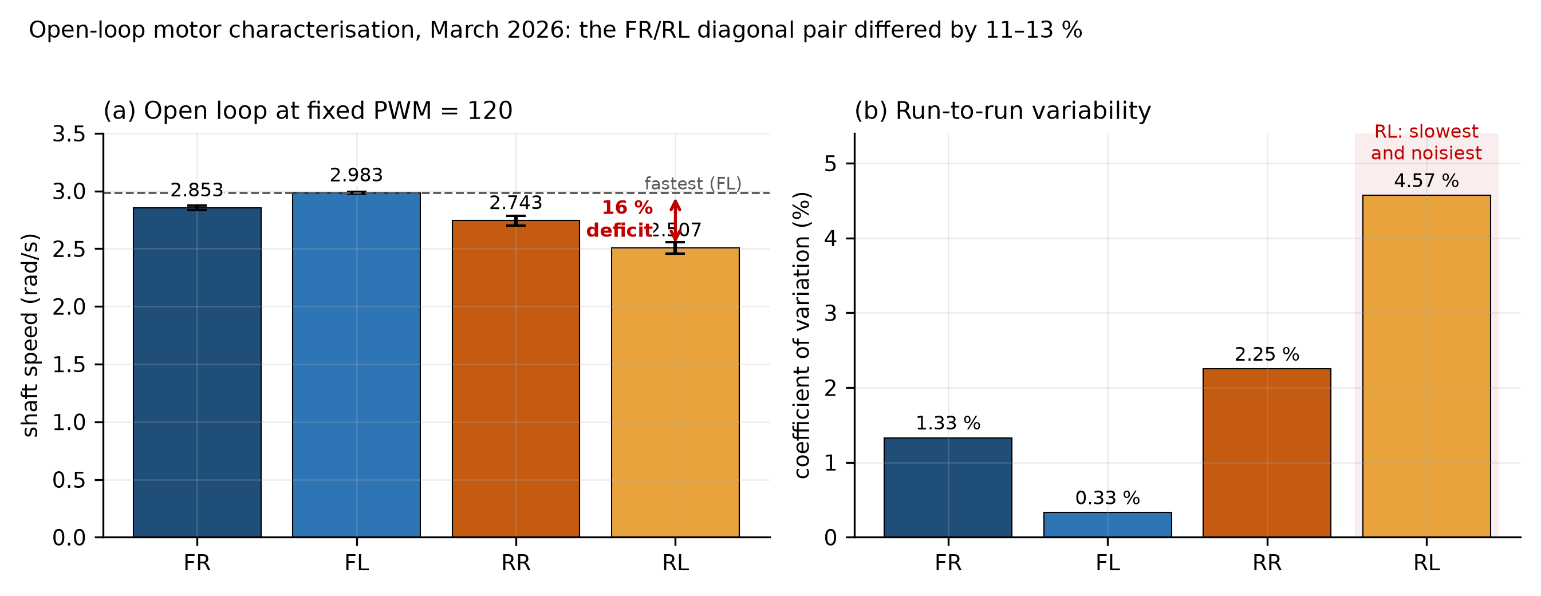
Open-loop characterisation
Figure 3. Open-loop motor characterisation at PWM 120, 20 Hz sampling, March 2026. The rear-left unit was slowest and most variable, 16 % below the fastest wheel with a coefficient of variation of 4.57 %.
The relevant number is not the 16 % spread across four motors but the 11–13 % mismatch within the front-right/rear-left diagonal pair. Under mecanum kinematics, lateral translation is produced by the two diagonal pairs acting in concert; when one member does 12 % more work than the other, the difference appears as a net yaw torque fighting the intended motion. That is the stutter. The conclusion is stronger than “closed loop is better”: open-loop control is acceptable when motors are well matched or when only one axis is used, and becomes untenable the moment two actuators must act together. Mecanum geometry makes that unavoidable.

6.2 The controller
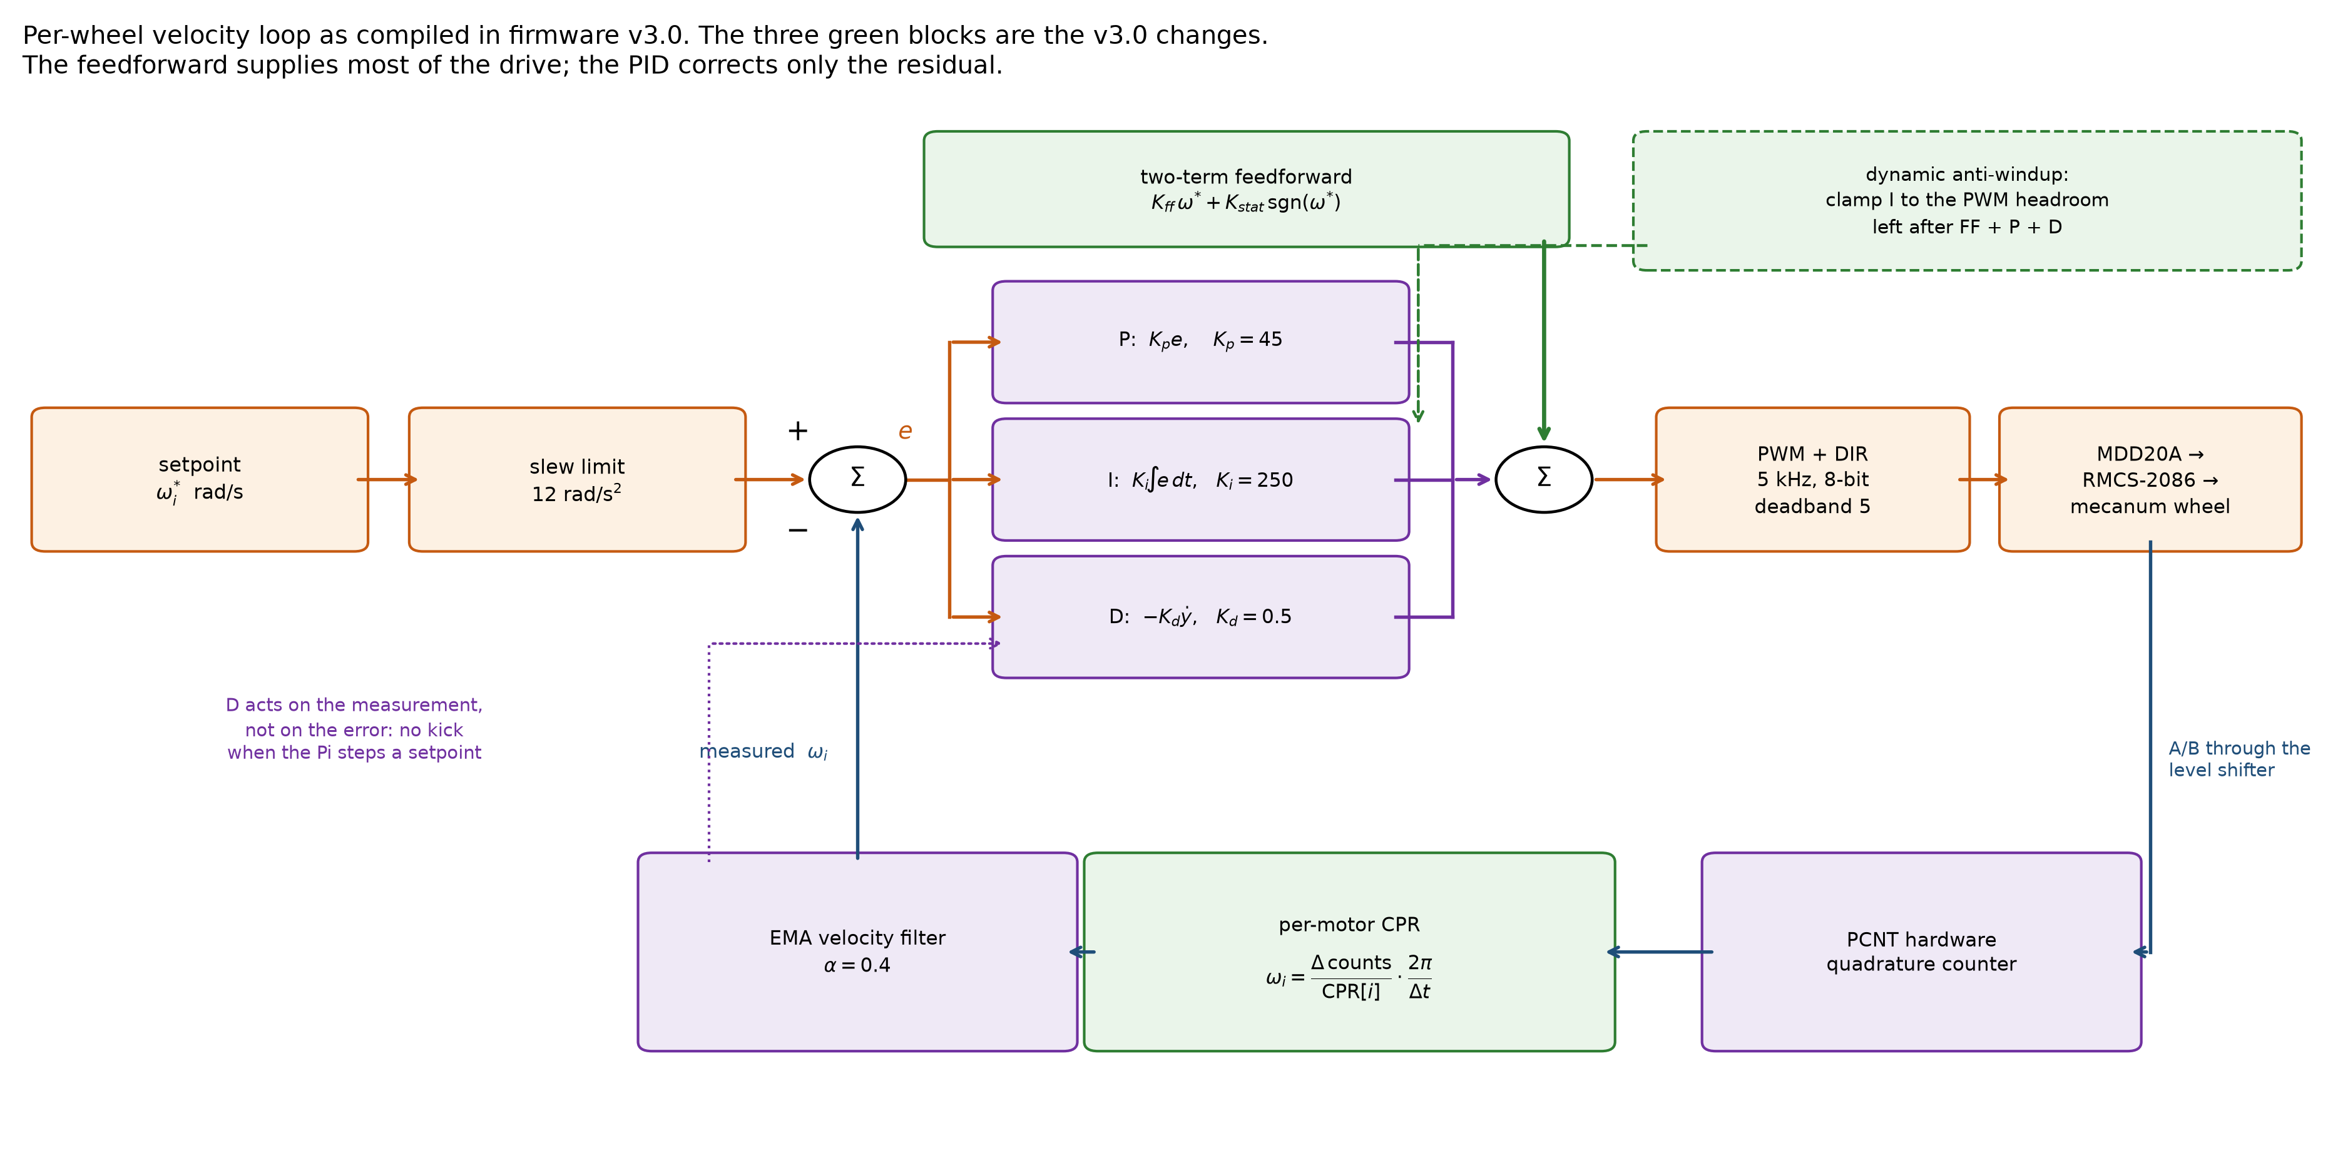
Control loop
Figure 4. The per-wheel velocity loop as compiled. The two-term feedforward supplies most of the drive signal; the PID terms correct the residual.
Three design choices are worth defending individually.
A two-term feedforward, not one slope. A single-slope model cannot fit the data, because the measured PWM-per-rad/s ratio rises at low speed. That is the signature of static friction and it requires a constant breakaway term alongside the viscous slope.
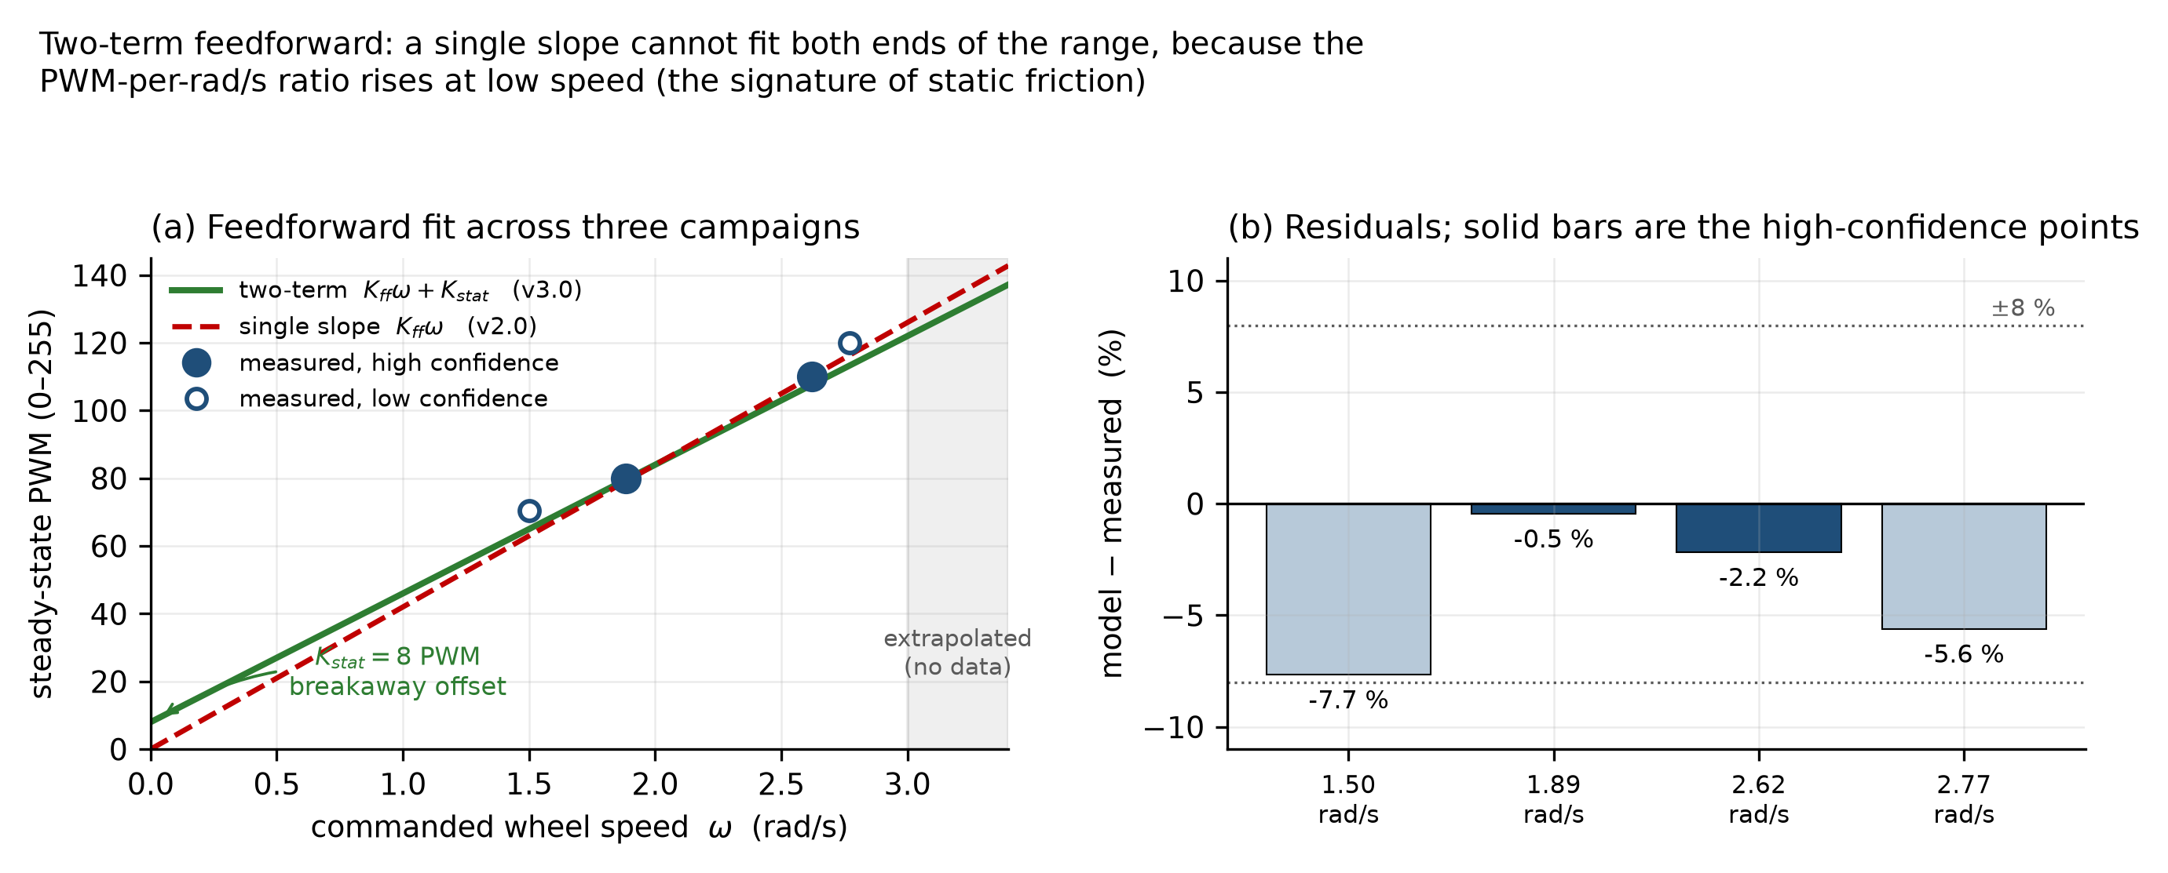
Feedforward model
Figure 5. The two-term fit against three independent in-air campaigns. Every point falls within about 8 % and the two highest-confidence points within 2.3 %. The shaded region above 3 rad/s is extrapolation, where the model will over-predict as the motor approaches rated speed. Over-prediction is the safe direction: the output saturates and the integral unwinds it, rather than the wheel falling short.
An honest limitation belongs with that figure. The split between the viscous and breakaway terms is poorly determined, because every measurement lies between 1.8 and 2.8 rad/s and over that span many parameter pairs fit almost equally well. What is well determined is the value of the whole expression across the measured range, which is what the controller consumes.
The integral gain follows from the plant gain, not from tuning by hand. The feedforward fit hands over the plant DC gain as $K=1/38=0.0263$ rad/s per PWM count. Direct-synthesis tuning gives $K_{i}=1/\left(Kλ\right)$, and with a conservative closed-loop time constant of 0.15 s that is 253, rounded to 250. The useful property is that this expression does not contain the plant time constant, which had not been measured. The previous value of 30 moved the output 3 PWM per second for a 0.1 rad/s error, so closing a realistic 10-PWM feedforward gap took over three seconds. That is exactly the 3.79 s worst-case settling time logged in May. At 250 the same gap closes in 0.4 s.
Anti-windup that actually binds. The previous fixed clamp, at the old integral gain, permitted an integral contribution of about 6000 PWM, some 23 times the output range. The clamp existed but could never engage. The current implementation clamps against the PWM headroom genuinely remaining after the other three terms, recomputed every tick.

6.3 The dual-encoder fault
Two motors carry a different encoder from the other two, following replacement of two failed units, and the replacements have exactly twice the resolution. Firmware through v2.0 applied one shared constant to all four.
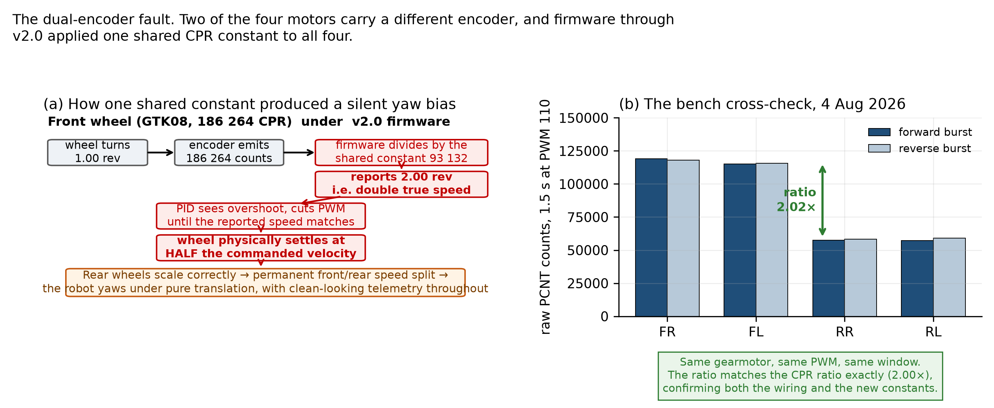
Encoder CPR fault
Figure 6. (a) The failure mechanism. (b) The bench cross-check that detected it: front and rear raw counts at matched PWM and matched window, on physically identical gearmotors, differing by exactly the ratio of the two resolutions.
The mechanism earns its emphasis because of how it fails, not how it is fixed. A front wheel completing one revolution emits 186 264 counts; divided by the shared constant of 93 132 that reports as 2.00 revolutions. The controller believes the sensor, sees itself overshooting, and reduces PWM until the reported speed matches the target, meaning until the wheel physically turns at half the commanded velocity. The rear wheels track properly. The result is a permanent front-to-rear speed split that scales with commanded velocity: the robot yaws under pure translation, with no error raised and clean tracking in every telemetry plot, because the loop is tracking. It is tracking a lie.
No test that examines one wheel at a time can find this. It was found by comparing front against rear on the same command, and it is the strongest early argument in this year’s work for cross-subsystem verification as routine practice rather than as a debugging measure.
A second finding fell out of the same correction.
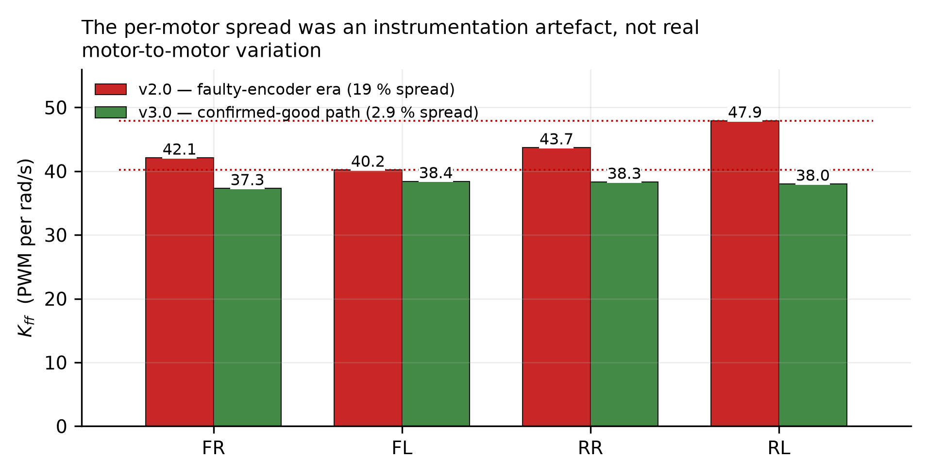
Feedforward spread
Figure 7. Re-measured on the confirmed-good signal path, all four motors fall within a 2.9 % band. The earlier 19 % spread had been treated for months as a physical property of the motors and used to justify per-motor compensation.

6.4 Results, in the air and on the floor
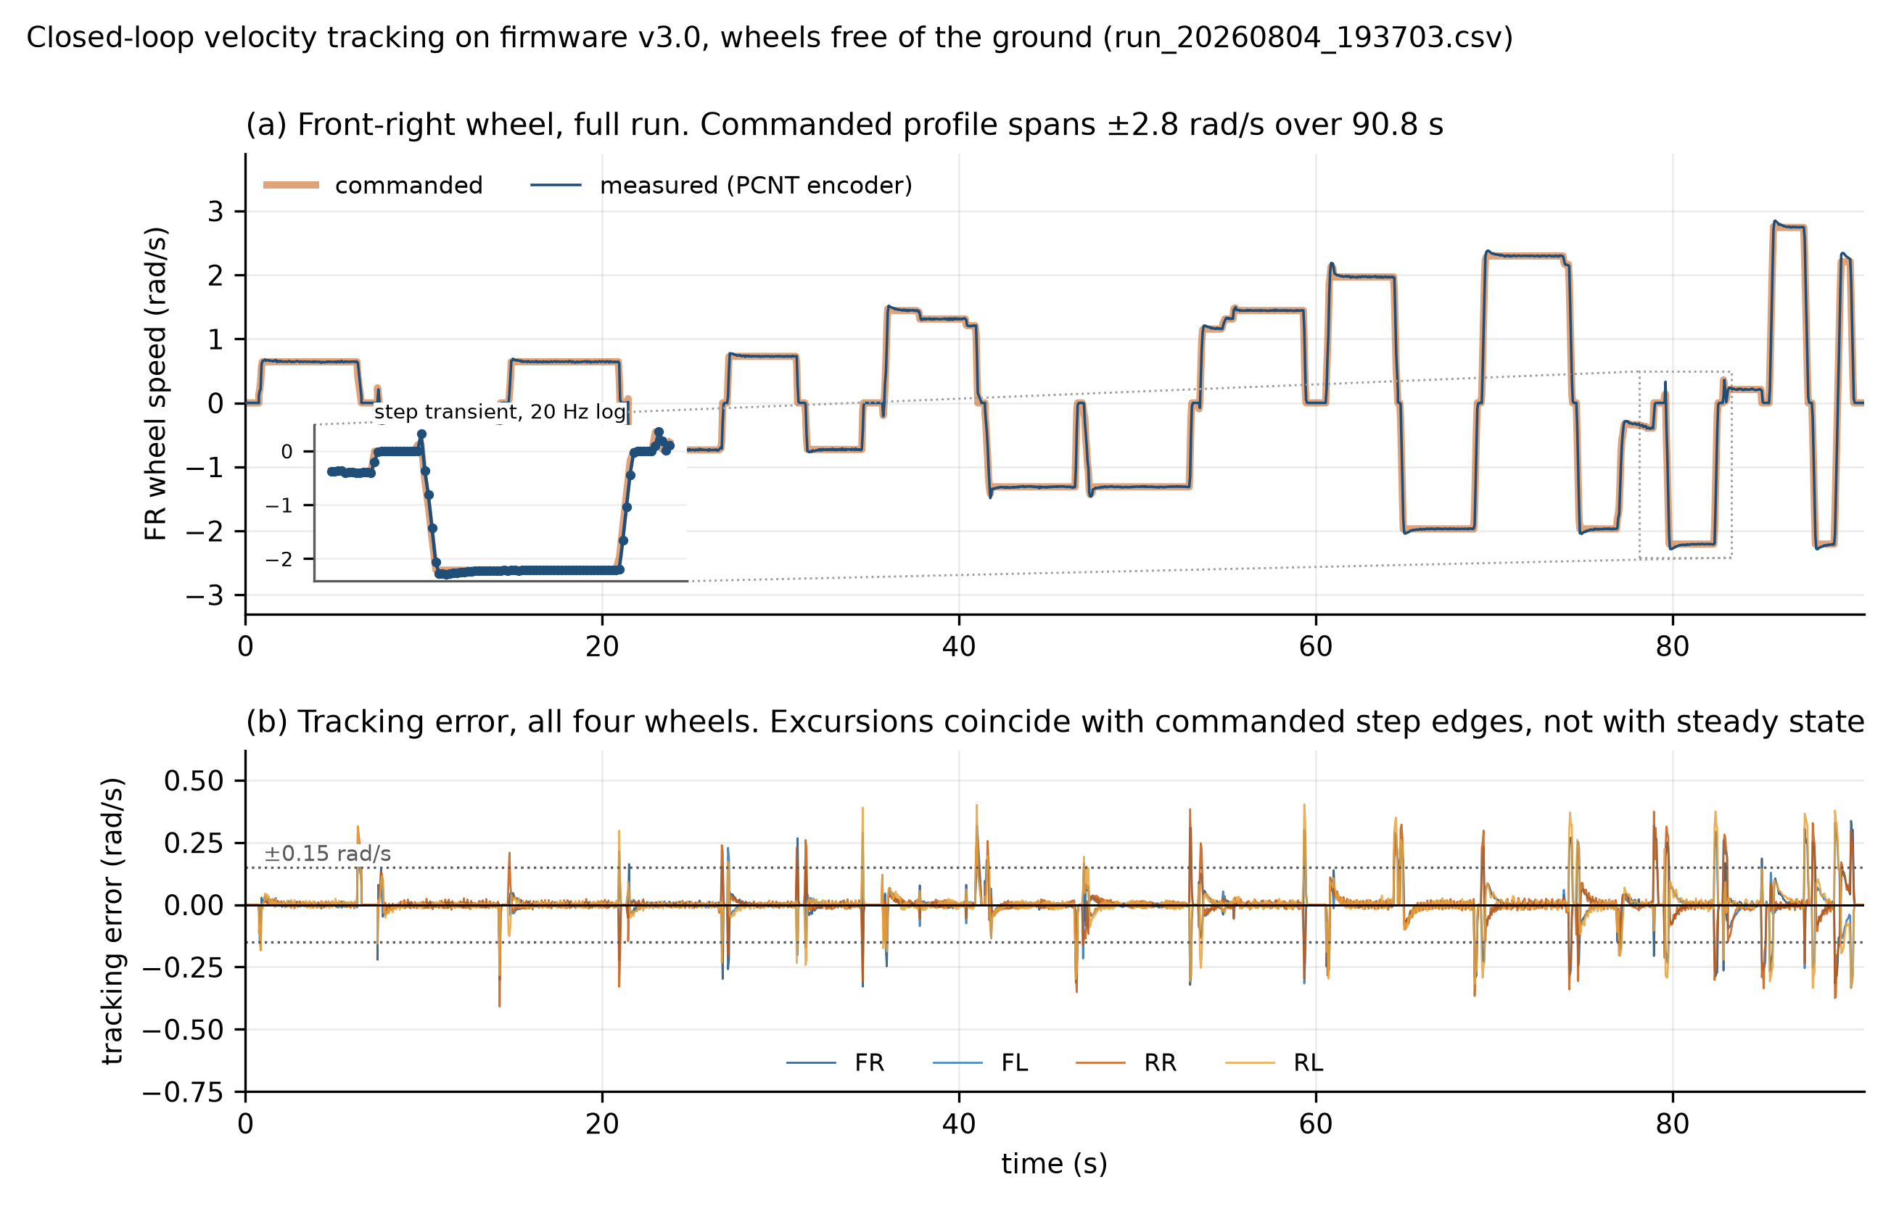
Closed-loop tracking
Figure 8. Closed-loop velocity tracking, wheels free, 1816 samples over 90.8 s. (a) The front-right wheel across the full run, with an inset over one commanded step. (b) Tracking error for all four wheels. Excursions coincide with commanded step edges and not with steady-state operation, which is the expected behaviour of a well-conditioned loop.
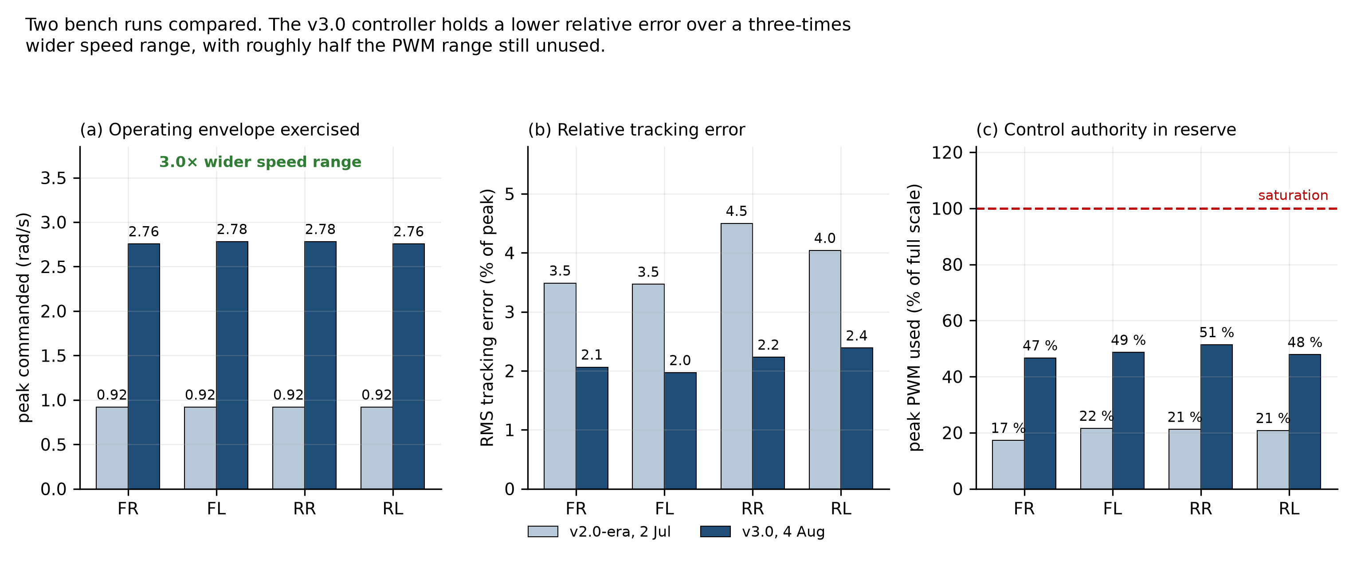
Tracking comparison
Figure 9. The same metrics against a run on the previous firmware generation. The current controller holds a lower relative error over a three times wider speed range with roughly half the actuator range unused.
Run | Peak commanded | RMS error, % of peak | Peak PWM of 255 | Saturation
Bench, 2 Jul, previous firmware | 0.92 rad/s | 3.5–4.5 % | 55 | 0
Bench, 4 Aug, v3.0 | 2.78 rad/s | 2.0–2.4 % | 131 | 0
Bench, 5 Aug, v3.0 | 2.78 rad/s | 1.2–1.4 % | 128 | 0
Ground, 6 Aug, v3.0 | 1.39 rad/s | 3.4–4.0 % | 77 | 0
The ground run is the one that closes an objective. The feedforward calibration carried a prediction, written down in docs/PID_Calibration.md §7 before any floor test existed: ground load would raise the feedforward demand by 10–30 %.
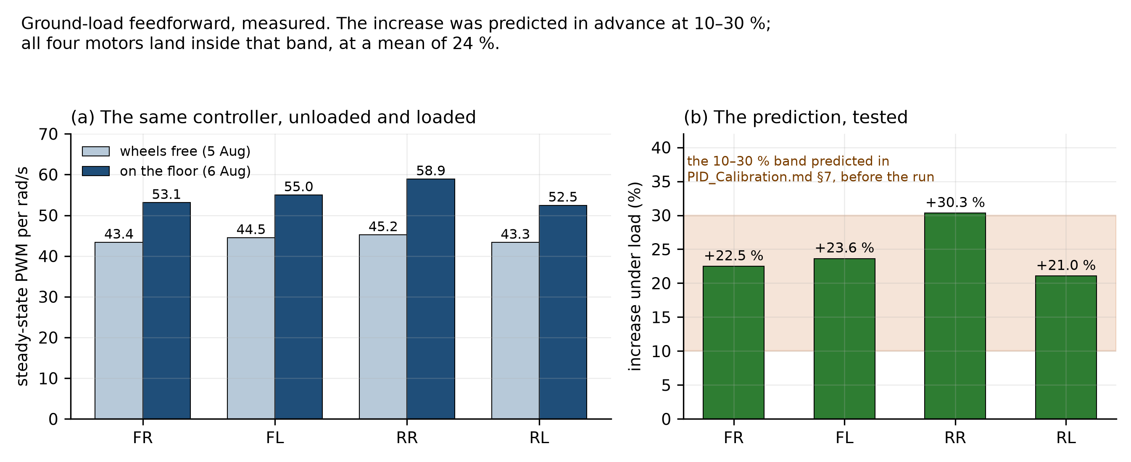
Ground load
Figure 10. Steady-state PWM per rad/s, unloaded against loaded, computed from the two logs for this report. All four motors land inside the predicted band, at a mean of 24 %. A prediction registered in advance and then met is worth more than an explanation offered afterwards, and this is one of two such results in the year; §8.3 is the other.
What these numbers establish and do not. They establish a loop that is healthy, consistent across all four wheels, free of saturation and of direction-sign faults, and now exercised under real chassis weight. They do not establish a step response, because these are live driving logs rather than isolated-step tests, so rise time and settling time cannot be fitted from them. The plant time constant remains unmeasured and the proportional gain remains an estimate; the bench run that closes it is implemented and takes about 40 seconds.

7. Perception, mapping and the frame-convention faults

7.1 Bringup, and three faults that produced no error message
A YDLIDAR X4 Pro was integrated and its parameters read off the hardware rather than copied from a forum. Getting from “the sensor spins” to “the map builds” took considerably longer than expected, for reasons worth reporting because all three obstacles shared a diagnostic character.
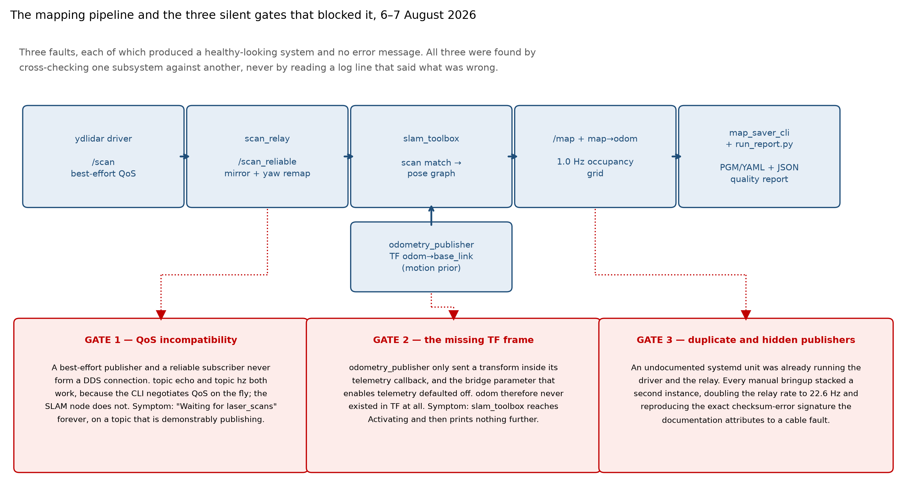
Mapping pipeline
Figure 11. The mapping pipeline and the three faults that blocked it. None produced an error message. Each was found by comparing one subsystem against another rather than by inspecting the component that appeared to be failing.
The quality-of-service incompatibility is the most transferable. The driver publishes scans as best-effort; the SLAM node subscribes as reliable; in DDS those endpoints never connect. Both ros2 topic echo and ros2 topic hz work perfectly on that topic, because the command-line tools negotiate a compatible profile at runtime and the SLAM node does not. A topic being demonstrably alive is not evidence that a given node will receive it. The same fault recurred later in a different consumer, the navigation costmaps, and was caught in the audit described in §9.1. A documented workaround is not a fix; only a check that fails when the workaround is bypassed is.

7.2 Self-occlusion, measured and then masked
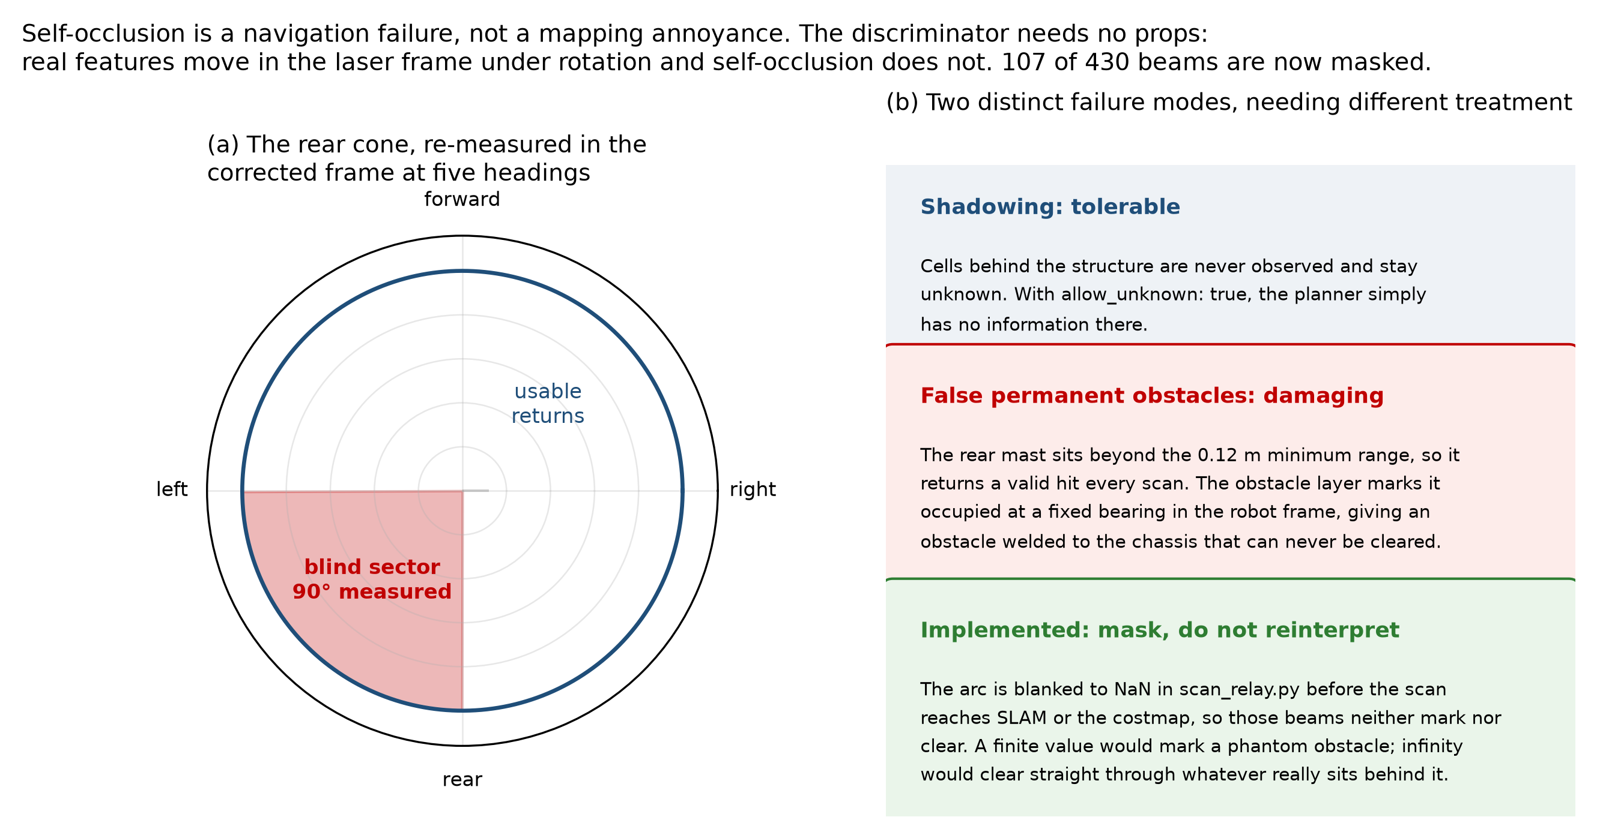
Self-occlusion
Figure 12. The rear cone, re-measured in the corrected frame at five headings roughly 90° apart. Cross-checking the five sector tables against each other found exactly one bearing block returning a close reading in all five independent headings: a 90° wedge centred directly behind the robot. Every other “always close” flag appeared in exactly one run, which is a real wall the robot happened to face, correctly not persisting.
The second failure mode is the damaging one. If the rear mast sits beyond the sensor’s 0.12 m minimum range it returns a valid hit on every scan, and the obstacle layer marks those cells occupied. Because they are fixed in the robot’s own frame they translate and rotate with it: a permanent obstacle welded to the chassis, which the inflation layer expands and the planner reads as a direction blocked everywhere and always.
The mask is implemented. The arc is blanked to not-a-number in the relay node before the scan reaches SLAM or the costmap, so those beams neither mark nor clear. A finite value would mark a phantom obstacle; infinity would clear straight through whatever really sits behind it. 107 of 430 beams, one quarter of every scan, are now masked, and that fact is carried explicitly into the loop-closure threshold reasoning of §8.
The discriminator needed no apparatus: rotate in place in a static environment and compare scans, because real features move in the sensor frame under rotation and self-occlusion does not. An earlier proposal to establish the same thing by standing opaque sheets around the chassis would not have worked, because sheets on all sides block everything and cannot separate self-occlusion from the sheet.

7.3 Two frame-convention faults, and the rule that came out of them
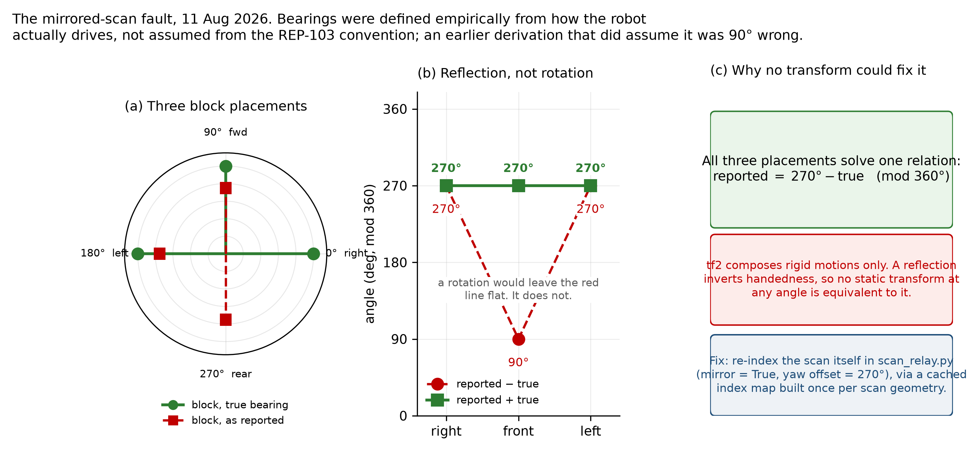
LiDAR mirror fault
Figure 13. The mirrored-scan fault. Bearings were defined empirically from how the robot actually drives rather than assumed from the standard convention; an earlier derivation that did assume it was 90° wrong and was caught before deployment.
A block placed in front of the robot appeared behind it. Three placements at known bearings all satisfied one relation. The distinction that mattered is that the difference between reported and true bearing is not constant across the three while their sum is, which is the signature of a reflection about a fixed line rather than a rotation. That decided where the fix could live: transform libraries compose rigid motions only, and a reflection inverts handedness, so no static transform at any angle is equivalent to one.
Immediately afterwards, driving forward made the accumulated map slide sideways. Raw transform measurements across two controlled single-axis moves showed 94 % of a forward move on one axis and 96 % of a lateral move on the other, which is the standard convention and the opposite of the one the scan fix had been built on. Two internally consistent conventions existed and nothing in the physics selects one. The question was therefore not which had been measured most recently but which rested on weaker evidence. The scan side had been confirmed by a recording of the robot driving toward a placed block while the block’s position closed in the map, made before the drift symptom was ever observed; the odometry side rested on a single transform reading. The correction went to the odometry node.
That decision was revisited a fortnight later and found to have been half applied. The published orientation and twist had been rotated; the published translation had not. Driving forward really did increase map X, and four separate downstream compensations had grown over the seam, each undoing it for one consumer, which is why it read as correct wherever anyone looked closely. It was reopened by a video, which was decisive in a way that argument had not been. The remaining half was applied, all four compensations were deleted in the same commit, and a verification script now proves the chain and fails if it is edited back out.
The standing rule that came out of this is stated in the project’s own documentation and is the most useful thing this episode produced: never fix an axis or placement complaint in the display. A display-side correction makes one consumer right and hides the fault from every other.

7.4 Why the maps were sparse
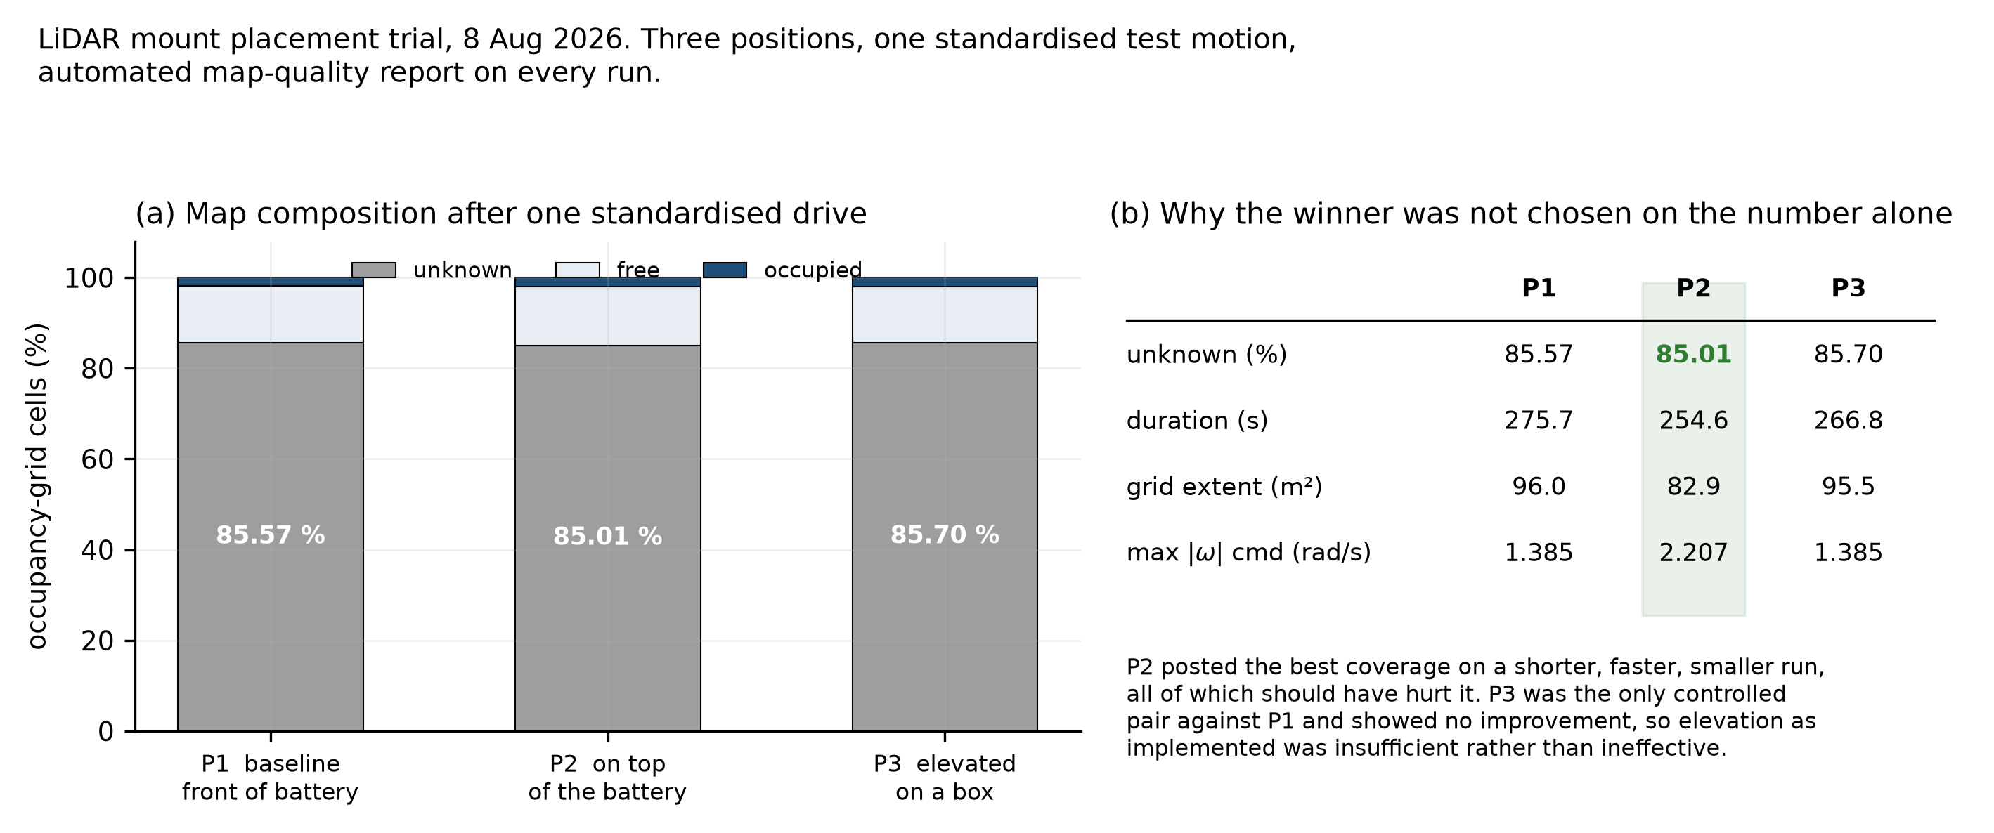
LiDAR placement trial
Figure 14. Placement-trial results, three mount positions on one standardised drive. Position 2 was selected on two grounds together rather than on the coverage figure alone: it posted the best number on a shorter, faster, smaller run, all of which should have hurt it, and it is the only position that removes the battery from the sensor’s line of sight by mechanism rather than by degree.
The controlled comparison in that trial is a negative result and is reported as one. Position 3 was the only run whose motion profile matched the baseline closely and it showed no improvement at all. Photographs of the mount explain why: on its temporary support the unit sat roughly level with the battery’s top edge rather than clearly above it. Elevation as a strategy was not refuted; that amount of elevation was insufficient.
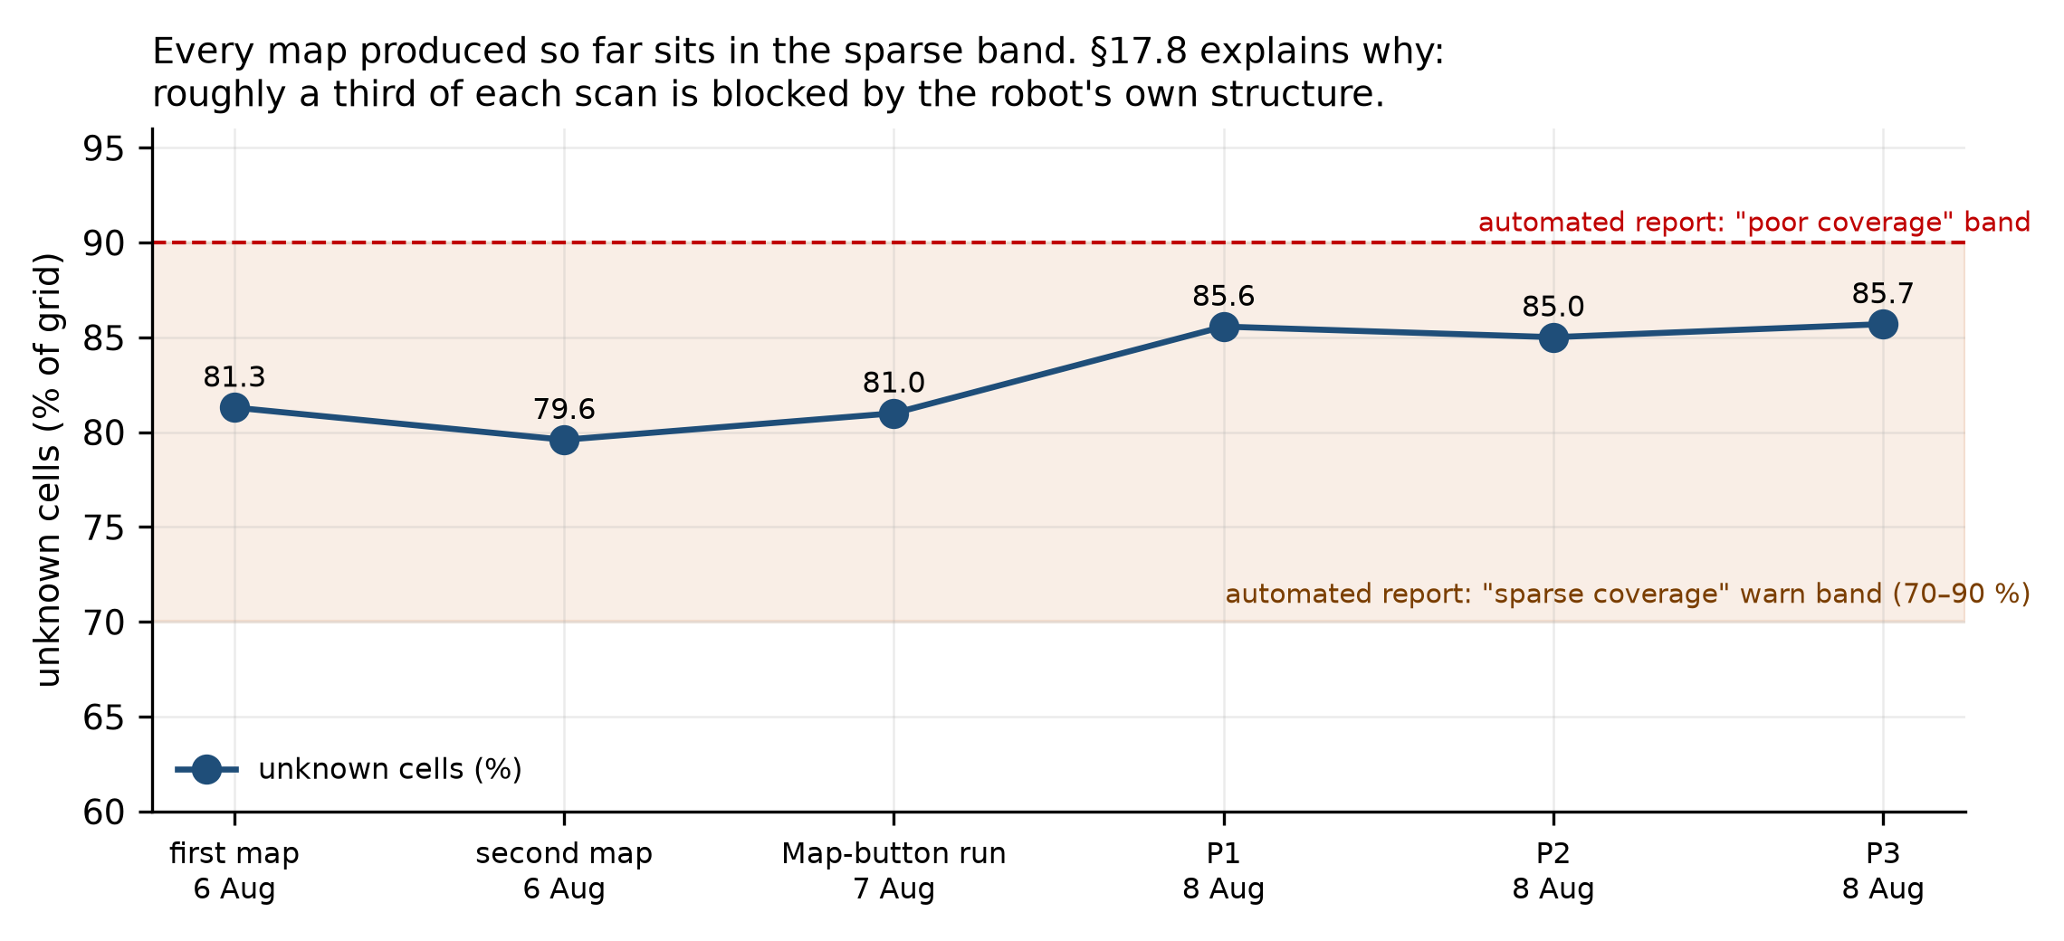
Map coverage
Figure 15. Unknown-cell fraction across the maps produced this year. All sit in the band the automated report flags as sparse.
The explanation was assumed for weeks to be short drive paths and turned out to be something else entirely, which §8.2 reports.

8. The SLAM front-end investigation
This section covers 19 August to 3 September and is the most substantial research content of the year. It is reported as a campaign rather than a list of fixes, because the method is the point: each stage carried a prediction written before the test, several predictions failed, and two conclusions were retracted in writing when the evidence went against them.

8.1 The symptom, and what it was not
Occupancy maps came back folded and unusable. The robot’s estimated pose jumped repeatedly during drives, sometimes by a quarter of a metre in a single 0.1 s sample, which is six to twenty times anything the chassis can physically do.
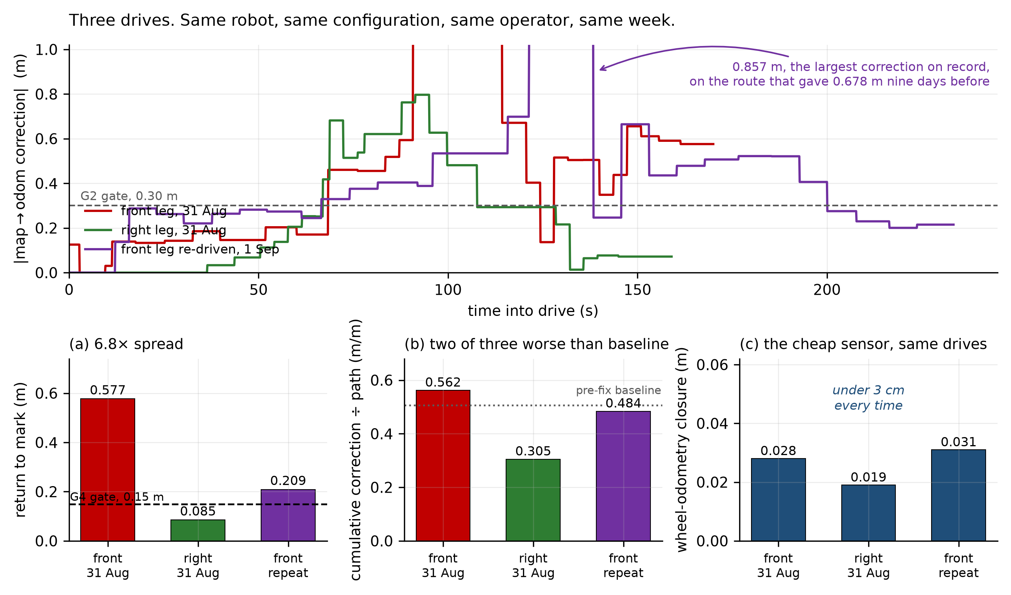
Correction traces
Figure 16. Three drives, same robot, same deployed configuration, same operator, same week, replotted for this report from the raw pose logs in data/field_runs/. (a) The 6.8× spread in return-to-mark across drives that should have been equivalent. (b) Two of the three are worse than the pre-fix baseline the tuning was built to cure. (c) The wheel odometry, on the same three drives, closes under 3 cm every time. The maps these three drives produced, with the ground each one actually covered marked on them, are in Appendix G.
Three candidate explanations were live and the data separated them. A repeat test on the identical route was registered in advance with two possible outcomes: reproduce near 0.577 m, meaning route geometry, or move toward 0.085 m, meaning intermittency. Neither happened. The repeat returned 0.209 m with a peak correction of 0.857 m, the largest on record. A third distinct number on one route rules out geometry.
Two things were ruled out by measurement rather than by argument. The back end is healthy: the pose-graph watcher reported no node moved and no shift across 645 seconds through all 19 loop closures on one drive, and again through 9 closures on another. And wheel odometry registered nothing unusual at the exact moment the map-frame estimate moved 40 cm, with per-tick deltas of 2.0–2.4 mm. The fault is in the front end, between the scan and the pose, and it is neither the optimiser nor the encoders.

8.2 A drive procedure that recorded nothing
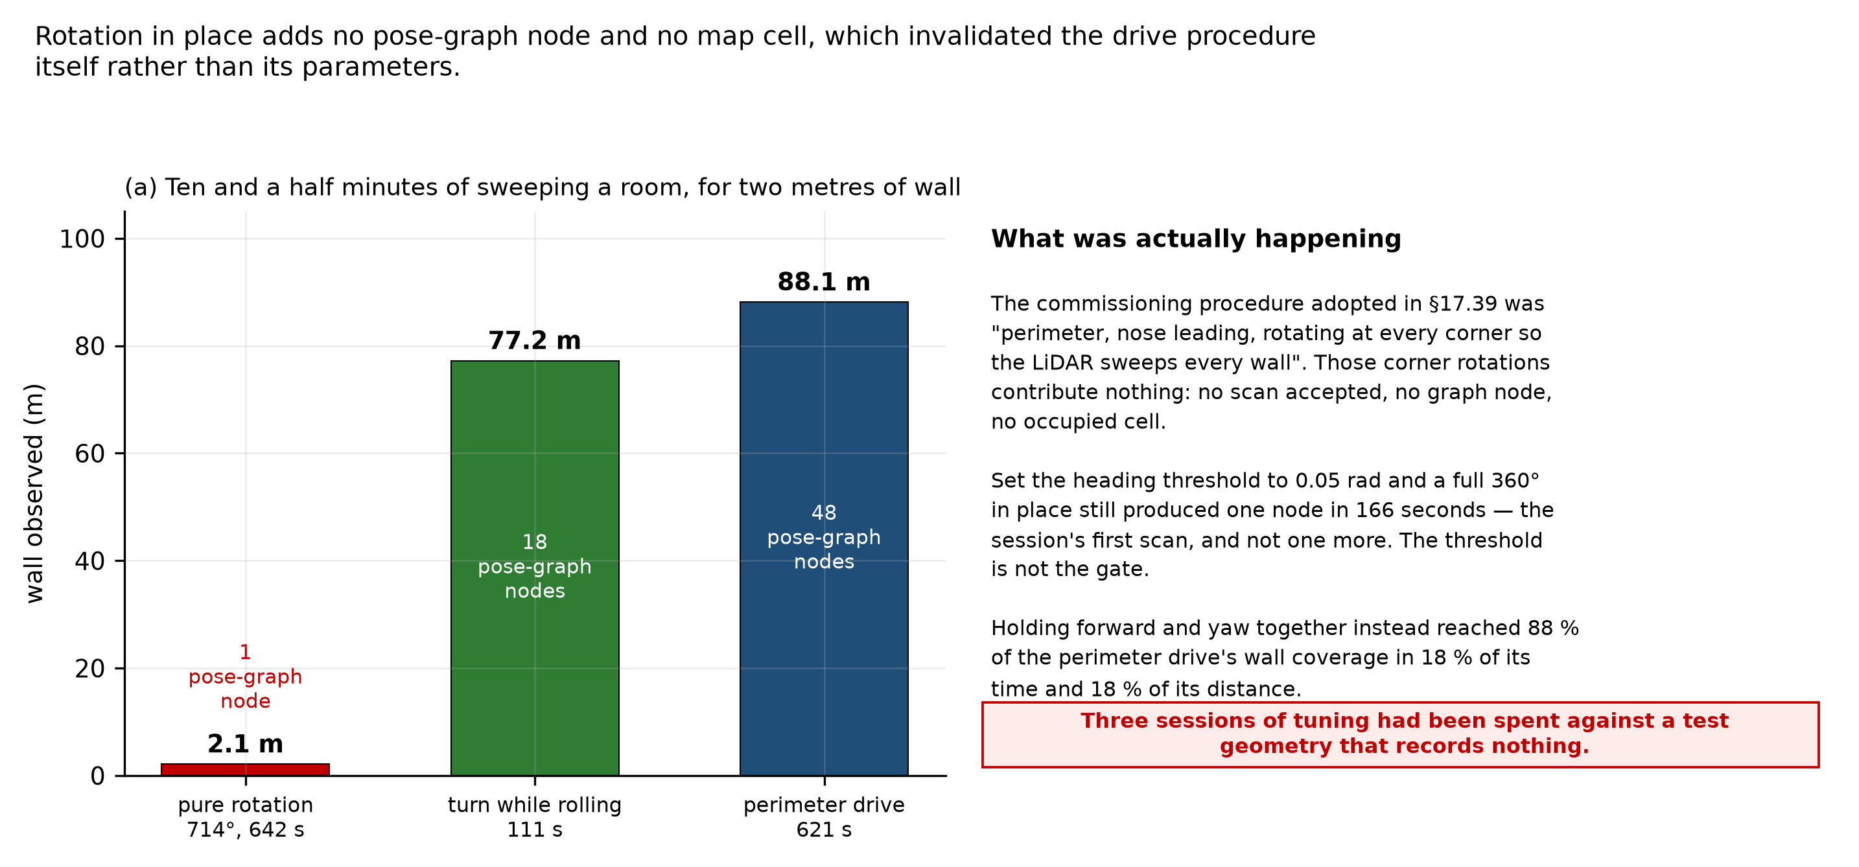
Rotation dead zone
Figure 17. Rotation in place adds no pose-graph node and no map cell. Two full turns, 714° over 642 seconds, produced 43 occupied cells: ten and a half minutes of sweeping a room for two metres of wall.
The commissioning procedure in use since late August was “perimeter, nose leading, rotating at every corner so the LiDAR sweeps every wall”, adopted specifically to work around the rear blind cone of §7.2. Those corner rotations contribute nothing. Setting the heading threshold to a quarter of its value and driving a full 360° in place still produced one pose-graph node in 166 seconds, the session’s first scan and not one more, which falsifies the threshold as the gate. A mechanism is proposed in the record and explicitly marked as unverified against source.
Turning while translating instead reached 88 % of the perimeter drive’s wall coverage in 18 % of its time and 18 % of its distance. This is a better explanation for maps returning 63–87 % unknown than anything previously considered, and it means the map-quality acceptance criterion was never reachable by that method.
The methodological error is recorded alongside the result: three sessions of parameter tuning had been spent against a tight-circle test geometry that records almost nothing, and which is separately degenerate for scan matching. At 5 m range, 1° of heading error is indistinguishable from 8.7 cm of translation, so rotation and translation stop being separable and the matcher resolves the ambiguity in favour of heading. That predicts the measured signature exactly: heading right to about 4°, position 27.6 cm out, wheels closing to 8 mm. Choosing the benchmark badly cost more than any single wrong parameter.

8.3 The result that decided it
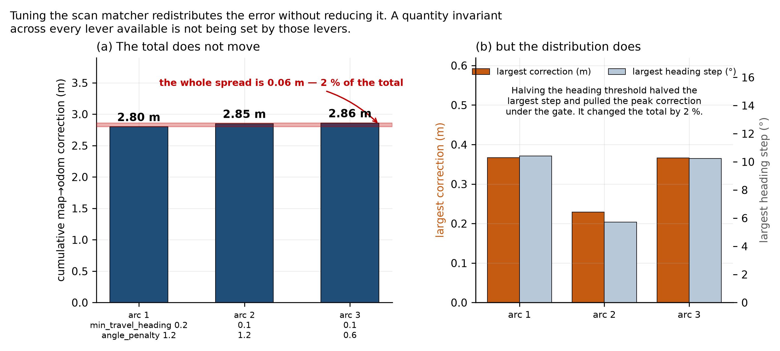
Invariance
Figure 18. The same tight arc driven three times on three parameter sets. Halving the heading threshold halved the largest heading step and pulled the peak correction under the acceptance gate, exactly as predicted. It changed the cumulative correction by 2 %.
This is the sharpest result of the year. Cumulative correction came out at 2.80, 2.85 and 2.86 m across every parameter set available. The tuning moves the distribution of the error and never its amount, which is the signature of something the search parameters do not reach.
Read against a second measurement, it becomes a diagnosis. Instrumenting the sensor input for the first time in the project found 74.8–78 % of rays flipping between valid and invalid between consecutive scans with the robot stationary, and only 47.4 % valid at any instant. The matcher is not searching badly. It is handed a different point cloud every sweep, and no search parameter can fix a moving objective function.
The sensor is behaving correctly. The YDLIDAR X4 Pro is a triangulation scanner rated at under 2 % of range, which is 32 mm at the 1.6 m median range measured in this lab and 200 mm at 10 m. The measured 90th-percentile scatter of 22.8 mm is inside specification. The sensor is performing to specification and the specification is not adequate for what is being asked of it. That is a conclusion pointing at hardware, and the reason to exhaust the software levers first was to justify it rather than guess at it.
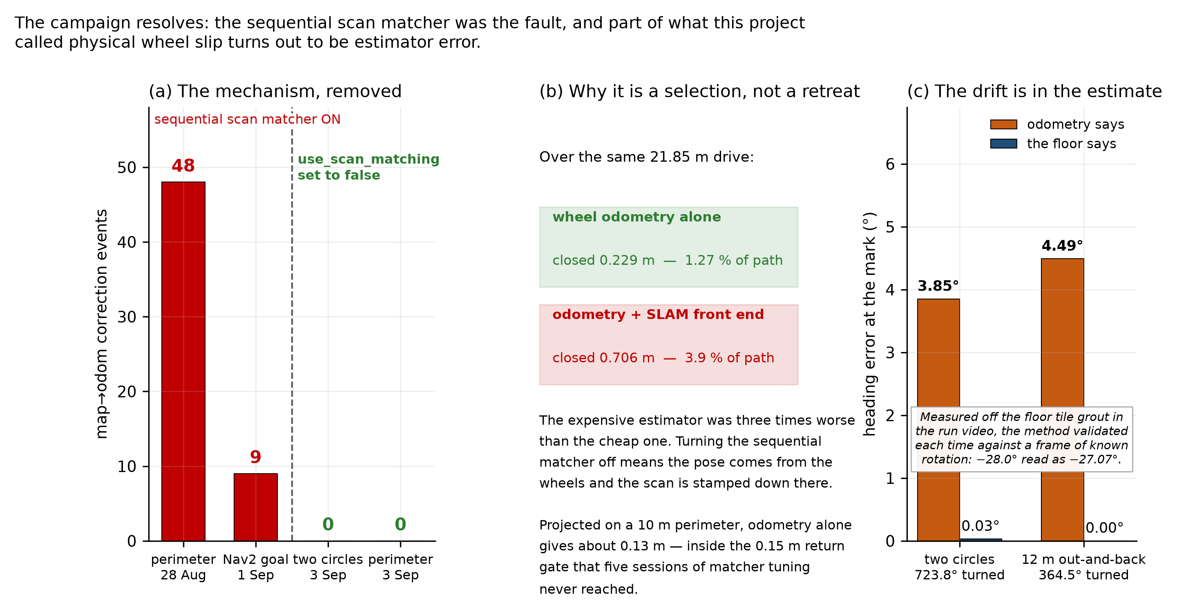
Stage G
Figure 19. (a) The mechanism removed. (b) Why disabling it is a selection between two measured estimators rather than a retreat. (c) The phantom-yaw result of §8.4.
Over one 21.85 m drive, wheel odometry alone closed 0.229 m and odometry plus the SLAM front end closed 0.706 m: the expensive estimator was three times worse than the cheap one. Disabling the sequential matcher, so the pose comes from the wheels and the scan is stamped down there, produced zero corrections across two structurally different routes, 698 seconds and 18.5 m of combined driving. Not one millimetre, across 6994 pose samples. The registered prediction was “corrections approximately zero”; the measured answer is zero to six decimal places.
The claim this supports is deliberately narrow. The correction mechanism is gone. Whether the resulting map is geometrically true over a real route is the next run’s question, and loop closure running on a separate matcher is expected to survive but is recorded as a hypothesis, not a result.

8.4 Phantom yaw
Photogrammetry on the run video, using the floor tile grout as a world-static reference, gives a ground truth independent of every instrument in the repository. Two runs, on different routes:
Run | Rotation commanded | Odometry says | The floor says | Validation
Two circles | 723.8° | −3.85° | −0.03° | −28.0° read as −27.07°
12 m out-and-back | 364.5° | −4.49° | +0.00° | −19.4° read as −18.50°
The robot physically returned to its starting heading both times. The estimator did not. Phantom yaw rates of 0.60°/m and 0.37°/m bracket the 0.58°/m this project measured over 18 m in August and attributed to physical slip.
The consequence is not small. Physical slip cannot be fixed by better estimation; estimator error can. A substantial fraction of what has been treated as a hardware limit is recoverable in software with a gyroscope, and this converts the inertial sensor from a general roadmap item into a measured priority.
The method failed twice before it worked, and both failures are more instructive than the result. The first attempt measured the robot’s own wheels against the video frame and returned “no rotation”; a validation frame of known −28.3° rotation also returned zero, which is impossible. The camera is mounted on the robot’s own mast, so the robot sits still in frame while the world moves around it. The second attempt measured a window that extended into the dashboard’s own border, a fixed screen edge that never rotates. Both were caught only because a frame with a known answer was checked before the result was believed. A measurement that cannot fail its own check is not a measurement.

9. Autonomous navigation

9.1 Bringup, and five configuration faults found by reading
The navigation stack was reviewed before it was run, and the review found five defects in configuration that had never been exercised.
Defect | Consequence had it run
Footprint declared 0.90 × 0.40 m against a real 1.00 × 0.36 m machine | Confident collisions along the length
Both costmaps subscribed to the best-effort scan topic | The §7.1 fault recurring in a new consumer
Unknown space forbidden to the planner | No path findable, since live maps run about 85 % unknown
Odometry topic pointed at a filter that has never run | No odometry reaching the behaviour tree
Raytrace and obstacle ranges exceeding the sensor’s rating | Phantom clearing beyond the sensor’s reach
A further seven surfaced across the first bringups, and the class is consistent enough to be worth naming: a stack default that is silently wrong here purely because this robot’s base frame is non-standard, or because a node the configuration predates is now started automatically. Among them, a second publisher of the same transform the odometry node already owns; a missing velocity-smoother block whose stock defaults zero the lateral axis, which on this robot is forward; a behaviour-tree parameter that replaces rather than extends the default node list; a service timeout whose unit is milliseconds, set to five; and two controller critics that assume the nose points along $+X$ and would reward travelling sideways.
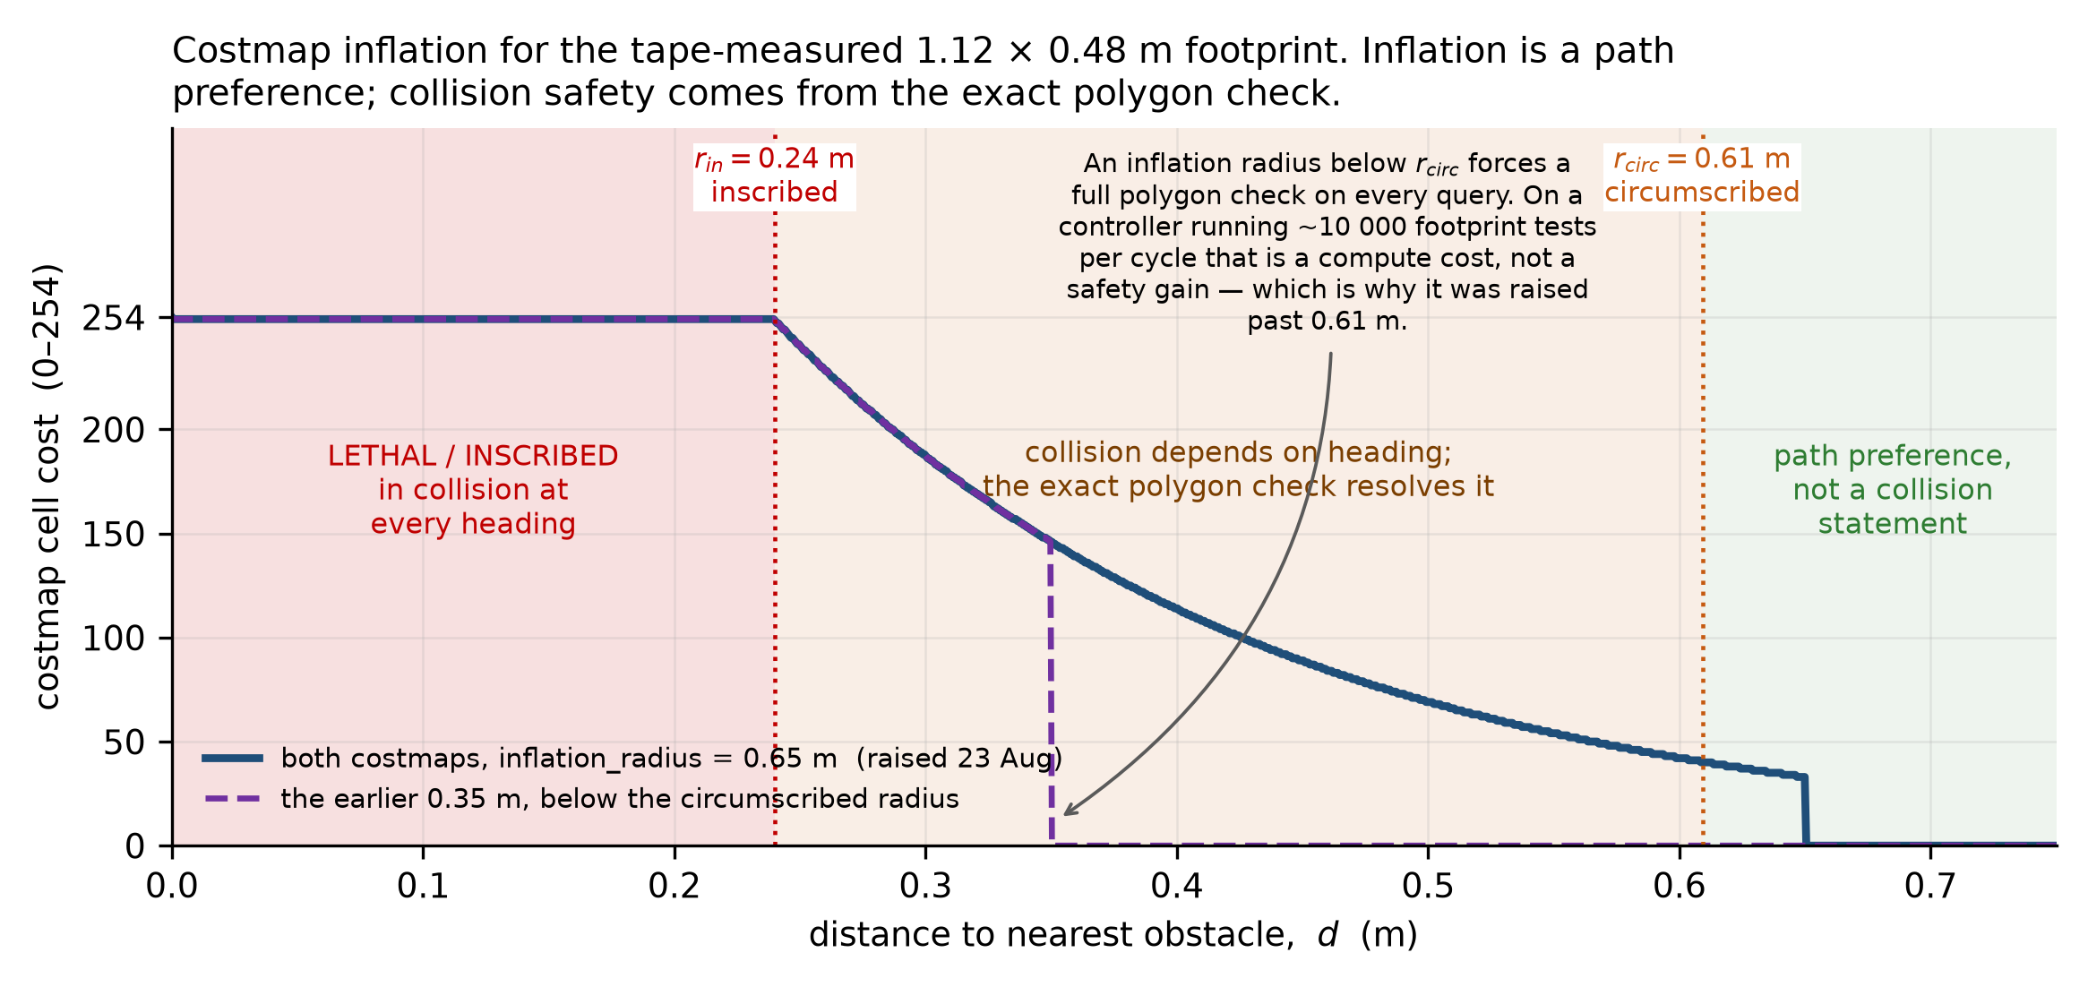
Costmap inflation
Figure 20. Costmap inflation for the tape-measured 1.12 × 0.48 m footprint. Below the inscribed radius the robot is in collision at every heading; between the inscribed and circumscribed radii collision depends on heading and is resolved by the exact polygon check; beyond, the decaying cost expresses a preference. Both inflation radii were later raised past the circumscribed radius, because an inflation radius below it forces a full polygon check on every query and the controller runs on the order of ten thousand of those per cycle.

9.2 The first autonomous goal, and the fault it exposed
The first goal ever sent travelled 0.96 m at 88.4° to the commanded direction and was stopped after contacting an obstacle. Two individually correct, individually validated axis conventions met at the velocity topic and nothing had reconciled them. The planner writes velocity in the base frame’s axes; the kinematics node reads that topic as the standard convention. Manual driving had never noticed, because its producers and its consumer already agreed with each other.
Because the error was a constant 90° rotation sitting inside a closed loop, the planner’s own cross-track corrections came out rotated too. The drive did not fail as a single wrong turn. It failed by never converging, which is a qualitatively harder failure to read from the outside.
The fix converts between the two conventions explicitly at the one place they meet, rather than editing either validated file. Two goals after the fix returned direction errors of 5.5° and 3.7°, the second stopping 4.6 cm short of target, completing the first autonomous forward-and-return round trip on this robot.

9.3 Where navigation stands
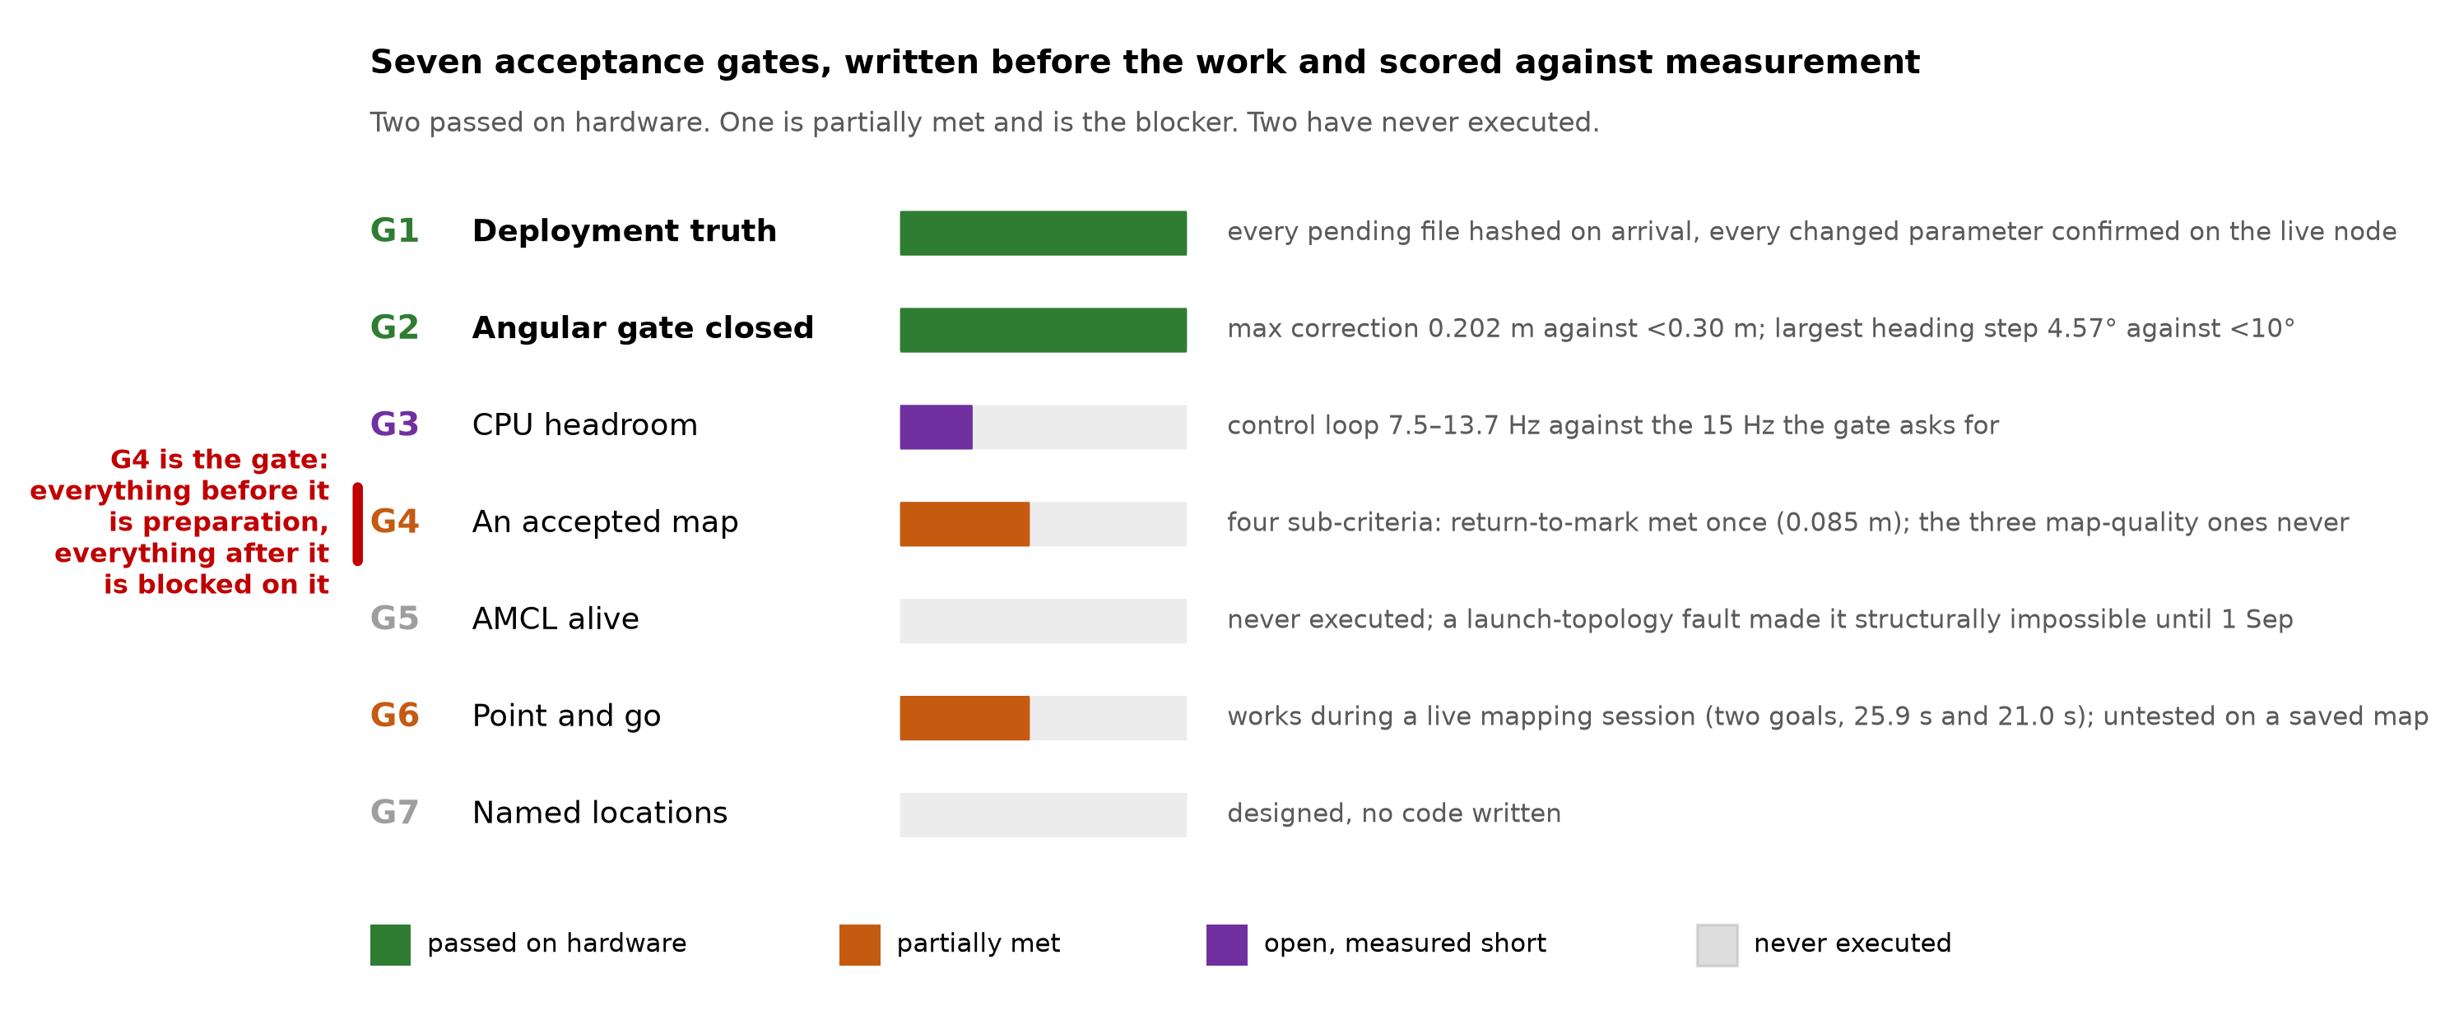
Autonomy gates
Figure 21. Seven acceptance gates, written before the work and scored against measurement. Two passed on hardware, one is partially met and is the blocker, two have never executed.
Point-and-go works today inside a live mapping session: two operator-tapped goals reached in 25.9 s and 21.0 s. Navigation on a saved map does not, and the reason is not the planner. Every navigation attempt in this project’s history was made inside a live SLAM session, against a map frame that was itself moving; on one 21.85 m drive that frame moved 11.08 m. A goal captured as a fixed coordinate in a frame that then slides underneath it is not a planner problem, and naming that explicitly re-ordered the roadmap: commissioning quality is a mapping problem, operating quality is a localisation problem, and the project had been trying to solve the second by tuning the first.
The localisation mode that closes this has never executed, and one reason it could not was found in September without any hardware. The launch file that starts the LiDAR also starts the SLAM node, and the localisation launch file forbids running alongside it while starting no scan source of its own. The only thing that could bring up the sensor was the one thing localisation forbids. It would have launched, activated, and waited for a scan forever, reading as a localisation fault when it was a launch-topology fault. The sensor bringup is now split into its own file, included by both.

10. Critical evaluation

10.1 What is established, what is provisional, what is not claimed
The project grades its own claims on a five-level scale, and this section uses it: measured means measured on this hardware and reproduced on a second run or by a second instrument; single means measured once; hypothesis means reasoned but not measured; retracted means believed and now known false.
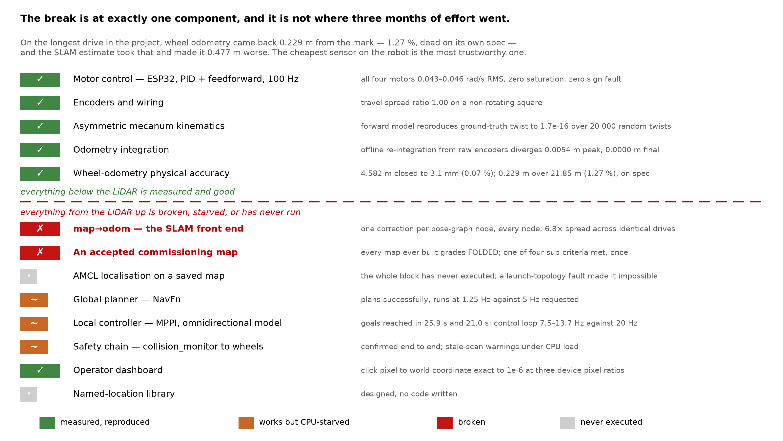
Layer audit
Figure 22. The layer-by-layer audit. The break is at exactly one component, and it is not where most of the year’s effort went.
Measured, and reproduced.
- Closed-loop velocity control tracks to 1.2–1.4 % of peak, wheels free, and 3.4–4.0 % under real chassis weight, with zero saturation samples in either.
- Ground load raises feedforward demand by a mean of 24 %, inside a band predicted before the run.
- Wheel odometry closes 4.582 m to 3.1 mm and 21.85 m to 0.229 m.
- The forward kinematic model reproduces ground-truth twist to 1.7 × 10⁻¹⁶ over 20 000 random twists, and offline re-integration from raw encoders diverges from the live estimate by 5.4 mm peak and 0.0 mm final.
- Cumulative pose correction is invariant to 2 % across every scan-matcher parameter set tried.
- Disabling the sequential matcher removes the correction mechanism entirely: zero events across two routes.
- Heading drift reported by odometry is substantially estimator error, confirmed on two runs by an independently validated method.
- The self-occlusion blind sector is a 90° wedge, consistent across five independent headings.
Provisional, stated only with the caveat.
- The proportional gain assumes an unmeasured plant time constant. Across a plausible range the cost is response speed, not stability, and the integral gain that was genuinely mis-set follows from the measured plant gain and is correct regardless.
- Whether loop closure survives with the sequential matcher disabled is a hypothesis supported only by a source read confirming the two matchers are separate objects.
- The translation half of the photogrammetry result is indicative rather than exact, because a mast camera at an oblique angle is sensitive to small pitch and roll of the mast.
Not claimed.
- No accepted commissioning map exists. One of four sub-criteria has been met, once.
- Localisation against a saved map has never run.
- No performance claim under cargo load.
- No quantitative verification of the width benefit that motivates the geometry. That claim rests on the foundational paper; reproducing it is Objective 4.
- No germicidal dose claim, in either project.
Retracted in writing during the year, and listed because the retractions are part of the evidence: that a loop-closure relaxation caused the pose jumps (the parameters were never deployed to the robot); that an earlier tuning produced a 50 cm to 2 cm improvement (same cause, so what did produce it is recorded as an open question rather than invented); that lateral motion is the weak axis (a third recording failed on the forward leg at the same speed the same day); and one pre-registered took-effect check, withdrawn before the experiment it belonged to was scored, because it differenced displacement from the origin on an out-and-back route where that quantity shrinks on the return.

10.2 The defect record as a finding
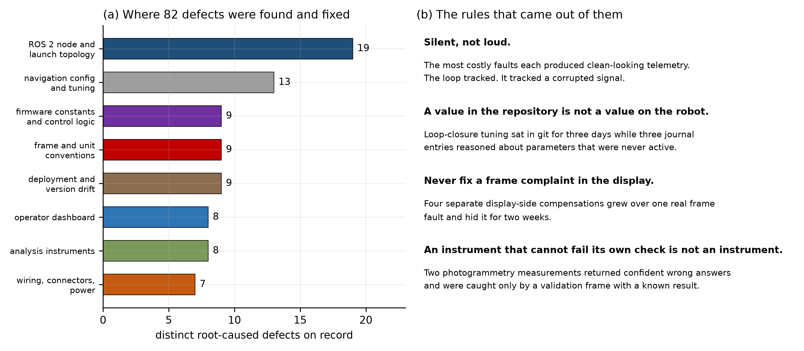
Defect taxonomy
Figure 23. Distribution of the 82 root-caused defects documented this year, and the four rules that came out of them.
The distribution is unremarkable. The shared diagnostic signature is not, and neither are the working rules the year produced, which are now written into the project’s standing documentation:
A value in the repository is not a value on the robot. Loop-closure tuning was committed on 19 August and reached the robot on 22 August. Three journal entries in between reasoned in detail about parameters that were never active, and one headline result had to be un-attributed. The check that matters is querying the live node, not reading a file. A read-only audit script now hashes every deployed file against the repository and reports the difference.
Never fix an axis or placement complaint in the display. Four separate display-side compensations grew over one real frame fault and hid it for two weeks. When an operator reports that the picture is wrong, the picture is usually right.
An instrument that cannot fail its own check is not an instrument. Two photogrammetry measurements returned confident wrong answers and were caught only by validation frames with known results. Three analysis tools were found raising false positives on turning drives, because their thresholds were written for straight-line data; they were scheduled for repair rather than patched immediately, because changing an instrument mid-campaign destroys the baseline it is being compared against.
Isolate before tuning. Gains were touched only after the actuator, the sensor and the unit conversion had each been verified independently. The corollary the year added is that choosing the benchmark is part of the isolation: three sessions were spent tuning against a test geometry that records almost nothing.
Two occasions involved two simultaneous faults, and both cost days. A bench supply current-limiting below peak demand masked a broken encoder line. An undocumented system service auto-starting the LiDAR masked a missing transform frame, and killing processes by hand did not converge because the service restarted them. A symptom that changes character but does not disappear after the suspected cause is fixed indicates at least one further fault.

10.3 On the balance between the two projects
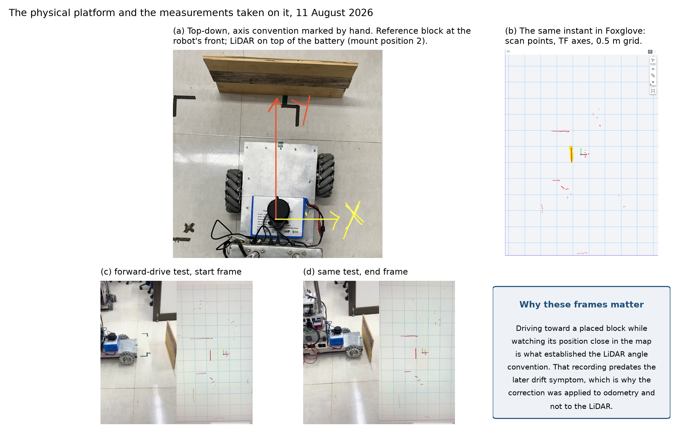
Platform photographs
Figure 24. The physical platform and the measurements taken on it.
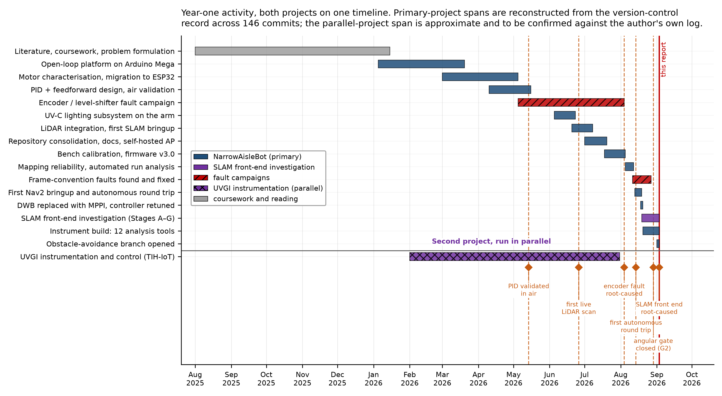
Timeline
Figure 25. Both projects on one timeline, reconstructed from 146 commits.
[CONFIRM] The start and end dates of the parallel project and an honest estimate of the fraction of working time it consumed. The repository holds no dates for it. This is the first question a committee will ask, and a defensible number offered voluntarily is a better answer than a range given under pressure.

11. Parallel project — instrumentation and control for a UVGI air-disinfection unit
An instrumentation and control system was designed, built and deployed for a UV-C air-disinfection unit under a departmental TIH-IoT activity. This is a parallel contribution and is not part of the thesis problem statement.
The justification for including it is capability rather than novelty. Multi-channel environmental monitoring is well-trodden, and the honest statement of what is new is narrow: the integration, and the dose-based control scheme proposed but not implemented. What the work developed transfers directly to the thesis: multi-sensor instrumentation and calibration, real-time acquisition with time-series storage, closed-loop control with safety interlocks, embedded and wireless protocol work, and a systematic self-audit. Every one of those appears in §6 to §9 applied to the robot.

11.1 What was built
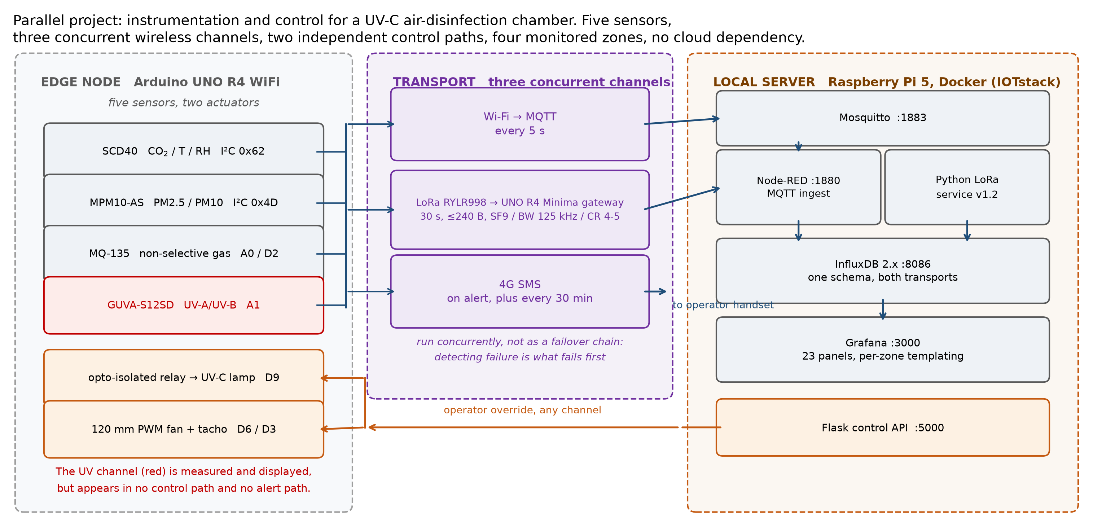
UVGI system architecture
Figure 26. Five sensors, three concurrent wireless channels, two independent control paths, four monitored zones across two radio-isolated deployments sharing one database, and no cloud dependency.
Item | Specification
Sensor node | Arduino UNO R4 WiFi, firmware v10.1
Gateway | Arduino UNO R4 Minima with RYLR998, level-shifted, firmware v4.1
Server | Raspberry Pi 5 (8 GB), containerised stack
Sensors | SCD40 (CO₂, temperature, humidity); MPM10-AS (PM2.5, PM10); MQ-135 (gas); GUVA-S12SD (UV)
Actuators | Opto-isolated relay for the lamp; 120 mm PWM fan with tachometer
Channels | Wi-Fi/MQTT at 5 s; LoRa at 30 s, ≤240 B; cellular SMS on alert and every 30 min
Server stack | Mosquitto, Node-RED, InfluxDB 2.x, Grafana, Portainer, Flask control API
Control law | Hysteresis, 150/200 dead band; fan scaled 128–255 across index 200–500
Alert thresholds | 38 °C; 1200 ppm CO₂; gas index 200; 55 µg/m³ PM2.5
Dashboard | 23 panels, per-zone templating, in-panel actuator control

11.2 Three engineering decisions worth defending
Each was a response to an observed failure rather than anticipatory design, which makes them stronger evidence than a clean specification would be.
A dedicated gateway microcontroller. Driving the radio directly from host GPIO was attempted and abandoned. The command protocol needs deterministic timing and Linux is not a real-time kernel, so scheduler jitter produced dropped packets and truncated responses hard to distinguish from radio-link failures. Interposing a microcontroller moved the timing-critical work to where timing is deterministic: architecturally less elegant, substantially more reliable.
Dual isolated power rails. The cellular modem draws about 2 A in transmit bursts. Sharing a rail with the microcontroller produced brownout resets. Two supplies with a single common ground point eliminated them.
Three concurrent channels rather than a failover chain. A failover design must detect failure before switching, and detection is exactly what fails first in a dead network. Running all three continuously costs bandwidth the system does not need anyway.

11.3 Self-audit
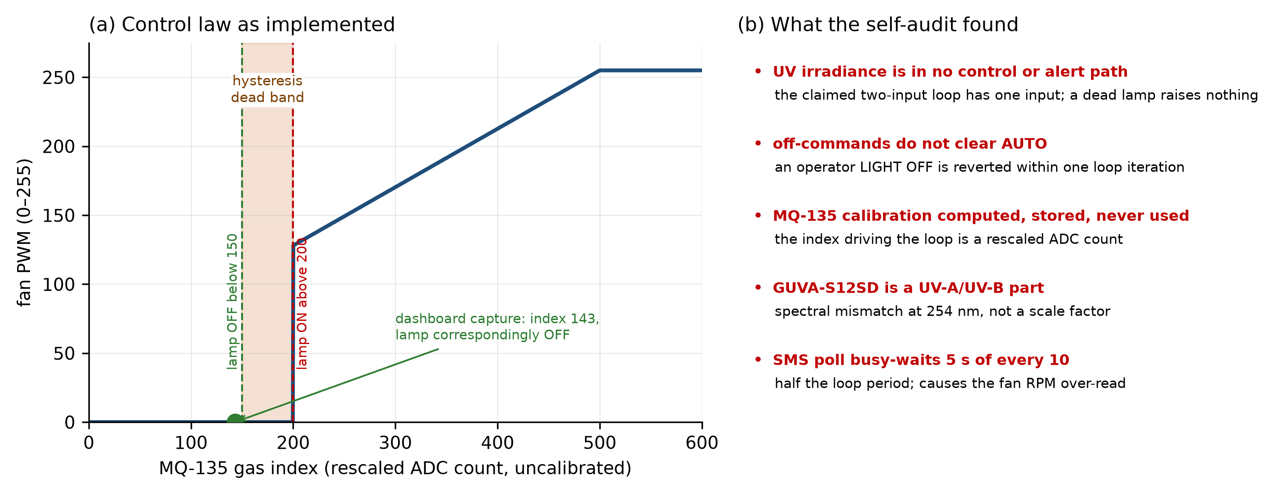
UVGI control law and audit
Figure 27. (a) The control law as implemented, with a dashboard capture at a gas index of 143 confirming the lamp correspondingly off. (b) The verified defect register.
A single dashboard capture demonstrates three separate things, and the third is why this section exists. The gas index of 143 sits below the 150 threshold and the lamp is off, confirming the control law executes as specified. The CO₂ reading of 1240 ppm exceeds the 1200 ppm alert threshold, so the node was in an alert state and had fired on all three channels. And the irradiance panel reads 3.64 in units of mW/cm² with the lamp off, which is the clearest available evidence that the ultraviolet channel is uncalibrated.
Finding | Consequence
Irradiance appears in no control path and no alert path | The two-input loop has one input; a failed lamp raises nothing
Off-commands do not clear the automatic mode | An operator’s explicit off is reverted within one loop iteration, safety-relevant for UV-C
Gas-sensor calibration computed, stored, never used | The index driving the loop is a rescaled analogue-to-digital count
The fitted UV sensor responds to UV-A and UV-B | A spectral mismatch at 254 nm, not a scale factor
Fan speed never divides by elapsed time | Over-reads during loop stalls, correlated with cellular activity
The cellular poll busy-waits 5 s of every 10 | Half the loop period, and the root cause of the item above
One node and its gateway share a radio address | A second node cannot be added to that deployment
Presenting the third reading of the dashboard capture without being asked is the difference between an audit and an excuse, and the same applies to this table.

11.4 What better would look like
The most defensible item is a conceptual correction rather than an engineering improvement. The device is triggered by a non-selective gas sensor with no causal relationship to airborne pathogen load. The established proxy is the rebreathed-air fraction derived from carbon dioxide concentration, which sits directly inside the Wells–Riley exposure model, and substituting it would make the trigger physically meaningful rather than merely correlated with occupancy.
Dose-based control follows. Dose is irradiance times residence time, and residence time is irradiated volume divided by airflow. Measuring irradiance with a detector appropriate to 254 nm, choosing a target log-reduction and computing the fan speed that delivers it would make the ultraviolet channel a genuine second feedback input and would compensate automatically as the lamp ages. This is the same dose-delivery problem the robot’s own UV-C payload faces, and is the concrete link between the two projects.
Remaining items: traceable calibration of every channel; correctly labelled particulate sub-indices; liveness alerting; buffered store-and-forward with a real-time clock; and authenticated control paths, since the present radio separation is an addressing filter and not a security mechanism.
[CONFIRM] Whether this section may be circulated. Consult the supervisor and IRCC on disclosure before the report leaves your hands, and consider marking it confidential.

12. Research gaps and the plan for years 2 to 4

12.1 Gaps this thesis can close
Gap 1: the asymmetry has never been evaluated against a matched baseline. The geometry is derived and simulated [1]. Whether the width reduction costs tracking accuracy, disturbance rejection or yaw authority, and by how much, is unmeasured. A controlled comparison at matched mass, wheel and controller parameters would be the first such result.
Gap 2: what sensing corridor-width localisation actually requires. This is the gap the year’s work opened, and it is the most defensible thing in this section because it rests on measurement rather than on a literature shortage. The low-cost 2D SLAM literature is built on a sensor tier whose specified accuracy, quantified against a corridor-width error budget, does not close: a triangulation scanner at 2 % of range gives 32 mm at 1.6 m, against a lateral budget of a few centimetres over 10 m. Separately, a substantial fraction of the heading drift this project attributed to physical slip is estimator error recoverable with a gyroscope. The open question is the minimum sensor complement, and its cost, that closes a stated error budget on a platform of this class. That is a question the field answers by convention rather than by measurement.
Gap 3: slip and odometry models assume symmetric geometry. The empirical drift figures that motivate inertial fusion [2] were measured on symmetric platforms and the standard slip formulation assumes symmetry. Whether per-wheel slip differs systematically between the inner and outer pairs of a non-collinear layout is open, and this platform’s slip residual, derived in §2.1, is the instrument that would answer it.
Gap 4: costmap semantics degenerate at narrow clearance. Inflation-based planning assumes free space wide enough for the bands from opposing walls not to meet. In a narrow aisle they do. What replaces or supplements inflation in that regime, without losing its computational advantage, is not settled.
Gap 5: self-occlusion from a tall payload is under-treated. Two-dimensional SLAM literature generally assumes an unobstructed sweep. A robot carrying a mast violates that, and the trade-off between sensor placement, sector masking and accepting reduced coverage has not been characterised quantitatively. This platform now has the measurement (a 90° wedge, 107 of 430 beams) and the mitigation, which is a starting point rather than a result.
Gap 6: load-dependent dynamics. Cargo changes mass and the position of the centre of mass. Fixed-gain control is not adaptive to this, and whether it needs to be is an empirical question a loaded trajectory-tracking experiment answers.
Gap 7: wheel-fault tolerance is unexamined for an asymmetric platform, and matters more in a narrow aisle than in the open. Fault-tolerant schemes for four-mecanum-wheel platforms exist and are validated on real hardware, compensating for one or two disabled wheels with adaptive control and navigation functions [21]. Like the adaptive and fuzzy-tuning literature already read [3, 4], that result assumes a symmetric wheel layout; whether the same compensation holds when the two wheel pairs sit at different radii from the centre of mass is open, and this platform has no fault detection or degraded-mode capability at all today. The stakes differ from the open workspace the literature tests in: a four-wheeled platform stalled in a sub-1 m aisle cannot be walked around, and may need to finish its current manoeuvre or reach a clear egress point on three wheels rather than simply stop. Unlike Gaps 1–6, nothing about this has been measured on this platform; it is included as a literature-motivated candidate, not a result in progress.
Gap 8: nobody couples a packing decision to the reach and tipping envelope of the machine that has to execute it. This is the gap Objective 6 opens, and it is the most defensible of the manipulator-side questions because it does not depend on the arm being built. Three-dimensional bin packing is a mature field, lately dominated by learned policies for the online case, and robotic execution of those decisions is demonstrated — but every such demonstration places items onto an open pallet, into an open box, or onto an open shelf face, where the arm can reach anywhere the packing algorithm might choose. Where stability is considered at all it enters afterwards, as a constraint on a trajectory that has already been planned to a slot that was already chosen. On a narrow-footprint vehicle the constraint binds the other way round: reach and tipping margin decide which slots are executable at all, and a slot the planner likes may be one this chassis cannot serve without leaving its stable envelope. The open question is what a packing algorithm should be told about the executing machine, and how a placement should be re-planned when the machine cannot deliver it. Note that this couples straight back to Gap 2: aiming an arm at a shelf cell presumes the base knows where it is, and the localisation this platform does not yet have is what would supply that.

12.2 Plan by year
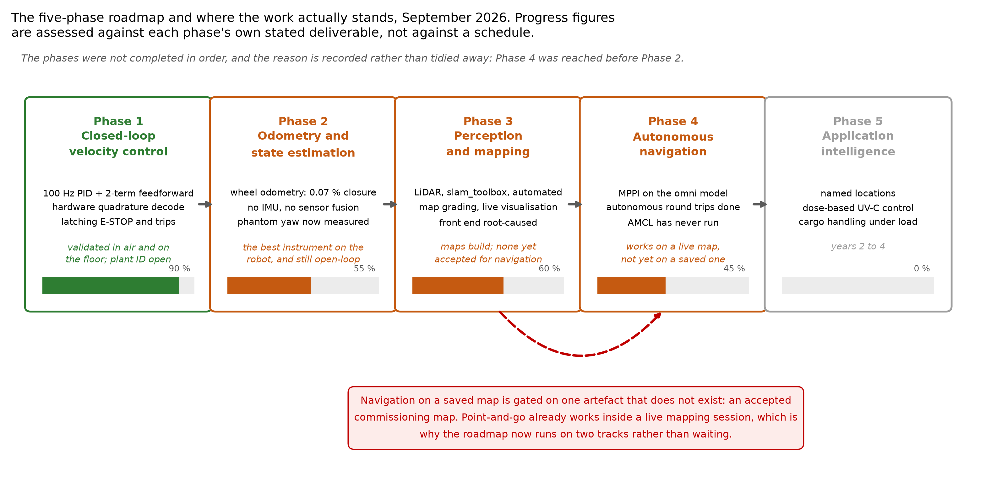
Roadmap
Figure 28. The five-phase roadmap and current standing. Progress figures are assessed against each phase’s own stated deliverable, not against a schedule.
Year 2 — close the sensing question, then close the autonomy chain.
The sequence is short and each step unblocks the next. Procure and mount an inertial sensor, close to the geometric centre so that tangential acceleration mixes minimally into the yaw channel, and quantify how much of the measured phantom yaw it recovers; §8.4 gives a specific number to test against rather than a general expectation. Run plant identification on the bench, which removes the last estimated gain in about 40 seconds. Complete a commissioning drive under the corrected procedure of §8.2 and grade it against the four existing criteria. Save that map, bring up localisation against it, and run the point-and-go sequence that currently works only inside a live session.
Two experiments are worth running whatever the outcome of that sequence. The first is a sensor comparison: the case against the current LiDAR is now quantitative, and putting a higher-grade scanner on the same routes with the same instruments would convert an inference into a controlled result. The second is the self-occlusion characterisation of Gap 5, which the platform is unusually well placed to do because the mask, the measurement method and the map-grading tools all already exist.
Publish the platform, its calibration methodology and the instrumentation-fault taxonomy of §10.2 as a systems paper. The cross-checking methodology is a contribution independent of the geometry, and the material for it exists now.
The manipulator of Objective 6 runs alongside this as design work only, and deliberately does not compete with it for bench time. Two things are worth doing in year 2 and neither needs hardware: re-run the design optimisation against this platform’s measured mass, which is nearly double what that model assumed and therefore moves the tipping margin it found binding; and put the resulting geometry into simulation with CAD-derived inertias. A single-joint bench test is the earliest point at which money is spent, and it should wait behind the localisation sequence above, because an arm that cannot be aimed is not worth actuating.
Year 3 — the geometry question, and control under load.
Build the symmetric baseline for Gap 1, in simulation first and on hardware if the wheelbase can be reconfigured without a new chassis, and run matched trajectory-tracking and disturbance-rejection experiments. Characterise per-wheel slip against the fused estimate using the residual of §2.1 to address Gap 3. Instrument the cargo arm’s effect on chassis dynamics under load. Only then compare fixed-gain control against the adaptive and model-based alternatives read this year [3, 4], with the decision criterion stated in advance: if the fixed-gain baseline produces visible imperfection in cargo-handling motion, advance; if not, the simpler controller wins and that is a result.
Year 4 — application, evaluation and writing.
Close the dose-based control loop for the UV-C payload, which requires a detector appropriate to 254 nm and a traceable calibration. Demonstrate end-to-end application behaviour in a realistic corridor. Complete whole-system evaluation with success rates, clearance statistics and failure modes, and write up.

12.3 Intended outputs
Three results appear publishable on their own terms, listed in the order the underlying work completes.
The first is a systems and methods paper covering the platform, its calibration methodology and the fault taxonomy of §10.2. Its contribution is the verification practice rather than the robot: a catalogue of failure modes that produce healthy-looking telemetry, and the cross-subsystem checks that detect each one. That material exists now.
The second is the sensing result of Gap 2, which is the most novel thing the year produced and the least anticipated. A quantitative account of why a standard low-cost 2D SLAM stack fails at corridor-width tolerances, with the invariance result as its central evidence, would be useful to anyone building on the same sensor tier.
The third is the controlled comparison of Objective 4, which answers the question the geometry was adopted to settle. It depends on Year 2’s localisation work, because a tracking comparison without a trustworthy pose estimate measures the estimator rather than the geometry.
[CONFIRM] Target venues, and whether the supervisor expects a conference or journal route. Also whether any part of the UV-C payload work is patent-restricted, since that changes what can be published and when.

12.4 Immediate next steps
Priority | Action | Blocks
1 | Procure and integrate the inertial sensor | Phase 2, and the phantom-yaw recovery of §8.4
2 | Commissioning drive under the corrected procedure, graded | Everything on a saved map
3 | First localisation bringup on that map | Objective 3 on a fixed frame
4 | Plant identification bench run | The last estimated gain
5 | Repair the three analysis tools raising false positives on turning drives | Trusting the instruments in year 2
6 | Sensor comparison against a higher-grade scanner | Converts Gap 2 from inference to result

13. References
Foundational and platform.
- An Omnidirectional Asymmetric Mobile Robot for Narrow-Aisle Spaces. [CONFIRM] — full bibliographic details required. Archived in the project documents; the kinematic basis of this platform.
- Galati et al. Adaptive heading correction for mecanum platforms. [CONFIRM] — full citation required. Source of the 4.56°-over-10 m drift figure that motivates Phase 2.
- Lin, L.-C., & Shih, H.-Y. (2013). Modeling and adaptive control of an omni-Mecanum-wheeled robot. Intelligent Control and Automation, 4, 166–179. https://doi.org/10.4236/ica.2013.42021
- Cao, G., Zhao, X., Ye, C., Yu, S., Li, B., & Jiang, C. (2022). Fuzzy adaptive PID control method for multi-mecanum-wheeled mobile robot. Journal of Mechanical Science and Technology, 36(4), 2019–2029. https://doi.org/10.1007/s12206-022-0337-x
SLAM.
- Macenski, S., & Jambrečić, I. (2021). SLAM Toolbox: SLAM for the dynamic world. Journal of Open Source Software, 6(61), 2783. https://doi.org/10.21105/joss.02783
- Grisetti, G., Stachniss, C., & Burgard, W. (2007). Improved techniques for grid mapping with Rao-Blackwellized particle filters. IEEE Transactions on Robotics, 23(1), 34–46. https://doi.org/10.1109/tro.2006.889486
- Sugiura, K., & Matsutani, H. (2021). An FPGA acceleration and optimization techniques for 2D LiDAR SLAM algorithm. IEICE Transactions on Information and Systems, E104.D(6), 789–800. https://doi.org/10.1587/transinf.2020edp7174
- Sugiura, K., & Matsutani, H. (2022). A universal LiDAR SLAM accelerator system on low-cost FPGA. IEEE Access, 10, 26931–26947. https://doi.org/10.1109/access.2022.3157822
- Laksono, P. S., & Kusuma, T. M. (2022). Performance analysis of Hector SLAM and GMapping for mobile robot navigation. Jurnal Ilmiah Teknologi dan Rekayasa, 27(2), 144–153. https://doi.org/10.35760/tr.2022.v27i2.6063
- Kohlbrecher, S., von Stryk, O., Meyer, J., & Klingauf, U. (2011). A flexible and scalable SLAM system with full 3D motion estimation. SSRR 2011, 155–160. https://doi.org/10.1109/ssrr.2011.6106777
- Heß, W., Kohler, D., Rapp, H., & Andor, D. (2016). Real-time loop closure in 2D LIDAR SLAM. ICRA 2016, 1271–1278. https://doi.org/10.1109/icra.2016.7487258
- Konolige, K., Grisetti, G., Kümmerle, R., Burgard, W., Limketkai, B., & Vincent, R. (2010). Efficient sparse pose adjustment for 2D mapping. IROS 2010, 22–29. https://doi.org/10.1109/iros.2010.5649043
- Censi, A. (2008). An ICP variant using a point-to-line metric. ICRA 2008, 19–25. https://doi.org/10.1109/robot.2008.4543181
- Grisetti, G., Kümmerle, R., & Stachniss, C. (2010). A tutorial on graph-based SLAM. IEEE Intelligent Transportation Systems Magazine, 2(4), 31–43. https://doi.org/10.1109/mits.2010.939925
- Moravec, H., & Elfes, A. (1985). High resolution maps from wide angle sonar. ICRA 1985, 116–121. https://doi.org/10.1109/robot.1985.1087316
Navigation.
- Macenski, S., Martín, F., White, R., & Ginés Clavero, J. (2020). The Marathon 2: A navigation system. IROS 2020. https://doi.org/10.48550/arxiv.2003.00368
- Lu, D. V., Hershberger, D., & Smart, W. D. (2014). Layered costmaps for context-sensitive navigation. IROS 2014, 709–715. https://doi.org/10.1109/iros.2014.6942636
- Fox, D., Burgard, W., & Thrun, S. (1997). The dynamic window approach to collision avoidance. IEEE Robotics & Automation Magazine, 4(1), 23–33. https://doi.org/10.1109/100.580977
- Li, X., Liu, F., & Liu, J. (2017). Obstacle avoidance for mobile robot based on improved dynamic window approach. Turkish Journal of Electrical Engineering & Computer Sciences, 25, 666–676. https://doi.org/10.3906/elk-1504-194
- Williams, G., Drews, P., Goldfain, B., Rehg, J. M., & Theodorou, E. A. (2018). Information-theoretic model predictive control: theory and applications to autonomous driving. IEEE Transactions on Robotics, 34(6), 1603–1622. https://doi.org/10.1109/tro.2018.2865891
Fault tolerance.
- Vlantis, P., Bechlioulis, C. P., Karras, G., Fourlas, G., & Kyriakopoulos, K. J. (2016). Fault tolerant control for omni-directional mobile platforms with 4 mecanum wheels. 2016 IEEE International Conference on Robotics and Automation (ICRA), 2395–2400. https://doi.org/10.1109/icra.2016.7487389
References 3–21 were retrieved from the publication record and checked for retractions. References 1–2 are held in the project’s document archive and need their full bibliographic details recovered before submission.

14. Appendices

Appendix A — Controller parameters as compiled
ENCODER_CPR = {186264, 186264, 93132, 93132} // FR FL | RR RL
Kff = { 37.3, 38.4, 38.3, 38.0} // PWM per rad/s, air
Kstat = { 8.0, 8.0, 8.0, 8.0} // PWM breakaway
Kp = 45 Ki = 250 Kd = 0.5 // 100 Hz loop
max_wheel_speed = 5.20 rad/s // AIR value
max_wheel_accel = 12.0 rad/s²
velocity filter alpha = 0.4 minimum output = 5
Every gain except Kp is derived from measured data; Kp assumes an unmeasured plant time constant. Measured ground-load feedforward is 24 % above these air values (§6.4), which is the correction to apply when the gains are refitted.

Appendix B — Derived geometric constants
Quantity | Symbol | Value
Outer wheel longitudinal distance | $l_{1}$ | 0.403 m
Inner wheel longitudinal distance | $l_{2}$ | 0.333 m
Half track width | $d$ | 0.15769 m
Wheel radius | $r_{w}$ | 0.0762 m
Outer yaw lever arm | $K_{o}=l_{1}+d$ | 0.5607 m
Inner yaw lever arm | $K_{i}=l_{2}+d$ | 0.4907 m
Footprint for collision checking | — | 1.12 × 0.48 m
Inscribed radius | $r_{in}$ | 0.24 m
Circumscribed radius | $r_{circ}$ | 0.61 m
Padded footprint corner from centre | — | 0.622 m
In-place rotation clearance required | — | ≈ 0.87 m in every direction

Appendix C — Acceptance gates and their current state
Gate | Criterion | State
G1 | Every pending file hashed on arrival; every changed parameter confirmed on the live node | Passed
G2 | No correction > 0.30 m; largest heading step < 10° | Passed at 0.202 m and 4.57°, on a shorter test than the gate specifies
G3 | Control loop ≥ 15 Hz sustained; no transform-extrapolation errors in five minutes | Open, measured at 7.5–13.7 Hz
G4 | Map not folded; doubled walls < 1.0 %; unknown < 50 %; return to mark < 0.15 m | One of four met, once (0.085 m return)
G5 | Localisation reaches active on a saved map; pose covariance converges | Never executed
G6 | Five consecutive tapped goals, each within 0.15 m / 10° measured on the floor | Partially met on a live map
G7 | Three taught locations recalled after a full power cycle | Never executed

Appendix D — Defect register, by category
Eighty-two distinct root-caused defects are documented across docs/Research_Journal.md. They are grouped here by where they lived. The section numbers in this table belong to that document, not to this report, and are the entry point for the detail.
Class | Count | Representative faults
ROS 2 node and launch topology | 19 | best-effort publisher against reliable subscriber (§13.4); telemetry parameter defaulting off, so the odometry transform never published (§16.9); duplicate node instances doubling the relay rate (§16.8); a second publisher of a transform another node owns (§17.14); the launch topology that made localisation structurally impossible (§17.49)
Navigation configuration and tuning | 13 | footprint declared smaller than the machine (§17.6); a service timeout whose unit is milliseconds, set to five (§17.23); progress checker measuring position only, on rotation-only goals (§17.21); inflation radius below the circumscribed radius (§17.23)
Firmware constants and control logic | 9 | encoder CPR from a different motor, a factor of 22.5 (§7.1); wheel radius hard-coded at 0.05 m (§7.2); one shared encoder constant across two encoder types (§16.1); an anti-windup clamp 23× larger than the output range (§16.1)
Frame and unit conventions | 9 | the mirrored scan, a reflection outside what any transform could correct (§17.9); the velocity-topic axis mismatch that sent the first autonomous goal 88.4° wrong (§17.19); a half-applied frame conversion hidden by four downstream compensations (§17.38)
Deployment and version drift | 9 | tuning committed to git that never reached the robot (§17.32); a parameter file committed without its nesting, which binds nothing and falls back to defaults (§17.33); a build-mode switch that reported success and destroyed two nodes (§17.49)
Operator dashboard | 8 | map view leaking drive commands into the joystick handler (§17.34); free-against-unknown contrast at 1.20:1 (§17.34); emergency stop not surviving a socket reconnect (§17.49); send failing silently while the interface reported success (§17.49)
Analysis instruments | 8 | a tuple-width mismatch that lost a 7117-sample run (§17.29); three false positives firing on every turning drive (§17.44, §17.47); map coverage estimated from a screenshot (§17.44)
Wiring, connectors and power | 7 | two broken level-shifter connections (§7.12); a front-encoder cross-connection that was the root cause of a multi-session campaign (§16.1); a bench supply current-limiting below peak demand and masking the first (§7.13)
Four remain open: the pull-up fix for the UV relay boards, a suspected controller brownout reset, the sensor-to-base translation still at a placeholder in the transform tree, and the plant identification that would remove the last estimated gain.

Appendix E — Instruments built this year
Twelve analysis tools were written and are in tools/. They are listed because several are the evidence behind claims in §8, and because the report’s honesty about what is measured depends on them.
Tool | What it measures
run_analyzer.py | correction events, wheel behaviour and map statistics for a whole run
map_integrity.py | the fold signature as five numbers, of which doubled walls carries the verdict
graph_residuals.py | whether the pose-graph optimiser moved any node, per loop closure
wheel_forensics.py | position and slip re-integrated offline from raw encoders alone
scan_quality.py | geometric conditioning of the scan, and scan-to-scan ray stability
bag_tf_diff.py | genuine value changes in one transform pair, with the republish noise collapsed
trajectory_viz.py | live pose recording with wall-clock stamps for cross-log correlation
zero_point_scan.py | automated rotate-and-check mapping from the zero mark
repeatability_test.py | repeated tape-measured out-and-back trials in all four body directions
verify_axis_chain.py | proves the frame convention and fails if it is edited out
pi_audit.sh | hashes every deployed file against the repository, read-only
map_corpus.py | compares a folder of maps side by side, ranked by occupied fraction
The doubled-wall detector is worth one sentence of method, because its argument is falsifiable. Free cells between two near-parallel walls mean the LiDAR returned through that space, so something observed both faces; but if the gap is narrower than the robot’s own 0.48 m, that something cannot have been this robot. Two walls whose far faces were both seen across a gap nothing could occupy is the geometry a false closure leaves behind. The known hole is that a genuine narrow gap between shelves, viewed end-on, looks identical, which is why flagged cells are reported in map coordinates rather than only counted.

Appendix F — Open items carried into year 2
Sensing. Procure and integrate the inertial sensor. Quantify how much of the measured phantom yaw it recovers. Run the sensor comparison that would convert the Gap 2 inference into a controlled result.
Control. Plant identification bench run. Refit the feedforward with the measured 24 % ground-load correction. Revisit the acceleration limit under load.
Perception. Complete a commissioning drive under the corrected procedure and grade it. Correct the sensor-to-base translation still at a placeholder. Establish whether loop closure survives with the sequential matcher disabled.
Navigation. First localisation bringup on a saved map. Repeat the point-and-go sequence against a fixed frame. Address the control-loop rate, which the gate specifies at 15 Hz and which measures 7.5–13.7 Hz.
Instruments. Repair the three analysis tools raising false positives on turning drives, and re-baseline the campaign afterwards.
Wiring. The ESP32 currently draws VIN from the Pi’s USB port, which couples SMPS switching noise and PWM ground transients into the encoder counts (docs/hardware/nab_circuit_diagram.png, deployment note). Cut VBUS in the Pi→ESP32 cable and feed VIN from the 5 V buck rail instead. Not yet applied on the robot.
Documentation. Keep the research journal current. It is the primary record from which this report was assembled, and every figure in it is regenerable from the data in this repository.

Appendix G — The three commissioning maps, reconstructed and as captured
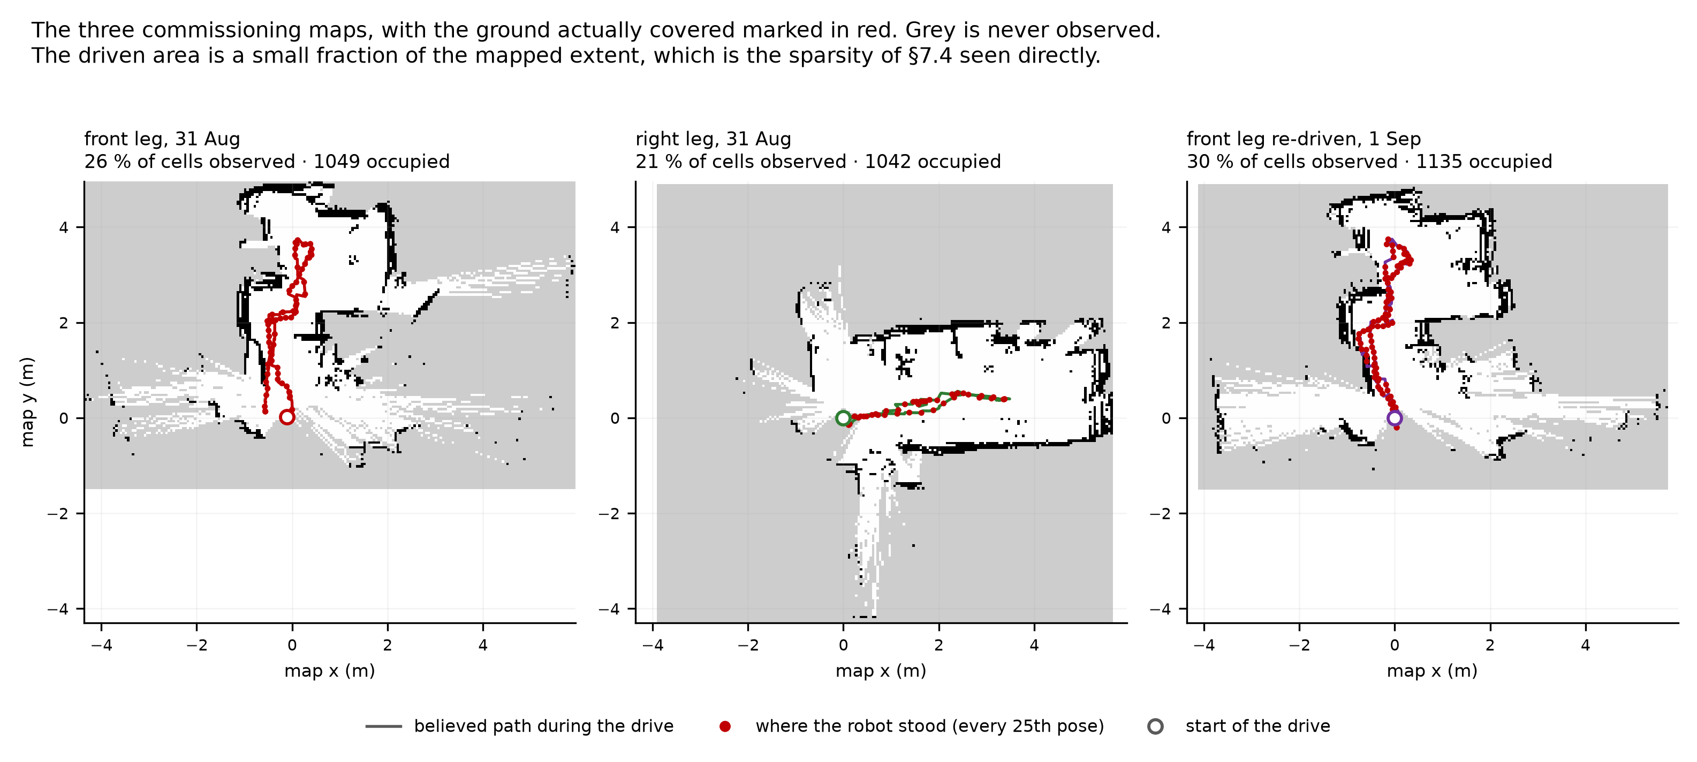
Field maps
Figure 29. The saved occupancy grids from the three drives of §8.3, each placed in world coordinates from its own YAML origin and resolution, sharing one window so the three are directly comparable. The believed pose during each drive is drawn over the map and the red dots mark where the robot actually stood. Grey is cell never observed.
The figure is included because the sparsity argued in §7.4 is easier to see than to describe. Between 21 % and 30 % of the cells in these maps were ever observed, and the ground the robot physically covered is a narrow ribbon through a much larger mapped extent: the LiDAR reaches far further than the chassis travels, so a long drive can produce a wide, thin map that still fails the commissioning criteria. The second panel is the clearest case, a single out-and-back leg whose observed fraction is the lowest of the three.
These are the same runs whose correction traces appear in Figure 16, so the two figures can be read together: Figure 16 gives the magnitude of what the estimator was doing, and this one gives the geometry it was doing it in.
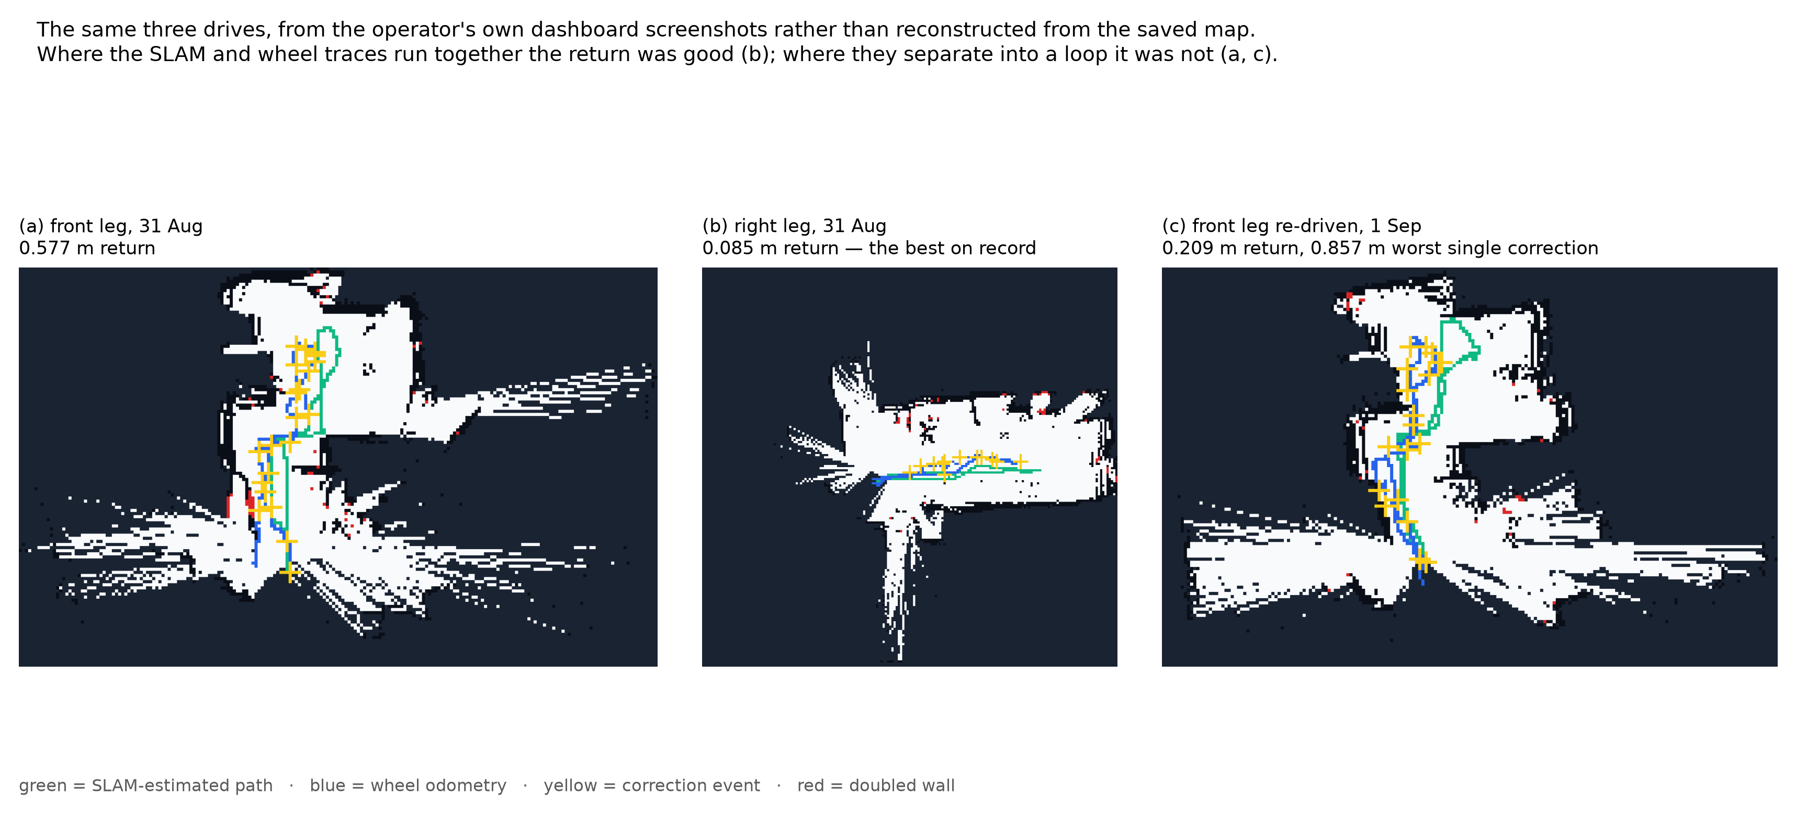
Dashboard screenshots
Figure 30. The same three drives again, this time from the operator’s own dashboard screenshots taken during the drives and hand-annotated at the time (docs/evidence/monday_recon/, docs/evidence/tuesday_repeat/), embedded as captured rather than reconstructed. Green is the SLAM-estimated path, blue is wheel odometry, yellow marks a correction event, red marks a doubled wall.
Figure 29 is regenerated from the saved map on every run and will never disagree with the numbers in this report; Figure 30 is the primary record those numbers were read from, and the two are included together so a reader can check one against the other. The pattern is visible directly here: in (b), the run that returned to within 0.085 m, the green and blue traces run almost on top of each other for the whole leg. In (a) and (c), the two runs that returned worse, they separate into a visible loop. That separation between the wheel estimate and the SLAM estimate is the map→odom correction Figure 16 plots the magnitude of.

End of draft.

