**Login/Registration form**

*There are different scenarios that can occur when a user performs action on a login page.

Code.cpp is the application

Records.txt is the database where all the accounts are stored.

*Scenario 1: User Registers*

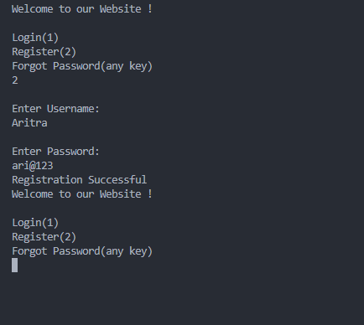

*Scenario 2: User Log in (Successful)*

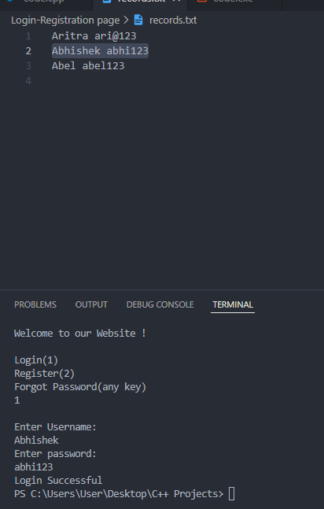

*Scenario 3: User Login (failed)*

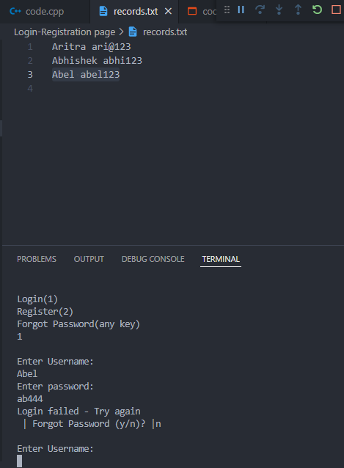

*3.1) Forgot password*

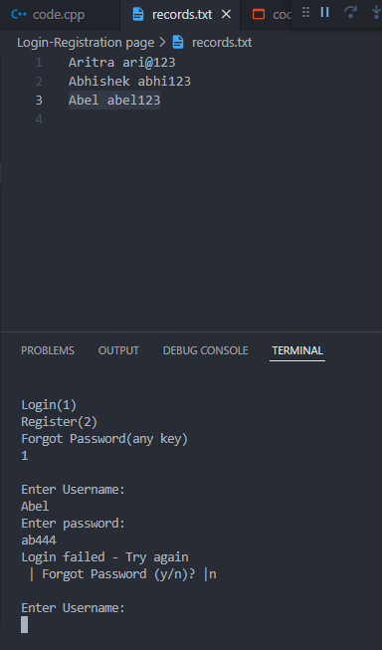

*3.2) Verification*

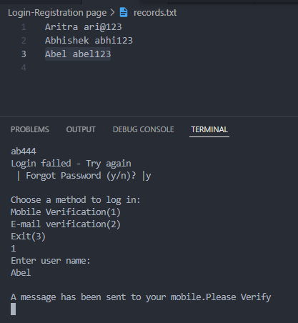

*3.3) Change password*

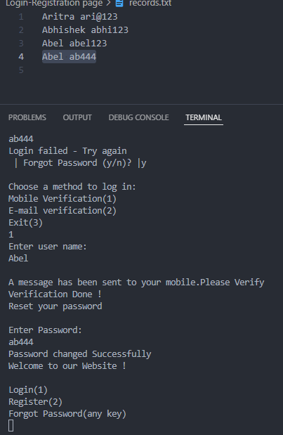

*Scenario 4: User tries to register but account*

*already exists*

