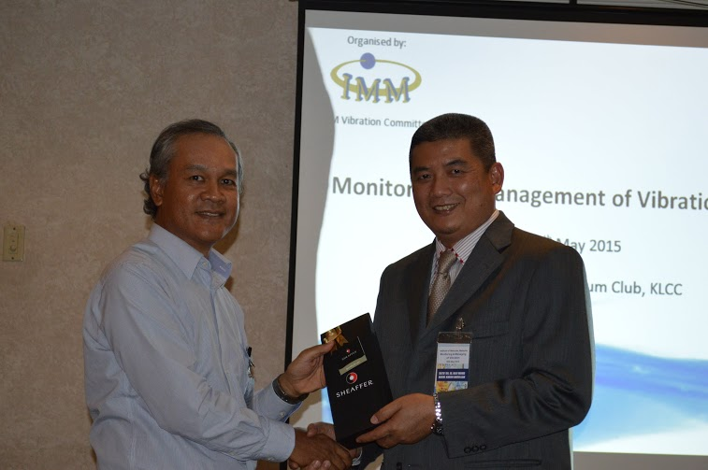

Dato’ Dr. Ir. Haji Mohd. Abdul Karim Abdullah (Right), Group President / CEO of Serba Dinamik Sdn Bhd presented a souvenir as a gesture of appreciation to Mr. Mohd. Azmi Mohd Noor (Left), Head of Asset Integrity, Upstream HSE from Petronas

**Vibration caused 21% of Offshore Hydrocarbon Release**

Reported by: Dr. Zulkarnain Kedah, Vice President for Education and Training Business Unit, Serba Dinamik Group Berhad

Mr. Mohd. Azmi Mohd. Noor, Head of Asset Integrity, Upstream HSE from Petronas said that vibration has caused 21% of the offshore hydrocarbon release in the UK sector which is relatively significant compared to other main contributors such as degradation of materials properties (28%), incorrect installation (21%), corrosion and erosion (13%).

He delivered his opening speech on “The Impact of Vibration on Asset Integrity” at the seminar on Monitoring and Management of Vibration held on 26th May 2015 at Malaysian Petroleum Club, Level 42, Tower 2, PETRONAS Twin Tower.

He also highlighted two local vibration fatigue incidents that caused fire at two local installations which were due to small bore piping failures from pump vibration and a pipe support failure during depressurisation efforts respectively.

This seminar was organised by the Vibration Committee of the Institute of Materials, Malaysia (IMM) led by Mr. Noor Hisham Abdul Hamid and is fully sponsored by Serba Dinamik Group Berhad. To enlighten the participants about this topic, IMM invited three guest speakers namely Dato’ Dr. Ir. Haji Mohd Abdul Karim Abdullah, Group President and Chief Executive Officer of Serba Dinamik Sdn Bhd, Dr. Gary Y. Lee, Fitness for Service Engineer of Shell Global Solutions (M) Sdn Bhd and Dr. Rahizar Ramli, Senior Lecturer of University Malaya.

Dr. Gary, the first guest speaker, presented the objectives and results of a “LNG Dust Separator Vessel Vibration Survey” conducted in 2009. The survey was to identify the worst case flow rates from process engineers and monitoring specialist, monitor vibration by using accelerometers, strain gauge, pressure transducers and noise microphones of vessels and pipework, and determine structural natural frequency of skirt and swirl vanes. The results revealed that the worst case vibration was not replicated, low frequency component at 10 to 40 Hz and high frequency component at ~ 255 Hz that showed a “lock-on” effect and structural natural frequency (SNF) check (Skirt ~ 252 Hz and Vane ~ 260 Hz). Based on these results, he recommended to handcuff small bore connections, brace nozzle or limit flow and implement continuous monitoring.

Then, Dato’ Abdul Karim talked about “Vibration Technology from Daily Practical Perspective”. He discussed the outcomes of fatigue and creep that will damage the integrity of material and their relation to misalignment, unbalance, cavitation, looseness, fluid induce instability and resonance. He concluded that vibration technology is not only capable of being the smart tools to help engineers identify the root cause of equipment problems and supporting the reliability centred maintenance master plan but also offers many advantages over other available techniques.

This was followed by Dr. Rahizar who presented an overview of Vibration Practitioner Levels 1 and 2 as well as Vibration Specialist Levels 3 and 4 based on ISO 18436 respectively. He explained the programme objectives, minimum requirements, learning outcomes and programme contents for each certification level. He also discussed key components for each certification level along with their relevant examples.

This seminar has become an eye opener and provided vivid insights for the participants to understand the importance of vibration monitoring and management and its impact on health, safety, environmental and financial aspects for oil and gas, power generation and other related engineering industries.

(Source: Materials Mind, Issue 11, July 2015)