Banking Accelerator Dashboard Document

Contents

Retail Dashboards 2

Retail Relationship Manager Dashboard 2

Daily Dashboard 3

Prospect and Referrals (Interactive Dashboard) 4

Commercial Dashboards 5

Corporate RM Dashboard 5

Today’s Insights 6

Commercial Relationship Manager 7

PowerBI 8

# Retail Dashboards

## Retail Relationship Manager Dashboard

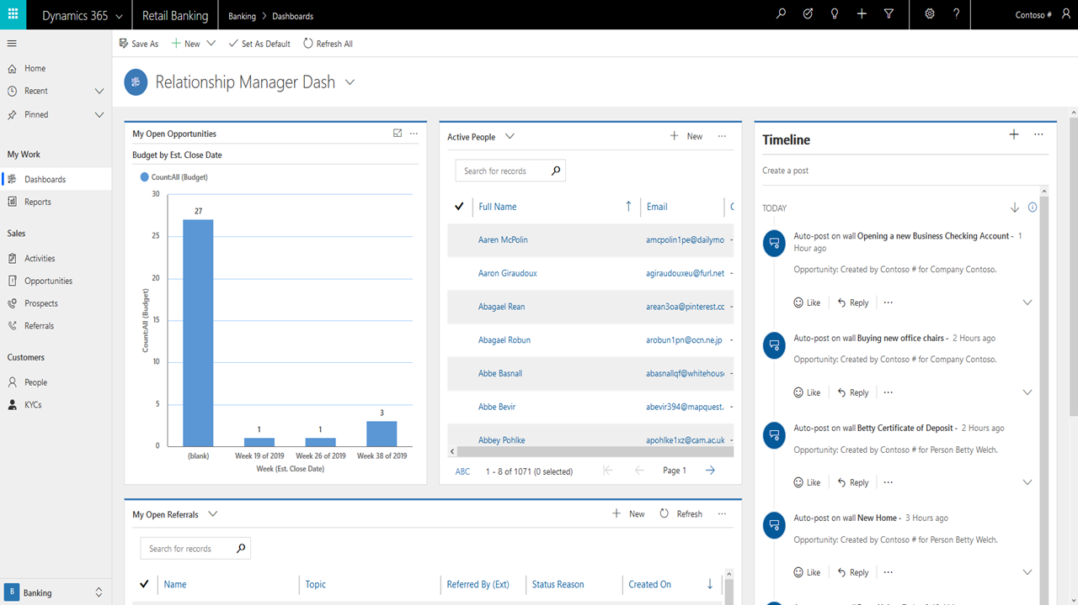

1. Persona Description
   1. This will be used by a Loan Officer would come to the dashboard throughout the day to check on different information. On the right they could see their timeline which has their appointments and different activities they are assigned. They can also see their open Opportunities and their Referrals they need to attend to. Finally, they have their Active People so they can see at a glance who they need to consult with.
2. Components
   1. Budget by Est. Close Date Chart
   2. Active People List
   3. My Timeline
   4. My Open Referrals List

## Daily Dashboard

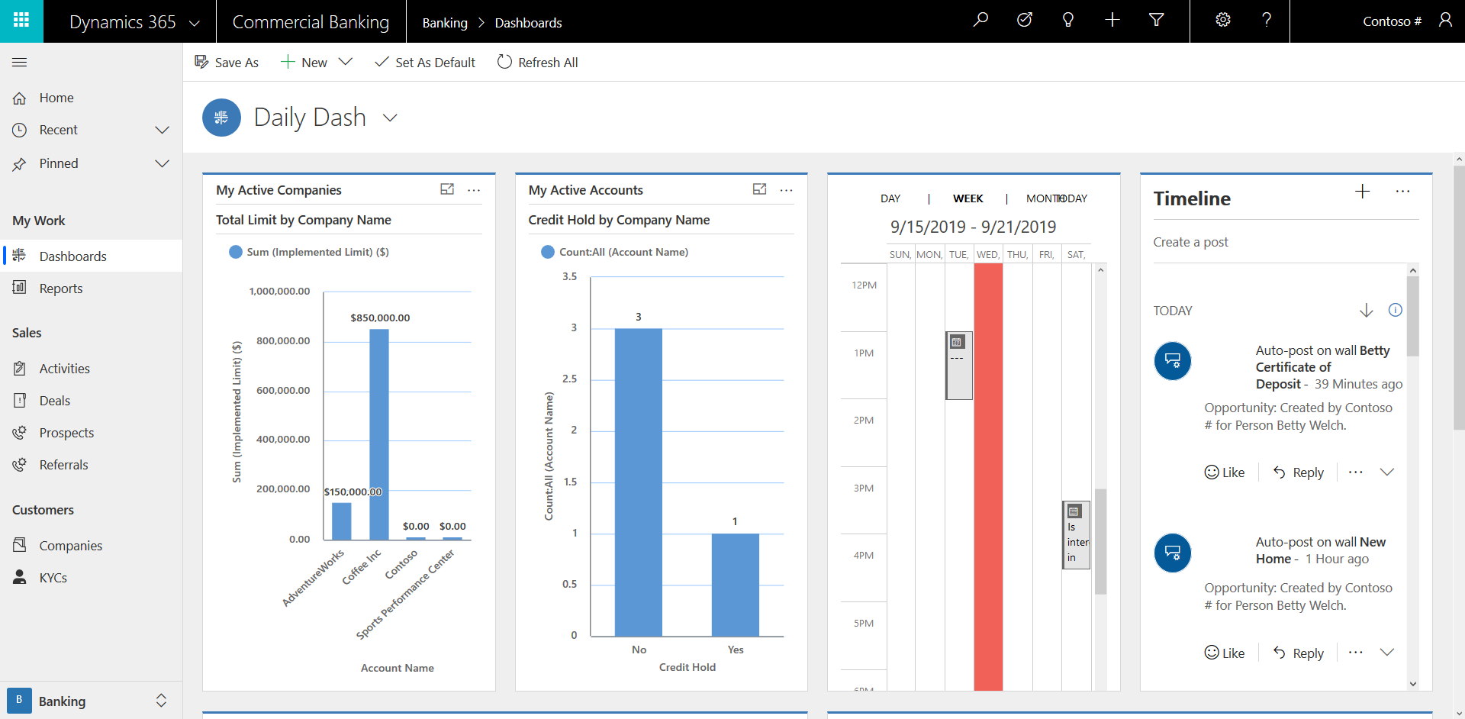

1. Persona Description
   1. Retail Relationship Manager sits down and logs into their computer. They login to dynamics to get a high-level overview of their day, along with important charts like any Opportunities scheduled to close this week and KYCs with Expiring business licenses this week. The Manager will also be able to see a timeline of their upcoming events and tasks along with all their Open Prospects and Referrals.
2. Components
   1. Opportunities Closing this week - Chart
   2. My Calendar
   3. My Timeline
   4. KYC with expiring ID - Chart
   5. My Open Prospects and Referrals

## Prospect and Referrals (Interactive Dashboard)

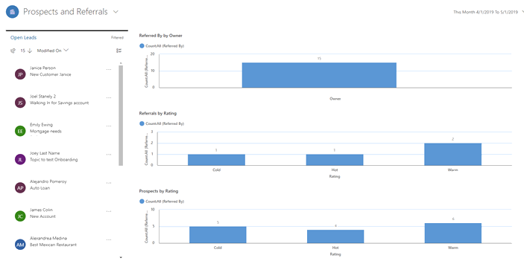

1. Persona Description
   1. This Relationship Manager dashboard used to find out more about the Prospects and Referrals. If the user wants to drill down into any of the information on the right-hand side, the list will change with the selection. With this dashboard they get a holistic view of the different prospects and referrals that the employee owns. If it is a manager, then you can see all the prospects for employees you over see.
2. Components
   1. Open Proposals and Referrals
   2. Referrals by Owner Chart
   3. Referrals by Rating Chart
   4. Prospects by Rating Chart

# Commercial Dashboards

## Loan Officer Dashboard

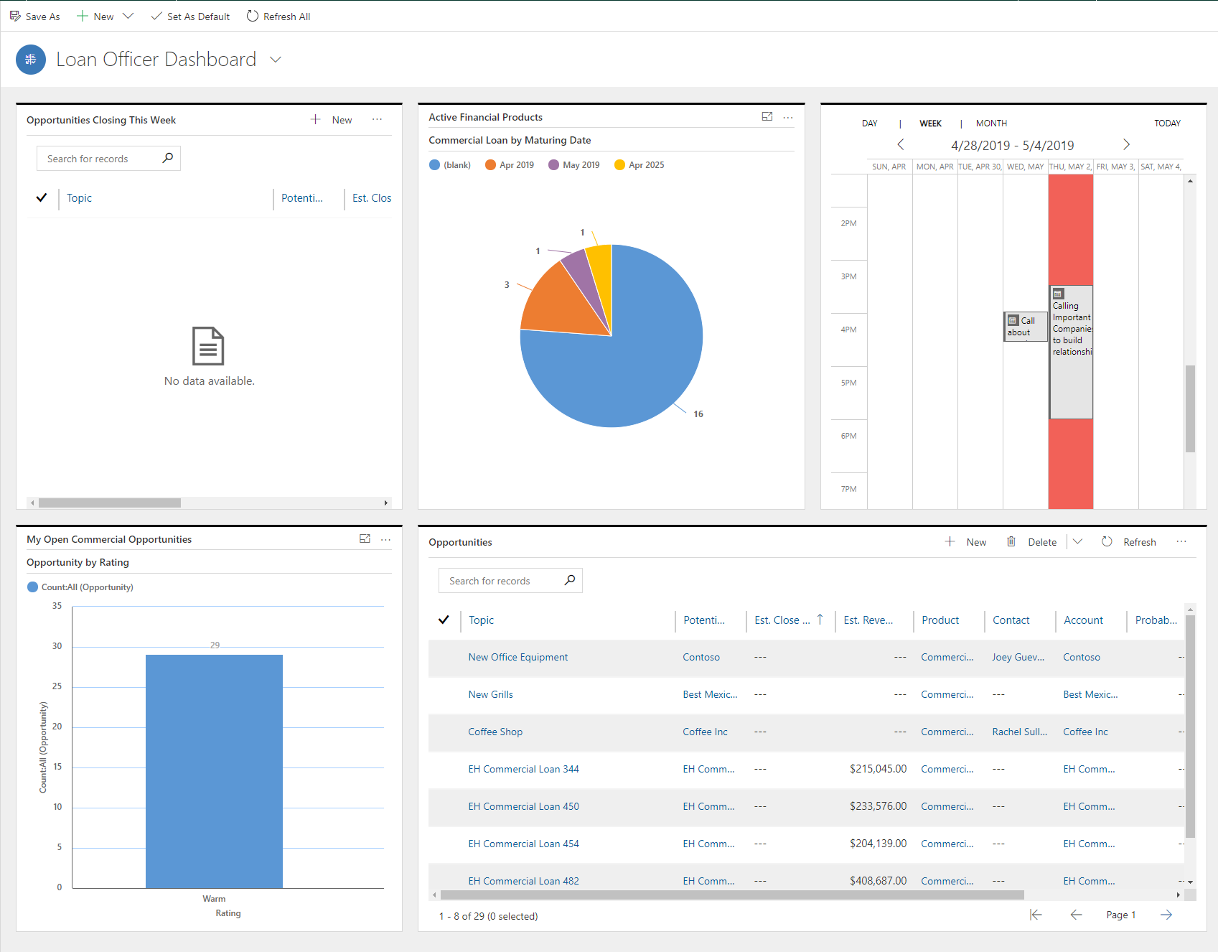

1. Persona Description
   1. The Loan Officer would come to their dashboard to get a well-rounded view of different aspects of their opportunities. Along with an entire list of their open opportunities, they can come here to find out how hot or cold their current opportunities are. There is a chart that shows when financial products they’ve sold are due to mature, and a calendar view of their appointments. The Loan Officer can come to this dashboard in order to know how to organize their day to be most effective.
2. Components
   1. Opportunities Closing This Week
   2. Active Financial Products by Maturing Date
   3. Appointments Calendar
   4. Opportunities by Rating
   5. My Commercial Opportunities

## Daily Dash

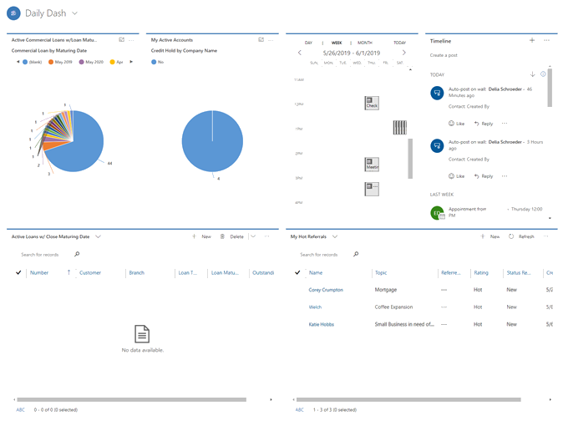

1. Persona Description
   1. On the Daily Dash Dashboard, a Relationship Manager would use this to get a view at their Companies and loans they have active. In the top row they will be able to see any Active Companies they are working with on a day to day. To the right of that they would look over and see their Timeline that lists out their various actives they have scheduled. On the bottom row, they can see a chart that lists their Top 5 companies with name and estimated revenue. Next, they’d be able to look and see any companies they’re working with that have active holds on their accounts. Lastly, they can see a list of any loans close to maturing.
2. Components
   1. Active Loans with Maturity Dates
   2. Companies with Credit Holds
   3. My Appointments Calendar
   4. My Timeline
   5. My Loans with Close Maturing Date
   6. My Hot Referrals

## Commercial Relationship Manager

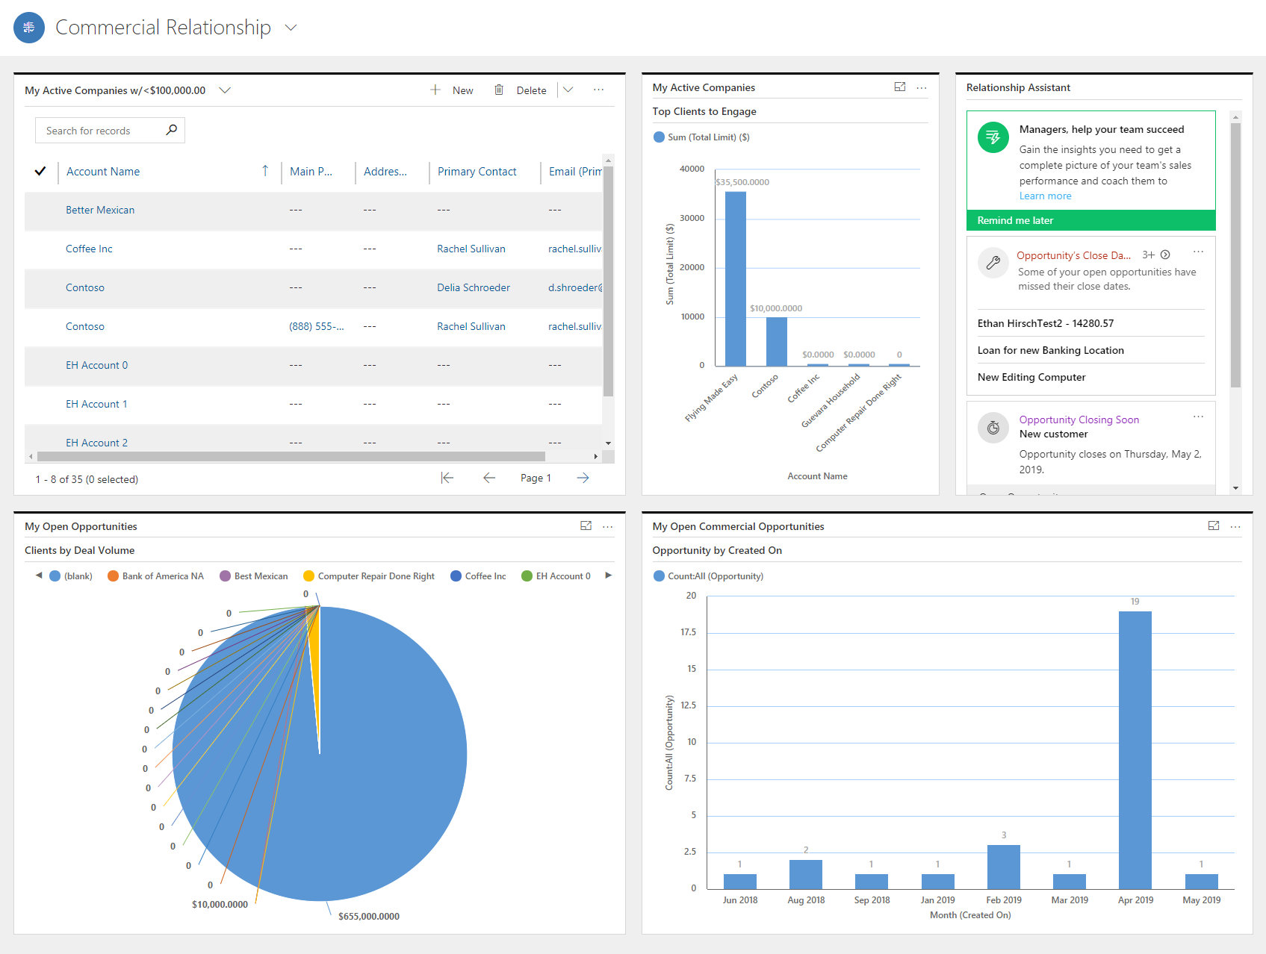

1. Persona Description
   1. The Commercial Relationship Dashboard would be used by a Relationship Manager to get a look at their accounts and day at a glance. On the top row, they will see a list of their Current Companies with less than $100,000 in Total Limit. Their Top 5 Active Companies they’re assigned to, and their Relationship Assistant describing closing Opportunities and other actions needed. The bottom row shows them Their Open Opportunities by Deal Volume and the Amount of Opportunities created by Month.
2. Components
   1. My Active Companies with less than $100,000 in total Limit
   2. Top 5 Clients to Engage by Total Limit
   3. Relationship Assistant
   4. Clients by Deal Volume
   5. Opportunities Created by Month

# PowerBI

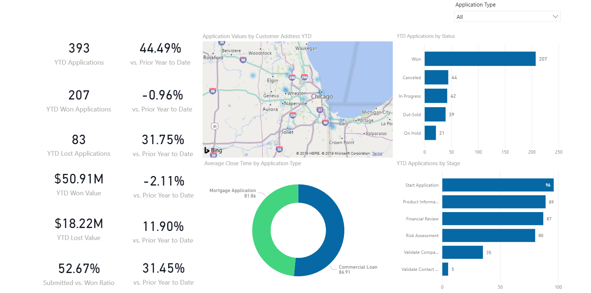

1. Persona Description
   1. The Application Overview Loan Dashboard would be used by a Branch Manager to have a holistic view of the Applications across the entire Branch.
2. Components
   1. Application Information
   2. Map of Applications by Zip Code
   3. YTD Applications by Status
   4. Average Close Time by Application Type
   5. YTD Applications by Stage