# Installing the Dynamics 365 Financial Services Accelerator

Prerequisites

* A Dynamics Customer Engagement Instance with the Sales application installed
* The Financial Services Package Deployer file
  + FinancialServicesAccelerator-PkgDeployer-x.x.x.x.zip
* NuGet
  + Download **nuget.exe** from <https://www.nuget.org/downloads>, and save it to your computer, say **c:\**. (This location is used in Step 2.a. so if you save this somewhere else, take note and update the sample path provided accordingly)

## Solutions

The Financial Services Accelerator can be implemented in 3 different forms. For a list of all entities and attributes, find the Financial Services Reference Guide amongst the included documentation.

1. The Financial Services Common solution
   1. This solution contains the entities, forms, and views used across the two specific solutions (Commercial and Retail). This solution does not have any dependencies on the Sales module, so no connection to Contact, Account, Opportunity or Lead is made. The custom entities include Financial Products, Requested Facilities, Banks, Branches, and Know Your Customers.
2. The Financial Services Common solution for Sales
   1. This solution contains additions to the core solution to further support sales scenarios, including: Contact, Account, Opportunity, and Lead.
3. The Retail Banking Accelerator
   1. This solution contains a layer that will sit on top of the Financial Common solution. This will contain customer business process flows and dashboards that are geared towards the Retail space. The app included in the solution will only surface Retail forms, views, charts, and fields.
4. The Commercial Banking Accelerator
   1. This solution contains a layer that will sit on top of the Financial Common solution. This will contain customer business process flows and dashboards that are geared towards the Commercial space. The app included in the solution will only surface Commercial forms, views, charts, and fields.
5. Sample Data
   1. The Sample Data package contains sample records to help understanding the data model. This package depends on the Sales package being installed.
6. Package Deployer
   1. The Package Deployer will contain all the solutions and will be used to assist in the import of the solutions the user chooses. The user will be able to choose the Common Accelerator solution with either Retail or Commercial or both.

## Use Package Deployer tool to deploy packages

1. Obtain the package to be deployed from GitHub using the link above. The package will contain:
   1. PkgFolder: This folder contains the solutions, import configuration, and the contents for your package.
   2. FinancialServicesAccelerator.Package.dll: The assembly contains the code for your package. By default, the name of the assembly is the same as your Visual Studio project name.
2. Obtain the Package Deployer tool. The Package Deployer tool is available as a [NuGet package](https://go.microsoft.com/fwlink/?linkid=859205).
   1. Then run the following command at the command prompt to extract the package contents to a folder, say **PD**, on your computer:  
      c:\nuget install Microsoft.CrmSdk.XrmTooling.PackageDeployment.Wpf -O c:\PD
      1. Note: This location may be different based on where you have the nuget.exe file saved
3. After you have extracted the Package Deployer tool, browse to the [ExtractedLocation]\tools folder to find the **PackageDeployer.exe** file.
4. Copy the PkgFolder and FinancialServicesAccelerator.Package.dll files from the zip file download to the [ExtractedLocation]\tools folder (same folder as the PackageDeployer.exe).
5. After all the files have been copied, run the tool from the command line to select which solutions you would like to import.
   1. The format for the command should be as follows, with settings separated by the pipe character:

.\PackageDeployer.exe /Settings:"FinancialServicesCommonAccelerator=true|FinancialServicesCommonAcceleratorSales=true|CommercialBankingAccelerator=false|RetailBankingAccelerator=true|SkipSampleData=false"

* 1. Note the options available to you for installing correspond to the solutions mentioned at the beginning of this document, they are:
     1. FinancialServicesCommonAccelerator
        1. When set to true, this will install the Financial Services Common Accelerator solution to the target environment.
     2. FinancialServicesCommonAcceleratorSales
        1. When set to true, this will install the Financial Services Common Accelerator for Sales solution to the target environment.
        2. Note that this depends on the Financial Services Common Accelerator solution being installed.
     3. CommercialBankingAccelerator
        1. When set to true, this will install the Commercial Banking Accelerator solution to the target environment.
        2. Note that this depends on the Financial Services Common Accelerator for Sales solution being installed.
     4. RetailBankingAccelerator
        1. When set to true, this will install the Retail Banking Accelerator solution to the target environment.
        2. Note that this depends on the Financial Services Common Accelerator for Sales solution being installed.
     5. SkipSampleData
        1. When set to false, sample data will be installed.
        2. Note that this depends on the Financial Services Common Accelerator for Sales solution being installed.

1. If you receive an error stating that no import package can be found, right click on FinancialServicesAccelerator.Package.dll and select Properties. Select the “Unblock” option at the bottom and then Ok. Retry running the command from step #5.
2. Click **Continue** on the main screen of the tool.

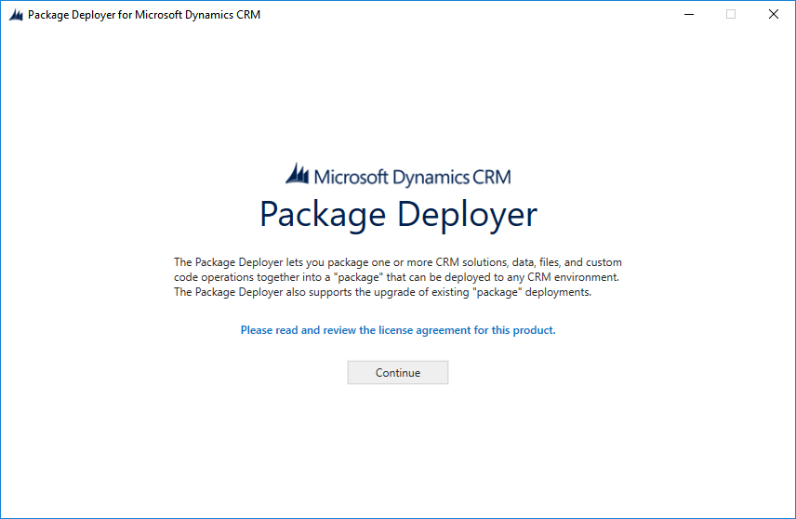

1. In the **Connect to Microsoft Dynamics 365** screen, provide authentication details to connect to your Dynamics 365 server where you want to deploy the package. Click **Login**.

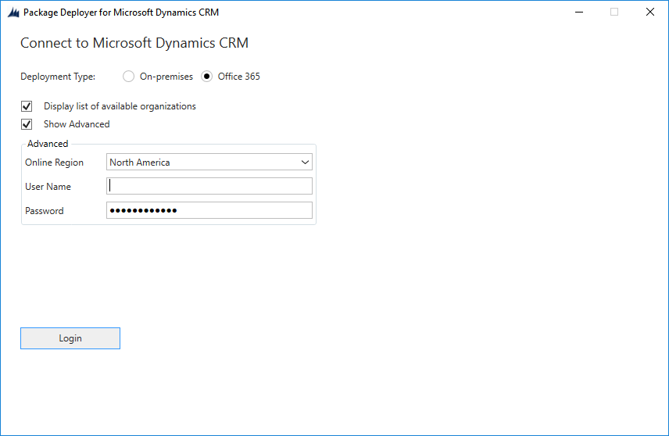

1. You will be presented with a Welcome screen. Select **Next**.

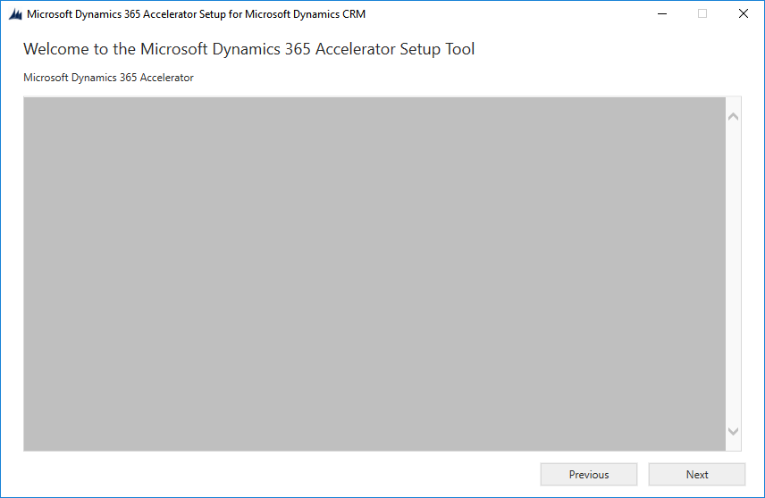

1. Review the Details of the instance where the package will be imported and **reconfirm you have selected the correct environment as the next step will start the deployment process.**

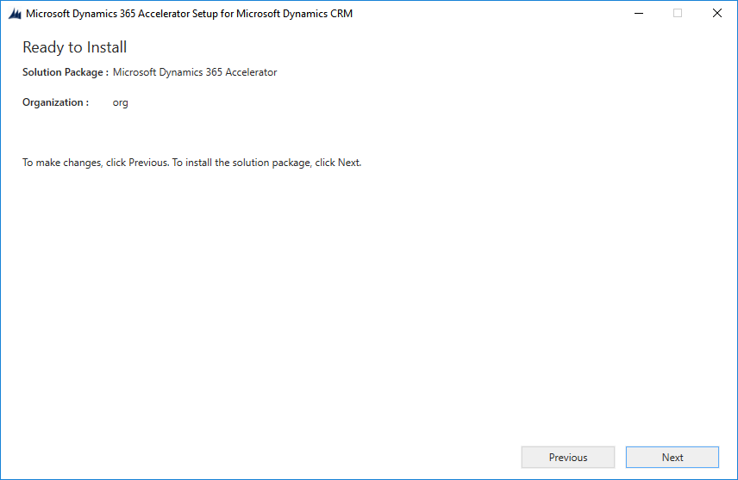

1. When you’ve confirmed you’ve selected the correct environment, select **Next** to begin the pre-install validation process.
2. The tool will validate that all components are available and when all green checks appear, select **Next**.

NOTE: if you see any warnings related to the target environment not containing the managed solution “Active”, feel free to ignore these and continue. If there are similar warnings for a different solution name, then please reconfirm you’ve met the dependencies listed at the beginning of this document. If you’ve confirmed the noted dependencies are there, then further troubleshooting is likely required before proceeding with the install.

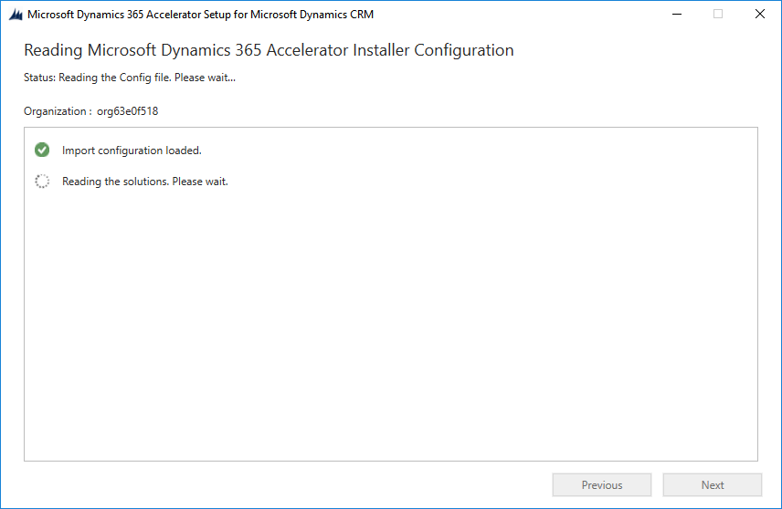

1. You can monitor the import or check your environment when it’s complete!