**CSE423**

*Name: Ariyan Hossain*

*ID: 20101099*

*Sec: 03*

**Lab-01**

**Task 1:**

from OpenGL.GL import *

from OpenGL.GLUT import *

from OpenGL.GLU import *

import random

def draw_points():

glPointSize(4)

glBegin(GL_POINTS)

for i in range(50):

x=random.randint(100,500)

y=random.randint(100,500)

glVertex2f(x,y)

glEnd()

def iterate():

glViewport(0, 0, 500, 500)

glMatrixMode(GL_PROJECTION)

glLoadIdentity()

glOrtho(0.0, 500, 0.0, 500, 0.0, 1.0)

glMatrixMode (GL_MODELVIEW)

glLoadIdentity()

def showScreen():

glClear(GL_COLOR_BUFFER_BIT | GL_DEPTH_BUFFER_BIT)

glLoadIdentity()

iterate()

glColor3f(1.0, 1.0, 0.0)

draw_points()

glutSwapBuffers()

glutInit()

glutInitDisplayMode(GLUT_RGBA)

glutInitWindowSize(800, 800)

glutInitWindowPosition(0, 0)

wind = glutCreateWindow(b"OpenGL Coding Practice")

glutDisplayFunc(showScreen)

glutMainLoop()

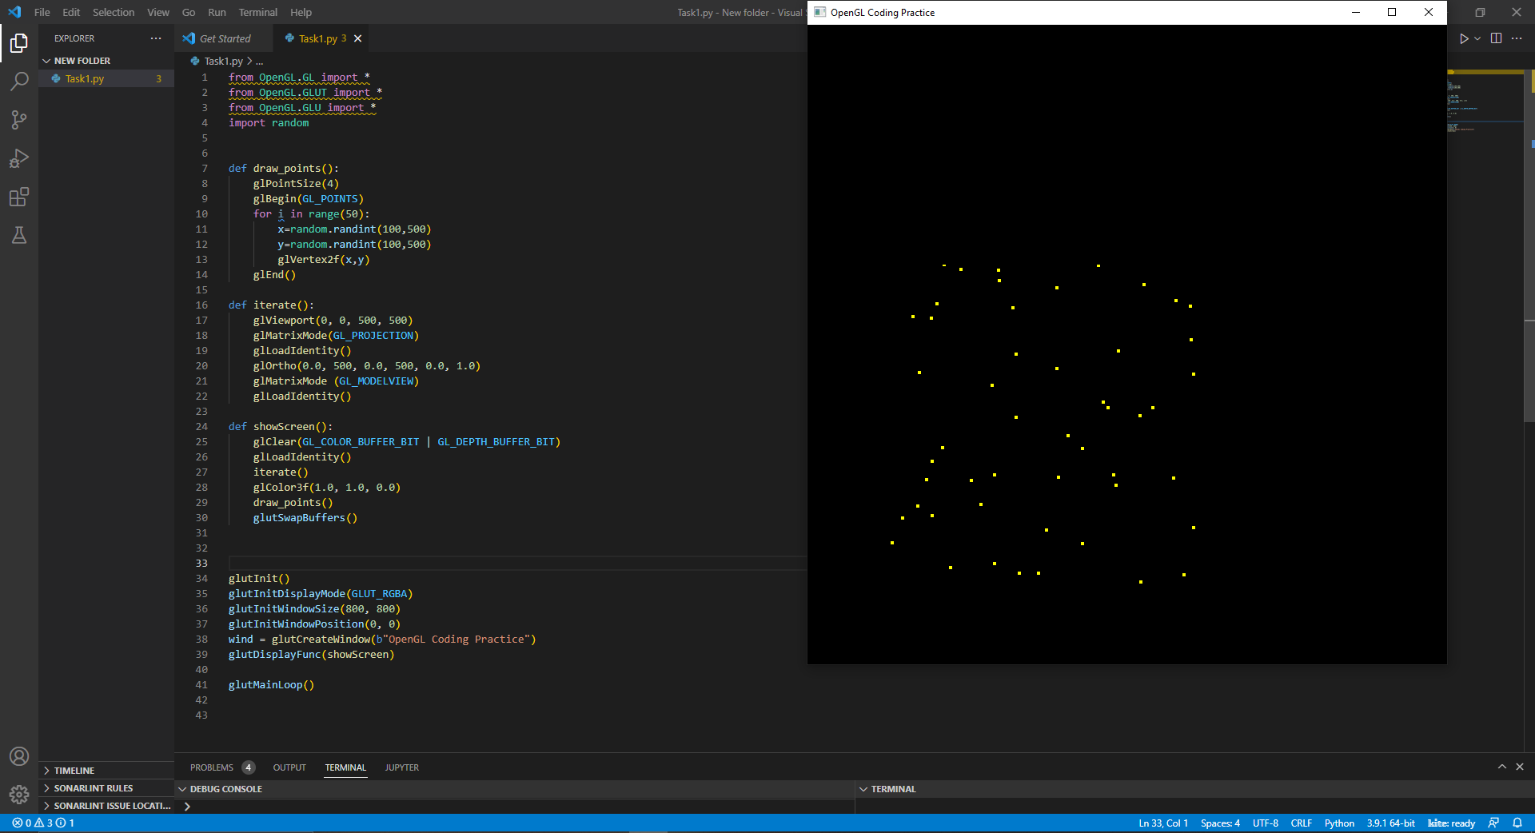

**Task 2:**

from OpenGL.GL import *

from OpenGL.GLUT import *

from OpenGL.GLU import *

def draw_points():

glPointSize(4) #pixel size. by default 1 thake

glBegin(GL_POINTS)

glColor3f(245.0/255,135.0/255,66.0/255)

glVertex2f(420,250)

glEnd()

def draw_lines():

glBegin(GL_LINES)

glColor3f(245.0/255, 66.0/255, 242.0/255)

glVertex2f(300, 200)

glVertex2f(300, 400)

glVertex2f(300, 400)

glVertex2f(500, 400)

glVertex2f(500, 400)

glVertex2f(500, 200)

glVertex2f(500, 200)

glVertex2f(300, 200)

#-------------------------------------------------------#

glColor3f(102.0/255,25.0/255,18.0/255)

glVertex2f(300, 400)

glVertex2f(400, 500)

glVertex2f(400, 500)

glVertex2f(500, 400)

# -------------------------------------------------------#

glColor3f(66.0/255,224.0/255,245.0/255)

glVertex2f(320, 330)

glVertex2f(320, 380)

glVertex2f(320, 380)

glVertex2f(370, 380)

glVertex2f(370, 380)

glVertex2f(370, 330)

glVertex2f(370, 330)

glVertex2f(320, 330)

# -------------------------------------------------------#

glVertex2f(480, 330)

glVertex2f(480, 380)

glVertex2f(480, 380)

glVertex2f(430, 380)

glVertex2f(430, 380)

glVertex2f(430, 330)

glVertex2f(430, 330)

glVertex2f(480, 330)

# -------------------------------------------------------#

glColor3f(245.0/255,224.0/255,66.0/255)

glVertex2f(370, 200)

glVertex2f(370, 300)

glVertex2f(370, 300)

glVertex2f(430, 300)

glVertex2f(430, 300)

glVertex2f(430, 200)

glVertex2f(430, 200)

glVertex2f(370, 200)

glEnd()

def iterate():

glViewport(0, 0, 500, 500)

glMatrixMode(GL_PROJECTION)

glLoadIdentity()

glOrtho(0.0, 500, 0.0, 500, 0.0, 1.0)

glMatrixMode (GL_MODELVIEW)

glLoadIdentity()

def showScreen():

glClear(GL_COLOR_BUFFER_BIT | GL_DEPTH_BUFFER_BIT)

glLoadIdentity()

iterate()

glColor3f(1.0, 1.0, 0.0)

draw_lines()

draw_points()

glutSwapBuffers()

glutInit()

glutInitDisplayMode(GLUT_RGBA)

glutInitWindowSize(800, 800)

glutInitWindowPosition(0, 0)

wind = glutCreateWindow(b"OpenGL Coding Practice")

glutDisplayFunc(showScreen)

glutMainLoop()

