BITS Pilani

APEX Project Report

P5 – BFSI Compliance Automation Pipeline

Student Name | Ariyan Pal
Roll Number | 2025EB1100270
Problem Statement | P5 – BFSI Compliance Automation Pipeline
Dataset | CFPB Consumer Complaint Database
Programme  GITHUB LINK | BS Programme – Trimester 3  https://github.com/AriyanPal08/Advance_Apex_Project

Table of Contents

- Problem Background

- Dataset Description

- Pipeline Design and Decisions

- Before and After Data Quality Assessment

- Exploratory Data Analysis

- Limitations

- Conclusion

- References

PROBLEM BACKGROUND

The Consumer Financial Protection Bureau (CFPB) is a United States government agency responsible for consumer protection in the financial sector. As part of its mandate, the CFPB maintains a publicly available database of consumer complaints filed against financial institutions. Each complaint record captures structured information including the financial product involved, the nature of the issue, the company against which the complaint was filed, geographic identifiers such as State and ZIP code, and operational metadata such as the date the complaint was received, the date it was forwarded to the company, and whether the company responded in a timely manner.
Consumer complaint data of this kind is widely used in the Banking, Financial Services, and Insurance (BFSI) sector for regulatory monitoring, operational auditing, and trend identification. However, raw complaint records collected over extended time periods inevitably contain data quality issues that undermine the reliability of any downstream analysis. Common problems include inconsistent text formatting across categorical fields, missing values in geographic and response columns, date fields stored as plain strings rather than proper datetime objects, and the absence of derived features that would be necessary for meaningful quantitative analysis.
When data quality issues remain unaddressed, the consequences are significant. Inconsistent capitalisation or stray whitespace in product names can cause a single product category to appear as multiple distinct entries during aggregation, inflating category counts and distorting complaint volume rankings. Missing geographic fields, if handled through row deletion rather than explicit imputation, can silently reduce the dataset and introduce selection bias. Dates stored as strings prevent temporal arithmetic, making it impossible to compute resolution times or conduct time-series analysis. In short, any analytical or modelling effort built on top of unclean complaint data risks producing misleading results.
The objective of this project is to construct a preprocessing pipeline that transforms raw CFPB complaint records into a clean, standardised, and analysis-ready dataset. The pipeline performs dataset inspection, duplicate verification, date standardisation, feature engineering, text normalisation, missing value treatment, categorical encoding, and numerical scaling. After preprocessing, a before-and-after quality assessment is conducted to quantify improvements. Finally, three exploratory charts are generated to illustrate complaint distributions across product categories, geographic regions, and company response timeliness.

2. Dataset Description
The dataset used in this project is sourced from the CFPB Consumer Complaint Database, a publicly accessible repository maintained by the United States Consumer Financial Protection Bureau. The original database contains over 16 million complaint records spanning multiple years. For this project, a filtered subset covering the years 2022 through 2024 was extracted using a separate Python script (filter_data.py) that reads the full file in chunks, applies year-based filtering, and then draws a reproducible random sample of 350,000 records using random_state=42. The resulting intermediate file, cfpb_raw_2022_2024.csv, serves as the input to the preprocessing notebook.

The working dataset contains 350,000 rows and 16 columns. The columns present in the dataset are:
Column Name | Description
Date received | Date the complaint was received by the CFPB.
Product | Financial product category (e.g., credit reporting, mortgage).
Sub-product | More specific product classification.
Issue | Primary issue described in the complaint.
Sub-issue | More specific issue classification.
Consumer complaint narrative | Free-text description provided by the consumer (optional).
Company public response | Company’s public-facing response.
Company | Name of the company against which the complaint was filed.
State | U.S. state abbreviation for the consumer’s location.
ZIP code | Consumer’s postal code (partially redacted for privacy).
Tags | Demographic tags (e.g., Servicemember, Older American).
Submitted via | Channel through which the complaint was submitted (e.g., Web).
Date sent to company | Date the complaint was forwarded to the company.
Company response to consumer | How the company resolved the complaint.
Timely response? | Whether the company responded within the regulatory timeframe (Yes/No).
Complaint ID | Unique identifier for each complaint record.
Table 1: Dataset Attributes
Initial inspection reveals several quality issues. The dataset has a total of 711,101 missing values, resulting in an overall completeness of 87.30%. The most severely affected columns are Tags (94.49% missing), Consumer complaint narrative (66.05% missing), and Company public response (39.83% missing). State has 853 missing entries (0.24%), Company response to consumer has 3 missing entries, Sub-product has 2, and Date sent to company has 1. The date columns are initially stored as object (string) types rather than proper datetime types, and all categorical columns are stored as generic object types without standardisation. No duplicate rows or duplicate Complaint IDs were detected in the filtered sample.

3. Pipeline Design and Decisions
The preprocessing pipeline consists of a series of sequential steps, each addressing a specific data quality concern. The design philosophy prioritises preserving the maximum number of complaint records while improving consistency and analytical readiness. Original columns are retained alongside their encoded counterparts to allow both human-readable inspection and numerical analysis.

3.1 Dataset Loading
The filtered dataset cfpb_raw_2022_2024.csv was loaded into a pandas DataFrame using pd.read_csv() with the low_memory=False option to ensure consistent dtype inference across all chunks. A copy of the original DataFrame (df_before) was immediately preserved to enable before-and-after quality comparison later in the pipeline. Upon loading, the dataset contained 350,000 rows and 16 columns, occupying approximately 446.50 MB of memory.

3.2 Dataset Inspection and Initial Quality Assessment
Before any transformation was applied, the dataset was inspected using df.head(), df.info(), df.describe(), and df.describe(include="object"). These operations revealed that the dataset contains 350,000 complaint records across 16 attributes. The most frequently occurring product was "Credit reporting or other personal consumer reports" with 201,191 records. The most common state was FL with 47,536 complaints. The most common submission channel was Web with 341,373 records. The most common company response was "Closed with explanation" with 187,865 records. Of the 350,000 records, 348,613 had a "Yes" value for Timely response?.
A formal quality summary was computed. The dataset contained 0 duplicate rows and 0 duplicate Complaint IDs. The total number of missing values was 711,101, yielding an overall dataset completeness of 87.30%. A per-column missing value report identified Tags (330,728 missing, 94.49%), Consumer complaint narrative (231,181 missing, 66.05%), and Company public response (139,422 missing, 39.83%) as the most affected columns.

3.3 Duplicate Verification
Duplicate records were checked at two levels: completely identical rows and rows with duplicate Complaint ID values. Each Complaint ID is intended to uniquely identify a single complaint, so any duplication would indicate data integrity issues. The check found 0 completely duplicate rows and 0 duplicate Complaint IDs. The df.drop_duplicates(subset="Complaint ID", keep="first") operation was still applied as a defensive measure to ensure idempotency if the pipeline were rerun on a different data slice. After the operation, all 350,000 rows were retained and no records were removed.

3.4 Date Standardisation
The Date received and Date sent to company columns were originally stored as object (string) types. They were converted to proper pandas datetime objects using pd.to_datetime() with errors="coerce" and utc=True, followed by .dt.tz_localize(None) to remove timezone information and produce timezone-naive datetime values. This conversion is necessary to enable date arithmetic, such as computing the difference between the two dates. During conversion, 31,250 entries in Date received and 31,250 entries in Date sent to company became NaT (Not a Time), indicating that these string values could not be parsed into valid dates. These newly invalid dates are an expected consequence of the strict parsing approach and are carried forward as missing values rather than dropped, preserving the associated complaint records for non-temporal analysis.

3.5 Feature Engineering: resolution_days
A new numeric feature, resolution_days, was created by computing the difference in days between Date sent to company and Date received using the .dt.days accessor. This feature represents the number of days the CFPB held a complaint before forwarding it to the relevant company. The pipeline checks for negative values, which would indicate logically inconsistent dates (a complaint forwarded before it was received). In this dataset, 0 negative values were found. After creation, the resolution_days column had 318,750 non-null entries with a mean of 0.365 days, a standard deviation of 3.626 days, and a maximum value of 409 days. The median and 75th percentile were both 0 days, indicating that the majority of complaints were forwarded on the same day they were received.

3.6 Text Standardisation
Several categorical columns contained text inconsistencies such as leading or trailing whitespace, multiple consecutive spaces, and inconsistent capitalisation. For example, "Credit card", " credit card", and "CREDIT CARD" would be treated as three separate categories during aggregation. To resolve this, 10 text columns (Product, Sub-product, Issue, Sub-issue, Company, Company public response, Company response to consumer, Submitted via, State, and Tags) were standardised by stripping whitespace, collapsing multiple spaces to a single space, and converting all text to Title Case. A total of 2,537,441 individual cell values were modified across these columns. Missing values were preserved and handled separately in the next step, rather than being overwritten during standardisation.

3.7 Missing Value Treatment
A column-specific imputation strategy was adopted rather than a blanket approach. Missing values in State were replaced with "Unknown" to preserve complaint records while explicitly indicating unavailable geographic information. ZIP code missing entries were similarly filled with "Unknown". Company response to consumer was filled with "No Response" to clearly distinguish missing responses from actual response categories such as "Closed with explanation". Timely response? was filled with "Unknown" to indicate that timeliness information was unavailable for those records.
For Consumer complaint narrative, the column was not imputed. Instead, a binary feature has_narrative was created, coded as 1 when a narrative is present and 0 when it is absent. This approach avoids fabricating textual content while still capturing whether a consumer chose to provide a narrative. The distribution shows 118,819 complaints (approximately 33.95%) with a narrative and 231,181 complaints (approximately 66.05%) without one. No natural language processing was performed on the narrative text.

3.8 Feature Encoding
Two categorical columns were encoded to provide numerical representations for potential future analysis. Timely response? was mapped manually: "Yes" → 1, "No" → 0, "Unknown" → −1. This encoding scheme preserves the original column and creates a new column (Timely response?_encoded / timely_response_encoded) containing the numeric values. Product was encoded using pd.Categorical().codes, which assigns an integer code to each unique product category. The dataset contains 14 unique product categories. The encoded values were stored in a new column (product_encoded), and the original Product column was retained to maintain human-readable labels.

3.9 Feature Scaling
The resolution_days column was scaled using sklearn.preprocessing.MinMaxScaler. Before scaling, NaN values were temporarily filled with the median of resolution_days to permit the scaler to operate. The scaled values were stored in a new column (resolution_days_scaled), and the original resolution_days column was preserved. MinMax scaling transforms all values to the range [0, 1], which is useful for algorithms sensitive to feature magnitude. Preserving the original column alongside the scaled version ensures that the raw day count remains available for interpretive analysis.

3.10 Final Quality Assessment and Dataset Export
After all preprocessing steps were completed, a final quality assessment was conducted. The cleaned dataset was then exported to clean_compliance_data.csv. The exported file contains 350,000 rows and 22 columns, including all 16 original columns and 6 newly engineered features.

4. Before and After Data Quality Assessment
This section presents a structured comparison of the dataset quality before and after the preprocessing pipeline was applied. All values are taken directly from the notebook output.

4.1 Summary Comparison
Metric | Before | After
Rows | 350,000 | 350,000
Columns | 16 | 22
Duplicate Rows | 0 | 0
Duplicate Complaint IDs | 0 | 0
Total Missing Values | 711,101 | 803,994
Dataset Completeness (%) | 87.30% | 89.56%
Table 2: Before vs. After Quality Comparison
The row count remained at 350,000 because no records were dropped during preprocessing. The pipeline was designed to impute missing values and flag incomplete data rather than discard complaint records. The column count increased from 16 to 22, reflecting the addition of 6 engineered features: resolution_days, resolution_days_original, resolution_days_scaled, has_narrative, timely_response_encoded, and product_encoded.

4.2 Interpreting the Missing Values Increase
The total missing value count increased from 711,101 (before) to 803,994 (after). This apparent increase is not a sign of quality deterioration. It is a direct and expected consequence of two factors. First, date standardisation converted 31,250 date string values that could not be parsed into NaT (missing datetime), adding approximately 31,250 missing entries each for Date received, Date sent to company, and the derived resolution_days column. Second, the dataset now has 22 columns instead of 16, and the missing value count is an absolute total across all cells (rows × columns). With more columns, the denominator for the completeness calculation is larger.
Despite the increase in absolute missing values, the completeness percentage actually improved from 87.30% to 89.56%. This improvement is because the imputation of State, ZIP code, Company response to consumer, and Timely response? eliminated missing values in those columns, and many of the new engineered columns (has_narrative, timely_response_encoded, product_encoded, resolution_days_scaled) are fully populated by construction. The net effect is a dataset that is proportionally more complete even though it contains more total cells.

4.3 New Features Created

New Feature | Description
resolution_days | Complaint processing duration (days between receipt and forwarding)
resolution_days_original | Preserved original resolution days before scaling
resolution_days_scaled | MinMax-scaled resolution days [0, 1]
has_narrative | Binary flag indicating whether a complaint narrative is present (1) or absent (0)
timely_response_encoded | Numeric encoding of Timely response? (Yes=1, No=0, Unknown=−1)
product_encoded | Integer category code for each unique Product

5. Exploratory Data Analysis
Three exploratory charts were generated from the cleaned dataset to illustrate key patterns in complaint distribution and company responsiveness. All charts were produced using matplotlib and seaborn, and the values displayed come directly from the preprocessed DataFrame.

5.1 Complaint Volume by Product Category
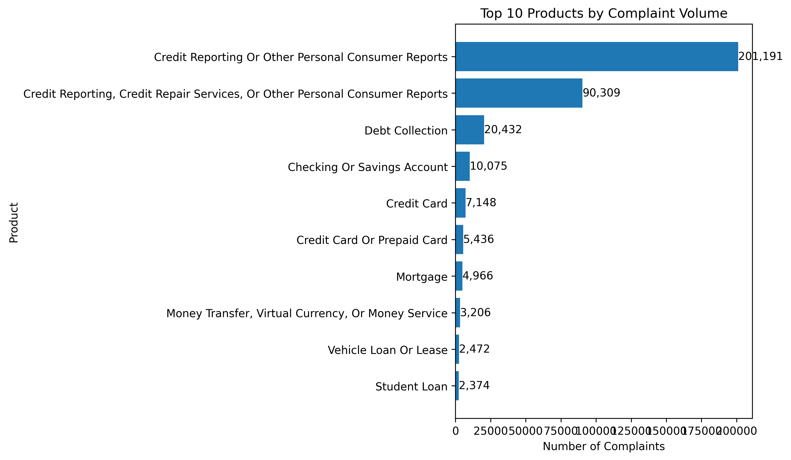
Figure 1: Top 10 Products by Complaint Volume
Figure 1 displays the ten product categories that received the highest number of complaints. Complaint volume is heavily concentrated in credit reporting products. The top two categories alone — "Credit Reporting Or Other Personal Consumer Reports" and "Credit Reporting, Credit Repair Services, Or Other Personal Consumer Reports" — account for the vast majority of all complaints in the dataset. These two categories represent variations in how CFPB has labelled credit-reporting-related products over time and together dominate complaint intake. The remaining categories, including Debt Collection, Checking Or Savings Account, Credit Card, and Mortgage, each contribute substantially fewer complaints by comparison.
This concentration indicates that credit reporting is the primary area of consumer dissatisfaction within the CFPB complaint system during 2022–2024. From a compliance perspective, financial institutions and credit bureaus operating in the credit reporting space face the highest regulatory scrutiny based on complaint volume alone. It should be noted that this chart reflects absolute complaint counts and does not adjust for the number of customers served by each product category.

5.2 Complaint Volume by State
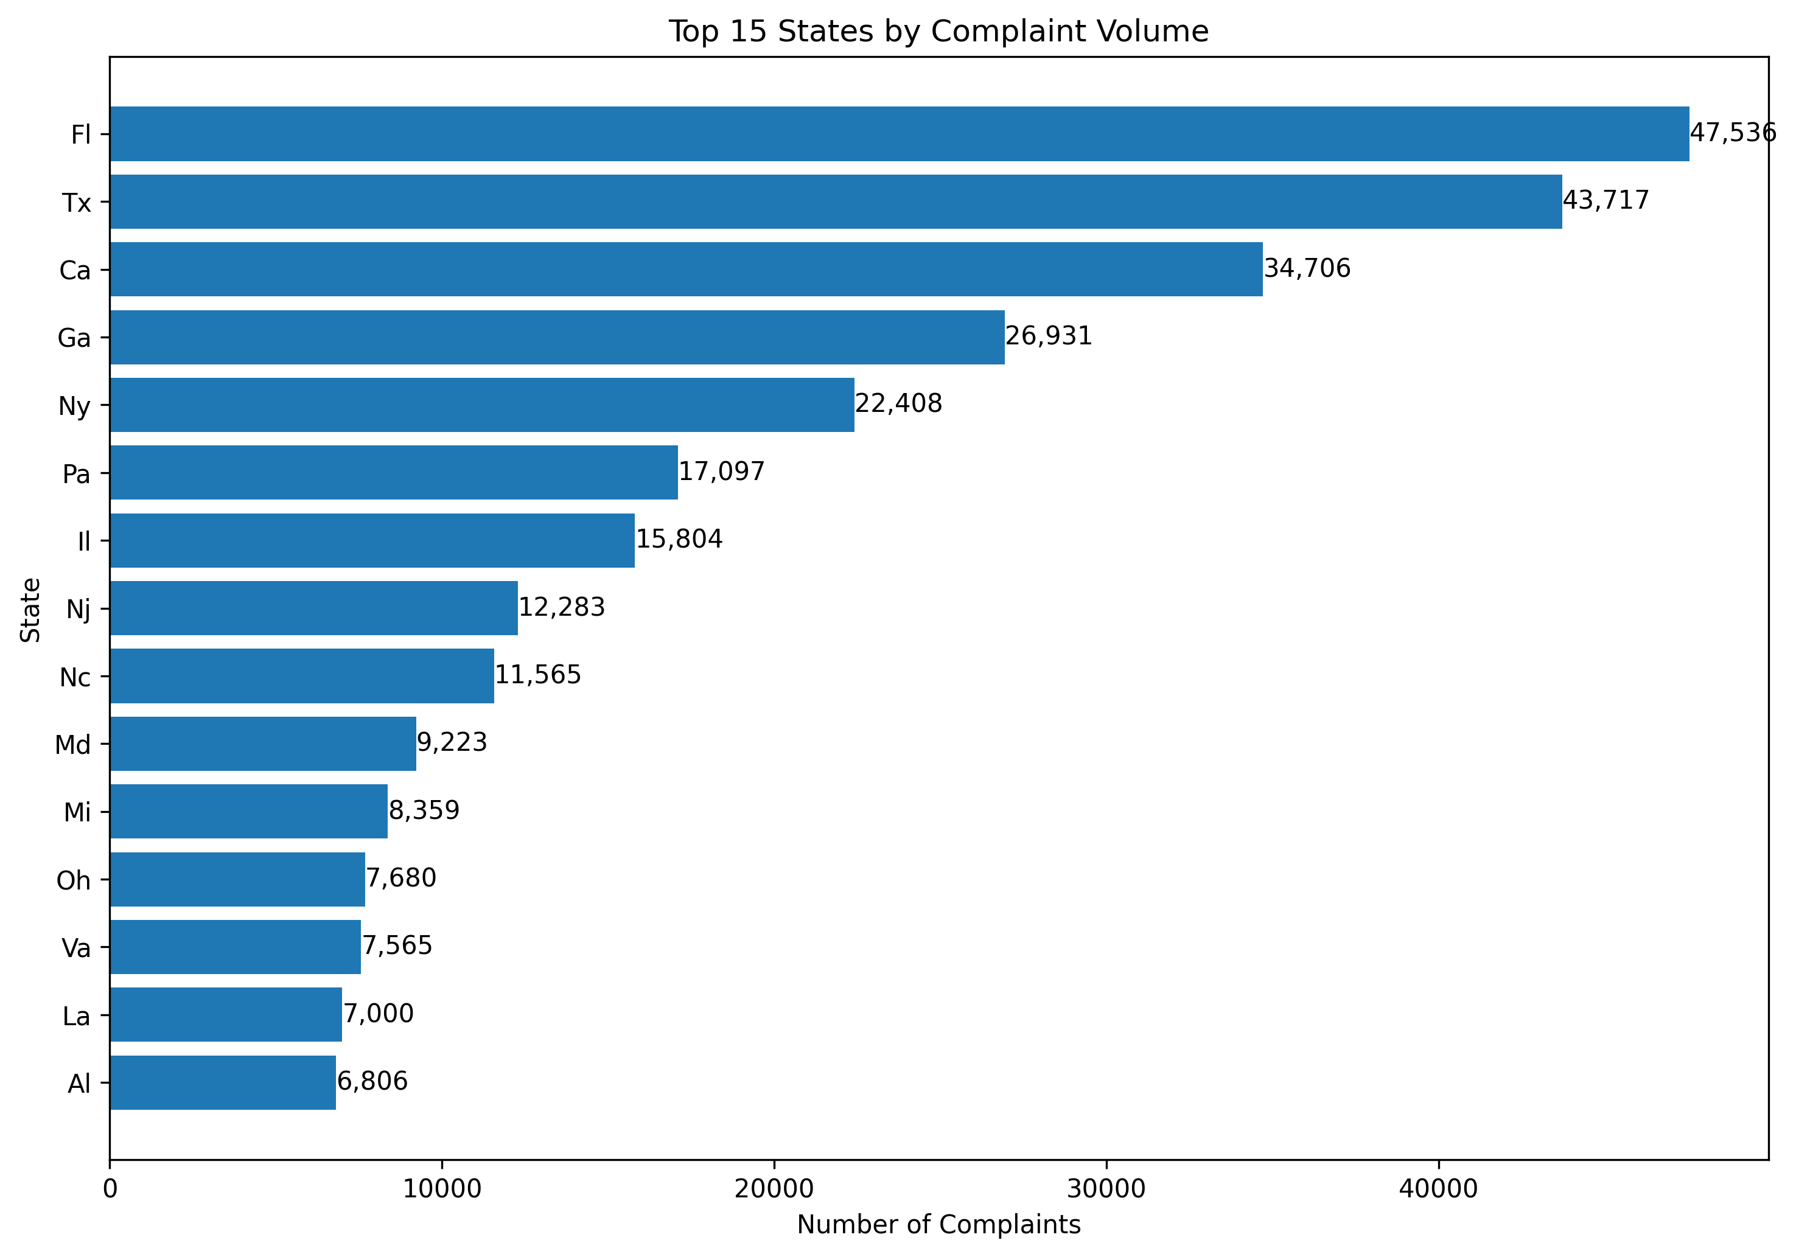
Figure 2: Top 15 States by Complaint Volume
Figure 2 ranks the top 15 U.S. states by complaint volume. Florida (FL), Texas (TX), and California (CA) lead with the highest absolute complaint counts. These are followed by Georgia (GA) and New York (NY). The distribution broadly correlates with state population sizes, as more populous states naturally generate more complaint submissions.
A key limitation of this chart is that complaint counts are not normalised by state population. A state with a large population will appear to have a higher complaint burden even if its per-capita complaint rate is average or below average. Population-adjusted analysis was not performed in this project because population data is outside the scope of the CFPB dataset. Consequently, the chart should be interpreted as a measure of absolute complaint volume rather than complaint propensity.

5.3 Timely Response Rate by Company Response Type
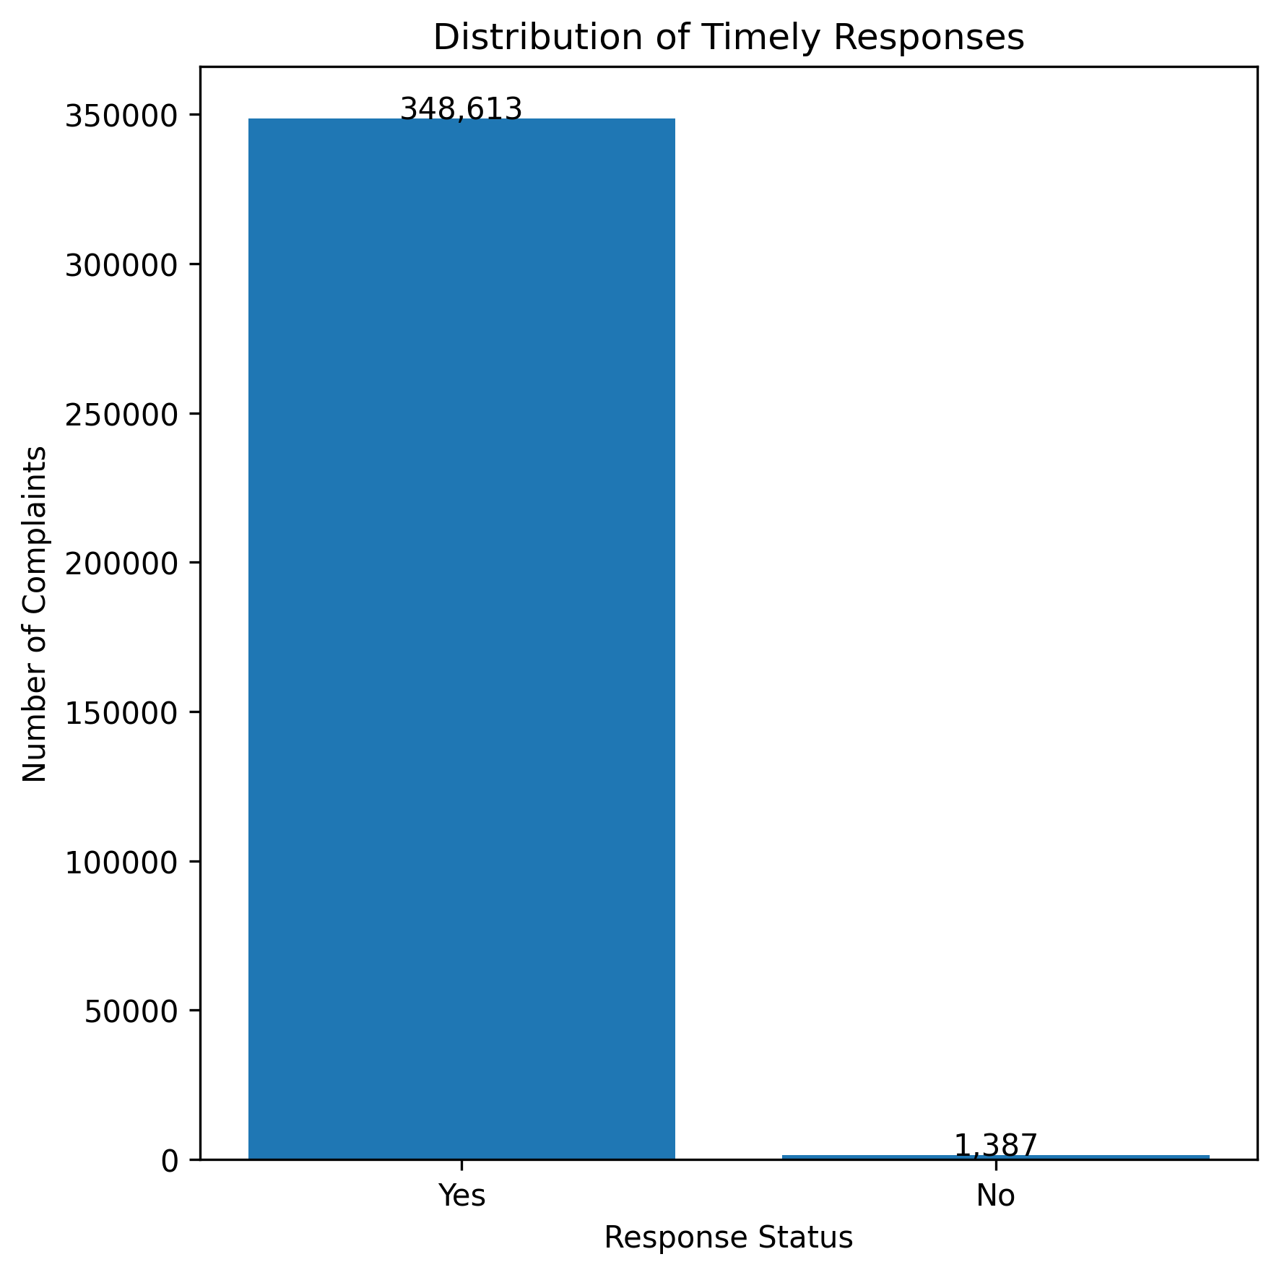
Figure 3: Timely vs. Late Response by Company Response Category
Figure 3 compares the count of timely and late responses across different company response categories. The chart shows that the overwhelming majority of complaints across all response types received a timely response. "Closed with explanation" is by far the most common response category, and it exhibits a high timely response rate. "Closed with non-monetary relief" and "Closed with monetary relief" also show strong timeliness. Only the "Untimely response" category, by definition, contains entirely late responses, but this category is very small relative to the others.
This pattern suggests that most companies within the CFPB complaint system respond within the regulatory timeframe. From an operational standpoint, the data does not indicate a widespread timeliness problem. However, the analysis is limited to the binary Timely response? flag and does not measure the actual number of days taken to
6. Limitations
This project has several limitations that should be considered when interpreting the results.
Temporal coverage. The dataset covers complaints received between January 2022 and December 2024. Patterns observed in this period may not generalise to earlier or later years, as regulatory environments, company practices, and consumer behaviour evolve over time.
Absence of the Consumer disputed? column. The current CFPB schema no longer includes the "Consumer disputed?" column, which previously indicated whether a consumer disagreed with the company’s response. As a result, this project analyses complaint volume and timely response metrics rather than dispute rates. Any analysis involving consumer dispute behaviour is not possible with this dataset.
No Natural Language Processing. The Consumer complaint narrative column, which contains free-text descriptions of complaints, was not subjected to NLP or text mining. Instead, a binary has_narrative flag was created to indicate narrative presence or absence. Sentiment analysis, topic modelling, or keyword extraction from narratives is outside the scope of this project.
No Machine Learning model. This project is limited to data preprocessing and exploratory analysis. No predictive, classification, or clustering model was developed. The cleaned dataset is intended to serve as an input for such tasks in future work.
Complaint counts are not population-adjusted. The geographic analysis (Figure 2) presents absolute complaint counts by state. States with larger populations naturally generate more complaints. Without normalising by population, it is not possible to determine whether a state has a disproportionately high or low complaint rate per capita.
Only available attributes analysed. The analysis is constrained to the 16 attributes present in the CFPB dataset. External data sources such as company size, customer base, or demographic information were not integrated. The findings are therefore limited to what the complaint data alone can reveal.
Date parsing limitations. During date standardisation, 31,250 date entries could not be parsed into valid datetime objects and became NaT. These records were retained in the dataset for non-temporal analysis but are excluded from any calculation involving Date received or Date sent to company.

7. Conclusion
This project successfully constructed a data preprocessing pipeline to transform raw CFPB consumer complaint records into a clean, standardised, and analysis-ready dataset. The pipeline addressed each of the major data quality concerns present in the raw data through a structured sequence of operations.
The original dataset, consisting of 350,000 complaint records and 16 columns, was subjected to a thorough initial inspection. The inspection revealed 711,101 total missing values (completeness 87.30%), with the Tags, Consumer complaint narrative, and Company public response columns most severely affected. No duplicate rows or duplicate Complaint IDs were found, confirming the integrity of the sampling process used by the filter_data.py script.
Duplicate verification was applied using the Complaint ID column as the uniqueness key. Although no duplicates were present in this sample, the operation was retained as a defensive step to ensure the pipeline functions correctly on other data slices. Date columns were converted from string to datetime format, enabling the derivation of the resolution_days feature. Text standardisation was applied to 10 categorical columns, modifying a total of 2,537,441 cell values to achieve consistent formatting. Missing values were treated with column-specific strategies: geographic fields received "Unknown", response fields received "No Response" or "Unknown", and the narrative column was converted into a binary flag (has_narrative). Categorical encoding was applied to Timely response? and Product, and MinMax scaling was applied to resolution_days. All original columns were preserved alongside their encoded or scaled counterparts.
After preprocessing, the dataset contained 350,000 rows and 22 columns. The total missing value count rose to 803,994 due to the introduction of new columns and the NaT values from date parsing. However, the overall dataset completeness improved from 87.30% to 89.56%, as imputation and feature construction filled values in multiple columns. Six new features were created: resolution_days, resolution_days_original, resolution_days_scaled, has_narrative, timely_response_encoded, and product_encoded.
Exploratory analysis revealed that credit reporting products account for the dominant share of complaint volume, with Florida, Texas, and California leading in absolute state-level counts. Timely response rates are high across most company response categories. These observations provide a factual starting point for more detailed regulatory or business analysis.

8. References
[1] Consumer Financial Protection Bureau (CFPB). Consumer Complaint Database. Available at: https://www.consumerfinance.gov/data-research/consumer-complaints/
[2] McKinney, W. (2022). Python for Data Analysis: Data Wrangling with pandas, NumPy, and Jupyter. 3rd Edition. O’Reilly Media.
[3] pandas Development Team. pandas: Powerful Python Data Analysis Toolkit. Available at: https://pandas.pydata.org/
[4] Pedregosa, F. et al. (2011). Scikit-learn: Machine Learning in Python. Journal of Machine Learning Research, 12, 2825–2830. Available at: https://scikit-learn.org/
[5] Hunter, J. D. (2007). Matplotlib: A 2D Graphics Environment. Computing in Science & Engineering, 9(3), 90–95. Available at: https://matplotlib.org/

