

**FEDERAL UNIVERSITY OYE EKITI**

**FACULTY OF ENGINEERING**

**DEPARTMENT OF ELECTRICAL AND ELECTRONICS ENGINEERING.**

**PRACTICAL MANUAL**

***for***

**EEE 311- Electrical Engineering Practical – I**

**Coordinated By: *Dr. Engr. A.M Zungeru***

**INTRODUCTION**

The place of laboratory work in Electrical and Electronic Engineering is very important. Laboratory course work enables students to do experiments on the fundamental laws and principles encountered in the theoretical work. In these formative years the student is made to identify a wide range of electrical components, measure their values thereby learning to handle instruments and equipment and to appreciate their limitations. Students are also made to learn how to bread board, connect simple circuits and verify the simple laws of Ohms’ Kirchhoff ’s Current and Voltage Laws, The venin’s, Norton’s, and others who have contributed immensely on the formulation of laws and theories. Other aspect of Electrical and Electronic practical were all dealt with.

It may also be observed that the background information to every experiment is the ‘theory’ aspect and it is quit lengthy in many cases. It is aimed at ensuring that the students are sufficiently familiar with the theoretical aspect of the experiment and consequently sharpen their focus on the results expected.

The laboratory exercises in this manual are designed to provide a working knowledge of some of the more fundamental principles of Electrical, Electronic an d Computer Engineering. All the experiments on this handbook were simulated to get the response of each circuit, and were all found working properly as expected. While working through the manual the student will become more familiarize with the manual and the basic theories in Electrical and Electronic Engineering.

In order to fully understand the principle being investigated, the student is advised to read extensively in the related topics before entering the laboratory. At the end of each laboratory, questions and exercises should be completed and returned to the Examiner for proper grading as scheduled.

**GENERAL LABORATORY SAFETY**

Safety is an important factor in any laboratory work. It should be understood that any use of electricity inherently involves some degree of safety hazard. The best way to achieve safety in the use of electrical equipment is to adhere to all the safety rules which include;

1. Understanding equipment you are proposing to use and its rating,
2. Understanding the application to which the equipment is to be used for,
3. Ensuring that all reasonable safety measures are followed,
4. Taking no chance, nor short cut, in safety procedures.

**GENERAL ENGINEERING LABORATORY RECORDS AND REPORTS**

The formats for the experimental records and reports of the experiments to be conducted are expected to be outlined as.

1. Experiment number, Title and Date: These should be stated clearly at the beginning of the report;
2. Objective of Experiment: The aim for which the experiment is taken;
3. Theory: This include the laws related to the experiment;
4. Apparatus: Description of apparatus, where applicable, the serial number of the apparatus and any special features of the apparatus must be stated;
5. Procedure (method): These should include the description of the connections made, the nature and range of inputs, how readings are taken, any adjustment made, etc.;
6. Circuit Diagram: The circuit diagram must be clearly labelled;
7. Results: Readings obtained should be clearly tabulated, calculations should be clearly outlined, graphs where necessary must be drawn neatly.
8. Observation: Difficulties encountered, precaution taken etc. should be clearly stated;
9. Conclusion: Comment on the result obtained, whether the result confirms the theory. If theory is not confirmed, give possible reasons

**TABLE OF CONTENTS**

**Contents Page**

COVER PAGE……………………………………………………………………………………………1

PREAMBLE………………………………………………………………………………………………2

INTRODUCTION………………………………………………………………………………………...3

GENERAL LABORATORY SAFETY…………………………………………………………………..4

GENERAL ENGINEERING LABORATORY RECORD AND REPORT……………………………..5

EXPERIMENT THREE: INVERTING AND NON-INVERTING OP-AMP CIRCUIT……………….6

EXPERIMENT FOUR: OP-AMP. COMPARATOR…………………………………………………….7

EXPERIMENT EIGHT: PASSIVE LOW-PASS AND HIGH-PASS FILTERS………………………...8

**INSTITUTION:------------------------------------------------------------------------------------------------------**

**DEPARTMENT:---------------------------------------------------------------------------------------------------- STUDENTS’S NAME: ----------------------------------------------REG/MAT NO: ------------------**

**GROUP NO: -----------------------------------------------------------DATE: ----------------------------------**

**INSTRUCTOR’S NAME: ------------------------------------------SIGNATURE: ---------------------**

**EXPERIMENT ONE: INVERTING AND NON INVERTING OP-AMP**

**CIRCUITS**

* 1. **OBJECTIVE**

To demonstrate the operation of both inverting and non-inverting amplifier circuits, using a 741 operational amplifier. Both circuits operate in the closed-loop mode.

* 1. **MATERIALS**

Resistors (1/2 W): 1k; 4.7k; (2) 10k; 22k; 47k; 100k

741 op-amp (8-pin mini-DIP)

Two 0-15 v dc power supplies

Signal generator Dual trace oscilloscope Breadboard.

**3.2 PREPARATION**

The inverting amplifier’s closed-loop (voltage) gain can be less than, equal to, or greater than 1. As its name implies, its output signal is always inverted with respect to its input signal. On the other hand, the non-inverting closed-loop (voltage) gain is always greater than 1; while the input and output signal are always in-phase.

Inverting amplifier closed-loop voltage gain

**Av =** (3.1)

Non-inverting amplifier closed-loop voltage gain

**Av = 1 +** (3.2)

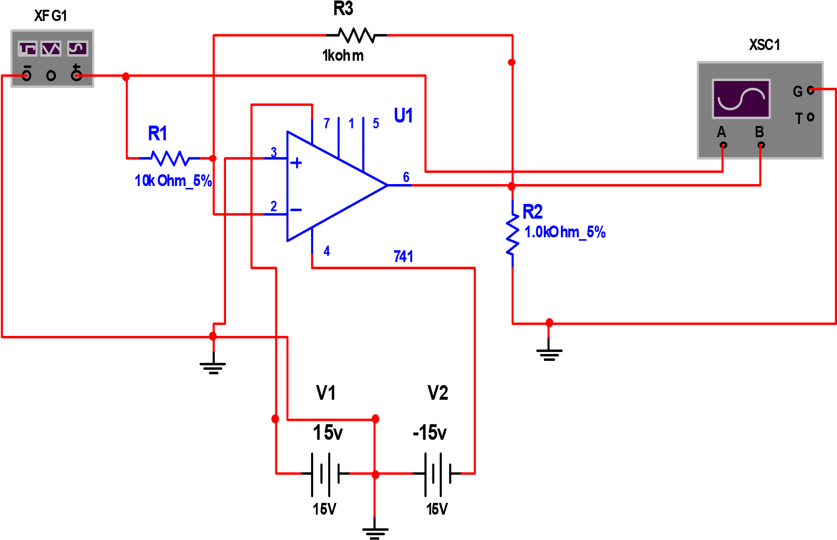

**Fig. 3.0: Inverting Amplifier Circuit**

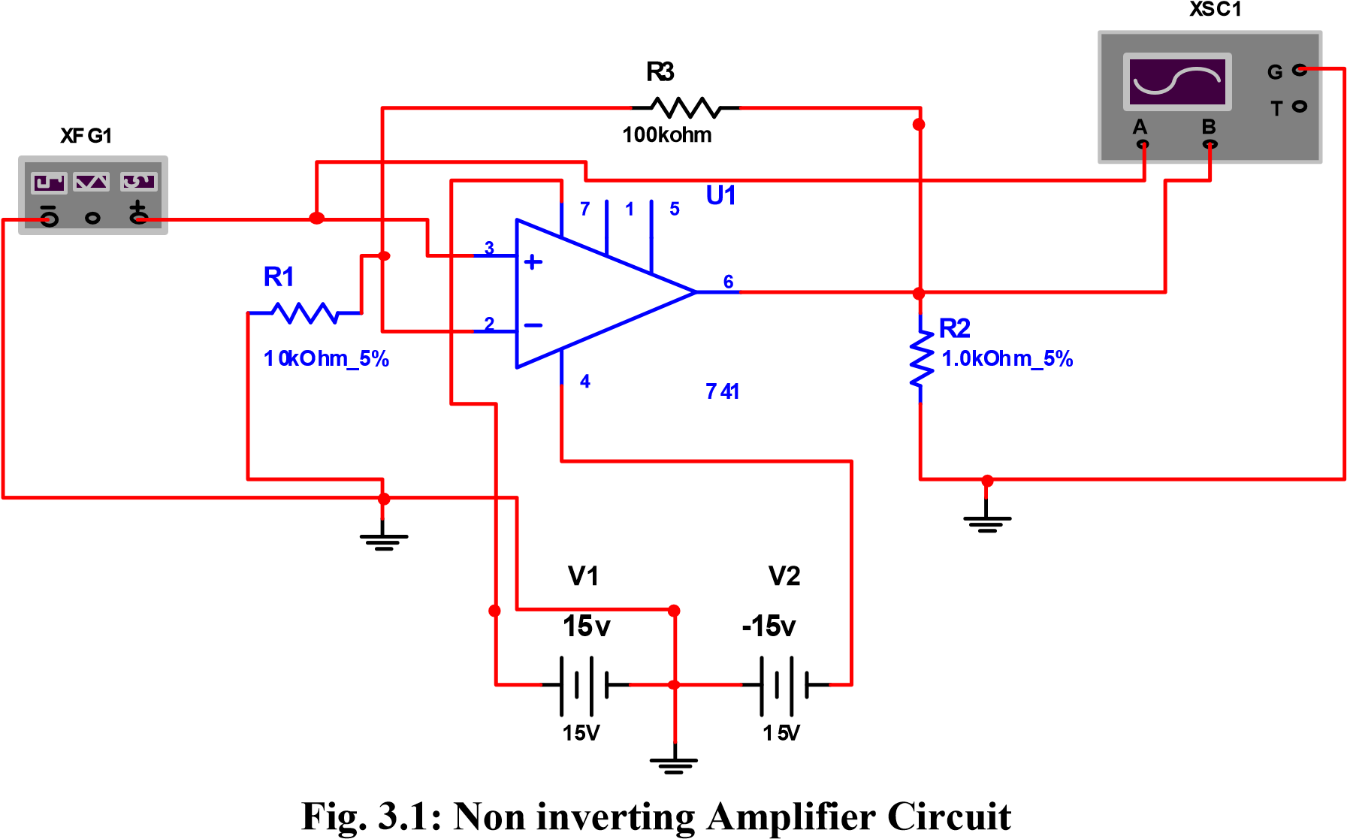

**3.3PROCEDURE**

**STEP 1:**Wire the inverting amplifier circuit shown in the schematic diagram of

Fig 3.0, and set your oscilloscope for the following settings: Channels 1 and 2: 5 v/ division, ac coupling Time base: 1 Ms/division

**STEP 2:** Apply power to the breadboard, and adjust the input voltage to 1v peak-

To- peak and the frequency at 500 Hz. Position the input voltage above the output voltage on the oscilloscope display. What is the difference between the two signals? Notice that the output signal is of opposite form, or is inverted, compare to the input signal. The output voltage is then said to be inverted from, or 180° out-of-phase with, the input, since the positive peak of the output signal occurs when the inputs peak is negative.

**STEP 3:** Measure the peak-to-peak output voltage. Then determine the voltage

Gain and compare it to the expected value, recording your results in table 3.0 the peak-to-peak output voltage should be the same as the input (1v), so that the voltage gain is -1. The minus sign indicates that the output is inverted with respect to the input.

**STEP 4:** Keeping the input signal at 1v peak-to-peak, change resistor Rf according

to table 3.0, recording your results as in step 3. Each time, disconnect the power supplies and signal generator before you change the resistor. Do your results agree with those obtained from the equation for the inverting amplifier voltage gain? As the results of table 3.0 indicate, the voltage gain of an inverting amplifier can be made to be less than 1, equal to 1, or greater than 1.

**STEP 5:** Wire the non-inverting amplifier circuit shown in the schematic diagram

Of fig 3.1. Apply power to the breadboard and adjust the input voltage to 1v peak- to -peak and the frequency at 500Hz. Again position the input voltage above the output voltage on the oscilloscope’s display. What is the difference between the two signals? The only difference is that the output signal is larger than the input signal. Both signals are said to be in-phase, since the output signal goes positive exactly when the input does.

**STEP 6:** Measure the peak-to-peak output voltage. Then determine the voltage

gain and compare it to the expected value, recording your results in table 3.1The peak-to-peak output voltage should be approximately 2V, so that the voltage gain is 2.

**STEP 7:** Keeping the input signal at 1v peak-to-peak, change resistor Rf according

to table 3.1, recording your results as in step 6. Each time, disconnect the power supplies and signal generator before you change the resistor. Do your results agree with those obtained from the equation for the non-inverting amplifier voltage gain? As the results of table 3.1 indicate, the voltage gain of a non-inverting amplifier can never be less than 1 or equal to 1.It will always be greater than 1.

**TABLE 3.0 INVERTING AMPLIFIER**

|  |  |  |  |  |
| --- | --- | --- | --- | --- |
| Rf | Measured  Vo | Measured  Gain | Expected  Gain | %  Error |
| 10k |  |  |  |  |
| 22k |  |  |  |  |
| 47k |  |  |  |  |
| 100k |  |  |  |  |
| 4.7k |  |  |  |  |
| 1k |  |  |  |  |

**TABLE 3.1 NON-INVERTING AMPLIFIERS**

|  |  |  |  |  |
| --- | --- | --- | --- | --- |
| Rf | Measured  Vo | Measured  Gain | Expected  Gain | %  Error |
| 10k |  |  |  |  |
| 22k |  |  |  |  |
| 47k |  |  |  |  |
| 100k |  |  |  |  |
| 4.7k |  |  |  |  |
| 1k |  |  |  |  |

**EXPERIMENT TWO: OP-AMP COMPARATORS**

**4.0 OBJECTIVE**

To demonstrate the operation of non-inverting and inverting comparator circuits using a 741 operational amplifier. A comparator determines whether an input voltage is greater than a predetermined reference level. Since a comparator operates in an open- loop mode, the output voltage approaches either its positive or its negative supply voltage.

**4.1 MATERIALS**

Resistors (1/2 W): (2) 1k; 4.7k; (2) 10k; 47k; 100k; 100k potentiometer

741 op-amp (8-pin mini-DIP)

1N914 (or 1N4148) diode

LED

2N3904 NPN transistor

Two 0-15v dc power supplies

Signal generator

Dual trace oscilloscope

Bread boarding socket

**4.2 PREPARATION**

Non-inverting comparator output

|  |  |  |
| --- | --- | --- |
| Vo = + Vsat |  | when Vi > VREF |
| Vo = - Vsat |  | when Vi < VREF |

Inverting comparator output

Vo = + Vsat  when Vi < VREF

Vo = - Vsat  when Vi > VREF

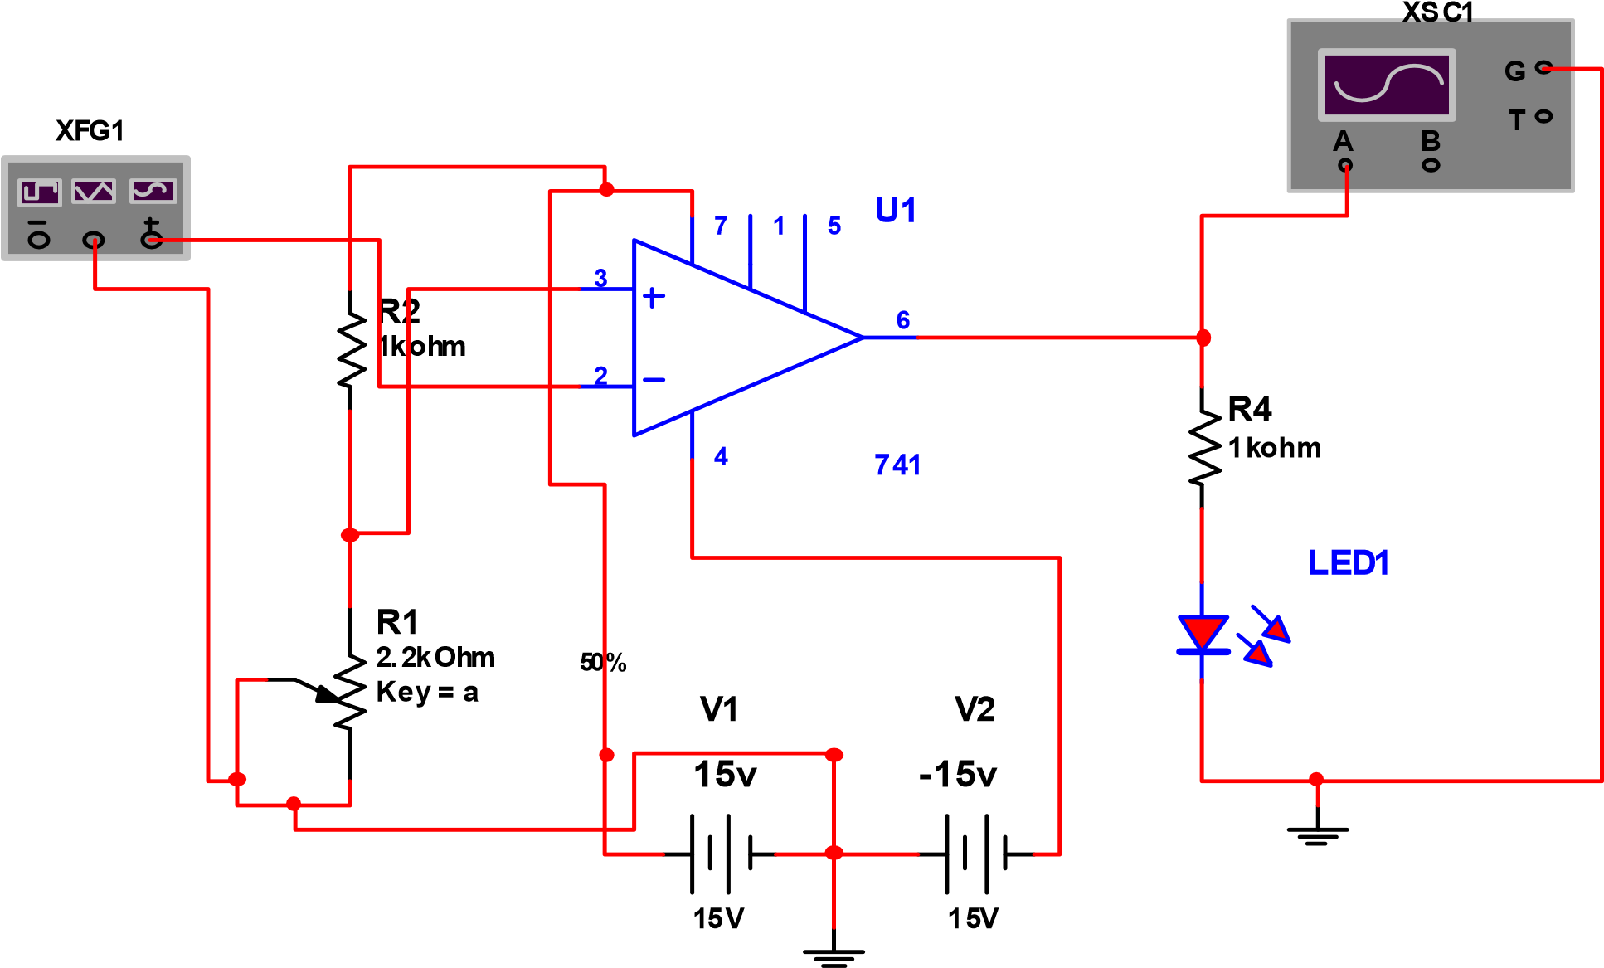

**Fig. 4.1: Inverting Operational Amplifier Comparator Circuit**

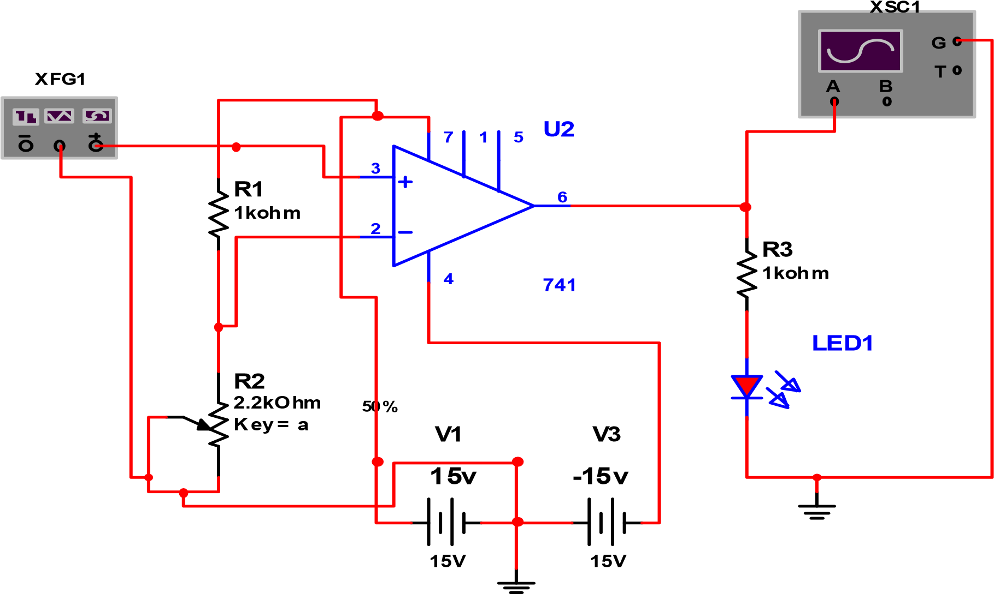

**Fig 4.2 Non Inverting Amplifier Comparator Circuit**

**4.3 PROCEDURE**

**STEP 1:** Wire the circuit shown in the schematic diagram of fig 4.1, and set

your oscilloscope for the following settings:

Channel 1: 1v / division. Dc coupling

Channel 2: 10v / division, Dc coupling

Time base: 1ms/ division

**STEP 2:** Apply power to the breadboard, and adjust the input voltage at 3v

peak-to-peak and the frequency at 300 Hz. What the polarity of the output voltage when the input signal goes positive? When the input goes negative? When the input signal Vi is applied to the op-amp’s non-inverting input, the output signal polarity will be the same as that of the input, so that this circuit is a non-inverting comparator. In this

case, the reference voltage VREF is zero (the inverting input is

Grounded). Because of high open loop gain of the op-amp, the output immediately goes positive when Vi is greater than zero volt (VREF), and vice versa. This circuit is also referred to as a non-inverting zero level detector since it detects the polarity of the input signal. The maximum output (saturation) voltage VSAT, for the 741 op-amp is typically 12V to 14V when using a 15V supply.

**STEP 3:** Disconnect the power and signal leads to the breadboard, and reverse

the input connections to the op-amp so that the input signal is now connected to the inverting input while the non-inverting input is grounded, as shown in fig 4.1.

**STEP 4:** Again apply both the power and signal leads to the breadboard. Now

what is the difference between the operation of this circuit and that of the circuit used earlier? Notice that the output of this comparator circuit has a polarity that is inverted with respect to the input signal. Such a circuit is called inverting comparator. Furthermore, since the reference voltage (the voltage at the non-inverting input) is zero, this circuit is also referred to as inverting zero-level detector. When the polarity of t he input signal is positive, the output voltage equals –VSAT, and vice versa. As can be seen, both circuits are useful in converting sine waves into square waves.

**STEP 5:** Disconnect the power and signal leads from the breadboard, and wire

the circuit shown in fig 4.1. Make sure that you have the 1N914 and LED diodes, as well as the NPN transistors, wire correctly.

**STEP 6:** Apply power to the breadboard. Depending on the setting of the

Potentiometer, the LED may or may not be ON when you connect the power. If the LED is on, turn the potentiometer pass the point at which the LED is off.

**STEP 7:** With your oscilloscope, measure the voltage at the op-amp’s inverting

terminal (pin 2), which is the reference voltage VREF for the comparator, and record the value in table 4.0

**STEP 8:** Now connect the oscilloscope to the op-amp’s non-inverting input (pin 2). While watching the LED, vary the potentiometer just until the LED lights up. Measure this voltage at pin 3, Vi (on), and record your result in table 4.0. How does this value compare with the one you determined in step 7? These two values should be nearly the same. When the input voltage Vi at the non-inverting input exceeds the comparator’s reference voltage at the inverting input, the op-amp comparator’s output switches from its negative saturation voltage to its positive saturation voltage. This circuit is a non-inverting comparator whose nonzero reference voltage is set by the 10kΩ and 1kΩ resistors connected as a simple voltage divider. The transistor-LED circuit connected to the output of the comparator allows you to determine visually whether the input voltage is greater or less than the reference voltage. If the input voltage exceeds the reference, the LED is lit.

**STEP 9:** Disconnect the power to the breadboard. Verify the operation of this non-

inverting comparator by varying voltage-divider resistor R1 and repeating step 6, 7 and 8, according to table 4.1

**TABLE 4.0 INVERTING COMPARATOR**

|  |  |  |
| --- | --- | --- |
| R1 | Measured VREF | Measured Vi (on) |
| 1k |  |  |
| 10k |  |  |
| 47k |  |  |

**TABLE 4.1: NON-INVERTING COMPARATOR**

|  |  |  |
| --- | --- | --- |
| R1 | Measured VREF | Measured Vi(on) |
| 1k |  |  |
| 10k |  |  |
| 47k |  |  |

**EXPERIMENT THREE:PASSIVE LOW- PASS AND HIGH –PASS FILTERS.**

**8.0 OBJECTIVES**

1. Plot the gain-frequency response of a first order (one-pole) R-C low pass filter.
2. Determine the cut-off frequency and roll–off of an R-C first order (one-pole) low pass filter.
3. Plot the phase frequency response of a first order (one-pole) low pass filter.
4. Determine how the value of Rand C affects the cut off frequency of an R-C low pass filter.
5. Plot the gain-frequency response of a first order (one-pole) R-C high pass filter.
6. Determine the cut off frequency and roll-off of a first order (one-pole) R-C high pass filter.
7. Plot the phase-frequency response of a first order (one-pole) high pass filter.
8. Determine how the value of R and C affects the cut off frequency of an R-C high –pass filter.
   1. **MATERIALS**

One function generator

One dual-trace oscilloscope

Capacitors: .02µf, .04µf , and Resistor: 1k, 2k.

* 1. **PREPARATION**

In electronics communications system, it is often necessary to separate a specific range of frequencies types of filter from the total frequency spectrum. This is normally accomplished with filters. A filter is a circuit that passes a specific range of frequencies while rejecting other frequencies .A passive filter consists of passive circuit elements such as capacitors, inductors, and resistors. There are four basic types of filter, low-pass, high-pass, band-pass, and band-stop. A low- pass filter is designed to pass all frequencies below the cut-off frequency and reject all frequencies above the cut-off frequency. A high-pass all frequencies above the cutoff frequency and reject all frequencies below the cut-off frequency. A band-pass filter passes all frequencies within a band of frequencies and rejects all other frequencies outside the band. A band stop filter rejects all frequencies within a band of frequencies and passes all other frequencies outside the band. A band stop filter is often referred to as a notch filter. In this experiment, you will study low pass and high pass filters.

The most common way to describe the frequency response characteristics of a filter is to plot the filter voltage gain (VO/VI) in dB as a function of frequency (f). The frequency at which the output gain drops to 50% of the maximum value is called the cut off frequency (FC). When the out put power gain drops to 50 %, the voltage gain drops3dB (0.707 of the maximum value). When the filter dB voltage gain is plotted as a function frequency on a semi log graph using straight lines to approximate the action frequency response, it is called a Bode plot. A Bode plot is an ideal plot of filter frequency response because it assumes that voltage gain remains constant in the pass-band until the cut off frequency is reached and then drops in a straight line. The filter network voltage gain in dB is calculated from the actual voltage gain (A) using the equation

A(db) = 20logA (8.1)

Where A = 01 (8.2)

A low pass RC filter is shown in fig 8.0 At frequencies well below the cut off frequency, the capacitive reactance of a capacitor C is much higher than the resistance of the resistor R, causing the output voltage to be practically equal to the input voltage (A=1) and constant with variations in frequency. At frequencies well above the cut off frequencies, the capacitive reactance of capacitor C is much lower than the resistance of resistor R and decreases with an increase in frequency, causing the output voltage to decrease 20 dB

Per decade, increase in frequency. At the cut off frequency, the capacitive reactance of capacitor C is equal to the resistance of the resistor R, causing the out voltage to be 0.707 times the input voltage (-3dB). The expected cut off frequency (fc) of the low pass filter in figure 19.0, based on the circuit component values, can be calculated from

Xc = R (8.3)

 = R (8.4)

Solving for fc produces the equation

 = (8.5)

**A** high pass RC filter is shown in fig 19.1. At frequencies well above the cut off frequency, the capacitive reactance of capacitor C is much lower than the resistance of resistor R, causing the output voltage to be practically equal to the input voltage {A= 1} and constant with variations in frequency. At frequencies well below the cut-off frequency, the capacitive reactance of capacitor C is much higher than the resistance of resistor R and increases with a decrease in frequency, causing the output voltage to decrease 20 dB per decade decrease in frequency. At the cut-off frequency, the capacitive reactance of capacitor C is equal to the resistor R, causing the voltage to be 0.707 times the input voltage {-3 Db). The expected cut-off frequency {fc} of the high-pass filter in fig 8.2, based on the circuit component values, can be calculated from

 = (8.6)

When the frequency at the input of a low-pass filter increases above the cut-off frequency, the filter output voltage drops at a constant rate. When the frequency at the input of a high- pass filter decreases below the cut-off frequency, the filter output voltage also drops at a constant rate. The constant drop in filter output voltage per decade increases {×10}, or decrease {÷10}, in frequency is called rolloff. An ideal low- pass or high-pass filter would have an instantaneous drop at the cut-off frequency [fc], with full signal level on one side of the cut-off frequency and no signal level on the other side of the cut-off frequency. Although the ideal is not achievable, actual filters roll off at -20dB/decade per pole [R- C Circuit]. A one-pole filter has one R-C circuit tuned to the cut-off frequency and rolls off at 20dB/decade. A two-pole has two R-C circuits tuned to the same cut-off frequency and rolls at -40dB/decade. Each additional pole [R-C circuit] will cause the filter to roll an additional -20dB/decade. Therefore, an R-C filter with more poles [R-C circuits] more closely approaches an ideal filter.

In a one- pole filter, as shown in fig 8.0 and 8.1, the phase [ø] between the input and the output will change by 90 degrees over the frequency range and be 45 degrees at the cut-off frequency. In a two- pole filter, the phase [ø] will change by 180 degrees over the frequency range and be 90 degrees at the cut-off frequency.

**R1**

**1**

**kohm**

**C1**

**0.02**

**uF**

**out**

**in**

**XBP1**

**XFG1**

**Fig. 8.0: Low-pass R-C Filter**

**out**

**in**

**XBP1**

**XFG1**

**C2**

**0.02**

**uF**

**R2**

**1**

**kohm**

**Fig. 8.1: High-pass R-C Filter**

**8.3 PROCEDURE**

***Low-pass filter***

**Step 1:**  Connect the circuit in Fig 8.0. Make sure that the following Bode plotter settings are selected: Magnitude, Vertical (Log, F = 0dB, I= -40dB), Horizontal (Log, F = 1 MHz, I = 100Hz).

**Step 2:** Run the circuit. Plot the response curves by taking measurements at different frequencies between 100HZ and 1MHZ using oscilloscope. Plot the curves on semilog paper Notice that voltage gain in dB has been plotted between the frequencies of 100Hz and 1MHz.

**Question 8.0:**

a. Is the frequency response curves that of a low-pass filter? Explain why.

**Step 3:**  Calculate the actual voltage gain [A] from the dB voltage gain [AdB].

**Questions 8.1:**

a.Was the voltage gain on the flat part of the frequency response curve what you expected for the circuit in Fig 8.0? Explain why.

**Step 4:** Calculate the expected cut-off frequency (fc) based on the circuit

component values in Fig 8.0.

**Questions 8.2:**

a.How did the calculated value for the cut-off frequency compare with the measured value recorded on the curve plot? How much did the dB gain decrease for a one-decade increase (x 10) in frequency? Was it what you expected for a single-pole (single R-C) low pass filter?

**Step 5:** Connect the circuit in fig 8.1. Plot the response curves by taking

measurements at different frequencies between 100HZ and 1MHZ using oscilloscope. Plot the curves on semilog paper Notice that voltage gain in dB has been plotted between the frequencies of 100Hz and 1MHz.

**Question 8.3:**

a.Is the frequency response curves that of a high-pass filter? Explain why.

**Step 6:** Calculate the actual voltage gain [A] from the dB voltage gain [AdB].

**Step 7:** Calculate the expected cut-off frequency (fc) based on the circuit

component values in Fig 8.1

**Questions 8.3:**

a.How did the calculated value for the cut-off frequency compare with the measured value recorded on the curve plot? How much did the dB gain decrease for a one-decade increase (x 10) in frequency? Was it what you expected for a single-pole (single R-C) high- pass filter?