**QUESTION 1**

What is an integrated circuit? Discuss the relative advantages and disadvantages of ICs over discrete assembly.

**SOLUTION**

An integrated circuit also known as an IC or microchip can be defined as a set of an electronic circuit of extremely small device which its circuit components (like diode, capacitors, transistors, resistors e.t.c) are automatically part of a small semiconductor chips. This device is situated on a flat piece of semiconductor material that is normally Silicon. This device consists of circuit component like resistors, transistors diode e.t.c. For ICS to perform a complete electronic function, the components are interconnected in a single small package. The component are formed and connected within small chip of semiconductor material.

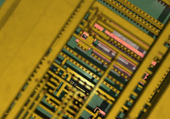

**THE RELATIVE ADVANTAGES OF ICS OVER DISCRETE ASSEMBLY**

* Low power requirement
* Very small weight owing to miniaturized circuit.
* Increase reliability due to lesser number of connections
* Greater ability to operate at extreme values
* Greater ability of operating at extreme temperatures.
* Extremely small size due to the fabrication of various circuit elements in a single chip of semiconductor material.
* Greater ability to operate at extreme values of temperature
* The circuit layout is greatly simplified because ICs are constrained to use minimum number of external connection.
* Easy replacement as it is more economical to replace them than to repair them.
* Suitable for small signal operation because of no chance of stray electrical pickup as various components of an INC are located very close to each other on a silicon wafer.
* Low cost because of simultaneous production of hundreds of alike circuits on a small semiconductor water.

**THE RELATIVE DISADVANTAGES OF ICS OVER DISCRETE ASSEMBLY**

* It is not possible to fabricate inductor and transformers on the surface of semiconductor chips.
* There is a lack of flexibility in an ICs.
* If any component in an ICs goes out of order, the ICs has to be replaced by the new one.
* Operation at low voltage as ICs functions at fairly low voltage.
* It is not possible to produce high power ICs.
* In an ICs, it is neither convenient nor economical to fabricate capacitor exceeding 30µF.
* High grade P-N-P assembly is not possible.
* Low temperature coefficient is difficult to be achieved.
* Large value of saturation resistance of transistors.

**QUESTION 2**

A small region of an impure silicon crystal with dimensions 1.25× ${10}^{-6}m$ × ${10}^{-3}m$ × ${10}^{-4}m$ has only the ions (with charge +1.6×10-19C) present with a volume density of 1025/m3. The rest of the crystal volume contain equal densities of electrons (with charge -1.6×10-19C)and positive ions find the net total charge of the crystal.

**SOLUTION**

The region where both ions and free electrons exist, their opposite charges cancel. So the net charge density is zero.

Recall that, The volume charge density = volume × charge

Ρ=× = C/m3

To find the total charges,

Recall that, Q = ρ×v

Q= $\left({1.6×10}^{6}\right)$ $\left({1.25×10}^{-6}×{10}^{-3}×{10}^{-3}\right)$ = ${2×10}^{-6} C$

Therefore, the total net charge of the crystal is ${2×10}^{-6} C$

**QUESTION 3**

How will you make a monolithic ICs?

**SOLUTION**

A monolithic IC is one in which all circuit components and their inter-connections are formed on a single thin wafer called the ***substrate.*** The word “**monolithic”** is from **Greek** meaning “**one stone**”. The productions of a monolithic IC are as follows;

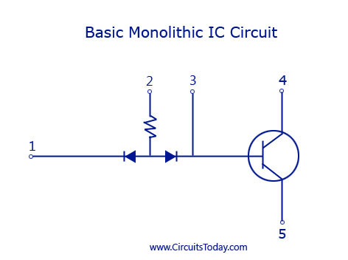

[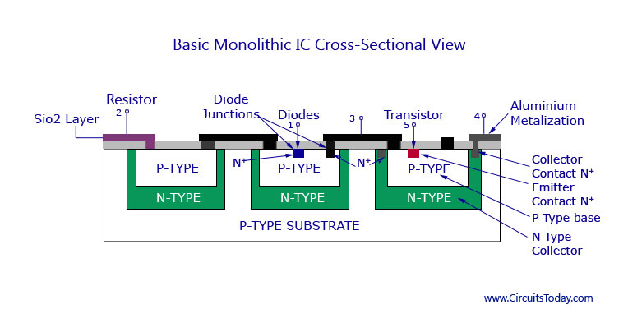](mhtml:file://C:\Users\ABIODUN%20DAVID\Downloads\Monolithic%20IC-Fabrication%20Process-Transistor,Diode,Resistor,Production.mhtml!https://www.circuitstoday.com/wp-content/uploads/2009/09/Basic-Monolithic-IC.jpg)

* **P-SUBSTRATE**: This is the first step in making IC. Here, a cylindrical p-type silicon crystal is grown having typical dimension 25cmlong and 2.5cm diameter. The crystal is then cut by a diamond saw into many thin wafers, the typical thickness of the wafer being 200µm. One side of the wafer is polished to get of surface imperfections. This wafers is called the ***substrate*.** The ICs are produced on this wafer.



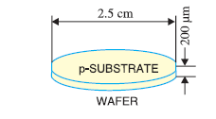

* **EPITAXIAL N LAYERS:** This is the second step which deals with the putting of the wafer in a diffusion furnace. A gas mixture of silicon atoms and pentavalent atoms is passed over the wafers. This form a thin layer of n-type semiconductor on the heated surface of substrate. This thin layer is called ***epitaxial layer*** and is about 10µm thick. It is in this layer that the whole IC is formed.



* **INSULATING LAYER:** this step is taken in order to prevent contamination of the epitaxial layer, a thin SiO2 layer about 1µm thick is deposited over the entire surface. This is achieved by passing pure oxygen over the epitaxial later. The oxygen atoms combine with silicon atoms to form a layer of silicon dioxide (SiO2).
* **PRODUCING COMPONENTS:** By the process of diffusion, appropriate materials are added to the substrate at specific location to produce diode, transistors, resistors and capacitors.
* **PHOTOLITHOGRAPHIC AND ETCHING:** Before any impurity is added to the substrate, the oxide layer (i.e the SiO2  layer) is etched. The process of etching exposes the epitaxial layer and permit the production of desired components are processed by etching the oxide layer at the desired location.
* **CHIP:** In practice, the wafer is divided into large number of layers. Each of these areas will be a separate chip. The manufacturer produces hundreds of alike ICs on the wafer over each area. To separate the individual ICs, the wafer is divided into small chip by a process similar to glass cutting. It may be seen that hundreds of alike ICs can be produced from a small wafer. This simultaneous mass production is the reasons for the low cost of ICs. After chip is cutted, it is bonded to its mounting and connections are made between the ICs and external leads. The ICs is now encapsulated to prevent it from becoming contaminated by the surrounding atmosphere.
* **Component Diffusion:** Diffusion is the process of fabricating the circuit components on the wafer. The etched wafer is now sub-divided into portions, ones that cannot take impurities because they still have the SiO2 layer remaining. The second are diffusion acceptor portions that have the SiO2 removed. Controlled and very high temperatures are used to diffuse p-type impurities into the exposed n-type epitaxial layer. This result in n-type regions called isolation islands; they permit isolation of the various components of the IC, the components will later be formed separately on different islands. The diffusion process is repeated a number of times as various components are fabricated on to the IC. Aluminum is used to create the required interconnections between the components.
* **Scribing and mounting**: The ready wafers now need to be put in chips. Hundreds of ICs can be produced from a single wafer. The wafer is then cut and assembled in the required chips. The chips have a ceramic casing and external leads are made after mounting the IC on to the cover, a process called encapsulating. The IC chips are now ready for use.

**QUESTION 4**

Find the intrinsic carrier concentration in silicon at 3000k for which N=3×1025m-3, Eg=1.1eV,µe=0.14m2/V-S, and µh=0.05m2/V-S. Also, find the conductivity of silicon.

**SOLUTION**

Recall that;

ni = N*exp $\left(-\frac{E_{g}}{2KT}\right)$*

Therefore,

N=3×1025m-3, Eg=1.1×1.6×10-19=1.76×10-19J

K=1.38×10-23J/K, T=3000K

Substituting the values;

ni = =2×1016m-3

Therefore, the intrinsic carrier concentration in silicon is  **2×1016m-3**

To find the conductivity,

Recall that,

Ơ=ni(µe + µh)

Ơ=2×1016×1.6×10-19(0.14+0.05)=0.61×10-3 S/m

Therefore, the conductivity of silicon = **0.61×10-3 S/m**

**QUESTION 5**

Explain how electronic circuit consisting of different components can be constructed in a monolithic IC.

**SOLUTION**

One notable feature of an ICs is that it comprises of a number of circuit elements inseparably associated in a single small package to perform a complete element function. The following are the ways by which various elements (like diodes, transistors, resistors e.t.c) can be constructed in an IC form.

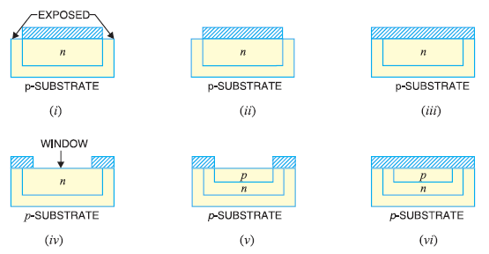

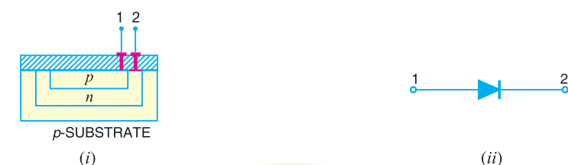

* **DIODES:** One or more diodes are formed by diffusing one or more small n-type deposits at appreciate locations on the substrates. The above diagram shows how a diode is formed on a portion of substrate of a monolithic IC. Part of SiO2 layers is etched off, exposing the epitaxial layer in (i). the wafer is then put into a furnace and trivalent atoms are diffused into he epitaxial layer. The trivalent atoms change the exposed epitaxial layer from n-type semiconductor to p-type. Thus we get an island of n-type material under the SiO2 layer in (ii).

The next pure oxygen is passed over the wafer to form a complete SiO2layer in (iii). A hole is then etched at the center of this layer thus exposing the n-epitaxial layer (iv). This hole is SiO2 layer is called ***window***. Now we passed trivalent atoms through the window. The trivalent atoms diffuse into the epitaxial layer to form a island of p-type material in (v). the SiO2 layer is formed on the wafer by blowing pure oxygen over the wafer (vi). Therefore, the p-n junction is formed on the substrate.

The last stage is to attach the terminals. For this purpose, we etch the SiO2layer at the desired location in (i) above. By depositing metal at this location, we make electrical contact with the anode and cathode of the integrated diode. In (ii) above shows the electrical circuit of the diode.

* **TRANSISTORS:** They are formed by using the same principle as for the diode. The below diagram shows how a transistor is formed on a portion of the substrate of the monolithic IC. For this purpose, the steps used for fabricating diode are carried out up to the point where p island has been formed and sealed off (vi) above. This diagram is repeated as (i) below and shall be taken as the starting point in order to avoid repetition.



A window is now formed at the center of SiO2 layer, thus exposing the p-epitaxial layer in (ii). Then we passed pentavalent atoms through the window. The pentavalent atoms diffused into the epitaxial layer to form an island of n-type materials in (iii). The SiO2 layer is reformed over the wafer by passing pure oxygen (iv). The terminals are processed by etching the SiO2 layer at appropriate locations and depositing the metal at this location in(v). In this way, we get the integrated circuit . (vi) shows the electrical circuit of a transistor.

* **RESISTOR:** The diagram below shows how a resistor is formed on a portion of the substrate of a monolithic IC for this purpose, the steps used in fabricating diode are carried out up to the point where n island has been formed and sealed off.

A window is now formed at the centre of SiO2 layer, thus exposing the n-epitaxial layer in (iv). The terminals are processed y etching SiO2 layers at two points above the p island depositing the metal at these locations in (v). in this way, we get an integrated circuit . (vi) shows the electrical circuit of a transistor.



The value of resistor is determined by the material, its length and area of cross-section. The high-resistance resistors are long and narrow while low-resistance resistors are short and of greater cross-section.

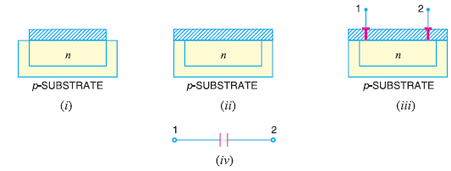

**CAPCITORS:** The diagram above shows the process of fabricating a capacitor in the monolithic IC. The first step is to diffuse an n-type material into the substrate which forms one plate of the capacitor in (i). the SiO2 layer is reformed over the wafer by passing pure oxygen in (ii).

The SiO2layer formed acts as the dielectric of the capacitor. The oxide layer is etched and terminal 1 is added in (iii). Next a large (compared to the electrode of terminal 1) metallic electrode is deposited on the SiO2layer and formed the second plate of the capacitor. The oxide plate is etched and terminal 2 is added. This gives an integrated capacitor. The value of capacitor formed depends upon the dielectric constant of SiO2 layer, thickness of SiO2­ layer and the area of cross-section of the smaller of the two electrodes.

**QUESTION 6**

How is an n and p-type semiconductor formed?

**SOLUTION**

**Formation of n-type semiconductors**

N-type semiconductor is formed by the addition of pentavalent material (e.g antimony) to pure Silicon crystal. Each silicon atom form covalent bond with the surrounding four silicon atoms with the help of four of its five electrons. The fifth electron is superfluous and is loosely bound to the antimony atom. Hence it can easily be excited from the valence band to the conduction band by the application of ***electric field*** or ***increase in thermal energy***. The fifth electron from the antimony atom move to the conduction band without creating a positive hole in the valence band. Here antimony is called ***donor*** impurity because it donate one electron to the conduction band of the silicon and makes the pure silicon an N-type and electron is the majority carrier while hole is the minority carrier because they have excess electron.

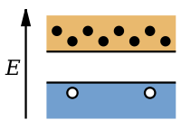



**Formation of P-type semiconductor**

P-type semiconductor is formed when trivalent electron like boron are added to pure germanium crystal. Here, the three valence electron of boron atom form covalent bonds with four surrounding germanium atoms but one bond is left incomplete and gives rise to a hole. Therefore, boron which is called ***acceptor*** impurity cause as many positive holes in a germanium crystals as there are boron atoms thereby producing a P-type and holes here are the majority carrier and the electron are the minority carrier.



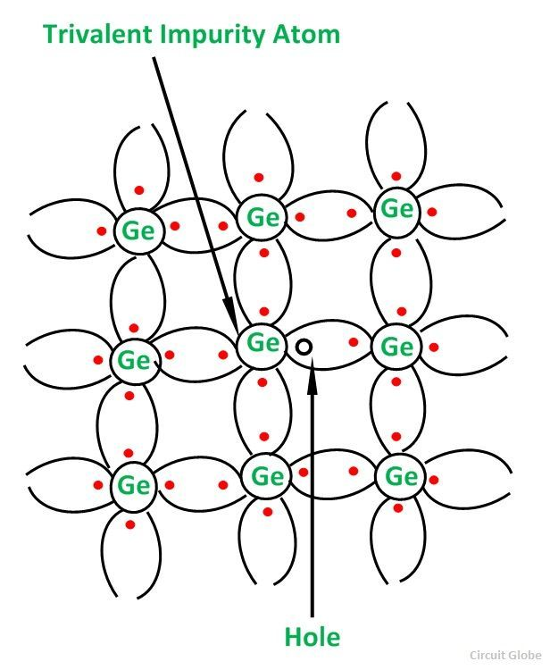

CRYSTAL SRUCTURE OF P-TYPE SEMICONDUCTOR

**QUESTION 7**

Discuss the effect of temperature on semiconductors?

**SOLUTION**

A semiconductor is a material which has electrically conductivity to a degree between that of a metal and that of an insulator.

**At absolute zero 00k** and **at low temperatures**, the valence electrons present in a semiconductor do not have sufficient energy to move from valence band to the conduction band. Thus, semiconductors acts as an insulator at 00k. As the temperature increases, a large number of valence electrons acquire sufficient energy to leave the valence band, cross the forbidden bandgap and reach conduction band. These are now free electrons as they can move freely under the influence of electric field.

**At room temperature**, there are sufficient electrons in the conduction band and hence, the semiconductor is capable of conducting some current at room temperature.

**QUESTION 8**

Explain what you understand by intrinsic and extrinsic semiconductor?

**SOLUTION**

**An intrinsic semiconductor** is one that has no impurities. This is one which is pure enough that impurities do not appreciably affects its electrical behavior. Here, all carriers are created due to thermally or optically excited electrons from the full valence band into the empty conduction band. Thus equal number of electrons and holes are present in an intrinsic semiconductor. Also, electrons and holes flows in opposite direction in the electric field, though they contribute to current in the same direction since they are oppositely charged. At low temperature, the valence band is completely full making the material an insulator and increase in temperature, leads to increase in number of carriers and a corresponding increase in conductivity. A good epitome of intrinsic semiconductor is silicon which is100% pure for use as a semiconductor.

**An extrinsic semiconductors** are those intrinsic semiconductors which some impurities has been added to them thereby making them impure. These impurities added are called ***dopant*** which gives rise to **doping. Doping** can be defined as the drastically increase of conductivity of an intrinsic semiconductor material by the addition of impurities. The controlled addition of impurities in an intrinsic semiconductors leads to continuous increase in conductivity of the material, thereby increase the number of current carriers (electrons or hole). Doping leads to N-type or P-type extrinsic semiconductor. The impurity added is 1 part of 106 atoms.

**QUESTION 9**

Discuss the behavior of p-n junction under forward and reverse biasing?

**SOLUTION**

**Forward biasing** is when the positive terminals of a dc source or a battery is connected to p-type and the negative terminal is connected to the N-type semiconductors of a p-n junction. This case is forward biasing because it permit easy flow of current across the junction. This current flow may e explained in the following ways:

* As soon as battery connection is made, holes are *repelled* by the positive battery terminal and electrons by the negative battery terminal with the result that both the electrons and the holes are driven *towards* the junction where they recombine. This *mass* movement of electrons to the left and that of holes to the right of the junction constitutes a large current flow through the semiconductor. Obviously, the junction offers *low resistance* in the forward direction. As free electrons move to the left, new *free* electrons are injected by the negative battery terminal into the *N*–region of the semiconductor. Thus, a flow of electrons is set up in the wire connected to the negative battery terminal. As holes are driven towards the junction, more holes are created in the *P*–region. These newly–created holes are driven towards the junction to keep up a continuous supply. But the electrons so produced are attracted to the left by the positive battery terminal from where they go to the negative terminal and finally to the *N*–region of the crystal. Incidentally, it may be noted that though there is movement of both electrons and holes *inside* the crystal, *only free electrons move in the external circuit.* There is also presence of an extremely small amount of current *Io* due to minority carriers on either side of the junction. But it is negligible as compared to forward current which is due to majority carriers. This current *Io* depends on temperature but is almost independent of applied voltage.
* Another way to explain current flow in forward direction is that forward bias of *V* volts lowers the barrier potential to (*V-VB*) which now allows more current to flow across the junction. Incidentally, it may be noted that forward bias reduces the thickness of the depletion layer.

**Reverse Biasing:** When the external d.c. voltage applied to the junction is in such a direction that potential barrier is increased, it is called reverse biasing.To apply reverse bias, the positive terminal of the battery is connected to n-type and negative terminal to p-type of the pn junction as shown in the fidure below:

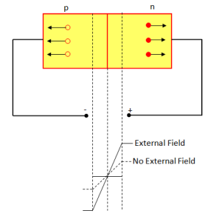

The applied reverse voltage establishes an electric field which acts in the same direction as the field due to potential barrier.Therefore, the resultant field at the junction is strengthened and the barrier height is increased as shown in the figure above.The increased potential barrier prevents the flow of charge carriers across the junction. Thus, a high resistance path is established for the entire circuit and hence the current does not flow.



**QUESTION 10**

Draw and explain the behavior of a V-I characteristics of a p-n junction?

**SOLUTION**

**V-I Characteristics of PN Junction Diode:**

Volt-ampere (V-I) characteristics of a pn junction or semiconductor diode is the curve between voltage across the junction and the current through the circuit.Normally the voltage is taken along the x-axis and current along y-axis.The circuit connection for determining the V-I characteristics of a pn junction is shown in the figure below.

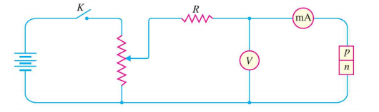

**Circuit connection for v-i characteristics of a p-n junction**

The characteristics can be explained under three cases, such as :

* Zero bias,
* Forward bias and
* Reverse bias.
* **Zero bias**: In zero bias condition , no external voltage is applied to the pn junction i.e the circuit is open at K.Hence, the potential barrier at the junction does not permit current flow.Therefore, the circuit current is zero at V=0 V, as indicated by point O in figure below:

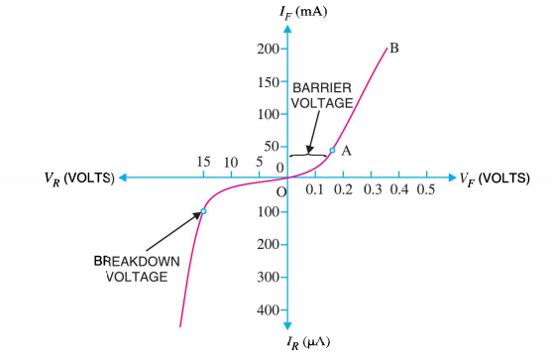

* **Forward Bias:** In forward biased condition , p-type of the pn junction is connected to the positive terminal and n-type is connected to the negative terminal of the external voltage.**This results in reduced potential barrier**. At some forward voltage  i.e 0.7 V for Si and 0.3 V for Ge, the potential barrier is almost eliminated and the current starts flowing in the circuit. From this instant, the current increases with the increase in forward voltage. Hence.  a curve OB is obtained with forward bias as shown in figure above. From the forward characteristics, it can be noted that at first i.e. region OA , the current increases very slowly and the curve is non-linear. It is because in this region the external voltage applied to the pn junction is used in overcoming the potential barrier.

However, once the external voltage exceeds the potential barrier voltage, the  potential barrier is eliminated and the pn junction behaves as an ordinary conductor. Hence , the curve AB  rises very sharply with the increase in external voltage and the curve is almost linear.

* **Reverse Bias:** In reverse bias condition, the p-type of the p-n junction is connected to the negative terminal and n-type is connected to the positive terminal of the external voltage. This results in **increased potential barrier** at the junction. Hence, the junction resistance becomes very high and as a result practically no current flows through the circuit.However, a very small current of the order of μA , flows through the circuit in practice. This is knows as reverse saturation current(IS) and it is due to the minority carriers in the junction.

As we already know, there are few free electrons in p-type material and few holes in n-type material. These free electrons in p-type and holes in n-type are called minority carriers . The reverse bias applied to the pn junction acts as forward bias to there minority carriers and hence, small current flows in the reverse direction. If the applied reverse voltage is increased continuously, the kinetic energy of the minority carriers may become high enough to knock out electrons from the semiconductor atom.At this stage breakdown of the junction may occur. This is characterized by a sudden increase of reverse current and a sudden fall of the resistance of barrier region. This may destroy the junction permanently

**QUESTION 11**

Explain briefly the following characteristics of electronic devices; Photoresistor, Phototransistor and photodiode.

**SOLUTION**

**PHOTORESISTOR**

Photoresistor also called **Light Dependent Resistor (LDR)** is a type of device whose resistance changes with respect to the intensity of the incident radiation. It has a tremendous ability to change its resistance in exposure to light. LDR is an acronym for Light Dependent Resistor. It is a non-linear device.The photoresistor is also termed as ‘**photoconductor**’ as it displays the property of photoconductivity. **Photoconductivity** is the phenomenon which improves the conductivity of the material by absorbing electromagnetic radiation. The radiation can be a gamma, UV, IR radiation or a visible light.

There are two types of photoresistor namely:

* **Intrinsic photoresistor:**
* **Extrinsic photoresistor**:

**Structure**

The photoresistor is composed of light-sensitive semiconductor material. Usually, it is made up of cadmium sulphide having negligible free electrons in the absence of any incident radiation.In the absence of light, LDR possesses very high resistance of about several mega ohms. However, in the presence of light, it exhibits low resistance property, having the resistance of about a few hundred ohms.

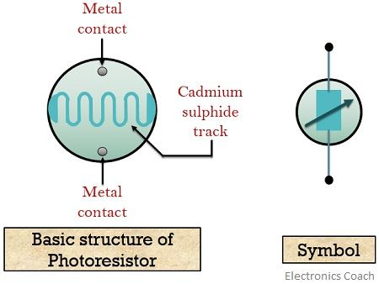

The device consists of a **snake-like** or **zigzag pattern** track which is made up of cadmium sulphide. The snake-like arrangement is done in order to get the expected power rating and resistance. This track separates a pair of metal contact. The whole structure is placed in a plastic case so as to have direct exposure to the incident radiation. As it is required to change the resistance by the action of light in LDR, so the resistance of the metal contacts must be low. By the absorption of light rays, the valence band electrons get excited to the conduction band. It is to be noted here that proper light energy is required by the electron to excite into the conduction band. Thus, higher the light energy, higher will be the presence of charge carriers resulting in greater conductivity. The approximate relationship between resistance and illumination, which is given as:

C:\Users\ABIODUN DAVID\AppData\Local\Microsoft\Windows\INetCache\Content.Word\eqn2-1.jpg

Here, **R** denotes the **resistance** in ohm

**E** denotes the **illumination** and

**A** and **α** are **constant**

The manufacturing procedure and Cadmium sulphide decide the value of constant α.

**PHOTOTRANSISTORS:**

A Phototransistor is a device that has the ability to detect the level of the incident radiation and accordingly change the flow of electric current between emitter and collector terminal. It is a 3-layer semiconductor device that consists of a light sensitive base region. It is basically a transistor whose action depends on the application of light. Hence named phototransistor. The phototransistor is basically an enhancement of Photodiode. Both photodiode and phototransistor are light sensing device but the sensitivity of phototransistor is somewhat more as compared to the photodiode. As phototransistor has the ability to give larger gain than that of the photodiode. It is similar to a normal**BJT** but the only variation is that in phototransistor, virtually the base region exists but it is kept unconnected with the external supply.

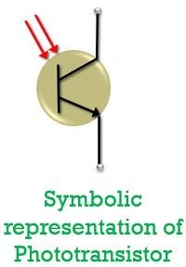

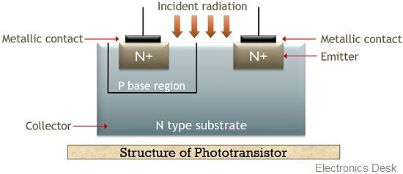

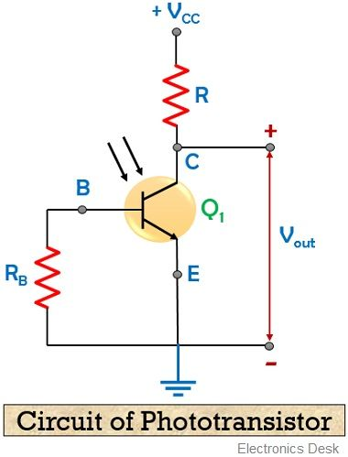

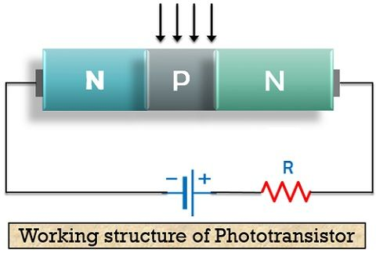

**PHOTODIODES**:

A photodiode is a semiconductor device with a P-N junction that converts photons (or light) into electrical current. The P layer has an abundance of holes (positive), and the N layer has an abundance of electrons (negative). Photodiodes can be manufactured from a variety of materials including, but not limited to, Silicon, Germanium, and Indium Gallium Arsenide. Each material uses different properties for cost benefits, increased sensitivity, wavelength range, low noise levels, or even response speed.

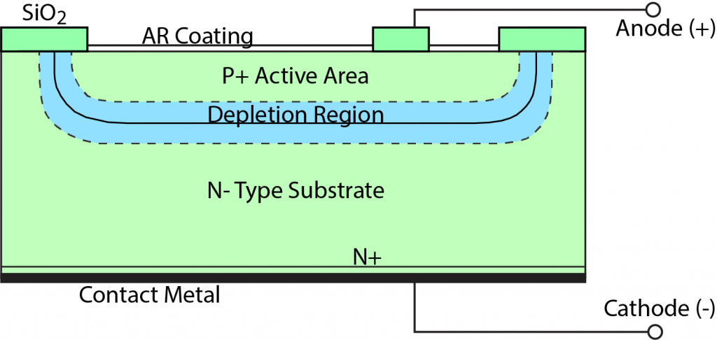

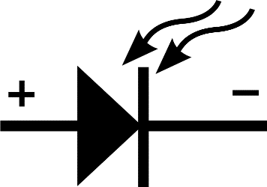

**Types of photodiodes**

* P-n junction
* Pin photodiode
* Avalanche photodiode