**Design and Analysis of Algorithm (DAA)**

**Lab File**

Name : Abir Banerjee

Registration No. : 209303126

Section : CCE D

**1. BINARY SEARCH – ITERATIVE**

**CODE :**

#include <iostream>

using namespace std;

int binarySearch(int array[], int x, int l, int h){

while (l <= h){

int m = l+(h-l)/2;

if (array[m] == x)

return m;

if (array[m] < x)

l = m+1;

else

h = m-1;

}

return -1;

}

int main(void){

cout<<”Registration Number : 209303126”<<endl;

int n,x;

cout<<"Enter size of array"<<endl;

cin>>n;

int array[n];

for(int i=0;i<n;i++){

cout<<"Enter element "<<(i+1)<<endl;

cin>>array[i];

}

cout<<"Enter the element to look for "<<endl;

cin>>x;

int result = binarySearch(array, x, 0, n - 1);

if (result == -1)

cout<<"Not found";

else

cout<<"Element is found at index "<< result<<" and position "<<result+1;

}

**OUTPUT :**

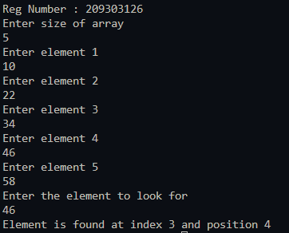

**2.BINARY SEARCH – RECURSIVE**

**Code:**

#include <iostream>

using namespace std;

int binarySearch(int array[], int x, int l, int h){

if (l == h){

if (array[l] == x)

return array[l];

else{

return -1;

}

}

else{

int m = l+(h-l)/2;

if(x==array[m]){

return m;

}

else if(x<array[m]){

return binarySearch(array,x,l,m-1);

}

else{

return binarySearch(array,x,m+1,h);

}

return -1;

}

}

int main(void){

int n, x;

cout << "Enter size of array" << endl;

cin >> n; int array[n];

for (int i = 0; i < n; i++){

cout << "Enter element " << (i + 1) << endl;

cin >> array[i];

}

cout << "Enter the element to look for " << endl;

cin >> x;

int result = binarySearch(array, x, 0, n - 1);

if (result == -1) cout << "Not found";

else cout << "Element is found at index " << result << " and position " << result + 1;

}

**OUTPUT:**

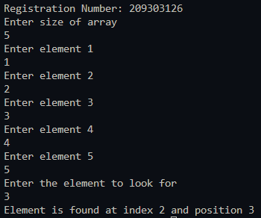

**3. SELECTION SORT**

**Code:**

#include <iostream>

using namespace std;

void swap(int *a, int *b) {

int temp = *a;

*a = *b;

*b = temp;

}

void printArray(int array[], int size) {

for (int i = 0; i < size; i++) {

cout << array[i] << " ";

}

cout << endl;

}

void selectionSort(int array[], int size) {

for (int i = 0; i < size - 1; i++) {

int x = i;

for (int j = i+1; j<size; j++) {

if (array[j] < array[x])

x = j;

}

swap(&array[x], &array[i]);

}

}

int main() {

cout<<"Registration Number: 209303126"<<endl;

int n,x;

cout<<"Enter size of array"<<endl;

cin>>n;

int data[n];

for(int i=0;i<n;i++){

cout<<"Enter element "<<(i+1)<<endl;

cin>>data[i];

}

selectionSort(data, n);

cout << "Sorted array in Acsending Order:\n";

printArray(data, n);

}

**Output:**

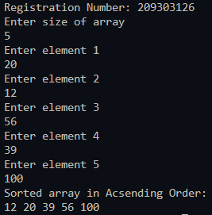

**4. BUBBLE SORT**

**Code:**

#include <iostream>

using namespace std;

void bubbleSort(int array[], int size){

for (int i = 0; i < size; ++i){

for (int j = 0; j < size – i-1; ++j){

if (array[j] > array[j + 1]){

int temp = array[j];

array[j] = array[j + 1];

array[j + 1] = temp;

}

}

}

}

void printArray(int array[], int size){

for (int i = 0; i < size; ++i){

cout << " " << array[i];

}

cout << "\n";

}

int main(){

cout<<"Registration Number: 209303126"<<endl;

cout<<"Enter size of array"<<endl;

int n; cin>>n;

int data[n];

for(int i=0;i<n;i++){

cout<<"Enter element "<<(i+1)<<endl;

cin>>data[i];

}

bubbleSort(data, n);

cout << "Sorted Array in Ascending Order:\n";

printArray(data, n);

}

**Output:**

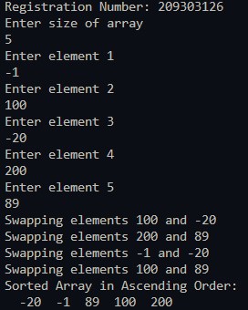

**5. QUICK SORT**

**Code:**

#include <iostream>

using namespace std;

void printArray(int array[], int size){

int i;

for (i = 0; i < size; i++)

cout << array[i] << " ";

cout << endl;

}

int partition(int array[], int low, int high){

int pivot = array[low];

int i = low+1;

int j=high;

do{

while(array[i] < pivot){

i++;

}

while(array[j] > pivot){

j--;

}

if(i<j){

int temp = array[i];

array[i] = array[j];

array[j] = temp;

}

}while(i<j);

int temp = array[j];

array[j] = array[low];

array[low] = temp;

return j;

}

void quickSort(int array[], int low, int high){

if (low < high){

int pi = partition(array, low, high);

quickSort(array, low, pi - 1);

quickSort(array, pi + 1, high);

}

}

int main(){

cout<<"Registration Number: 209303126"<<endl;

cout<<"Enter size of array"<<endl;

int n; cin>>n;

int data[n];

for(int i=0;i<n;i++){

cout<<"Enter element "<<(i+1)<<endl;

cin>>data[i];

}

cout << "Unsorted Array: \n";

printArray(data, n);

quickSort(data, 0, n - 1);

cout << "Sorted array in ascending order: \n";

printArray(data, n);

}

**Output:**

**6. Merge Sort**

**Code:**

#include<iostream>

using namespace std;

void display(int *array, int size) {

for(int i = 0; i<size; i++)

cout << array[i] << " ";

cout << endl;

}

void merge(int *array, int l, int m, int r) {

int i, j, k, nl, nr;

nl = m-l+1; nr = r-m;

int larr[nl], rarr[nr];

for(i = 0; i<nl; i++)

larr[i] = array[l+i];

for(j = 0; j<nr; j++)

rarr[j] = array[m+1+j];

i = 0; j = 0; k = l;

while(i < nl && j<nr) {

if(larr[i] <= rarr[j]) {

array[k] = larr[i];

i++;

}else{

array[k] = rarr[j];

j++;

}

k++;

}

while(i<nl) {

array[k] = larr[i];

i++; k++;

}

while(j<nr) {

array[k] = rarr[j];

j++; k++;

}

}

void mergeSort(int *array, int l, int r) {

int m;

if(l < r) {

int m = l+(r-l)/2;

mergeSort(array, l, m);

mergeSort(array, m+1, r);

merge(array, l, m, r);

}

}

int main() {

cout<<"Registration Number : 209303126"<<endl;

int n;

cout << "Enter the number of elements: "<<endl;

cin >> n;

int arr[n];

for(int i = 0; i<n; i++) {

cout << "Enter element "<<(i+1)<<endl;

cin >> arr[i];

}

cout << "Array before Sorting: ";

display(arr, n);

mergeSort(arr, 0, n-1);

cout << "Array after Sorting: ";

display(arr, n);

}

**Output:**

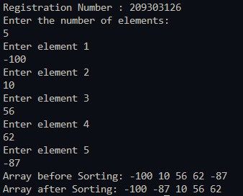

**7. KNAPSACK PROBLEM**

**Code:**

#include<bits/stdc++.h>

using namespace std;

int max(int a, int b){

if (a > b){ return a;}

else{ return b; }

}z

int knapsack(int W, int wt[], int prof[], int n){

int i, w;

int knap[n + 1][W + 1];

for (i = 0; i <= n; i++){

for (w = 0; w <= W; w++){

if (i == 0 || w == 0)

knap[i][w] = 0;

else if (wt[i - 1] <= w)

knap[i][w] = max(prof[i - 1] + knap[i - 1][w - wt[i - 1]], knap[i - 1][w]);

else

knap[i][w] = knap[i - 1][w];

}

}

return knap[n][W];

}

int main(){

int n;

cout<<"For registration number : 209303126 \n";

cout<<"Enter number of values \n";

cin>>n;

int prof[n], wt[n];

for (int i = 0; i < n; i++){

cout<<"Enter the profit and weight of object"<<(i+1)<<endl;

cin>>prof[i];

cin>>wt[i];

}

cout<<"Enter the capacity of the knapsack \n";

int weight;

cin>>weight;

cout<<"Maximum Profit is "<< knapsack(weight, wt, prof, n);

return 0;

}

**Output:**

**8. INSERTION SORT**

**Code:**

#include <iostream>

using namespace std;

void printArray(int array[], int size) {

for (int i = 0; i < size; i++) {

cout << array[i] << " ";

}

cout << endl;

}

void insertionSort(int array[], int size) {

for (int step = 1; step < size; step++) {

int key = array[step];

int j = step - 1;

while (key < array[j] && j >= 0) {

array[j + 1] = array[j];

--j;

}

array[j + 1] = key;

}

}

int main() {

cout<<"Enter number of elements"<<endl;

int n;

cin>>n;

int a[n];

for(int i=0;i<n;i++){

cout<<"Enter element "<<(i+1)<<endl;

cin>>a[i];

}

insertionSort(a,n);

cout << "Sorted array in ascending order:\n";

printArray(a,n);

}

**Output:**

