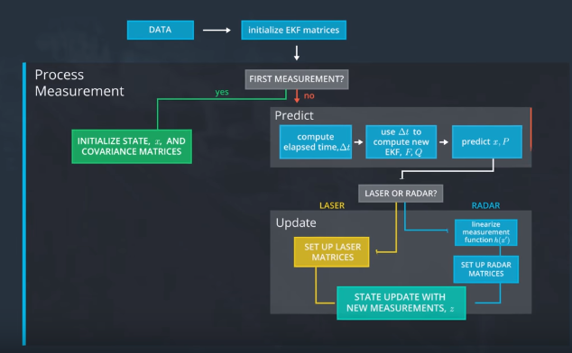

CPP code for:

Update-Laser: Lesson 5.13

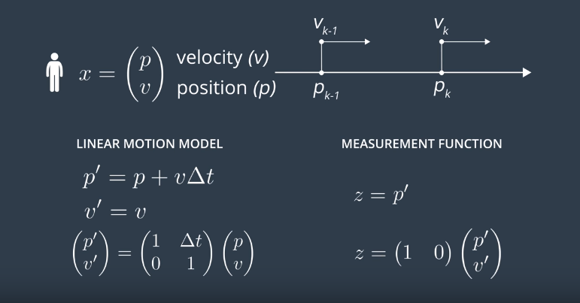

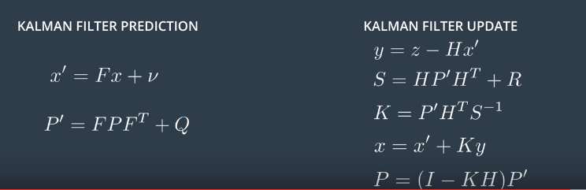

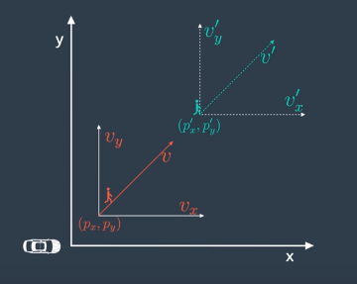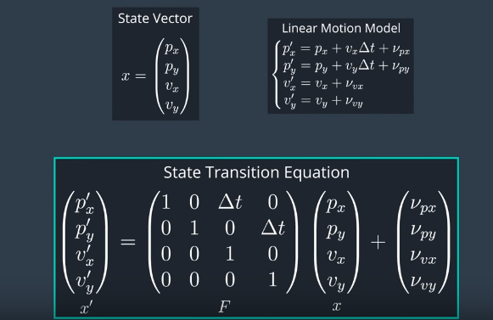

As a reminder, the above equation is *x*​′​​=*Fx*+*noise*

Motion noise and process noise refer to the same case: uncertainty in the object's position when predicting location. The model assumes velocity is constant between time intervals, but in reality we know that an object's velocity can change due to acceleration. The model includes this uncertainty via the process noise.

Measurement noise refers to uncertainty in sensor measurements

**RADAR**

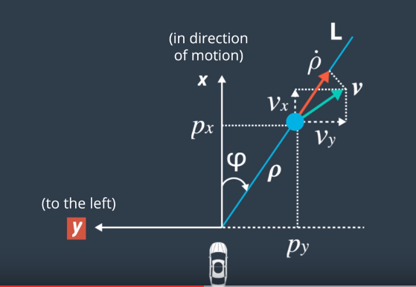 L5.14

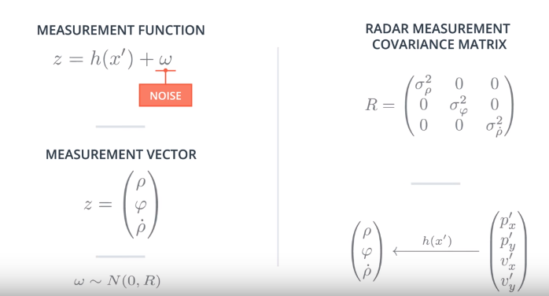L5.14

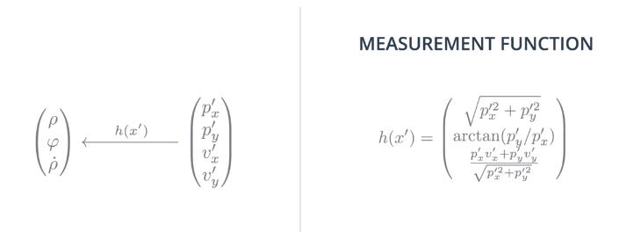L5.14

NOTE: The Measurement Function is NON-LINEAR !!!

That is why we do not have a linear measurement matrix **H**, as in Lidar, but a non-linear measurement function **h(x’).**

A Gaussian does stay a Gaussian!

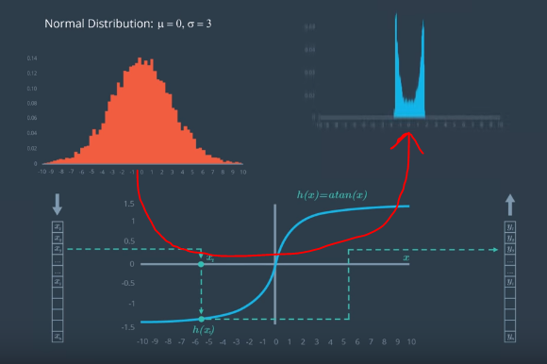

That is why we need an Extended Kalman Filter. (L5.16)

EKF uses a linear approximation of h(x)!

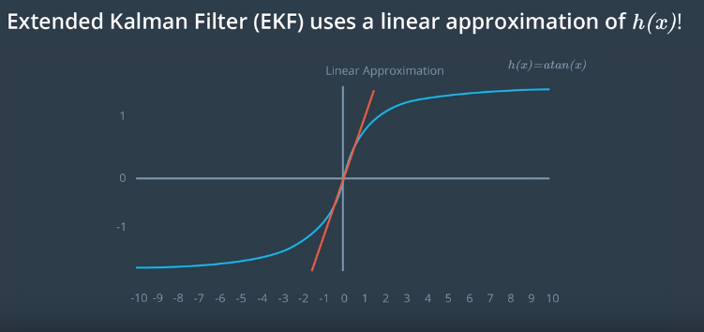

EKF uses First Order Taylor expension of h(x) (measurement) , and also for f(x) if the state transition is non-linear!

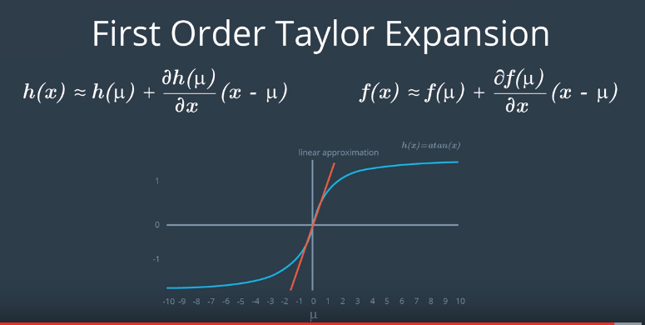

First derivatives of multivariate Taylor Series are given by the Jacobian (D) – Lesson 5.17,18,19

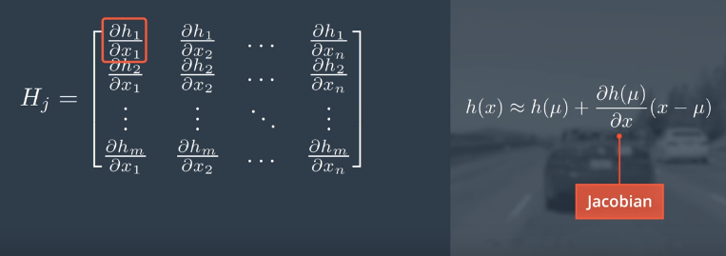

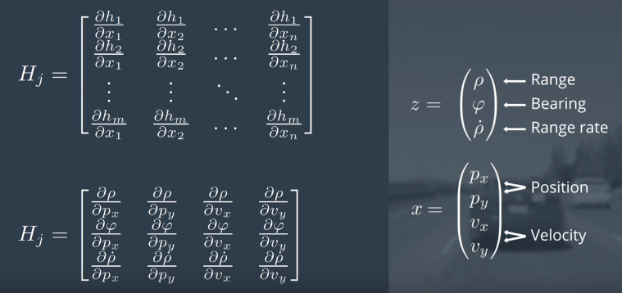

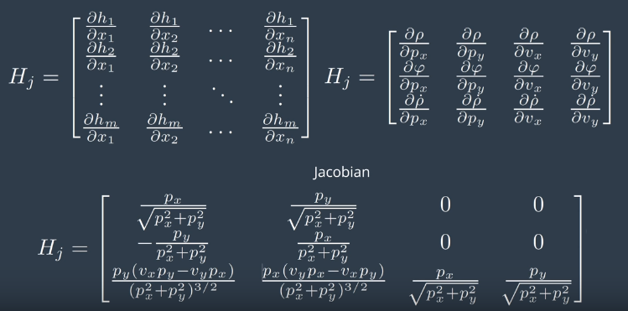

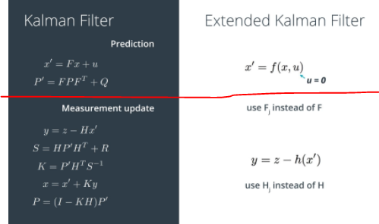 (L5.19)

