LESSON 8.2: Advanced Deep Learning Preview

First study again Term1 deep learning module, summarized in the theory document.
Also review these two examples, using the Le-Net convolutional networks for classification of MNIST & Traffic Signgs:

PROJECTS/Term1/CarND_Traffic_Sign_Classifier_Project/Theory:
- MiniFlow_TensorFlow_Keras_Traffic-Sign-Classifier-with-Convolutional-Neural-Network.odt
- Traffic_Sign_Classifier.ipynb

PROJECTS/Term1/CarND_LeNet_Lab
- lenet_lab_solution.py

----------------------------------------------------------------------------------------------------------------------------

Partnered with NVIDIA Deep Learning Institute to build a module that covers:
- Semantic Segmentation
- Inference Optimization

Semantic segmentation:
Identifies free space on the road at pixel-level granularity.

Inference optimization:
Accelerate the speed at which neural networks can make predictions.
(definition of Inference = A conclustion reached on the basis of evidence and reasoning)

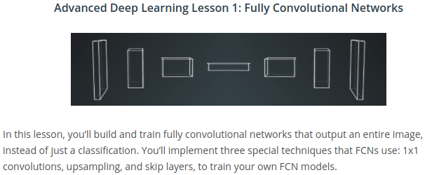

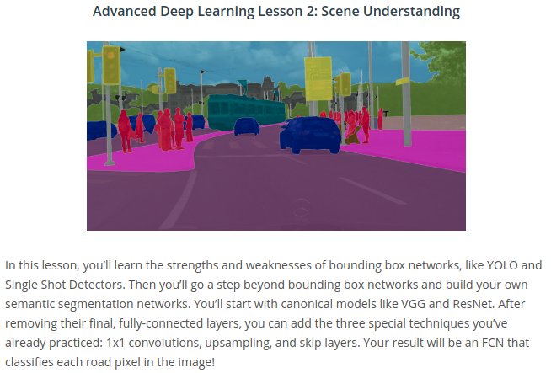
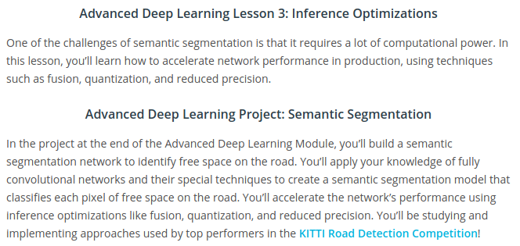
LESSON 9.2: Why Fully Convolutional Networks?

A typical convolutional neural network for classification (See Term1 (Le-Net)):

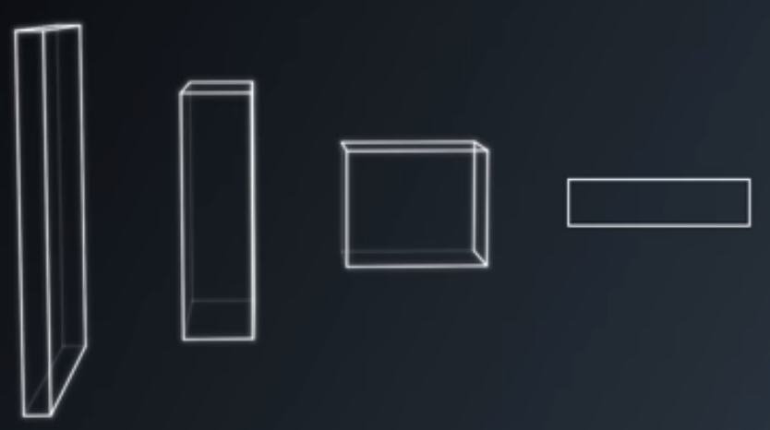
\_____________________________________________________/ \________________________/

Convolutional Layers ---> Fully connected layers with a
softmax activation function
(eg. Linear_softmax_cross_entropy)

Great architecture for tasks like classification of picture: “Is this a hotdog?”

Not good for answering a question like: “Where in this picture is the hotdog?”

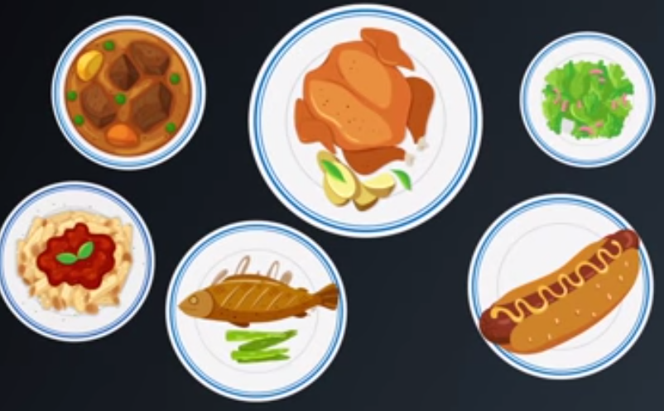

Cannot be answered by Fully Connected Layers, because they don’t preserve spatial information!

That is where Fully Convolutional Networks come in:

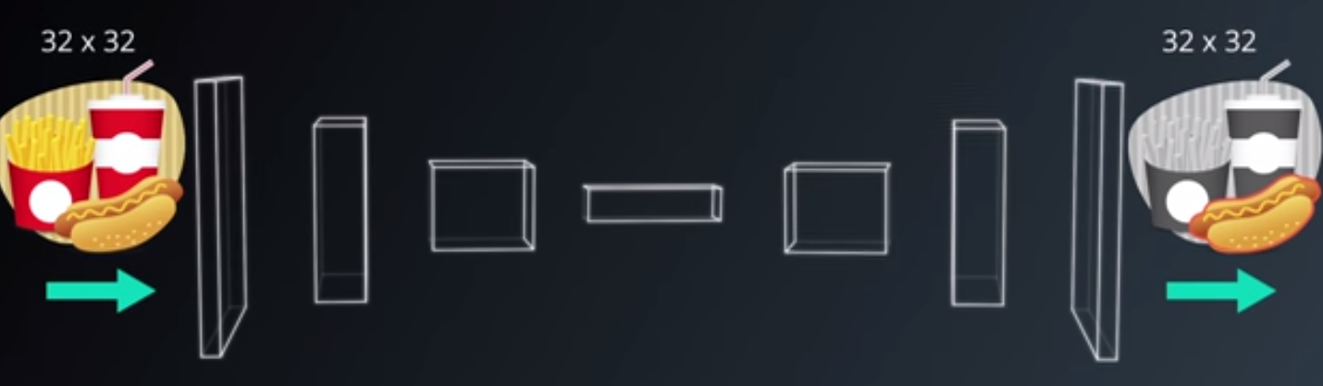
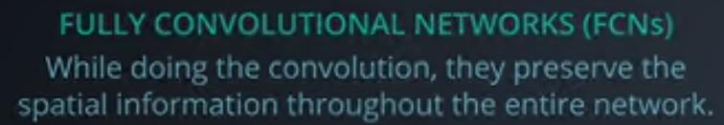
Also: They work on images of any size. (28x28, or 32x32, or....)

In the regular Convolutional Networks of Term1, the last layers were Linear nodes (Fully Connected, xW+b), which are set up with pre-defined sizes for the Weight Matrices, and thus only work on a single image size.

LESSON 9.3: Fully Convolutional Networks (FCNs)
Give state of the art results in computer vision tasks, such as semantic segmentation.

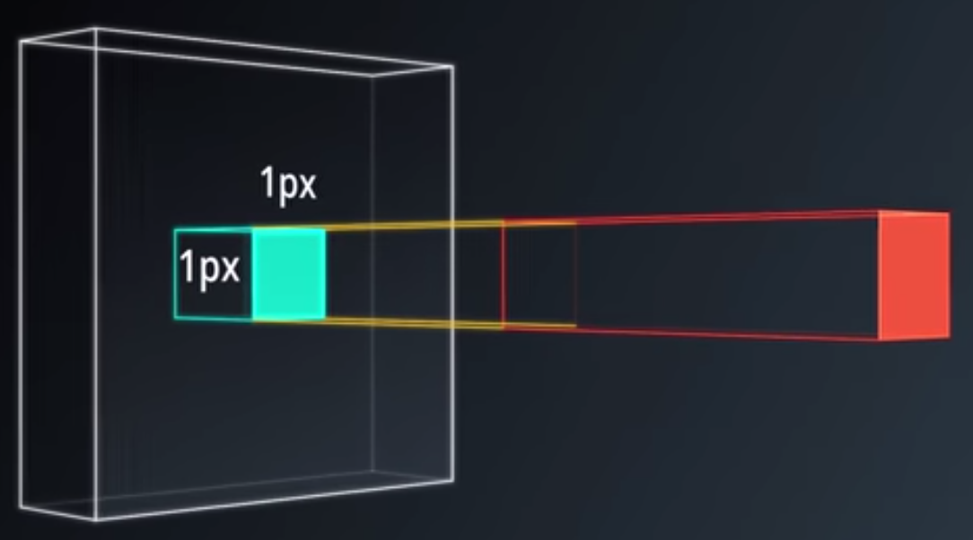
FCNs take advantage of 3 special techniques:
- Replace fully connected layers (Linear Nodes at the end) with 1x1 convolutional layers. (It does the same, but in a different approach that is size independent. For good explanation see TERM1 Lesson 8.28 or https://stackoverflow.com/questions/39366271/for-what-reason-convolution-1x1-is-used-in-deep-neural-networks )

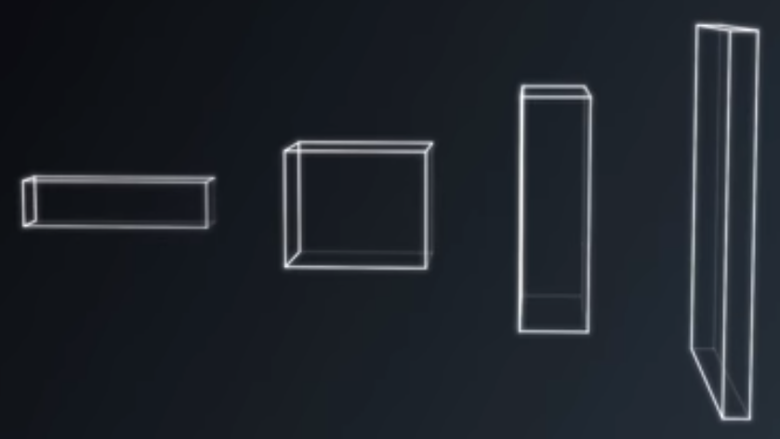
- Up-sampling through the use of transposed convolutional layers. (Also known as deconvolution)

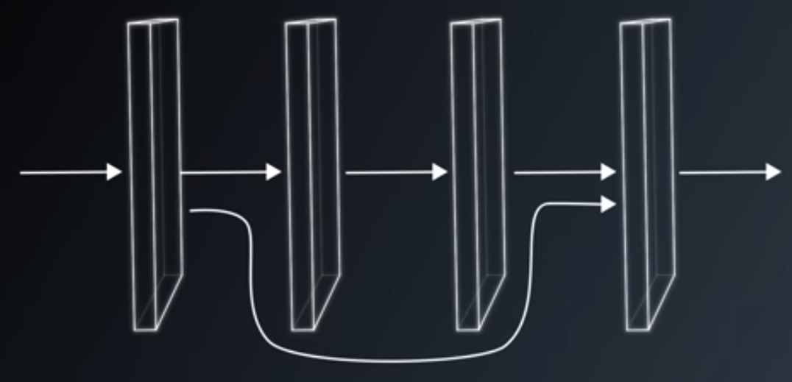
- Skip Connections, to allow the network to use information from multiple resolution scales, allowing the network to make more precise segmentation decistions:
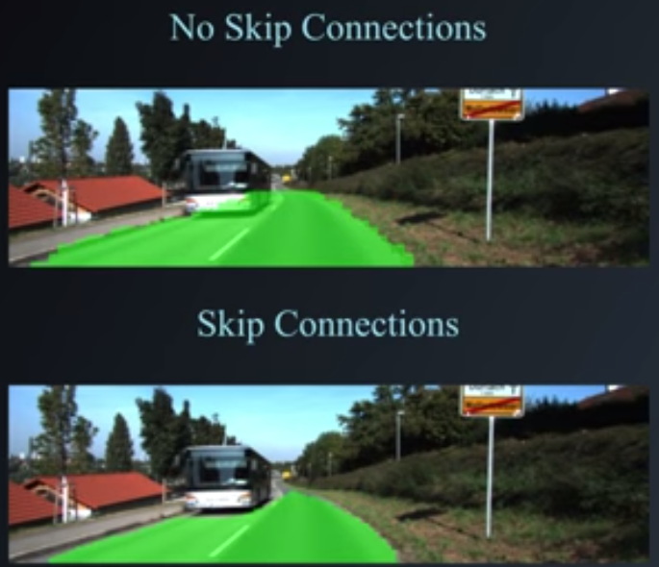

Structurally an FCN is usually comprised of two parts: Encoder & Decoder

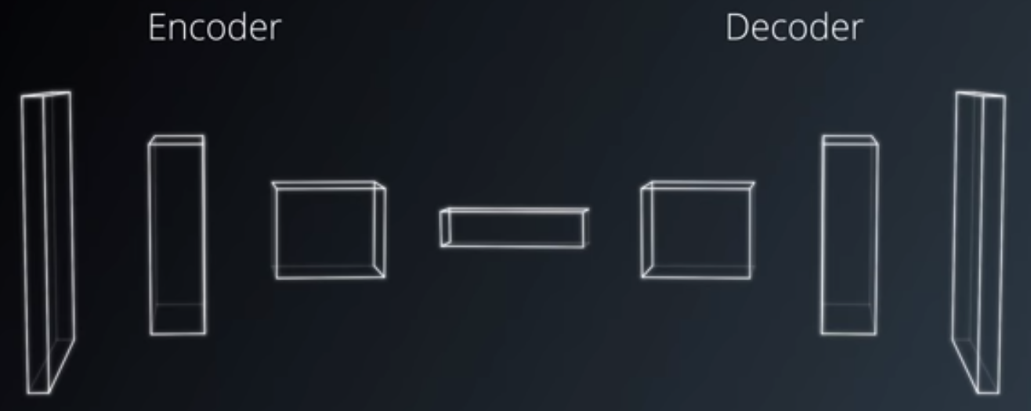
Encoder:
- Series of convolutional layers, like VCG and ResNet
- The goal of encoder is to extract features from the image

Decoder:
- Up-scales the output of the encoder such that it’s the same size as the original image
- Thus, it results in segmentation or prediction of each individual pixel in the original image.

LESSON 9.4: Fully Connected replace by 1x1 Convolution

Fully Connected layer = XW+b --> Matrix multiply with:
- Input is a 2D Matrix: (n_batch, n_features) n_features is flattened height x weight x depth
  - X = Input = (n_batch, n_features) n_features are # output features of previous layer
  - W = Weights = (n_features, n_hidden) n_hidden are the # of output features of this layer
  - b = bias = (n_batch)
- Output is a 2D Matrix: (n_batch, n_hidden)

1x1 Convolution: It does the same multiplications, but it maintains spatial information in 4D Tensor, instead of having flatten everything to 2D Matrix (n_batch, n_features).
- Input is a 4D tensor: (n_batch, height, width, depth_in)
  - Note that at first input, the depth is # color channels (3 for RGB, 1 for Grayscale)
- Output tensor will remain 4D (n_batch, height, width, depth_out)
- The only dimension changing is the DEPTH, because for a Convolutional Layer:
  - out_height = ceil(float(in_height - filter_height + 1) / float(strides[1]))
  - out_width = ceil(float(in_width - filter_width + 1) / float(strides[2]))
With filter_height = 1 and sride=1, the out_height = in_height

In Tensorflow (Lesson 9.5 & 9.6, but now here for new tensorflow)

def conv_1x1(x, num_outputs):
kernel_size = 1
stride = 1
return tf.layers.conv2d(x, num_outputs, kernel_size, stride, kernel_initializer=custom_init)

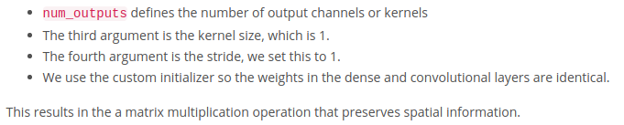

LESSON 9.7: Transposed Convolutions (also known as deconvolution)
The second special technique to create the decoder of FCN’s.

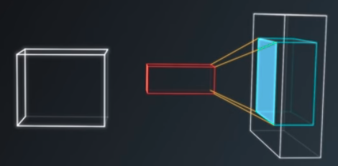
A transpose convolution is a reverse convolution in which the forward an the backward passes are swapped.

Some people call it deconvolution, because it undoes the previous convolution.

Because all we do is swap forward and backward passes, the math is exactly the same as what we’ve done earlier. The property of differentiability is retained and training is exactly the same as previous neural networks. For some helpful animations, see: https://github.com/vdumoulin/conv_arithmetic
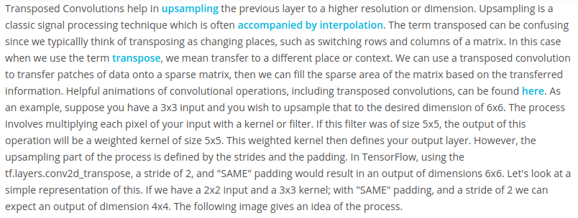
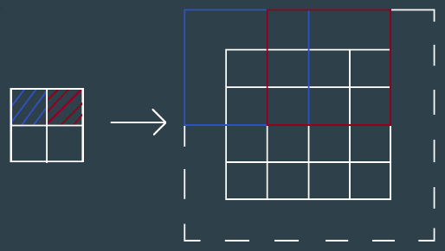
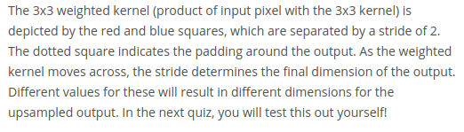

LESSON 9.8 – 9.9: Transposed Convolution Quiz (use of tf.layers.conv2d_transpose)

Usethe quiz.py to check what output size you get with different kernel sizes and strides.

It prints:
Input Shape: (1, 4, 4, 3)
Output Shape: (1, 8, 8, 3)

LESSON 9.9: Skip Connections
The 3rd technique used in FCNs (Fully Convolutional Networks)
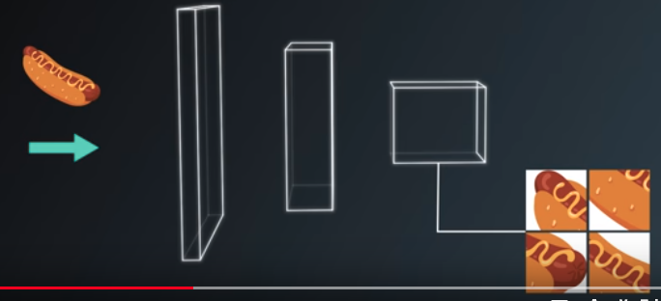
One effect of convolutions is that you narrow down the scope by looking closely at some picture and lose the bigger picture as a result, so even if the decoder upsamples it back to the original image size, some information has been lost.

Skip Connections are a way of retaining the information easily. The way skip connections work is by connecting the output of one layer to a non-adjacent layer. For example, here the output of the pooling layer from the encoder combine with the current layers output using element-wise addition operation.

The result is sent into the next layer.
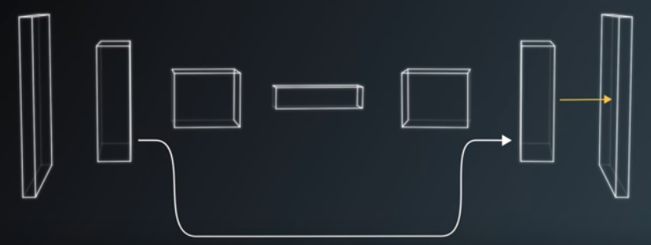
Element-wise addition
These skip connections allow the network to use information from multiple resolutions. As a result, the network is able to make more precise segmentation decisions. For example, compare performance of FCN-8 architecture which has 2 skip connections (TOP) with FCN-32 architecture without skip connections (BOTTOM):
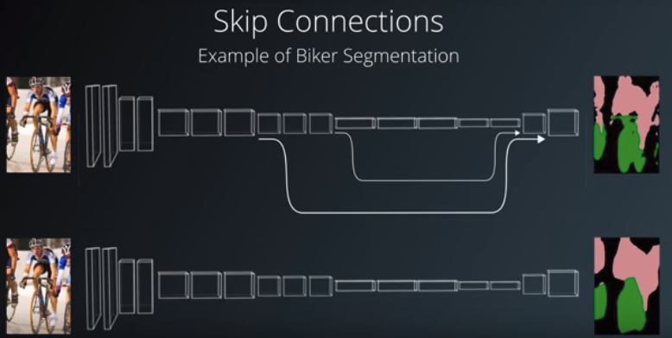

FCN-8,
2 Skip Connections
FCN-32, no skip connections

LESSON 9.11: FCNs in the wild ... (Using FCNs in practice.)
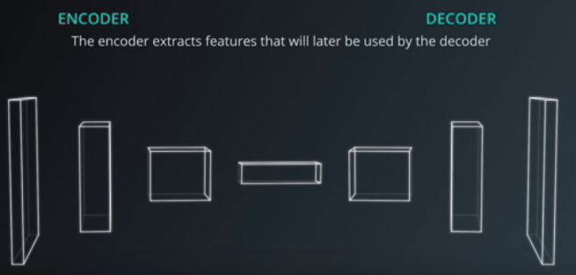
An FCN has two components, the encoder and the decoder.

The encoder extracts features that will later be used by the decoder. Exactly like transfer learning.

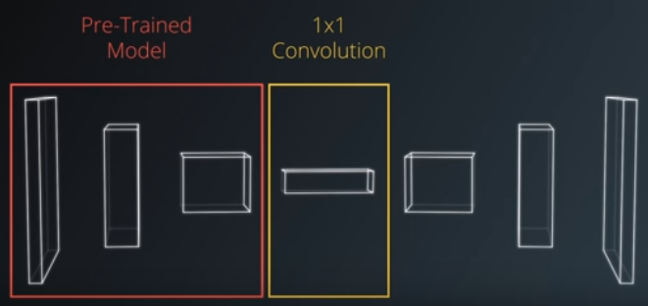
We can borrow techniques from transfer learning to accelerate the training of our FCNs.
eg. VGG, ResNet
It is common for the ENCODER to be pre-trained on ImageNet. VGG and ResNet are popular choices, as examples.

Then complete the ENCODER portion of the FCN by applying the first special technique of 1x1 convolutional layer conversion.

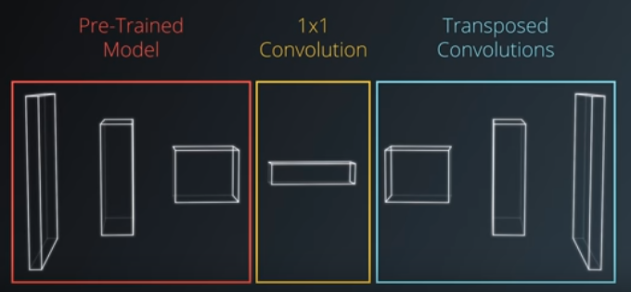
Then add the DECODER, by adding Transposed Convolutional layers to upsample the image.

Then add the skip connections, as the third special FCN technique.

WARNING for SKIP CONNECTIONS:
- Do not to add to many skip connections. It can lead to the explosion in the size of your model.
- Eg., when using VGG-16 as the encoder, only the 3rd and 4th pooling layers are typically used for skip connections.

LESSON 10.1: Scene Understanding – Intro

In this lesson you’ll learn how to extract meaning from an image:
- Object detection
- Semantic segmentation
- Intersection over Union (IoU), a metric to measure performance of Semantic Segmantation

We will finish with the walk through of a fully convolutional network for semantic segmentation.

LESSON 10.2: Bounding Boxes (for Object Detection --> limited usability)

First task is object detection. For that we can use bounding boxes.

POSITIVES for BOUNDING BOXES
- They are a simpler method of scene understanding compared to segmentation.
- A neural network just has to figure out where an object is and draw a tight box around it.
- There are already great open source state of the art solutions:
  - YOLO
  - SSD
- These solutions perform extremely well even at high frames per second
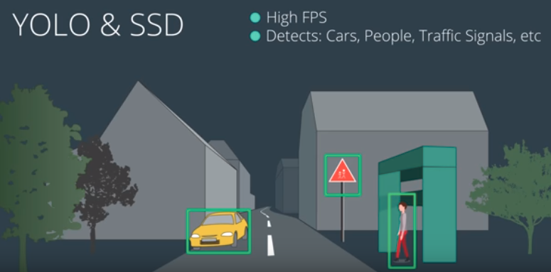
- They’re useful for detecting different objects such as cars, people, traffic lights and other objects in the scene.

LIMITATIONS of BOUNDING BOXES
- Does not work for shapes like curvy roads or the sky. The boxes are not tight:
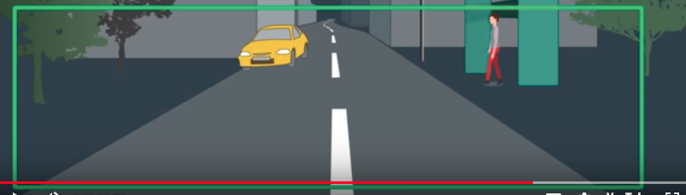

LESSON 10.3: Semantic Segmentation
Semantic segmentation is the task of assigning meaning to part of an object:
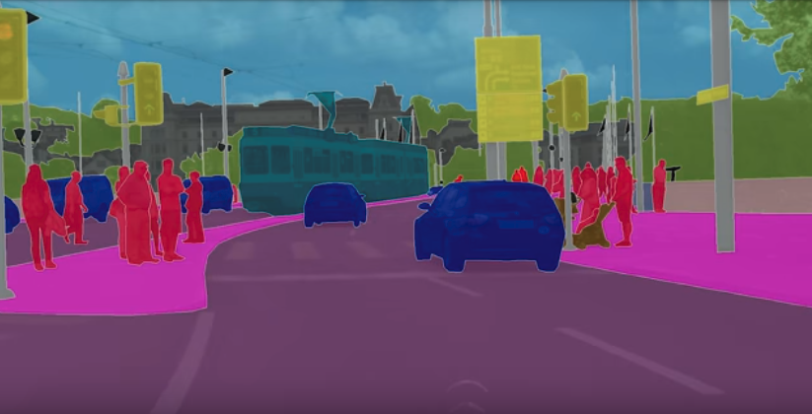
- Semantics = Study of meanining
- Segmentation = Partitioning

- This is done at the pixel level where we assign each pixel to a target class (road, car, pedestrian, sign, etc..)

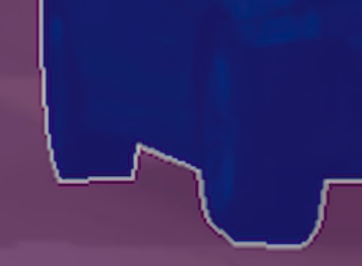
- It helps us derive valuable information about every pixel in the image rather than just slicing sections into bounding boxes.

This is a field known as scene understanding, and it is particularly relevant to autonomous vehicles:
- Full scene understanding help with perception, which enables vehicles to make decisions.

LESSON 10.4: Scene Understanding

One approach to scene understanding is to train multiple DECODERS:

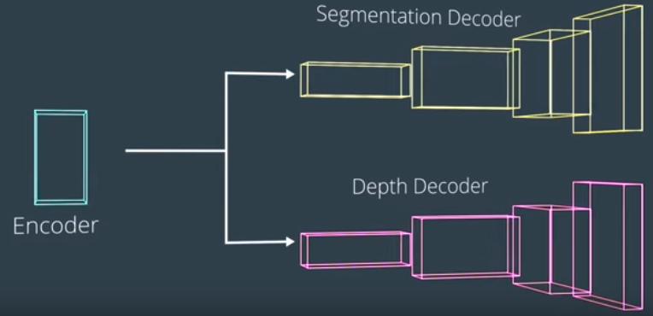
- Each decoder trains on a separate task.
  - One decoder for semantic segmentation
  - Another for depth measurement

- This way we can have a single network which not only predicts the class of a pixel but additionally how far away it is.

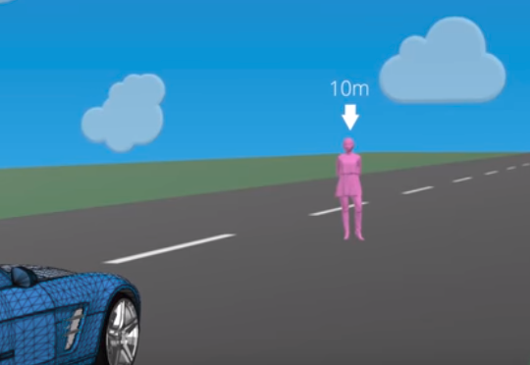

For now though, we just focus on a single decoder, for semantic segmentation.

LESSON 10.5: IoU (Intersection over Union) -> a metric to measure performance

IoU is commonly used to measure the performance of a model on the semantic segmentation task.
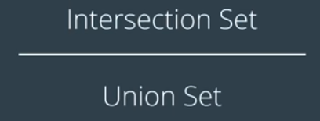
It is literally just the intersection set divided by the union set:

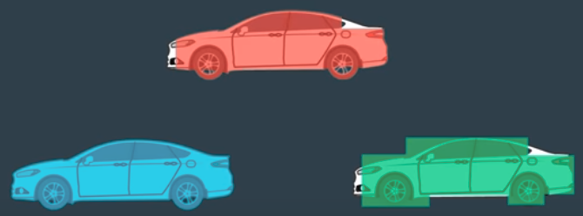
INTERSECTION Set is an AND operation:
- if it exists in both sets, then we put it in the interscection set.
- For each class, the intersection is defined as the number of pixels that are both truly part of that class and are classified as part of that class by the network.

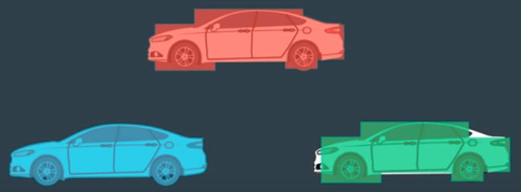
UNION Set is an OR operation:
- if it exists in at least one of the two sets, then we put it in the union set.
- The union is defined as the number of pixels that are truly part of that class plus the number of pixels that are classified as part of that class by the network.

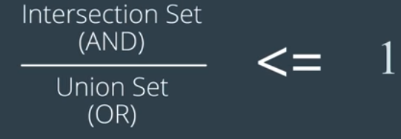
The intersection set should always be smaller or equal to the union set.

IoU = The ratio, which tells us the overall performance per pixel, per class, and is always less or equal to one.

We can go even further and calculate the mean IoU for a network, which is just the average of all the IoU for all the classes.

The mean IoU gives you an idea how well the network performs for all the different classifications for every single pixel.

In TensorFlow we can use matrix mean IoU function and call it directly.

LESSON 10.6: IoU Quiz (Intersection over Union) -> a metric to measure performance
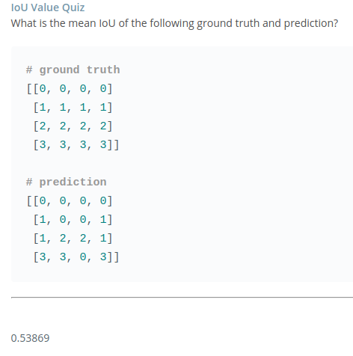

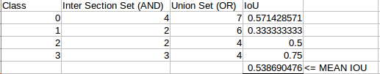

In TensorFlow, you use tf.metrics.mean_iou.
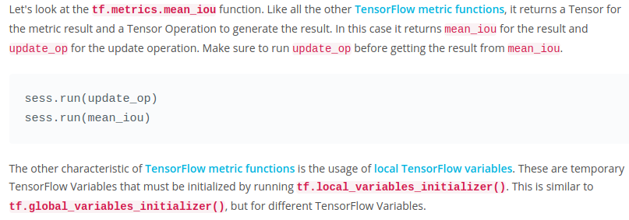
SEE Quiz that goes with this lesson!!!

LESSON 10.7: FCN-8 – Encoder
See: https://people.eecs.berkeley.edu/~jonlong/long_shelhamer_fcn.pdf (FCN-8 architecture)

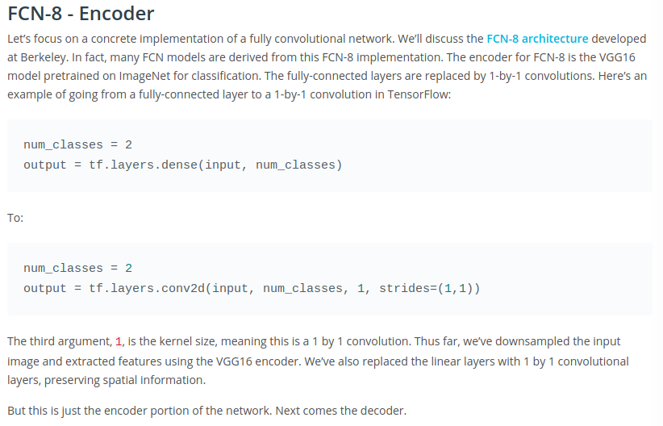

LESSON 10.8: FCN-8 – Decoder & Skip Connections

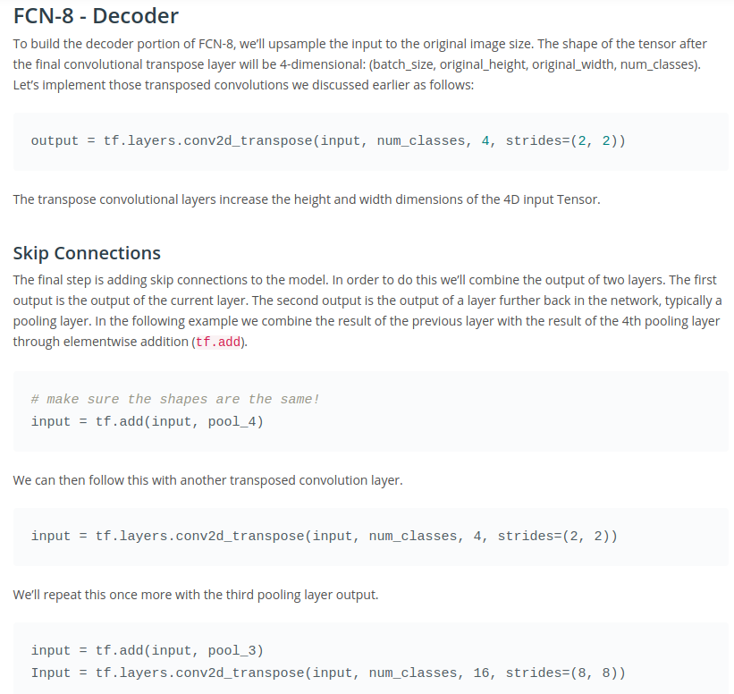

LESSON 10.9: FCN-8 – Classification & Loss

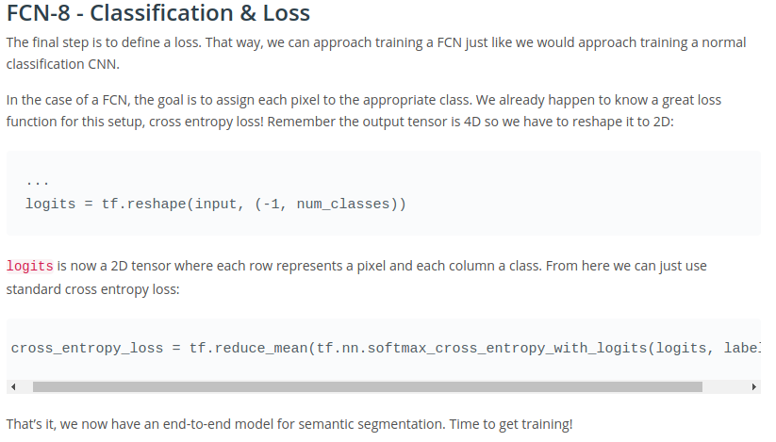
LESSON 10.11: Object Detection Lab

This is stored as it’s separate github repository, and on disk in :

PROJECTS/Term3/CarND-Object-Detection-Lab

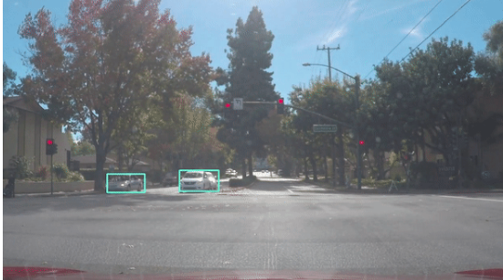
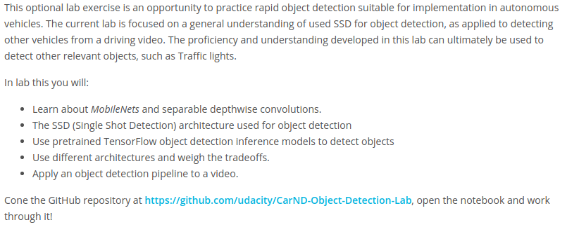

There is a file environment.yml:
name: carnd-advdl-odlab
channels:
- https://conda.anaconda.org/menpo
- conda-forge
dependencies:
- python==3.6
- numpy
- matplotlib
- jupyter
- pillow
- scipy
- ffmpeg
- imageio==2.1.2
- pip:
- moviepy
- tensorflow-gpu==1.2

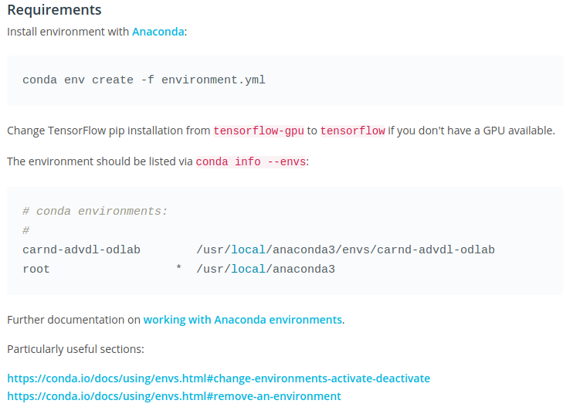
that is used to install a brand new conda environment with tensorflow-gpu and all it’s dependencies. Detailed instructions.

Resources
- TensorFlow object detection model zoo
- Driving video

LESSON 11.1: Inference Optimizations - INTRO

Inference = a conclusion reached on the basis of evidence and reasoning.

Inference Optimization is to accelerate how quickly the network performs inference (=how fast it can make predictions!)

Techniques used:
- Fusion
- Quantization
- Machine code compilation

LESSON 11.2: Why bother with performance?

Aren’t neural networks fast enough already?
- Inference speeds for classifiers to identify objects, like hotdogs, is typically OK
- Autonomous vehicles are much more demanding.
  - The perception system in our vehicle has to make predictions in real time
  - We can’t use cloud computing resources due to the latency
  - All of these predictions have to be done on the vehicle computational hardware.
  - Squeezing every last bit of performance out of this hardware is crucial.

LESSON 11.3: Semantic Segmentation Revisited
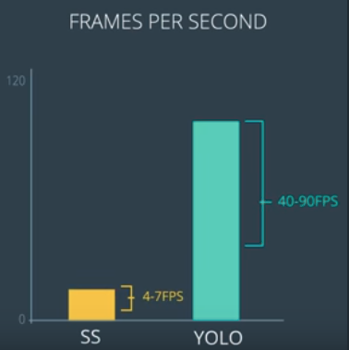
Semantic segmentation is computationally intensive.

It is not uncommon for this pipeline to put out 4-7 Frames Per Second (FPS), compared to bounding box type detection (like YOLO) 40-90 FPS.

That is NOT fast enough !!!

By various optimizations, (fusion, quantization, graph to binary) we can increase the performance of this system by 3-5 times.

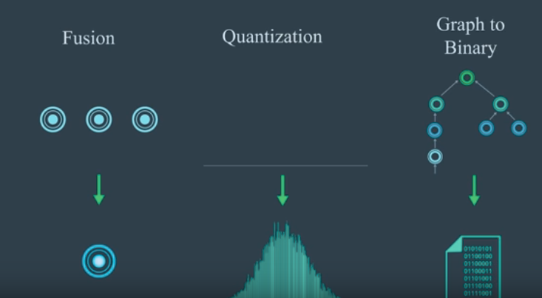

LESSON 11.4: Using the AMI (Amazon Machine Instance !!) for running tensorflow-gpu

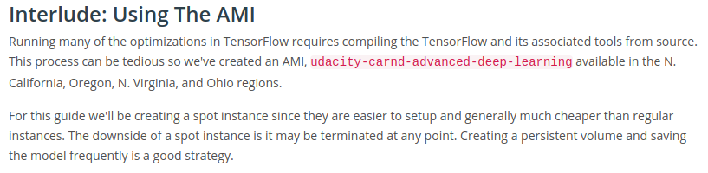
See movie to select a spot request:
https://classroom.udacity.com/nanodegrees/nd013/parts/6047fe34-d93c-4f50-8336-b70ef10cb4b2/modules/595f35e6-b940-400f-afb2-2015319aa640/lessons/b6de6f99-281f-44e8-a9df-196577204638/concepts/1f496bc5-022b-4bff-b30c-cb3bc6eeae98

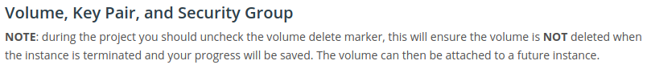
LESSON 11.5: Freezing Graphs --> reduces numbers of operations
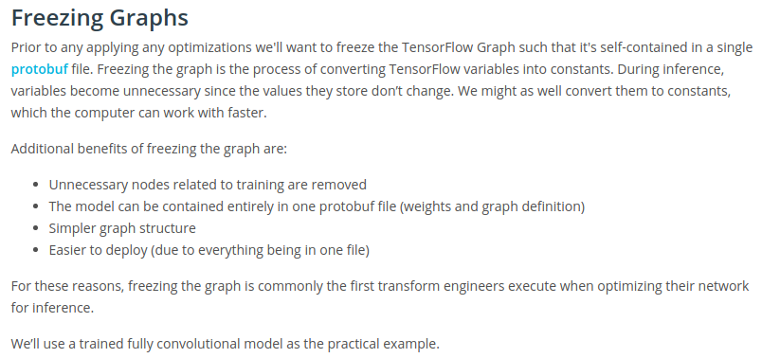
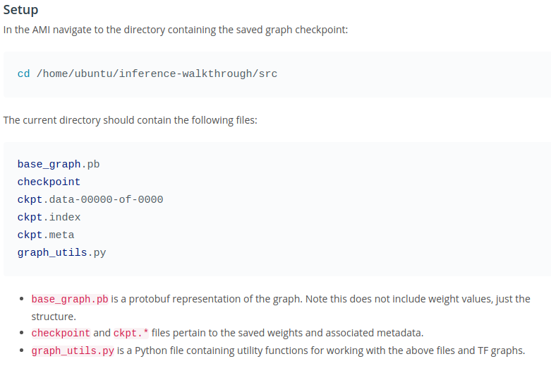

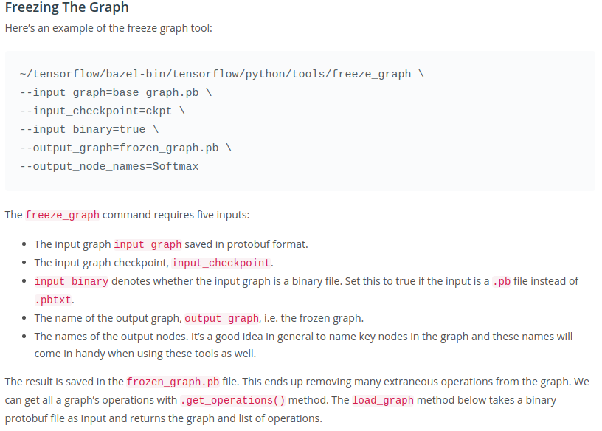
def load_graph(graph_file, use_xla=False):
jit_level = 0
config = tf.ConfigProto()
if use_xla:
jit_level = tf.OptimizerOptions.ON_1
config.graph_options.optimizer_options.global_jit_level = jit_level

with tf.Session(graph=tf.Graph(), config=config) as sess:
gd = tf.GraphDef()
with tf.gfile.Open(graph_file, 'rb') as f:
data = f.read()
gd.ParseFromString(data)
tf.import_graph_def(gd, name='')
ops = sess.graph.get_operations()
n_ops = len(ops)
return sess.graph, ops

sess, base_ops = load_graph('base_graph.pb')
print(len(base_ops)) # 2165
sess, frozen_ops = load_graph('frozen_graph.pb')
print(len(frozen_ops)) # 245

As you can see, just freezing the graph substantially reduces the number of operations.
LESSON 11.6: Graph Transforms
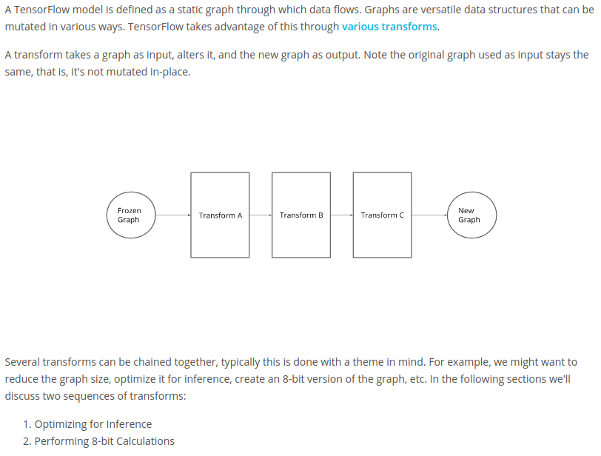
LESSON 11.6: FUSION
What are we fusing? --> Graph Operations!

This reduces the number of operations and accelerates the data passing through the graph.

For example, we can avoid storing a lot of temporary tensors by fusing BATCH NORMALIZATION, FOLLOWED BY RELU, FOLLOWED BY CONVOLUTION into one layer:

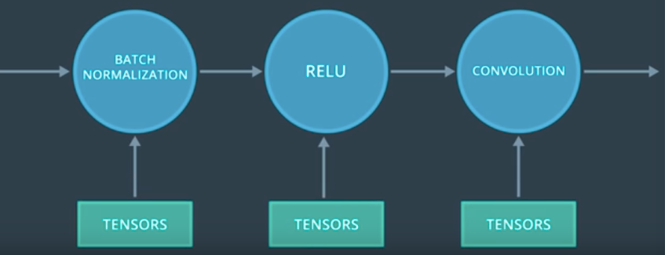
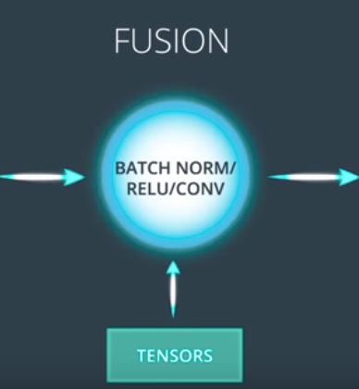

Even better, the fuse operation only executes one kernel on the GPU instead of three!!
Each time a kernel is called, there is an overhead.

==> Fusion saves both memory and time.

Of course, fusing could be beneficial in training as well as inference. The trade off is that fusing reduces the flexibility of the network. During training, we might want to preserve the flexibility of the model in case we want to add or remove layers, or transfer part of the network.
By the time we get to inference (prediction!), we’re no longer changing the network architecture, so we can fuse operations more aggressively.

It’s important to know we could do this manually by coding up a single kernel that performs the 3 fuse operations together. However, the compiler is capable of doing this on its own, allowing us to write understandable code and still reap performance benefits.

We can automate this process using an optimizer that will fuse common layers together. This allows us to write easier to understand code an manipulate it, while the final version after the optimization will have all the performance advantages by applying tricks like fusion automatically.

LESSON 11.8: Optimizing for inference (=prediction)
TensorFlow tool: optimize_for_inference
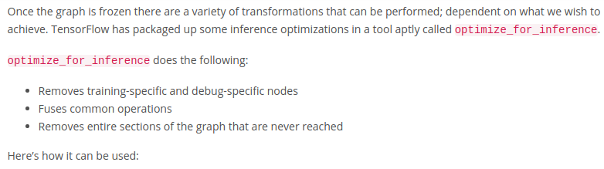
~/tensorflow/bazel-bin/tensorflow/python/tools/optimize_for_inference \
--input=frozen_graph.pb \
--output=optimized_graph.pb \
--frozen_graph=True \
--input_names=image_input \
--output_names=Softmax

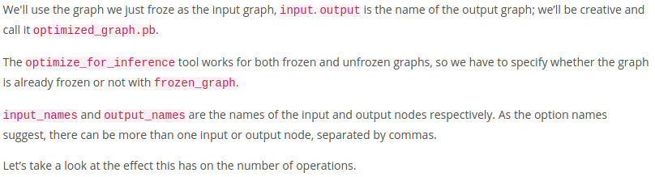
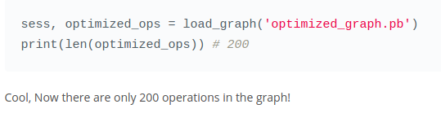

LESSON 11.9: Optimize Inference by Reducing Precision and by Quantization

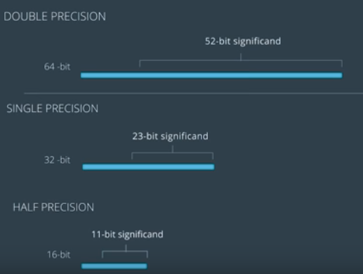
Floating Point Precision
Neural networks are typically trained with single precision – 32 bit floating point number.
The accuracy that comes with Double Precision is not needed for training neural networks.

It turns out that we don’t even need single precision for inferencing !

Inferencing can be done at half precision – 16-bits, with minimal changes in accuracy.

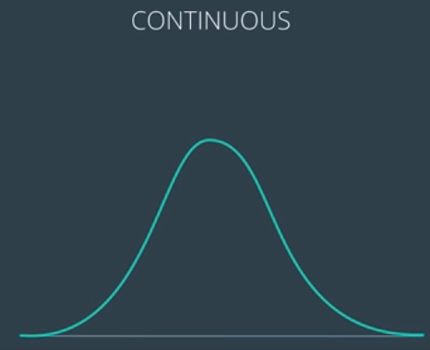
Quantization
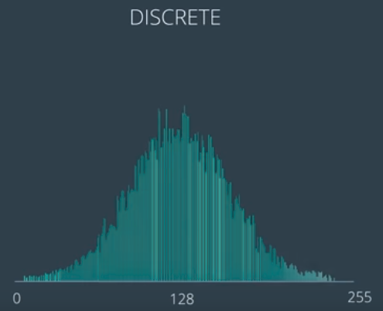
Typically, we convert floating point values to an 8 bit integer representation for 256 unique values (eg. 0-255).

This specific reduction in precision from floating points to integers introduces another type of optimization.

The process of constraining values like this from a continous range to a discrete range, is known as quantization.

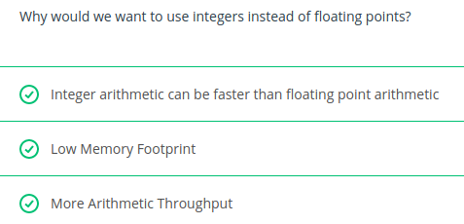

LESSON 11.11: Quantization Conversion
There are a variety of ways to convert our floating point values to integers. The simplest is a linear conversion.

The weights in a neural network inhibit a relatively small range. For example, in a layer, weights might range from -8 to 10. To perform a linear conversion we would assign:
- -8 --> 0
- 1 --> 128
- 10 --> 255

And all the values in between accordingly:

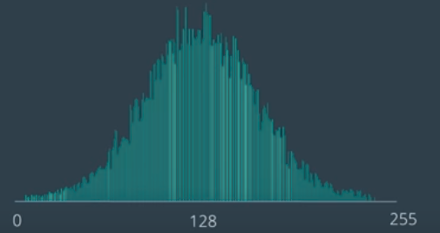
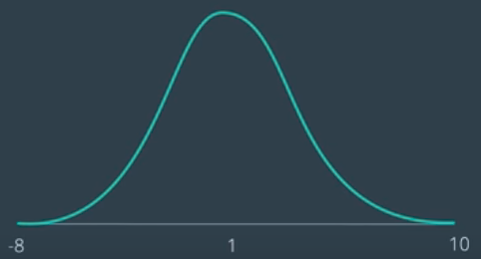

Note that converting back to a floating point number if needed is also easy.

With just this small change, we save 75% in this space!

LESSON 11.12: 8-bit Calculations (INTEGERS) through Quantization
~/tensorflow/bazel-bin/tensorflow/tools/graph_transforms/transform_graph \
--in_graph=frozen_graph.pb \
--out_graph=eightbit_graph.pb \
--inputs=image_input \
--outputs=Softmax \
--transforms='
add_default_attributes
remove_nodes(op=Identity, op=CheckNumerics)
fold_constants(ignore_errors=true)
fold_batch_norms
fold_old_batch_norms
fuse_resize_and_conv
quantize_weights
quantize_nodes
strip_unused_nodes
sort_by_execution_order'

See: TensorFlow Graph Transforms documentation

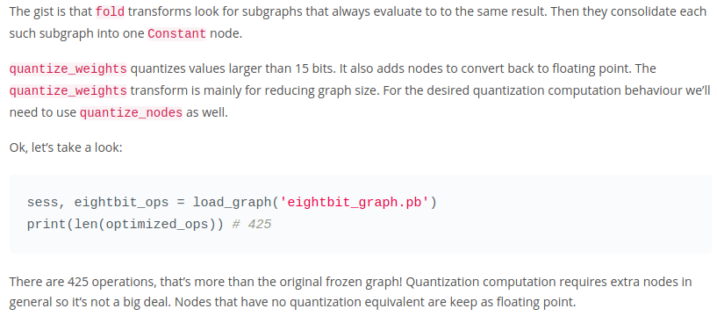

LESSON 11.13: Compilation

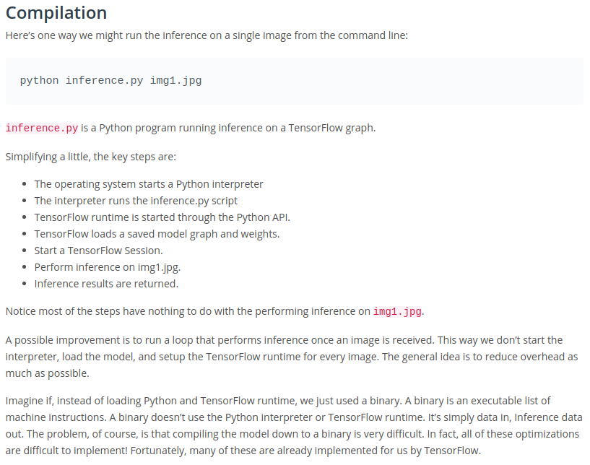
LESSON 11.14: AOT (Ahead Of Time) & JIT (Just In Time) Compilation
See: LLVM

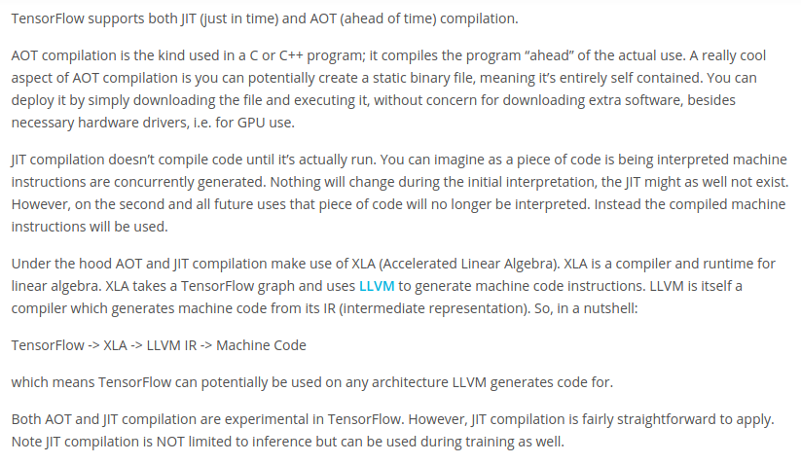
# Create a TensorFlow configuration object. This will be
# passed as an argument to the session.
config = tf.Config()
# JIT level, this can be set to ON_1 or ON_2
jit_level = tf.OptimizerOptions.ON_1
config.graph_options.optimizer_options.global_jit_level = jit_level

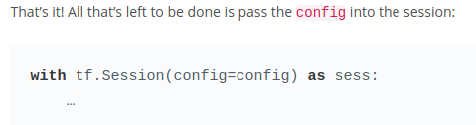

LESSON 11.15: Reusing the Graph

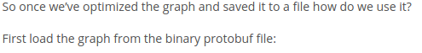

from graph_utils import load_graph

sess, _ = load_graph(‘your_graph.pb’)
graph = sess.graph

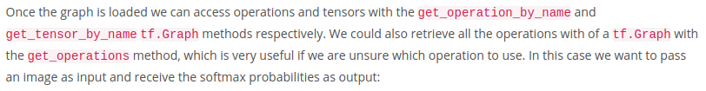
image_input = graph.get_tensor_by_name('image_input:0')
keep_prob = graph.get_tensor_by_name('keep_prob:0')
softmax = graph.get_tensor_by_name('Softmax:0')

probs = sess.run(softmax, {image_input: img, keep_prob: 1.0})

PROJECT: Semantic Segmentation
In this project:
- Split up an automotive video into individual camera frames
- Then paint each pixel of each frame using a fully convolutional network.
- Classify each pixel as being either road or not road.

This classification will help other systems in the car determine where the free space is. You can also extend this technique to more classes like:
- road
- vehicle
- bicycle
- pedestrian
- ...

