**LESSON 7.13: Generating Sigma Points**



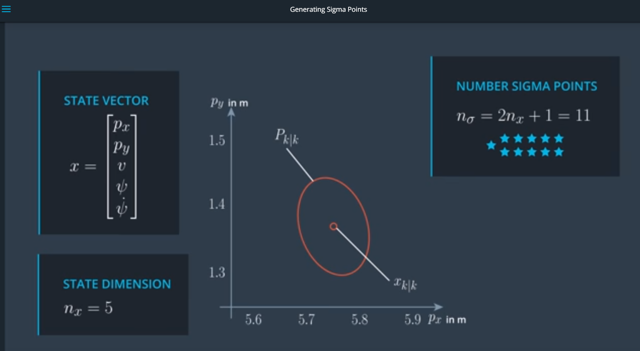



Each column is a sigma point !

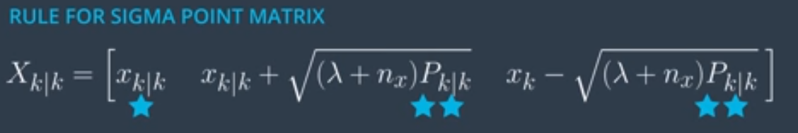

 = a design parameter!

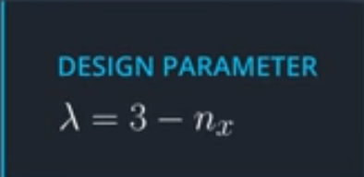 🡺 Seems to give good results

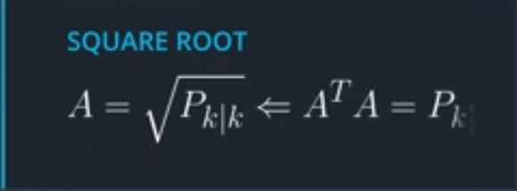 This is the square root of the co-variance matrix. This can be calculated with Cholesky decomposition, which results in a lower triangular matrix.

As example, to keep it simple, let’s use just (px, py), with symmetric 2x2 covariance matrix:

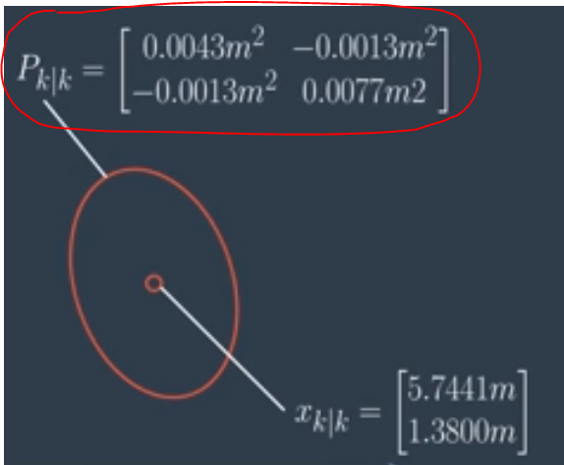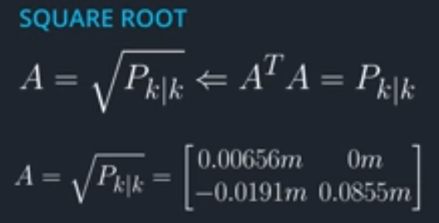

These values for A do not seem correct!

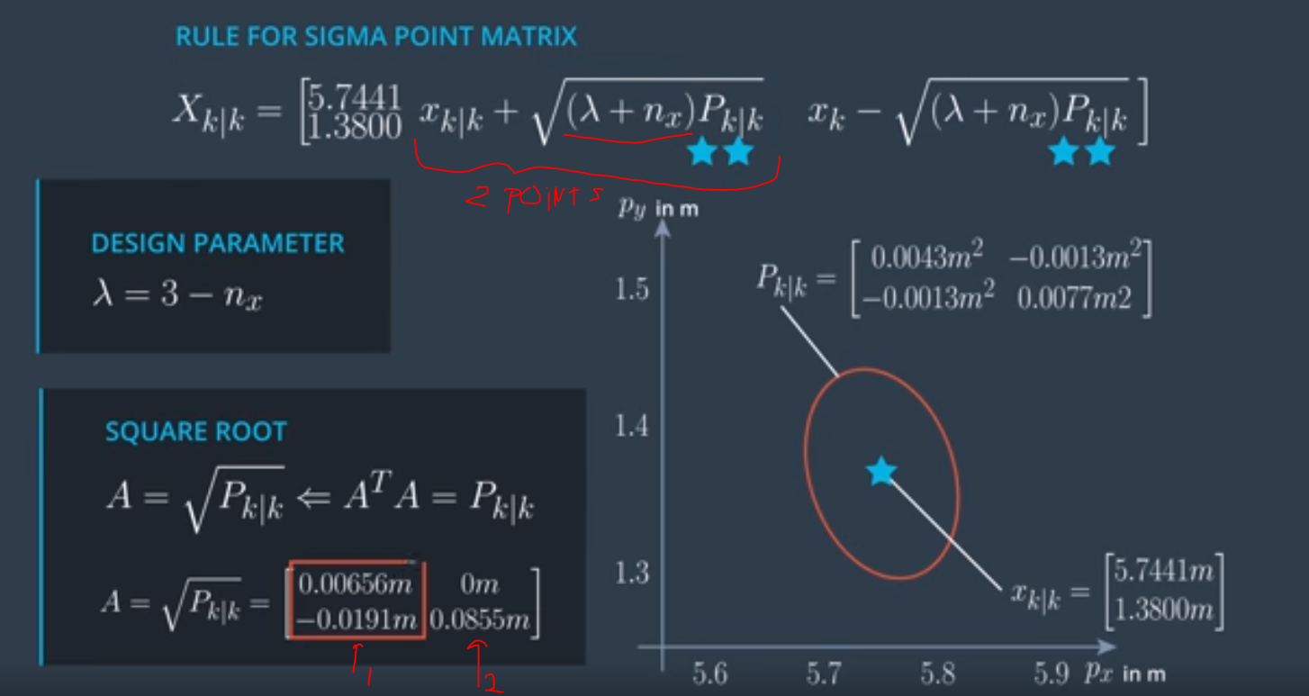

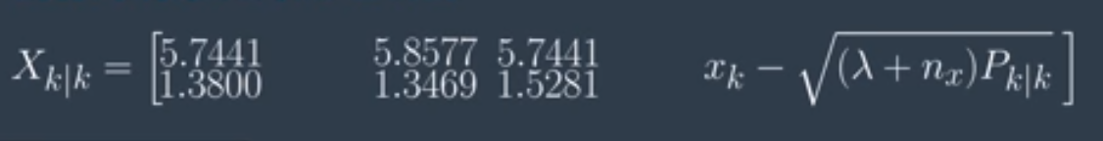

LESSON 7.16: UKF AUGMENTATION

IMPORTANT: See beginning of this lesson for explanation of Process Noise and Process Noise Covariance Matrix (Q), to distinguish between meaning in context of Regular/Extended Kalman filters vs Unscented Kalman Filters. It is actually much simpler for Unscented Kalman Filters.

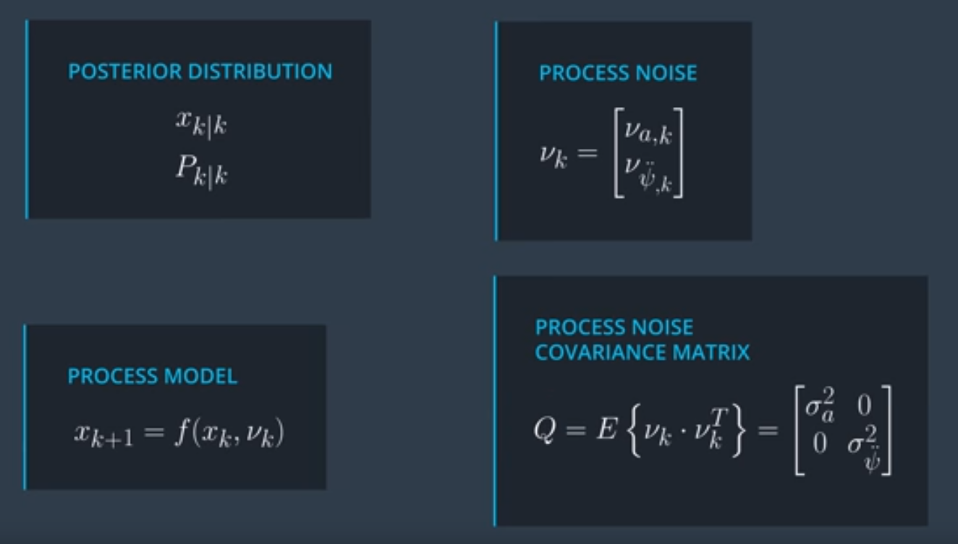

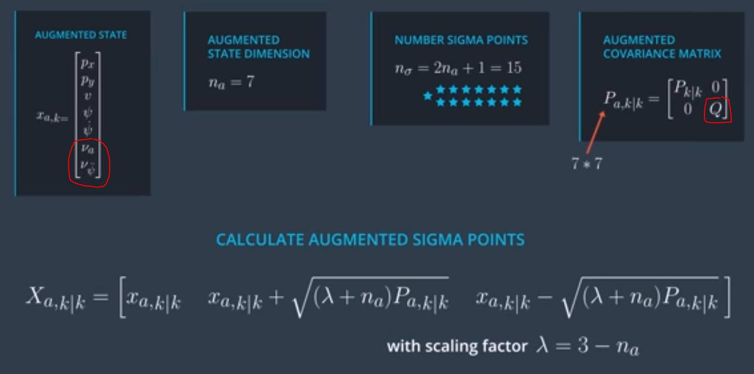

Lesson 7.17 – Cheat Sheet

