|  |
| --- |
| CEWP MOD4 **INTRODUCTION TO JAVA** FALL 2019  Deliverable 1  Yahtzee project  (Group B/Team E)  Lucas CHAMPSAUR / Lucas PECH / Arthur RAPP |

Table of Contents

1 - Reflection on working with the others towards a common goal

2 – Contribution on deliverable

3 – Evidences of tests

4 - Ideas for enhancements

5 – Yahtzee rules we are using

1) Reflection on working with the others towards a common goal

Lucas CHAMPSAUR:

Although I had already work on a project as the member of a team several times, this time I had to do it with people that I don’t necessarily know that well. However, I think that we worked well together. We got along really quickly and have been able to work efficiently together. There were no disagreements on the project nor on the organization of the work. Though, we still have a lot of work until we finish this project completely.

Lucas PECH:

Working as a team is not something new for me, we are doing for 2 years now. But the fact is that I usually work with the same person, Lucas is one of these persons, while Arthur is not. At first, I was a bit afraid to be with somebody I never worked with. However, after speaking all three about the project we find a good way to work together by meeting each other after classes and using GitHub. Moreover, the time at the end of classes we had to spend on the project helped us helped us to know us better.

Finally, this first phase of the project went well, the cooperation helped us to go way faster and the fact of being 3 to think about the same project but in different way allowed us to find the best way to do it. I hope the other phase will be like this one.

Arthur RAPP:

Working with both Lucas turn out better than expected. We start the project as soon as possible because we didn’t know how much time it would take to complete it. Each one had a task to complete and for each it worked out very well. I'm really pleased with my teammates and wouldn't mind keeping working with them on this project.

2) Contribution on deliverable

|  |  |
| --- | --- |
| **Group B / Team E** | **Contributions** |
| **Lucas CHAMPSAUR** | * Security of the inputs. * Optimization of the algorithm. * Implementation of the “play again” option. * Implementation of the exit of the algorithm. * Improvements on the display of the game. * Detection of the winner when playing multiplayer. * Correction of mistakes created by the implementation of the lower part of the scoreboard * Save implementation * Design of GUI |
| **Lucas PECH** | * Implementation of the function that enters the score in the scoresheet and reset the other rows. * Implementation of the condition that forbid the user to choose the same score again. * Implementation of the end condition and of the calculation of the score. * Implementation of the limitation of 2 reroll per turn. * Implementation of multiplayer * Implementation of detection of all lower section rows * Implementation of the GUI * Hint button implementation |
| **Arthur RAPP** | * Implementation of all the function permitting to roll the dice. * Implementation of the function permitting to reroll. * Implementation of the menu permitting to choose if we want to reroll or block a score. * Implementation of the display of the scoresheet. * Separation of the code in different class * Load function |

**Tests:**

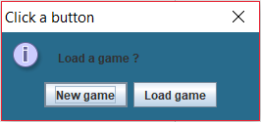**Test of the new game / load game menu:**

When running our program this first window is displayed, it asks you if you want to play a new game or to load the last game you saved.

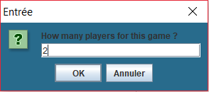**Test of the how many player windows:**

When selecting new game this menu is displayed asking you the number of players you want for this game. Note that this window is not displayed if you load a game as the choice as already be made for the game you load.

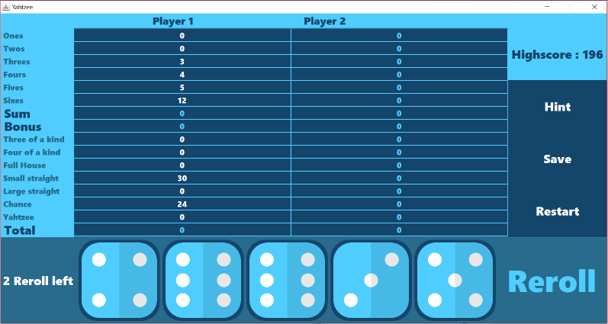Here is the window you obtain by selecting 2 players for the game.

**Test of the upper section:**

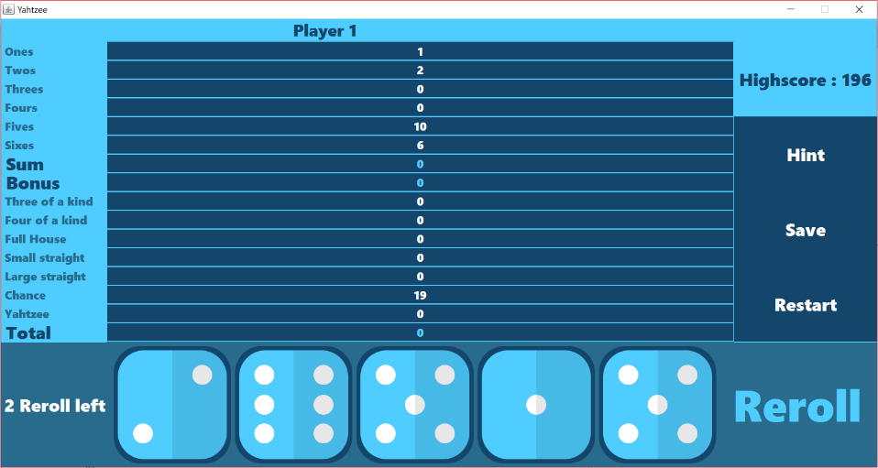

Here we can see that depending of the values of the dices the upper section is filled well.

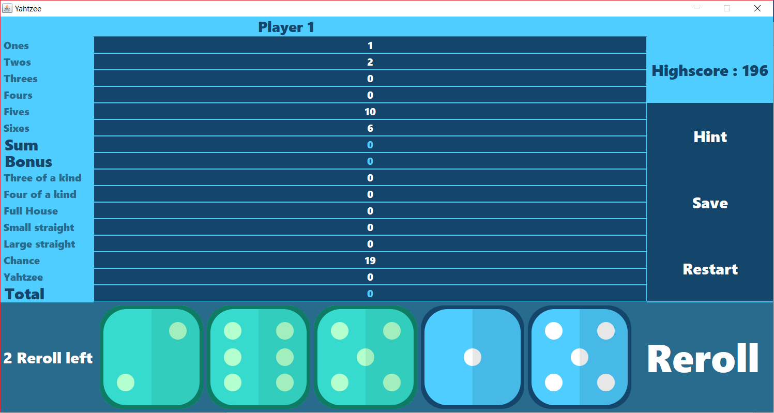**Test of the reroll:**

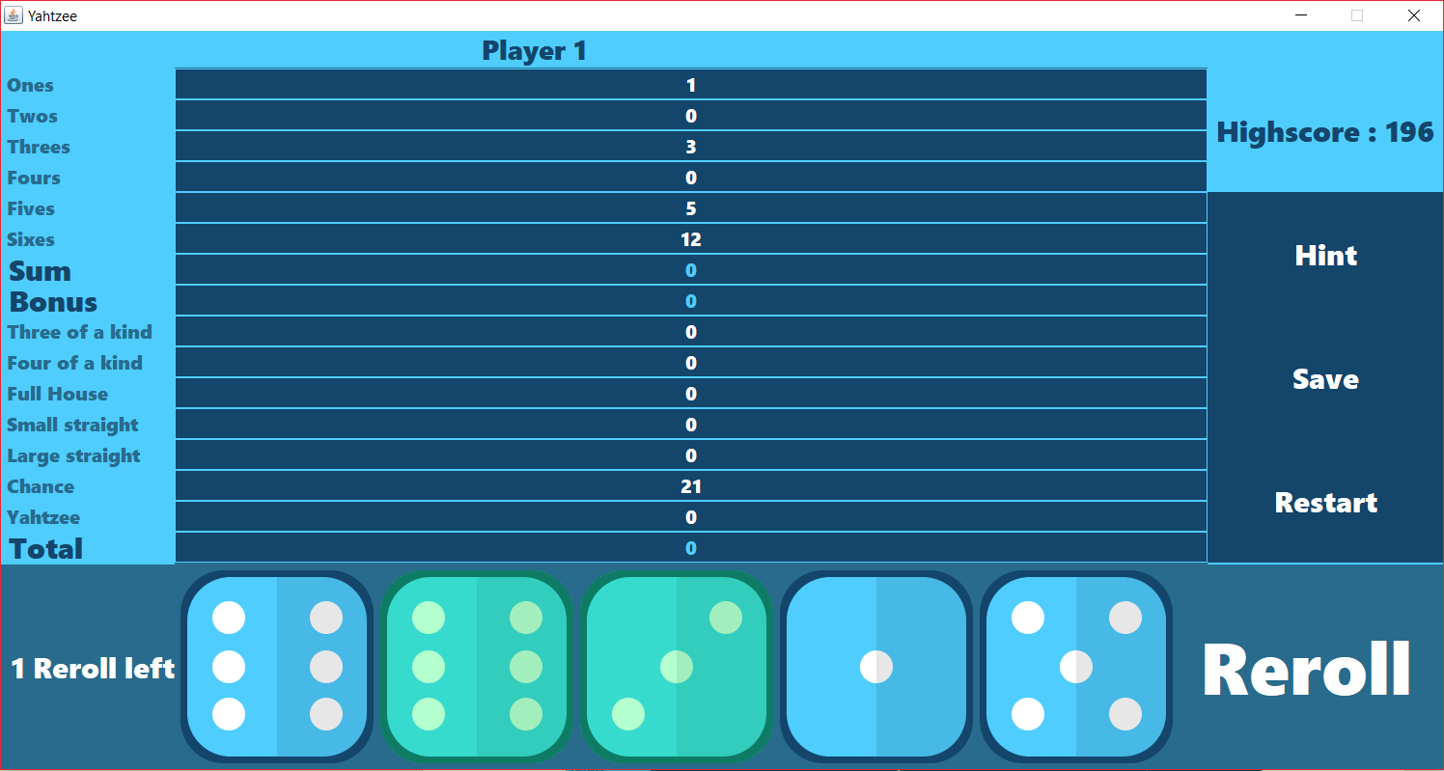The player can select the dices he wants to reroll, they will change of color to signal that they are select. Note that the button reroll is enabled only when at least one dice is selected

When the user rerolls dices then its number of reroll decreases and the scoreboard preview values changes.

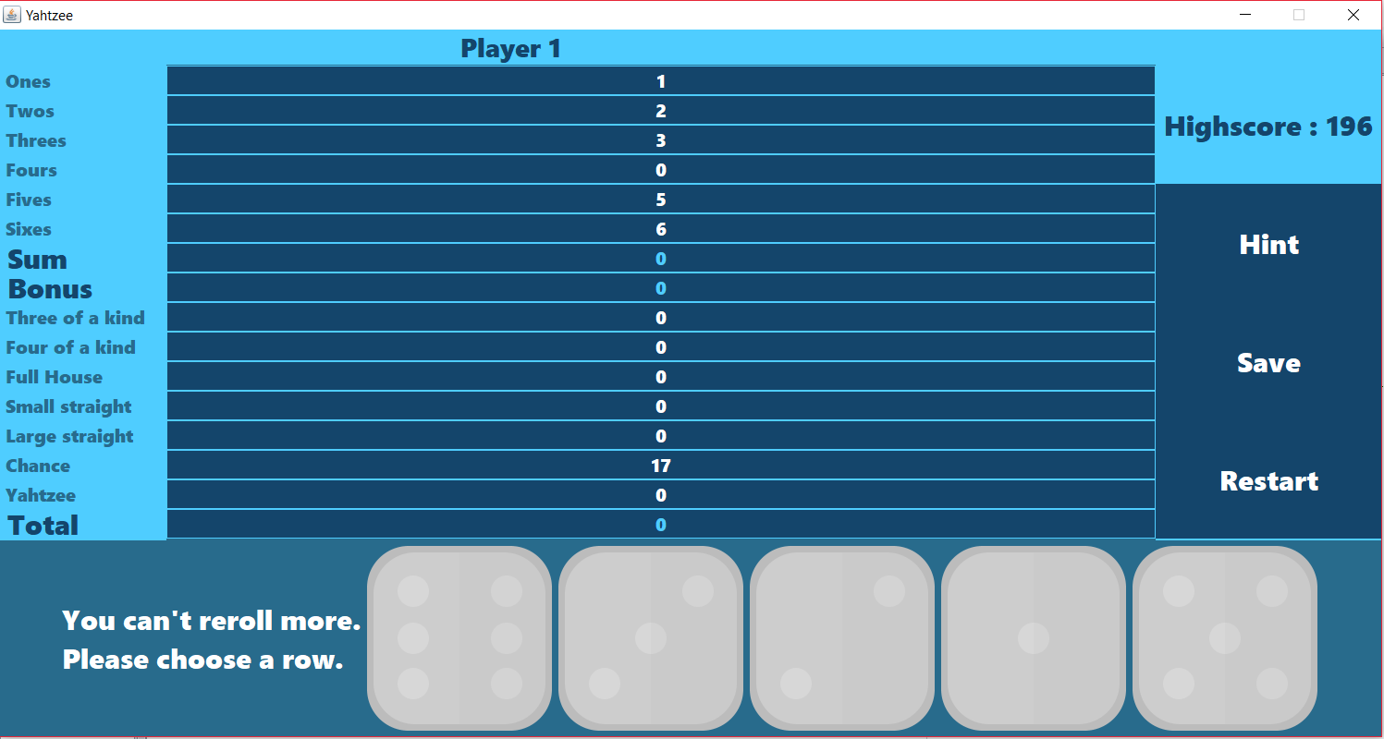When the player has used its 2 reroll then the button rerolls disappear and the dices are disabled so that the user is forced to choose a row in the scoreboard.

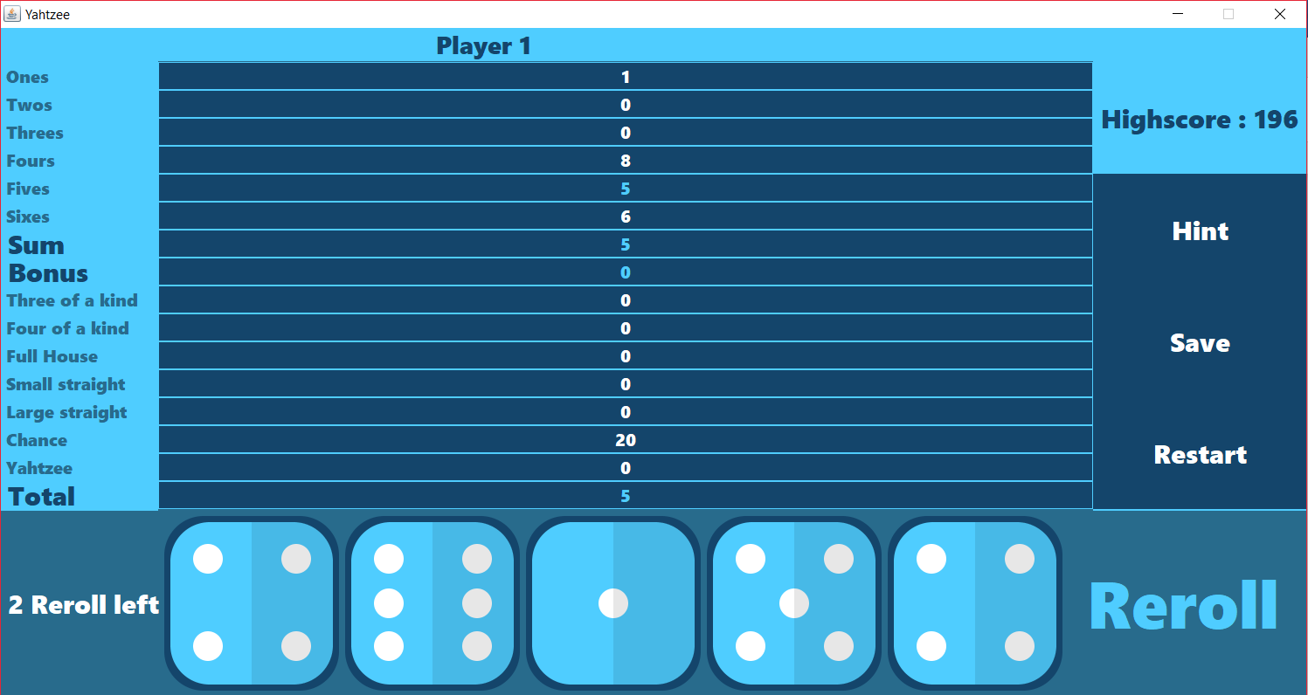When the user has chosen the row to block in the scoreboard, the row change of color and is enabled so that the player can’t choose it again.

Then the dices are enabled, and we give him 2 reroll for its new turn.

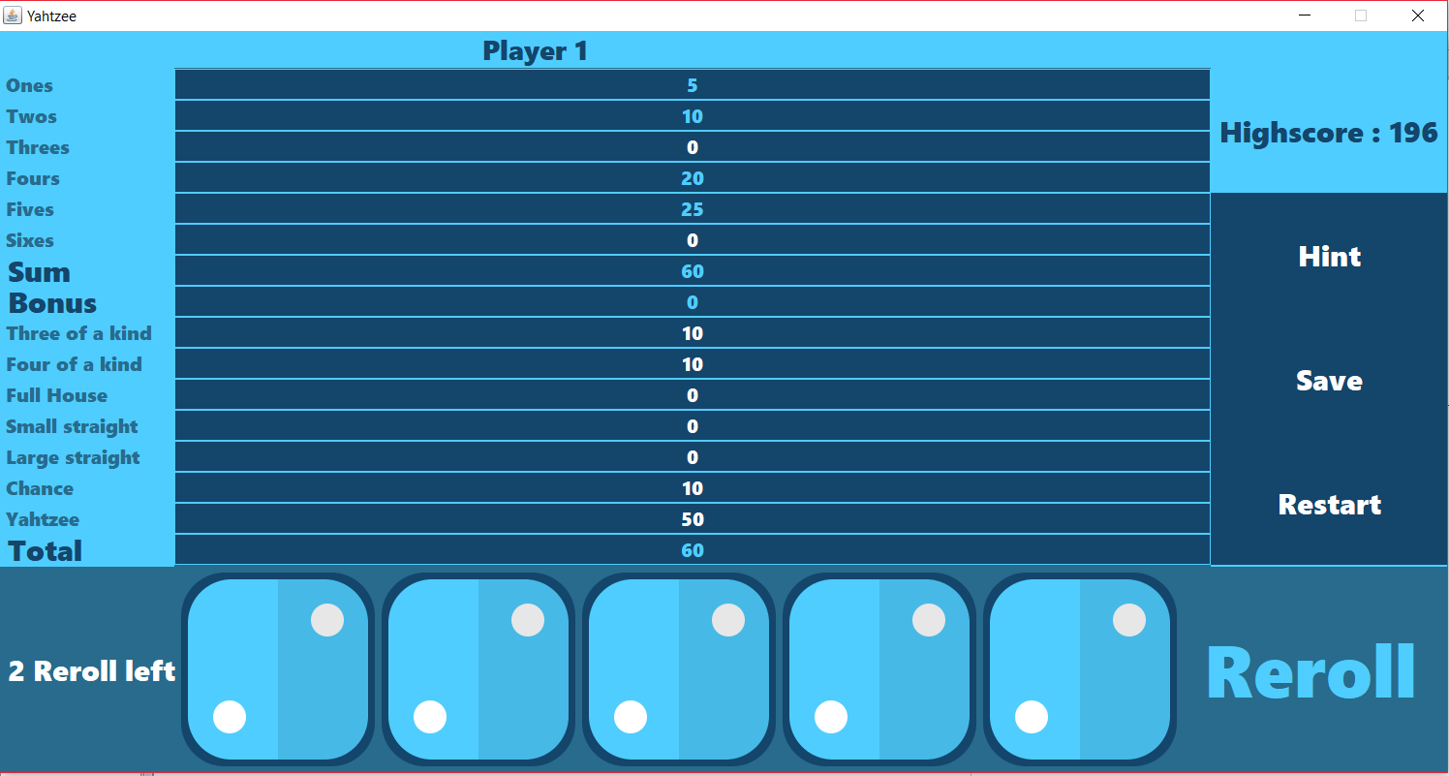**Test of the upper section:**

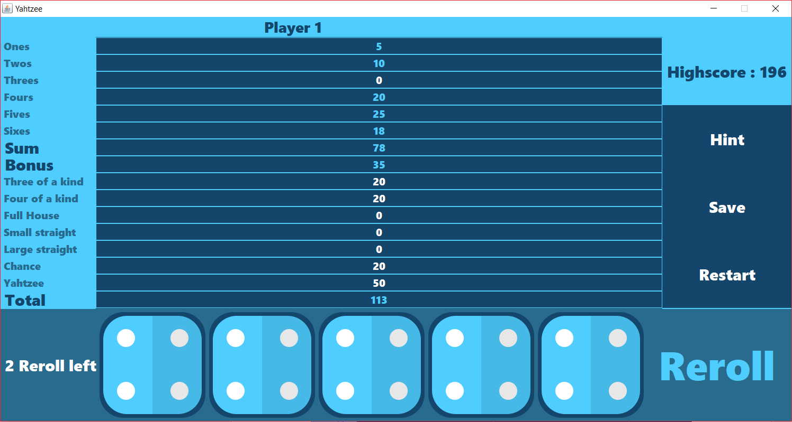We can see on this screen that if the sum of the upper section is lower than 63 then the bonus of 35 point is not given to the player.

Here we can see that the sum of the upper section is working well. It does the addition of all the blocked rows. The bonus section also works: the bonus of 35 points appear because there is more than 63 point in the sum.

The total score also works, it does the addition of all the blocked rows.

**Test 3 of a kind:**

He we can see that there are 3 dice of the same kind (5,5,5) and that the row corresponding to this combination is well filled with the sum of all the dices.

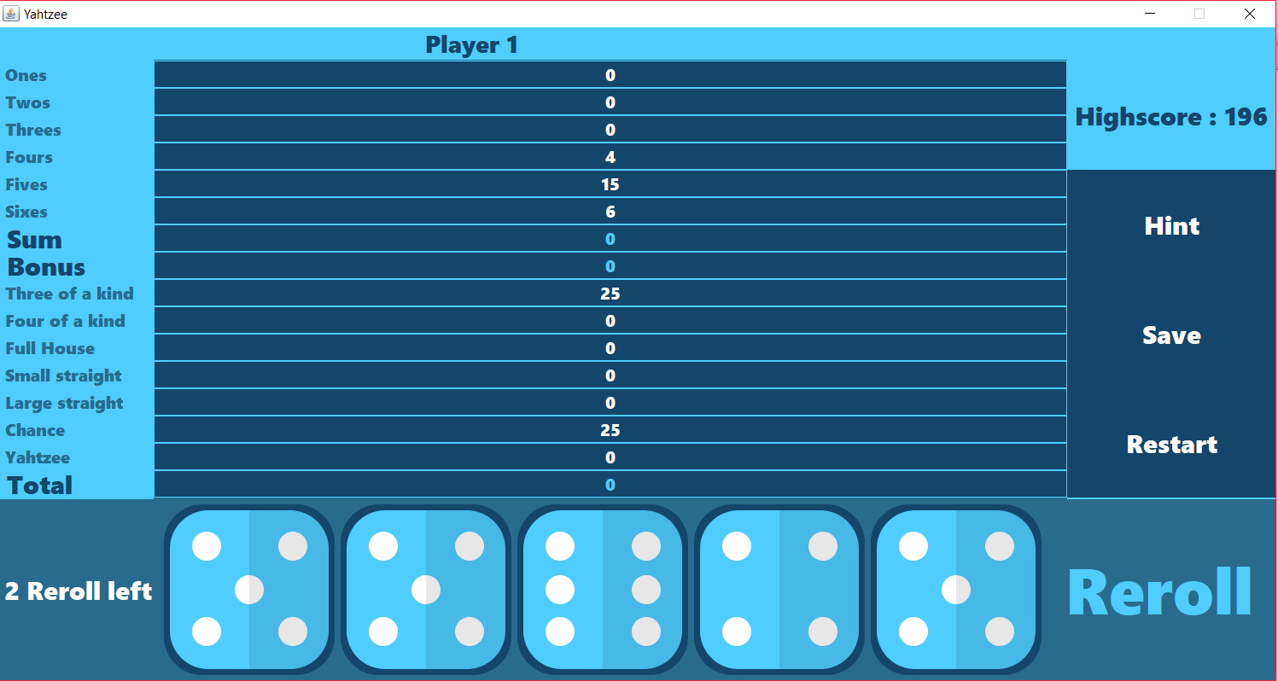

**Test 4 of a kind:**

He we can see that there are 4 dice of the same kind (5,5,5,5) and that the row corresponding to this combination is well filled with the sum of all the dices.

We also observe that the row three of a kind is filled with the sum of the dices which is logic.

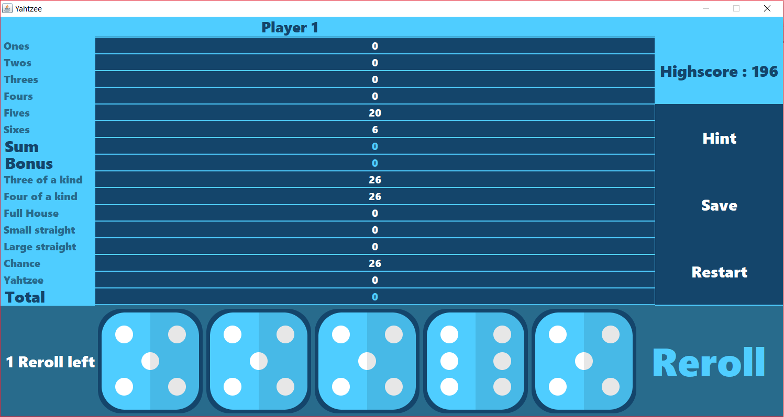

**Test full house:**

Here we can observe that the full house row is working well. In fact, the dices are forming a full house (a pair of three and a brelan of fives) and the full house row is filled with 25 point.

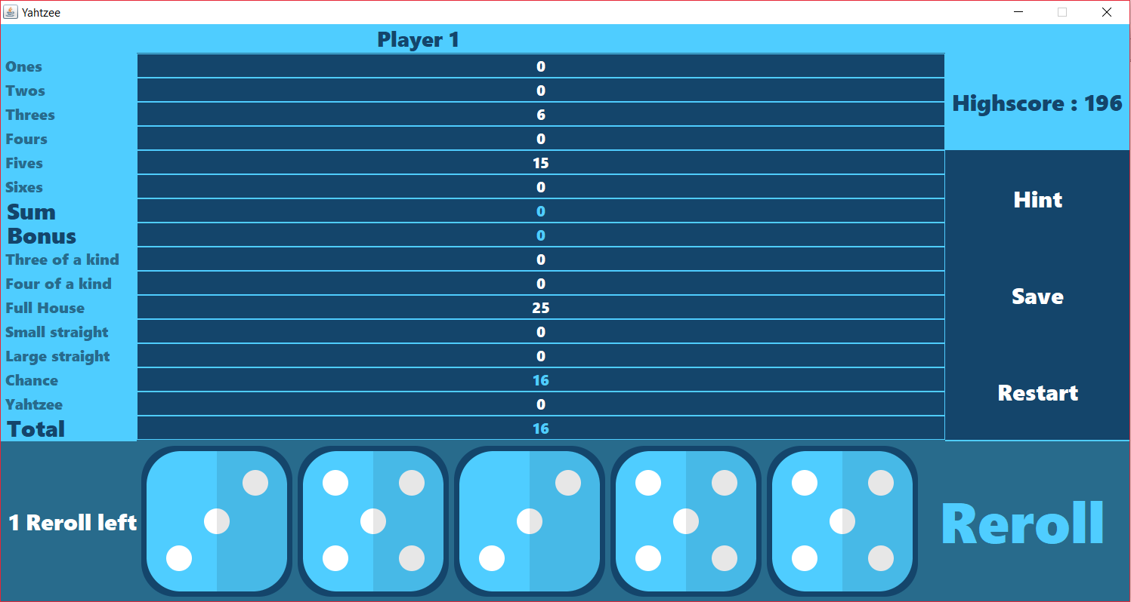**Test small straight:**

Here we can see that there is a small straight in the roll (2,3,4,5) and that the small straight row is well filled with 30 point.

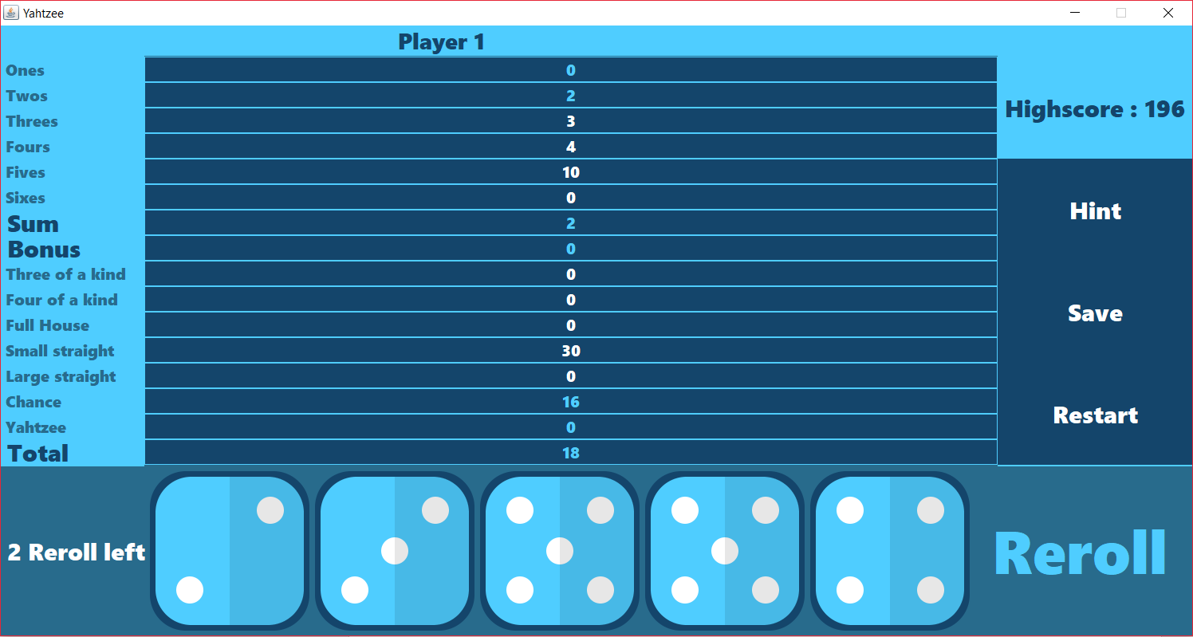

**Test large straight:**

Here we can see that there is a large straight in the roll (2,3,4,5,6) and that the large straight row is well filled with 40 point.

We also observe that the small straight row is filled too which is logic as a large straight is also a small one.

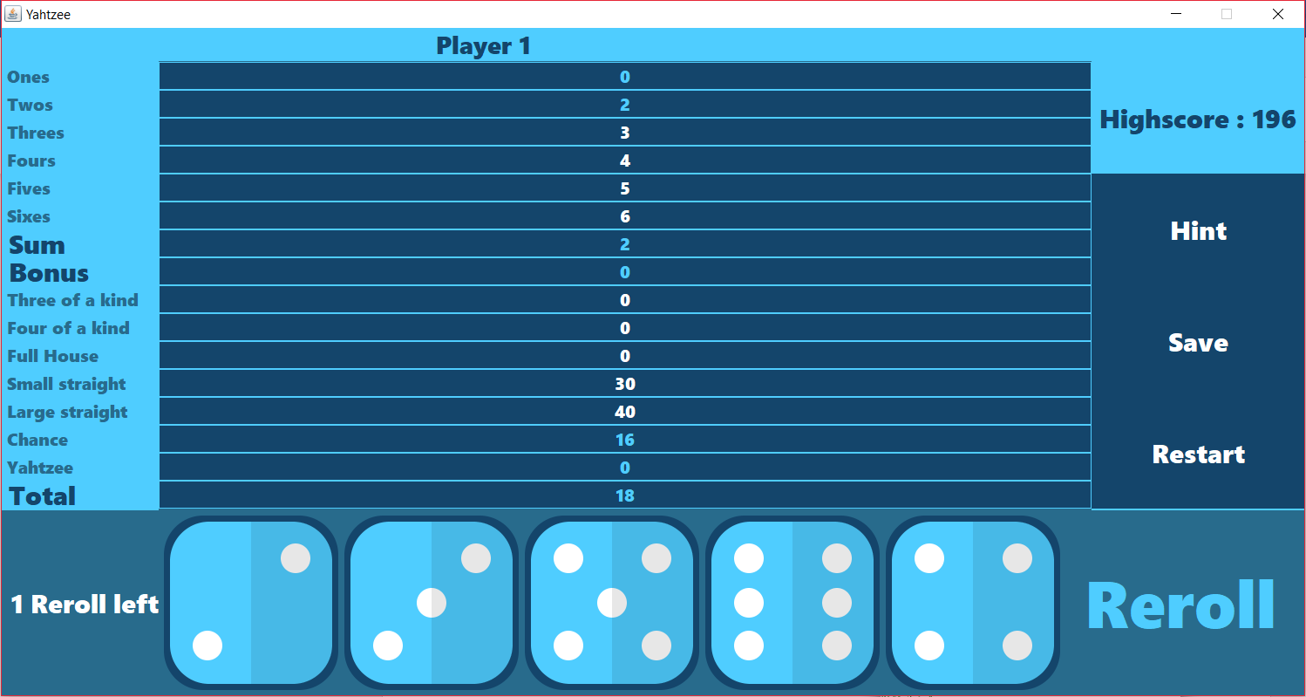**Test chance:**

Here we observe that the chance row works well. This row is always filled with the total of all the dice of the roll.

Here 3+6+4+4+4 = 21 and the chance row is filled with 21.

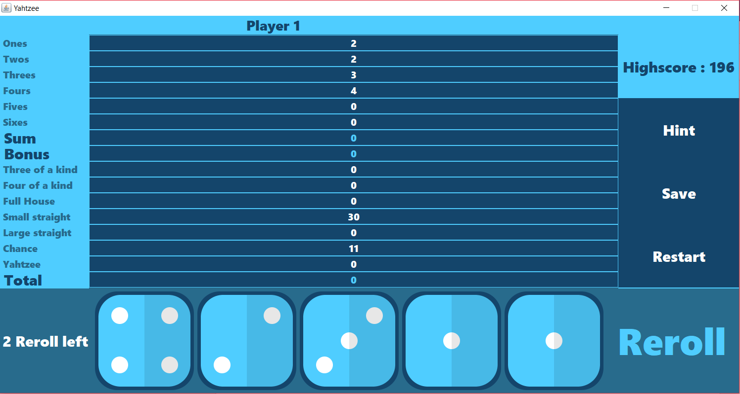

**Test Yahtzee:**

Here we have 5 same dices and the Yahtzee column if well filled with 50 points.

The three/four of a kind columns are filled which as well means they work well.

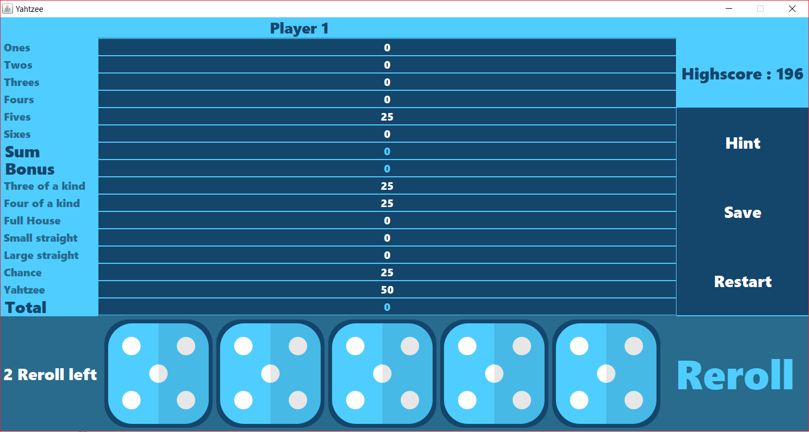

**Test multiple Yahtzee:**

Here we are testing multiple Yahtzee. The rules say that when a player is having a Yahtzee and he has already filled the Yahtzee row, then he gets 100 bonus point.

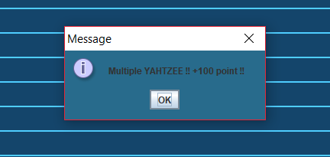

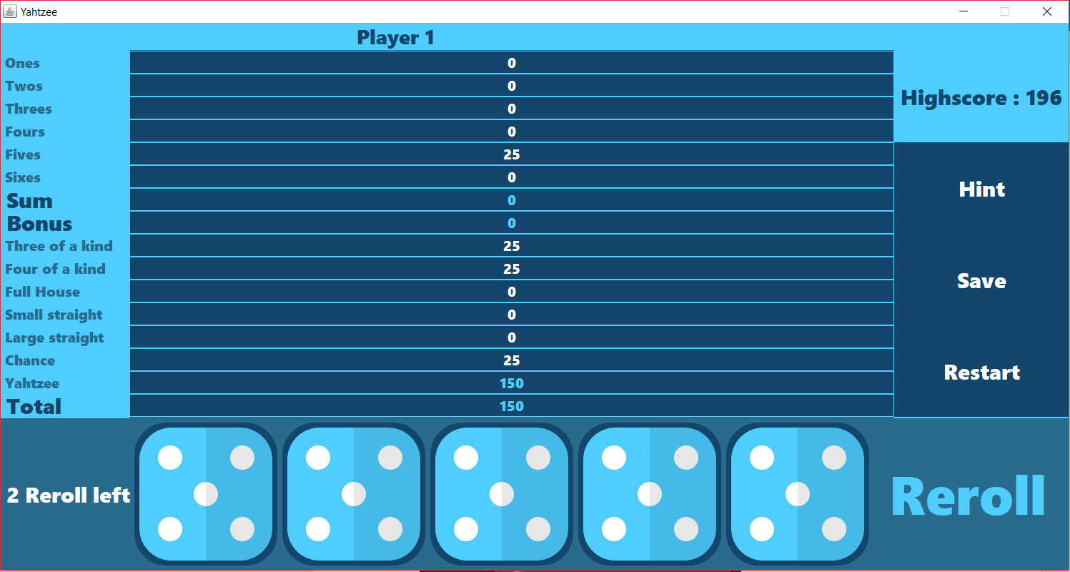

**Test multiple Yahtzee:**

Here we can observe what happen when the player gets multiple Yahtzee and the upper section is already filled.

The rules say that he can choose the row he wants in the lower section scoring the normal score. We the program is doing exactly this.

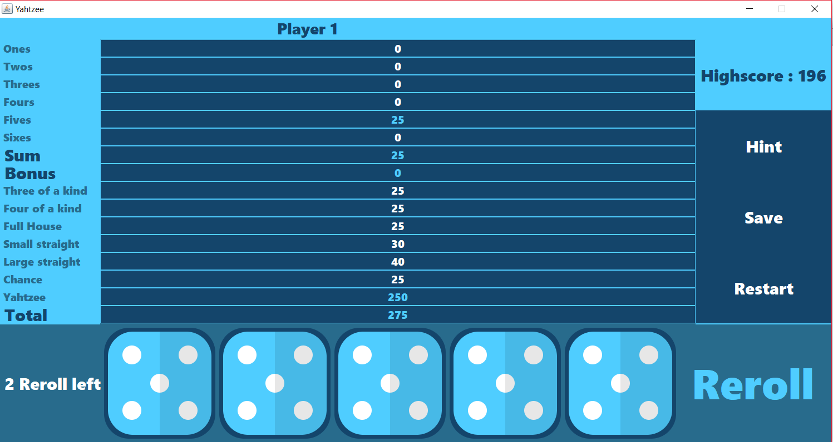

**Test end of a game and high score:**

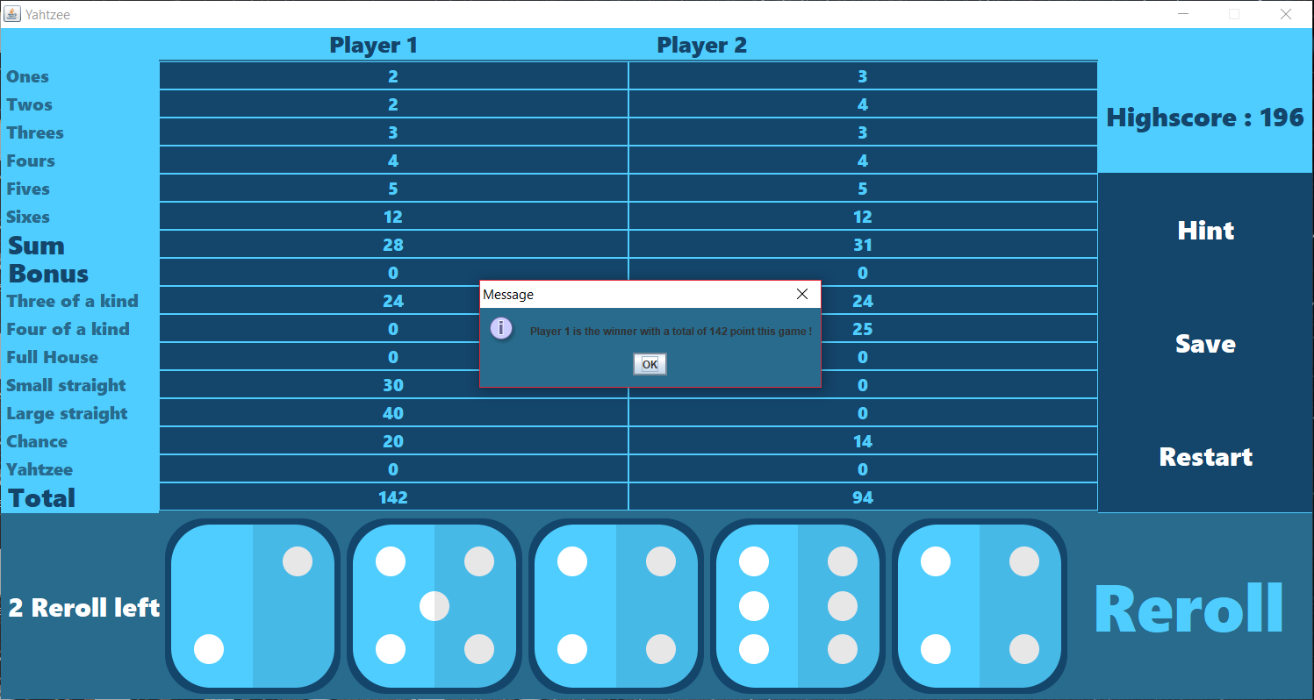Here we can see that the scoresheet has been fully filled by the 2 players, so the game end and the winner is showed.

Our program also handles the case of an equality.

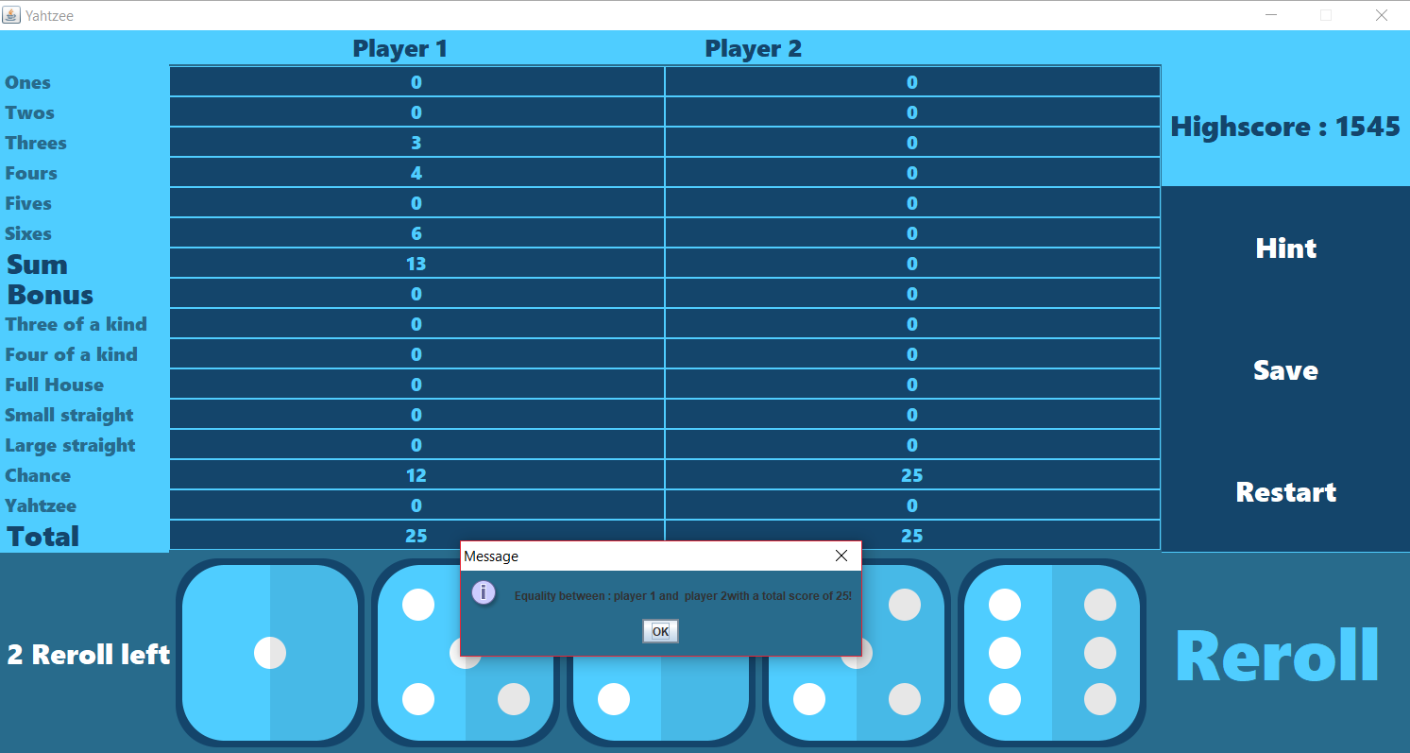

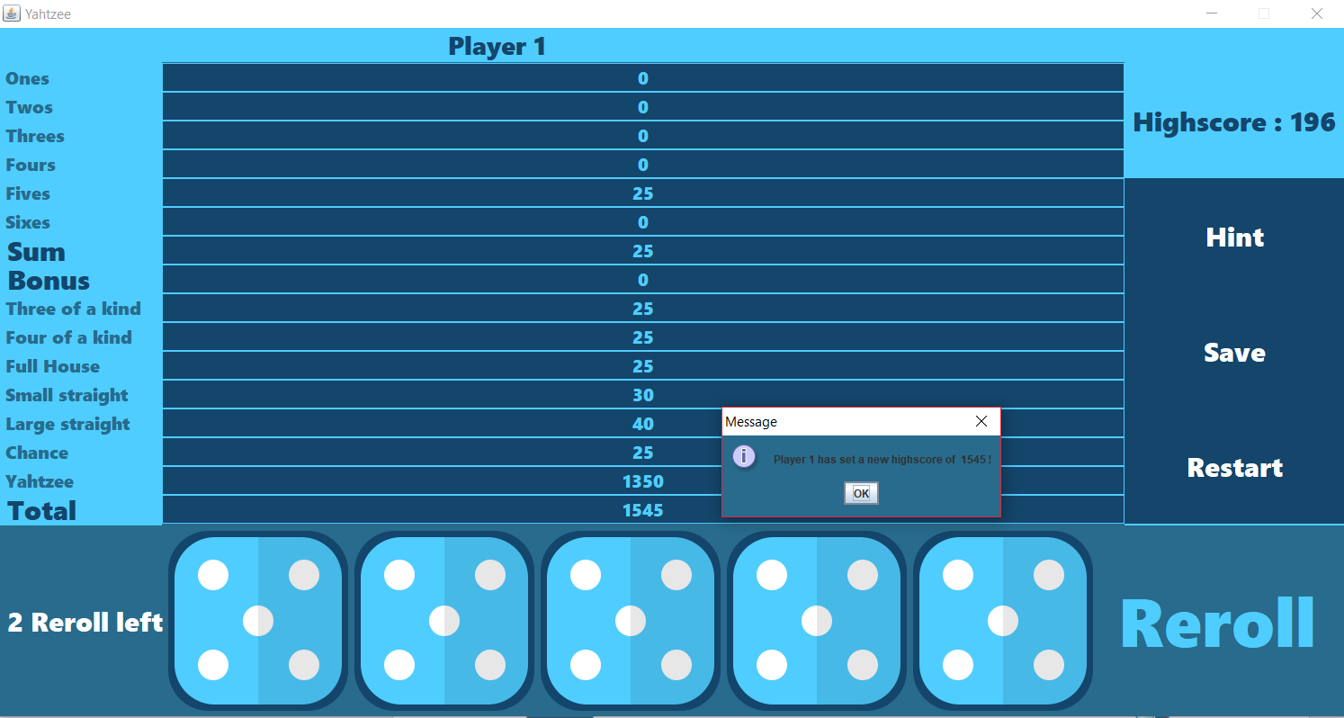At the end of the game we check if the player beat the high score, if it is the case then we display a message to tell him and we refresh the value of the high score.

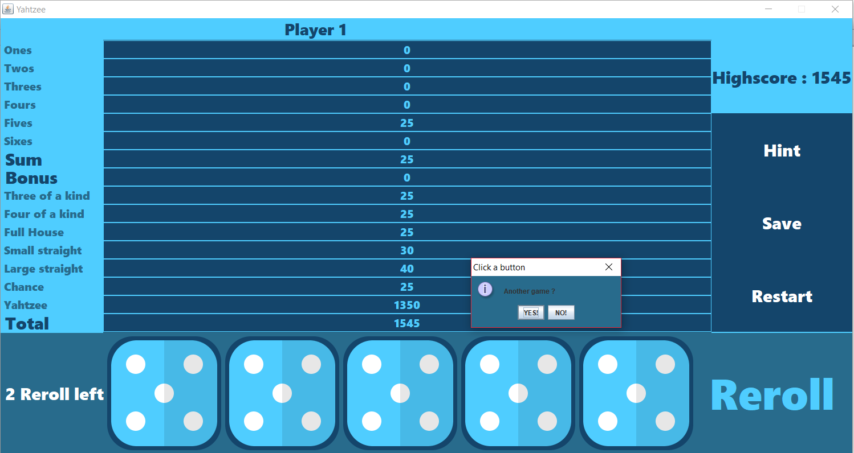Then we can see that it asks the user if he wants to play again or not.

If the user chooses yes it display him **the new game / load game menu**

**Test hint menu:**

When the play clicks on the hint button then it displays the Yahtzee rules.

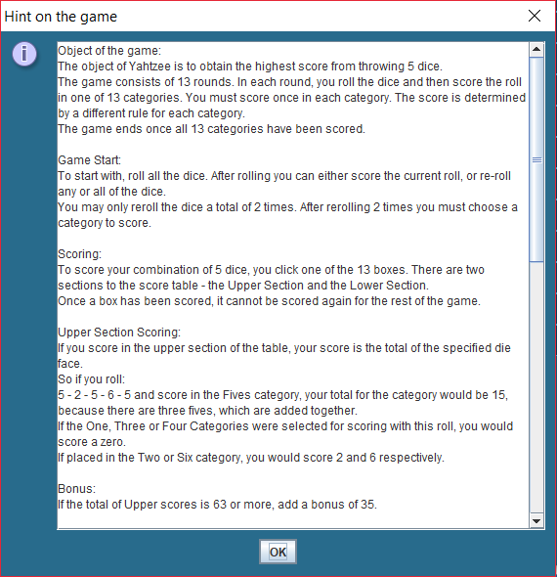

**Save button:** save the current score, player turn and number of reroll in a file so that the user can later load this game again.

**Restart button:** close the window and show the player the **new game / load game menu**

**Ideas for enhancements:**

There are two types of enhancements we could make to improve our actual Yahtzee.

First, we could make enhancements that offers the player a more enjoyable experience while playing. For example, we could add a graphical interface to the game. This would improve a lot the clearness and fun of the game. Also, we could find a new way of keeping dices during a reroll. The user could enter directly all the dices he wants to keep rather than saying yes/no five times.

Then, we could make enhancements that offers more options to the player. For example, we could implement a high score option in our game.

**Yahtzee rules we are using:**

Object of the game:

The object of Yahtzee is to obtain the highest score from throwing 5 dice.

The game consists of 13 rounds. In each round, you roll the dice and then score the roll in one of 13 categories. You must score once in each category. The score is determined by a different rule for each category.

The game ends once all 13 categories have been scored.

Game Start:

To start with, roll all the dice. After rolling you can either score the current roll, or re-roll any or all of the dice.

You may only reroll the dice a total of 2 times. After rerolling 2 times you must choose a category to score.

Scoring:

To score your combination of 5 dice, you click one of the 13 boxes. There are two sections to the score table - the Upper Section and the Lower Section.

Once a box has been scored, it cannot be scored again for the rest of the game.

Upper Section Scoring:

If you score in the upper section of the table, your score is the total of the specified die face.

So, if you roll:

5 - 2 - 5 - 6 - 5 and score in the Fives category, your total for the category would be 15, because there are three fives, which are added together.

If the One, Three or Four Categories were selected for scoring with this roll, you would score a zero.

If placed in the Two or Six category, you would score 2 and 6 respectively.

Bonus:

If the total of Upper scores is 63 or more, add a bonus of 35.

Lower Section Scoring:

In the lower scores, you score either a set amount, or zero if you don't satisfy the category requirements.

3 and 4 of a kind:

For 3 of a kind you must have at least 3 of the same die faces. You score the total of all the dice. For 4 of a kind you would need 4 die faces the same.

Small and Large Straight:

A Straight is a sequence of consecutive die faces, where a small straight is 4 consecutive faces, and a large straight 5 consecutive faces.

Small straights score 30 and a large 40 points.

So, if you rolled: 2 - 3 - 2 - 5 - 4 you could score 30 in small straight or 0 in large straight.

Full House:

A Full House is where you have 3 of a kind and 2 of a kind. Full houses score 25 points.

For example: 3 - 3 - 2 - 3 - 2 would score 25 in the Full House category.

First Yahtzee:

A Yahtzee is 5 of a kind and scores 50 points, although you may elect NOT to score it as a yahtzee, instead choosing to take it as a top row score.

Additional Yahtzees:

If you roll a second Yahtzee in a game, and you scored your first yahtzee in the Yahtzee box, you would score a further bonus 100 points in the yahtzee box. You must also put this roll into another category, as follows;

-If the corresponding Upper section category is not filled then you can score the dices in the upper section category or in the 3 or 4 of a kind.

-If the corresponding Upper section category is filled you may then put the score anywhere on the lower section, scoring the maximum point for this category. In 3 of a Kind, 4 of a Kind, and Chance categories you would score the total of the die faces. For the Small Straight, Large Straight, and Full House categories, you would score 30, 40 and 25 points respectively.

Chance:

You can roll anything and be able to put it in the Chance category. You score the total of the die faces.