MUC02

Credit Pre-Screening Engine
Loan Intake Optimisation
  - Personal Project Guide

What this guide contains
The business problem, CBIM canvas, dataset map, all seven assignment steps, cleaning decisions, formulas with worked examples, Python and machine-learning methods, measured results, threshold decision, estimated business impact, fairness findings, limitations, topics learned, and presentation / viva preparation.

Prepared for: Manish Arja
Calibo AI Academy • Path 2 • KLU Batch
Module: Supervised Learning Part 1 — Regression & Problem Framing

How to use this document
Use this as your own reference while studying the notebook and preparing for class. It is deliberately more detailed than the one-page assignment summary. It explains what was done, why each method was chosen, how important numbers are calculated, what the results support, and what they do not prove.
- Read Sections 1–5 to explain the business problem and understand the dataset.
- Use Sections 6–13 to review each assignment step in order.
- Use Sections 14–18 to revise formulas, methods, topics learned and limitations.
- Use Sections 19–21 for a spoken briefing, likely questions, and the submission checklist.
Important distinction
The notebook predicts historical analyst decisions, not actual loan repayment. “Historically approved but predicted Declined” is a model error relative to the recorded decision; it does not prove that the applicant was creditworthy or would repay.

Contents
- 1. Project at a glance
- 2. Business problem and proposed solution
- 3. CBIM Problem Canvas
- 4. Dataset and key terms
- 5. End-to-end workflow
- 6. Step 5.1 — Load, inspect and clean
- 7. Step 5.2 — What drives approval today?
- 8. Step 5.3 — Feature engineering and affordability
- 9. Step 5.4 — Logistic Regression and evaluation
- 10. Coefficients: how to interpret them
- 11. Step 5.5 — Threshold selection and business case
- 12. Step 5.6 — Fairness check
- 13. Step 5.7 — Credit Policy Briefing
- 14. Formula book and worked calculations
- 15. Why we used these methods
- 16. What we learned
- 17. Limitations and what we should not claim
- 18. Four-member work plan
- 19. Presentation-ready explanation
- 20. Likely viva questions and answers
- 21. Submission checklist and glossary

1. Project at a glance
The Credit Pre-Screening Engine is a small supervised-learning project for retail personal lending. The bank wants to reduce unnecessary manual review by identifying applications that look very likely to be declined under its historical decision pattern, while keeping the risk of wrongly auto-declining historically approved applications within a strict limit.
Item | Project answer
Industry | BFSI — retail lending / unsecured personal loans
Dataset | 12,000 simulated loan applications received April–September 2026; 19 original columns
Target | Historical decision: Approved or Declined
Model | Logistic Regression classifier
Main engineered features | FOIR, loan-to-income ratio and is_ntc flag
Evaluation | 80/20 stratified train-test split; test set has 2,400 applications
Business risk rule | No more than 5% of auto-declined applications should have been historically Approved
Selected tested threshold | 0.90 predicted probability of Declined
Test-set threshold result | 15.17% auto-declined; 4.67% historically Approved within that group
Scaled monthly estimate | About 455 applications and 189.6 analyst hours potentially freed
Main limitation | Historical analyst decisions are not repayment outcomes

One-sentence purpose
Use six months of historical applications to test whether a model can identify a limited, high-confidence group of likely declines for pre-screening, and quantify the potential review time saved without exceeding the bank’s historical wrong-decline risk limit.

2. Business problem and proposed solution

2.1 The problem in plain English
The bank receives about 3,000 personal-loan applications each month. A credit analyst takes around 25 minutes to manually review one application. Nearly half of applications are eventually declined, and some decisions may be obvious from the first checks, such as very low credit scores or an unaffordable EMI burden. Reviewing every application manually consumes time that could be spent on cases requiring judgement.

2.2 What the bank wants to change
The Credit Policy Analyst wants an evidence-based pre-screening process. The model should not make every lending decision. It should estimate the likelihood of a historical decline. A strict probability threshold then identifies a limited group for the proposed auto-decline lane; all remaining cases stay in manual review.

2.3 Proposed flow
Stage | What happens | Why
1. Receive application | Collect applicant, income, credit, loan and employment information. | These inputs describe the application.
2. Prepare the data | Clean income entries, handle missing values and create affordability features. | Bad inputs can distort analysis and model predictions.
3. Predict | Logistic Regression estimates probability of Declined. | A probability allows the bank to choose a threshold.
4. Apply threshold | Use the tested 0.90 threshold for the proposed auto-decline lane. | Only high-confidence predictions meet the chosen risk rule in the test data.
5. Human review | Applications not in the auto-decline lane go to analysts; new-to-credit cases should remain with humans. | The model is weaker for new-to-credit applicants and is not a full lending system.
6. Monitor | Track outcomes by gender and other relevant groups; validate against repayment data before live use. | Past decisions may contain bias and do not prove repayment performance.

2.4 What success means
Success is not simply the highest accuracy. For this use case, the essential business test is whether the threshold keeps historically approved applications at or below 5% of the auto-decline group while removing as many applications as possible from manual review among the thresholds tested. We must translate this into applications and analyst hours per month.

3. CBIM Problem Canvas
Canvas element | Completed answer | What it prevents
Situation (S) | A mid-size bank receives about 3,000 personal-loan applications per month; each receives an approximately 25-minute manual review. | Prevents an overly vague description such as “a bank gives loans.”
Complication (C) | Analysts spend time on applications that may be clear-cut declines, which leaves less time for cases requiring judgement and can increase wait times. | Explains why the current process is a business problem.
Question (Q) | Which applications can safely leave manual review, and at what decline-probability threshold, while keeping historically approved applications to no more than 5% of auto-declines? | Defines a decision the model enables rather than merely saying “build a model.”
SSOT | The CSV dataset is the source of truth. The decision column records past analyst judgement, not customer repayment. | Makes the target and its limitation explicit.
Success definition | A tested threshold satisfying the 5% rule, plus estimated applications and analyst hours freed and a fairness check. | Connects the model to measurable business value and risk.
Stakeholders | Credit Policy Analyst, Head of Retail Lending, credit analysts and the applicants affected. | Keeps operational and customer impacts in view.

4. Dataset and key terms

4.1 Overall dataset facts
Measure | Result | Calculation / meaning
Rows and columns | 12,000 rows × 19 columns | One row per loan application.
Approved | 6,353 (52.94%) | 6,353 ÷ 12,000 × 100.
Declined | 5,647 (47.06%) | 5,647 ÷ 12,000 × 100.
Missing monthly income | 441 | 3.68% of all rows.
Missing credit score | 1,039 | 8.66% of all rows; all have zero credit-history months.
Income values above ₹6,00,000 | 12 | All were Salaried and were reviewed as likely annual income entered monthly.

4.2 Meaning of the original 19 columns
Column | Meaning / use
application_id | Unique application identifier; excluded from model features.
application_date | Date the application arrived; excluded from model features.
age | Applicant age in years.
gender | Gender as recorded; excluded from model features but used in fairness checks.
city | City of residence; excluded from model features.
city_tier | City tier (1 = metro, 2 = large city, 3 = smaller city); included as a numeric feature per assignment.
employment_type | Salaried, Self-Employed Professional, Business Owner or Gig / Contract; one-hot encoded.
years_in_current_job | Years in the current job or business.
monthly_income | Declared gross monthly income; cleaned before analysis.
existing_emi | Monthly EMI obligations on existing loans.
credit_score | Credit bureau score from 300 to 900; blank for no-credit-history applicants in this dataset.
credit_history_months | Length of credit history in months; zero for the blank-score group.
num_active_loans | Count of active loans.
delinquencies_24m | Late or missed repayments in the previous 24 months.
loan_purpose | Purpose given for the loan; one-hot encoded.
loan_amount | Requested loan amount.
tenure_months | Requested repayment duration in months.
proposed_emi | Estimated monthly EMI for the requested loan.
decision | Historical analyst decision: Approved or Declined; used as the target, never as an input feature.

4.3 Terms used throughout the project
Term | Plain-English meaning
BFSI | Banking, Financial Services and Insurance.
EMI | Equated Monthly Instalment: the monthly payment on a loan.
FOIR | Fixed Obligation to Income Ratio: the share of monthly income used by existing and proposed EMIs.
NTC / new-to-credit | An applicant with no recorded credit score / credit history in this dataset.
Supervised learning | Learning a relationship from examples where the target outcome is already known.
Classification | Predicting a category, here Approved or Declined.
Probability threshold | A cut-off applied to the model’s predicted probability to decide which applications enter the proposed lane.
False positive for Declined | Model predicts Declined, but the historical decision was Approved.
Proxy variable | A feature such as income or employment that can be related to a sensitive attribute even when that attribute is excluded.
ROC-AUC | A measure of how well a model ranks positive cases above negative cases across thresholds; it is not the same as accuracy.

5. End-to-end workflow
Step | Question answered | Main outputs
CBIM canvas | What business decision are we trying to improve? | Situation, complication, question, SSOT, success definition, stakeholders.
5.1 — Clean | Can the data be trusted enough to analyse? | Shape, data types, missingness, cleaning log.
5.2 — Approval patterns | What patterns are associated with historical approvals? | Credit-score bands and employment-type rates.
5.3 — Features | How can affordability be represented numerically? | FOIR, loan-to-income, is_ntc and FOIR chart.
5.4 — Model | How well does Logistic Regression reproduce historical decisions? | Metrics, confusion matrix, coefficients, group accuracy.
5.5 — Threshold | How strict must the model be to meet the 5% rule? | Seven-threshold table, trade-off chart, monthly hours.
5.6 — Fairness | Do outcomes differ across gender groups? | Historical and predicted outcome comparisons.
5.7 — Briefing | What should the policy analyst do next? | Specific threshold, business impact, strongest factors, NTC caveat and data limitation.

6. Step 5.1 — Load, inspect and clean

6.1 What we checked
- Dataset dimensions: 12,000 rows and 19 columns.
- Data types: numerical columns, categorical columns and the application date converted to datetime.
- Missing values: monthly_income had 441 blank entries; credit_score had 1,039.
- Target balance: 52.9% Approved and 47.1% Declined.

6.2 Missing income by employment type
Employment type | Applications | Missing incomes | Missing rate | Median used for filling
Business Owner | 1,749 | 227 | 13.0% | ₹69,500
Self-Employed Professional | 1,428 | 154 | 10.8% | ₹75,000
Salaried | 7,057 | 49 | 0.7% | ₹50,000
Gig / Contract | 1,766 | 11 | 0.6% | ₹28,000

The median values shown are calculated after dividing the 12 very large income entries by 12, and before filling missing values. We filled each blank using the median of the same employment type. This avoids deleting applicants and respects that typical income differs across employment categories.

6.3 Blank credit scores
There are 1,039 blank credit scores. Every one of these rows has credit_history_months = 0. In this dataset, the blanks therefore indicate applicants without recorded credit history rather than random missing scores. We keep all these rows and create `is_ntc` before model-time score imputation.

6.4 Twelve unusually high monthly-income values
Twelve Salaried applications have monthly_income above ₹6,00,000. The notebook assumes that these are annual income amounts accidentally entered in a monthly field and divides each by 12. This is an explicit data-cleaning assumption, not a fact proven from the CSV. It is documented because leaving the values unchanged could make FOIR look unrealistically low.

6.5 Why we do not fill credit_score in the main EDA table
If we replaced blank scores immediately, the “No score” group would disappear. Instead, the notebook keeps credit_score missing in the analysis table and retains `is_ntc`. In the model pipeline, a median imputer fills credit_score for the algorithm. The flag lets the model distinguish those cases from applicants whose observed score happens to be near the median.
Cleaning summary
All 12,000 rows are retained. After Step 5.1, monthly_income has zero missing values, while the 1,039 missing credit scores remain identifiable for analysis and are imputed only in the model pipeline.

7. Step 5.2 — What drives approval today?
This step describes the historical credit team’s decisions before any model is trained. Approval rate is calculated as Approved applications divided by all applications in the group, multiplied by 100.

7.1 Approval rate by credit-score band
Credit score band | Applications | Approved | Approval rate
Below 600 | 246 | 5 | 2.0%
600–649 | 933 | 30 | 3.2%
650–699 | 2,529 | 822 | 32.5%
700–749 | 3,377 | 1,836 | 54.4%
750–799 | 2,526 | 1,950 | 77.2%
800+ | 1,350 | 1,150 | 85.2%
No score | 1,039 | 560 | 53.9%

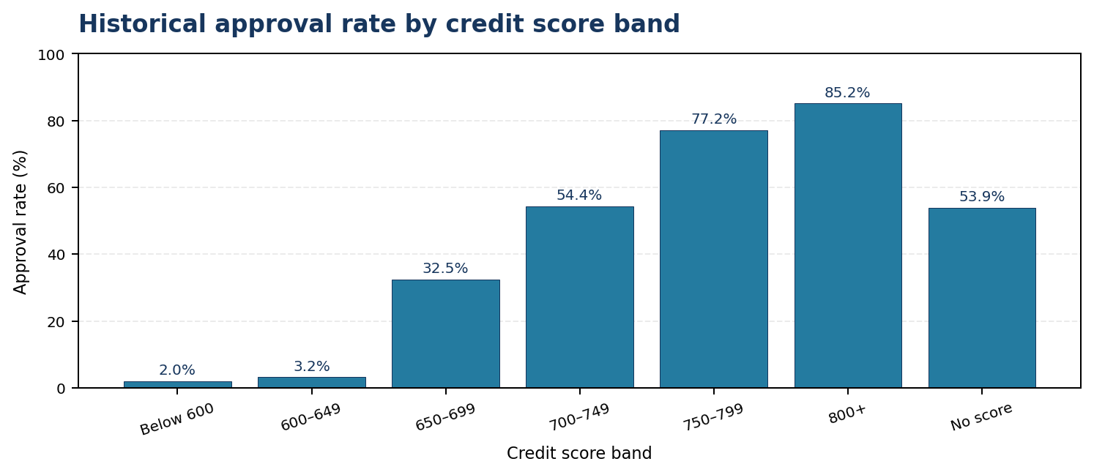
Figure 1. Calculated from the supplied CSV after the documented income cleaning.

7.2 Interpretation
Approval is very rare in the two bands below 650: 2.0% below 600 and 3.2% in the 600–649 band. It rises to 32.5% in the 650–699 band, then rises again in higher bands. This is a strong historical association and suggests the bank may operate as though there is an informal score floor near 650. It does not prove a formal policy or make every individual below 650 automatically ineligible.
The “No score” group has a 53.9% approval rate: 560 of the 1,039 applicants were Approved. This is an important reason not to treat missing credit history as the same thing as a low credit score.

7.3 Approval rate by employment type
Employment type | Applications | Approved | Approval rate
Salaried | 7,057 | 4,119 | 58.4%
Business Owner | 1,749 | 895 | 51.2%
Self-Employed Professional | 1,428 | 722 | 50.6%
Gig / Contract | 1,766 | 617 | 34.9%

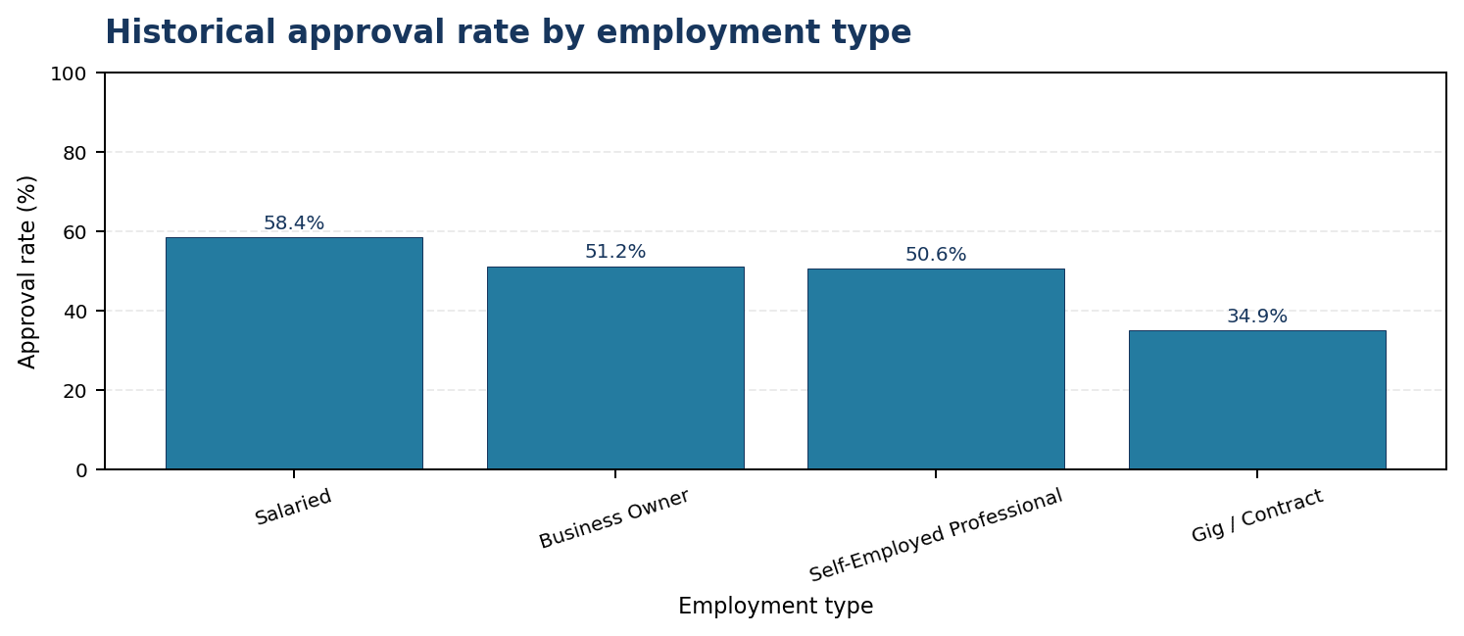
Figure 2. Calculated historical approval rates by employment type.
Salaried applicants have the highest approval rate (58.4%), while Gig / Contract applicants have the lowest (34.9%). We should not claim that employment label alone causes the difference. Income stability, time in the current job, existing obligations and other factors may be related. The charts motivate further analysis; they are not standalone rejection rules.

8. Step 5.3 — Feature engineering and affordability

8.1 FOIR formula
FOIR = (Existing EMI + Proposed EMI) ÷ Monthly Income

FOIR measures the portion of monthly income that would be committed to existing and proposed loan instalments. A FOIR of 0.50 is equivalent to 50%. In this project, the formula uses values in the same currency and the monthly time period for all three fields.

8.2 Worked FOIR calculation
Input | Amount
Monthly income | ₹50,000
Existing EMI | ₹10,000
Proposed EMI | ₹15,000
Total monthly EMI obligation | ₹25,000
FOIR calculation | ₹25,000 ÷ ₹50,000 = 0.50
FOIR as percentage | 0.50 × 100 = 50%

In this example, half of monthly income would be used for loan repayments. This is an affordability signal, not a complete lending decision.

8.3 Loan-to-income formula
Loan-to-income = Requested loan amount ÷ (Monthly income × 12)

We multiply monthly income by 12 to estimate annual income, then divide the requested loan by annual income. For example, if monthly income is ₹50,000 and the loan amount is ₹3,00,000, annual income is ₹6,00,000 and loan-to-income is ₹3,00,000 ÷ ₹6,00,000 = 0.50. This means the requested loan is 50% of the annual income.

8.4 New-to-credit flag
is_ntc = 1 if credit_score is missing; otherwise is_ntc = 0

The flag is built before credit-score imputation. It preserves a distinction that would otherwise be lost when the model fills in a numeric score.

8.5 FOIR bands and measured results
FOIR band | Applications | Approved | Approval rate
Below 30% | 5,491 | 3,595 | 65.5%
30–40% | 2,497 | 1,473 | 59.0%
40–50% | 1,766 | 845 | 47.8%
50–55% | 531 | 172 | 32.4%
Above 55% | 1,715 | 268 | 15.6%

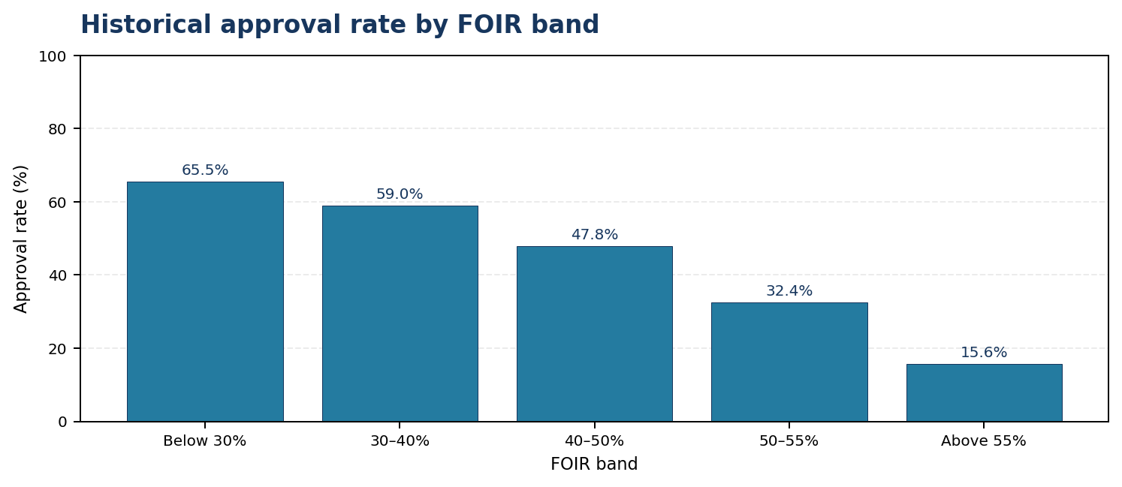
Figure 3. Calculated approval rates across the FOIR bands.
Approval drops as FOIR rises: 65.5% below 30%, 47.8% in the 40–50% band, 32.4% in the 50–55% band and 15.6% above 55%. The largest policy message is that approval becomes much less common when obligations are above about half of income. A 50–55% limit is a proposal to test further, not a guaranteed safe cut-off for every applicant.

8.6 Exact band boundaries
Band label | Actual interval used | Meaning
Below 30% | FOIR < 0.30 | Less than 30% of income.
30–40% | 0.30 ≤ FOIR < 0.40 | 30% up to, but not including, 40%.
40–50% | 0.40 ≤ FOIR < 0.50 | 40% up to, but not including, 50%.
50–55% | 0.50 ≤ FOIR < 0.55 | 50% up to, but not including, 55%.
Above 55% | FOIR ≥ 0.55 | 55% and above under the code’s right=False boundary rule.

9. Step 5.4 — Logistic Regression and evaluation

9.1 What kind of model is this?
This is supervised binary classification. The historical decision is known for every training example. Logistic Regression estimates the probability of the positive class, which we defined as Declined = 1. Approved = 0. The course title includes “Regression,” but Logistic Regression is used here as a classifier, not to predict a continuous amount such as salary.

9.2 Why Logistic Regression?
- It is the model specified by the student assignment, so the submission stays within the taught scope.
- It supports binary outcomes and produces probabilities through `predict_proba`, which is necessary for testing thresholds such as 0.50 to 0.95.
- Its coefficients provide a relatively interpretable view of how features relate to the prediction, which helps explain results to a credit-policy stakeholder.
- We did not compare Random Forest, Decision Tree or other models because the assignment asks for one Logistic Regression model. This is a scope choice, not proof that Logistic Regression is universally best.

9.3 Target and features
Role | Fields
Target y | decision mapped to Approved = 0 and Declined = 1.
Numeric features | credit_score, is_ntc, foir, loan_to_income, delinquencies_24m, num_active_loans, years_in_current_job, age, tenure_months, city_tier.
Categorical features | employment_type and loan_purpose.
Excluded inputs | application_id, application_date, city, gender and decision. Decision is the target; the others are excluded as instructed.
Why exclude application ID/date? | ID is an identifier rather than a customer-risk measure; date is excluded by the brief and could let the model learn time patterns rather than the requested policy factors.
Why exclude city and gender? | The assignment explicitly says not to use them as features; gender is still used for an outcome fairness check.

9.4 Train-test split
Training size = 12,000 × 80% = 9,600 applications

Test size = 12,000 × 20% = 2,400 applications

The notebook uses `train_test_split(test_size=0.20, stratify=y, random_state=42)`. Stratification preserves a similar Approved/Declined proportion in training and test sets. `random_state=42` makes the split reproducible so the same rows are selected when the same data and code are used.

9.5 Preprocessing: imputation, scaling and encoding
Tool / method | Where / how it is used | Why
SimpleImputer(strategy="median") | Numeric pipeline, including credit_score during model training. | Fills missing numerical values using the median learned from training data, which is less sensitive to extreme values than the mean.
StandardScaler | Numeric pipeline after imputation. | Puts numeric features on a comparable scale: subtracts training mean and divides by training standard deviation.
SimpleImputer(strategy="most_frequent") | Categorical pipeline. | Fills any missing category using the most frequent training category.
OneHotEncoder(drop="first", handle_unknown="ignore") | employment_type and loan_purpose. | Creates binary indicator columns, avoids implying a numeric order among categories, drops one reference category and handles unseen categories.
ColumnTransformer | Combines numeric and categorical preprocessing. | Applies the correct transformation to the correct columns.
Pipeline | Preprocessing followed by LogisticRegression. | Keeps model-time imputation, scaling, encoding and classification together; these learned transformations fit on training data. Step 5.1 income cleaning occurs before the split as the assignment requests, so a production implementation could move that imputation into training-only preprocessing.

9.6 Core model code shape
y = df["decision"].map({"Approved": 0, "Declined": 1})

X_train, X_test, y_train, y_test = train_test_split(
X, y, test_size=0.20, stratify=y, random_state=42
)

numeric_pipeline = Pipeline([
("imputer", SimpleImputer(strategy="median")),
("scaler", StandardScaler())
])

categorical_pipeline = Pipeline([
("imputer", SimpleImputer(strategy="most_frequent")),
("onehot", OneHotEncoder(handle_unknown="ignore", drop="first"))
])

preprocessor = ColumnTransformer([
("num", numeric_pipeline, numeric_features),
("cat", categorical_pipeline, categorical_features)
])

model = Pipeline([
("preprocessor", preprocessor),
("classifier", LogisticRegression(max_iter=2000, random_state=42))
])
The full implementation is in the notebook. The code block above shows the structure and why the preprocessors sit inside the pipeline; it is not a replacement for the full executable notebook.

9.7 Model metrics
Metric | Result | Meaning in this project
Accuracy | 79.1% | About 79.1% of the 2,400 test predictions matched the historical decision.
Precision for Declined | 79.1% | Of applications predicted Declined at the default 0.50 cut-off, 79.1% were historically Declined.
Recall for Declined | 75.5% | Of all historically Declined test applications, 75.5% were predicted Declined at the default cut-off.
ROC-AUC | 0.867 (86.7%) | Measures ranking discrimination across thresholds; it is not an accuracy figure.

9.8 Confusion matrix
Actual decision | Predicted Approved | Predicted Declined | Business interpretation
Actually Approved | 1,046 | 225 | 225 historically approved applications were predicted Declined at threshold 0.50.
Actually Declined | 277 | 852 | 852 historical declines were identified; 277 were missed by the model at 0.50.

The test set has 2,400 applications. At the default 0.50 threshold the matrix contains 1,046 + 852 = 1,898 correct predictions, giving 1,898 ÷ 2,400 = 79.08%, or 79.1% accuracy. The auto-decline threshold decision is considered separately in Step 5.5; the confusion matrix above is the default 0.50 result.
The most important customer-risk number
At the default 0.50 cut-off, 225 applications that the historical credit team Approved were predicted as Declined. The threshold step raises the cut-off to reduce this proportion before proposing any auto-decline lane.

10. Coefficients: how to interpret the top factors
Feature | Coefficient | Interpretation
FOIR | +1.220 | Higher FOIR pushes the model toward Declined.
Credit score | -1.009 | Higher credit score pushes the model toward Approved.
Delinquencies in 24 months | +0.980 | More recorded late/missed repayments push the model toward Declined.
Employment type: Gig / Contract | +0.639 | This category is associated with higher decline predictions relative to the encoded reference category, holding other inputs constant.
Loan purpose: Debt Consolidation | +0.509 | This category is associated with higher decline predictions relative to the encoded reference category, holding other inputs constant.

The target is Declined = 1, so positive coefficients push the model toward the Declined class while negative coefficients push it toward Approved, holding the other model inputs constant. Numeric variables are standardized, so a numeric coefficient corresponds to a one-standard-deviation increase. One-hot encoded coefficients are relative to the omitted reference category.
The five largest absolute coefficients are not a ranking of causes. They show how the fitted model uses the available patterns. Correlations between features, data generation and the fact that the target is past human judgement can all affect these values.

10.1 Performance by new-to-credit status
Applicant group | Test applications | Accuracy
Applicants with a recorded credit score | 2,197 | 81.2%
New-to-credit applicants | 203 | 56.7%

This group-level result is one reason to keep NTC applicants with human reviewers. The model is much less accurate for them; treating its prediction as decisive would be risky.

11. Step 5.5 — Threshold selection and business case

11.1 What is the threshold?
The model’s `predict_proba` output estimates the probability of Declined. The threshold specifies how high that probability must be before an application is put into the proposed auto-decline lane. Raising the threshold generally reduces the number of auto-declines and reduces the proportion of historically approved applications in that lane, but it also catches fewer of the historical declines.

11.2 Threshold table from the executed notebook
Threshold | Test set auto-declined | Historically Approved within that group | Auto-declined count | Wrong-decline count | Share of actual declines caught*
0.50 | 44.88% | 20.89% | 1,077 | 225 | 75.5%
0.60 | 37.62% | 16.83% | 903 | 152 | 66.5%
0.70 | 30.79% | 12.04% | 739 | 89 | 57.6%
0.80 | 23.42% | 7.12% | 562 | 40 | 46.2%
0.85 | 19.67% | 5.93% | 472 | 28 | 39.3%
0.90 | 15.17% | 4.67% | 364 | 17 | 30.7%
0.95 | 10.00% | 2.08% | 240 | 5 | 20.8%

*The “share of actual declines caught” column is calculated from the notebook’s threshold counts: (auto-declined cases − historically Approved auto-declines) ÷ 1,129 actual Declined cases in the test set. It is an additional derived view, not a required column in the assignment.
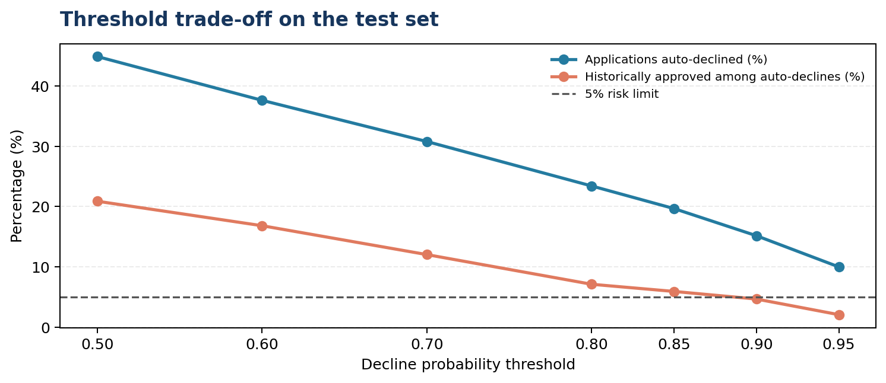
Figure 4. Higher thresholds reduce the share of applications flagged and the historical wrong-decline proportion.

11.3 Apply the 5% rule
Wrong-decline proportion = Historically Approved among auto-declines ÷ All auto-declines × 100

At threshold 0.90, 17 of 364 auto-declined test applications were historically Approved: 17 ÷ 364 × 100 = 4.67%. At threshold 0.85, 28 of 472 were historically Approved: 28 ÷ 472 × 100 = 5.93%, which fails the rule. Therefore 0.90 is the lowest passing threshold among the seven required thresholds and gives the largest auto-decline share among those that pass.

11.4 Monthly business impact
Monthly applications flagged = 3,000 × 15.17% ≈ 455 applications

Monthly hours potentially freed = 455 × 25 minutes ÷ 60 ≈ 189.6 hours

The reported result is about 455 applications and 190 analyst hours per month. This assumes the test-set auto-decline rate is representative of future incoming applications and that each flagged application would otherwise use a full 25-minute manual review. The result is a planning estimate, not a guaranteed saving.
Why not keep the 0.50 threshold?
At 0.50, 44.88% of test applications are flagged, but 20.89% of that group were historically Approved. This is far above the bank’s 5% risk limit. A model probability is not itself a policy decision; the bank’s risk appetite sets the threshold.

12. Step 5.6 — Fairness check

12.1 Historical comparison by gender
Measure | Female | Male | Interpretation
Applications | 3,795 | 8,205 | The groups differ in size.
Historical approval rate | 50.4% | 54.1% | The raw gap is about 3.7 percentage points.
Median monthly income | ₹45,000 | ₹55,000 | The female group has a lower median in this dataset.
Gig / Contract share | 21.4% | 11.6% | The share is about 1.8 times as high among female applicants.

12.2 Approval rate within employment type
Employment type | Female approval | Male approval | Difference (male − female)
Salaried | 56.8% | 59.1% | 2.3 percentage points
Self-Employed Professional | 47.6% | 52.0% | 4.4 percentage points
Business Owner | 51.6% | 51.1% | −0.5 percentage points
Gig / Contract | 34.6% | 35.2% | 0.6 percentage points

12.3 Model auto-decline rates by gender at 0.90
Gender | Test applications | Auto-declined | Auto-decline rate
Female | 750 | 117 | 15.6%
Male | 1,650 | 247 | 15.0%

The auto-decline rates are close in this test set, but this does not prove the model is fair in every respect. The historical approval gap may be associated with differences in income and employment mix, but these comparisons alone do not prove the cause. Income and employment type may act as proxy variables. Outcomes should be monitored by gender and other relevant groups after any deployment.
The model’s NTC accuracy is comparatively low, so those applicants should remain in a human-review lane until their performance and the appropriate policy treatment are better understood.

13. Step 5.7 — Credit Policy Briefing
Briefing you can explain to the Credit Policy Analyst
I recommend an auto-decline threshold of 0.90: the application should enter the proposed auto-decline lane only when the model estimates at least a 90% probability of Declined. On the held-out test set, 15.17% of applications met this threshold; scaled to 3,000 monthly applications, that is about 455 applications and approximately 190 analyst hours potentially freed. Of the applications flagged at this threshold, 4.67% were historically Approved, which meets the stated 5% limit on this test set. FOIR (+1.22) and credit score (−1.01) had the two largest absolute coefficients; higher FOIR pushes predictions toward Declined, while a higher credit score pushes them toward Approved. New-to-credit applicants should remain with human reviewers because group accuracy was only 56.7%, compared with 81.2% for scored applicants. Gender was not used as a feature, but income and employment type may act as proxies, so outcomes should be monitored; before live use, the bank should obtain actual repayment data such as on-time payments and defaults.

13.1 Why this briefing is strong
- It gives a specific threshold rather than leaving the default at 0.50.
- It translates the threshold into both monthly applications and analyst hours.
- It names two important model factors and includes their coefficients.
- It identifies a group that should not be decided by the model alone.
- It addresses fairness and asks for additional evidence before deployment.

14. Formula book and worked calculations

14.1 Overall approval rate
Approval rate = Number Approved ÷ Total applications × 100

6,353 ÷ 12,000 × 100 = 52.94%, reported as 52.9%. The Declined rate is 5,647 ÷ 12,000 × 100 = 47.06%, reported as 47.1%.

14.2 Group approval rate
Group approval rate = Approved in group ÷ Total applications in group × 100

For the 600–649 credit-score band: 30 Approved ÷ 933 applications × 100 = 3.22%, reported as 3.2%.

14.3 FOIR
FOIR = (Existing EMI + Proposed EMI) ÷ Monthly income

Example: (₹10,000 + ₹15,000) ÷ ₹50,000 = 0.50 = 50%.

14.4 Loan-to-income
Loan-to-income = Loan amount ÷ (Monthly income × 12)

Example: ₹3,00,000 ÷ (₹50,000 × 12) = ₹3,00,000 ÷ ₹6,00,000 = 0.50.

14.5 Accuracy
Accuracy = (TP + TN) ÷ (TP + TN + FP + FN)

Here TP = 852, TN = 1,046, FP = 225 and FN = 277 for the Declined-positive setup. Accuracy = (852 + 1,046) ÷ 2,400 = 1,898 ÷ 2,400 = 79.08%, or 79.1%.

14.6 Precision for Declined
Precision = TP ÷ (TP + FP)

852 ÷ (852 + 225) = 852 ÷ 1,077 = 79.11%, or 79.1%. This answers: among applications predicted Declined at 0.50, what share were historically Declined?

14.7 Recall for Declined
Recall = TP ÷ (TP + FN)

852 ÷ (852 + 277) = 852 ÷ 1,129 = 75.47%, or 75.5%. This answers: among all historically Declined applications, what share did the model identify at 0.50?

14.8 Wrong-decline proportion at a threshold
Wrong-decline proportion = Historically Approved in auto-decline group ÷ Auto-decline group size × 100

At 0.90: 17 ÷ 364 × 100 = 4.67%. At 0.85: 28 ÷ 472 × 100 = 5.93%, so 0.85 fails the 5% rule.

14.9 Monthly operational estimate
Applications flagged per month = Monthly applications × Test-set auto-decline proportion

Hours potentially freed = Applications flagged × Review minutes ÷ 60

3,000 × 0.1517 = 455.1, rounded to approximately 455 applications. 455.1 × 25 ÷ 60 = 189.625 hours, approximately 189.6 hours or about 190 hours.

14.10 Gender gap and mix
Overall historical approval gap = 54.1% male − 50.4% female = approximately 3.7 percentage points. Gig / Contract share ratio = 21.4% ÷ 11.6% ≈ 1.84, meaning the share is about 1.8 times as high among female applicants in this dataset. These comparisons describe the data; they do not establish a causal explanation.

15. Why we used these methods
Method / tool | Reason for using it here | What it does not guarantee
Pandas | Load CSVs, inspect columns, clean values, group data and calculate approval rates. | Correct conclusions still depend on sensible assumptions and clean definitions.
NumPy | Numerical operations and handling boundaries such as FOIR bands. | It does not choose a policy rule for us.
Matplotlib / Seaborn | Show approval patterns and threshold trade-offs visually. | A chart shows association, not causation.
Median imputation | Fill missing numeric values with a typical value less affected by extreme values. | Imputation does not recover the true missing amount.
One-Hot Encoding | Represent employment type and loan purpose as numerical indicators. | Encoding does not make categories fair or causal.
StandardScaler | Put numeric feature scales on comparable standardised units. | Scaling does not improve every model automatically.
Logistic Regression | Binary classification with interpretable coefficients and predicted probabilities. | It may miss non-linear interactions and inherits patterns in historical labels.
Train-test split | Evaluate on applications held out from model fitting. | One random split is not proof of performance on future months.
Threshold testing | Translate probability estimates into an operating rule tied to the 5% constraint. | The 5% result is measured on the test set and may change in production.
Gender fairness analysis | Measure gaps even though gender is excluded as an input. | Similar auto-decline rates alone do not establish overall fairness.

15.1 Why only one model?
The student brief explicitly asks for a Logistic Regression pre-screener and the module is focused on supervised learning fundamentals. We therefore built and interpreted one model rather than comparing several. That is the correct scope for this assignment. A real bank would generally require additional validation, comparison against policy baselines, calibration checks, repayment-outcome testing and governance before deployment.

16. What I learned from this project
Topic learned | What it means in this project
Business problem framing | Translate a broad problem into a precise decision, stakeholder, source of truth and measurable success condition.
Data inspection in pandas | Use shape, dtypes, isna, groupby, agg and value counts to understand data quality.
Missing-data reasoning | Missing information can mean something (such as no credit history), and should not always be deleted.
Outlier handling | Investigate suspicious values, state assumptions and document every correction.
Exploratory data analysis | Use group approval rates to identify patterns across credit score, employment and FOIR.
Feature engineering | Create FOIR, loan-to-income and is_ntc from existing columns.
Classification vs regression | Logistic Regression predicts a class probability; it is a classifier in this project.
Train-test methodology | Use stratified splitting and a fixed random state for reproducible evaluation.
Preprocessing pipelines | Use imputation, scaling, One-Hot Encoding, ColumnTransformer and Pipeline in an ordered workflow.
Model evaluation | Interpret accuracy, precision, recall, ROC-AUC and the confusion matrix in business language.
Model interpretation | Read coefficient sign and magnitude carefully, with awareness of feature scaling and reference categories.
Probability thresholds | Recognise that 0.50 is a default, not necessarily the right business decision threshold.
Operational calculations | Translate a percentage of applications into workload and hours using transparent arithmetic.
Fairness and proxy variables | Excluding gender does not eliminate all possible indirect relationships or outcome gaps.
Clear business communication | Explain what a number means for a customer, analyst and policy decision, not just what the chart displays.

17. Limitations and what we should not claim
Limitation / risk | Safe way to describe it
Target is historical decision | The model predicts what the credit team historically decided, not repayment success or default.
Simulated dataset | Results are valid for this dataset exercise; they should not be presented as verified real-bank performance.
Income corrections are assumptions | The 12 high values were assumed to be annual income entered monthly because of their scale and group pattern; that should be verified in real data.
One train-test split | A random 80/20 split is useful for the assignment, but out-of-time testing on later applications is needed before live use.
Income imputation timing | The required employment-type income median was applied in Step 5.1 before the split. A stricter production workflow could fit this imputation rule on training data only and apply the learned medians to later data.
Threshold risk estimate may drift | The 4.67% figure reflects the held-out test set. Future applicant mix or policy changes could change it.
New-to-credit accuracy is low | Group accuracy is only 56.7%; these applicants should not be automatically decided by this model alone.
Fairness is not proven by excluding gender | Income and employment type may be proxies; outcome monitoring remains necessary.
Coefficient is not causation | A model coefficient describes a fitted relationship, not the cause of a human decision or repayment outcome.
Savings are an estimate | 190 hours assumes the test-set rate generalises and each flagged application would take a full 25 minutes otherwise.
Not production-ready | The project is a pre-screening study. Real deployment would need repayment outcomes, policy and legal review, additional validation, monitoring and human oversight.

18. Four-member work plan
The assignment’s written team guidance describes teams of two or three. For your four-person presentation, this is a practical division of the seven steps; confirm any four-person-specific rules with the trainer.
Member / role | Sections | Owns these outputs | What to explain
Member 1 — Data preparation | CBIM canvas + 5.1 | Problem canvas, data shape, missing-value table, cleaning log. | Why each data-quality choice was made and why NTC rows remain.
Member 2 — Approval analysis & affordability | 5.2–5.3 | Credit-score and employment charts; FOIR feature and chart; loan-to-income and is_ntc. | What historical approval patterns show and how FOIR is calculated.
Member 3 — Model builder | 5.4–5.5 | Logistic Regression, metrics, confusion matrix, coefficients, threshold table and time-saving estimate. | Why Logistic Regression, encoding/scaling, 225 errors at 0.50 and why 0.90 is selected.
Member 4 — Fairness & policy synthesis | 5.6–5.7 | Gender comparisons and final Credit Policy Briefing. | Why fairness needs monitoring and why NTC applicants need human review.

19. Quick glossary
Word / term | Plain-English explanation
Approval rate | Percentage of applications in a group that are marked Approved.
Auto-decline lane | The proposed group of applications flagged for automatic decline because their predicted decline probability meets the selected threshold; this is not a live deployment recommendation.
Coefficient | A weight learned by Logistic Regression that describes how a feature relates to the model’s prediction.
Confusion matrix | A table comparing predicted labels with actual labels.
Data leakage | When information that would not be legitimately available or should not be used enters training inputs or training procedures; target leakage occurs if the target itself is an input.
Feature | An input variable used by the model.
Feature engineering | Creating useful variables from existing data, such as FOIR.
Imputation | Filling missing values with an estimated or chosen value.
One-Hot Encoding | Representing categories as binary indicator columns.
Precision | Among predictions labelled positive, the share that is actually positive.
Recall | Among actual positive cases, the share identified by the model.
Threshold | The probability cut-off used to turn a score into a lane or class decision.
Train-test split | Dividing data into examples used to fit the model and examples reserved to evaluate it.
Proxy | An input that can indirectly carry information related to an excluded or sensitive attribute.
ROC-AUC | A probability-ranking performance metric across possible classification thresholds.

Final takeaway
The project in one paragraph
We cleaned and explored 12,000 simulated applications, engineered FOIR, loan-to-income and a new-to-credit flag, then trained Logistic Regression to predict the historical Declined label. The model achieved 79.1% test accuracy, but the default 0.50 cut-off would have predicted Declined for 225 applications that were historically Approved. By testing stricter cut-offs, we selected 0.90 because it was the lowest tested threshold meeting the 5% limit: 4.67% of its auto-decline group had been historically Approved. Scaling the 15.17% test-set auto-decline share to 3,000 monthly applications suggests roughly 455 reviews and 190 hours could be freed. New-to-credit applicants need human review, fairness needs monitoring, and actual repayment outcomes are required before real deployment.

