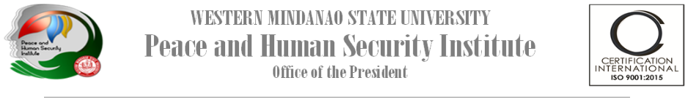

**History**

*Western Mindanao State University (WMSU) created the Center for Peace and Development (CPD) in January 2000, to generate well-rounded and productive people for the region, ensuring the good welfare of the society grounded on democratic and peaceful initiative.*

*In 2010, it was renamed as Peace and Human Security Institute (PHSI), becoming the peace-building arm of the Office of the University President. Today, under Dr. Ma. Carla A. Ochotorena, the office takes the lead in engaging WMSU in the government-led peace efforts to be the main protagonist in peace education and research on the resolution of local conflicts.*

**Vision**

**A group of men and women in WMSU working in the field of instruction, research, and extension, towards the promotion of a Culture of Peace and the provision of the opportunities and caring spaces that facilitate the development and expression of the potentials, capabilities, and talents of the people of Mindanao and the country.**

**Mission**

**The WMSU-PHSI seeks to expand and deepen the commitment, engagement, and involvement of individuals and groups inside and outside the university not only within the region but even in the national and international community, thru the offering of peace studies, integration of peace education, and other peace and development initiatives.**

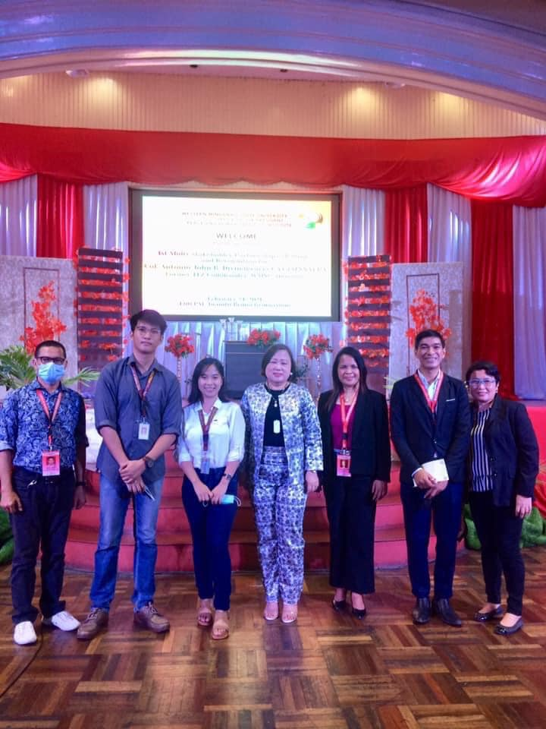

**Core Programs**

As a transformative response to major societal challenges especially in Mindanao, WMSU-PHSI’s new direction will focus on the following programs:

**Peace Studies** are central to understanding the modern world and the increasingly complex challenges we all face, as well as the strategies available to promote justice and peace.  The peace studies program is designed to help students understand correctly what is   happening in Mindanao and help in correcting historical injustices committed against the Bangsamoro people, the indigenous peoples, and other inhabitants of Mindanao- which are often affecting the peace initiatives in the region

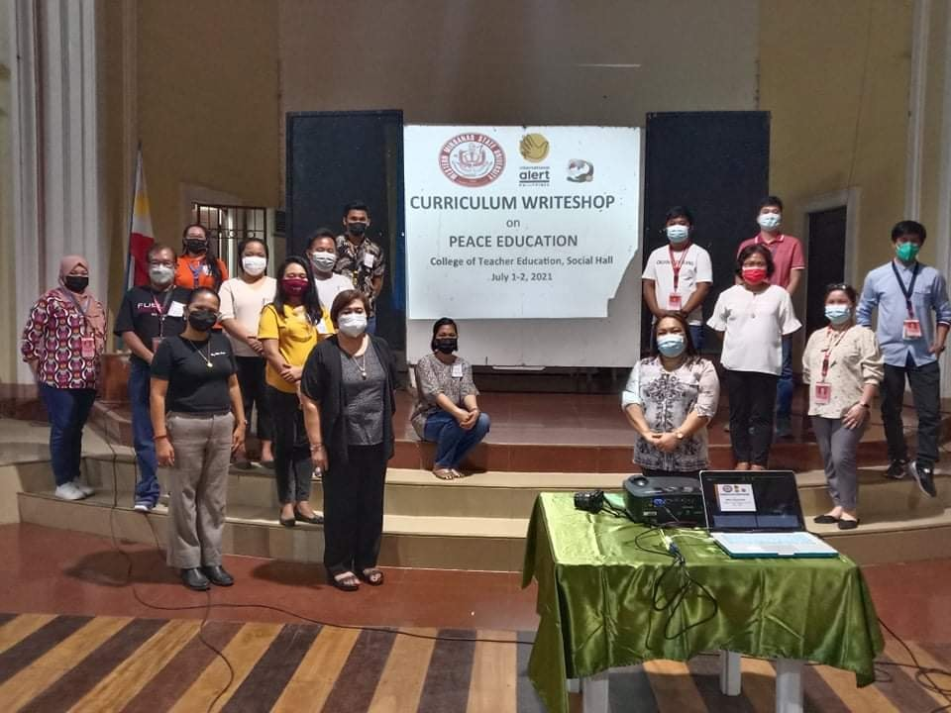

Ø  **Integration of Peace Education in the Curricula**

Monitors the compliance to CHED Memo. No.1 series of 2019 encouraging SUCs to integrate Peace Education in the curricula.

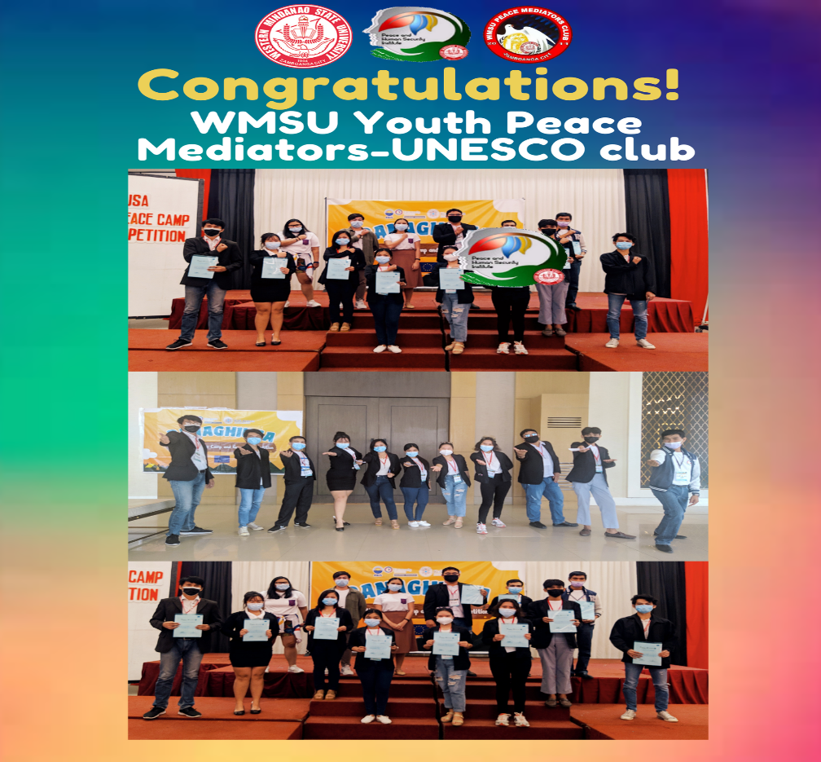

Ø  **Multi-Stakeholder Partnerships Convergence**

Strengthens its partnerships and collaboration with the different stakeholders on peacebuilding and development including international and private organizations and can serve as a facilitator in convening the different sectors when needed.

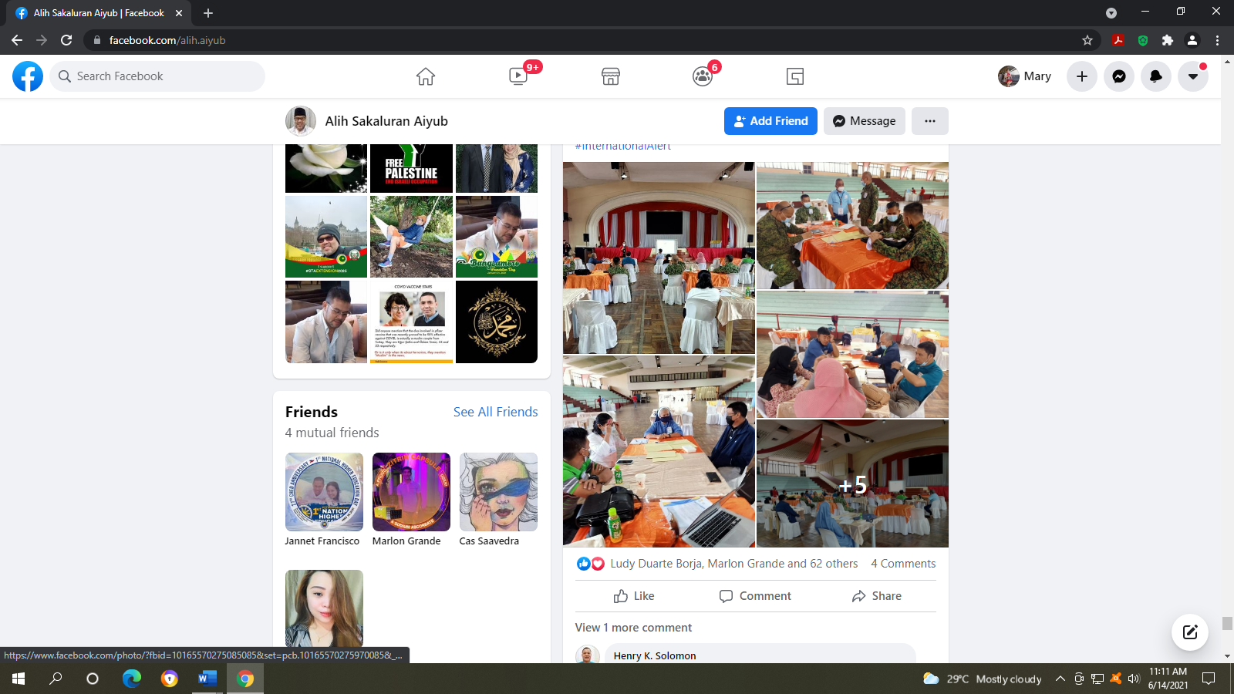

➢ **Research and Extension**

Develops research proposals related to peace and human security issues, especially in the region and the neighboring provinces. It conducts extension activities to some adopted communities.

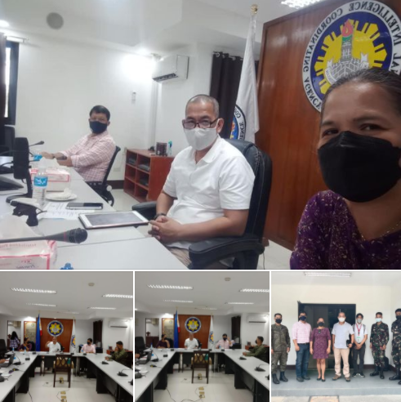

➢ **Training and Advocacy**

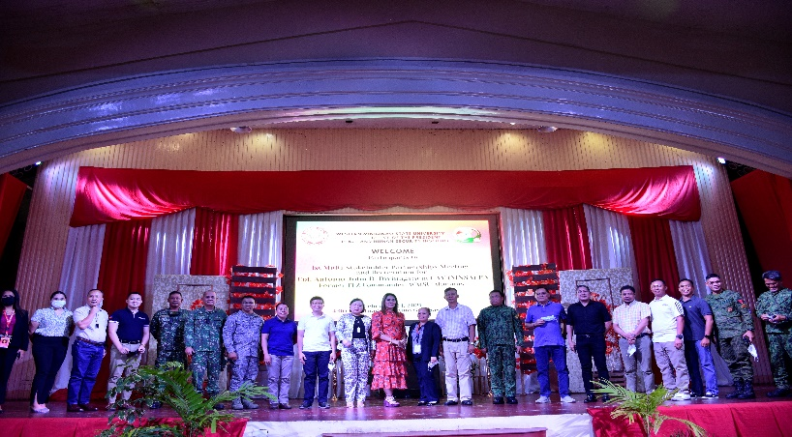Commits to addressing the challenges of creating safe spaces, the team continues to provide training on the Culture of Peace within and outside the university as well as provide technical assistance to other SUCs and HEIs who may need support in capacitating teachers on peace education and the development of a peace curriculum.

**FRAMEWORK FOR PEACE STUDIES CURRICULUM**

WMSU-PHSI utilizes a multi-disciplinary approach in the development of a curriculum on peace studies; conducts series of consultations/conversations and brainstorming activities and the continuous capacity building of the faculty in collaboration with local and foreign institutions.

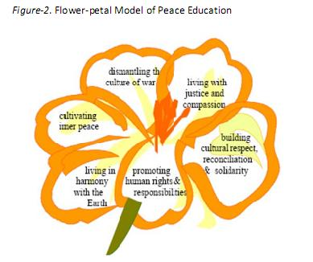

|  |  |  |
| --- | --- | --- |
| **Contact Us:** | | |
| President | **Dr. Ma. Carla A. Ochotorena** | 0917125400**9** |
| Director | **Asst. Prof. Ludivina B. Dekit** | 09056088968 |
| Asst. Director | **Engr. Marlon C. Grande** | 09178881897 |
| E-mail | **wmsu.phsi2021@gmail.com** | |
| Location | **Executive Building, Western Mindanao State University, Normal Road, Baliwasan, Zamboanga City** | |

Peace is more than

the absence of war,

it is living together

with our differences –

of sex, race, language,

religion or culture – while

furthering universal respect

for justice and human rights

on which such coexistence depends

– Tap Tant, UNESCO