**Abstract**

This report describes the “Line follower using Arduino” which is the next step towards the field of robotics. The increasing pace of demand in different fields can be met with the full-fledged bot of the given technology. The robot uses IR sensors facing the ground to sense the path (line) and the code helps the sensor to differentiate between colours and traverse its path to reach its desired destination. When the IR sensors are applied facing the front of the robot they can be used as to avoid obstacles which is been seen in modern automobiles. The proposed model simplifies the manual labour work hence becoming time efficient as well as cost efficient.

**Table of Contents**

1. Introduction
2. Block Diagram
3. Tools used
   * 1. Arduino
     2. Arduino Board
     3. Motor driver shield
     4. IR Sensors
     5. Robotic Chassis
4. Working of the robot
5. Results and Discussions
6. Conclusion
7. Future Scope
8. References

**Introduction**

A line follower bot is a robot designed in such a way that it follows a line or the given path already predetermined by the user. The path may be simple as a straight line as well as complex as with curves at different angles or checkboxes etc. In order to detect these lines of the track various sensing schemes are undertaken. The line follower bot schemes vary from low cost line sensing IR sensors to expensive systems as well. The choice of the schemes depends on the user demand and purpose for which the line follower bot is to be used. In technically advanced society these bots are flexible, cost efficient and time efficient from industrial point of view and can be implemented in semi to fully autonomous industries. In such environment these bots will function as material carrier to deliver various products from one place to another.

Apart from the line following capabilities, with the help of coding algorithms they should have the ability to navigate junctions and decide which path to continue upon and which path to ignore. This requires the line follower to move 90 degree turn freely. All these functions depend upon the placement of the IR sensors on the plate as their position can increase or decrease the complexity of work for the bot.

A line follower robot is a self-operational bot that detects the path through the help of reflection of the surface detected by the IR sensors and then converting the generated signal into output and follow the line drawn on the floor. The path to be traversed is drawn by black lines on white surface or vice versa. The control system which is arduino here plays a vital role in performing the breakdown of given signals into desired output.

The field of robotics is filled with variety of opportunities and line follower bot is the first step towards it which will endeavour the problems of transits in industries, hospitals as well as public transits in the near future.

**Block Diagram**

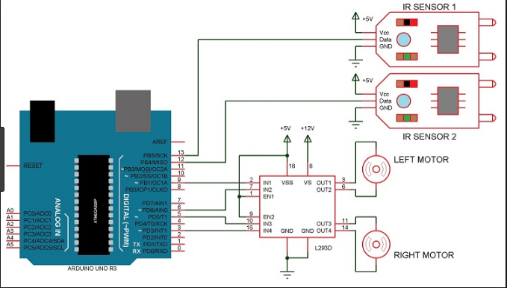

**The Arena**

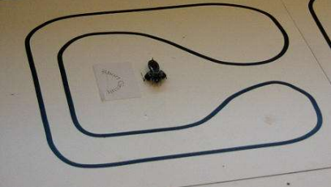

**Figure 1:-Simple race track**

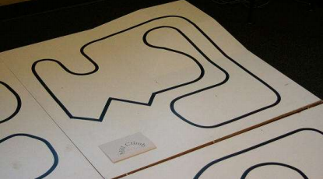

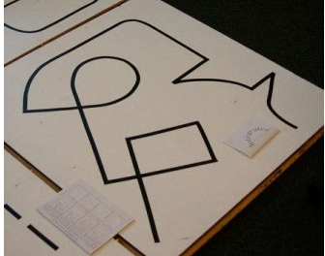**Figure 2:-Hill Climb – An arena with varying gradient, and note the sharper turnings**

**Figure 3:- Integrator**

**Tools Used**

**Arduino**

Arduino project started in Italy back in the 2003 has now become one of the biggest open source electronic platforms in the world. The popularity of Arduino boards increased due to its easy to use hardware and software. These boards have the ability to read inputs (light on IR sensors and turning it into an output) and activating the motors. To achieve all this and to make the robot functional one must need to know how to use the Arduino programming language and Arduino software based on processing.

There are many other microcontrollers and microcontroller platforms available for physical computing. Parallax Basic Stamp, Netmedia's BX-24 etc. But all these tools becomes complex to use while Arduino fits everything in a simple package. Moreover, Arduino is inexpensive, runs on Windows, Linux operating systems, and is extensible software. Also, Arduino can be expanded over C++ libraries as well thus making it beneficial for the people related to computer science.

Arduino programs can be divided in three main parts: **Structure, Values** (variables and constants), and **Functions.**

**Arduino Board**

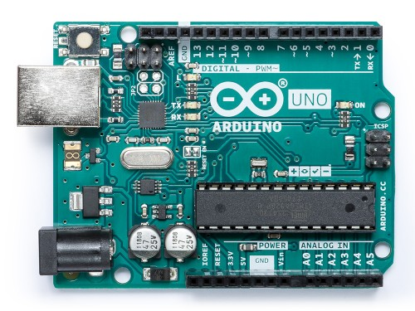**Arduino Uno** is an microcontroller board based on the ATmega328P (datasheet). It has 14 digital i/o pins , 6 analog inputs, a 16 MHz quartz crystal, a USB connection, a power jack, an ICSP header and a reset button.. You can tinker with your UNO without worrying too much about doing something wrong, worst case scenario you can replace the chip for a few dollars and start over again. In Italian dialect “uno” means one and was selected to release the arduino software 1.0.

**Motor Driver Shield**

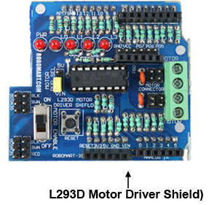L293D is a typical Motor driver or Motor Driver IC which allows DC motor to drive on either direction. L293D is a 16-pin IC which can control a set of two DC motorssimultaneously in any direction.. In addition to this the given motor driver board enables the IR sensors to operate through the different ports available in it. The IR sensors could be weld on the motor driver board or they can be connected with the help male and female jumpers.

**IR sensors**

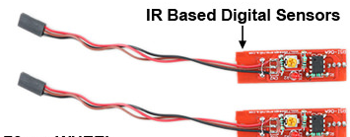An infra-red sensor popularly known as an IR sensor detects infra-red light from a particular object and then converts the light energy into electrical energy. An ir sensor pair consists of and detector and emitter. The emitter available is blue in colour while the detector can black or white in colour.

**Robotic Chassis(2 Wheel with DC Motor):**

This robotic chassis kit contains of an acrylic base with two gear motors, two compatible wheels, a ball caster, and other accessories such as batteries, usb cable etc.

**Working Procedure**

**Working**

Robotics has been the trending subject in the field of computer science and engineering and in this technically advanced world robotics is becoming an essential part in our life slowly and steadily. The given project discusses how a robot is able to find its own path by following a line without any external help.

The line follower robot uses two motors to move the rear wheels. It has 2- infrared sensors on the bottom plate for the detection of black tape which is the robots tracking path. When the sensor detects the black colour of the line, the output is given to the comparator. This comparator compares the reference voltage and gives us an output.

The line follower robot follows a simple logic in order to work in an desired manner. As we all know that black colour is a good absorbent thus making it capable of absorbing radiation and on the contrary white colour is a good reflector thus reflecting back .The robot uses these IR sensors facing towards the track so that they are able to sense the line and follow it.

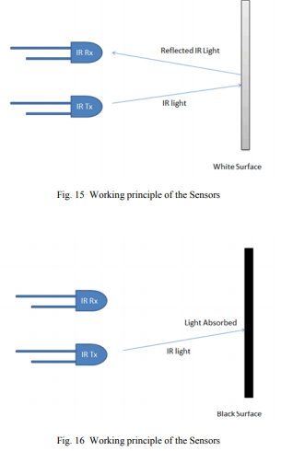

The output generated from the IR sensors is an analog signal which is dependent on the amount of light reflected back and theses signals are used to produce 0s and 1s.

The rotation of the wheels is dependent on the response generated by the comparator. For example the IR sensor is placed on the black line it reads initial value 0 and when placed on the white surface it reads 1.

We will come across the following cases:

Straight direction

Right Curve

Left Curve

**Straight Direction**

The robot is expected to move in the forward as well as backward direction (at some instances) when the arduino receives low responses of light from the sensors. The movement and the radiation are based on the surface the sensor is facing.

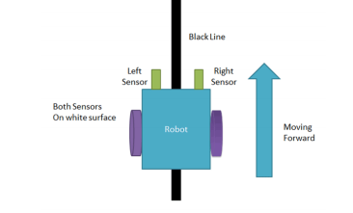

**Right Curve**

When the line follower faces a right curve then the responses will change that is the response from the right sensor which is placed at the rightmost of the plate will give low response while the other IR sensor will provide a high response. With this data provided to the arduino the control of the wheels will be changed that is the right wheel will be held while the left wheel will be made to move until the responses change.

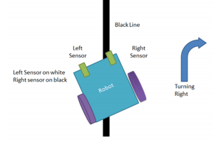

**Left Curve**

When the line follower faces a left curve then the responses will change that is the response from the left sensor which is placed at the leftmost of the plate will give low response while the other IR sensor will provide a high response. With this data provided to the arduino the control of the wheels will be changed that is the left wheel will be held while the right wheel will be made to move until the responses change.

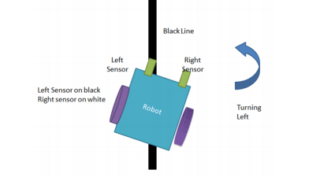

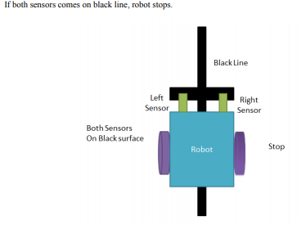

It is important to note that sometimes the path will have curves at different angles like a right curve at right angle or a complete circle. For all these conditions too the line follower robot will apply the above conditions as the basics for the robot is dependent on the response it generates from the surface of the track.

**The Code**

Every hardware is pointless without a good software or algorithm to put it to use. The coming to main core where we define the guidelines for the line follower bot to operate.

In programming arduino Uno PID (‘Proportional Integral and Differential Control) algorithm is developed which uses three constants namely kp,ki and kd. These constants are to be set by us for testing and defining how good our control works.

We use the arduino function analogread() to retrieve sensor values, serial. Print() to display these values and observer them in arduino IDE. Also, we need an array to store all these variables.

Burn the code onto the arduino and place the line follower bot over the track designed. Move the bot little bit over the line and note down the sensor readings. The readings will be different for white and black and other colours that we want.

**Advantages**

* Can be used in home and industrial automation
* Cost efficient
* Simple to construct and understand
* Fit and forget system

**Disadvantages**

* The robot follows a black line about 1 0r 2 inches in width on surfaces.
* Slow speed and instable on different thickness of line and complex angle
* Always requires a coloured path to run so that IR sensor can work on the reflections

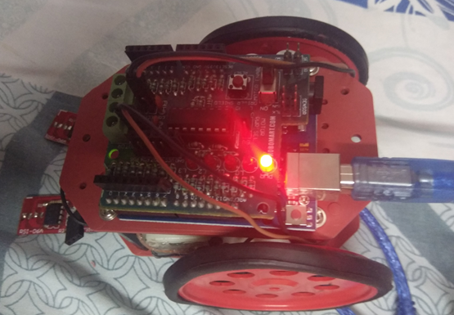

Actual image of the line follower bot**Result**

The objective of the line follower robot which was to find its own path by following a line is obtained for which the robot uses IR sensors which detects the path and send the signals to the arduino which then reads the given commands and help the robot function according to the demand of the responses generated.

**Conclusion**

In this project we have studied and implemented a Line following robot using arduino board. The programming and interface between the mechanical aspect of robotics has been learnt and implemented.

**Future Scope**

Smarter and more advanced version of line follower is being used to deliver mails within a office premises.

This technology is also being utilized in hospitals for sending medication from one location in the hospital to another.

Further it has been suggested for running public transport in the foreign countries.

**References**

* Kriti Bhagat, Saylee Deshmukh, Shraddha Dhonde, SnehaGhag publications of International Journal of Science,Engineering and Technology Research (IJSETR), Volume 5,Issue 2, February 2016.
* SubhranilSom, Arjun Shome by publication SubhranilSomInt. Journal of Engineering Research and Applications, ISSN:2248-9622, Vol. 4, Issue 6 (Version 3), June 2014.
* M. S. Islam & M. A. Rahman published by Asian Journal ofApplied Science and Engineering, Volume 2, No 2 (2013).
* PrananjaliKoppad, Vishnu Agarwal published byInternational Journal of Engineering Research & Technology(IJERT), ISSN: 2278-0181, IJERTV3IS090023 Vol. 3 Issue

9, September-2014

* S. Akash, Bibek Kabi , Mr. S.Karthick published byInternational Journal of Recent Trends in Engineering, Vol 2,No. 7, November 2009.
* Juing-HueiSu, Chyi-Shyong Lee, Hsin-HsiungHuang,Sheng-Hsiung Chuang &Chih-Yuan Lin published by WorldTransactions on Engineering and Technology Education 2010WIETE Vol.8, No.4, 2010
* International Journal of Engineering Trends and Technology(IJETT) – Volume 32 Number 5- February 2016. SubankarRoy #1, TashiRapden Wangchuk#2, Rajesh Bhatt#3
* K.A.Unyelioglu, C.Hatipoglu, and U.Ozguner, “Design and analysis of a line following robot controller”, IEEE Trans. Control System Technol., Vol.5, no.1, pp.127-134, 1997 (Pubitemid 127770536)