RK4-ODEsolverX

RK4-ODEsolverX is a Java-based project that allows users to solve ordinary differential equations (ODEs) using numerical methods like Runge-Kutta 4th Order (RK4), Euler's method, and the Adams-Moulton method.

# Tech Stack

- Java

- Maven

- exp4j library

- (Frontend in progress)

# Implemented Numerical Methods

- Euler's Method

- Runge-Kutta 4th Order (RK4)

- Adams-Moulton Method

# Features

- Easy usability

- User-friendly design

- Expression-based ODE input

# Libraries Used

- exp4j

- Maven for dependency management

# Code Snippet Screenshot

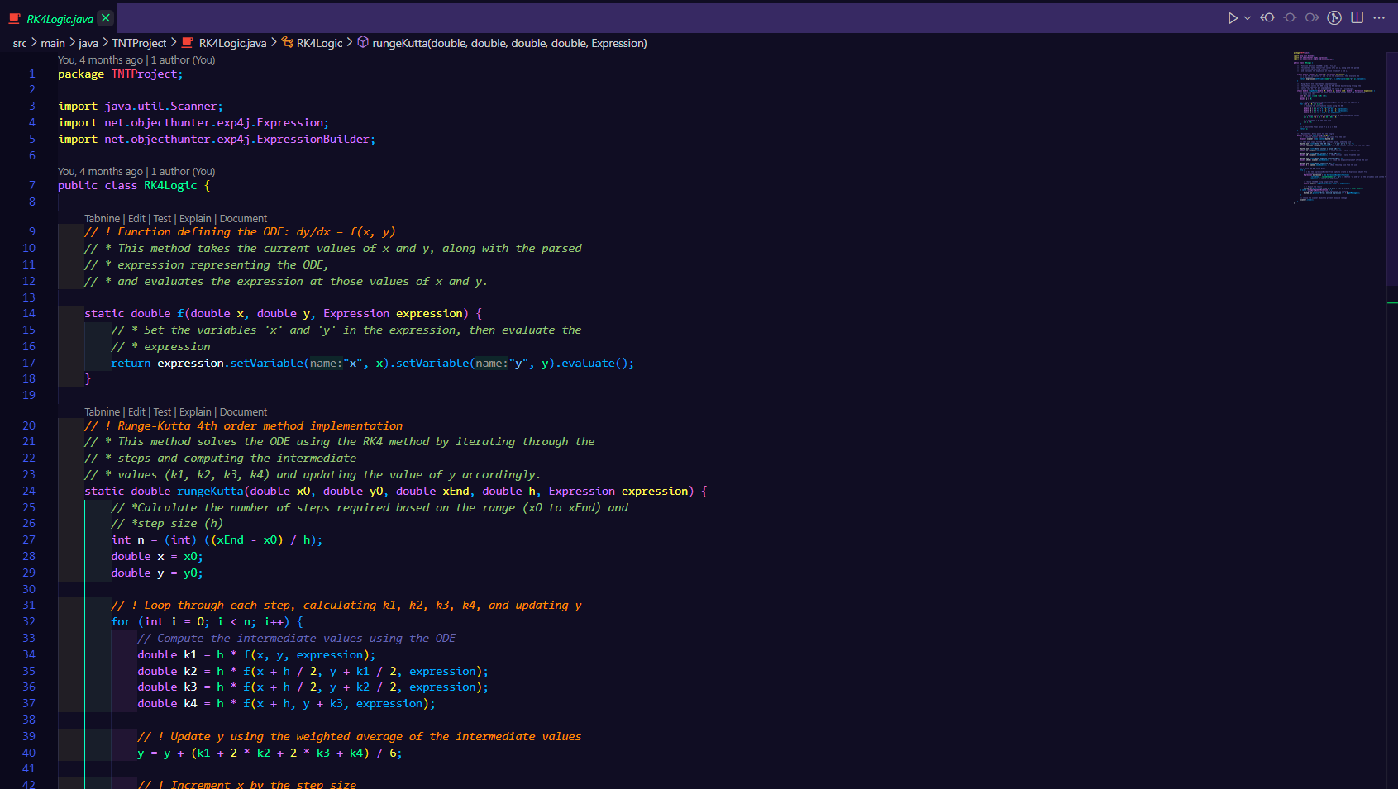

Check the Full Project at: <https://github.com/ArjiJethin/RK4-ODEsolverX>

-Made by Arji Jethin