Arjina Khanom

CST3613

Assignment – 13, output

Simple Calculator running

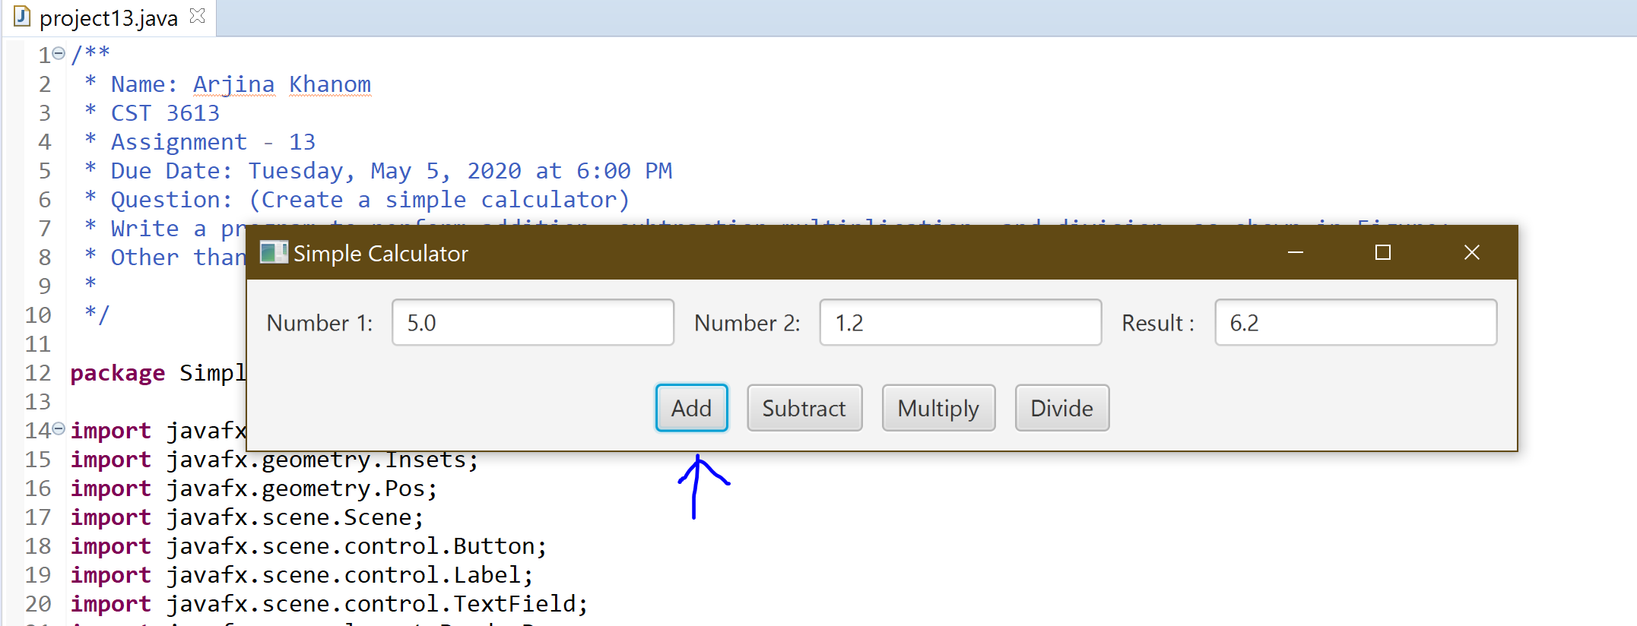

Figure 1: adding

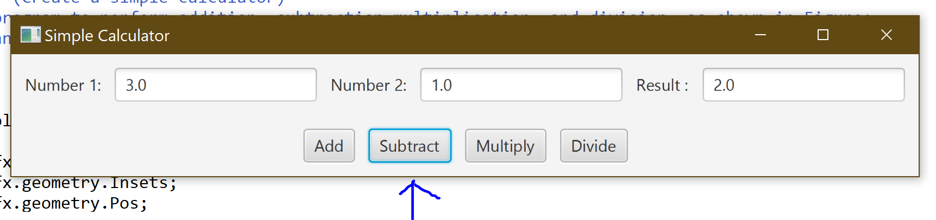

Figure 2: Subtract

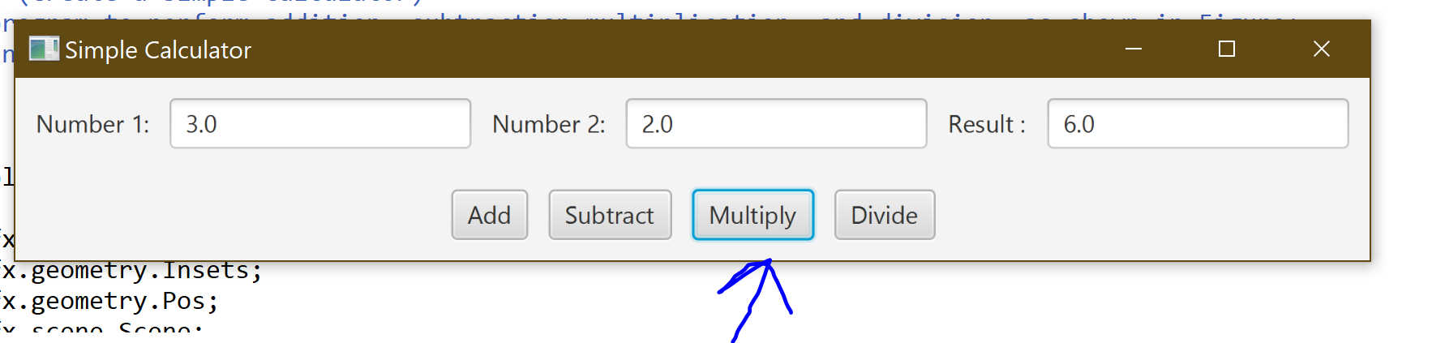

Figure 3: Multiply

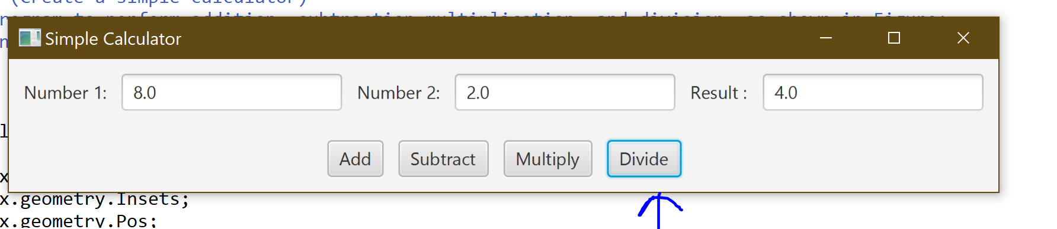

Figure 4: Divide