/\*\*

\* Name: Arjina Khanom

\* CST 3613

\* Output of Final Project

\* Assignment – 15

\* Due Date: Tuesday, May 19, 2020 At 6:00 PM

\*\*/

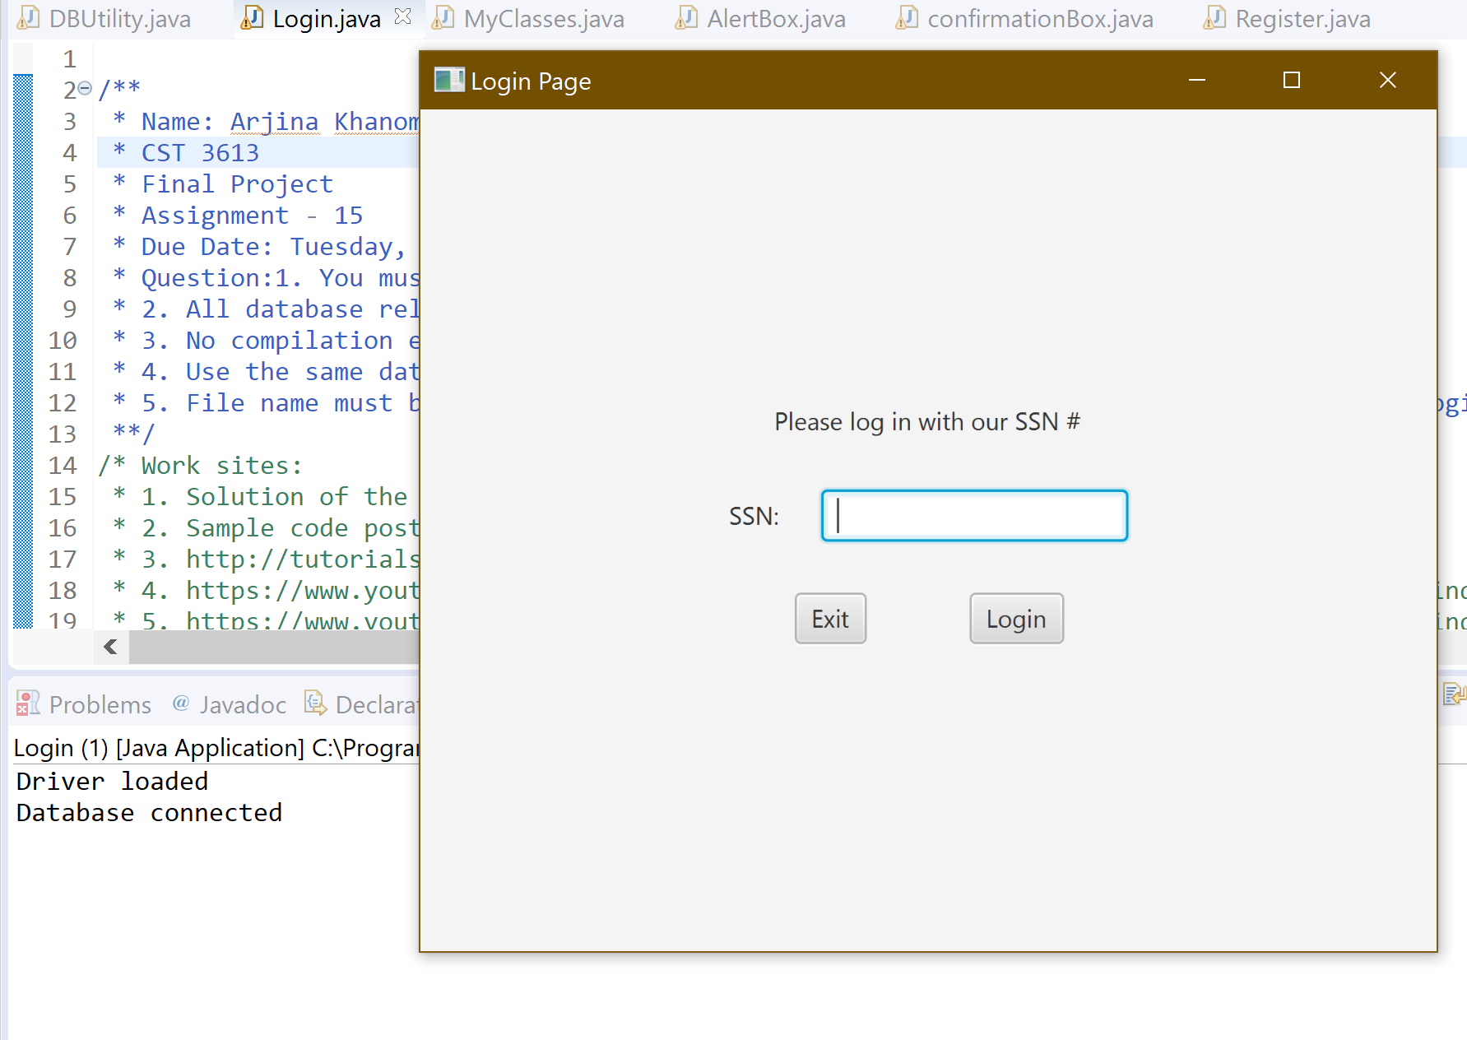

*Figure- 1: after run the code*

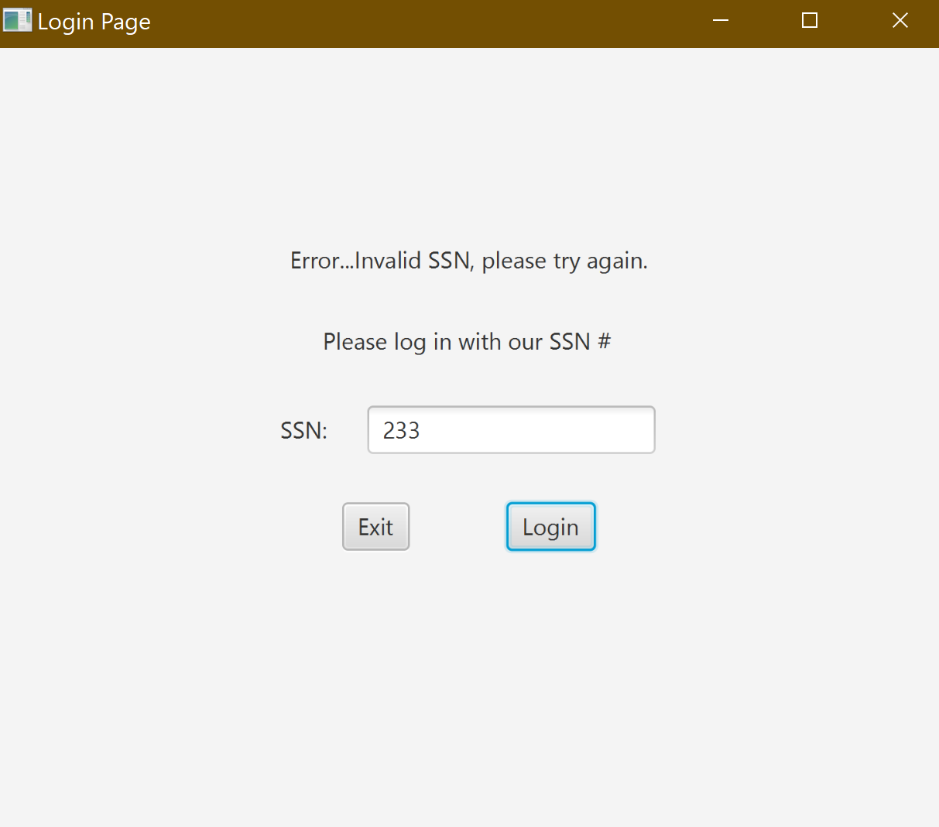

Figure 2: After putting the invalid password

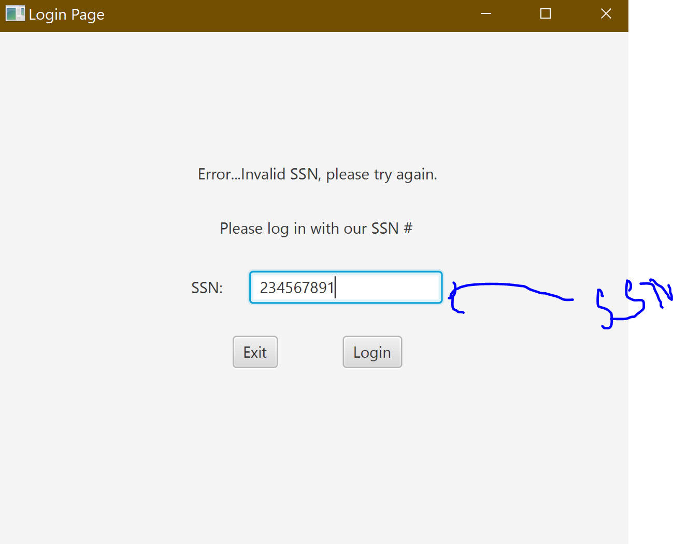

Figure 3: After putting my SSN

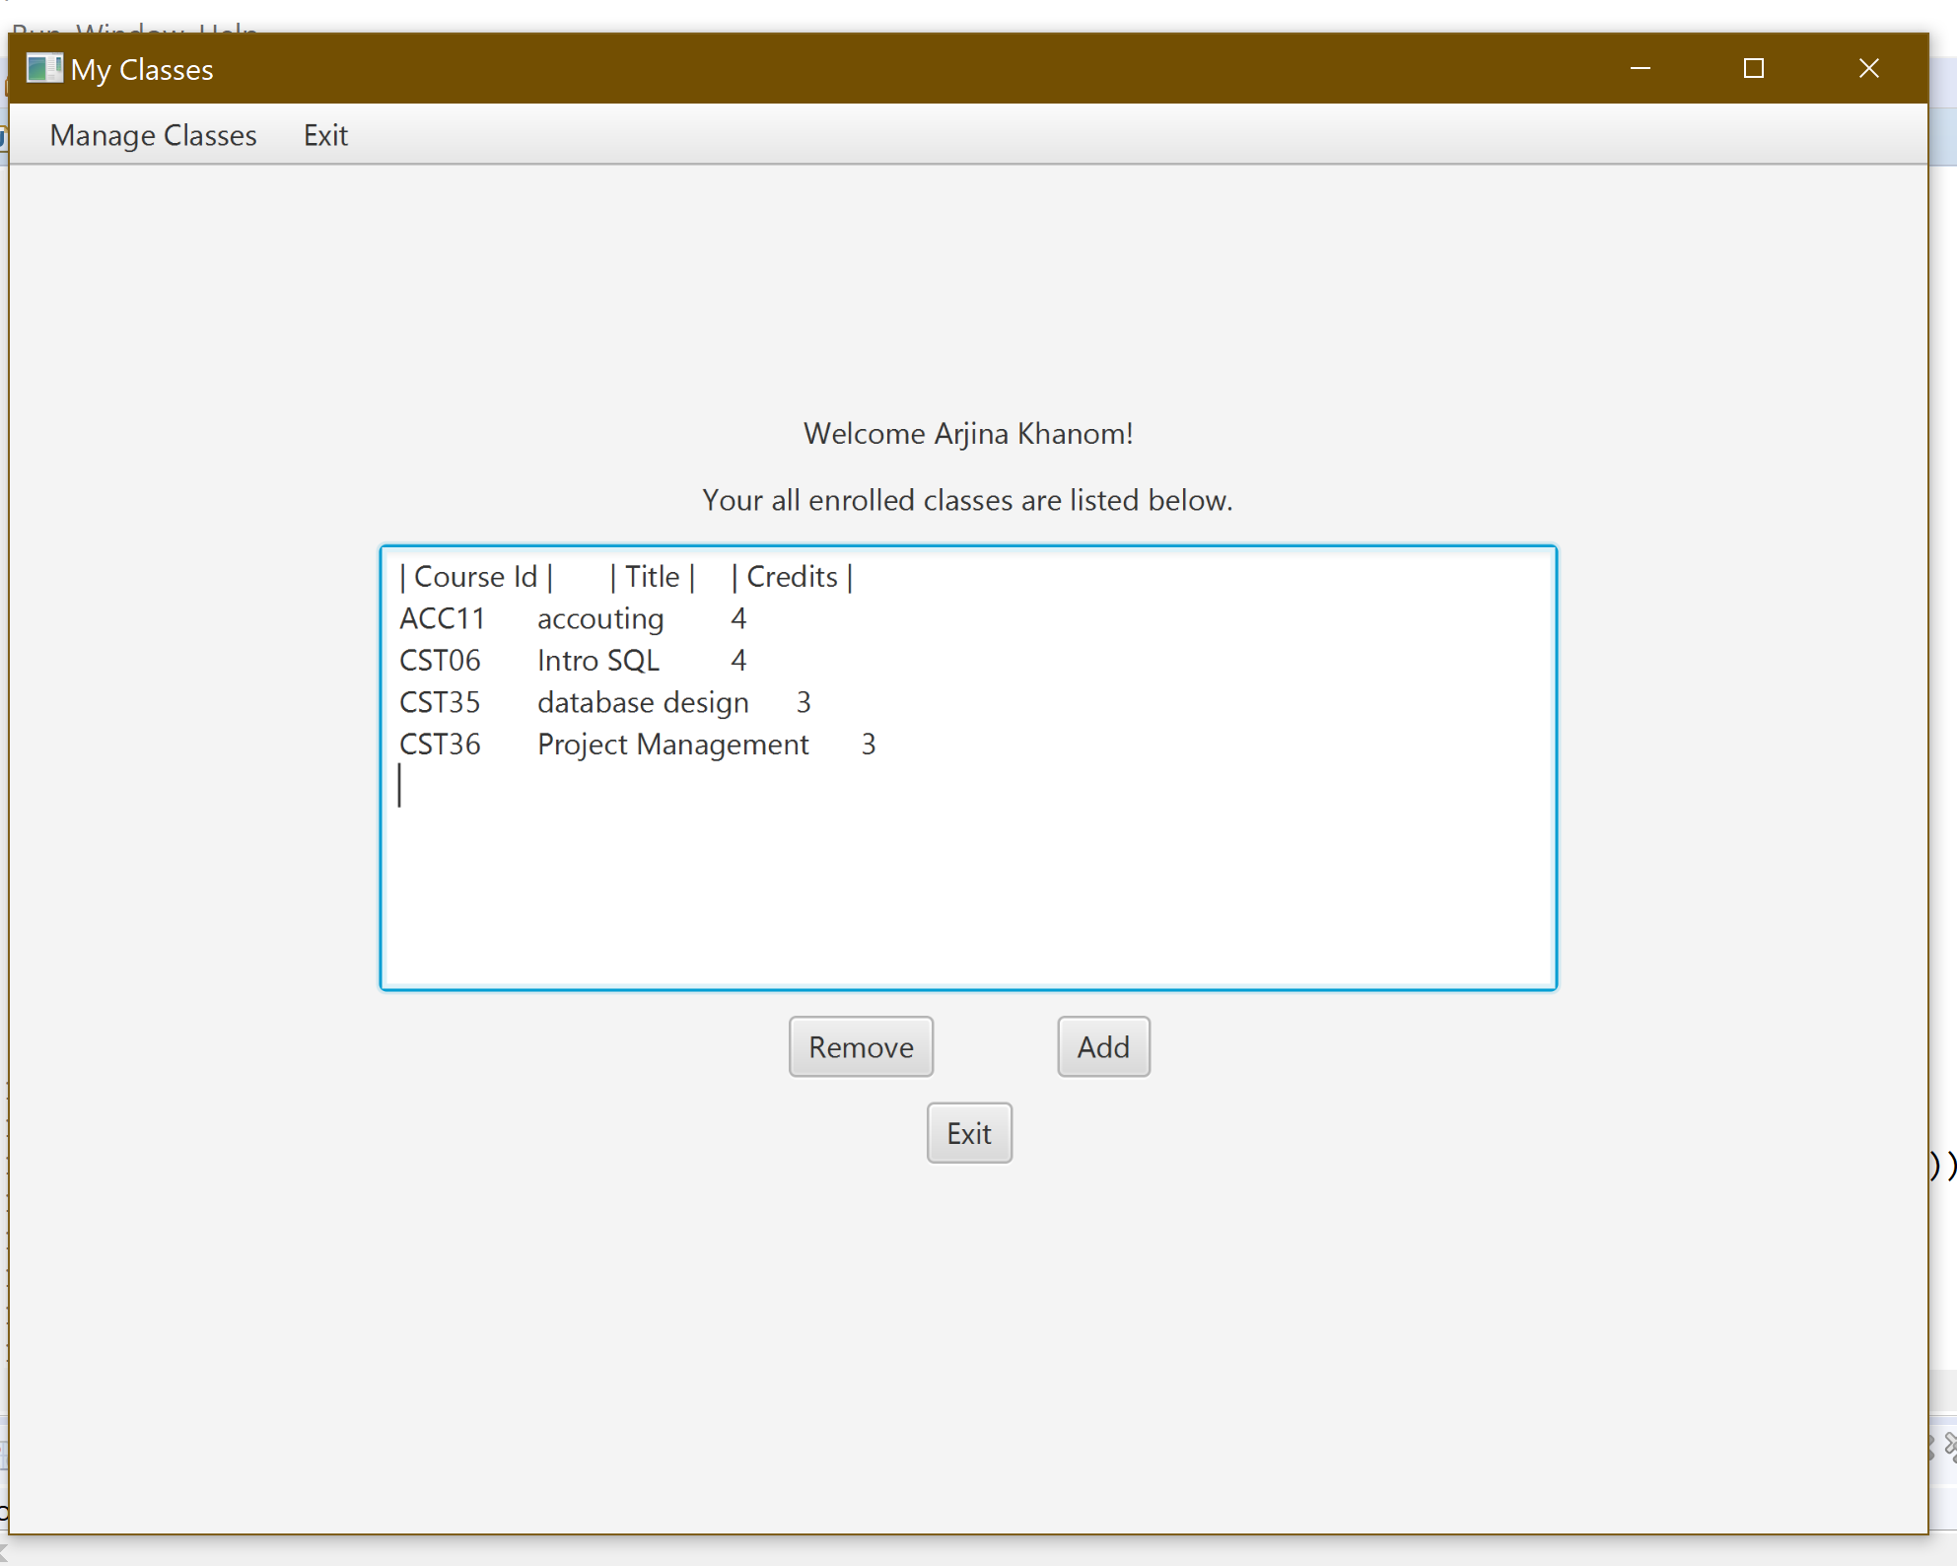

Figure – 4: after logging in with my SSN.

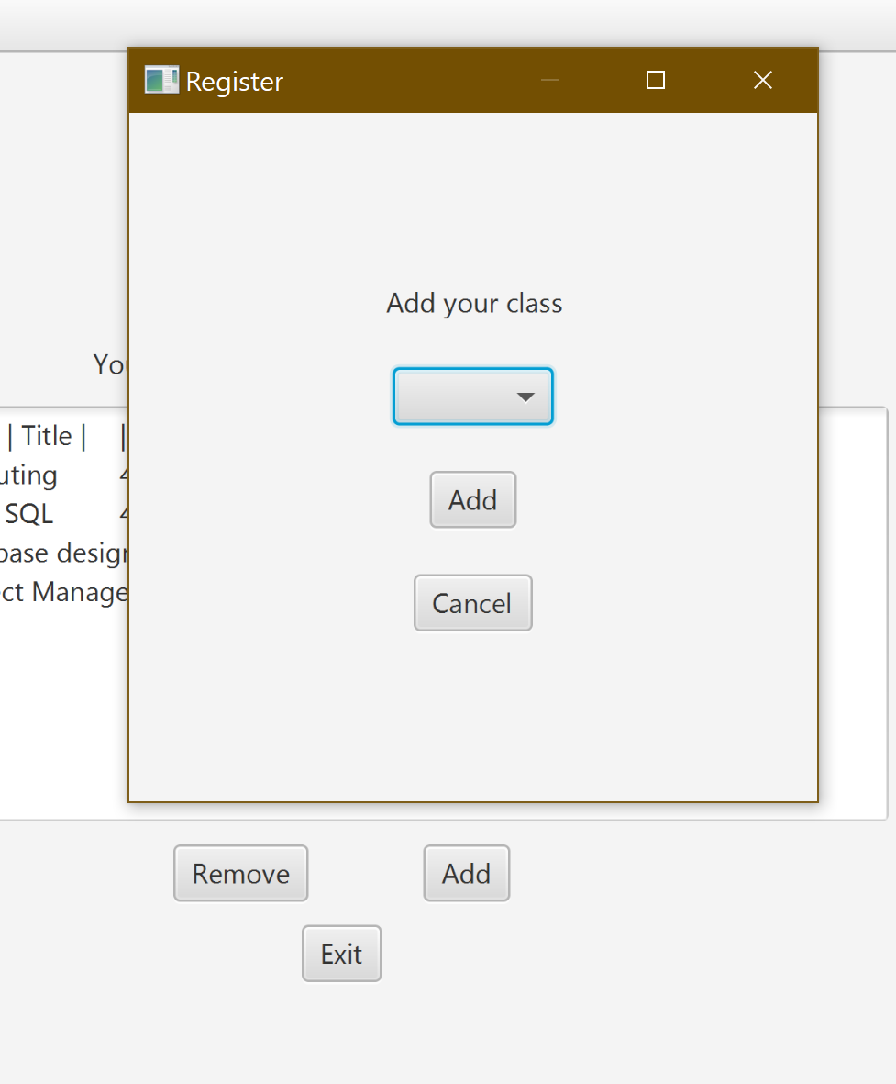

Figure -5 : After clicking the add button

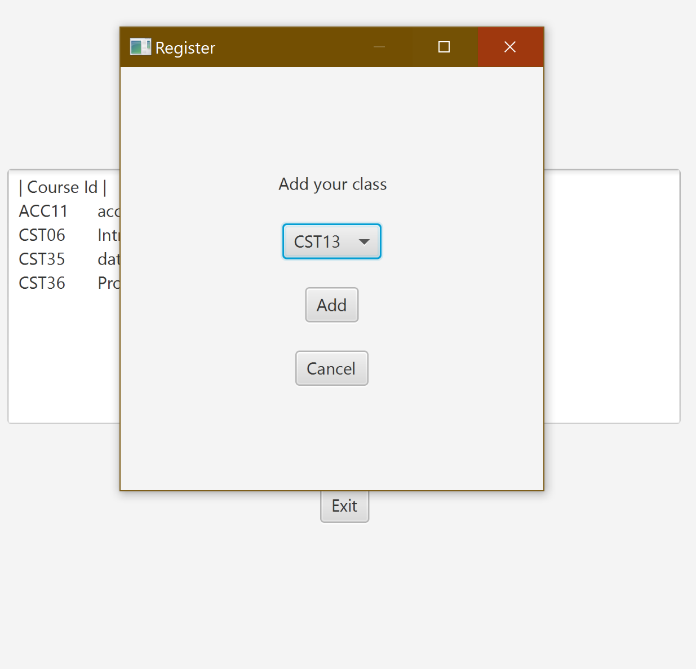

Figure -6 : After select the class from the menu bar

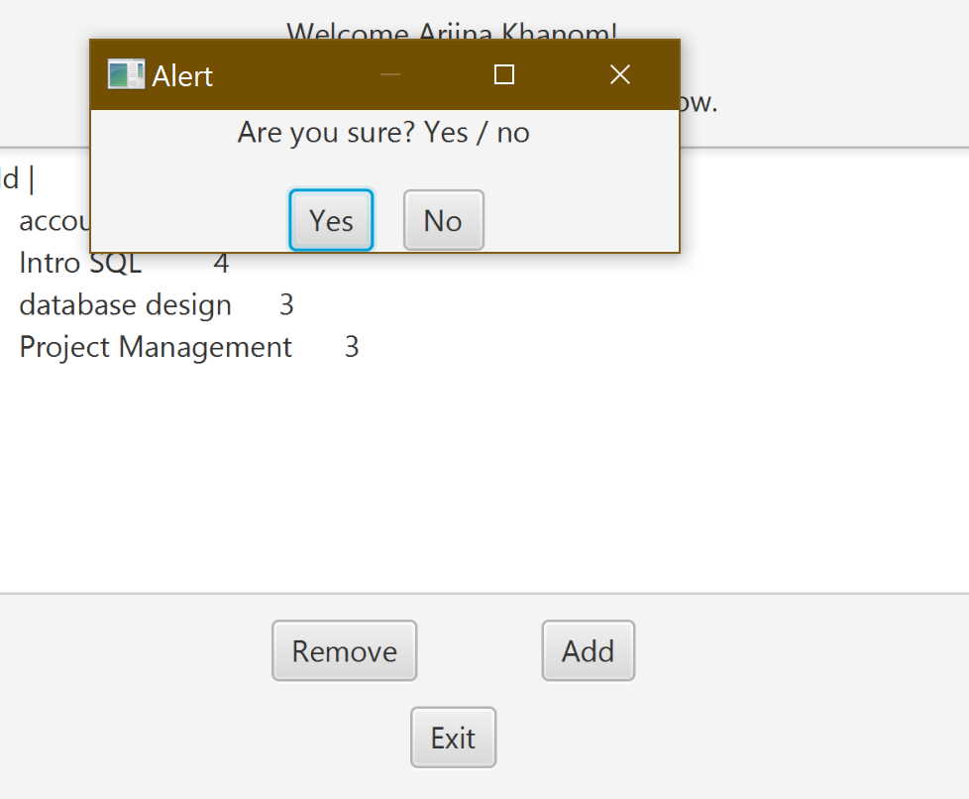

Figure -7: After click the “Remove” button.

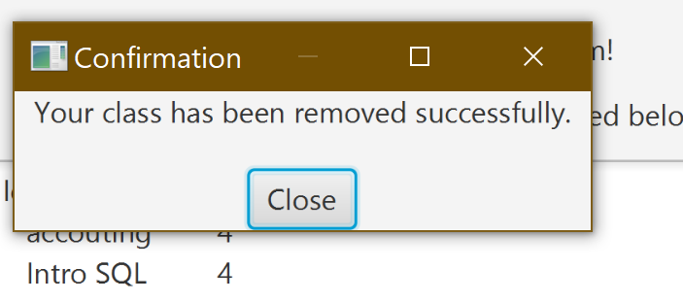

Figure -8: after clicking the “Yes” button inside the “Alert Box”

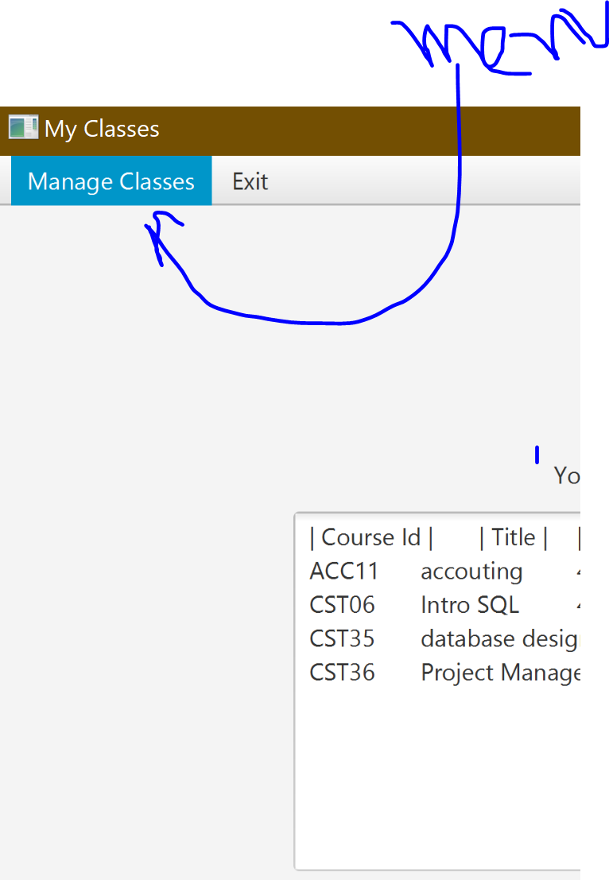

Figure -9: Menu where hiding “Add” and “Remove” button