Name: Arjina Khanom

MAC-190

Assignment: Final Exam

Date: 8/7/2017

|  |
| --- |
| /*Name:Arjina Khanom  * MAC-190  * Professor: Luis Rizo  * Assignment: Final Exam  * Date: 8/7/2017  *  */  //Student.java  **package** StudentFinalAssign;  //import java.text.NumberFormat;  **public** **class** Student {  // **TODO** Auto-generated method stub  // the instance variables  **private** String grade;  **private** String description;  **private** **double** gpa;    **public** Student()  {  grade ="";  description ="";  gpa = 0;  }  **public** **void** setgrade(String name)  {  **this**.grade = grade;  }  **public** String getgrade()  {  **return** grade;  }  **public** **void** setdescription(String color)  {  **this**.gpa = gpa;  }  **public** String getdescription()  {  **return** description;  }    **public** **void** setgpa(**double** gpa)  {  **this**.gpa = gpa;  }    **public** **double** getgpa()  {  **return** gpa;  }      /**public String getgpaFormatted()  {  NumberFormat currency = NumberFormat.getCurrencyInstance();  String gpaFormatted = currency.format(gpa);  return gpaFormatted;  }**/  } |
| //StudentDB.java  **package** StudentFinalAssign;  **import** java.util.Scanner;  **public** **class** StudentDB {  **public** Student StudentDB(**double** gpa,String grade,String description)  {  Student s=**new** Student();  s.setgrade(grade);  s.setdescription(description);  s.setgpa(gpa);    **return** s;  }  } |
| //Console.java  **package** StudentFinalAssign;  **import** java.util.List;  **import** java.util.Scanner;  **public** **class** Console {  **private** **static** Scanner *sc* = **new** Scanner(System.***in***);  **public** **static** String *message*;      **public** **static** String getString(String prompt)  {  System.***out***.print(prompt);  String s = *sc*.nextLine();  **return** s;  }  **public** **static** **double** getDouble(String prompt)  {  **double** i=0.0;  **while** (**true**)  {  System.***out***.print(prompt);  **try**  {  i = Double.*parseDouble*(*sc*.nextLine());  **break**;  }  **catch** (NumberFormatException e)  {  System.***out***.println("Error invalid Double. Try again. ");  }  }  **return** i;  }      } |
| //StringUtil.java  **package** StudentFinalAssign;  **public** **class** StringUtil {  **public** **static** String pad(String s, **int** length)  {  **if** (s.length() < length)  {    StringBuilder sb = **new** StringBuilder(s);  **while** (sb.length() < length)  {  sb.append(" ");  }  **return** sb.toString();  }  **else**  {    **return** s.substring(0, length);  }  }  } |
| //StudentIO.java  **package** StudentFinalAssign;  **import** java.util.List;  **import** java.io.IOException;  **import** java.nio.file.Paths;  **import** java.util.ArrayList;  **import** java.util.*;  **import** java.io.*;  **import** java.nio.file.*;  **public** **class** StudentIO **extends** StudentMain  {  **private** **static** **final** Path ***sPath*** = Paths.*get*("Students.txt");  **private** **static** **final** File ***sFile*** = ***sPath***.toFile();  **private** **static** **final** String ***FIELD_SEP*** = "\t";  **private** **static** List< Student > *s* = *getAll*();  **private** StudentIO() {};  **public** **static** List< Student > getAll()  {    **if** (*s* !=**null**)  {  **return** *s*;  }    *s* = **new** ArrayList<> ();    **if** (Files.*exists*(***sPath***))  {  **try** (BufferedReader in = **new** BufferedReader( **new** FileReader(***sFile***)))  {      String line = in.readLine();  **while** (line != **null**)  {  String [] columns = line.split(***FIELD_SEP***);  String grade = columns[0];  String description = columns[1];  String gpa = columns[2];    Student st = **new** Student();  st.setgrade(grade);  st.setdescription(description);  st.setgpa(Double.*parseDouble*(gpa));    *s*.add(st);    line = in.readLine();  }      }  **catch**(IOException e)  {  System.***out***.println(e);  **return** **null**;  }  }  **return** *s*;  }  **public** **static** Student get(String grade)  {  **for** (Student st : *s*)  {  **if** (st.getgrade().equals(grade))  **return** st;  }    **return** **null**;  }  **private** **static** **boolean** saveAll()  {  **try**(PrintWriter out = **new** PrintWriter( **new** BufferedWriter( **new** FileWriter(***sFile***))))  {      **for** (Student st : *s*)  {  //edit to print out all  out.print(st.getgrade() + ***FIELD_SEP***);  out.print(st.getdescription() + ***FIELD_SEP***);  out.println(st.getgpa());    }  }  **catch**(IOException e)  {  System.***out***.println(e);  **return** **false**;  }  **return** **true**;  }  **public** **static** **boolean** add(Student st)  {    *s*.add(st);  **return** *saveAll*();      }  **public** **static** **boolean** delete(Student st)  {    *s*.remove(st);  **return** *saveAll*();      }  **public** **static** **boolean** update(Student newStudent)  {    Student oldStudent = *get*(newStudent.getgrade());  **int** i = *s*.indexOf(oldStudent);  *s*.remove(i);  *s*.add(i, newStudent);  **return** *saveAll*();  }  } |
| // StudentMultiIO.java  **package** StudentFinalAssign;  **import** java.util.Scanner;  **import** java.io.*;  **public** **class** StudentMultiIO {    Scanner sc;  **static** String *grade1*,*grade2*,*grade3*,*grade4*,*grade5*,*grade6*;  **static** String *description1*, *description2*, *description3*,*description4*,*gpa1*,*gpa2*,*gpa3*,*gpa4*,*gpa5*;    **public** **void** open()  {  //test file and print the file on output field  **try**{  sc = **new** Scanner(**new** File("C:/Users/Arjina/Desktop/Lab/Practice/src/MultipleFile/Student.txt"));  System.***out***.println("It is working");  }  **catch** (FileNotFoundException e)  {  System.***out***.println("Not working");  }  }  **public** **void** Read()  {  **do** {  //to print each line from the text file  *grade1* = sc.next();  *description1* = sc.next();  *gpa1* = sc.next();    *grade2* = sc.next();  *description2* = sc.next();  *gpa2* = sc.next();    *grade3* = sc.next();  *description3* = sc.next();  *gpa3* = sc.next();    *grade4* = sc.next();  *description3* = sc.next();  *gpa3* = sc.next();    *grade5* = sc.next();  *description4* = sc.next();  *gpa5* = sc.next();    }  **while**(sc.hasNext());    System.***out***.println(*grade1*+*description1*+*gpa1*);  System.***out***.println(*grade2*+*description2*+*gpa2*);  System.***out***.println(*grade3*+*description3*+*gpa3*);  System.***out***.println(*grade4*+*description3*+*gpa4*);  System.***out***.println(*grade5*+*description4*+*gpa5*);    //to close the file  sc.close();    }  } |
| //StudentMain.java  //MainClass of the whole programs and all classes  // for geting open_file button      //StudentMain.java  //MainClass of the whole programs and all classes  package StudentFinalAssign;  import java.util.List;  import java.awt.event.ActionEvent;  import java.awt.event.ActionListener;  import java.io.BufferedWriter;  import java.io.File;  import java.io.FileWriter;  import java.io.IOException;  import javax.swing.*;  import java.awt.*;  public class StudentMain implements ActionListener{  JFrame f;  JLabel l,l1, l2,l3,l4,l5,Gpa;  JButton b1,b2,b3,b4,b5,b6;  JRadioButton b7,p1;  JTextField t1;  JRadioButton pst,fst; // full_time student and part_time student  JComboBox itemList;  JButton add,reset;    static int operator =0 ;    // for geting open_file button  private JButton open = new JButton("Open Text File");      public StudentMain()  {  f=new JFrame("Student Grade Application");  l = new JLabel("#Click the buttons:");  l.setBounds(20,0,250,50);  f.add(l);  JPanel pl=new JPanel();    // all of buttons of the menu  b1=new JButton("Menu");  b2=new JButton("List");  b3=new JButton("Add");  b4=new JButton("Delete");  b5=new JButton("Help");  b6=new JButton("Exit");      // stored in the JPanel & addActionListener  /**button for the command list**/  pl.add(b1);  b1.addActionListener(new action5());  b1.addActionListener(this);    /**button for the list**/  pl.add(b2);  b2.addActionListener(this);    /**button for the add grade**/  pl.add(b3);  b3.addActionListener(this);    /**button for the delete**/  pl.add(b4);  b4.addActionListener(this);    /**button for the help **/  pl.add(b5);  b5.addActionListener(new action4());    /**button to exit from the window**/  pl.add(b6);  b6.addActionListener(new exitaction());    l1= new JLabel(".........Welcome to Student Grade Application..........");  l1.setBounds(180,40,300,100);  f.add(l1);    l2 = new JLabel("# Select the Student type.");  l2.setBounds(20,80,300,100);  f.add(l2);    l3 = new JLabel("# Select the Grade to get the GPA.");  l3.setBounds(20,180,300,100);  f.add(l3);    l4 = new JLabel("# Enter the total average score to get the grade.");  l4.setBounds(20,320,300,100);  f.add(l4);    l5 = new JLabel("# Click the (GET GRADE) to get the grade.");  l5.setBounds(20,330,300,300);  f.add(l5);    // TO show the Radio buttons names  b7=new JRadioButton("Full Time Student");  b7.setBounds(75,150,150,30);  p1=new JRadioButton("Part Time Student");  p1.setBounds(280,150,150,30);    //To show the Radio buttons lists  //button for full-time student  b7.setActionCommand("fulltime");  b7.addActionListener(new action1());  f.add(b7);  //button for part-time student  p1.setActionCommand("parttime");  p1.addActionListener(new action1());  f.add(p1);      //To select the one buttons from two items  ButtonGroup bg=new ButtonGroup();  bg.add(b7);  f.add(b7);  bg.add(p1);  f.add(p1);    //To get the items of Combo box  String list[] = {"Grades"};  itemList = new JComboBox(list);  itemList.setBounds(50,250,150,50);  itemList.setActionCommand("grades");  itemList.addActionListener(this);  f.add(itemList);    //To get the label of Gpa  Gpa = new JLabel(" GPA: 0.00");  Gpa.setBounds(300,250,150,50);  f.add(Gpa);      //To get the TextField  t1 = new JTextField("");  t1.setBounds(50,400,160,50);  f.add(t1);    //To get the add button which is known by GET TOTAL  add = new JButton("GET GRADE");  add.setBounds(100,500,150,70);  add.setActionCommand("add");  add.addActionListener(new action2());  f.add(add);    //To get the reset button  reset = new JButton("RESET");  reset.setBounds(400,500,150,70);  reset.setActionCommand("reset");  reset.addActionListener(new action1());  f.add(reset);      //to get the open the text file  pl.setLayout(new FlowLayout());  pl.add(open);  open.addActionListener(new action3());    f.add(pl, BorderLayout.SOUTH);      // Frame  f.add(pl);  pl.setBackground(Color.pink);  f.setTitle("Student Grade Application");  f.setVisible(true);  f.setSize(800,800);  f.setResizable(false);  f.setDefaultCloseOperation(JFrame.EXIT_ON_CLOSE);    }  public void actionPerformed(ActionEvent e)  {  System.out.println("ENTER THE COMMAND ");  System.out.println();  if(e.getSource()==b1)  {  displayMenu();    }    else if (e.getSource()==b2)  {  /** display the "Studenta.txt" file**/  displayAllgrades();    }    else if (e.getSource()==b3 )  {  /**to add grade into the file**/  addgrade();    }  else if (e.getSource()==b4 )  {  /** to delete grade from the file**/  deletegrade();    }    // else if (e.getSource()==b5)  //{    // displayMenu();  // }  }  //to get the text file and print the file of the grade list  public static void displayAllgrades() {  System.out.println("Grade LIST");    List< Student > s = StudentIO.getAll();    if(s == null)  {  System.out.println("\nError! Unable to get grades.\n");  }  else  {  Student st;  StringBuilder sb = new StringBuilder();  for (Student student : s)  {  st = student;  sb.append(StringUtil.pad(st.getgrade(),12));  sb.append(StringUtil.pad(st.getdescription(), 34));  sb.append(st.getgpa());  sb.append("\n");    }    System.out.println(sb.toString());  }  }  //to add the grade on the list  public static void addgrade() {  String grade = Console.getString("Enter Student grade: ");  String description = Console.getString("Enter Student description: ");  double gpa = Console.getDouble("Enter the gpa: ");    Student s = new Student();  s.setgrade(grade);  s.setdescription(description);  s.setgpa(gpa);    StudentIO.add(s);  System.out.println("\n" + description + "was added to the database.\n");  // TODO Auto-generated method stub    }  // to delete the grade from the list  public static void deletegrade() {  String grade = Console.getString("Enter the grade to delete: ");    Student s = StudentIO.get(grade);  if (s == null)  {  System.out.println("\nError: Unable to get the grade.");  }  else  {  StudentIO.delete(s);  System.out.println("\n" + s.getdescription() + " was deleted from the database. \n");  }      }  //to display the command menu  public static void displayMenu() {  System.out.println("Welcome to the grades menu ");  System.out.println("");  System.out.println("COMMAND MENU");  System.out.println("list -List all grades");  System.out.println("add -add a grades");  System.out.println("del -delete a grades");  System.out.println("help -show this menu");  System.out.println("exit -Exit this application");  }  // To exit from the Jwindow  class exitaction implements ActionListener{  public void actionPerformed (ActionEvent e){    System.exit(0);  }    }//end exitaction  //to get the comboBox items  class action1 implements ActionListener{    public void actionPerformed(ActionEvent e) {    String s = e.getActionCommand();    // for getting the putting quantity and Total.  if (s == "reset") {    String txt =" " ;  t1.setText(txt);  }//end if for reset    // conditions to get each grade separately  if (s == "fulltime") {    itemList.addItem("A");  itemList.addItem("B");  itemList.addItem("C");  itemList.addItem("D");  itemList.addItem("F");  }  if (s == "parttime") {  itemList.addItem("A");  itemList.addItem("B");  }  if (s == "grades") {  String item = (String)itemList.getSelectedItem();  if (item == "A") {  //to get the gpa for grade A  String text ="4.00";  Gpa.setText(text);  }  if (item == "B") {  // to get the gpa for grade B  Gpa.setText("3.7");  }  if (item == "C") {  Gpa.setText("3.4");  }  if (item == "D") {  Gpa.setText("2.7");  }// end if  if (item == "F") {  Gpa.setText("1.90");  }// end if    }//end items if  } //end action performed  }  //to print the grade  class action2 implements ActionListener{  public void actionPerformed (ActionEvent e){  String s = e.getActionCommand();    if(s=="add"){    if ( operator >= 90 )  {  t1.setText("A");  }  else if ( operator >= 80 )  {  t1.setText("B");  }  else if ( operator >= 70 )  {  t1.setText("C");    }  else if ( operator >= 60 )  {  t1.setText("B");  }  else  {  t1.setText("A");  }  }  }    }//end exitaction  class action3 implements ActionListener{  public void actionPerformed(ActionEvent e)  {    if(e.getSource()==open){  JFileChooser chooser = new JFileChooser("C:/Users/Arjina/Desktop/Lab/Practice/src/");  int x = chooser.showOpenDialog(null);  if (x==JFileChooser.APPROVE_OPTION)  {  File file = chooser.getSelectedFile();  try  {  Desktop.getDesktop().open(file);  }catch(IOException EE)  {  System.out.println("You Failed..........");  }    }//end if    }//end open if    }//end actionPerformed  }//end action3 class  static class action4 implements ActionListener{    public void actionPerformed (ActionEvent e) {    JFrame frame4 = new JFrame("Help");  frame4.setVisible(true);  frame4.setSize(350, 250);  frame4.setResizable(false);  JLabel label = new JLabel("Exit -Exit this application");  JPanel panelp = new JPanel();  frame4.add(panelp);    // to get the frame color  panelp.setBackground(Color.pink);  panelp.add(label);    JLabel label1 = new JLabel("List - list all grades.");  panelp.add(label1);    JLabel label2 = new JLabel("menu - to get the command menu.");  panelp.add(label2);    }  }  static class action5 implements ActionListener{    public void actionPerformed (ActionEvent e) {    JFrame frame4 = new JFrame("Command Menu");  frame4.setVisible(true);  frame4.setSize(350, 250);  frame4.setResizable(false);  JLabel label = new JLabel("List - List all grades");  JPanel panelp = new JPanel();  frame4.add(panelp);    // to get the frame color  panelp.setBackground(Color.pink);  panelp.add(label);    JLabel label1 = new JLabel(" Add -add a grades");  panelp.add(label1);    JLabel label2 = new JLabel("del - delete a grades");  panelp.add(label2);    JLabel label3 = new JLabel(" Help - Show the menu");  panelp.add(label3);    JLabel label4 = new JLabel("del - delete a grades");  panelp.add(label4);        }  }  public static void main(String[] args)  {    StudentMultiIO f = new StudentMultiIO();  f.open();  f.Read();  StudentMain s=new StudentMain();  }  } |
| B Best Academic Understanding 3.50  C Better Academic Understanding 3.20  D Good Academic Understanding 2.70  F Bad Academic Understanding 1.70  A- good academic understanding 4.6 |
| Grade Description GPA  A Great Academic Understanding 4.00  B Better Academic Understanding 3.50  C Good Academic Undersatanding 3.1  D Good Academic Understanding 2.7  F Bad Academic Understanding 1.5 |

**Output:**

It is working

AGreat4.00

BBetter3.80

CGood4.50

DGoodnull

FBad1.50

ENTER THE COMMAND

Welcome to the grades menu

COMMAND MENU

list -List all grades

add -add a grades

del -delete a grades

help -show this menu

exit -Exit this application

ENTER THE COMMAND

Grade LIST

3.5

3.2

2.7

1.7

4.6

ENTER THE COMMAND

Welcome to the grades menu

COMMAND MENU

list -List all grades

add -add a grades

del -delete a grades

help -show this menu

exit -Exit this application

ENTER THE COMMAND

Welcome to the grades menu

COMMAND MENU

list -List all grades

add -add a grades

del -delete a grades

help -show this menu

exit -Exit this application

ENTER THE COMMAND

Welcome to the grades menu

COMMAND MENU

list -List all grades

add -add a grades

del -delete a grades

help -show this menu

exit -Exit this application

Enter Student grade: B+

Enter Student description: better understanding

Enter the gpa: 3.5

better understandingwas added to the database.

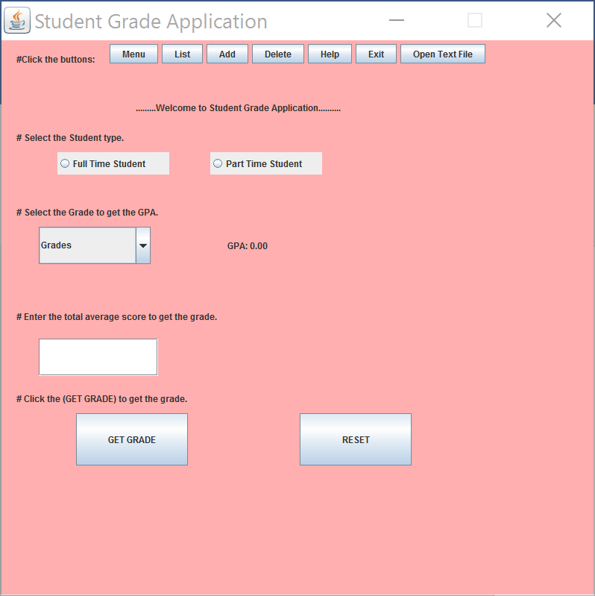

When you will click the (open text file) button then you can see this

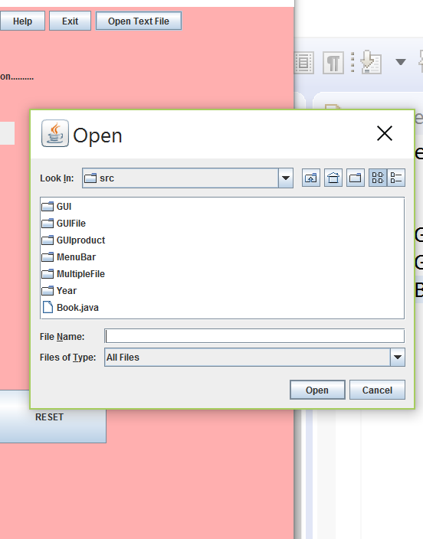

Then you can choose file whatever you want to see

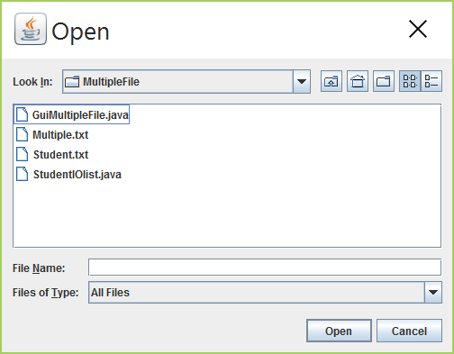

If you open it

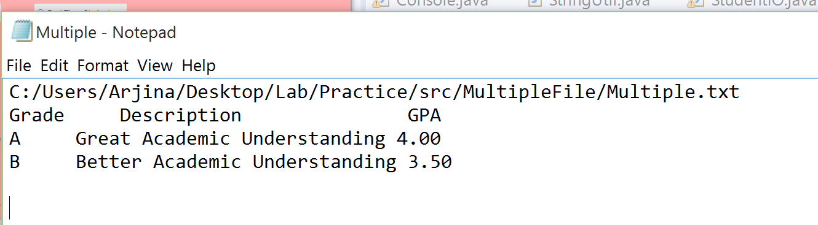

Other buttons

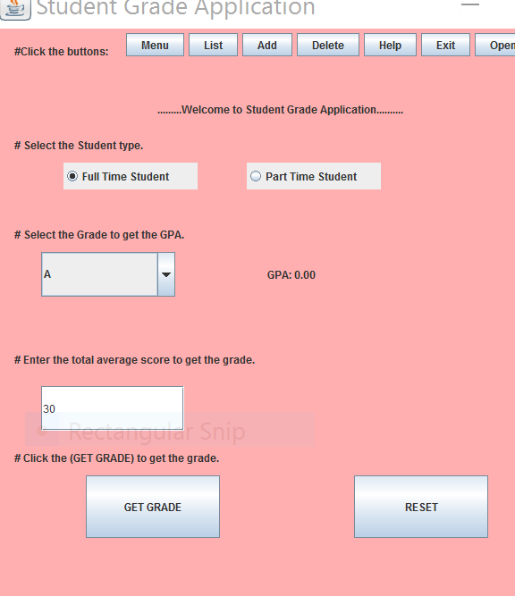

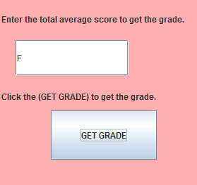 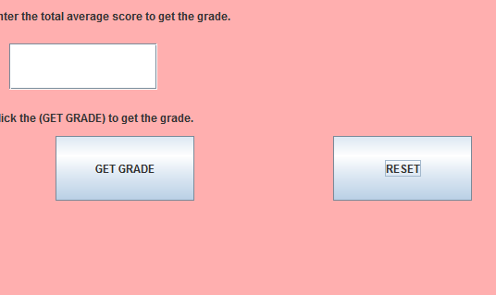

If you click the help button

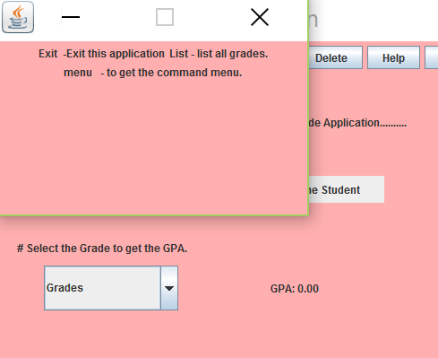

If you click the menu button

