## horizontal line



Findemy

v1

**─**

# Overview

**Findemy** is an Online Learning marketplace where students/professionals can buy courses and start using them. The courses bought are free for lifetime.

# Goals

1. User is able to search for online courses without signup/signin, if he/she wishes to buy the course it is mandatory to sign up.
2. After Sign up, the user should be able to login using the credentials mentioned.
3. Users can search the courses, add them to cart, view the summary, delete a course from cart and then finally checkout.

# Specifications

This project is created using the following specs and libraries :

* React (v18^)
* Redux
* React Hook Forms
* React Router DOM

The screens and goals are captured in snapshots.

# Homescreen

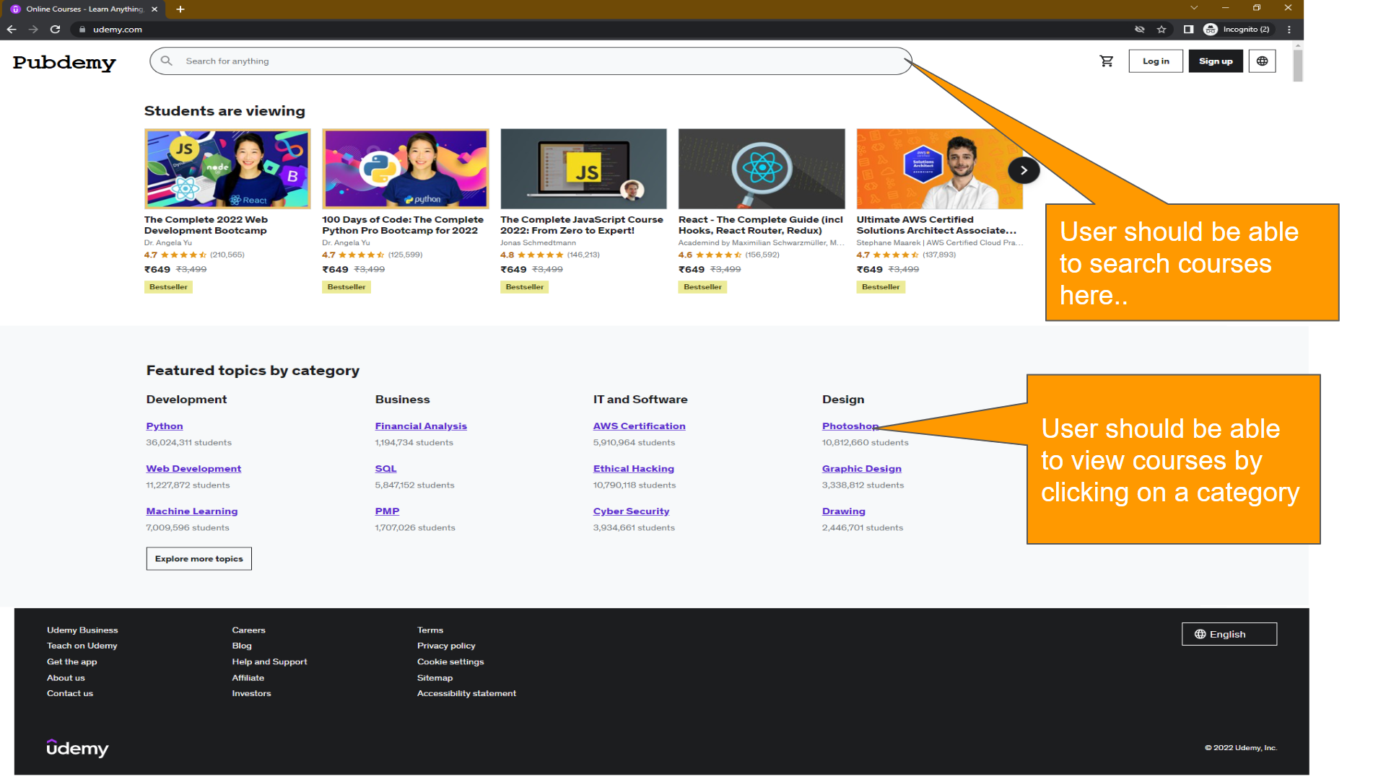

**Login Screen**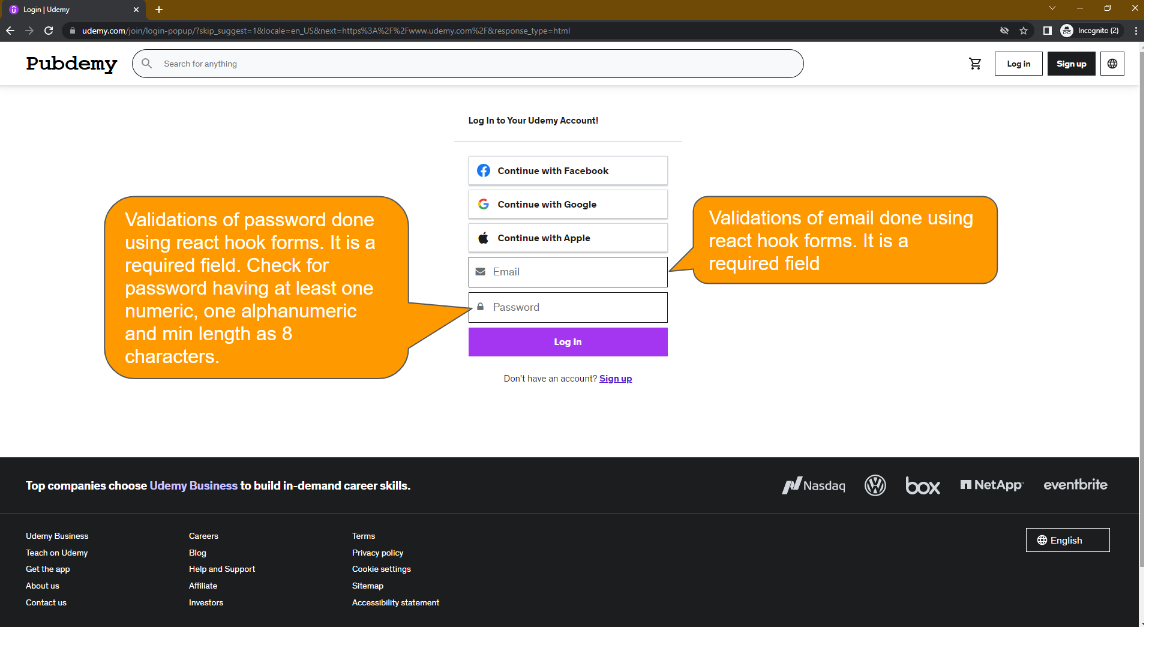

**Sign Up Screen**

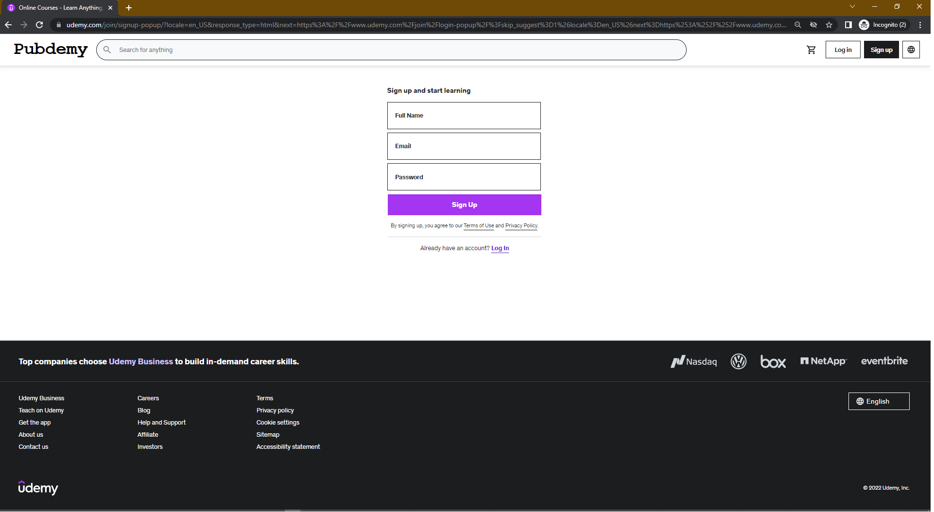

**Home Screen after login**

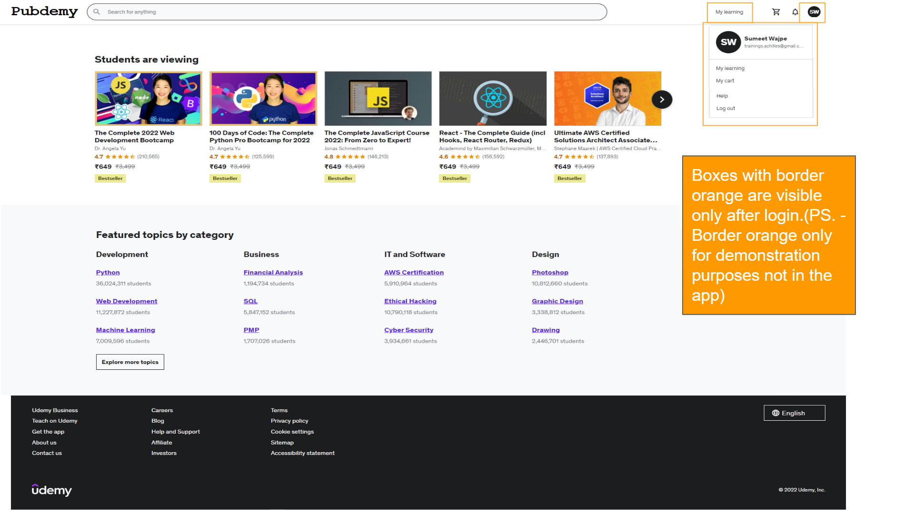

**Search Screen**

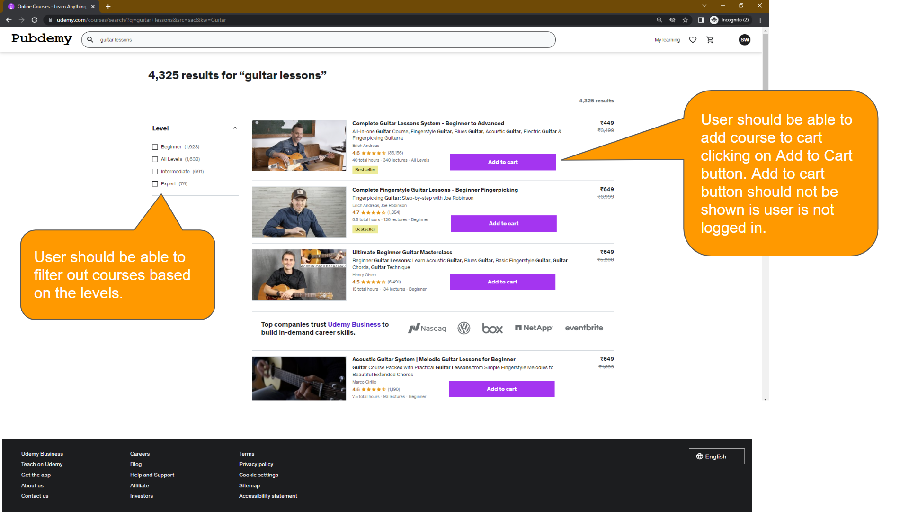

**Course Details Screen (Snapshot-1)**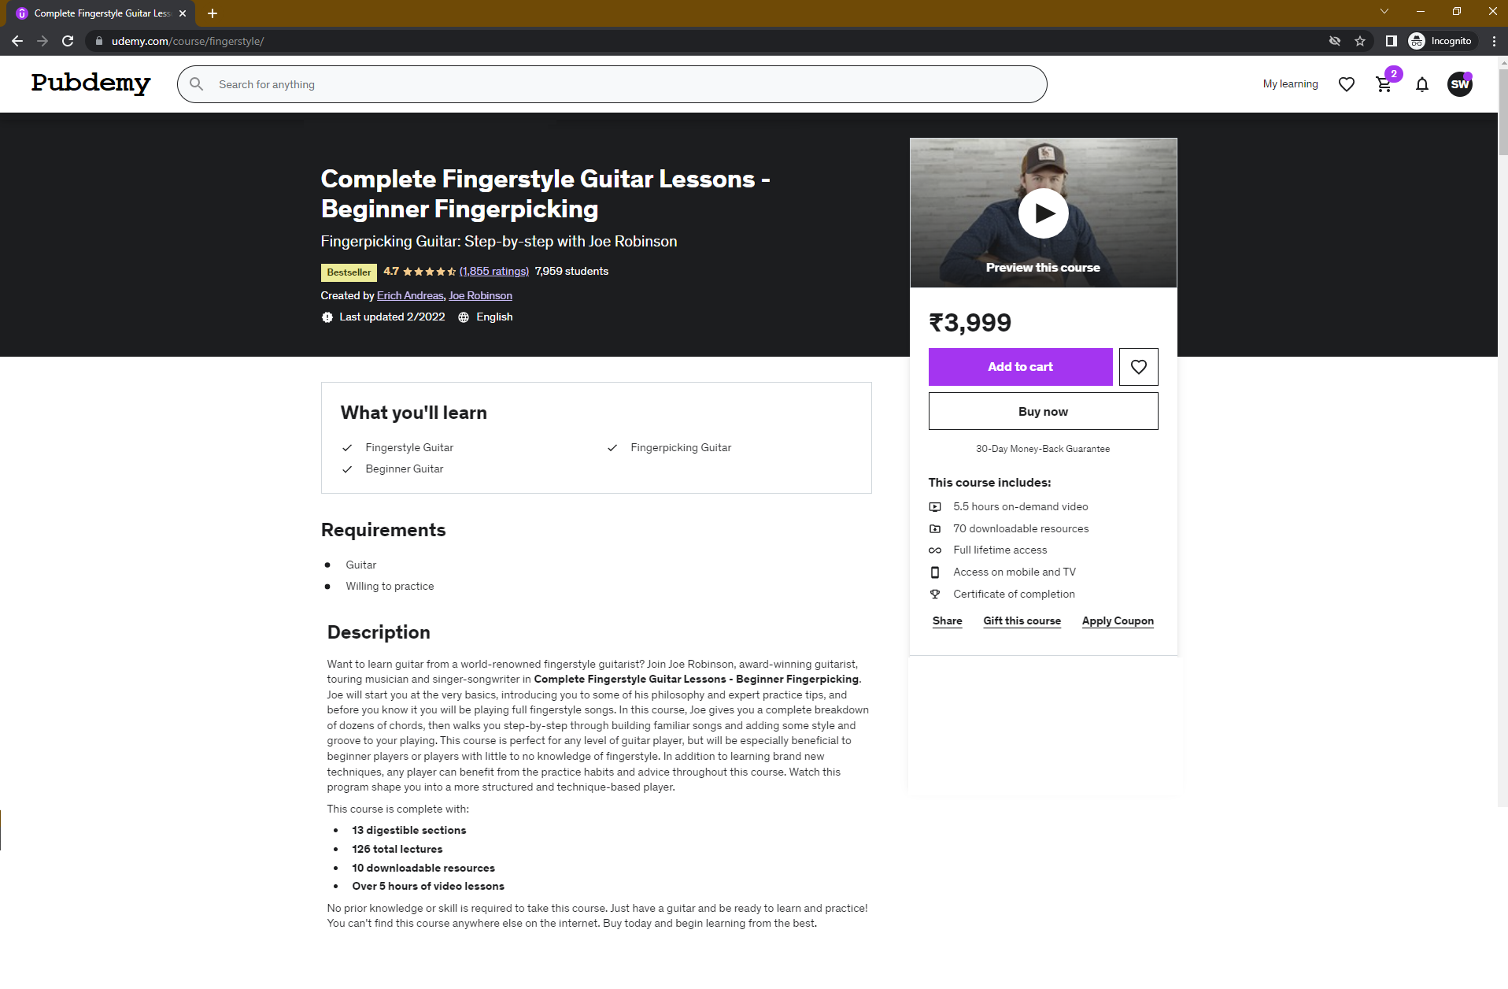

**Course Details Screen (Snapshot-2)**

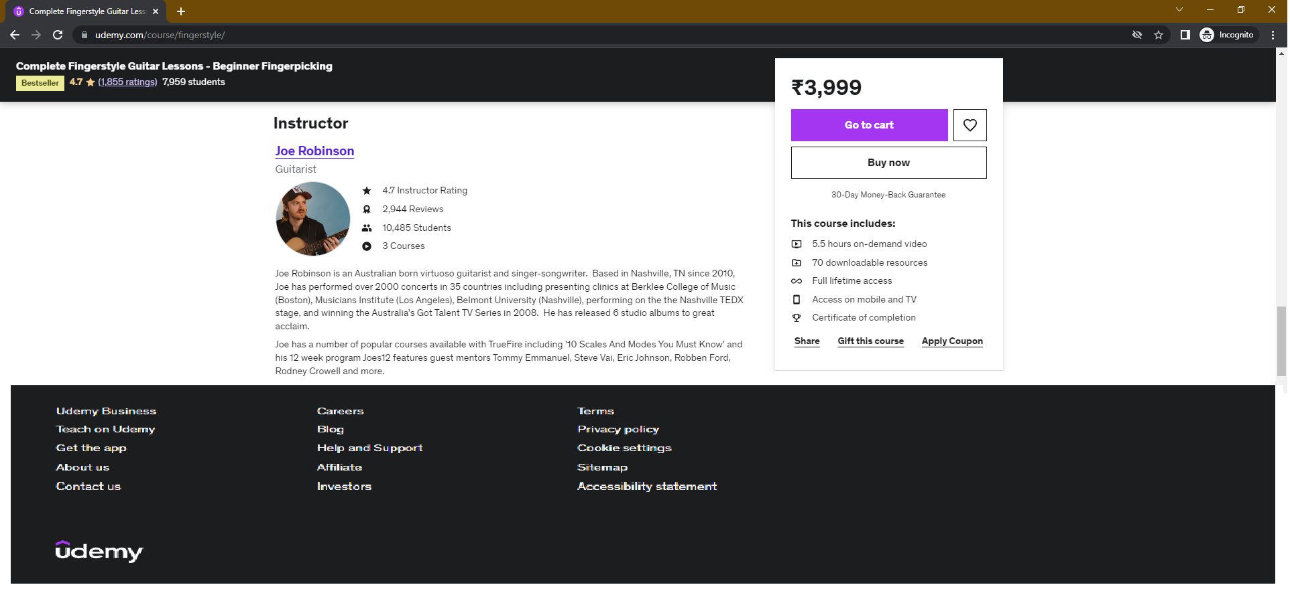

**Cart Summary Screen**

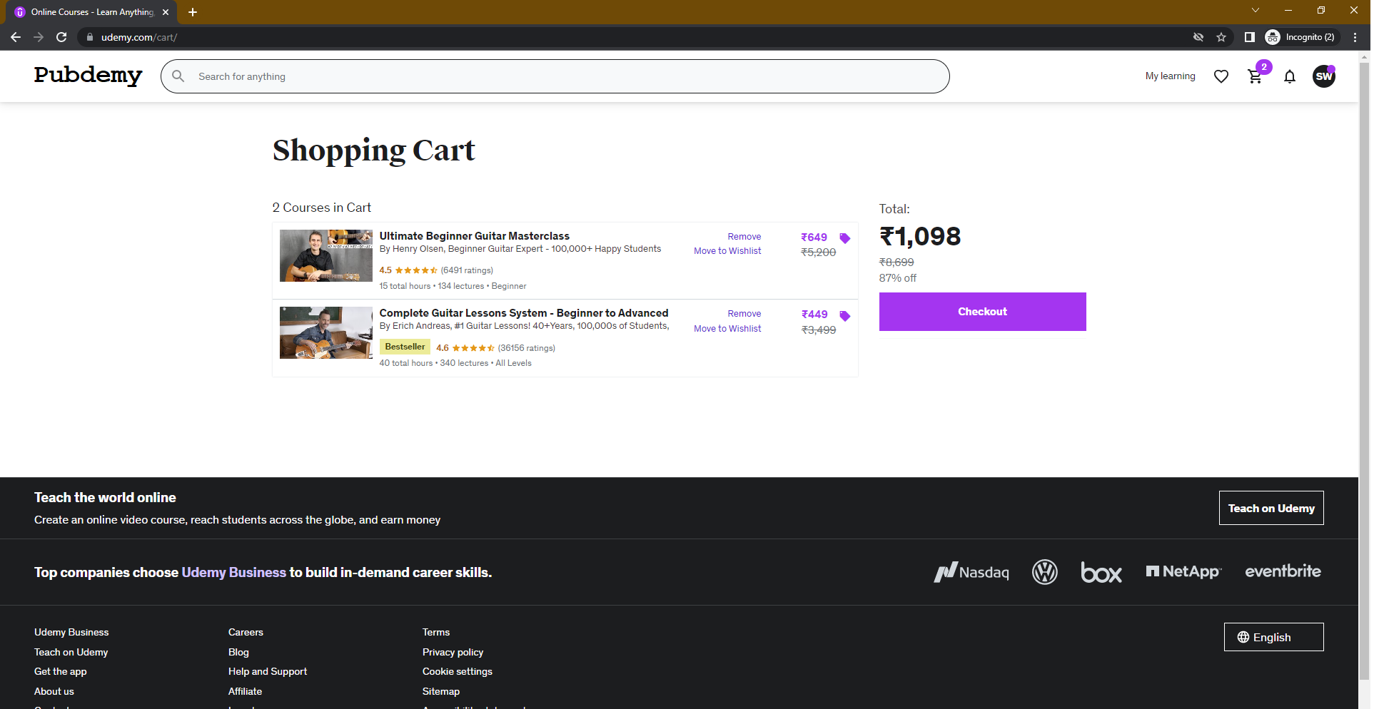

**Checkout Screen**

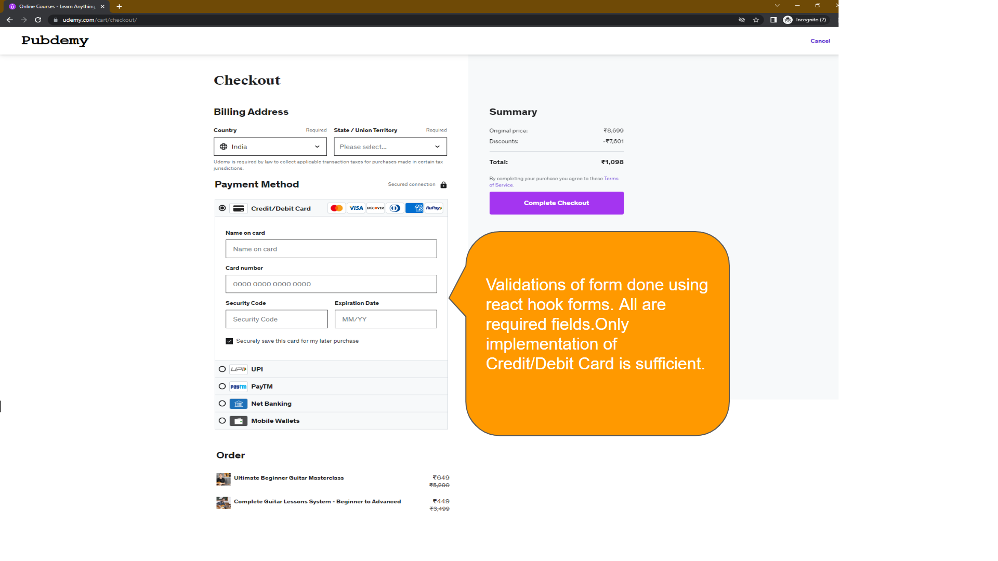

**Order Complete**

