**Birthday problem and Coupon collector**

**Birthday problem :**

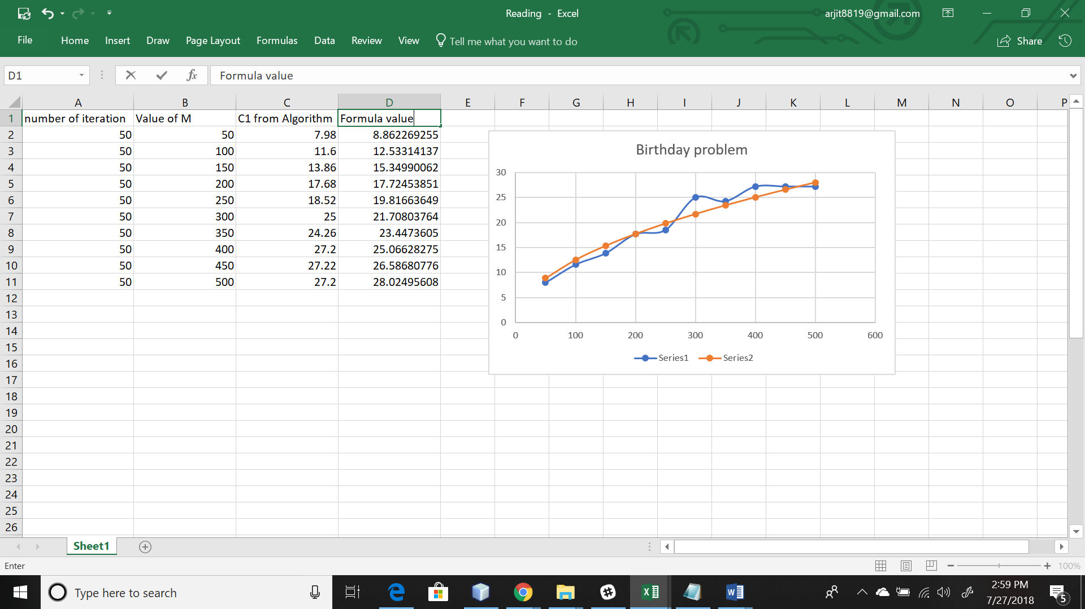

In birthday problem we were supposed to calculate the number of people required to have same birthday. Formula given was C1 = sqrt(pi.m/2). Where m is number of days in year. In this we have to calculate the hashes used before the first collision occurs. In this using a hash fuction we allot index in hash table and keeps the counter increasing as soon as two hash function values have same vale we print it.

As we can see from the observations that when m = 50 then formula value is 8.86 and code value is 7.98 which are very close and for m =100 formula value is 12.56 and code value is 11.6 which are very close again.

Hence the formula can be validated.

**Coupon collector:**

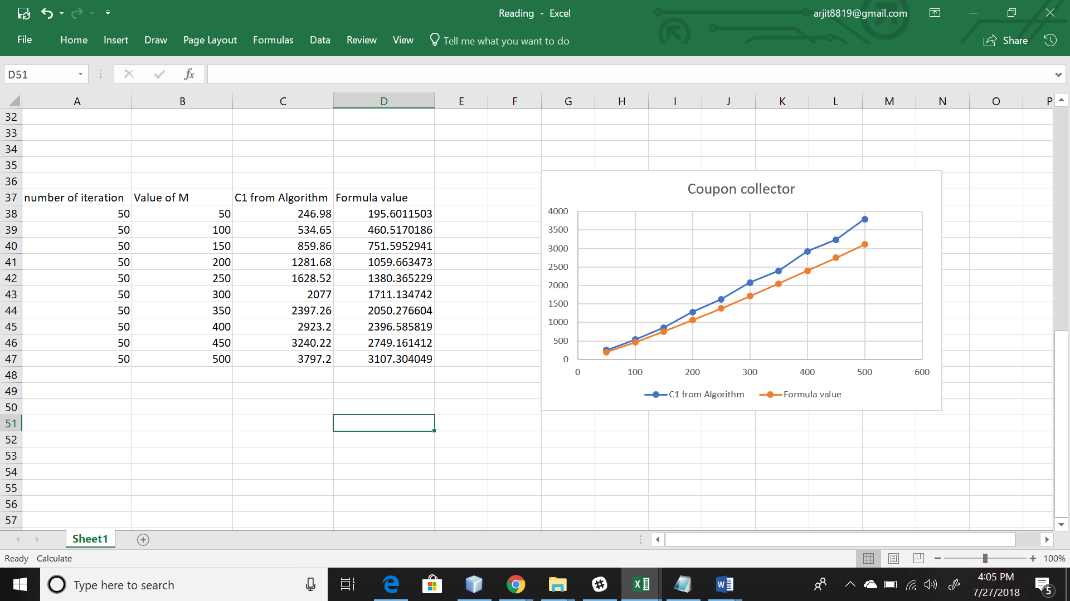

In coupon collector we are supposed to calculate all number of values as for the hashtable index are completely filled.

For this we check every index of hashtable if they are empty we fill the hashtable again by using hashfunction.

Observations:

As we can see from the observations that when m = 50 then formula value is 195.6 and code value is 246.98 which are very close and for m =100 formula value is 460. and code value is 534.6 which are very close again.

Hennce the formula can be validated.

**Test cases :**

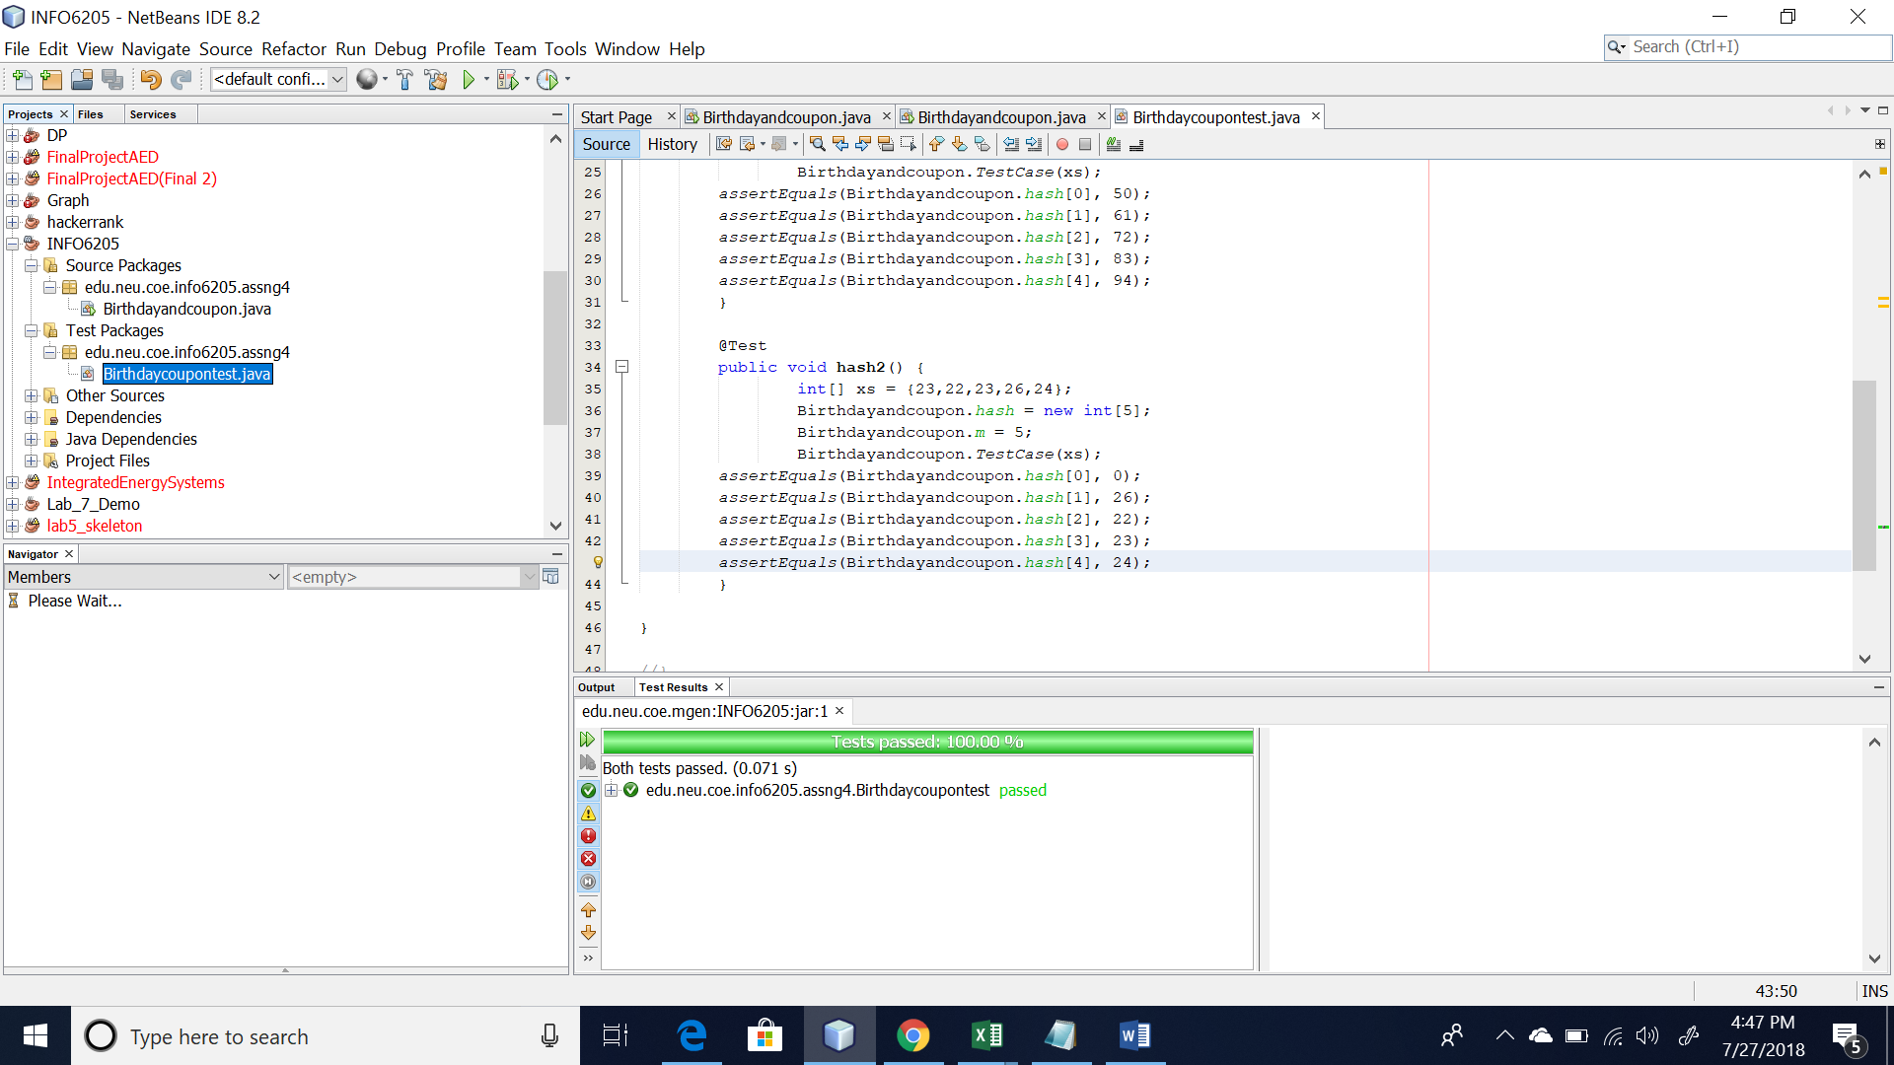

There are two simple test cases.

For birthday problem if we take 365 days then value generated by formula and code is almost same near about 23 so this again can we validated.

