We will perform a rolling update deployment alongside shadow testing

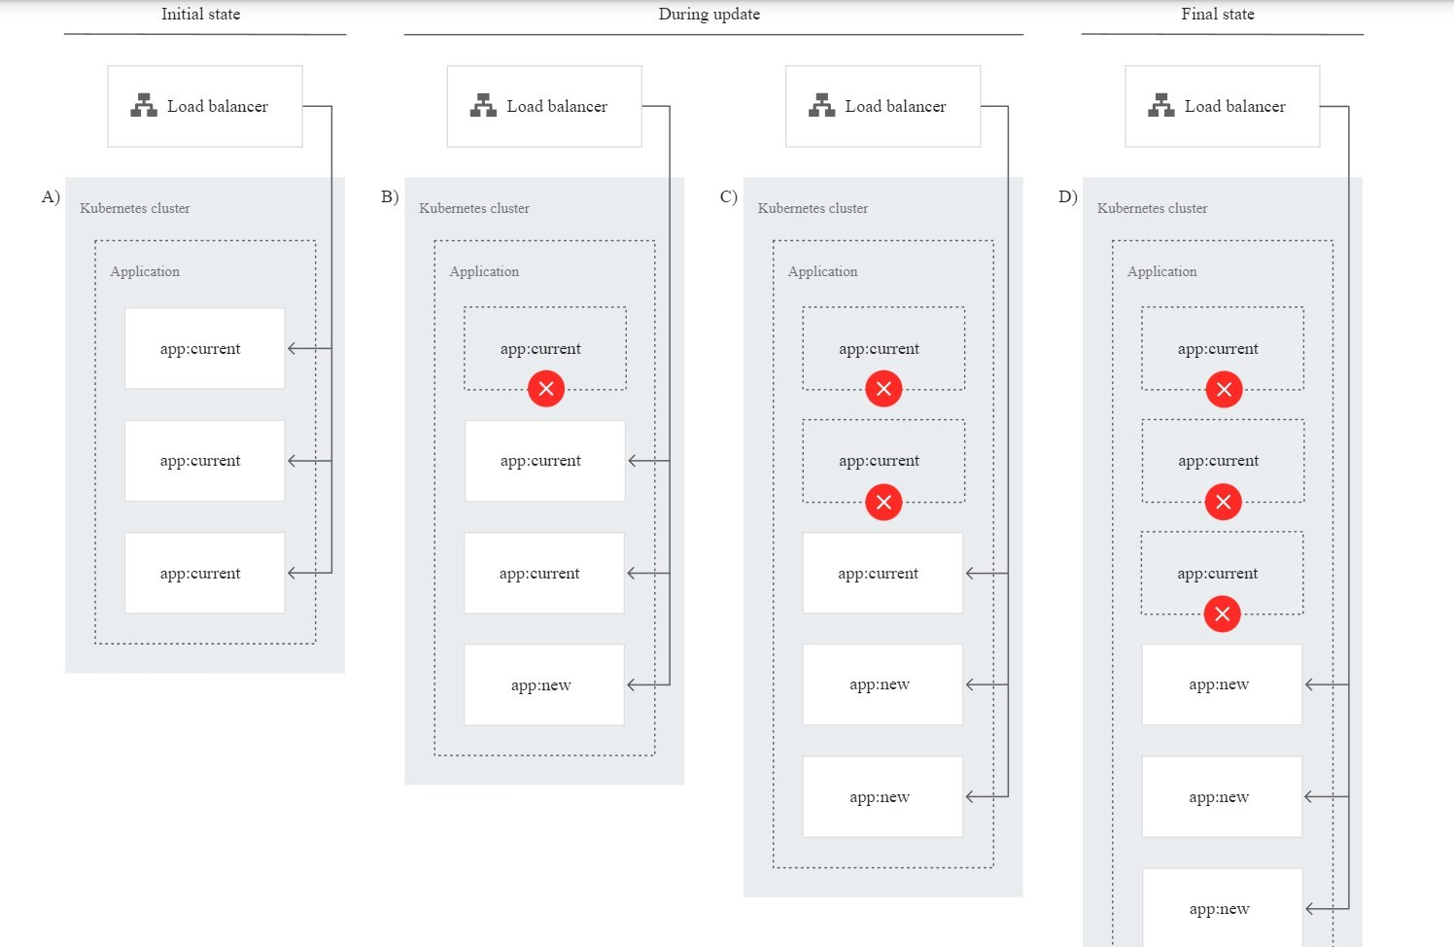

To try this pattern, you perform the following steps:

* Deploy the current version of the application (app:current) on the GKE cluster.
* Test the deployed application by generating traffic against it.
* Deploy a new version of the application (app:new).
* Verify that the traffic switched from app:current to app:new.

Once deployment is done, we will perform shadow testing to mimic the expected users and to test if our deployment is able to handle the number of requests at different stages